Machine Learning to Predict Ischemic Stroke Complications among Type 2 Diabetes Mellitus Patients
Supplementary Appendix

Table of Contents
S1. Method 2
Table S1. Detailed demographic characteristics of study cohorts 4
Table S2. The associations between different features and the outcome at the patient baseline 6
Table S3. The detailed performance of different machine-learning models with various measurements 8
Table S4. The performance of the ANN model stratified by different antidiabetic medications 9
Figure S1. The ROC and PROC curve of best model stratified by different antidiabetic medications 10
Reference 11

S1. Method
Development of the Algorithms
ML algorithms, including logistic regression (LR), linear discriminant analysis (LDA), gradient boosting machine (GBM), LightGBM (LBGM), AdaBoost, random forest, extreme gradient boosting (XGBoost), and artificial neural network (ANN) algorithms, were used for model training and validation.
- Logistic Regression
Among the options in the latter category, one of the popular models in medicine is LR. An LR model calculates the class membership probability for one of two categories in a data set. (Dreiseitl & Ohno-Machado, 2002) The parameters for modeling in this study were penalty = ‘l2’ and C = 0.0001.
- Linear Discriminant Analysis
LDA is generally used to classify patterns between two classes; however, it can be extended to classify multiple patterns. LDA assumes that all classes are linearly separable, and according to this, multiple linear discrimination functions representing several hyperplanes in the feature space are created to distinguish the classes. If there are two classes, then LDA draws one hyperplane and projects the data onto this hyperplane to maximize the separation of the two categories.(Vaibhaw et al., 2020) LDA parameters were established to solve for recommended data with a large number of features using the least squares solution (lsqr), which can be combined with shrinkage or a custom covariance estimator with fixed shrinkage at 0 value.
- Gradient Boosting Machine
Gradient boosting of regression trees produces competitive, highly robust, interpretable procedures for regression and classification. The ability of TreeBoost procedures to provide a quick indication of potential predictability, coupled with its extreme robustness, makes it a useful preprocessing tool that can be applied to imperfect data.(Friedman, 2001) GBM was applied with default parameters and n_estimators, which is the number of boosting stages to perform at 100.
- LightGBM
LGBM is a gradient-boosting framework that uses tree-based learning algorithms. It is designed to be distributed and efficient with the following advantages: faster training speed and higher efficiency, lower memory usage, better accuracy, support of parallel, distributed, and GPU learning, and capability to large-scale handling data.(Microsoft, 2022) The hyper-tuning parameters of LGBM were as follows: objective = 'binary', class_weight = 'balanced', learning_rate = 0.05, reg_alpha = 0.1, reg_lambda = 0.1, subsample = 0.8, and random_state = 12.
- AdaBoost
The AdaBoost algorithm is an iterative procedure that combines many weak classifiers to approximate the Bayes classifier C∗(x). Starting with the unweighted training sample, AdaBoost builds a classifier, such as a classification tree that produces class labels. If a training data point is misclassified, the weight of that data point is increased. A second classifier is built using the new weights, which are no longer equal. Again, misclassified training data have their weights boosted, and the procedure is repeated.(Hastie et al., 2009)
- Random Forest
Random forest fits many classification trees into a dataset and then combines the predictions from all the trees. The algorithm begins with the selection of bootstrap samples from the data. Observations in the original dataset that do not occur in a bootstrap sample are called out-of-bag observations. A classification tree fits each bootstrap sample, but at each node, only a small number of randomly selected variables are available for binary partitioning. The trees are fully grown, and each is used to predict the out-of-bag observations. The predicted observation class is calculated by the majority vote of the out-of-bag predictions for that observation, with ties split randomly.(Cutler et al., 2007)
- Extreme Gradient Boosting
XGBoost, an efficient and scalable implementation of the gradient boosting framework developed by Friedman, is an ML system for tree boosting. The scalability of XGBoost is due to several important systems and algorithmic optimizations. These innovations include a novel tree learning algorithm for handling sparse data; a theoretically justified weighted quantile sketch procedure enables handling instance weights in approximate tree learning. Parallel and distributed computing make learning faster, which enables quicker model exploration.(Chen & Guestrin, 2016)
(8) Voting ensemble
Ensemble learning, originally proposed for classification by Nilsson (1965), is a hybrid learning system in which various machine learning models are merged intelligently to get better predictive performance and robustness than a single weak model. The effectiveness obtained via ensemble method is achieved through a mechanism based on the variance component reduction of prediction errors of contributing models by adding bias.(Kibria et al., 2022)

Table S1. Detailed demographic characteristics of study cohorts
Feature |  | Training cohort  (n=25,334) | Testing cohort  (n=14,312)
1-year Stroke, N (%) |  | 399 (1.6) | 201 (1.4)
3-year Stroke, N (%) |  | 600 (1.5) | 399 (1.6)
Age, Mean (SD), y |  | 62.5 (13.9) | 61.7 (13.6)
Gender, N (%)
Male |  | 11,777 (46.5) | 6,646 (46.4)
Female |  | 13,557 (53.5) | 7,666 (53.6)
Body mass index (BMI), Mean (SD) |  | 26.4 (4.96)) | 26.4 (5.08)
Disease duration, Mean (SD), y |  | 0.576 (1.60) | 0.503 (1.42)
No. Visits with anti-diabetic drugs, N (%) |  | n=1,216,987 | n=601,151
Insulin |  | 111,610 (9.2) | 68,111 (11.3)
Metformin |  | 199,515 (16.4) | 90,541 (15.1)
Sulfonylureas |  | 35,747 (2.9) | 24,056 (4.0)
Alpha glucosidase inhibitors |  | 8,256 (0.7) | 3,268 (0.5)
Thiazolidinediones |  | 2,490 (0.2) | 1,043 (0.2)
Dipeptidyl peptidase 4 (DPP-4) inhibitors |  | 51,056 (4.2) | 17,846 (3.0)
Glucagon-like peptide-1 (GLP-1) analogues |  | 1,130 (0.1) | 178 (0.0)
Sodium-glucose co-transporter 2 (SGLTI-2) inhibitors |  | 2,702 (0.2) | 1,035 (0.2)
Other blood glucose lowering drugs, excl. insulins |  | 11,755 (1.0) | 12,063 (2.0)
Combinations of oral blood glucose lowering drugs |  | 792,726 (65.1) | 383,010 (63.7)
 | Comorbidities, N (%)
 | Hyperlipidemia | 7,286 (28.8) | 1,439 (10.1)
 | Hypertension | 7,764 (30.6) | 2,439 (17.0)
 | Prior stroke | 760 (3.0) | 536 (3.7)
 | Cardiovascular diseases | 2,098 (8.3) | 626 (4.4)
 | Chronic obstructive pulmonary disease – COPD | 733 (2.9) | 87 (0.6)
 | Renal disease | 969 (3.8) | 477 (3.3)
 | Rheumatic disease | 65 (0.3) | 13 (0.1)
 | Cancer | 304 (1.2) | 70 (0.5)
 | Peptic ulcer disease | 759 (3.0) | 117 (0.8)
 | Paralysis | 17 (0.1) | 3 (0.0)
 | Liver disease | 1978 (7.8) | 211 (1.5)
 | Anemias | 542 (2.1) | 95 (0.7)
 | Depressive disorder | 978 (3.9) | 135 (0.9)
 | Dementia | 200 (0.8) | 104 (0.7)
 | Parkinson | 106 (0.4) | 43 (0.3)
 | CCI score, Mean (SD) | 2.16 (1.61) | 1.91 (1.45)
 | Other medications, N (%)
 | Antacids (A02AA, A02AX) | 525 (2.1) | 82 (0.6)
 | Drugs for peptic ulcer and gastro-esophageal reflux disease (A02BA, A02BC) | 198 (0.8) | 86 (0.6)
 | Gastrointestinal disorders (A03AX, A03FA) | 272 (1.1) | 51 (0.4)
 | Laxatives (A06AB, A06AD) | 759 (3.0) | 128 (0.9)
 | Antithrombotic (B01AA, B01AC) | 2,598 (10.3) | 589 (4.1)
 | Antianemic agents (B03BA, B03BB, B03XA) | 528 (2.1) | 180 (1.3)
 | Cardiac therapy (C01AA, C01BD, C01DA, C01DX) | 938 (3.7) | 258 (1.8)
 | Antihypertensives (C02CA, C02DB) | 184 (0.7) | 59 (0.4)
 | Diuretics (C03AA, C03BA, C03CA, C03DA) | 1,410 (5.6) | 256 (1.8)
 | Beta blocking agents (C07AA, C07AB, C07AG) | 2,281 (9.0) | 430 (3.0)
 | Calcium channel blockers (C08CA, C08DB) | 2,319 (9.2) | 352 (2.5)
 | Renin angiotensin (C09AA, C09CA, C09DB, C09DX) | 3,554 (14.0) | 488 (3.4)
 | Lipid modifying agents (C10AA, C10AB, C10AX, C10BA) | 3,645 (14.4) | 502 (3.5)
 | Glucocorticoids (H02AB) | 53 (0.2) | 6 (0.0)
 | Anti-inflammatory and antirheumatic, non-steroids (M01AB, M01AC, M01AH) | 213 (0.8) | 69 (0.5)
 | Antigout (M04AA, M04AB, M04AC) | 808 (3.2) | 106 (0.7)
 | Nervous system (N02AJ, N02BE, N03AE, N03AX, N04BA, N05AH, N05BA, N05BB, N05CD, N05CF, N06AA, N06AX, N06BX, N07AB, N07CA) | 1,760 (6.9) | 403 (2.8)
 | Antihistamines (R06AE, R06AX) | 139 (0.5) | 41 (0.3)
 | Peripheral vasodilators (C04AD) | 332 (1.3) | 161 (1.1)
 | Liver therapy (A05BA) | 200 (0.8) | 33 (0.2))
 | Benign prostatic hypertrophy (G04CA) | 291 (1.1) | 41 (0.3)
 | Corticosteroids (H02AB) | 71 (0.3) | 16 (0.1)
 | Thyroid hormones (H03AA) | 211 (0.8) | 30 (0.2)
 | Laboratory test
 | HbA1C, mean (SD), mmg/l | 8.07 (2.00) | 8.64 (2.33)
 | AC glucose, mean (SD), mmg/l | 162 (83.4) | 172 (75.5)
 | Creatinine, mean (SD), mmg/l | 1.16 (1.20) | 1.27 (1.51)
 | Triglyceride, mean (SD), mmg/l | 167 (166) | 194 (270)
 | Total Cholesterol, mean (SD), mmg/l | 187 (43.6) | 199 (49.7)
 | High Density Lipoprotein Cholesterol, mean (SD), mmg/l | 47.6 (12.6) | 43.7 (11.9)
 | Low density lipoprotein Cholesterol, mean (SD), mmg/l | 113 (37.2) | 113 (38.1)
Note: SD, Standard Deviation; IQR, Interquartile Range; ATC, Anatomical Therapeutic Chemical;
ªTraining and Testing cohorts consisted of Taipei Medical University, Wan-fang hospitals data and Shuang-ho hospital, respectively.
^{b}Heart problem included heart failure, myocardial infarction, cerebrovascular disease, and peripheral vascular disease.

Table S2. The associations between different features and the outcome at the patient baseline
Feature | 1-year Stroke |  | 3-year Stroke
Feature | Odds ratio  (95% CI) | P-value | Odds ratio  (95% CI) | P-value
Demographic
Gender | 0.81 (0.6,1.09) | 0.165 | 0.89 (0.73,1.08) | 0.244
Age | 1.04 (1.03,1.05) | < 0.001 | 1.04 (1.04,1.05) | < 0.001
BMI | 0.95 (0.88,1.02) | 0.143 | 0.96 (0.91,1) | 0.079
Anti-diabetic agent,
Reference= Insulins
Metformin | 0.18 (0.12,0.29) | < 0.001 | 0.26 (0.19,0.35) | < 0.001
Sulfonylureas | 0.3 (0.14,0.62) | 0.001 | 0.73 (0.49,1.08) | 0.12
Alpha glucosidase inhibitors | 0.2 (0.03,1.44) | 0.109 | 0.71 (0.31,1.64) | 0.426
Thiazolidinediones | - | 0.965 | - | 0.964
Dipeptidyl peptidase 4 (DPP-4) inhibitors | 1.06 (0.61,1.83) | 0.848 | 1.14 (0.75,1.73) | 0.536
Glucagon-like peptide-1 (GLP-1 RA) analogues | - | 0.985 | - | 0.985
Sodium-glucose co-transporter 2 (SGLTi-2) inhibitors | 3.7 (0.86,15.87) | 0.078 | 2.18 (0.51,9.28) | 0.29
Other blood glucose lowering drugs, excl. insulins | 0.15 (0.02,1.06) | 0.057 | 0.26 (0.08,0.82) | 0.022
Combinations of oral blood glucose lowering drugs | 0.25 (0.17,0.36) | < 0.001 | 0.42 (0.33,0.54) | < 0.001
Comorbidities
Hyperlipidemia | 0.51 (0.35,0.76) | < 0.001 | 0.72 (0.57,0.91) | 0.006
Hypertension | 0.84 (0.6,1.17) | 0.298 | 1.23 (1,1.51) | 0.053
Prior stroke | 5.91 (3.87,9.02) | < 0.001 | 6.39 (4.82,8.46) | < 0.001
CVD | 1.87 (1.22,2.87) | 0.004 | 2.85 (2.22,3.65) | < 0.001
COPD | 0.9919 (0.41,2.4) | 0.986 | 0.95 (0.52,1.74) | 0.87
Peptic ulcer disease | - | 0.97 | 0.49 (0.22,1.1) | 0.084
Renal disease | 0.44 (0.14,1.38) | 0.159 | 0.98 (0.58,1.65) | 0.945
Liver disease | 0.28 (0.1,0.74) | 0.011 | 0.33 (0.18,0.6) | < 0.001
Anemias | 0.53 (0.13,2.14) | 0.372 | 0.69 (0.31,1.56) | 0.379
Depression | 0.44 (0.14,1.37) | 0.155 | 0.97 (0.58,1.64) | 0.916
Dementia | 3.78 (1.54,9.31) | 0.004 | 3.35 (1.76,6.37) | < 0.001
Parkinson | 5.77 (2.1,15.86) | < 0.001 | 2.47 (0.9,6.73) | 0.078
CCI score | 1.23 (1.13,1.33) | < 0.001 | 1.28 (1.21,1.35) | < 0.001
Long-term medications
Antacids | 0.55 (0.14,2.22) | 0.401 | 1.35 (0.74,2.47) | 0.335
Gord | - | 0.964 | 0.64 (0.16,2.57) | 0.525
Gastrointestinal disorders | - | 0.973 | 0.93 (0.35,2.51) | 0.889
Laxatives | 0.57 (0.18,1.78) | 0.329 | 0.83 (0.44,1.56) | 0.564
Antithrombotic | 0.42 (0.21,0.85) | 0.017 | 0.97 (0.7,1.35) | 0.879
Antianemic | - | 0.962 | 0.59 (0.24,1.44) | 0.247
Cardiac therapy | 0.93 (0.41,2.1) | 0.857 | 0.94 (0.55,1.62) | 0.836
Antihypertensives | 1.59 (0.39,6.47) | 0.514 | 0.69 (0.17,2.77) | 0.596
Diuretics | 0.5 (0.21,1.22) | 0.128 | 1.24 (0.83,1.83) | 0.292
Beta blocking | 0.42 (0.2,0.9) | 0.025 | 0.91 (0.64,1.3) | 0.606
Calcium channel blockers | 0.23 (0.09,0.63) | 0.004 | 0.95 (0.67,1.35) | 0.79
Renin angiotensin | 0.26 (0.12,0.54) | < 0.001 | 0.7 (0.5,0.97) | 0.03
Lipid modifying | 0.32 (0.16,0.63) | < 0.001 | 0.7 (0.5,0.96) | 0.028
Antigout | 0.17 (0.02,1.25) | 0.082 | 0.7 (0.36,1.35) | 0.287
Nervous system drugs | 1.75 (0.55,5.51) | 0.341 | 0.89 (0.59,1.34) | 0.59
Antihistamines | 1.05 (0.15,7.53) | 0.964 | 1.38 (0.44,4.36) | 0.581
Benign prostatic hypertrophy | - | 0.972 | 0.65 (0.21,2.03) | 0.457
Laboratory test
HbA1c | 1.06 (0.97,1.16) | 0.211 | 1.06 (1,1.13) | 0.04
AC glucose | 1.0029 (1.0019,1.0039) | < 0.001 | 1.0021 (1.0012,1.003) | < 0.001
Creatinine | 1.07 (0.94,1.21) | 0.303 | 1.06 (0.98,1.16) | 0.157
Triglyceride | 1 (0.9988,1.0013) | 0.967 | 0.9999 (0.9989,1.0008) | 0.781
Total cholesterol | 0.9975 (0.9921,1.0029) | 0.36 | 0.9996 (0.9962,1.003) | 0.818
High Density Lipoprotein Cholesterol | 0.94 (0.91,0.98) | 0.006 | 0.96 (0.93,0.99) | 0.002
Low density lipoprotein Cholesterol | 0.9997 (0.9911,1.0083) | 0.941 | 1.0018 (0.9963,1.0074) | 0.511

Table S3. The detailed performance of different machine-learning models with various measurements
Mode | Model | Training-AUC | Testing-AUC | Accuracy | Sensitivity | Specificity | PPV | NPV | F1-score
1-year follow-up | LR | 0.66 | 0.67 | 0.63 | 0.66 | 0.62 | 0.01 | 1.00 | 0.02
1-year follow-up | LDA | 0.76 | 0.78 | 0.71 | 0.72 | 0.71 | 0.01 | 1.00 | 0.04
1-year follow-up | LGBM | 0.92 | 0.77 | 0.71 | 0.69 | 0.72 | 0.01 | 1.00 | 0.04
1-year follow-up | GBM | 0.82 | 0.77 | 0.69 | 0.73 | 0.69 | 0.01 | 1.00 | 0.04
1-year follow-up | RF | 0.97 | 0.72 | 0.68 | 0.66 | 0.68 | 0.01 | 1.00 | 0.03
1-year follow-up | XGB | 0.91 | 0.77 | 0.82 | 0.58 | 0.82 | 0.02 | 1.00 | 0.04
1-year follow-up | RF | 0.82 | 0.78 | 0.68 | 0.77 | 0.68 | 0.01 | 1.00 | 0.04
1-year follow-up | AdaBoost* | 0.94 | 0.78 | 0.77 | 0.65 | 0.77 | 0.02 | 1.00 | 0.04
1-year follow-up | Voting | 0.66 | 0.67 | 0.63 | 0.66 | 0.62 | 0.01 | 1.00 | 0.02
3-year follow-up | LR | 0.72 | 0.75 | 0.63 | 0.77 | 0.63 | 0.03 | 1.00 | 0.07
3-year follow-up | LDA | 0.75 | 0.76 | 0.67 | 0.71 | 0.67 | 0.03 | 0.99 | 0.07
3-year follow-up | LGBM* | 0.96 | 0.76 | 0.70 | 0.69 | 0.70 | 0.03 | 0.99 | 0.09
3-year follow-up | GBM | 0.93 | 0.75 | 0.69 | 0.68 | 0.69 | 0.03 | 0.99 | 0.09
3-year follow-up | RF | 0.99 | 0.66 | 0.70 | 0.56 | 0.70 | 0.02 | 0.99 | 0.06
3-year follow-up | XGB | 0.97 | 0.72 | 0.71 | 0.63 | 0.71 | 0.03 | 0.99 | 0.07
3-year follow-up | RF | 0.91 | 0.75 | 0.69 | 0.71 | 0.68 | 0.03 | 0.99 | 0.08
3-year follow-up | AdaBoost | 0.88 | 0.76 | 0.68 | 0.72 | 0.68 | 0.03 | 1.00 | 0.08
3-year follow-up | Voting | 0.72 | 0.75 | 0.63 | 0.77 | 0.63 | 0.03 | 1.00 | 0.07

Note: LR, Logistic Regression; LDA, Linear Discriminant Analysis; LGBM, Light Gradient Boosting Machine; GBM, Gradient Boosting Machine; XGBoost, Extreme Gradient Boosting; RF, Random Forest; *, Best model based on AUC values.

Table S4. The model performance stratified by different antidiabetic medications
Mode | Antidiabetic  medications | Testing-AUC | Accuracy | Sensitivity | Specificity | PPV | NPV | F1-score
1-year follow-up | Insulin | 0.77 | 0.68 | 0.76 | 0.68 | 0.02 | 1.00 | 0.05
1-year follow-up | Metformin | 0.81 | 0.80 | 0.69 | 0.80 | 0.02 | 1.00 | 0.04
1-year follow-up | DPP4 | 0.67 | 0.61 | 0.70 | 0.61 | 0.01 | 1.00 | 0.02
1-year follow-up | Combination | 0.77 | 0.72 | 0.72 | 0.72 | 0.01 | 1.00 | 0.03
3-year follow-up | Insulin | 0.72 | 0.67 | 0.66 | 0.67 | 0.04 | 0.99 | 0.12
3-year follow-up | Metformin | 0.81 | 0.66 | 0.82 | 0.66 | 0.02 | 1.00 | 0.10
3-year follow-up | DPP4 | 0.75 | 0.65 | 0.76 | 0.64 | 0.03 | 1.00 | 0.06
3-year follow-up | Combination | 0.74 | 0.66 | 0.72 | 0.66 | 0.02 | 0.99 | 0.08

(A) 1-year follow-up
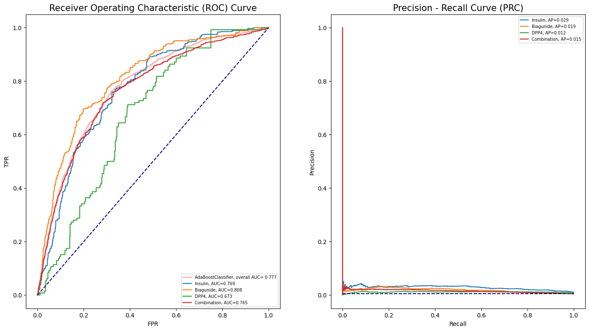
(B) 3-year follow-up
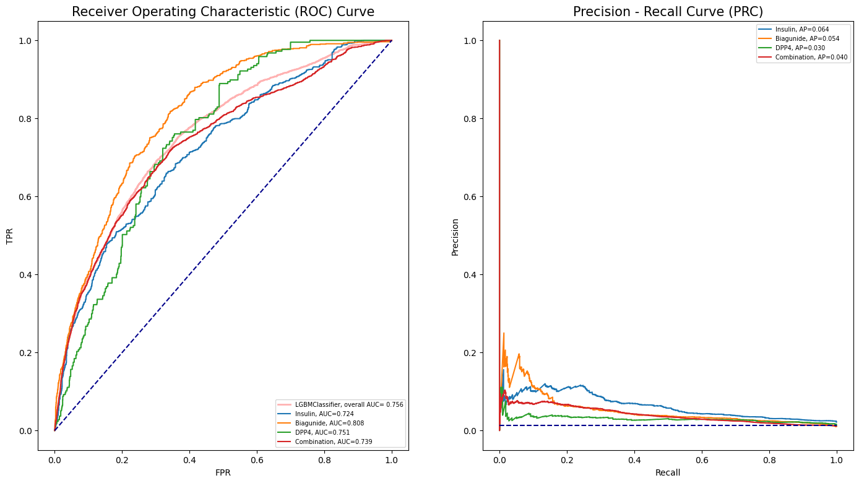

Figure S1. The ROC and PROC curve of best model stratified by different antidiabetic medications

Reference
Chen, T., & Guestrin, C. (2016). XGBoost: A Scalable Tree Boosting System. 22nd ACM SIGKDD International Conference on Knowledge Discovery and Data Mining, 785-794. https://doi.org/http://dx.doi.org/10.1145/2939672.2939785
Cutler, D. R., Edwards, T. C., Beard, K. H., Cutler, A., Hess, K. T., Gibson, J., & Lawler, J. J. (2007). Random forests for classification in ecology. Ecology, 88, 2783-2792. https://doi.org/10.1890/07-0539.1
Dreiseitl, S., & Ohno-Machado, L. (2002). Logistic regression and artificial neural network classification models: A methodology review. Journal of Biomedical Informatics, 35, 352-359. https://doi.org/10.1016/S1532-0464(03)00034-0
Friedman, J. H. (2001). Greedy Function Approximation: A Gradient Boosting Machine. The Annals of Statistics, 29, 1189-1232.
Hastie, T., Rosset, S., Zhu, J., & Zou, H. (2009). Multi-class AdaBoost. Statistics and Its Interface, 2, 349-360. https://doi.org/10.4310/sii.2009.v2.n3.a8
Kibria, H. B., Nahiduzzaman, M., Goni, M. O. F., Ahsan, M., & Haider, J. (2022). An Ensemble Approach for the Prediction of Diabetes Mellitus Using a Soft Voting Classifier with an Explainable AI. Sensors (Basel), 22(19). https://doi.org/10.3390/s22197268
Microsoft, C. (2022). LightGBM.
Vaibhaw, Sarraf, J., & Pattnaik, P. K. (2020). Brain-computer interfaces and their applications. Elsevier. https://doi.org/10.1016/B978-0-12-821326-1.00002-4

