pH-responsive and hyaluronic acid-functionalized metal-organic frameworks for therapy of osteoarthritis
Feng Xiong^{1,2,3,4}, Zainen Qin^{1,2,5}, Haimin Chen^{1,2,5}, Qiumei Lan^{1,3,5}, Zetao Wang¹, Nihan Lan^{1,2,5,}*, Yuan Yang^{1,2,4,}*, Li Zheng^{1,2,5,}*, Jinmin Zhao^{1,2,3,6}, Dan Kai⁷
1 Guangxi Engineering Center in Biomedical Material for Tissue and Organ Regeneration, Life Sciences Institute, Guangxi Medical University, Nanning, 530021, China
2 Guangxi Collaborative Innovation Center for Biomedicine, Life Sciences Institute, Guangxi Medical University, Nanning, 530021, China
3 Department of Orthopaedics Trauma and Hand Surgery, The First Affiliated Hospital of Guangxi Medical University, Guangxi Medical University, Nanning, 530021, China
4 Orthopaedics, Langdong Hospital of Guangxi Medical University, Guangxi Medical University, Nanning, 530021, China
5 Life Sciences Institute, Guangxi Medical University, Nanning, 530021, China
6 Guangxi Key Laboratory of Regenerative Medicine, Life Sciences Institute, Guangxi Medical University, Nanning, 530021, China
7 Institute of Materials Research and Engineering (IMRE), A*STAR, 2 Fusionopolis Way, #08-03 Innovis, 138634, Singapore
* Co-Corresponding authors: Nihan Lan, Yuan Yang, Li Zheng
E-mail addresses: 1142963164@qq.com (Prof. Nihan Lan), yangy062@sina.com (Prof. Yuan Yang), and zhengli224@163.com, Fax: +86-07715306456 (Prof. Li Zheng)
¹ Feng Xiong, Zainen Qin, Haimin Chen contributed as first authors.

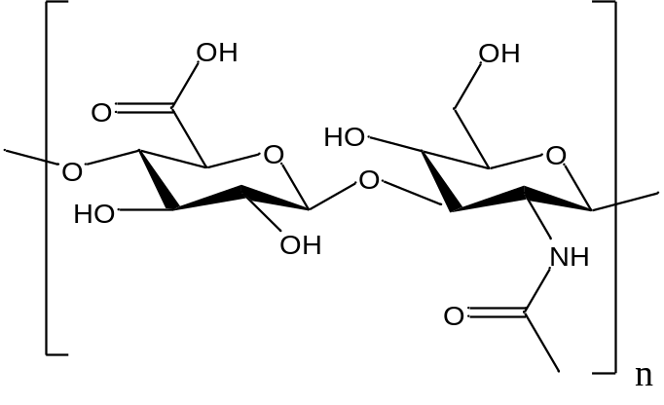
Figure S1. The chemical structures of HA (hyaluronic acid).

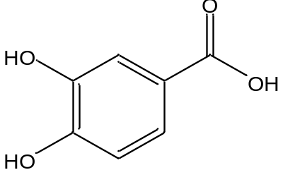
Figure S2. The chemical structures of PCA (protocatechuic acid).

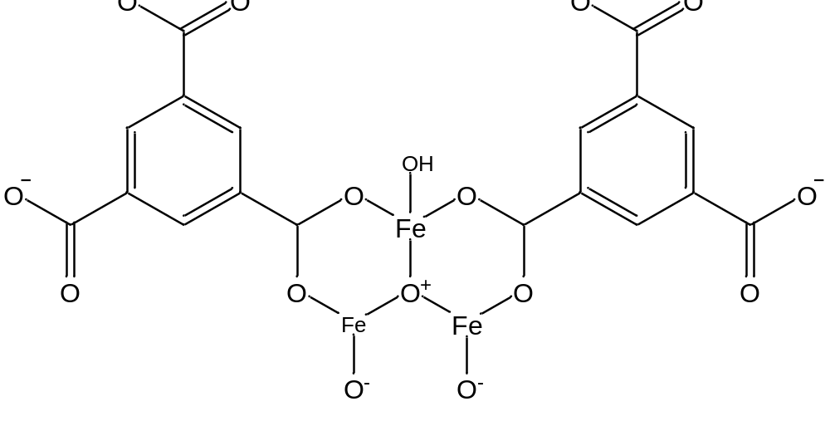

Figure S3. The chemical structures of MOF.
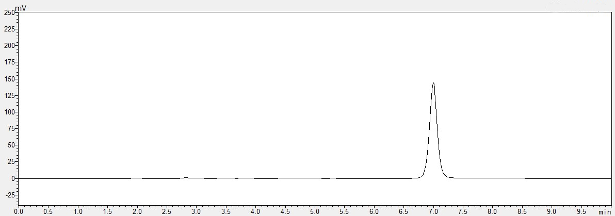
Figure S4. The typical chromatogram of PCA.

1. Quantify the amount of HA on MOF NPs
The MOF@HA NPs could be obtained by mixing MOF NPs with HA (Sigma-Aldrich, USA) at weight ratio of 2:1 for 24 h. The mixtures were washed with water for three times to remove the free HA, then MOF@HA NPs were obtained after lyophilization under vacuum. We quantified the amount of HA on MOF NPs and calculated the rate of HA on MOF NPs (HA, %) by the following formula :
$$HA \left(\%\right)=\frac{weight\text{ of MOF@}\text{HA}\text{ - }weight\text{ of MOF }\text{feeding}}{weight\text{ of MOF}\text{ feeding}}×100\%$$

2. Quantitative measurement of released Fe³⁺ by the method of o-phenanthroline
The degradation of MOF was investigated by quantitative measurement of released Fe³⁺ at different pH (Figure S5＆6). FeCl₃ (4 mM) was diluted to different concentration and reduced to Fe²⁺ by Vitamin C (10 mM, 1 mL) for 5 min, then the mixture was reacted with o-phenanthroline (0.1%, 1 mL) and the red complex was produced, which absorbance is at 510 nm. The volume of the reaction system was 5 mL. The absorption spectra of different samples were obtained using an UV-vis spectrometer. The absorbance intensity at 510 nm was correlated with the Fe³⁺ in concentration. The obtain standard curve is y=0.00548x+0.04226 (y: absorbance value at 510 nm; x: concentration of Fe³⁺，R²= 0.9998) (Fig. S5).

Figure S5. The quantification of Fe³⁺ by using o-phenanthroline. The absorption spectra of inset: The standard curve for absorbance value at 510 nm. y=0.00548x+0.04226，R²=0.9998.
Figure S6. Degradation study of MOF at different pH. The quantitative analysis of the Fe³⁺ released from MOF in various pH environment. The data represents the mean ± SD (n=3).

3. ROS production from MOF in chondrocytes

Figure. S7 ROS production induced by MOF after incubation in chondrocytes for 24h. Data was presented as the mean ± SD (n=3). * p < 0.05; ** p < 0.01; *** p < 0.001.

