1. H&E staining of tendinopathy model samples
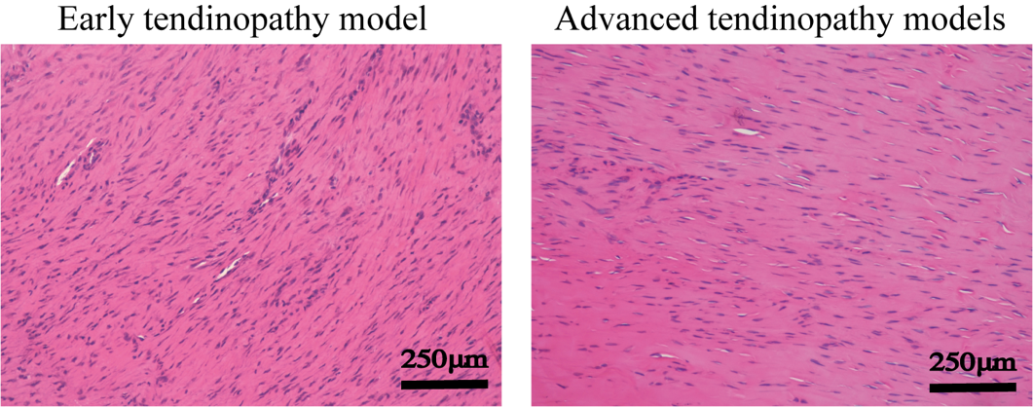

2. Information of primary antibodies used in this study
Primary antibody | Application | Company | Catalog Number | RRID
Col I | 1: 200 | Affinity | AF7001 | AB_2835309
Col III | 1: 200 | Affinity | AF5457 | AB_2837941
MMP-3 | 1: 400 | Affinity | AF0217 | AB_2833347
TIMP-3 | 1: 200 | Affinity | DF6432 | AB_2838395

