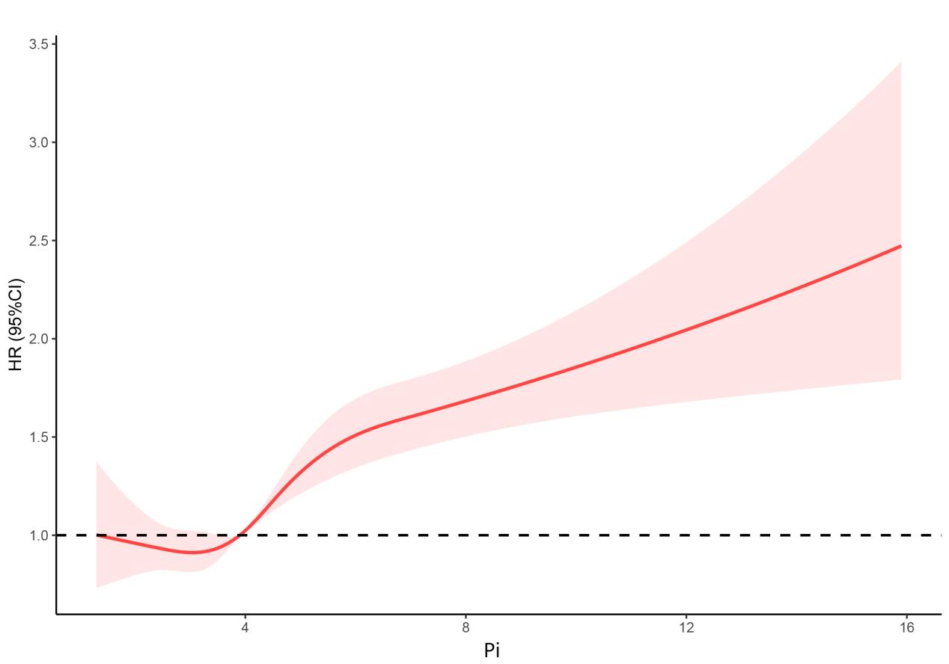
Supplemental Figure 1. The nonlinear curve fitting of the association between serum phosphate levels and 30-day mortalities in patients with AKI. 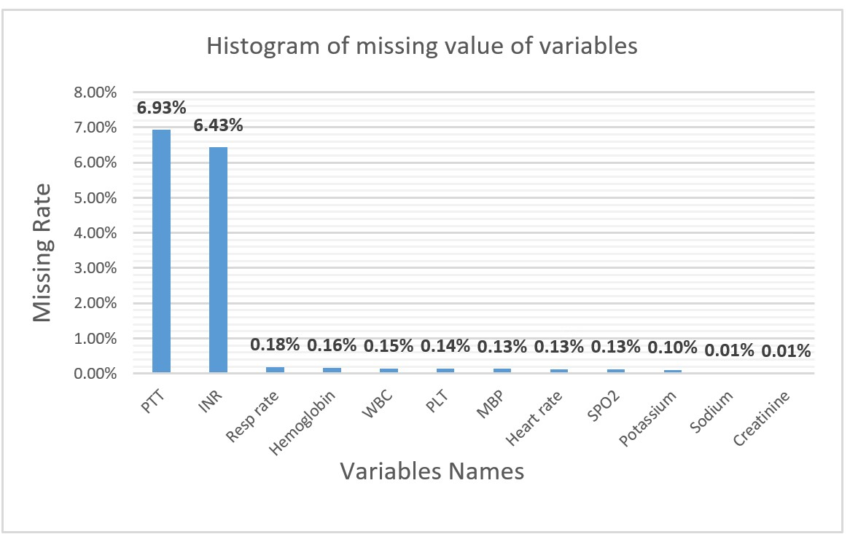
Supplemental Figure 2. Histogram of missing value of variables.

