Title: Nitrogen transformations in soil under plastic film mulching
journal name: Plant and soil
Names of authors: Hao Zhang¹, Zihao Zhang¹, Zhe Liu¹, Tingting Lei¹, Jinbo Zhang^{2,3}, Christoph Müller^{3,4,5}, Abeer S Aloufi⁹, Ekaterina Filimonenko¹⁰, Yakov Kuzyakov^{6,7,8}, Rui Jiang¹*
* Corresponding author: Rui Jiang
- mail: haixia992000@hotmail.com
Tel: +86-15191864899
Institutions: Key Laboratory of Plant Nutrition and the Agri-environment in Northwest China, Ministry of Agriculture, College of Natural Resources and Environment, Northwest A&F University, Yangling 712100, China
Address: No.3, Rd.Tai Cheng, Yangling, Xianyang, Shaanxi, China. 712100

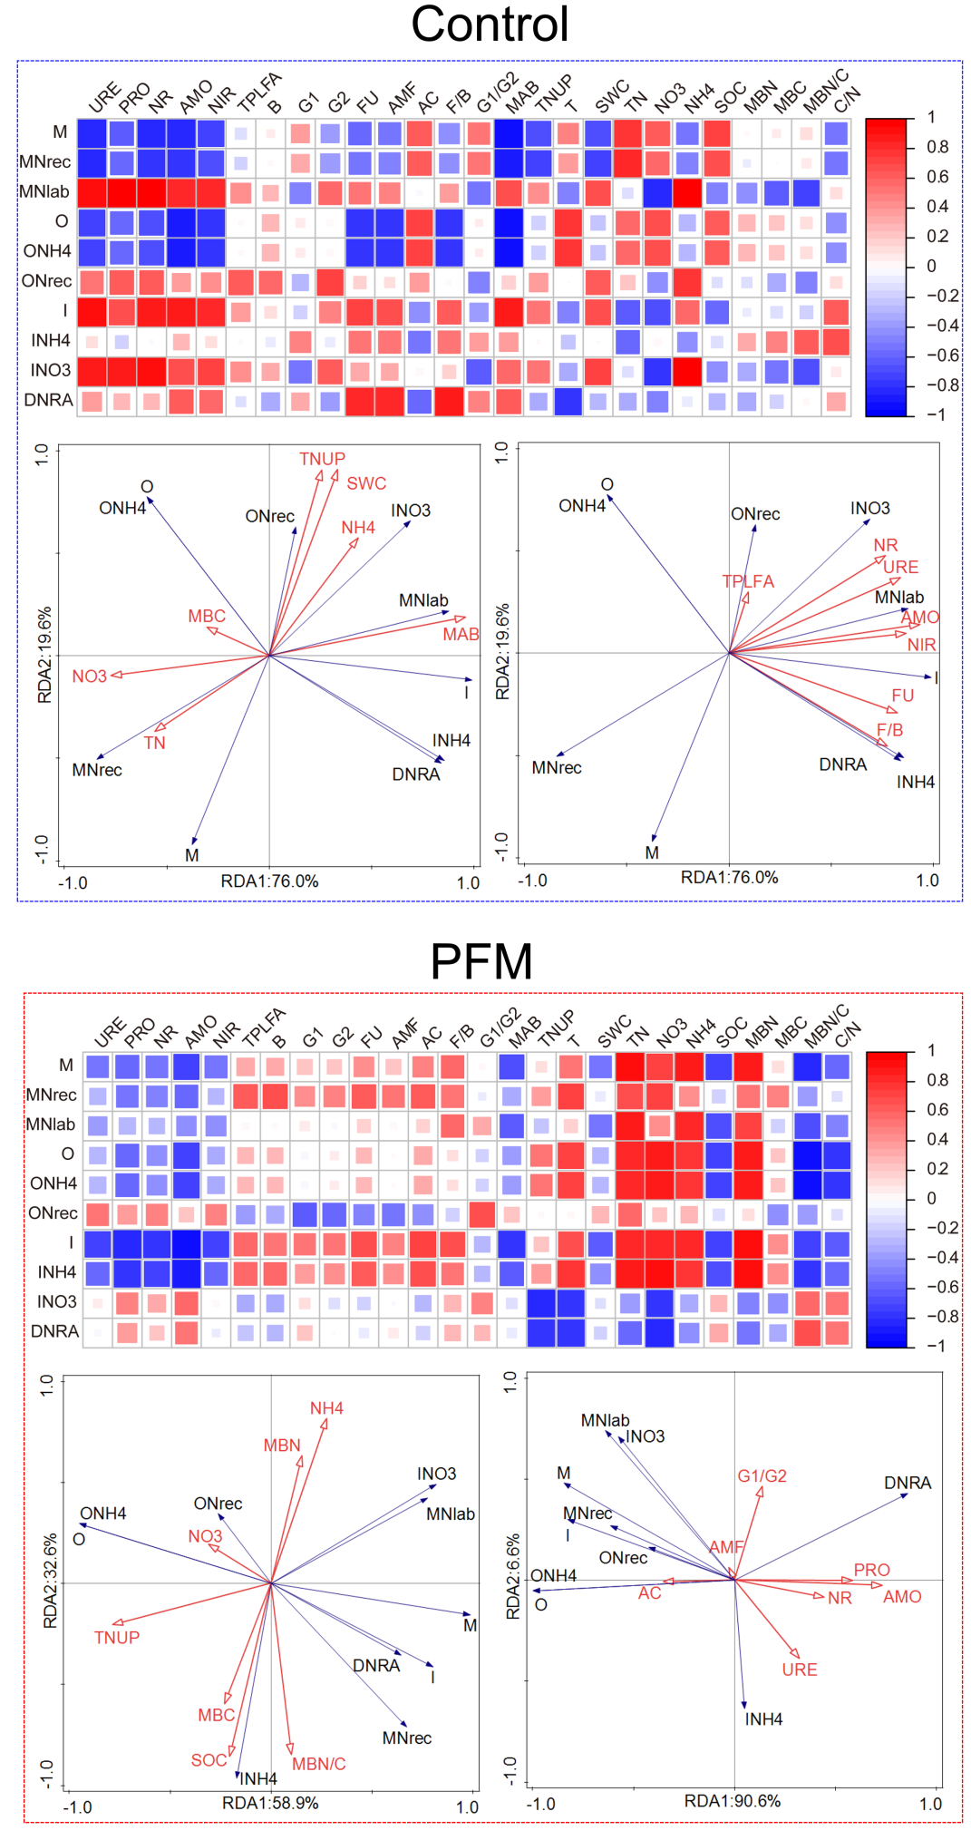
Fig. S1 Correlation between gross N transformation rates and their influential factors. Pearson correlation between microbial community, enzyme activities and soil properties, crop growth indices under Control and PFM . Redundancy analysis (RDA) of gross N transformation rates with biological factors and environmental factors Control and PFM. Control, soil without film mulching; PFM, soil under plastic film mulch. M, the rate of gross mineralization; M_{Nrec}, the mineralization rate of recalcitrant organic N to NH₄⁺; M_{Nlab}, the rate of mineralization of labile organic N to NH₄⁺; O, the rate of nitrification; I, the rate of gross immobilization; O_{NH4}, the rate of autotrophic nitrification; O_{Nrec}, the rate of heterotrophic nitrification; I_{NH4}, the rate of immobilization of NH₄⁺; I_{NO3}, the rate of immobilization of NO₃⁻; DNRA, dissimilatory NO₃⁻ reduction to NH₄⁺; AMO, Ammonia monooxygenase; PRO, Protease; NR, Nitrate reductase; URE, Urease; NIR, Nitrogenase; TPLFA, Total PLFAs; AMF, Arbuscular mycorrhizal fungi PLFAs; B, Bacteria PLFAs; G1, Gram-positive bacteria PLFAs; G2, Gram-negative bacteria PLFAs; FU, Fungi PLFAs; AC, Actinomycetes PLFAs; B, Bacteria PLFAs; F/B, the ratio of fungi PLFAs to bacteria PLFAs; G1/G2, the ratio of gram-positive to gram-negative bacteria PLFA; MAB, maize aboveground biomass; TNUP, plant N uptake; SWC, soil water content; T, soil temperature; NH4, ammonium nitrogen; NO3, nitrate nitrogen; TN, soil total N; SOC, soil organic C; MBC/N, soil microbial biomass C/N; C/N, soil organic C/total N

Table S1 Gross N transformation processes calculated by ¹⁵N tracing tool Ntrace
Gross N transformation rates (mg N kg⁻¹ d⁻¹) | jointing |  | tasseling |  | milk stage |  | maturity
 | Control | PFM | Control | PFM | Control | PFM | Control | PFM
M_{Nrec} | 7.98 | 3.14 | 3.01 | 3.41 | 1.34 | 2.24 | 0.57 | 1.63
M_{Nlab} | 0.22 | 3.02 | 0.06 | 0.59 | 3.31 | 0.64 | 1.70 | 0.54
O_{NH4} | 25.1 | 20.7 | 20.7 | 15.6 | 18.2 | 14.1 | 8.41 | 5.90
O_{Nrec} | 0.01 | 0.01 | 0.01 | 0.01 | 0.07 | 0.12 | 0.01 | 0.01
I_{NH4} | 0.21 | 3.09 | 1.81 | 2.53 | 0.11 | 1.22 | 2.35 | 0.63
I_{NO3} | 0.01 | 0.1 | 0.01 | 0.01 | 2.81 | 0.14 | 0.92 | 0.74
D_{NO3} | 0.01 | 0.01 | 0.01 | 0.01 | 0.01 | 0.01 | 0.03 | 0.06
Total gross N transformation ratesª | 33.5 | 30.1 | 25.6 | 22.2 | 25.9 | 18.5 | 14.0 | 9.51
Net NH₄⁺ production^{b} | -17.1 | -17.6 | -19.4 | -14.1 | -13.7 | -12.4 | -8.46 | -4.30
Net NO₃⁻ production^{c} | 25.1 | 20.6 | 20.7 | 15.6 | 15.5 | 14.1 | 7.47 | 5.11
ª Total gross N transformation rates = M_{Nrec} + M_{Nlab} + O_{NH4} + O_{Nrec} + I_{NH4} + I_{NO3} + D_{NO3.}
^{b} Net NH₄⁺ production = M_{Nrec} + M_{Nlab} + D_{NO3} - O_{NH4} - I_{NH4}.
^{c} Net NO₃⁻ production = O_{NH4} + O_{Nrec} - I_{NO3} - D_{NO3}.
Control, soil without film mulching; PFM, soil under plastic film mulch. M_{Nrec}, the rate of mineralization of recalcitrant organic N to NH₄⁺; M_{Nlab}, the rate of mineralization of labile organic N to NH₄⁺; O_{NH4}, the rate of autotrophic nitrification; O_{Nrec}, the rate of heterotrophic nitrification; I_{NH4}, the rate of immobilization of NH₄⁺; I_{NO3}, the rate of immobilization of NO₃⁻; O_{NH4}, the rate of oxidation of NH₄⁺ to NO₃⁻; D_{NO3}, dissimilatory NO₃⁻ reduction to NH₄⁺
Table S2 Redundancy analysis influential factors sorting
Name | Pseudo-F | p | Name | Pseudo-F | p
Biological factors in Control |  |  | Environmental factors in Control
AMO | 21 | 0.002 | MAB | 24 | 0.001
NR | 16 | 0.002 | TNUP | 15 | 0.002
NIR | 19 | 0.002 | MBC | 16 | 0.001
URE | 5.5 | 0.016 | NO3 | 14 | 0.008
TPLFA | 4.9 | 0.022 | TN | 23 | 0.01
Biological factors in PFM |  |  | Environmental factors in PFM
AMO | 15 | 0.002 | MBC/N | 7 | 0.002
NR | 24 | 0.002 | TNUP | 8.1 | 0.006
G1/G2 | 9.7 | 0.002 | NH4 | 21 | 0.002
URE | 14 | 0.001 | SOC | 13 | 0.001
PRO | 9.9 | 0.011 | NO3 | 5 | 0.008
AC | 9.7 | 0.014 | MBC | 13 | 0.03
Control, soil without film mulching; PFM, soil under plastic film mulch. AMO, Ammonia monooxygenase; PRO, Protease; NR, Nitrate reductase; URE, Urease; NIR, Nitrogenase; TPLFA, Total PLFAs; AMF, Arbuscular mycorrhizal fungi PLFAs; AC, Actinomycetes PLFAs; B, Bacteria PLFAs; DM, maize dry matter; NH4, ammonium nitrogen; NO3, nitrate nitrogen; TNUP, plant N uptake; SWC, soil water content; SOC, soil organic carbon; MBC/N, soil microbial biomass carbon/nitrogen; C/N, soil organic C/total N

Table S3 The N balance in cropping systems during maize growth
kg N ha⁻¹ |  | Sowing-jointing | Sowing-tasseling | Sowing-milk stage | Sowing-maturity
Input
Fertilizer N | Control | 225 | 225 | 225 | 225
Fertilizer N | PFM | 225 | 225 | 225 | 225
Deposition N | Control | 5 | 10 | 15 | 21
Deposition N | PFM | 5 | 10 | 15 | 21
Mineralization | Control | 97 | 152 | 187 | 187
Mineralization | PFM | 73 | 81 | 111 | 129
Output
Crop N uptake | Control | 23 | 85 | 154 | 196
Crop N uptake | PFM | 48 | 147 | 219 | 233
Soil N accumulation | Control | 98 | 1 | 87 | 53
Soil N accumulation | PFM | 105 | 140 | 173 | 112
Gas emissions | Control | 51 | 53 | 55 | 57
Gas emissions | PFM | 21 | 22 | 24 | 25
Potential N leaching | Control | 155 | 248 | 131 | 128
Potential N leaching | PFM | 129 | 7 | -65 | 5
Control, without film mulching; PFM, plastic film mulching. The N deposition in the study area is 21 kg N ha⁻¹ (Guo et al., 2019); the N mineralization amounts were calculated from the gross N mineralization rates minus the gross immobilization rates of NH₄⁺; Soil N accumulation ( 0-80 cm) comes from our previous study (Wang et al., 2022); Gas emissions (N₂O, NH₃) come from Wang (2022); Potential N leaching estimate is that the sum of Fertilizer N, Deposition N, the amount mineralization and Root layers residual N minus Crop N uptake, Soil N accumulation, and Gas emissions

Table S4 Accumulated maize aboveground biomass and N uptake in various organs during maize growth
 |  | Aboveground biomass  (t ha⁻¹) | Total N uptake  (kg N ha⁻¹) | Stem N uptake  (kg N ha⁻¹) | Leaf N uptake  (kg N ha⁻¹) | Maize ear N uptake  (kg N ha⁻¹)
jointing | Control | 0.5±0.1 | 23±3.2 | 13±2.1 | 10±2.3 | —
jointing | PFM | 1.2±0.2 | 48±5.8 | 17±2.2 | 30±2.7 | —
tasseling | Control | 3.1±0.4 | 85±12 | 24±2.8 | 61±12 | —
tasseling | PFM | 6.2±0.4 | 147±19 | 35±4.7 | 104±14 | —
milk stage | Control | 10±1.0 | 154±11 | 19±2.5 | 61±8.8 | 73±19
milk stage | PFM | 16±1.5 | 219±9.7 | 18±2.3 | 76±9.5 | 122±13
maturity | Control | 21±1.6 | 196±15 | 16±2.1 | 35±5.2 | 146±20
maturity | PFM | 22±1.5 | 233±10 | 16±1.9 | 34±3.7 | 182±15
Data are expressed as means ± standard errors (n = 3). Control, without film mulching; PFM, plastic film mulching

* Corresponding author. Key Laboratory of Plant Nutrition and the Agri-environment in Northwest China, Ministry of Agriculture, College of Natural Resources and Environment, Northwest A&F University, Yangling 712100, China. E-mail address: jiangrui@nwafu.edu.cn.

