Supplementary Information
Deafness DFNB110 associated with a human MAP3K1 recessive variant recapitulates the mouse mutant Map3k1 deafness

Rabia Faridi, Rizwan Yousaf, Sayaka Inagaki, Rafal Olszewski, Shoujun Gu, Robert J. Morell, Elizabeth Wilson, Ying Xia, Tanveer Ahmed Qaiser, Muhammad Rashid, Cristina Fenollar-Ferrer, Michael Hoa, Sheikh Riazuddin, Thomas B. Friedman

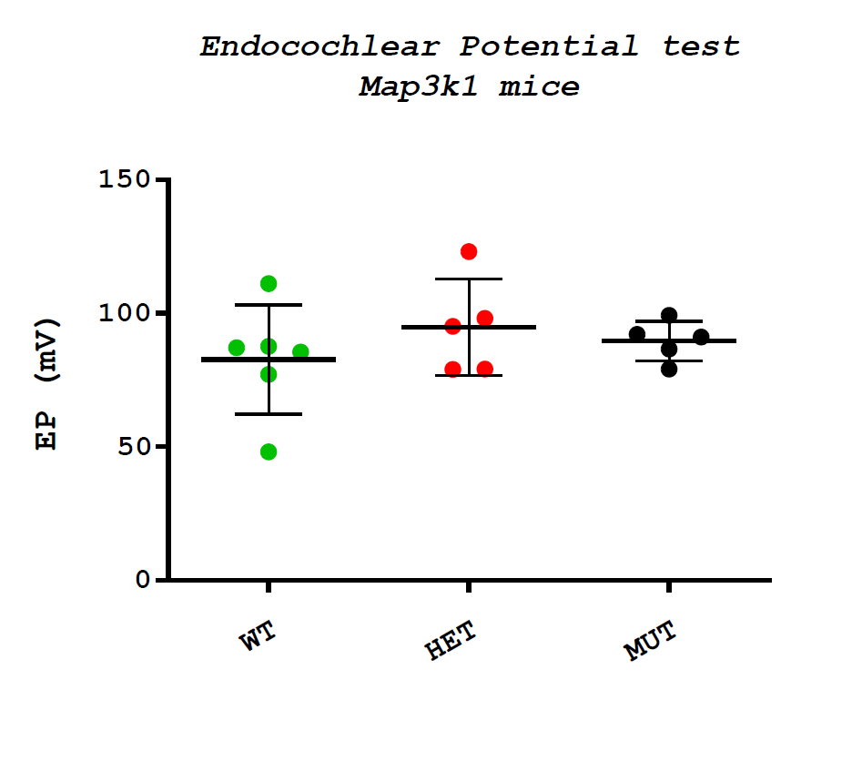
Fig.S1. Endocochlear potential (EP) measurements data of Map3k1 mutant mouse. EP measurements were unchanged across genotypes, including wildtype (WT) littermates, and mice heterozygous (HET) or homozygous for the Map3k1 mutation referred to as mutant (MUT) (ANOVA, p = 0.50 = NS). The method we used for EP measurements employed a glass micro-electrode that was inserted into the round window off the mouse as previously described in detail (Morell et al., 2020; Wangemann et al., 2004; Wangemann et al., 2007). Anesthesia of mice used tribromoethanol (Avertin, 15.1 mg/ml) at 0.35 mg per gm body weight.
Fig. S2. Expression of Hgf-Met signaling pathway genes amongst cochlear cell types. (First column on left) Expression of Hgf-Met signaling pathway genes, including Gab1, Hgf, and Met, amongst stria vascularis cell types, including marginal, intermediate, basal and spindle cells as well as adjacent root cells, fibrocytes and Reissner’s membrane. (Second column in middle) Expression of Hgf-Met signaling pathway genes, including Gab1, Mettl13, Spry2, and Hgf amongst adult spiral ganglion neuron subtypes, including subtypes 1A, 1B, 1C and 2. (Third column on right) Expression of Hgf-Met including Gab1, Mettl13, Spry2, and Met amongst P7 organ of Corti cell types, including inner hair cells (IHC), outer hair cells (OHC), pillar cells, and Deiters cells. Violin plots depict gene expression in normalized counts.
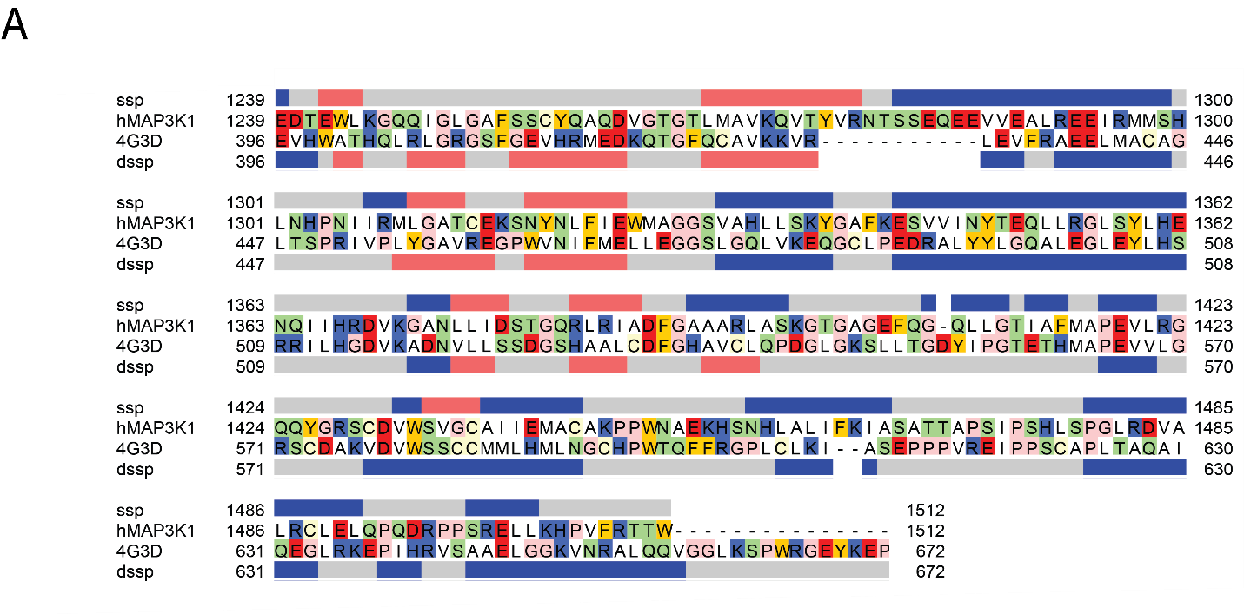

Figure S3.
Amino acid sequence alignment between the kinase domain of human MAP3K1 (hMAP3K1, UniProt: Q13233) and that of human MAP3K14 (aka NF-kappaB, PDB ID: 4G3D) was used for the modelling process. The secondary structure of 4G3D, the kinase domain of human MAP3K14 and the secondary structure prediction of human MAP3K1 kinase domain are shown at the bottom and top of the alignment, respectively. C, H and E stand for coil, helix and beta-strand respectively.

Fig. S3. HGF-MET signaling pathway
Abridged HGF-MET signaling pathway including MAP3K1. Mature HGF binds to MET and activates it through autophosphorylation. Binding proteins and direct kinase substrates activate downstream in the HGF-MET signaling pathway are shown. Full length MAP3K1 activate c-JUN, ERK18/2 and NF-кB pathways. MAP3K1 C-terminal fragment containing the kinase domain is formed by caspase-3 cleavage and activates the JNK pathway. For further details, see references (Chamberlin et al., 2019; Grotegut et al., 2006; Morell et al., 2020; Pham et al., 2013; Zhang et al., 2003).
Abbreviations: CBL, Cbl proto-oncogene; c-JUN, Jun proto-oncogene, AP-1 transcription factor subunit; CRK, CRK proto-oncogene, adaptor protein; CRKL, CRK like proto-oncogene, adaptor protein; ERK1/2, Extracellular signal-regulated kinase 1 and 2; GAB1, GRB2 associated binding protein 1; GAB2, GRB2 associated binding protein 2; HGF, Hepatocyte growth factor; H-RAS, v-Ha-ras Harvey rat sarcoma viral oncogene homolog; IкB, IκB kinase; IKKα/β, IκB kinase alpha and beta complex; JNK, c-Jun N-terminal kinase JNK; MAP2K1, mitogen-activated protein kinase kinase 1; MAP2K2, mitogen-activated protein kinase kinase 2; MAP2K4, mitogen-activated protein kinase kinase 4; MAP2K7, mitogen-activated protein kinase kinase 7; MAP3K1, mitogen-activated protein kinase kinase kinase 1; MET, MET proto-oncogene, receptor tyrosine kinase; METTL13, Methyltransferase 13, eEF1A lysine and N-terminal methyltransferase; NF-кB, Nuclear factor kappa-light-chain-enhancer of activated B cells; PIK3R1, phosphoinositide-3-kinase regulatory subunit 1; PTPN11, protein tyrosine phosphatase non-receptor type 11; RAC1, Rac family small GTPase 1 RAF1, Raf-1 proto-oncogene, serine/threonine kinase; SHC, SHC-adaptor protein SOS, Son of sevenless, SPRY2, Sprouty RTK signaling antagonist 2; SRC, SRC proto-oncogene, non-receptor tyrosine kinase; STAT3, Signal transducer and activator of transcription 3.

Table S1A. Exome variants identified on chromosome 1 from sibship A
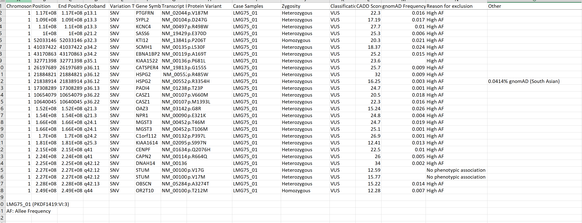
Table S1B. Exome variants identified on chromosome 5 from sibship A
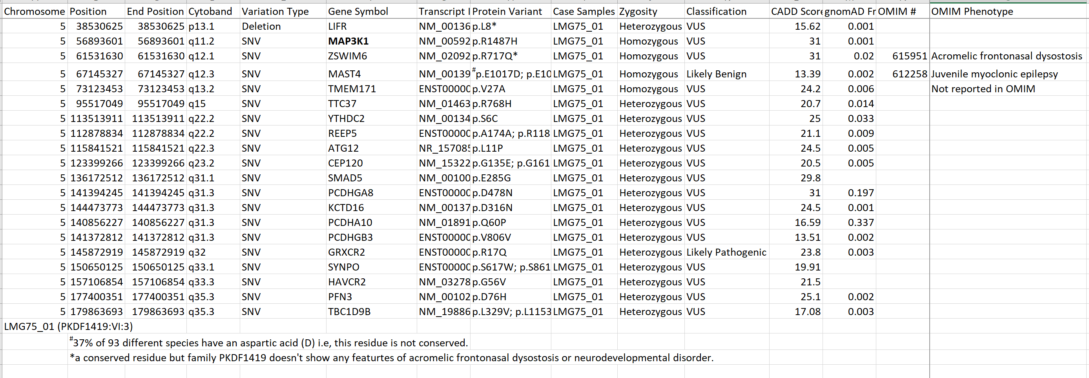

Table S2. Variant classification using in-silico tools and ACMG classification
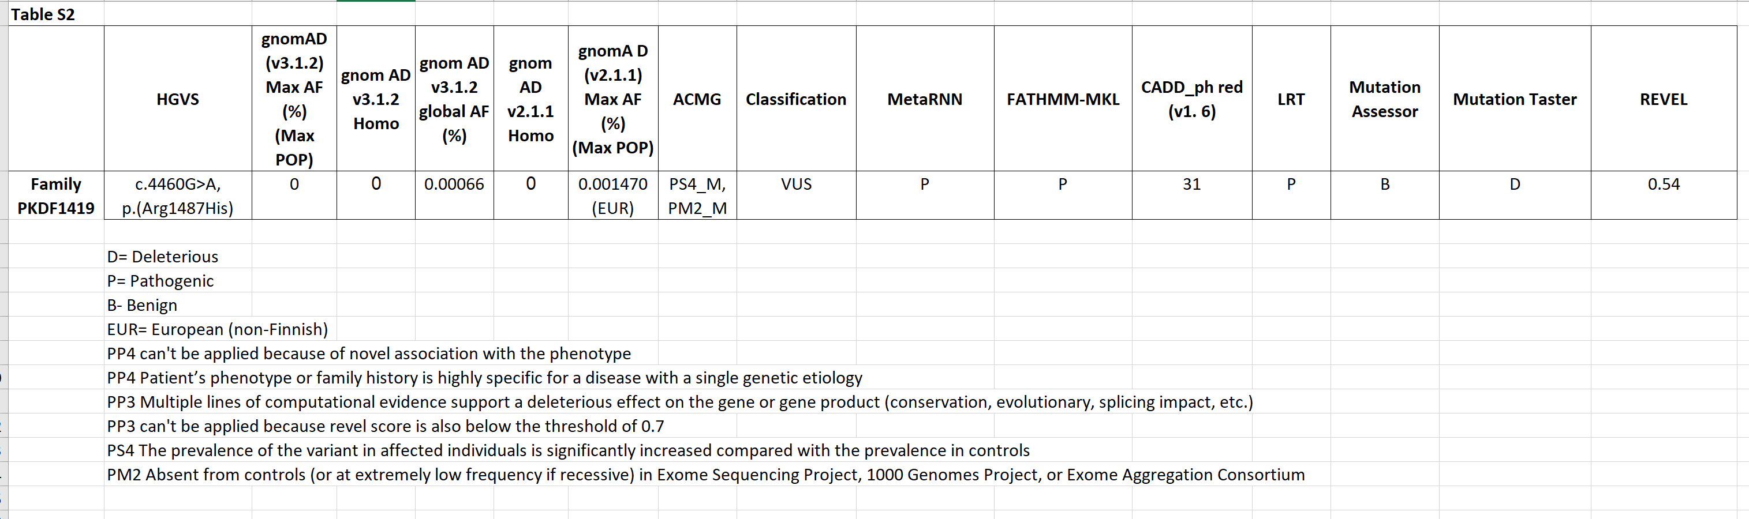

Table S3. List of MAP3K1 variants associated with reported phenotypes and their references

c.DNA | Protein | Reported phenotype | Reference
c.283C>A | Pro95Thr | Breast cancer, male | Rizzolo et al (2019) Int J Cancer 145, 390
c.458C>T | Pro153Leu | DSD | Loke et al (2014) Hum Mol Genet 23, 1073, Chamberlin et al (2019) Hum Mol Genet 28: 1620
c.485G>A | Arg162His | Increased risk of neurodevelopmental disorder | Stessman et al (2017) Nat Genet 49, 515
c.548G>A | Arg183Gln | Hearing impairment | Schrauwen et al (2019) Eur J Hum Genet 27, 869
c.556A>G | Arg186Gly | 46,XY DSD | Chen et al (2022) Front Genet 13,
c.566T>G | Leu189Arg | DSD | Pearlman et al (2010) Am J Hum Genet 87, 898, Eggers et al (2016) Genome Biol 17: 243, Chamberlin et al (2019) Hum Mol Genet 28: 1620, Loke et al (2012) Clin Genet 81: 272
c.566T>A | Leu189Gln | 46,XY gonadal dysgenesis | Granados et al (2017) Am J Med Genet C Semin Med Genet 175, 253
c.566T>C | Leu189Pro | DSD | Pearlman et al (2010) Am J Hum Genet 87, 898, Chamberlin et al (2019) Hum Mol Genet 28: 1620, Loke et al (2012) Clin Genet 81: 272, Upadhyay et al (2018) Clin Genet 93: 412
c.570G>C | Lys190Asn | 46,XY DSD | Yu et al (2022) Taiwan J Obstet Gynecol 61, 903
c.629C>T | Pro210Leu | 46,XY DSD | Yu et al (2020) Asian J Androl 23, 69
c.710A>G | Gln237Arg | DSD | Mazen et al (2021) Am J Med Genet A 185, 1666
c.736A>G | Lys246Glu | DSD | Loke et al (2014) Hum Mol Genet 23, 1073, Chamberlin et al (2019) Hum Mol Genet 28: 1620
c.764A>G | Asn255Ser | Breast and/or gynecological cancer | Dominguez-Valentin et al (2018) Hered Cancer Clin Pract 16, 4
c.770C>T | Pro257Leu | DSD | Baxter et al (2015) J Clin Endocrinol Metab 100, E333, Capalbo et al (2019) PLoS Genet 15: e1008409
c.778C>T | Arg260Cys | 46,XY DSD | Cheng et al (2020) Biosci Rep 40, BSR20200616, Stessman et al (2017) Nat Genet 49: 515, Cheng et al (2020) Biosci Rep 40
c.916C>T | Arg306Cys | Sepsis, modifier of | Taudien et al (2016) EBioMedicine 12, 227
c.934A>T | Met312Leu | 46,XY DSD | Eggers et al (2016) Genome Biol 17, 243
c.1016G>A | Arg339Gln | DSD | Baxter et al (2015) J Clin Endocrinol Metab 100, E333
c.1213C>T | Arg405Cys | Developmental disorder | Turner et al (2019) Am J Hum Genet 105, 1274
c.1340T>G | Leu447Trp | 46,XY DSD | Machado et al (2017) Arch Endocrinol Metab 61 S48
c.1640A>T | Gln547Leu | Breast cancer | Xie et al (2018) Clin Genet 93, 41
c.1705G>A | Val569Ile | Breast cancer | Liu et al (2017) Cancer Med 6, 547
c.1760T>A | Leu587His | 46,XY gonadal dysgenesis | Granados et al (2017) Am J Med Genet C Semin Med Genet 175, 253
c.1801G>A | Glu601Lys | Breast cancer | Xie et al (2018) Clin Genet 93, 41
c.1846G>A | Gly616Arg | DSD | Pearlman et al (2010) Am J Hum Genet 87, 898, Capalbo et al (2019) PLoS Genet 15: e1008409, Chamberlin et al (2019) Hum Mol Genet 28: 1620
c.1912G>A | Val638Ile | Hypercholesterolaemia | Marmontel et al (2020) Clin Genet 98, 589, Gomes et al (2018) Clin Endocrinol (Oxf) 89: 164,
c.1916T>C | Leu639Pro | 46,XY DSD | Machado et al (2017) Arch Endocrinol Metab 61 S48
c.1970C>G | Thr657Arg | 46,XY DSD | Machado et al (2017) Arch Endocrinol Metab 61 S48, Al Shamsi et al (2020) Mol Genet Genomic Med 8: e1514
c.1985T>C | Leu662Pro | 46,XY DSD | Yu et al (2020) Asian J Androl 23, 69
c.2071T>C | Cys691Arg | 46,XY gonadal dysgenesis | Eggers et al (2016) Genome Biol 17, 243, Machado et al (2017) Arch Endocrinol Metab 61: S48
c.2117T>G | Leu706Arg | 46, XY gonadal dysgenesis | Xue et al (2019) Gene 718, 144072
c.2152G>A | Ala718Thr | Increased risk of neurodevelopmental disorder | Stessman et al (2017) Nat Genet 49, 515
c.2273T>C | Leu758Pro | DSD | Stranneheim et al (2021) Genome Med 13, 40
c.2282T>C | Ile761Thr | 46,XY DSD | Cheng et al (2021) Orphanet J Rare Dis 16, 268
c.2291T>G | Leu764Arg | 46,XY gonadal dysgenesis | Granados et al (2017) Am J Med Genet C Semin Med Genet 175, 253
c.2416G>A | Asp806Asn | Asthma, association with | Szczepankiewicz et al (2012) J Asthma 49, 329, Das et al (2013) Indian J Hum Genet 19: 437
c.2558G>A | Arg853His | Increased risk of neurodevelopmental disorder | Stessman et al (2017) Nat Genet 49, 515
c.2564G>A | Arg855His | Increased risk of neurodevelopmental disorder | Stessman et al (2017) Nat Genet 49, 515
c.2617G>A | Val873Ile | Breast cancer | Liu et al (2017) Cancer Med 6, 547, Xie et al (2018) Clin Genet 93: 41
c.2665G>C | Val889Leu | Breast cancer | Xie et al (2018) Clin Genet 93, 41
c.2716G>A | Val906Ile | Acute respiratory distress syndrome, association with | Morrell et al (2018) Am J Respir Cell Mol Biol 58, 117
c.2816C>G | Ser939Cys | Breast and/or gynecological cancer | Dominguez-Valentin et al (2018) Hered Cancer Clin Pract 16, 4
c.2975C>G | Ser992Cys | Breast cancer, male | Rizzolo et al (2019) Int J Cancer 145, 390
c.3020A>G | Gln1007Arg | 46,XY DSD | Cheng et al (2022) Mol Med Rep 26,
c.3247C>T | Leu1083Phe | Breast cancer, male | Rizzolo et al (2019) Int J Cancer 145, 390
c.3757G>A | Ala1253Thr | Breast cancer | Xie et al (2018) Clin Genet 93, 41
c.4063C>T | Arg1355Cys | Increased risk of neurodevelopmental disorder | Stessman et al (2017) Nat Genet 49, 515
c.4328C>T | Ala1443Val | 46,XY DSD | Eggers et al (2016) Genome Biol 17, 243
c.634-8T>A |  | DSD | Pearlman et al (2010) Am J Hum Genet 87, 898, Chamberlin et al (2019) Hum Mol Genet 28: 1620, Loke et al (2012) Clin Genet 81: 272
c.1035+1G>T |  | Increased risk of neurodevelopmental disorder | Stessman et al (2017) Nat Genet 49, 515
c.2180-2A>G |  | DSD | Chamberlin et al (2019) Hum Mol Genet 28: 1620, Loke et al (2012) Clin Genet 81: 272
c.2254C>T |  | 46,XY DSD | Igarashi et al (2020) Sci Rep 10, 17375
c.-79579C>A |  | Reduced risk of breast cancer | Glubb et al (2015) Am J Hum Genet 96, 5
c.-78308T>C |  | Associated with risk of breast cancer | Glubb et al (2015) Am J Hum Genet 96, 5
c.-58706T>C |  | Increased risk of breast cancer | Glubb et al (2015) Am J Hum Genet 96, 5
c.-57922C>T |  | Increased risk of breast cancer | Glubb et al (2015) Am J Hum Genet 96, 5
c.483-18151A>G |  | Increased risk of breast cancer | Glubb et al (2015) Am J Hum Genet 96, 5
c.2845_2847delACA | p.(Thr949del) | Pancreatic cancer | Ma et al (2020) Cancer Biomark 27, 389
c.3111delA | p.(Asp1038Thrfs*44) | Breast cancer | Aloraifi et al (2015) FEBS J 282, 3424
c.14_16dupCGG | p.(Ala5dup) | 46,XY DSD | Granados et al (2017) Am J Med Genet C Semin Med Genet 175, 253
c.1369dupA | p.(Thr457Asnfs*4) | Increased risk of neurodevelopmental disorder | Stessman et al (2017) Nat Genet 49, 515
c.4151dupT | p.(Arg1385Lysfs*35) | Breast cancer | Lhota et al (2016) Clin Genet 90, 324, Stessman et al (2017) Nat Genet 49, 515
c.4531dupA | p.(Thr1511Asnfs*12) | Congenital heart disease | Morton et al (2021) JAMA Cardiol 6, 457
c.823_824delTCinsCT | p.(Ser275Leu) | Increased risk of neurodevelopmental disorder | Stessman et al (2017) Nat Genet 49, 515
DSD = Disorders of Sex Development

References
Chamberlin, A., Huether, R., Machado, A. Z., Groden, M., Liu, H. M., Upadhyay, K., O, V., Gomes, N. L., Lerario, A. M., Nishi, M. Y. et al. (2019). Mutations in MAP3K1 that cause 46,XY disorders of sex development disrupt distinct structural domains in the protein. Hum Mol Genet 28, 1620-1628. 10.1093/hmg/ddz002
Grotegut, S., Von Schweinitz, D., Christofori, G. and Lehembre, F. (2006). Hepatocyte growth factor induces cell scattering through MAPK/Egr-1-mediated upregulation of Snail. EMBO J 25, 3534-45. 10.1038/sj.emboj.7601213
Morell, R. J., Olszewski, R., Tona, R., Leitess, S., Wafa, T. T., Taukulis, I., Schultz, J. M., Thomason, E. J., Richards, K., Whitley, B. N. et al. (2020). Noncoding Microdeletion in Mouse Hgf Disrupts Neural Crest Migration into the Stria Vascularis, Reduces the Endocochlear Potential, and Suggests the Neuropathology for Human Nonsyndromic Deafness DFNB39. J Neurosci 40, 2976-2992. 10.1523/JNEUROSCI.2278-19.2020
Pham, T. T., Angus, S. P. and Johnson, G. L. (2013). MAP3K1: Genomic Alterations in Cancer and Function in Promoting Cell Survival or Apoptosis. Genes Cancer 4, 419-26. 10.1177/1947601913513950
Wangemann, P., Itza, E. M., Albrecht, B., Wu, T., Jabba, S. V., Maganti, R. J., Lee, J. H., Everett, L. A., Wall, S. M., Royaux, I. E. et al. (2004). Loss of KCNJ10 protein expression abolishes endocochlear potential and causes deafness in Pendred syndrome mouse model. BMC Med 2, 30. 10.1186/1741-7015-2-30
Wangemann, P., Nakaya, K., Wu, T., Maganti, R. J., Itza, E. M., Sanneman, J. D., Harbidge, D. G., Billings, S. and Marcus, D. C. (2007). Loss of cochlear HCO3- secretion causes deafness via endolymphatic acidification and inhibition of Ca2+ reabsorption in a Pendred syndrome mouse model. Am J Physiol Renal Physiol 292, F1345-53. 10.1152/ajprenal.00487.2006
Zhang, L., Wang, W., Hayashi, Y., Jester, J. V., Birk, D. E., Gao, M., Liu, C. Y., Kao, W. W., Karin, M. and Xia, Y. (2003). A role for MEK kinase 1 in TGF-beta/activin-induced epithelium movement and embryonic eyelid closure. EMBO J 22, 4443-54. 10.1093/emboj/cdg440

