Supplemental materials
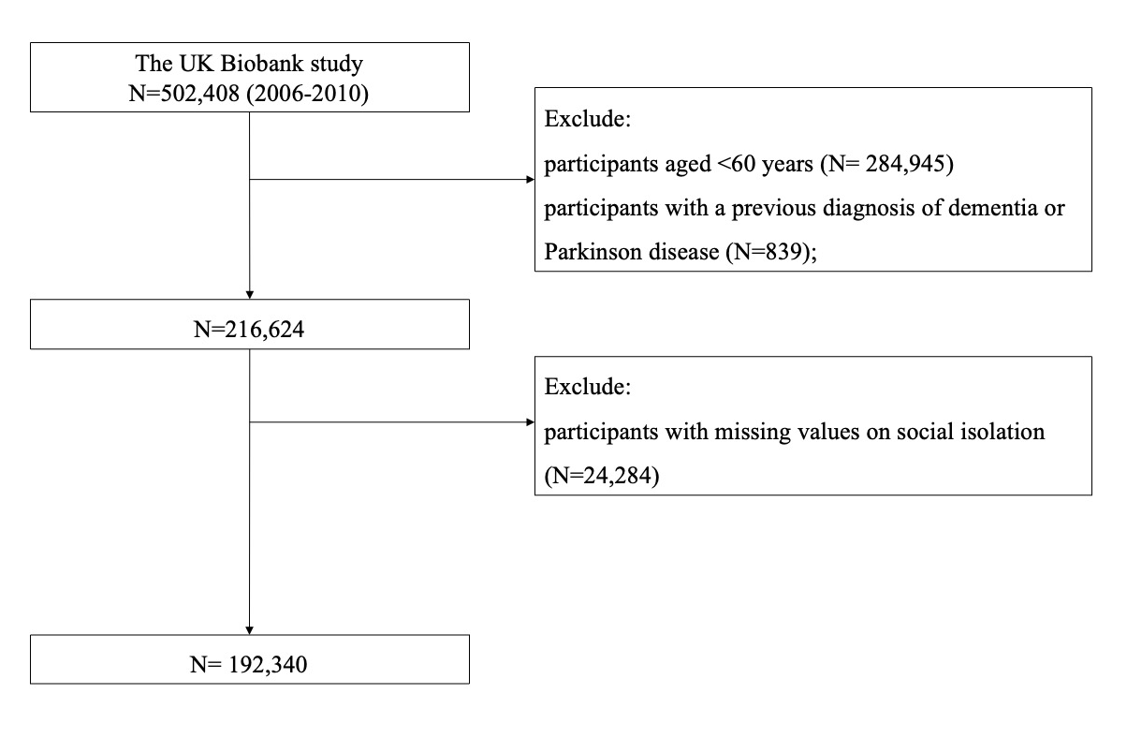
Supplemental Figure 1. Flowchart for the selection of the study population

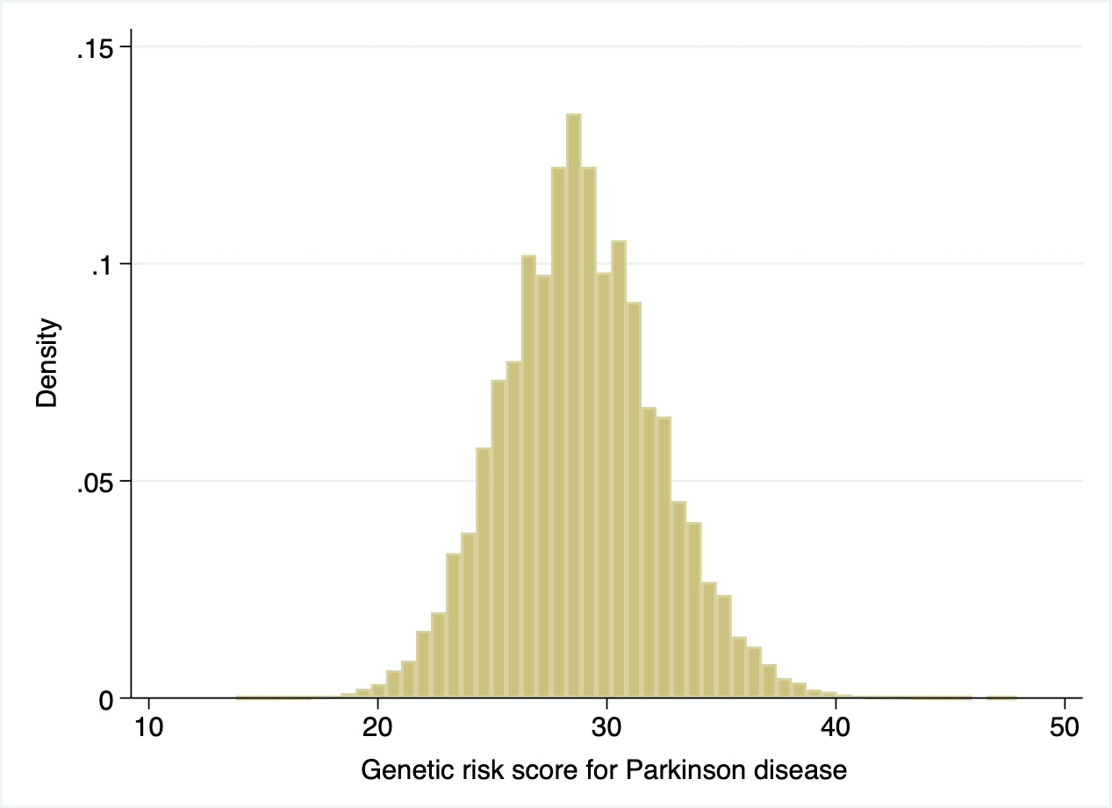
Supplemental Figure 2. Distribution of the genetic risk score for Parkinson disease

Supplemental Table 1. SNPs used to generate the genetic risk score for Parkinson disease
SNP | Effect allele | EAF | p-value | OR
rs10797576 | T/C | 0.137 | 1.76 × 10⁻¹⁰ | 1.13
rs10906923 | C/A | 0.306 | 2.37 × 10−8 | 0.93
rs11060180 | G/A | 0.45 | 3.08 × 10−11 | 0.91
rs11158026 | T/C | 0.307 | 2.88 × 10−10 | 0.91
rs11343 | T/G | 0.454 | 1.46 × 10−9 | 1.07
rs115185635 | C/G | 0.036 | 2.2 × 10−8 | 1.79
rs11724635 | C/A | 0.437 | 4.26 × 10−17 | 0.89
rs117896735 | A/G | 0.012 | 1.21 × 10−11 | 1.77
rs12456492 | G/A | 0.332 | 2.15 × 10−11 | 1.10
rs12497850 | G/T | 0.347 | 6.80 × 10−8 | 0.93
rs12637471 | A/G | 0.219 | 5.38 × 10−22 | 0.84
rs13294100 | T/G | 0.371 | 1.99 × 10−12 | 0.91
rs14235 | A/G | 0.397 | 3.63 × 10−12 | 1.10
rs143918452 | G/A | 0.996 | 2.25 × 10−7 | 0.68
rs1474055 | C/T | 0.881 | 7.11 × 10−16 | 0.82
rs1555399 | T/A | 0.544 | 5.70 × 10−16 | 1.15
rs17649553 | T/C | 0.232 | 6.11 × 10−49 | 0.77
rs199347 | G/A | 0.368 | 5.62 × 10−14 | 0.90
rs2280104 | T/C | 0.367 | 9.06 × 10−7 | 1.06
rs2414739 | G/A | 0.292 | 3.59 × 10−12 | 0.90
rs2694528 | C/A | 0.115 | 1.69 × 10−11 | 1.15
rs2740594 | A/G | 0.753 | 9.54 × 10−11 | 1.10
rs329648 | T/C | 0.327 | 8.05 × 10−12 | 1.11
rs34043159 | C/T | 0.352 | 3.83 × 10−8 | 1.07
rs34311866 | C/T | 0.199 | 6.00 × 10−41 | 1.26
rs353116 | T/C | 0.385 | 9.73 × 10−7 | 0.94
rs356182 | G/A | 0.375 | 1.85 × 10−82 | 1.34
rs35749011 | G/A | 0.976 | 6.10 × 10−23 | 0.57
rs3793947 | A/G | 0.463 | 2.59 × 10−8 | 0.91
rs4073221 | G/T | 0.132 | 3.02 × 10−9 | 1.11
rs4653767 | C/T | 0.315 | 2.40 × 10−10 | 0.92
rs4784227 | T/C | 0.265 | 8.29 × 10−8 | 1.08
rs591323 | A/G | 0.293 | 3.17 × 10−8 | 0.91
rs601999 | C/T | 0.699 | 8.03 × 10−9 | 0.93
rs62120679 | t/C | 0.324 | 2.52 × 10−9 | 1.14
rs6430538 | T/C | 0.488 | 3.35 × 10−19 | 0.88
rs6812193 | T/C | 0.398 | 1.85 × 10−11 | 0.91
rs76904798 | T/C | 0.132 | 4.86 × 10−14 | 1.16
rs78738012 | C/T | 0.106 | 2.11 × 10−9 | 1.14
rs8005172 | T/C | 0.424 | 1.20 × 10−9 | 1.08
rs8118008 | A/G | 0.596 | 2.32 × 10−8 | 1.11
rs823118 | C/T | 0.467 | 1.96 × 10−16 | 0.89
rs9275326 | T/C | 0.114 | 5.81 × 10−13 | 0.80
rs9468199 | A/G | 0.172 | 3.44 × 10−13 | 1.12
EAF, effect allele frequency; SNP, single nucleotide polymorphism; OR, odds ratio.

Supplemental Table 2. Ascertainment for Parkinson disease cases in the UK Biobank study
ICD-9 | ICD-10 | Self-reported in UK Biobank (field ID)
3320, 3321, 3330 | G20, G21, G21.0, G21.1, G21.2, G21.3, G21.4, G21.8, G21.9, G22, G23.0, G23.1, G23.2, G23.3, G23.8, G23.9, G25.9, G26, G90.3 | Field 20002  Code 1262

Supplemental Table 3. Associations of the genetic risk score with the risk of Parkinson disease
 | Parkinson disease
 | HR (95%CI)* | P-value
Genetic risk score, per unit | 1.07 (1.05-1.08) | < 0.001
* Adjusted for age at recruitment (continuous, years), and sex (men, women).

Supplemental Table 4. HR (95% CI) of Parkinson disease according to individual social isolation items
Items of social isolation | HR (95% CI)* | P-value
Number in household
More than one | 1.00
One | 1.05 (0.95-1.17) | 0.34
Frequency of friend/family visits
About once a week to almost daily | 1.00
No friends/family to about once a month | 1.12 (1.00-1.25) | 0.047
Leisure/social activities
Yes | 1.00
No | 1.08 (0.98-1.19) | 0.14
* Adjusted for age at recruitment (continuous, years), sex (men, women), education (college or university degree, others), Townsend Deprivation Index (continuous), ethnic (White, others), body mass index (continuous, kg/m²), alcohol intake (never or special occasions, monthly to weekly, daily), smoking status (never, past, current), sleep duration (≤6, 7–8, ≥9 hours/day), and history of hypertension, cardiovascular disease, diabetes, cancer, chronic kidney disease (yes, no), and also mutually adjusted for the other items of social isolation.

Supplemental Table 5. HR (95% CI) of Parkinson’s disease according to social isolation after excluding the cases occurring within the first two years of follow up
 |  | Social isolation
 | Least isolated | Moderately isolated | Most isolated | P-trend
Cases/person-years | 914/1,083,120 | 761/925,802 | 309/308,023
HR (95% CI) * | 1.00 | 0.99 (0.90-1.09) | 1.18 (1.04-1.35) | 0.06
* Adjusted for age at recruitment (continuous, years), sex (men, women), education (college or university degree, others), Townsend Deprivation Index (continuous), ethnicity (White, others), body mass index (continuous, kg/m²), alcohol intake (never or special occasions, monthly to weekly, daily), smoking status (never, past, current), sleep duration (≤6, 7–8, ≥9 hours/day), and history of hypertension, cardiovascular disease, diabetes, cancer, and chronic kidney disease (yes, no).

Supplemental Table 6. HR (95% CI) of Parkinson disease according to social isolation using multiple imputation method
 |  | Social isolation
 | Least isolated | Moderately isolated | Most isolated | P-trend
HR (95% CI) * | 1.00 | 1.00 (0.91-1.10) | 1.20 (1.05-1.37) | 0.03
* Adjusted for age at recruitment (continuous, years), sex (men, women), education (college or university degree, others), Townsend Deprivation Index (continuous), ethnic (White, others), body mass index (continuous, kg/m²), alcohol intake (never or special occasions, monthly to weekly, daily), smoking status (never, past, current), sleep duration (≤6, 7–8, ≥9 hours/day), and history of hypertension, cardiovascular disease, diabetes, cancer, and chronic kidney disease (yes, no).
Supplemental Table 7. HR (95% CI) of Parkinson disease according to social isolation
 |  | Social isolation
 | Least isolated | Moderately isolated | Most isolated | P-trend
HR (95% CI) * | 1.00 | 1.00 (0.91-1.10) | 1.19 (1.05-1.36) | 0.04
HR (95% CI) † | 1.00 | 1.00 (0.91-1.10) | 1.19 (1.05-1.36) | 0.04
HR (95% CI) ¶ | 1.00 | 0.99 (0.90-1.09) | 1.18 (1.04-1.35) | 0.05
* Adjusted for age at recruitment (continuous, years), sex (men, women), education (college or university degree, others), Townsend Deprivation Index (continuous), ethnic (White, others), body mass index (continuous, kg/m²), alcohol intake (never or special occasions, monthly to weekly, daily), smoking status (never, past, current), sleep duration (≤6, 7–8, ≥9 hours/day), and history of hypertension, cardiovascular disease, diabetes, cancer, chronic kidney disease (yes, no), and C-reactive protein (continuous, mg/L).
† Adjusted for age at recruitment (continuous, years), sex (men, women), education (college or university degree, others), Townsend Deprivation Index (continuous), ethnic (White, others), body mass index (continuous, kg/m²), alcohol intake (never or special occasions, monthly to weekly, daily), smoking status (never, past, current), sleep duration (≤6, 7–8, ≥9 hours/day), and history of hypertension, cardiovascular disease, diabetes, cancer, chronic kidney disease and loneliness (yes, no).
¶ Adjusted for age at recruitment (continuous, years), sex (men, women), education (college or university degree, others), Townsend Deprivation Index (continuous), ethnic (White, others), body mass index (continuous, kg/m²), alcohol intake (never or special occasions, monthly to weekly, daily), smoking status (never, past, current), sleep duration (≤6, 7–8, ≥9 hours/day), and history of hypertension, cardiovascular disease, diabetes, cancer, chronic kidney disease and physical activity (MET-min/week).

