Supplementary informations
Supplementary Table 1: Genes related to plant growth promotion BU72 genome
Supplementary Figure 1: Alignments of Seven clusters associated with secondary metabolites detected in BU72 genome : N-acetylglutaminylglutamine amide (NAGGN), Non-alpha poly-amino acids like e-Polylysin (NAPAA), siderophore, betalactone, acyl amino_acids, terpene, and arylpolyene

Supplementary Table 1. Genes related to plant growth promotion BU72 genome
Plant growth promotion traits | Feature ID | Product name | EC number
Phosphate metabolism | fig|571256.30.peg.1327 | Alkaline phosphatase | EC 3.1.3.1
Ammonia assimilation | fig|571256.30.peg.1169 | Glutamate synthase [NADPH] large chain | EC 1.4.1.13
Ammonia assimilation | fig|571256.30.peg.1168 | Glutamate synthase [NADPH] small chain | EC 1.4.1.13
Ammonia assimilation | fig|571256.30.peg.3754 | Glutamine synthetase type I | EC 6.3.1.2
Ammonia assimilation | fig|571256.30.peg.3753 | Nitrogen regulatory protein P-II
Auxin biosynthesis | fig|571256.30.peg.2481 | Tryptophan synthase alpha chain | EC 4.2.1.20
Auxin biosynthesis | fig|571256.30.peg.2479 | Tryptophan synthase beta chain | EC 4.2.1.20
Proline Synthesis | fig|571256.30.peg.2774 | Glutamate 5-kinase | EC 2.7.2.11
Proline Synthesis | fig|571256.30.peg.2775 | Gamma-glutamyl phosphate reductase | EC 1.2.1.41
Proline Synthesis | fig|571256.30.peg.327 | Pyrroline-5-carboxylate reductase | EC 1.5.1.2
Proline Synthesis | fig|571256.30.peg.1440 | Nitrite reductase accessory protein NirV
Proline Synthesis | fig|571256.30.peg.1441 | NnrS protein involved in response to NO
Denitrification | fig|571256.30.peg.1447 | Nitric oxide reductase activation protein NorE
Denitrification | fig|571256.30.peg.1448 | Nitric oxide reductase activation protein NorF
Denitrification | fig|571256.30.peg.1449 | Nitric-oxide reductase subunit C | EC 1.7.99.7
Denitrification | fig|571256.30.peg.1450 | Nitric-oxide reductase subunit B | EC 1.7.99.7
Denitrification | fig|571256.30.peg.1451 | Nitric oxide reductase activation protein NorQ
Denitrification | fig|571256.30.peg.1452 | Nitric oxide reductase activation protein NorD

Supplementary Figure 1: Alignments of Seven clusters associated with secondary metabolites detected in BU72 genome
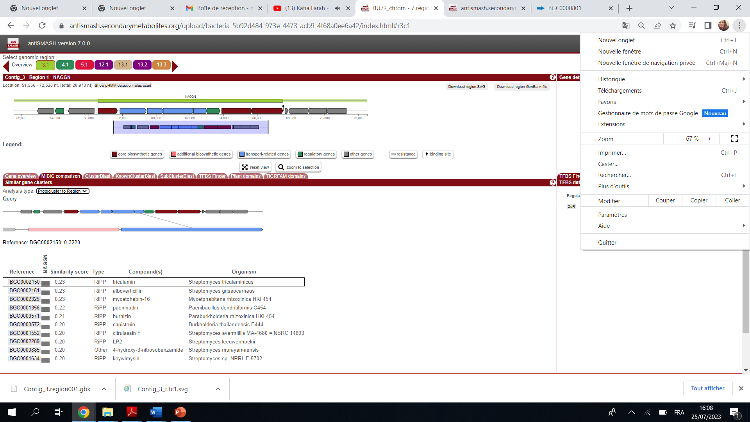
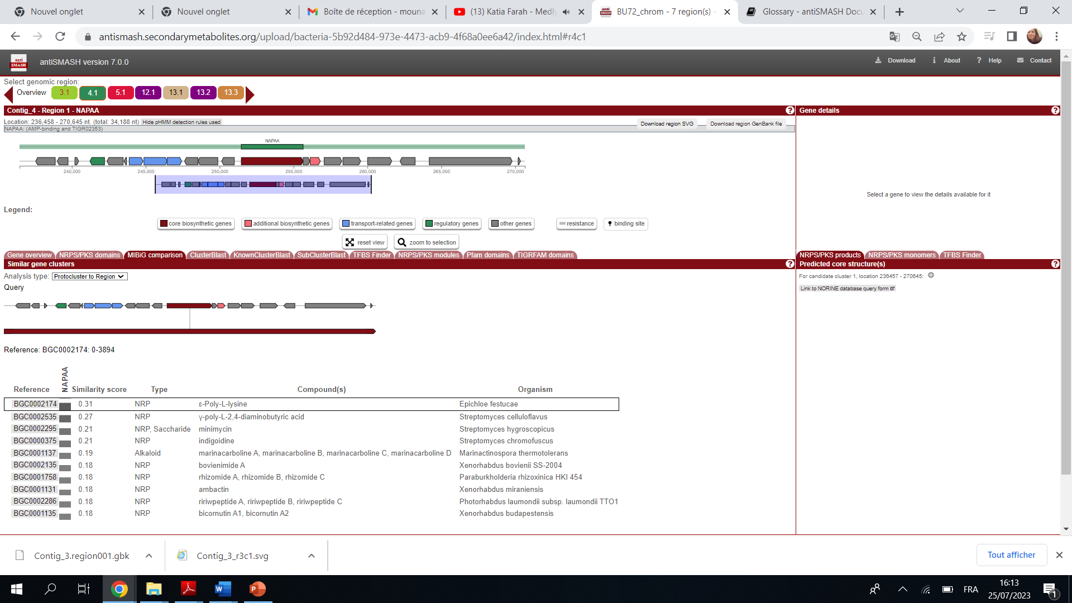
Cluster 1
Cluster 2

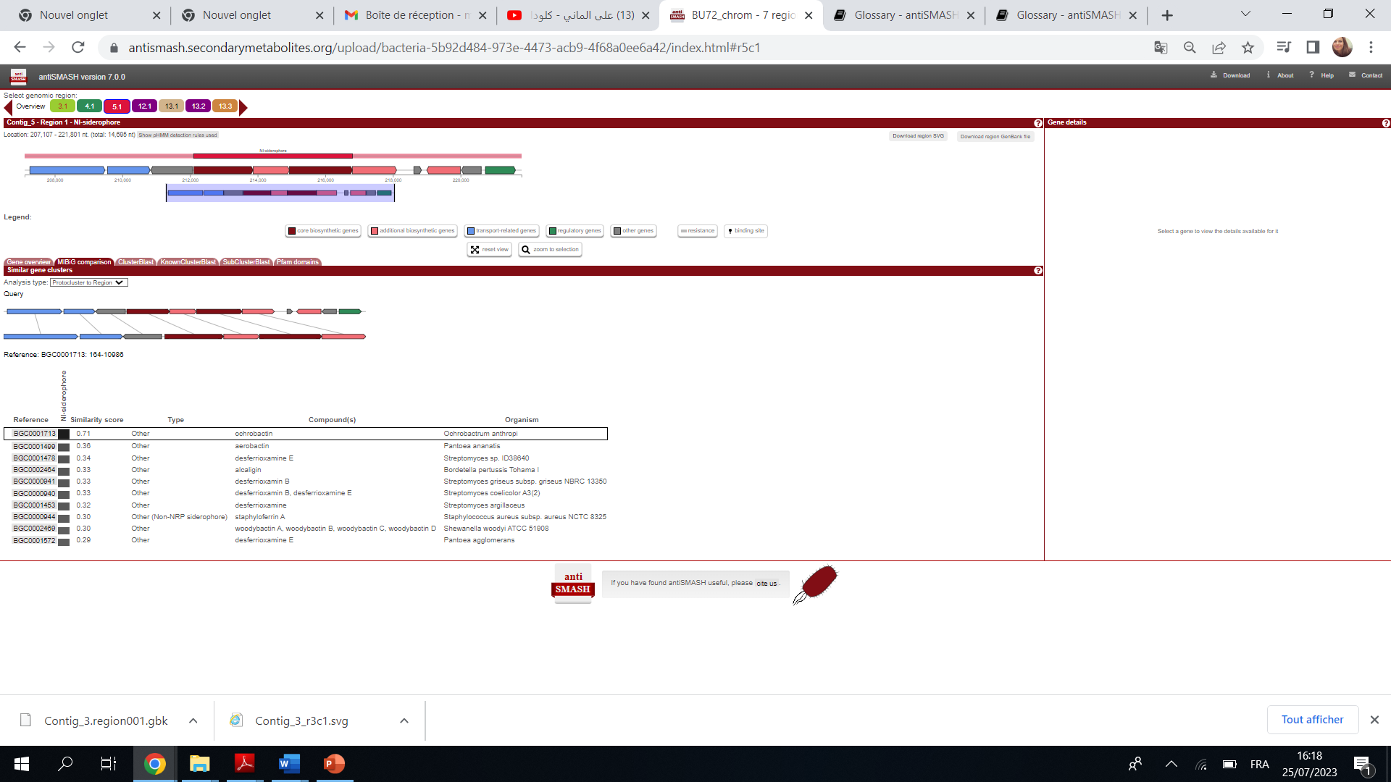
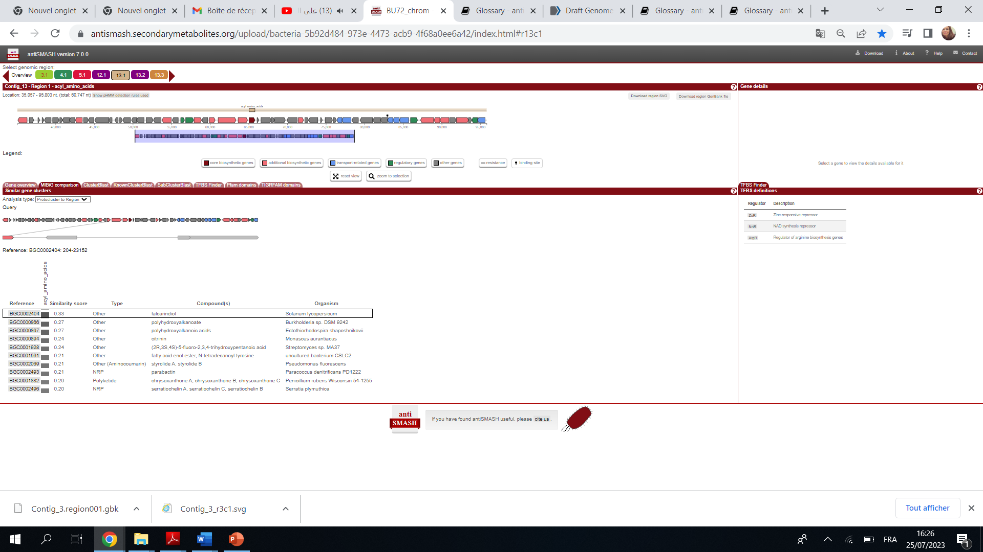
Cluster 3
Cluster 4

