Supplementary information

Online Resource 1. Enrolment criteria

Inclusion criteria

- Previously confirmed histological diagnosis of glioblastoma multiforme (GBM), with current clinical or imaging evidence for first recurrence according to modified Response Assessment in Neuro-Oncology criteria. History of GBM standard therapy (debulking surgery, followed by radiochemotherapy (50–60 Gy in 2 Gy fractions, temozolomide). Patients with recurrent GBM (WHO°IV), diagnosed in accordance with WHO classification, which required the IDH status, were enrolled;
- Interval since end of first-line external radiation therapy (XRT) ≥6 months;
- Amino acid-based molecular imaging (preferably O-(2-¹⁸F-fluoroethyl)-l-tyrosine ([¹⁸F]FET) or ¹¹C-methionine, as institutionally established) indicating pathologically increased amino acid uptake inside or in the vicinity of the tumor, clearly discernible from background activity;
- Current indication for repeat radiation therapy as discussed at the multidisciplinary neuro-oncological tumor board meeting, planned as standard fractionated dose schedule (18 x 2 Gy);
- Gross tumor volume ≤4.8 cm diameter, clinical target volume 0.5 cm margin and planning target volume ≤0.5 cm margin;
- Male or female ≥18 years of age;
- Karnofsky performance status ≥70. Life expectancy of at least 16 weeks;
- Hematological, liver and renal function test results as follows:
  - White blood cells >3 x 10⁹/L
  - Hemoglobin >80 g/L
  - Platelets >100 x 10⁹/L
  - Alanine transaminase, alkaline phosphatase, aspartate transaminase ≤5 x upper limit of normal (ULN)
  - Bilirubin ≤3 x ULN
  - Serum creatinine: within normal limits or <120 μmol/L for patients ≥60 years
  - Urine protein dipstick: No protein
- Female patients surgically sterile or postmenopausal for at least 2 years. Participants of generative potential agreeing to use effective contraception during the period of therapy and 6 months after the end of study;
- Written informed consent.

Exclusion criteria

Patients meeting any of the following criteria were to be excluded from the study:

- Primary XRT dose >60 Gy;
- Doses to organs at risk defined by Yaşar and Tuğrul (2005) exceeded or reached by prior radiation therapy; e.g., cumulative total dose on the optical chiasm >54 Gy for 2 Gy/fraction, α/β=2;
- Multifocal distant recurrence, defined as tumor lesion outside the primary XRT field, as evidenced by amino acid-based Positron Emission Tomography imaging;
- Prior treatment with brachytherapy;
- Prior treatment with bevacizumab;
- History or evidence of delayed-type hypersensitivity-dependent chronic infection (e.g., tuberculosis, systemic fungal or parasitic infection), potentially exacerbating under systemic corticoid therapy;
- Localization of tumor related to brain stem or axis, unless sufficient reserve capacity (e.g., remnant resection cavity, marked atrophy) to accommodate possible post-procedural tissue reactions, or pre-therapeutic consent for emergency trepanation;
- Hematological conditions precluding catheterization or invasive procedures;
- Clinically significant illness or clinically relevant trauma within 2 weeks before the administration of the investigational product;
- Known impairment of liver or kidney function or known liver or kidney disease, such as hepatitis, cirrhosis, or renal failure;
- Known human immunodeficiency virus positive serology or chronically active hepatitis B or C;
- Ongoing toxicity > Grade 2 as defined by the National Cancer Institute Common Terminology Criteria version 4.03 from previous standard or investigational therapies;
- Administration of another investigational medicinal product within 90 days prior to screening;
- Expected non-compliance with longer-term admission at isolated nuclear medicine ward;
- In premenopausal women: Pregnant as evidenced by a positive pregnancy test, or breast-feeding;
- Patients with known phenylketonuria.

Online Resource 2. Listing of serious adverse events by patient

Dose regimen group | Patient | SOC/Preferred term* | Start date | Resolution date | Causality† | Severity | Outcome
1f | 002-01 | GASTROINTESTINAL DISORDERS/  Gastroesophageal reflux disease | 08-Feb-2020 | 27-May-2020 | None | Moderate | Recovered/  resolved
 | 004-02 | NERVOUS SYSTEM DISORDERS/Brain edema | 21-Jan-2021 | 27-Jan-2021 | Possible | Mild | Recovered/  resolved
3f-p | 005-01 | NERVOUS SYSTEM DISORDERS/  Intracranial pressure increased | 01-Sep-2020 | Unknown | Possible | Severe | Recovered/  resolving
 |  | RESPIRATORY, THORACIC, AND MEDIASTINAL DISORDERS/  Acute respiratory failure | 07-Nov-2020 | 16-Nov-2020 | None | Severe | Fatal
3f-s | 002-05 | NERVOUS SYSTEM DISORDERS/Brain edema | 26-Oct-2020 | 27-Oct-2020 | Possible | Moderate | Recovered/  resolved
 |  | VASCULAR DISORDERS/  Deep vein thrombosis | 02-Feb-2021 | 06-Feb-2021 | None | Moderate | Recovered/  resolved
 |  | RESPIRATORY, THORACIC, AND MEDIASTINAL DISORDERS/  Pulmonary embolism | 02-Feb-2021 | 06-Feb-2021 | None | Moderate | Recovered/  resolved
 | 002-08 | INVESTIGATIONS/  Platelet count decreased | 08-Jul-2021 | 28-Oct-2021 | Possible | Moderate | Recovered/  resolved with residual effects
*AEs were named according to the NCI CTCAE version 4.03 criteria.
†Causality regarding study product was determined by the principal investigator/ designated study personnel and defined as either None, Unlikely, Possible, Probable, or Definite.

Abbreviations: SOC, system organ class.
*The following definition for serious adverse event is based on ICH guidelines and the final rule issued by the Food and Drug Administration and effective 06 Apr 1998. A serious adverse event is classified as any untoward medical occurrence that at any dose results in death; is life-threatening; requires inpatient hospitalization or prolongation of existing hospitalization; results in persistent or significant disability/incapacity or leads to any congenital anomaly/birth defect.

Online Resource 3. Mean total EORTC QLQ-C30 score over time by dose regimen group*
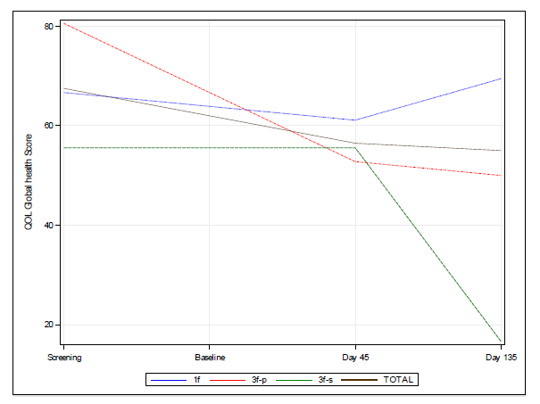
Abbreviations: 1f, single fractionated dose; 3f-p, fractionated parallel dose regimen; 3f-s, fractionated sequential dose regimen; EORTC QLQ-C30, European Organisation for Research and Treatment of Cancer 30‐item Quality of Life Questionnaire; QoL, quality of life. *There was only one evaluable patient in the 3f-s dose regimen group.
Online Resource 4. Biodistribution of [¹³¹I]IPA after 0.3 h, 2 h, 46 h, and 96 h post injection of first of 3 dose fractions
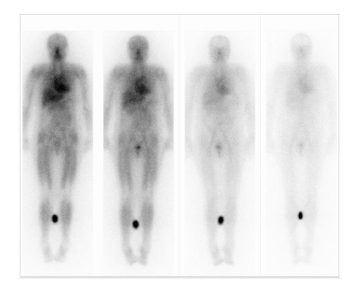
Abbreviations: [¹³¹I]IPA, carrier-added 4-L-[131I]iodo-phenylalanine. Times given are the actual image times for this patient after the first dose of [¹³¹I]IPA. The reference vial, containing a known activity of [¹³¹I], was positioned between the calves of this patient.
Online Resource 5. Metabolic tumor response based on peak uptake in lesion
 | TBR_{max} | % diff | TBR_{max} | % diff | TBR_{max} | % diff | TBR_{max} | % diff
1f: Single-dose regimen, patient ID | 002-01 |  | 002-02 |  | 002-04 |  | 004-02*
Day 45 | 4.13 | - | 2.37 | - | 1.43 | - | 2.64 | -
Day 135 | 3.39 | -18 | 2.30 | -3 | 2.11 | +47 | - | -
6 months | 3.75 | -9 | - | - | - | - | - | -
9 months | 4.07 | -1 |  |  |  |  | - | -
3f-p: Fractionated parallel dose regimen, patient ID | 002-03 |  | 004-01* |  | 005-01
Day 45 | 1.66 | - | 1.59 | - | 1.68 | -
Day 135 | 2.03 | +23 | - | - | - | -
6 months | - | - | - | - | - | -
9 months | - | - | - | - | - | -
3f-s: Fractionated sequential dose regimen, patient ID | 002-05 |  | 002-07 |  | 002-08
Day 45 | 2.38 | - | 2.06 | - | 1.77 | -
Day 135 | 2.51 | +6 | 2.53 | +23 | 1.63 | -8
6 months | - | - | - | - | - | -
9 months | - | - | - | - | - | -
Abbreviations: diff, difference; MTR, metabolic tumor response; TBR, Tumor-to-Brain Ratio.
*Mean of 2 lesions.

Online Resource 6. Normalized mean tumor absorbed radiation doses in the 2000 MBq dose cohort.
Dose regimen group | 1f: Single-dose regimen (n=4) | 3f-p: Fractionated parallel dose regimen (n=3) | 3f-s: Fractionated sequential dose regimen (n=3)
Tumor Absorbed Radiation Dose | Mean ± SD [mGy/MBq] | Mean ± SD [mGy/MBq] | Mean ± SD [mGy/MBq]
Dose 1 | 0.701 ± 0.207 | 1.380 ± 0.643 | 1.231 ± 0.789
Dose 2 | - | 4.161 ± 4.064 | 0.781 ± 0.127
Dose 3 | - | 2.465 ± 2.507 | 0.857 ± 0.216
Total | 0.701 ± 0.207 | 8.006 ± 7.077 | 2.323 ± 0.689

Abbreviations: 1f, single fractionated dose; 3f-p, fractionated parallel dose regimen; 3f-s, fractionated sequential dose regimen; MBq, megabecquerel; mGy, milligray; SD, standard deviation.

