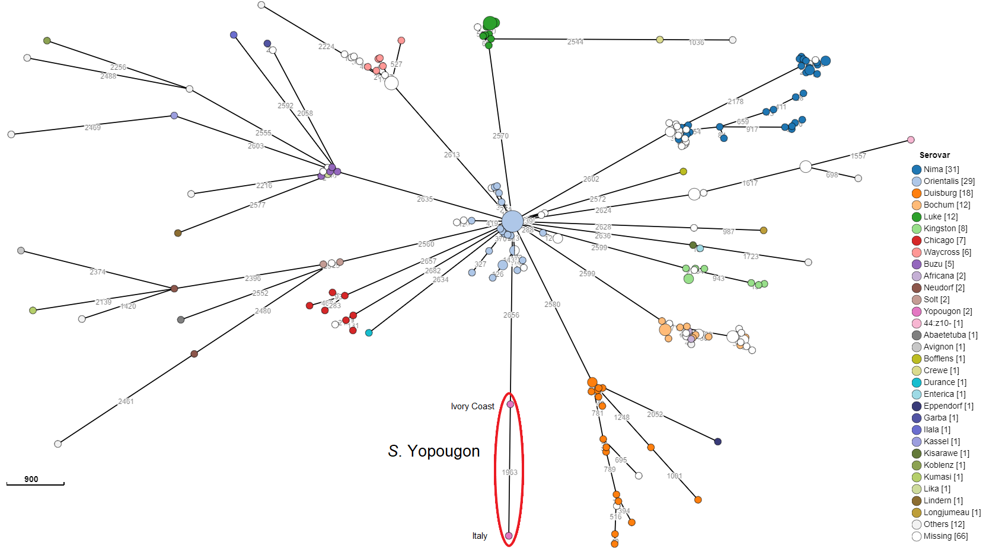Figure S1. Minimum Spanning Tree of the cgMLST calculated with the most similar strains collected in EnteroBase. Highlighted in red the S. Yopougon from the clinical isolate in Ivory Coast (IP 7148/89) and from wild snake in Italy (SAL_117300)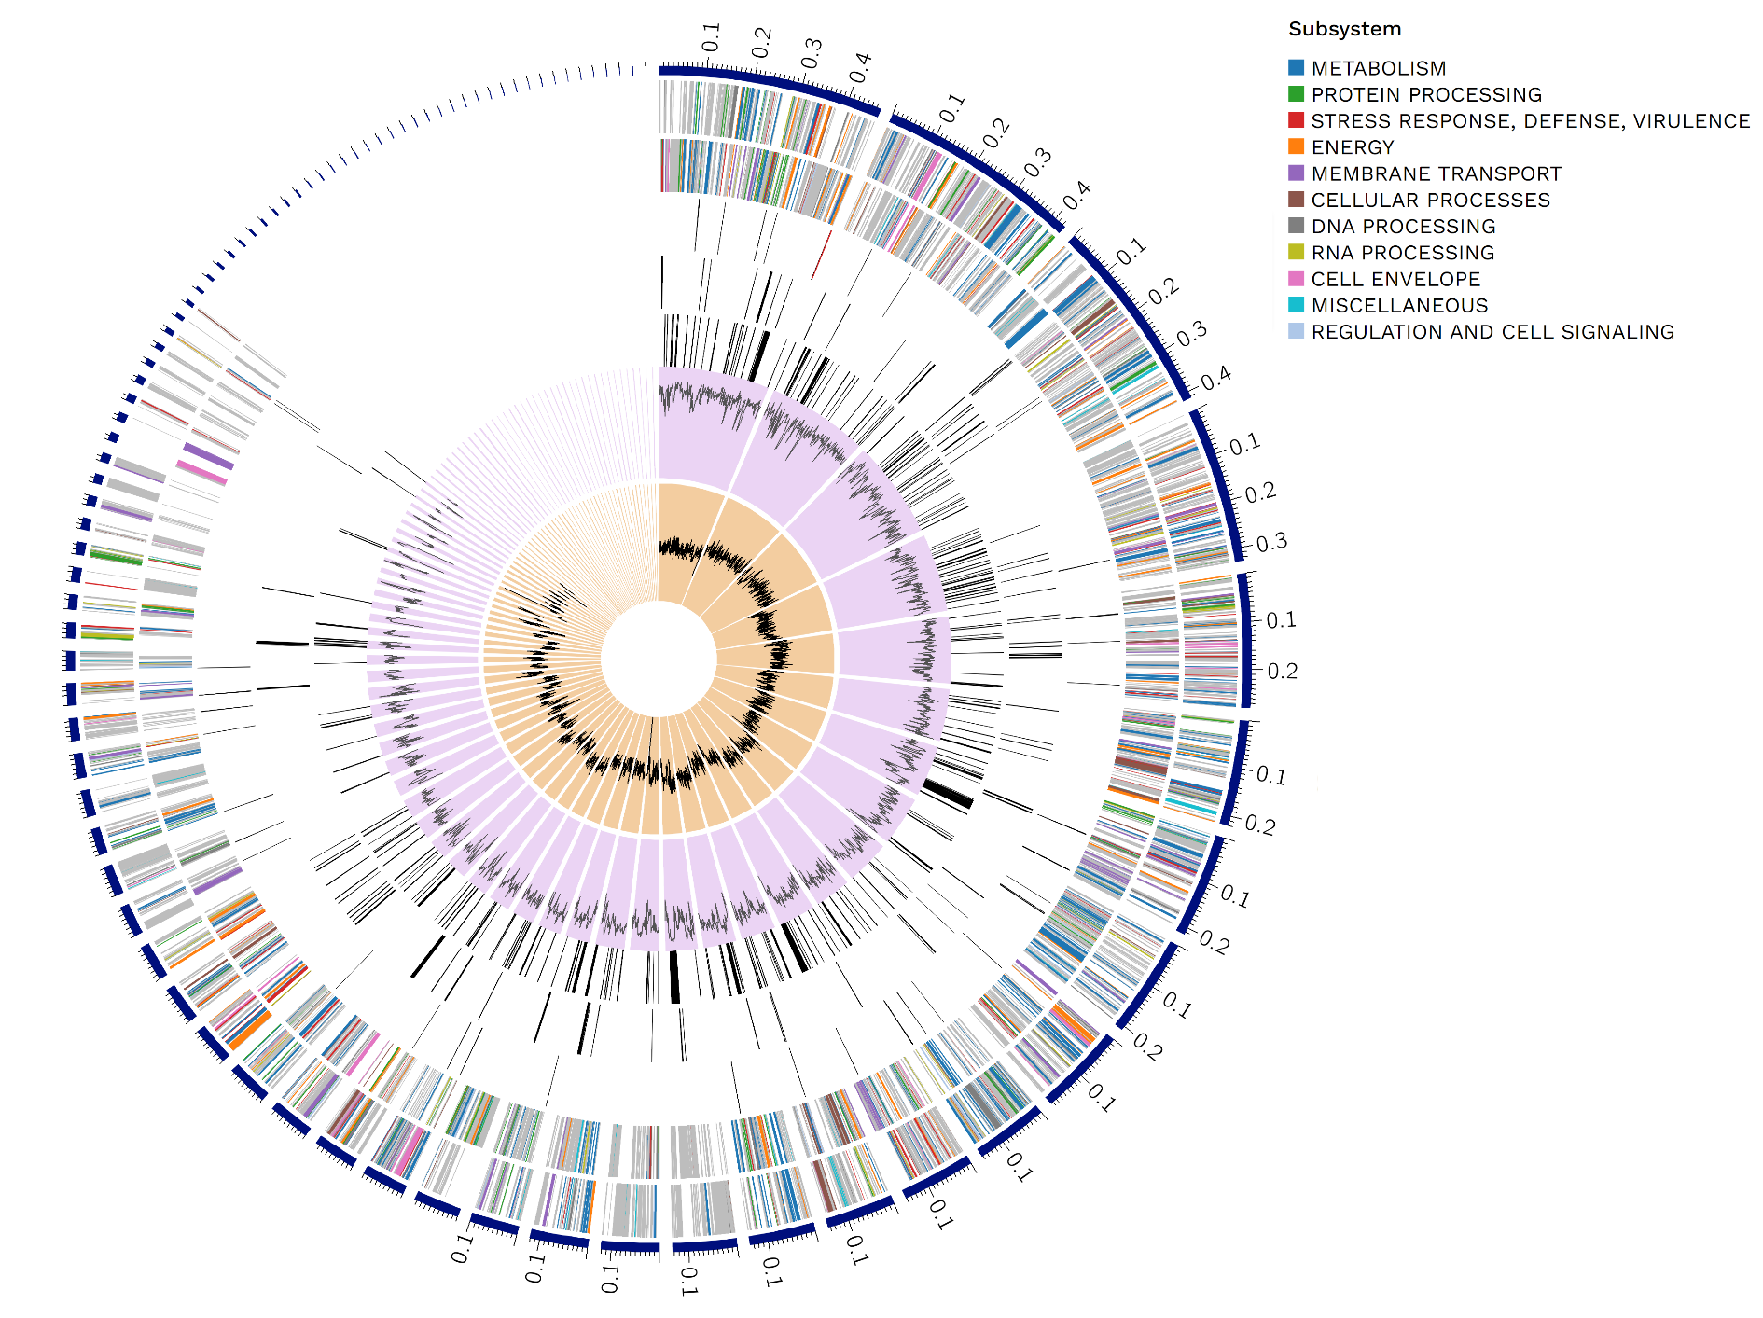
Figure S2. Circular distribution of the genome annotations. From outer to inner rings, the contigs, CDS on the forward strand, CDS on the reverse strand, RNA genes, CDS with homology to known antimicrobial resistance genes, CDS with homology to know virulence factors, GC content and GC skew. The colours of the CDS on the forward and reverse strand indicate the subsystem that these genes belong to.

Table S1. Core virulence genes found in S. Yopougon isolated from the wild snake
Virulence factors | Related genes | Presence
Adherence
Agf | csgG | +
Agf | csgF | +
Agf | csgE | +
Agf | csgD | +
Agf | csgB | +
Agf | csgA | +
Agf | csgC | +
Bcf | bcfA | +
Bcf | bcfB | +
Bcf | bcfC | +
Bcf | bcfD | +
Bcf | bcfE | +
Bcf | bcfF | +
Bcf | bcfG | +
Lpf | lpfE | -
Lpf | lpfD | -
Lpf | lpfC | -
Lpf | lpfB | -
Lpf | lpfA | -
MisL | misL | +
Pef | pefD | -
Pef | pefC | -
Pef | pefA | -
Pef | pefB | -
Peg | pegD | -
Peg | pegC | -
Peg | pegB | -
Peg | pegA | -
RatB | ratB | +
Saf | safA | +
Saf | safB | +
Saf | safC | +
Saf | safD | +
Sef | sefA | -
Sef | sefB | -
Sef | sefC | -
Sef | sefD | -
ShdA | shdA | -
SinH | sinH | +
Sta | staG | -
Sta | staF | -
Sta | staE | -
Sta | staD | -
Sta | staC | -
Sta | staB | -
Sta | staA | -
Stb | stbE | +
Stb | stbD | +
Stb | stbC | +
Stb | stbB | +
Stb | stbA | +
Stc | stcD | -
Stc | stcC | -
Stc | stcB | -
Stc | stcA | -
Std | stdC | +
Std | stdB | +
Std | stdA | +
Ste | steA | +
Ste | steB | +
Ste | steC | +
Ste | steD | -
Ste | steE | -
Ste | steF | -
Stf | stfA | -
Stf | stfC | -
Stf | stfD | -
Stf | stfE | -
Stf | stfF | -
Stf | stfG | -
Stg | stgA | -
Stg | stgB | -
Stg | stgC | -
Stg | stgD | -
Sth | sthE | +
Sth | sthD | +
Sth | sthC | +
Sth | sthB | +
Sth | sthA | +
Sti | stiH | -
Sti | stiC | -
Sti | stiB | -
Sti | stiA | -
Stj | stjB | -
Stj | stjC | -
Stk | stkG | -
Stk | stkF | -
Stk | stkE | -
Stk | stkD | -
Stk | stkC | -
Stk | stkB | -
Stk | stkA | -
Tcf | tcfA | -
Tcf | tcfB | -
Tcf | tcfC | -
Tcf | tcfD | -
Type 1 fimbriae | fimA | +
Type 1 fimbriae | fimI | +
Type 1 fimbriae | fimC | +
Type 1 fimbriae | fimD | +
Type 1 fimbriae | fimH | +
Type 1 fimbriae | fimF | +
Type 1 fimbriae | fimZ | +
Type 1 fimbriae | fimY | +
Type 1 fimbriae | fimW | +
Effector delivery system
SCI (Salmonella centrisome island) | tssA | +
SCI (Salmonella centrisome island) | TssB | +
SCI (Salmonella centrisome island) | TssC | +
SCI (Salmonella centrisome island) | TssD/Hep | -
SCI (Salmonella centrisome island) | tssE | -
SCI (Salmonella centrisome island) | tssF | +
SCI (Salmonella centrisome island) | tssG | +
SCI (Salmonella centrisome island) | TssK | +
SCI (Salmonella centrisome island) | TssH/clpV | -
SCI (Salmonella centrisome island) | PAAR | -
SCI (Salmonella centrisome island) | TssI/vgrG | -
SCI (Salmonella centrisome island) | TssJ | +
SCI (Salmonella centrisome island) | tssM | +
SCI (Salmonella centrisome island) | tssL | -
TTSS (SPI-1 encode) | sprB | +
TTSS (SPI-1 encode) | hilC | +
TTSS (SPI-1 encode) | orgC | +
TTSS (SPI-1 encode) | orgB/SctL | +
TTSS (SPI-1 encode) | orgA/sctK | +
TTSS (SPI-1 encode) | prgK | +
TTSS (SPI-1 encode) | prgJ | +
TTSS (SPI-1 encode) | prgI | +
TTSS (SPI-1 encode) | prgH | +
TTSS (SPI-1 encode) | hilD | +
TTSS (SPI-1 encode) | hilA | +
TTSS (SPI-1 encode) | iagB | +
TTSS (SPI-1 encode) | sicP | +
TTSS (SPI-1 encode) | iacP | +
TTSS (SPI-1 encode) | sipD | +
TTSS (SPI-1 encode) | sicA | +
TTSS (SPI-1 encode) | spaS | +
TTSS (SPI-1 encode) | spaR | +
TTSS (SPI-1 encode) | spaQ | +
TTSS (SPI-1 encode) | spaP | +
TTSS (SPI-1 encode) | spaO/sctQ | +
TTSS (SPI-1 encode) | invJ | +
TTSS (SPI-1 encode) | invI | +
TTSS (SPI-1 encode) | invC/sctN | +
TTSS (SPI-1 encode) | invB | +
TTSS (SPI-1 encode) | invA | +
TTSS (SPI-1 encode) | invE | +
TTSS (SPI-1 encode) | invG | +
TTSS (SPI-1 encode) | invF | +
TTSS (SPI-1 encode) | invH | +
TTSS (SPI-2 encode) | ssrB | +
TTSS (SPI-2 encode) | ssrA | +
TTSS (SPI-2 encode) | ssaC | +
TTSS (SPI-2 encode) | ssaD | +
TTSS (SPI-2 encode) | ssaE | +
TTSS (SPI-2 encode) | sseA | +
TTSS (SPI-2 encode) | sseB | +
TTSS (SPI-2 encode) | sscA | +
TTSS (SPI-2 encode) | sseC | +
TTSS (SPI-2 encode) | sseD | +
TTSS (SPI-2 encode) | sseE | +
TTSS (SPI-2 encode) | sscB | +
TTSS (SPI-2 encode) | ssaG | +
TTSS (SPI-2 encode) | ssaH | +
TTSS (SPI-2 encode) | ssaI | +
TTSS (SPI-2 encode) | ssaJ | +
TTSS (SPI-2 encode) | ssaK | +
TTSS (SPI-2 encode) | ssaL | +
TTSS (SPI-2 encode) | ssaM | +
TTSS (SPI-2 encode) | ssaV | +
TTSS (SPI-2 encode) | ssaN | +
TTSS (SPI-2 encode) | ssaO | +
TTSS (SPI-2 encode) | ssaP | +
TTSS (SPI-2 encode) | ssaQ | +
TTSS (SPI-2 encode) | ssaR | +
TTSS (SPI-2 encode) | ssaS | +
TTSS (SPI-2 encode) | ssaT | +
TTSS (SPI-2 encode) | ssaU | +
TTSS effectors secreted via both systems | slrP | +
TTSS-1 secreted effectors | sptP | +
TTSS-1 secreted effectors | sipA/sspA | +
TTSS-1 secreted effectors | sipC/sspC | +
TTSS-1 secreted effectors | sipB/sspB | +
TTSS-1 secreted effectors | sopA | +
TTSS-1 secreted effectors | sopB/sigD | +
TTSS-1 secreted effectors | sopD | +
TTSS-1 secreted effectors | sopE | -
TTSS-1 secreted effectors | sopE2 | +
TTSS-1 secreted effectors | avrA | +
TTSS-2 secreted effectors | spiC/ssaB | +
TTSS-2 secreted effectors | sseF | +
TTSS-2 secreted effectors | sseG | +
TTSS-2 secreted effectors | sseI/srfH | -
TTSS-2 secreted effectors | sseJ | +
TTSS-2 secreted effectors | sseL | +
TTSS-2 secreted effectors | sseK2 | +
TTSS-2 secreted effectors | sifA | +
TTSS-2 secreted effectors | sifB | +
TTSS-2 secreted effectors | pipB | +
TTSS-2 secreted effectors | pipB2 | +
TTSS-2 secreted effectors | sopD2 | +
TTSS-2 secreted effectors | gogB | -
TTSS-2 secreted effectors | sspH2 | -
TTSS-2 secreted effectors | sseK1 | +
TTSS-2 secreted effectors | spvD | -
TTSS-2 secreted effectors | spvC | -
Exotoxin
SpvB | spvB | -
Typhoid toxin | cdtB | +
Typhoid toxin | pltA | +
Typhoid toxin | pltB | +
Immune modulation
Rck | rck | -
Vi antigen | vexE | -
Vi antigen | vexD | -
Vi antigen | vexC | -
Vi antigen | vexB | -
Vi antigen | vexA | -
Vi antigen | tviE | -
Vi antigen | tviD | -
Vi antigen | tviC | -
Vi antigen | tviB | -
Vi antigen | tviA | -
Nutritional/Metabolic factor
MgtBC | mgtB | +
MgtBC | mgtC | +
Stress survival
SodCI | sodCI | -
Antimicrobial activity/Competitive advantage
Mig-14 | mig-14 | +
Mig-5 | mig-5 | -
Regulation
PhoPQ | phoQ | +
PhoPQ | phoP | +

