Forced Degradation of an Anticancer Drug Apalutamide: Impurity Profiling and Structure Elucidation Study
Rekha Sapkal¹, Sadaf Quadri¹, Rupali Mahajan¹, Hara Prasad Padhy¹, Amit Asthana², Gananadhamu Samanthula¹, Amol G. Dikundwar¹*
¹Department of Pharmaceutical Analysis, National Institute of Pharmaceutical Education and Research, Hyderabad
²Department of Medical Devices, National Institute of Pharmaceutical Education and Research, Hyderabad
Author for correspondence:
Dr. Amol G. Dikundwar (Email: amol.dikundwar@niperhyd.ac.in)
Supplementary information
List of Figures
Fig. S1 Preparative HPLC Chromatogram of DP-7
Fig. S2 HRMS data of DP-1
Fig. S3 Fragmentation pathway of DP-1
Fig. S4 HRMS data of DP-2
Fig. S5 Fragmentation pathway of DP-2
Fig. S6 HRMS data of DP-3
Fig. S7 Fragmentation pathway of DP-3
Fig. S8 HRMS data of DP-4
Fig. S9 Fragmentation pathway of DP-4
Fig. S10 HRMS data of DP-5
Fig. S11 Fragmentation pathway of DP-5
Fig. S12 HRMS data of DP-6
Fig. S13 Fragmentation pathway of DP-6
Fig. S14 HRMS spectra of DP-7 in negative ion mode
Fig. S15 LC-MS/MS fragmentation pathway of DP-7
Fig. S16 ¹H NMR of apalutamide
Fig. S17 ¹H NMR of DP-7
Fig. S18 Overlay of ¹H NMR of apalutamide and DP-7
Fig. S19 Detailed reaction pathways for the formation of all the DPs

List of Tables
Table S1 LC-Q-TOF-MS data of apalutamide degradation products (DP-1 to DP-7)
Table S2 Predicted degradation products by using Zeneth sofware

Fig. S1 Preparative HPLC Chromatogram of DP-7
Fig. S2 HRMS data of DP-1

Fig. S3 Fragmentation pathway of DP-1
Fig. S4 HRMS data of DP-2
Fig. S5 Fragmentation pathway of DP-2
Fig. S6 HRMS data of DP-3

Fig. S7 Fragmentation pathway of DP-3

Fig. S8 HRMS data of DP-4
Fig. S9 Fragmentation pathway of DP-4

Fig. S10 HRMS data of DP-5
Fig. S11 Fragmentation pathway of DP-5

Fig. S12 HRMS data of DP-6
Fig. S13 Fragmentation pathway of DP-6
Fig. S14 HRMS spectra of DP-7 in negative ion mode

Fig. S15 LC-MS/MS fragmentation pathway of DP-7

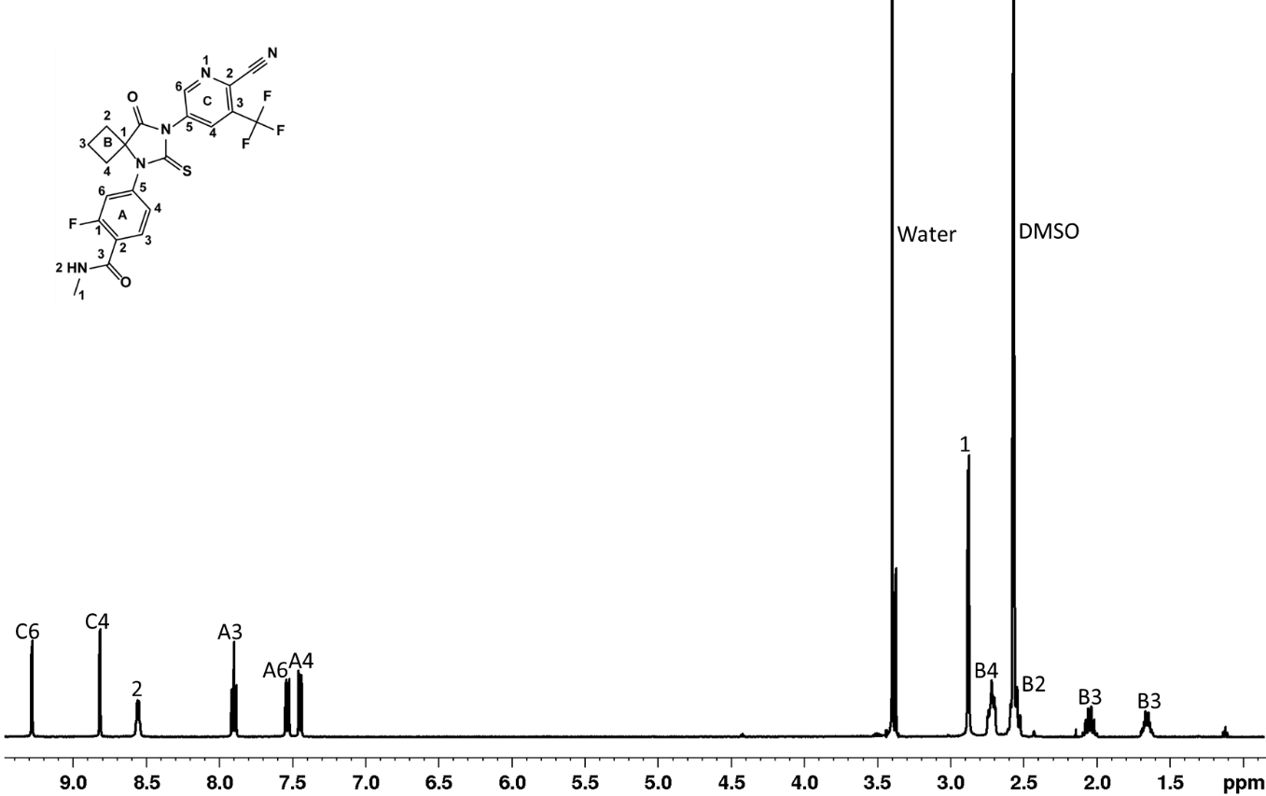
Fig. S16 ¹H NMR of apalutamide
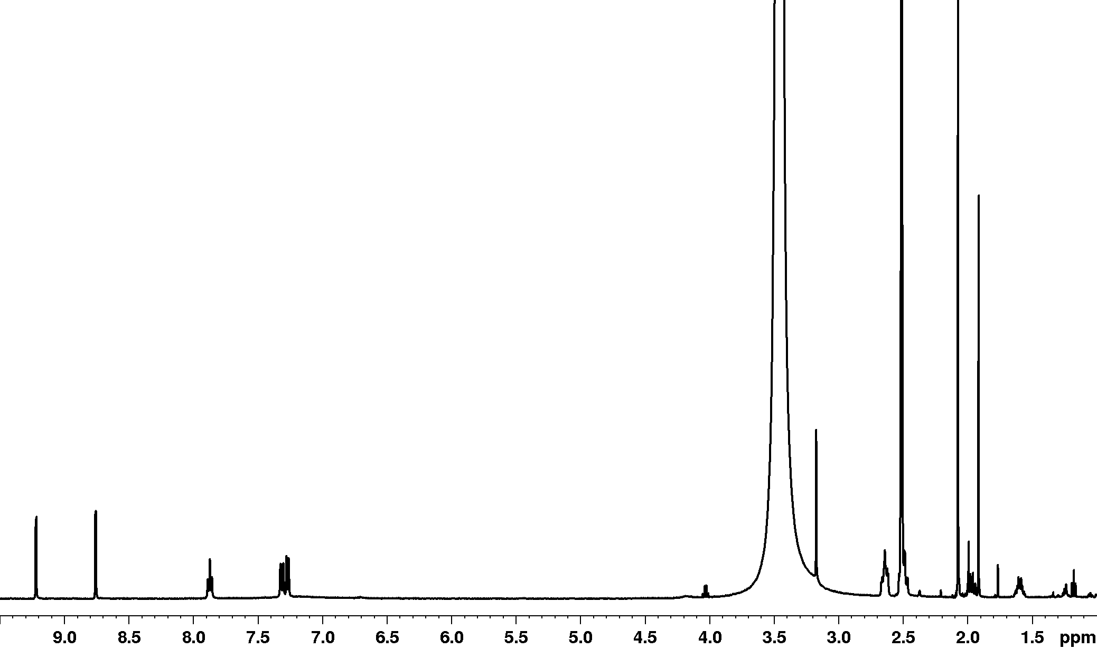
C6
C4
A3
A6
A4
B3
B3
B4
B2
#
*

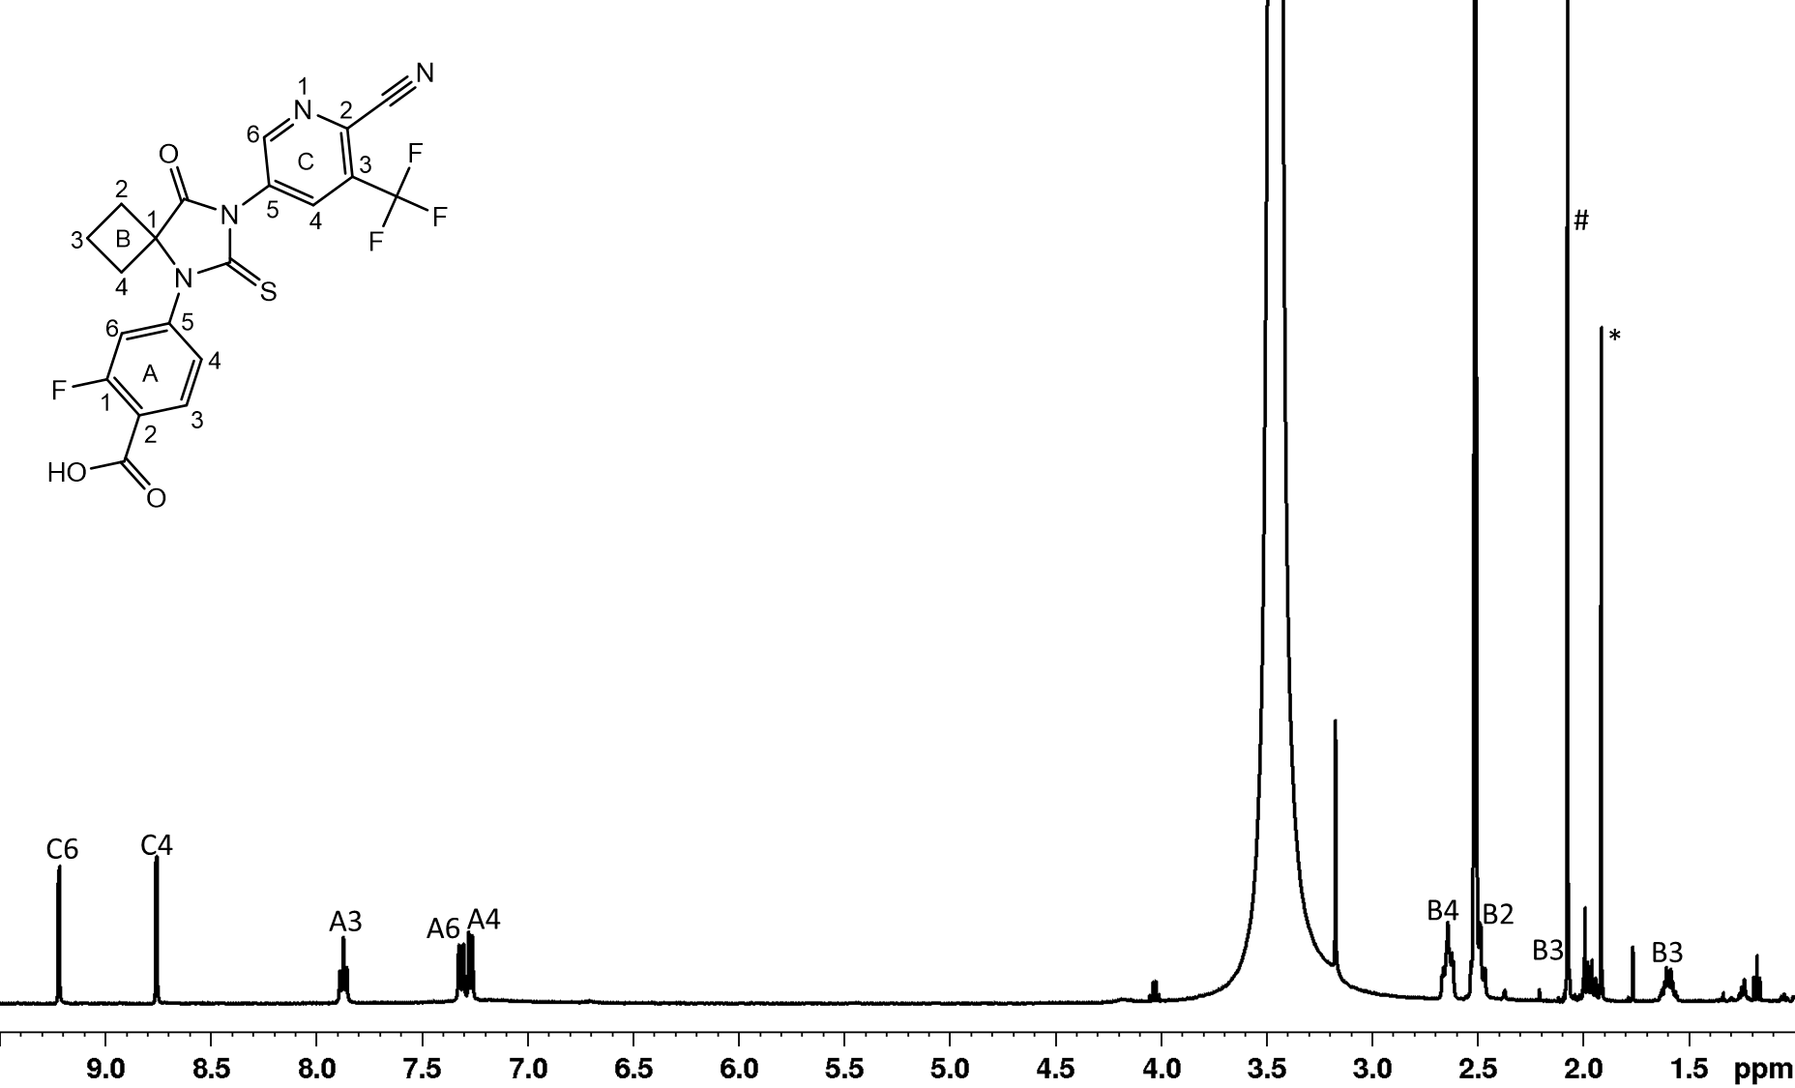
Fig. S17 ¹H NMR of isolated fraction of DP-7 in solvent. Peaks marked with (#) and (*) are due to residual
amount ACN and acetate buffer respectively.

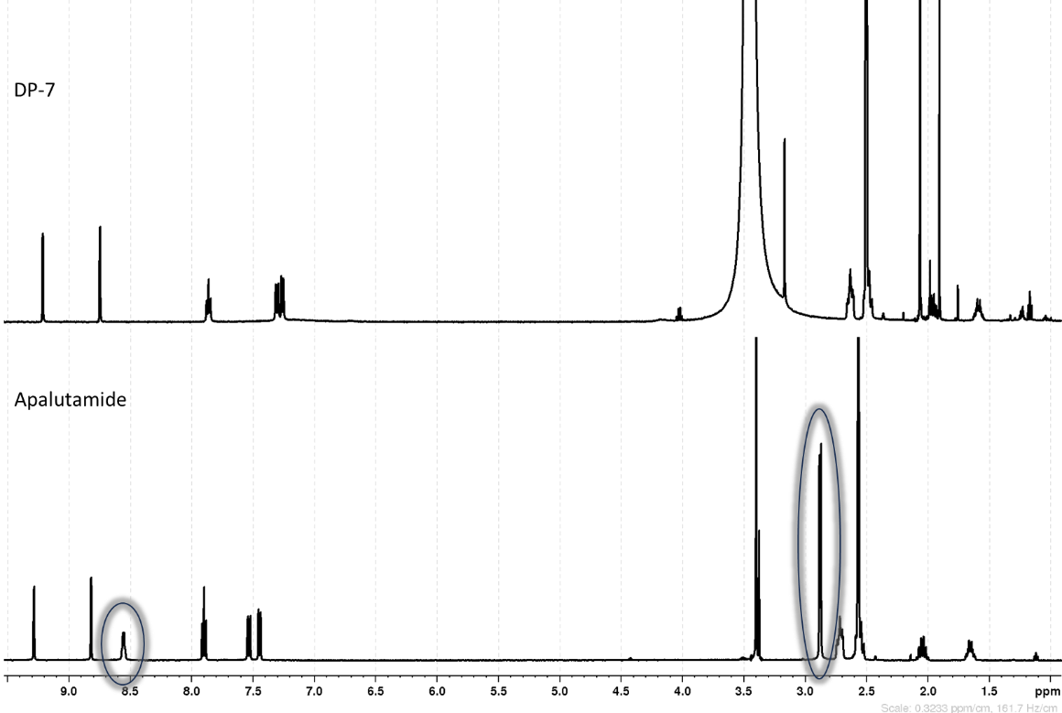
Fig. S18 Overlay of ¹H NMR of apalutamide and DP-7 highlighting the absence of peaks corresponding to NH and CH₃ in DP-7.
Fig. S19 Detailed reaction pathways for the formation of all the DPs
Table S1 LC-Q-TOF-MS data of apalutamide degradation products (DP-1 to DP-7)
DPs | Accurate mass | Best possible molecular formula | Theoretical  mass | Error in ppm | RDB | Major fragments  accurate mass, molecular formula, RDB, error in ppm
Dp-1 | 295.1082 | C₁₄H₁₆FN₂O₄⁺ | 295.1089 | -2.37 | 7.5 | 267.1118, C₁₃H₁₆FN₂O₃⁺,7.5,-2.37;  249.1025, C₁₃H₁₄FN₂O₂⁺, 7.5, -3.61;  239.0821, C₁₁H₁₂FN₂O₃⁺6.5, -2.09;  236.07, C₁₂H₁₁FNO₃⁺, 7.5, -7.20;  221.1081, C₁₂H₁₄FN₂O⁺, 6.5, -1.81;  208.0395, C₁₀H₇FNO₃⁺, 7.5, -4.33;  193.0768, C₁₀H₁₀FN₂O⁺, 6.5, -2.07
DP-2 | 267.1141 | C₁₃H₁₆FN₂O₃⁺ | 371.1238 | 0.75 | 6.5 | 249.1035, C₁₃H₁₄FN₂O₂⁺, 7.5, 0.40;  239.0823, C₁₁H₁₂FN₂O₃⁺, -1.25, 6.5;  236.0714, C₁₂H₁₁FNO₃⁺, 7.5, -1.27;  221.1073, C₁₂H₁₄FN₂O⁺, 6.5, -5.43;  208.0401, C₁₀H₇FNO₃⁺, 7.5, -1.44;  193.0768, C₁₀H₁₀FN₂O⁺, 6.5, -2.07;  162.0347, C₉H₅FNO⁺, 7.5, -1.85;  136.0554, C₈H₇FN⁺, 5.5, -2.20;  134.0398, C₈H₅FN⁺, 6.5, -2.24;  58.0287, C₂H₄NO⁺, 1.5, 0.00;
DP-3 | 188.0425 | C₇H₅F₃N₃⁺ | 188.043 | -2.66 | 5.5 | 171.017, C₇H₂F₃N₂⁺, 6.5, 2.92;  168.0363, C₇H₄F₂N₃⁺, 6.5, -2.98;  161.0316, C₆H₄F₃N₂⁺, 4.5, -3.10;  141.0254, C₆H₃F₂N₂⁺, 5.5, -3.55;  68.9944, CF₃⁺, 0.5, -4.35
DP-4 | 496.1057 | C₂₁H₁₈F₄N₅O₃S⁺ | 496.1061 | -0.81 | 13.5 | 479.0784, C₂₁H₁₅F₄N₄O₃S⁺, 14.5,-2.50;  468.0748, C₁₉H₁₄F₄N₅O₃S⁺, 13.5, 0.00;  451.0483, C₁₉H₁₁F₄N₄O₃S⁺, 14.5, 0.00;  423.0526, C₁₈H₁₁F₄N₄O₂S⁺, 13.5,  -1.65;  423.0887, C₁₉H₁₅F₄N₄OS⁺, 12.5, -2.36;  392.0466, C₁₈H₁₀F₄N₃OS⁺, 13.5, -2.30;  58.0288, C₂H₄NO⁺, 1.5, 1.72;
DP-5 | 464.1326 | C21H18F4N5O3+ | 464.134 | -3.02 | 13.5 | 433.0901, C₂₀H₁₃F₄N₄O₃⁺, 14.5,-3.93;  405.0956, C₁₉H₁₃F₄N₄O₂⁺, 13.5, -3.21;  377.065, C₁₇H₉F₄N₄O₂⁺, 13.5, -1.59;  277.0971, C₁₄H₁₄FN₂O₃⁺, 8.5, -4.33;  249.1024, C₁₃H₁₄FN₂O₂⁺, 7.5, -4.01;  221.1075, C₁₂H₁₄FN₂O⁺, 6.5,-4.52;  162.0337, C₉H₅FNO⁺, 7.5, -8.02;  138.0342, C₇H₅FNO⁺, 5.5, -5.80;  58.0286, C₂H₄NO⁺, 1.5, -1.72;
DP-6 | 462.1176 | C₂₁H₁₆F₄N₅O₃⁺ | 462.1184 | -1.73 | 14.5 | 434.0858, C₁₉H₁₂F₄N₅O₃⁺, 14.5, -2.99;  431.0745, C₂₀H₁₁F₄N₄O₃⁺, 15.5, -3.94;  416.0751, C₁₉H₁₀F₄N₅O₂⁺, 15.5, -3.36;  403.0434, C₁₈H₇F₄N₄O₃⁺, 15.5,-3.72;  377.064, C₁₇H₉F₄N₄O₂+, 13.5, -4.24;  249.1024, C₁₃H₁₄FN₂O₂+, 7.5, -4.01;  221.1076, C₁₂H₁₄FN₂O+, 6.5, -4.07;  193.0764, C₁₀H₁₀FN₂O+, 6.5, -4.14;  162.034, C₉H₅FNO+, 7.5, -6.17;  136.055, C₈H₇FN+, 5.5,-5.14;  58.0284, C₂H₄NO+, 1.5, -5.17;
DP-7 | 463.0484 | C₂₀H₁₁F₄N₄O₃S⁻ | 463.0493 | -1.94 | 15.5 | 419.0587, C₁₉H₁₁F₄N₄OS⁻, 14.5, -1.91;  391.0276, C₁₇H₇F₄N₄OS⁻, 14.5, -1.53;  371.0214, C₁₇H₆F₃N₄OS⁻, 15.5, -1.62;  297.006, C₁₁H₄F₃N₄OS⁻, 10.5, -1.01

Table S2 Predicted degradation products by using Zeneth sofware
Acidic hydrolysis

Sr no | Structure | Name | Parent | Score | Transformation name | Transformation group | Condition trigger
 | 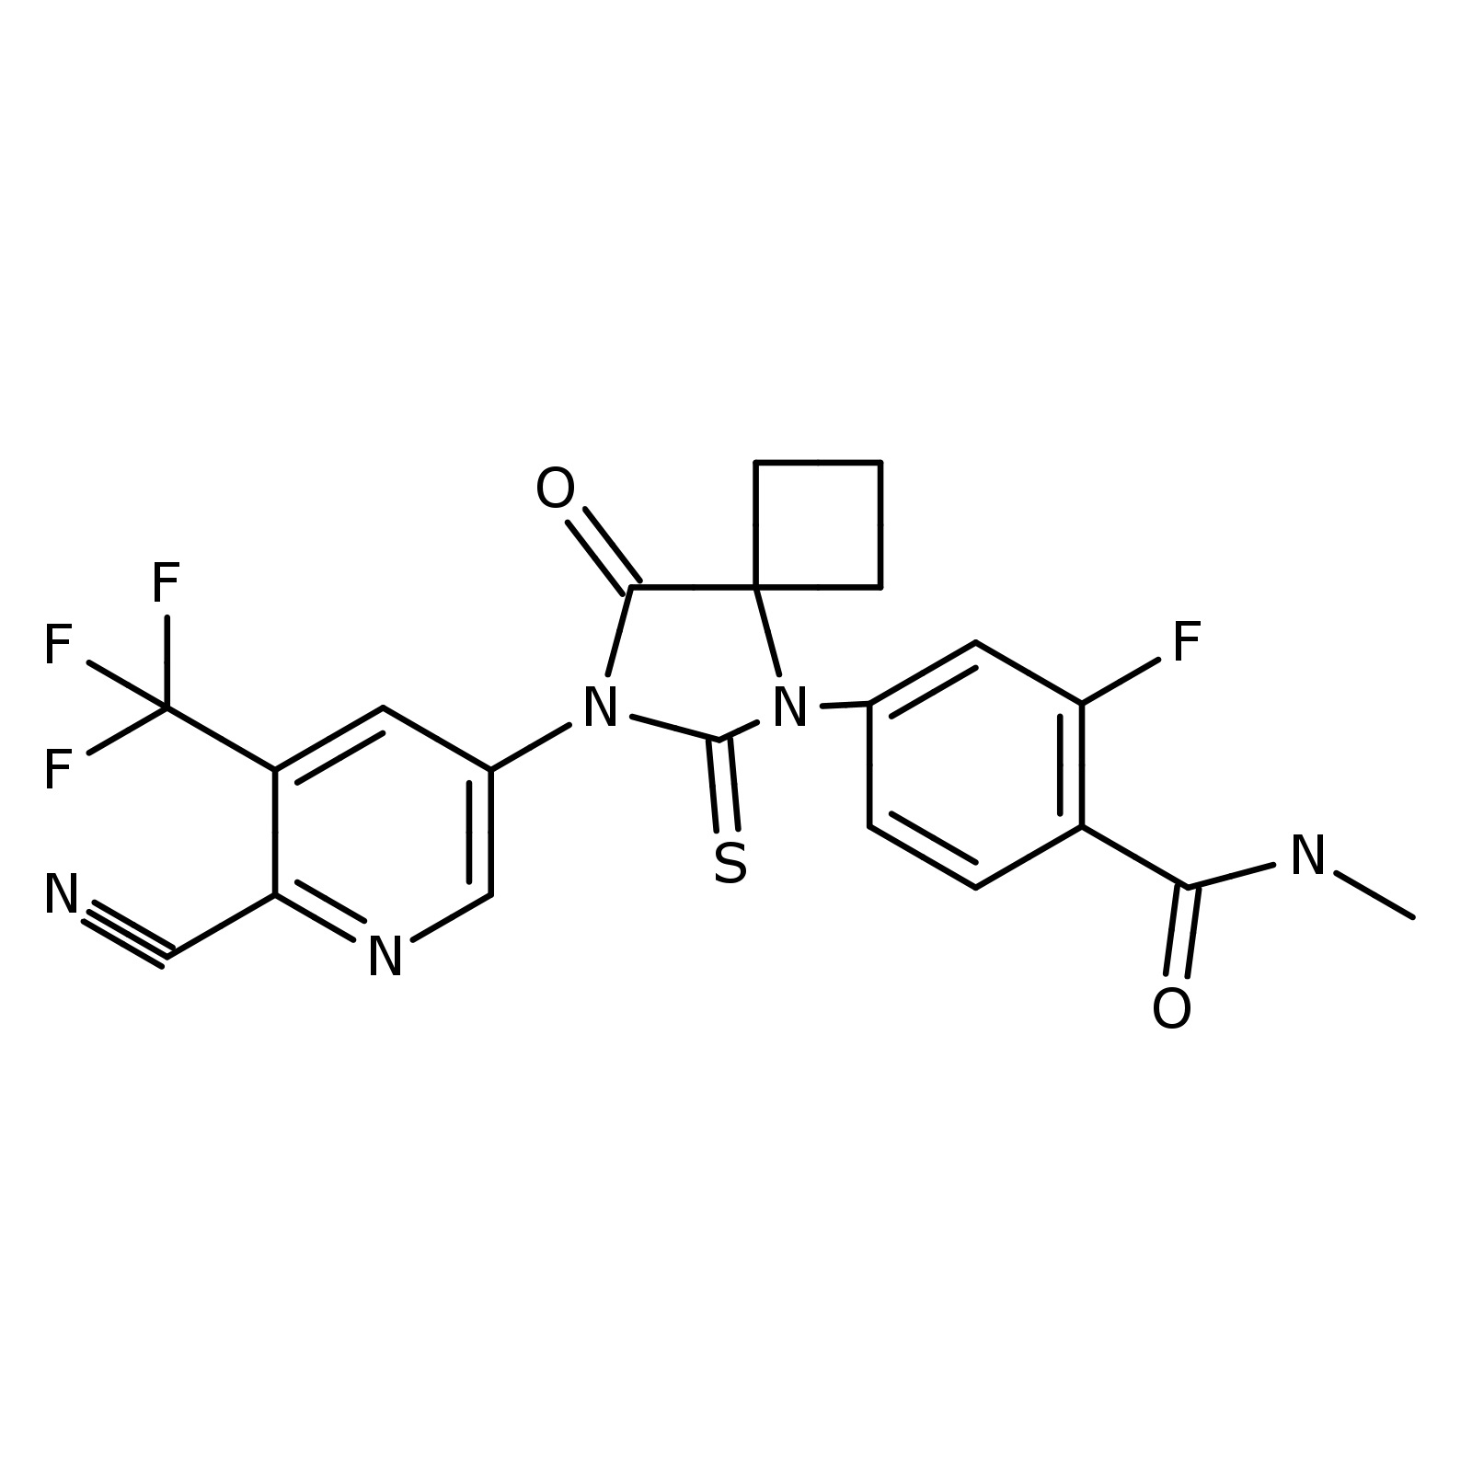 | Query
1 | 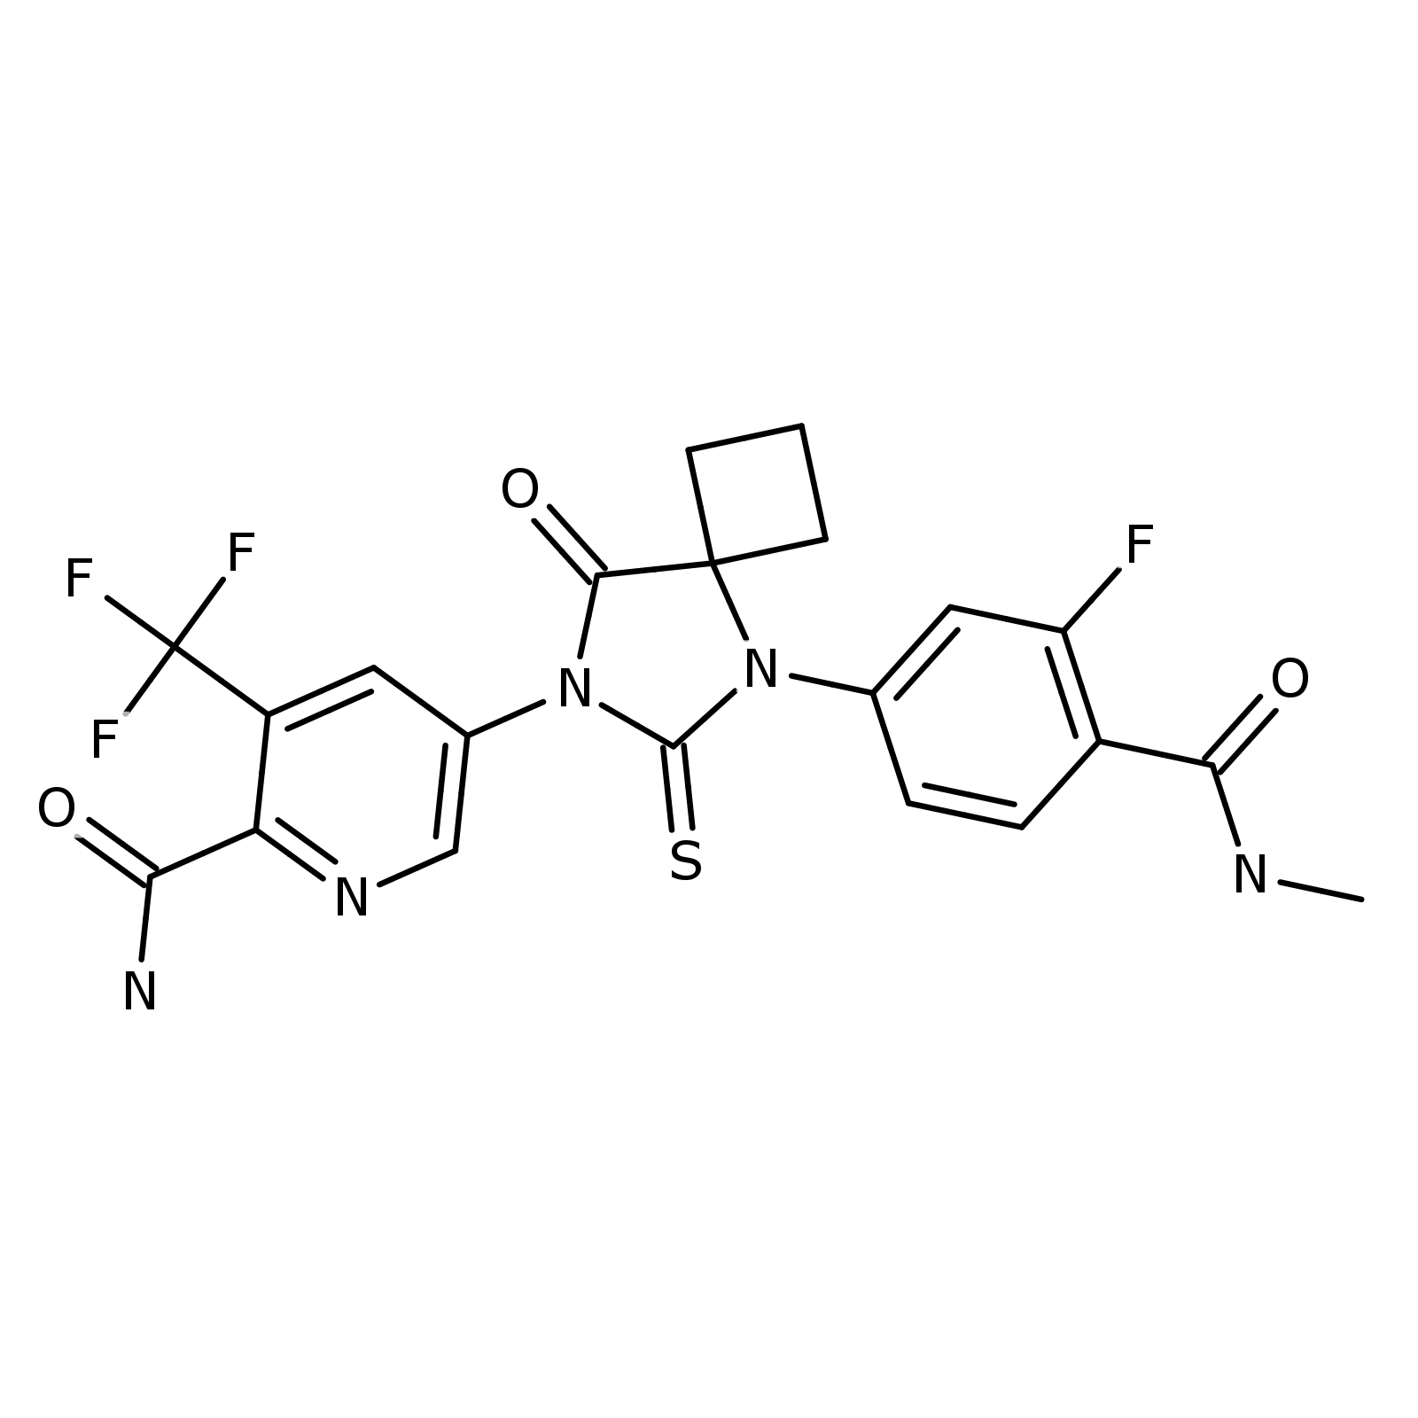 | D1 | Q | 900 | Hydration of nitrile | Condensations and additions | Water; pH
2 | 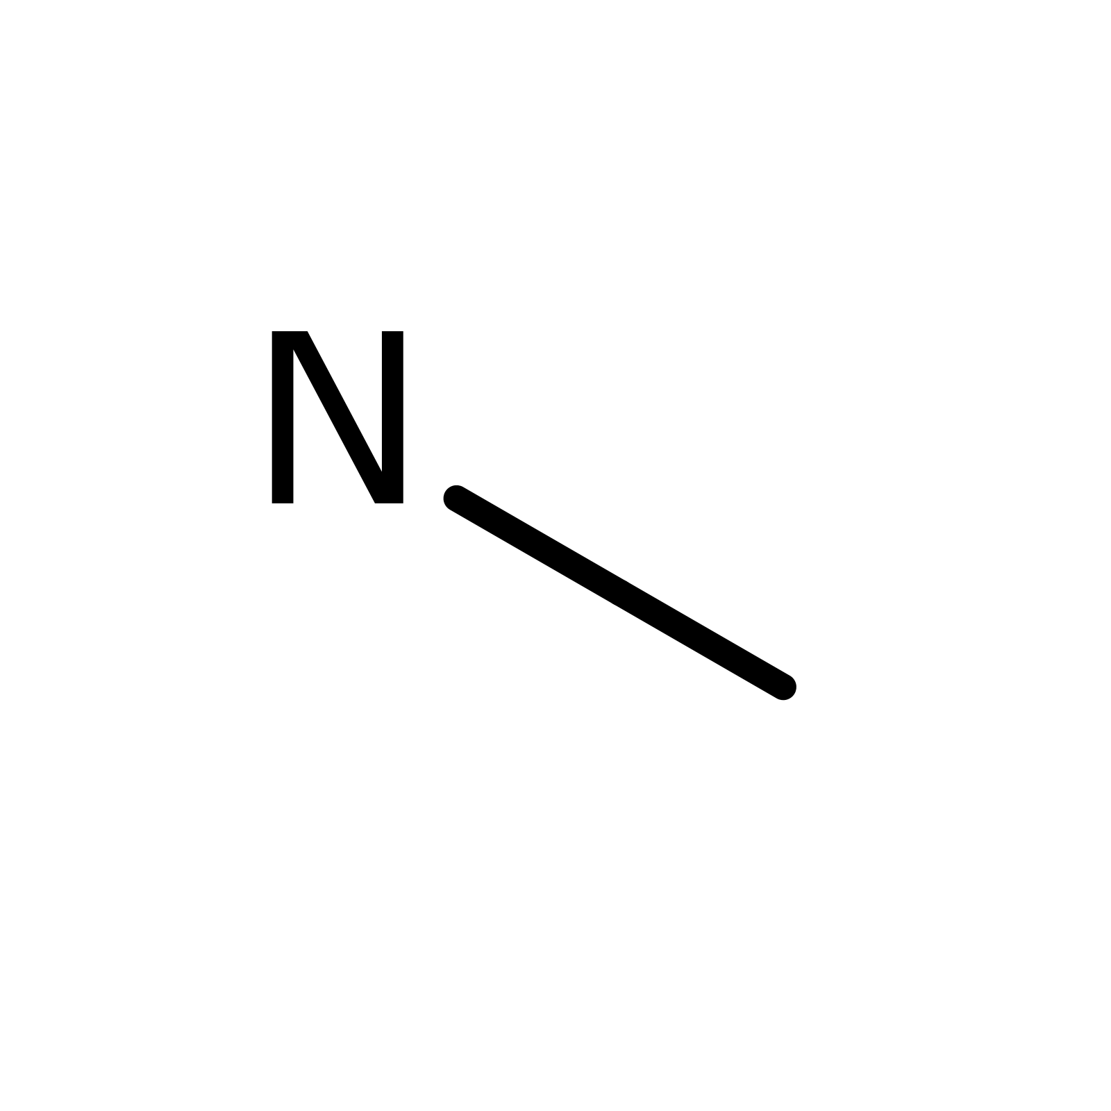 | D2 | Q | 700 | Hydrolysis of amide | Hydrolyses | Water; pH
3 | 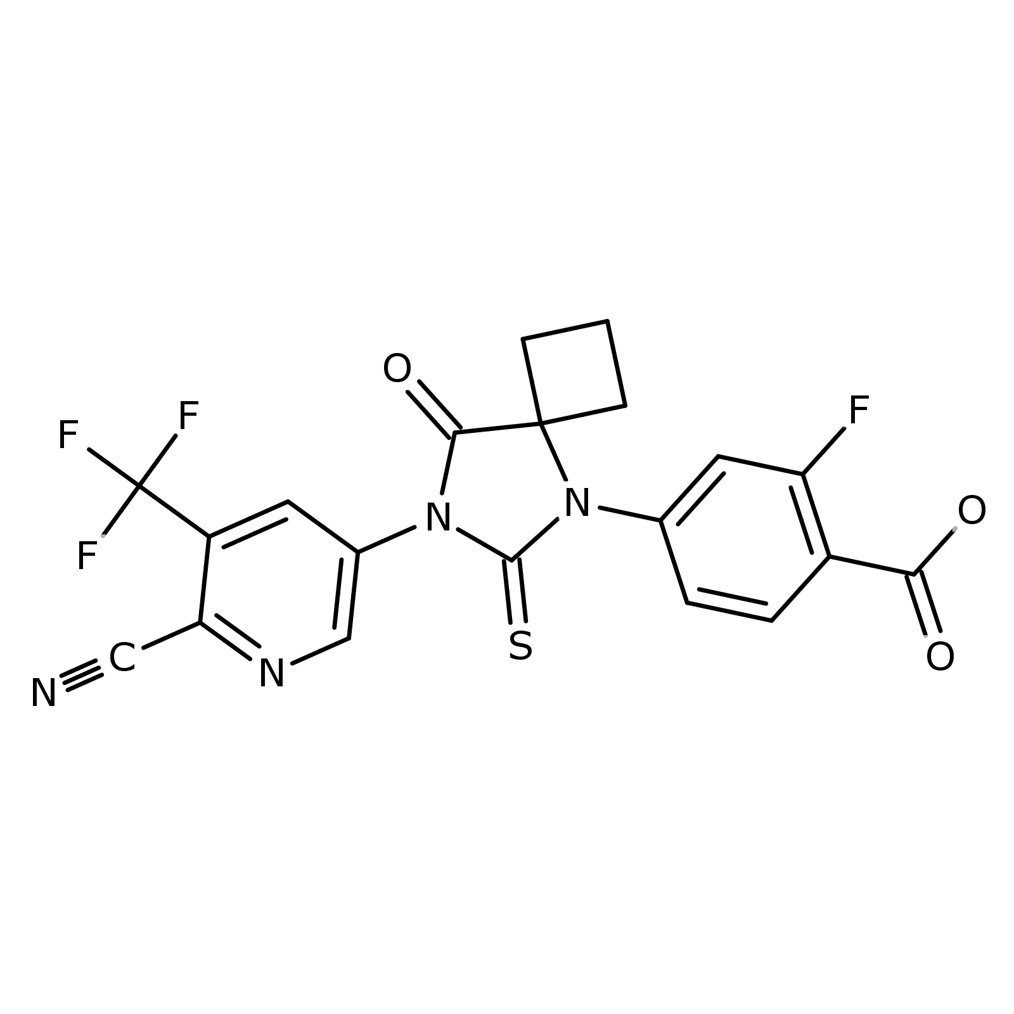 | D3 | Q | 700 | Hydrolysis of amide | Hydrolyses | Water; pH
4 | 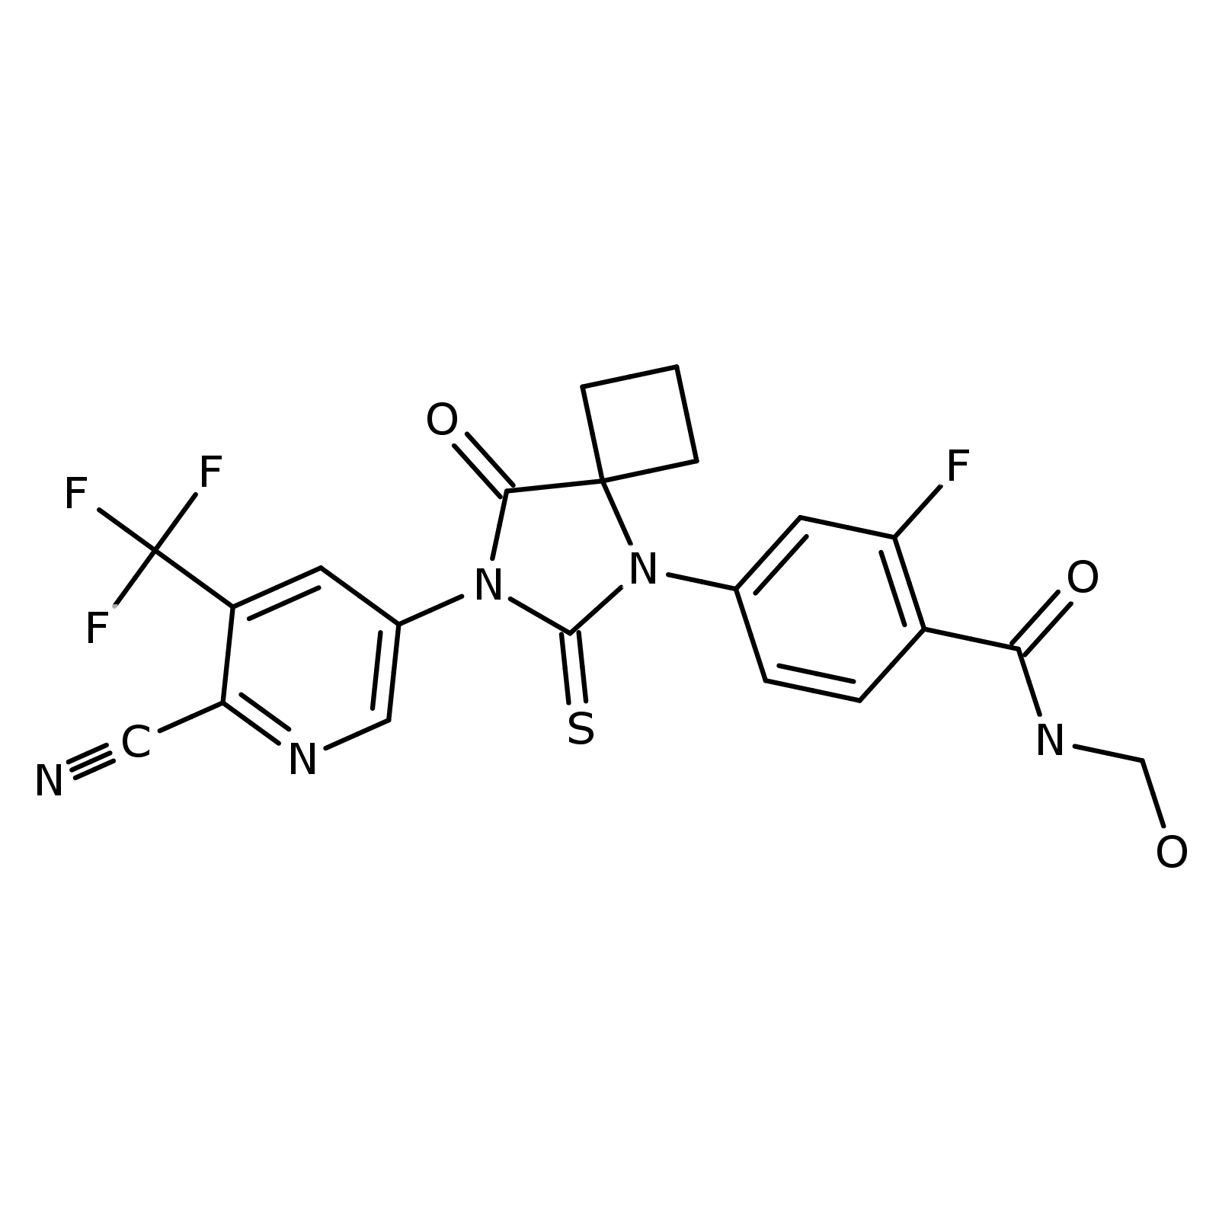 | D4 | Q | 700 | Oxidation of N-alkyl amide to hemiamidal | Oxidations | Oxygen; Radical or Light
5 | 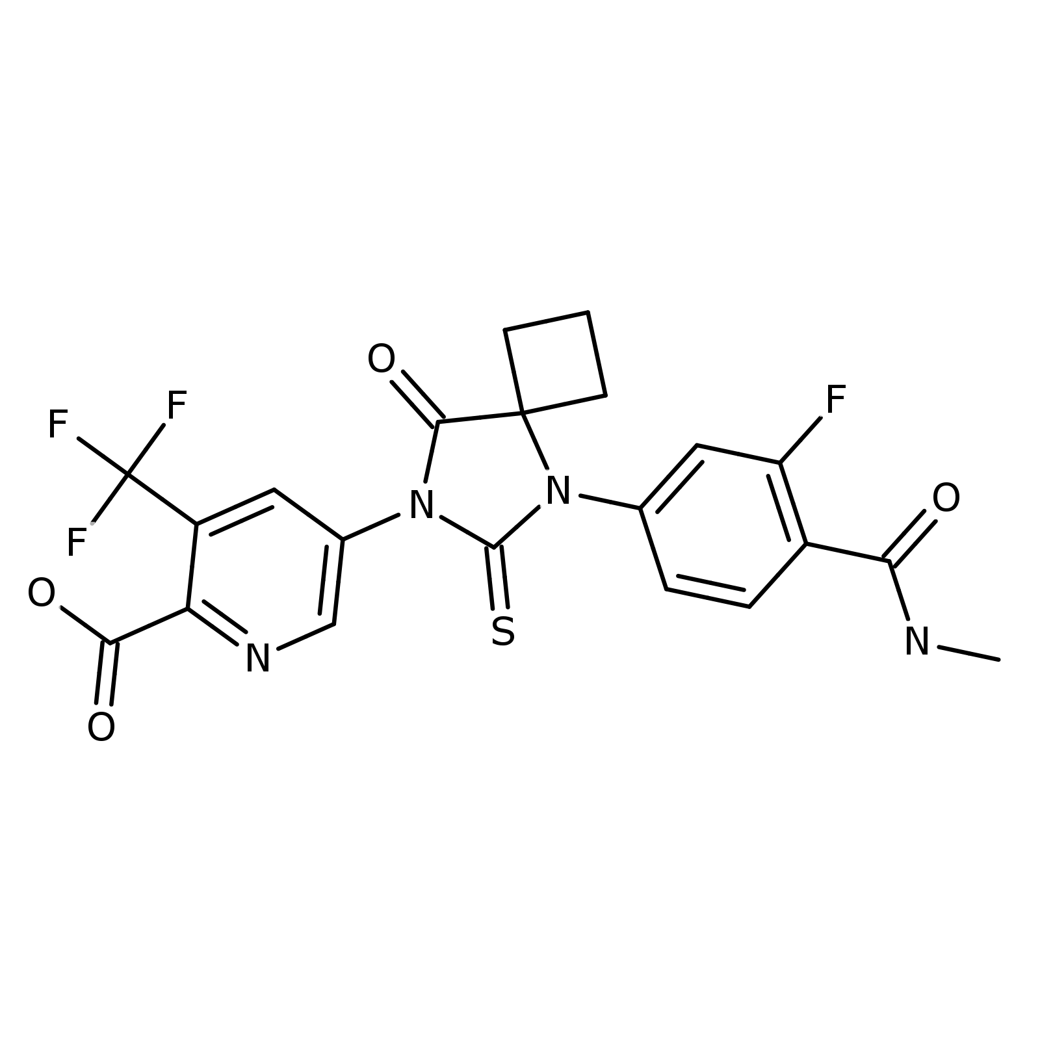 | D5 | D1 | 630 | Hydrolysis of amide | Hydrolyses | Water; pH
6 | 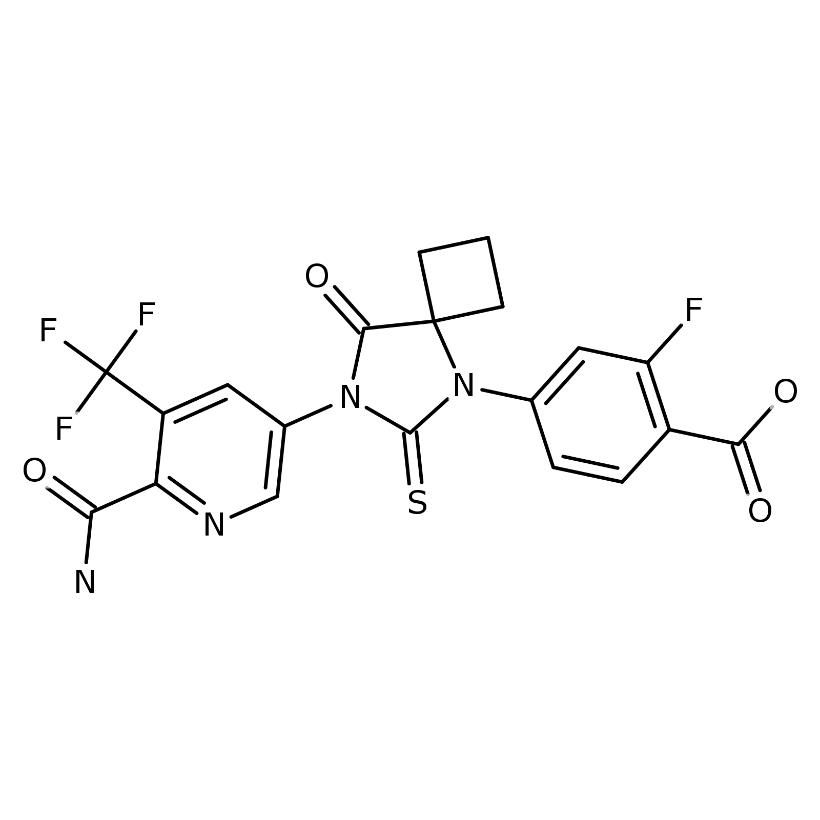 | D7 | D1 | 630 | Hydrolysis of amide | Hydrolyses | Water; pH
7 | 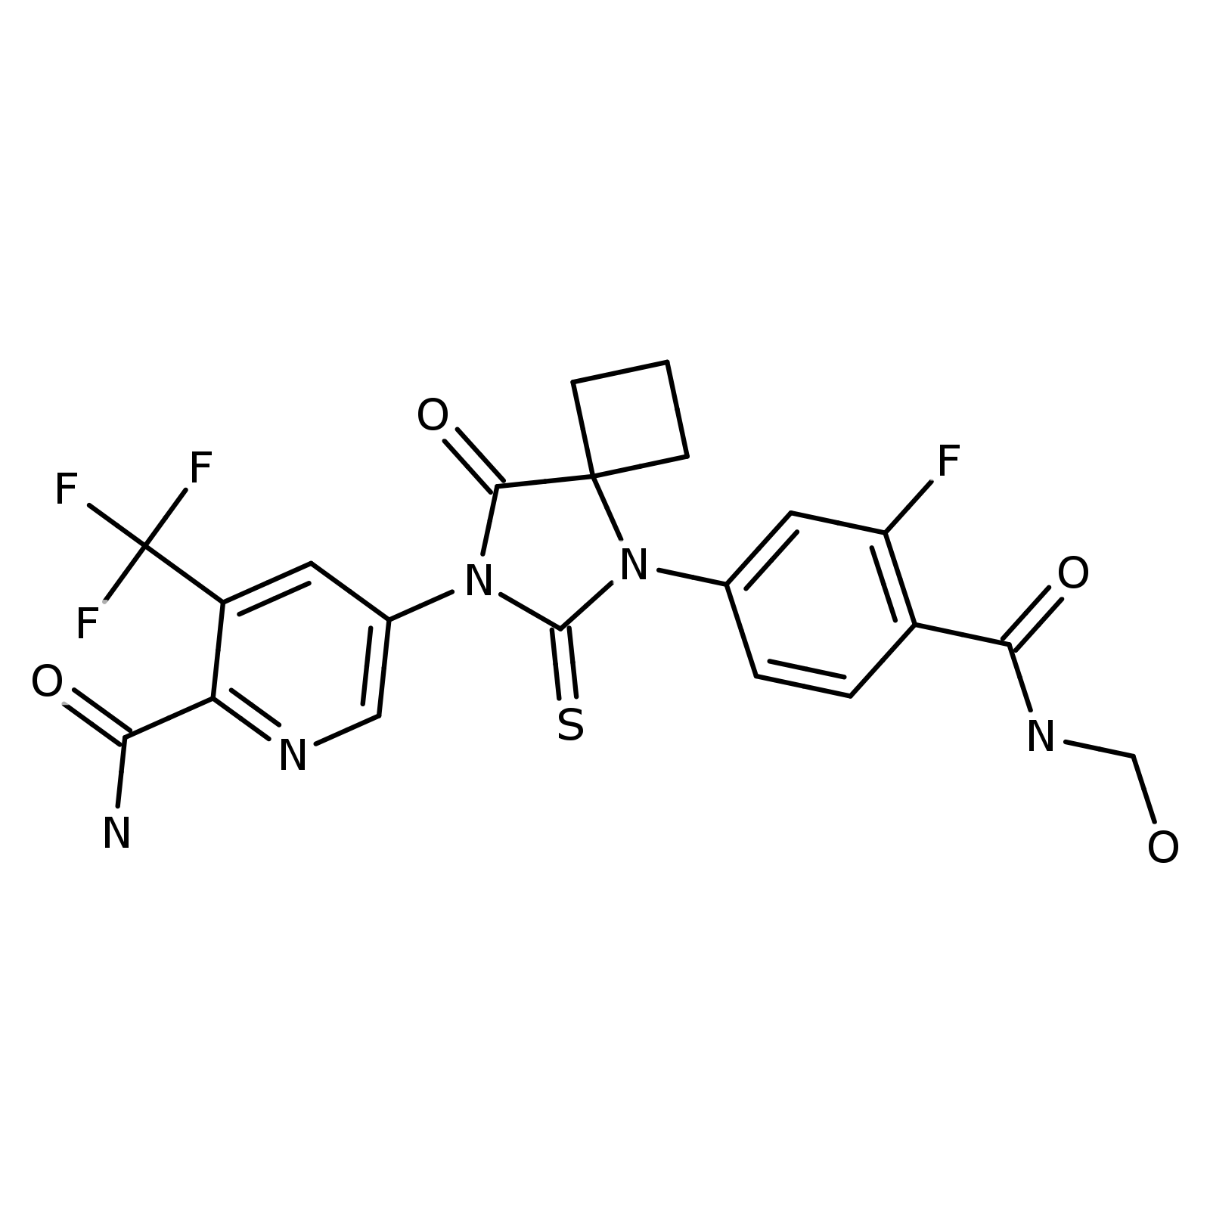 | D8 | D1 | 630 | Oxidation of N-alkyl amide to hemiamidal | Oxidations | Oxygen; Radical or Light
8 | 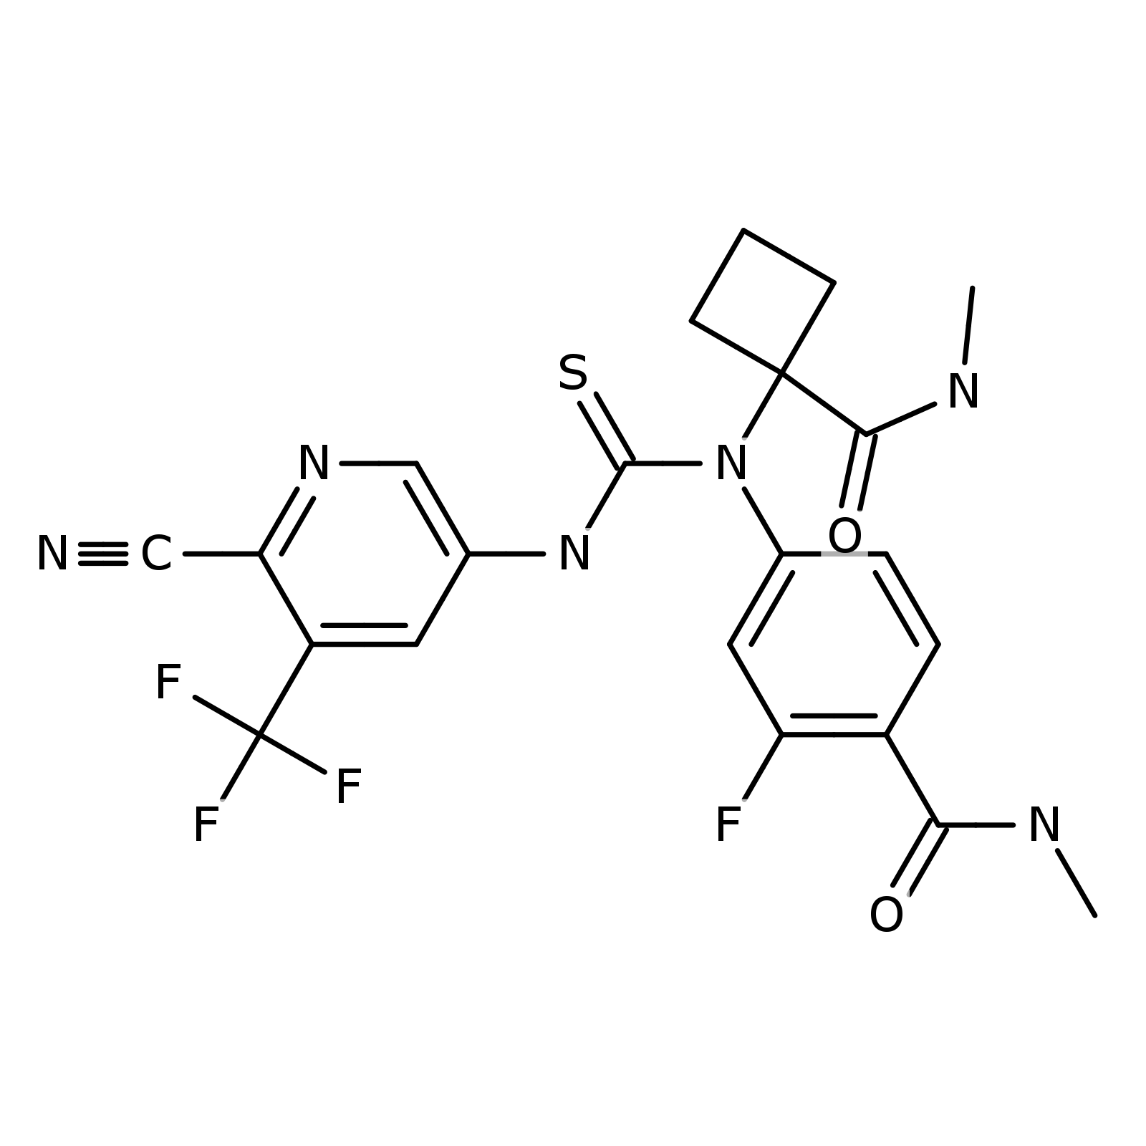 | D9 | D2 | 630 | N-Acylation of amine, hydroxylamine or hydrazine | Condensations and additions
9 | 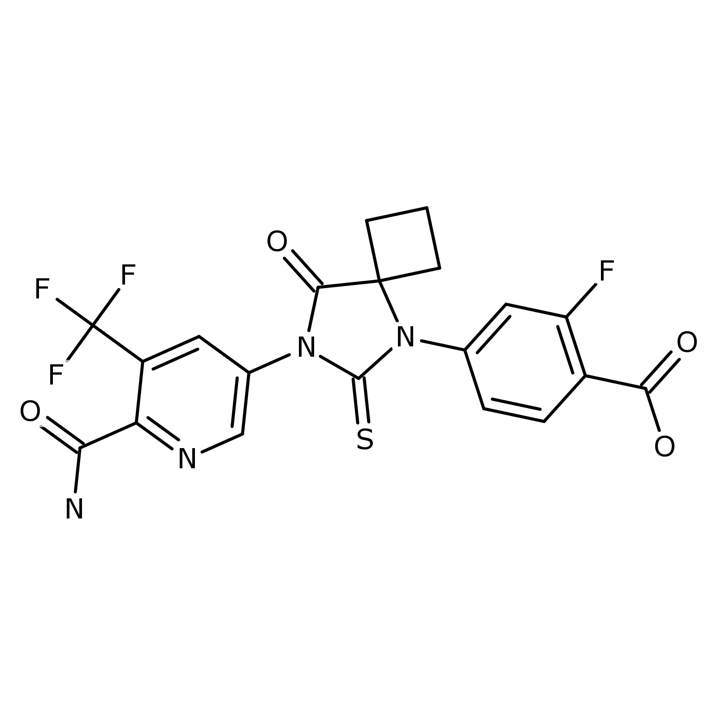 | D10 | D3 | 630 | Hydration of nitrile | Condensations and additions | Water; pH
10 |  | D11 | D4 | 630 | Hydration of nitrile | Condensations and additions | Water; pH
11 |  | D12 | D4 | 630 | Cleavage of acyclic hemiaminal, hemiacetal or hemimercaptal | Eliminations and fragmentations
12 | 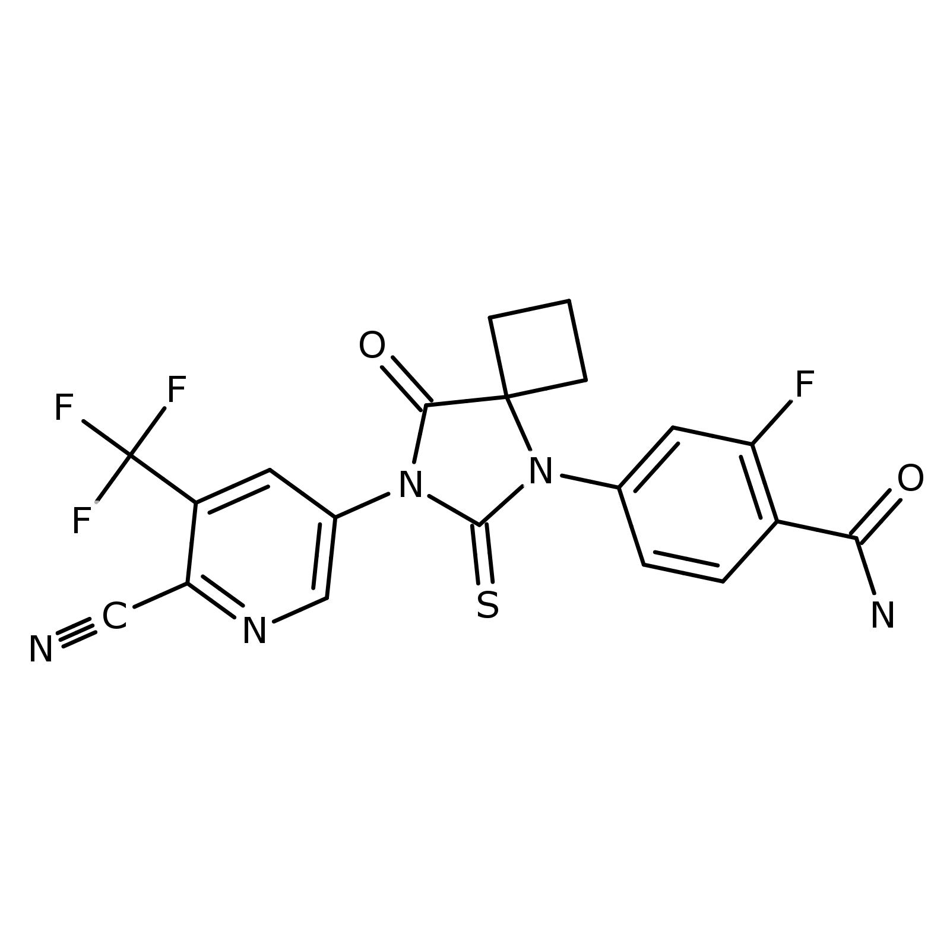 | D13 | D4 | 630 | Cleavage of acyclic hemiaminal, hemiacetal or hemimercaptal | Eliminations and fragmentations
Basic hydrolysis

1 |  | D1 | Q | 700 | Hydration of nitrile | Condensations and additions | Water; pH
2 |  | D2 | Q | 700 | Oxidation of N-alkyl amide to hemiamidal | Oxidations | Oxygen; Radical or Light
3 |  | D3 | D2 | 630 | Cleavage of acyclic hemiaminal, hemiacetal or hemimercaptal | Eliminations and fragmentations
4 |  | D4 | D2 | 630 | Cleavage of acyclic hemiaminal, hemiacetal or hemimercaptal | Eliminations and fragmentations
Neutral hydrolysis
1 |  | D1 | Q | 700 | Oxidation of N-alkyl amide to hemiamidal | Oxidations | Oxygen; Radical or Light
2 |  | D2 | D1 | 630 | Cleavage of acyclic hemiaminal, hemiacetal or hemimercaptal | Eliminations and fragmentations
3 |  | D3 | D1 | 630 | Cleavage of acyclic hemiaminal, hemiacetal or hemimercaptal | Eliminations and fragmentations
Oxidation

1 | 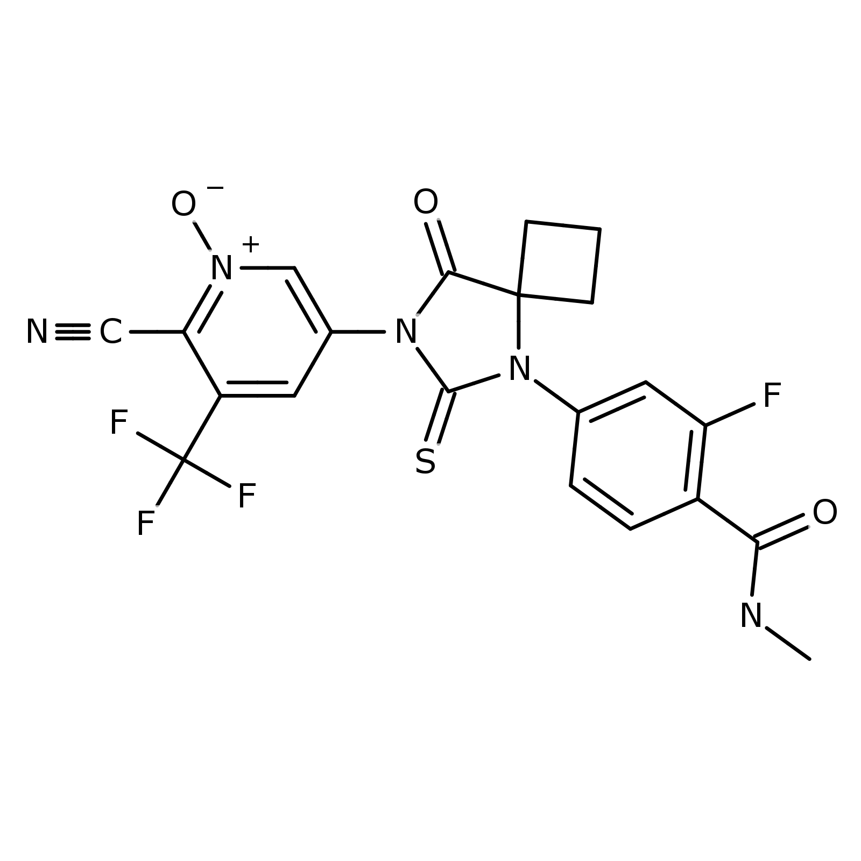 | D1 | Q | 700 | N-Oxidation of pyridine-type nitrogen | Oxidations | Oxygen or Peroxide; pH

