Supporting Information

Preparation and characterization of sulfamic acid-functionalized Fe3O4 nanoparticles as an efficient magnetic nanocatalyst for the facile and eco-friendly synthesis of quinoxalines, benzothiazoles and benzoxazoles
Mahmood Tajbakhsh^{*a}, Fatemeh Mazhariª and Negar Niroueiª
ª Department of Organic Chemistry, Faculty of Chemistry, University of Mazandaran, Babolsar
47416-95447, Iran
Email address: Tajbaksh@umz.ac.ir

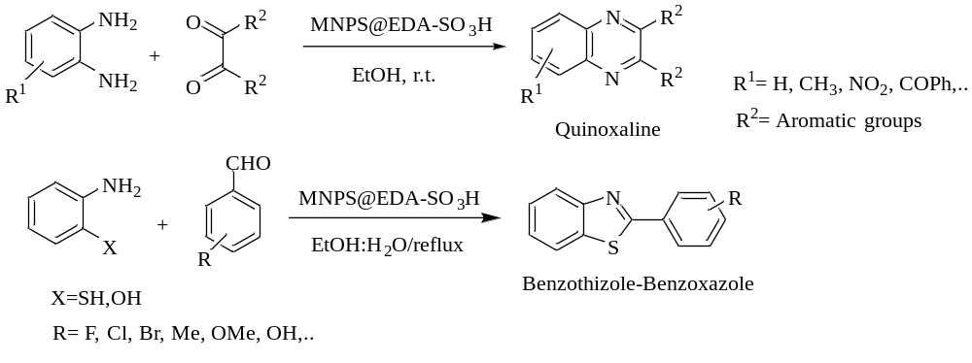
Scheme 1. Synthesis of quinoxalines, benzothiazoles and benzoxazoles using Fe₃O₄@EDA-SO₃H as an efficient and recoverable magnetic nanocatalyst.
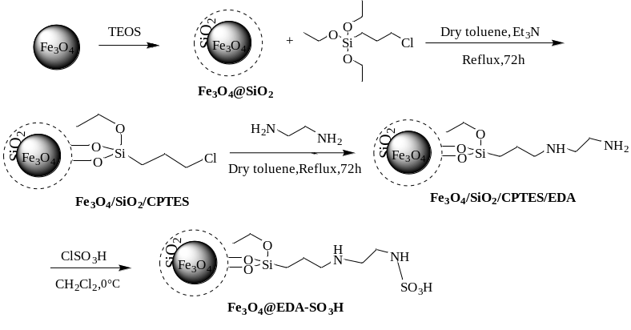
Scheme 2. Synthetic procedure for the preparation of the nanomagnetic catalyst (Fe₃O₄@EDA-SO₃H)

Fig. 1. FT-IR spectra of a) Fe₃O₄ nanoparticles; b) Fe₃O₄@SiO₂; c) Fe₃O₄/SiO₂/CPTES; d) Fe₃O₄/SiO₂/CPTES/EDA; e) Fe₃O₄@EDA-SO₃H.

Fig.2. TGA curve of Fe₃O₄ nanoparticles

Fig. 3. TGA curve of Fe₃O₄@EDA-SO₃H

Fig. 4. The SEM images of a) Fe₃O₄ b) Fe₃O₄@SiO₂ c) Fe₃O₄@ EDA-SO₃H

Fig. 5. XRD powder pattern of samples: a) Fe₃O₄ b) Fe₃O₄@SiO₂ c) Fe₃O₄@ EDA-SO₃H
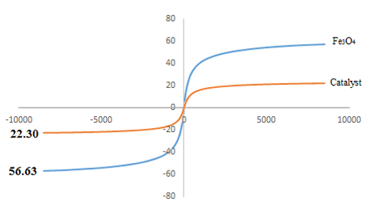
Fig. 6. Magnetization curves for Fe₃O₄ and Fe₃O₄@ EDA-SO₃H obtained by VSM analysis at room temperature

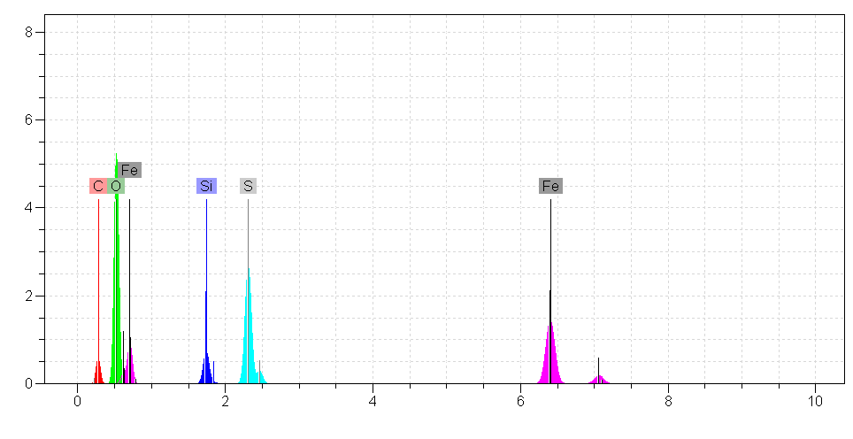
Fig. 7. EDX analysis of the catalyst (Fe₃O₄@EDA-SO₃H)
Table 1 CHNS analysis for Fe₃O₄@EDA-SO₃H
S% | N% | H% | C% | Sample
3.26 | 3.37 | 2.14 | 6.95 | Fe₃O₄@EDA-SO₃H

Spectral Data for Selected Products:
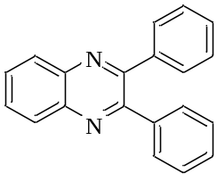
3,2-Diphenylquinoxaline(Table 3, entry 1): Yield: 97 %; m.p.: 126-128°C (Lit. [52] 125-126 °C); ¹H-NMR(CDCl₃, 400 MHz) δ= 8.21(dd, ³J=6.4 Hz, ⁴J=3.6 Hz, 2H), 7.8(dd, ³J=6.4 Hz, ⁴J=3.6 Hz, 2H), 7.53-7.56(m, 4H, Ar), 7.28-7.39(m, 6H, Ar). ¹³C-NMR (CDCl₃, 100 MHz): δ= 153.49, 141.24, 139.08, 129.98, 129.85, 129.22, 128.82, 128.29.

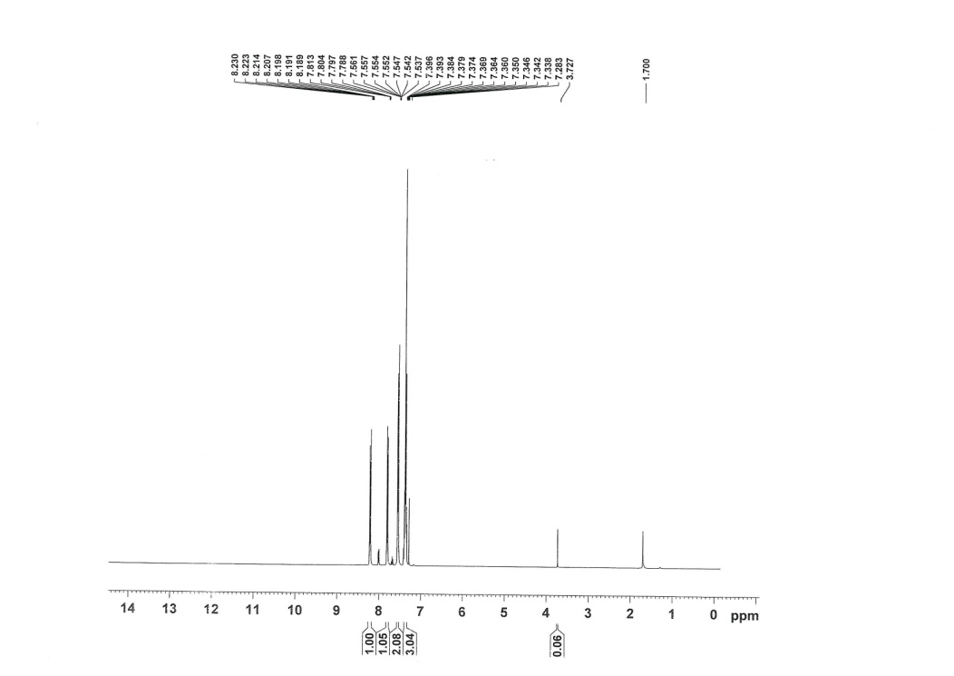
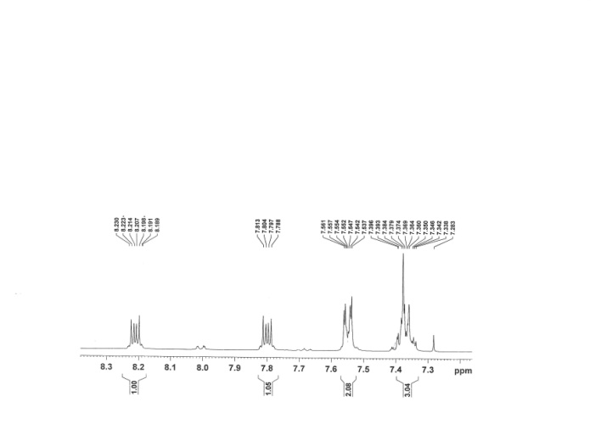

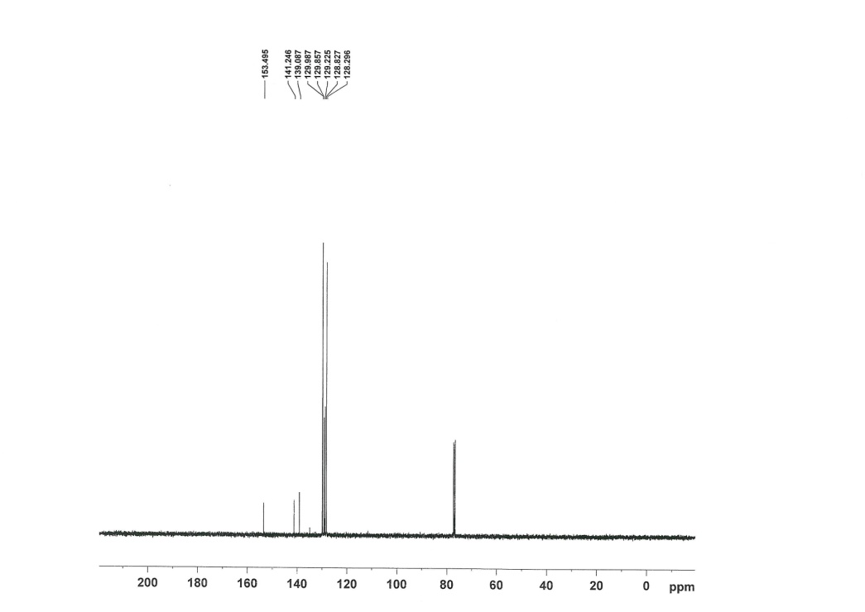
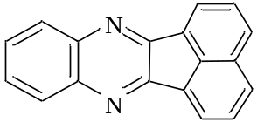
Acenaphtho[1,2-b] quinoxaline (Table 3, entry 2): Yield: 96 %; m.p.: 237-240°C (Lit. ^{[51]} 237-240 °C); ¹H-NMR (CDCl₃, 400 MHz): δ (ppm) = 8.42 (d, J=6.8 Hz, 2H), 8.22 (dd, J= 5.2, 3.6 Hz, 2H), 8.10 (d, J=8.4 Hz, 2H), 7.84 (t, J= 7.6 Hz, 2H), 7.77 (dd, J= 6.2, 3.6 Hz, 2H). ¹³C-NMR (CDCl₃, 100 MHz): δ= 154.09, 141.27, 136.50, 131.81, 130.01, 129.60, 129.49, 129.24, 128.68, 121.87.

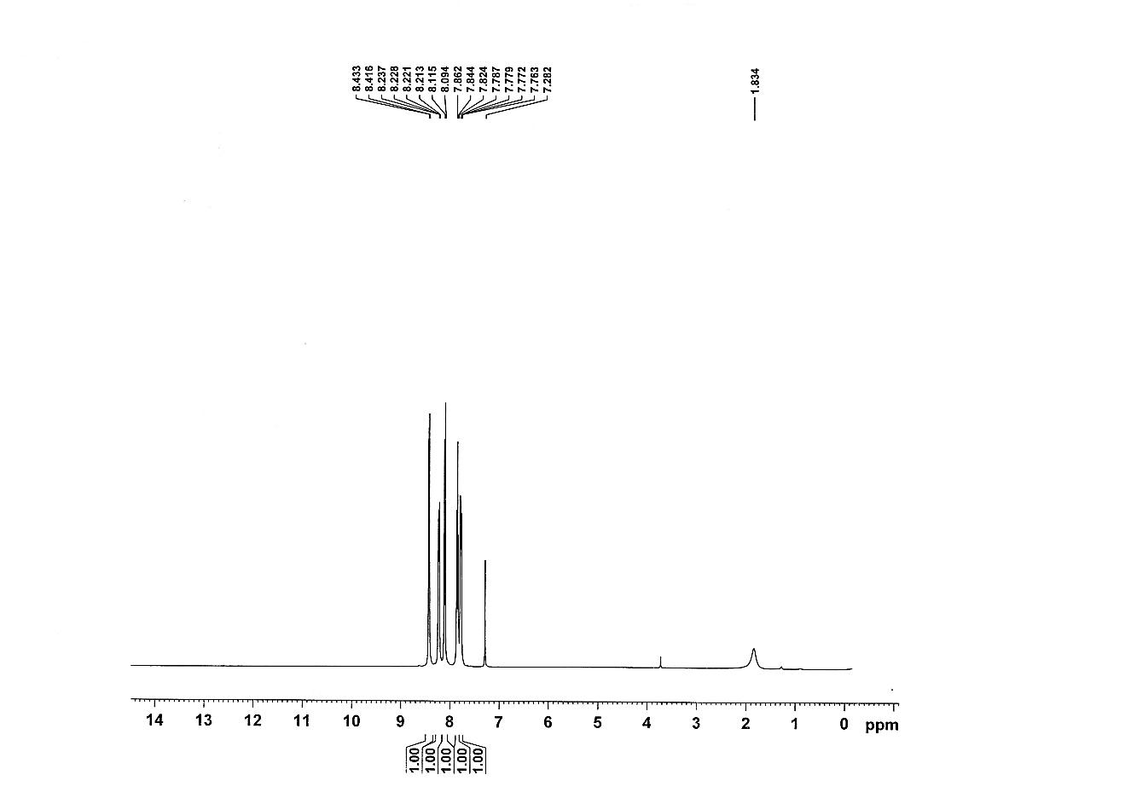
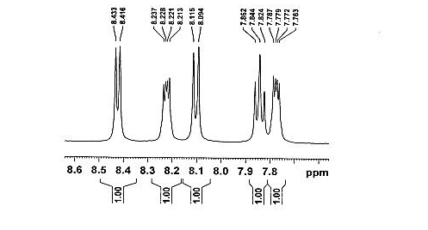

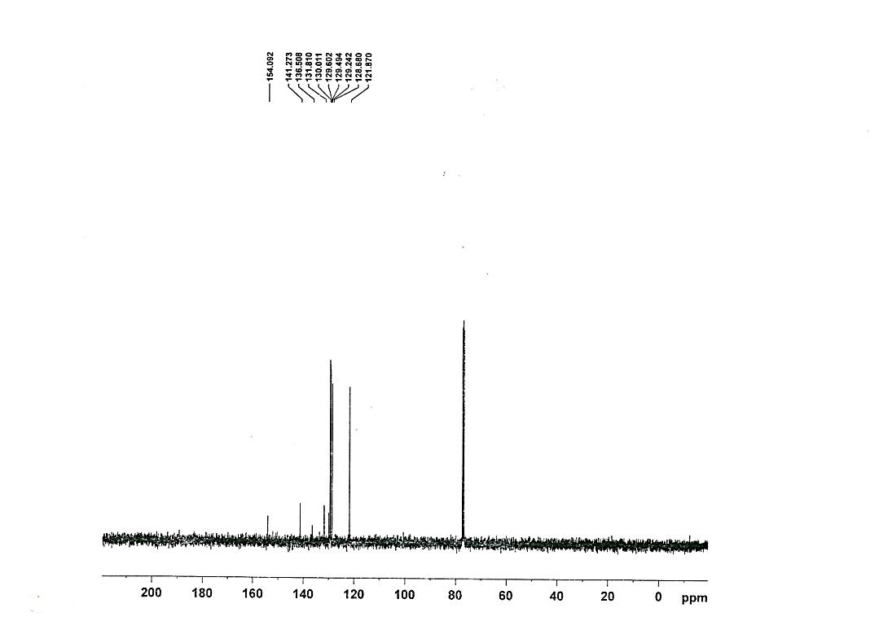
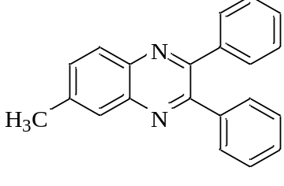
6-methyl-2,3-diphenyl-quinoxaline (Table 3, entry 3): Yield: 95 %; m.p.: 114-117°C (Lit. ^{[52]} 116-117 °C); ¹H-NMR (CDCl₃, 400 MHz): δ (ppm) = 8.10 (d, J= 8.0 Hz, 1H), 7.98 (s, 1H), 7.63 (dd, J= 8.4, 1.6 Hz, 1H), 7.51-7.54 (m, 4H), 7.28-7.38 (m, 6H), 2.60 (s, 3H). ¹³C-NMR (CDCl₃, 100 MHz): δ= 153.34, 152.59, 141.30, 140.51, 139.72, 139.23, 132.32, 129.85, 129.83, 128.71, 128.70, 128.64, 128.24, 128.03, 21.94.

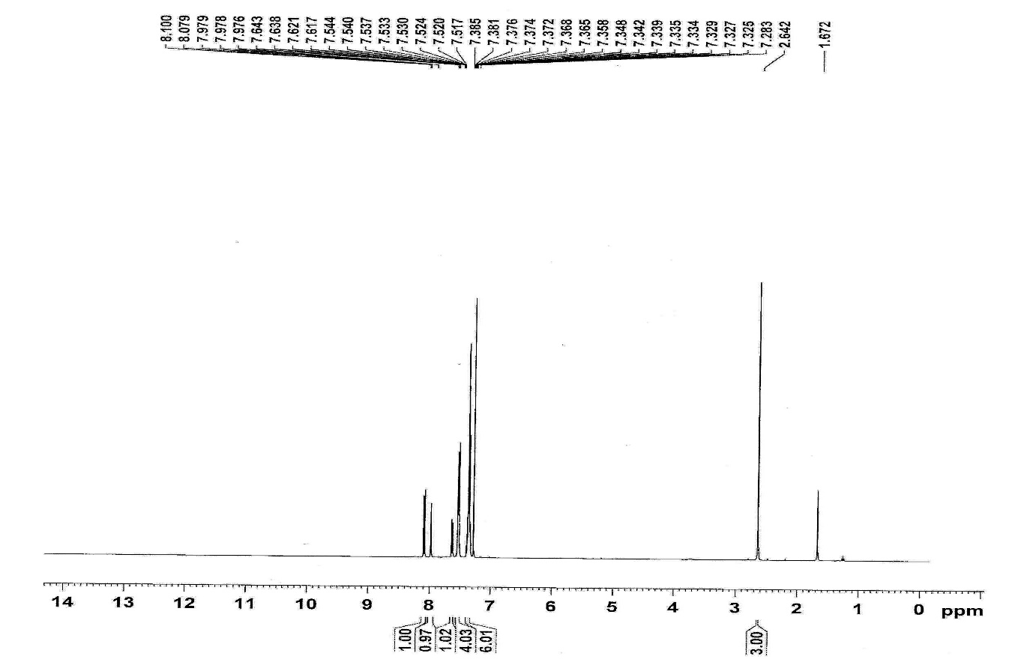
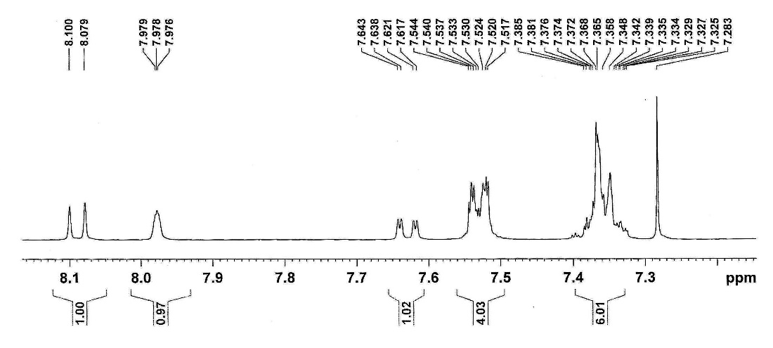

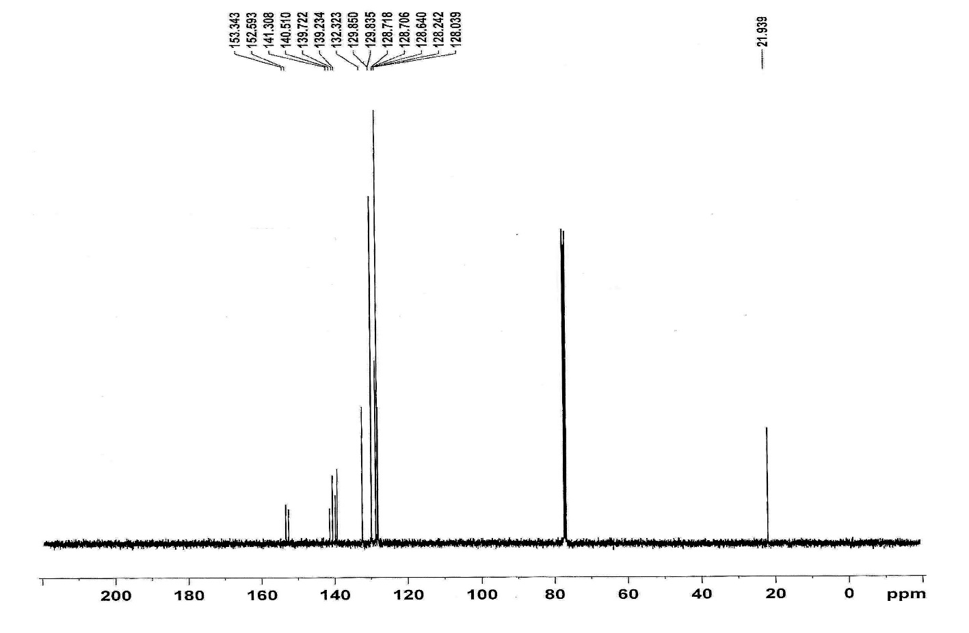

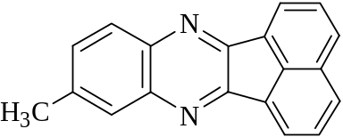
6- Methyl-snephto[2,1-b]quinoxaline-11-one(Table 3, entry 4): Yield: 96 %; m.p.: 226-228°C (Lit. [51] 228-229 °C); ¹H- NMR(CDCl₃, 400 MHZ): δ= 8.33(t, J=6.2 HZ, 2H), 8-8.04(m, 3H, Ar), 7.91(s, 1H), 7.77(t, J=7.2 Hz, 2H ), 7.52(d, J=8.4 Hz, 1H), 2.6(s, 3H). ¹³C-NMR (CDCl₃, 100 MHz): δ=153.96, 153.25, 141.16, 139.72, 139.05, 136.18, 131.85, 131.31, 129.93, 129.39, 129.24, 128.98, 128.63, 128.60, 121.73, 121.57, 30.81.

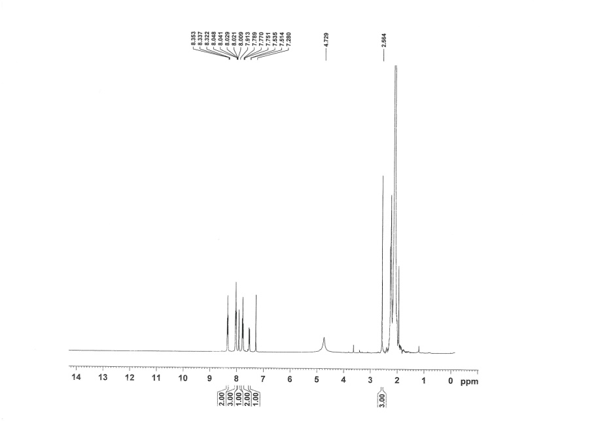
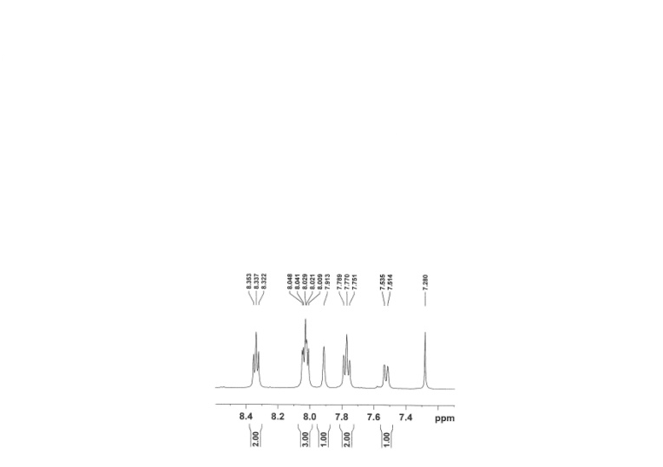

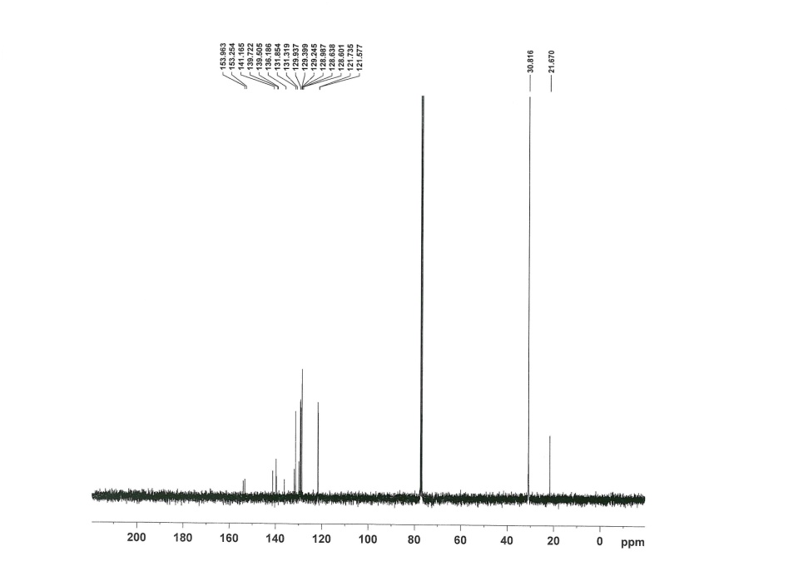
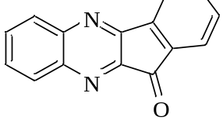
Indeno[2,1-b]quinoxaline-11-one(Table 3, entry 5): Yield: 96 %; m.p.: 217-220°C (Lit. [56] 217-218 °C); ¹H-NMR(CDCl₃, 400 MHz): δ= 8.24-8.27(m, 1H, Ar), 8.12-8.15(m, 2H, Ar), 7.93-7.96(m, 1H, Ar), 7.82-7.86(m, 1H, Ar), 7.75-7.81(m, 2H, Ar), 7.60-7.64(m, 1H, Ar). ¹³C-NMR (CDCl₃, 100 MHz): δ=189.96, 156.63, 149.28, 143.13, 142.64, 141.55, 136.84, 136.67, 132.53, 132.47, 131.61, 130,30, 129.67, 124.80, 122.53.

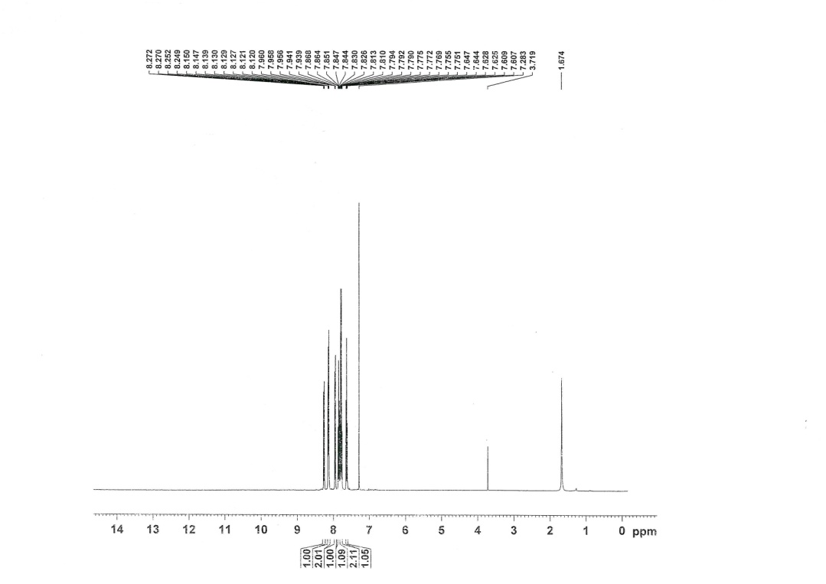

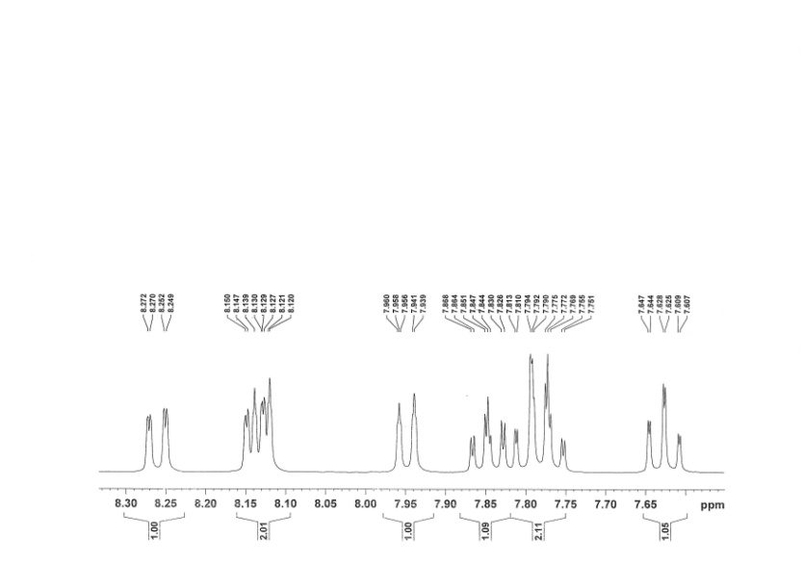

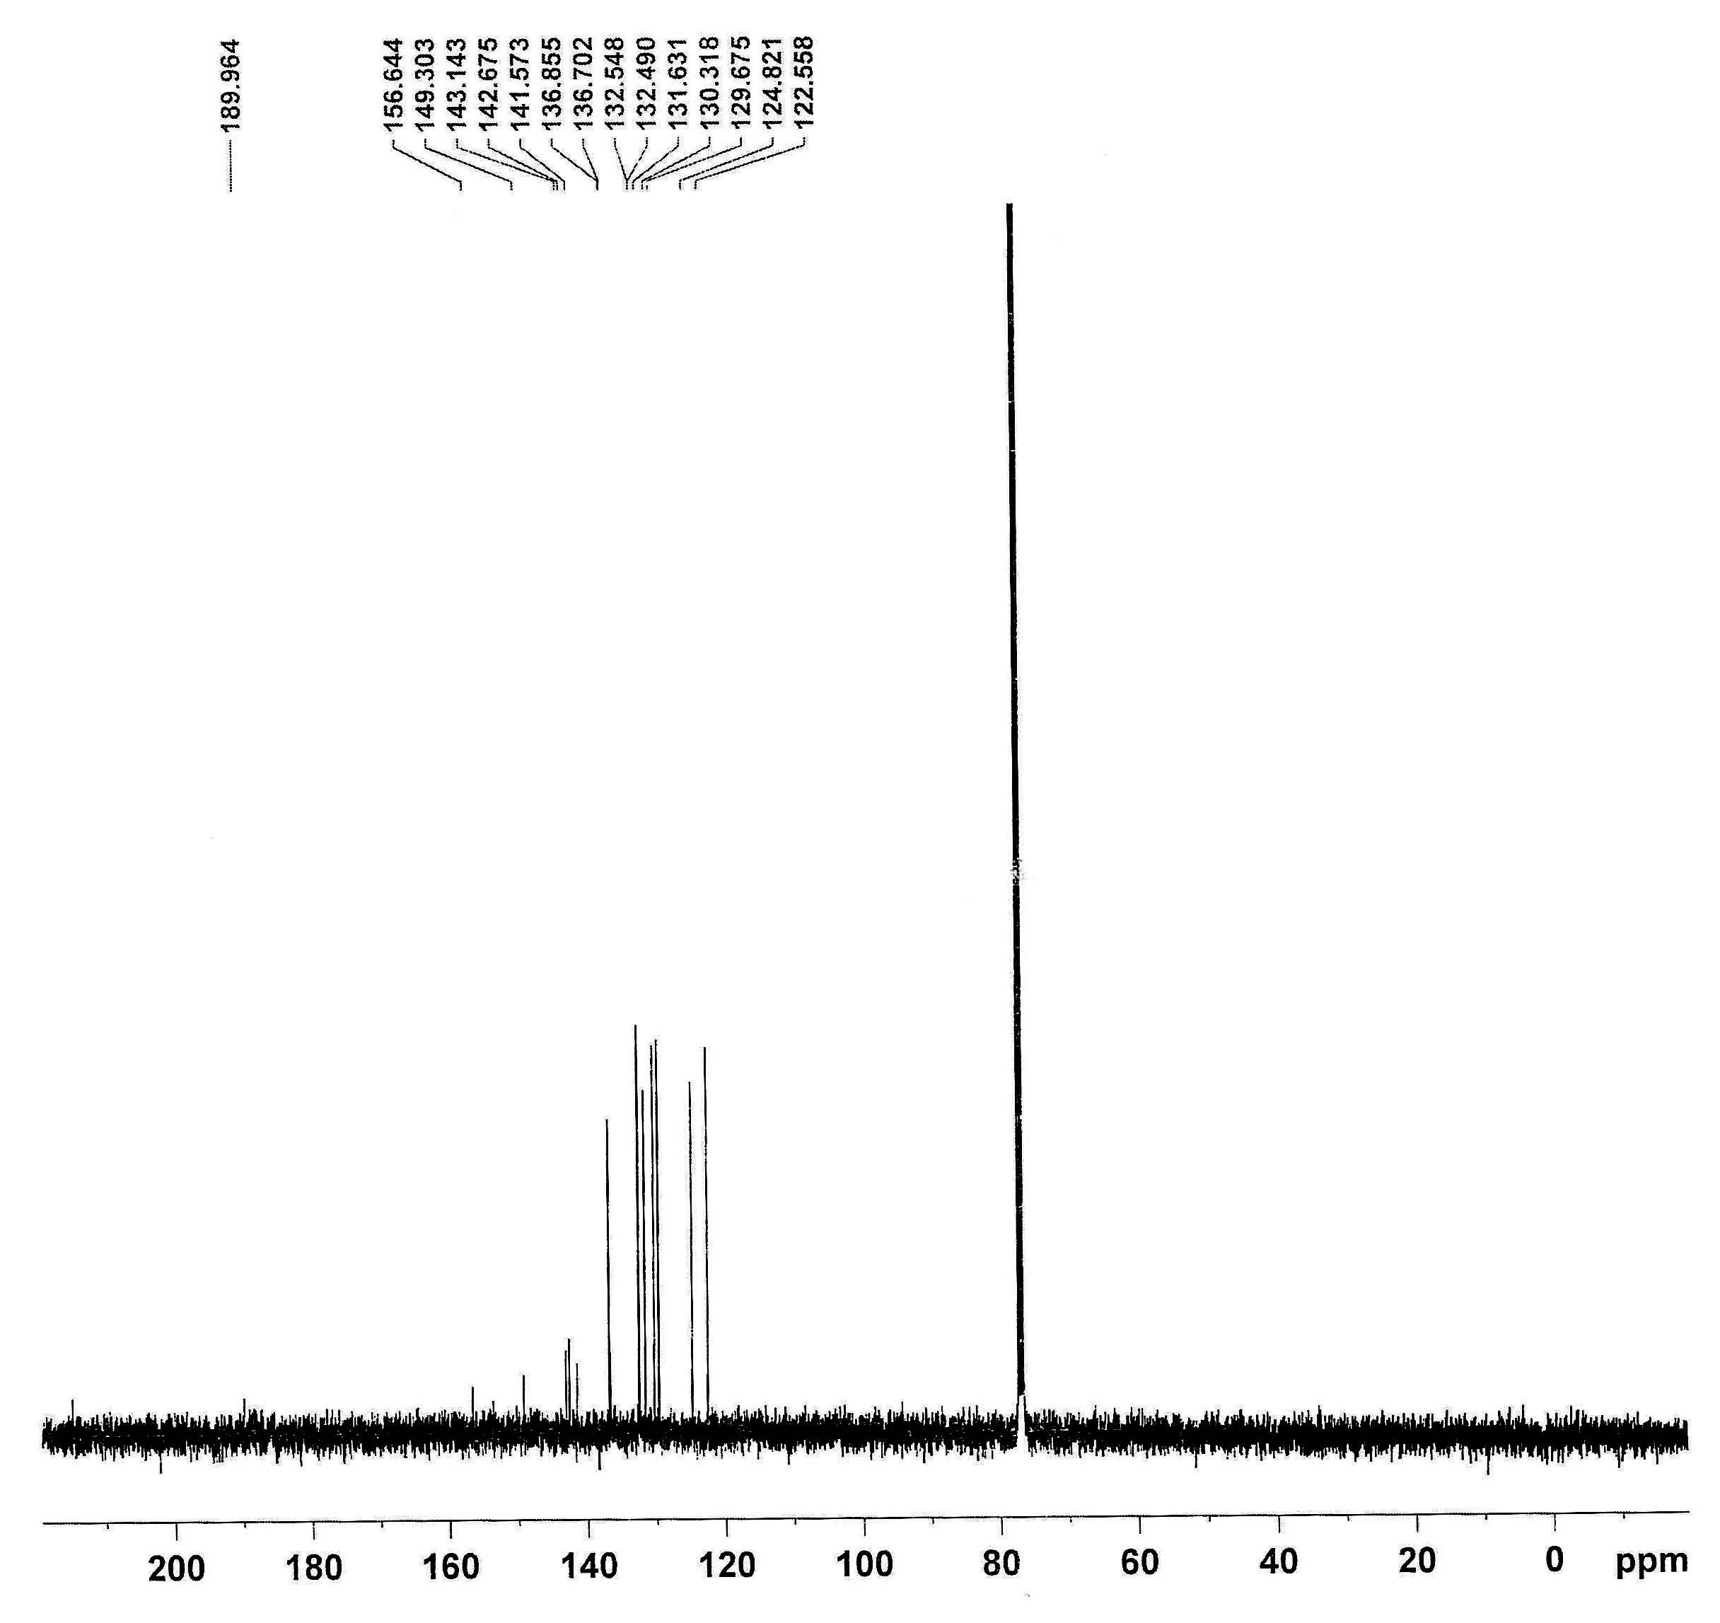

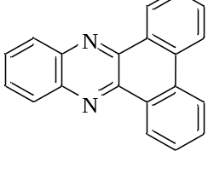
Phenantro[9,10-b]quinoxaline-11-one(Table 3, entry 6): Yield: 98 %; m.p.: 220-223°C (Lit. [51] 223-225 °C); ¹H-NMR(CDCl₃, 400 MHZ): δ=9.41(d, J=7.6 HZ, 2H), 8.57(d, J=8 Hz, 2H), 8.33-8.34(m, 2H, Ar), 7.82-7.87(m, 2H, Ar), 7.74-7.81(m, 2H, Ar). ¹³C-NMR (CDCl₃, 100 MHz): δ= 142.44, 142.18, 132.05, 130.30, 129.75, 129.45, 127.93, 126.26, 122.91.

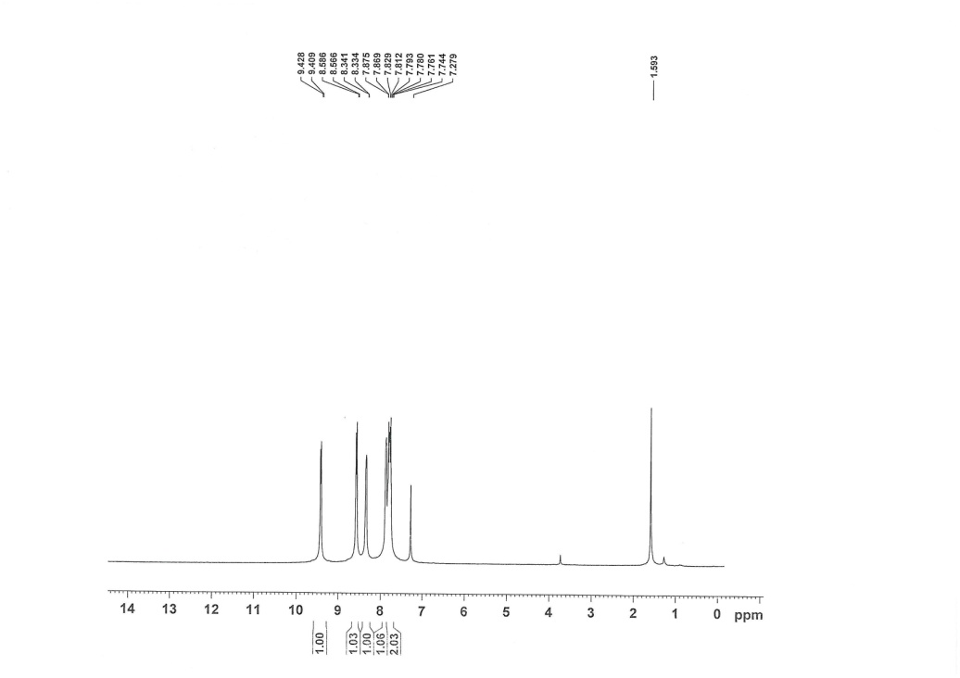

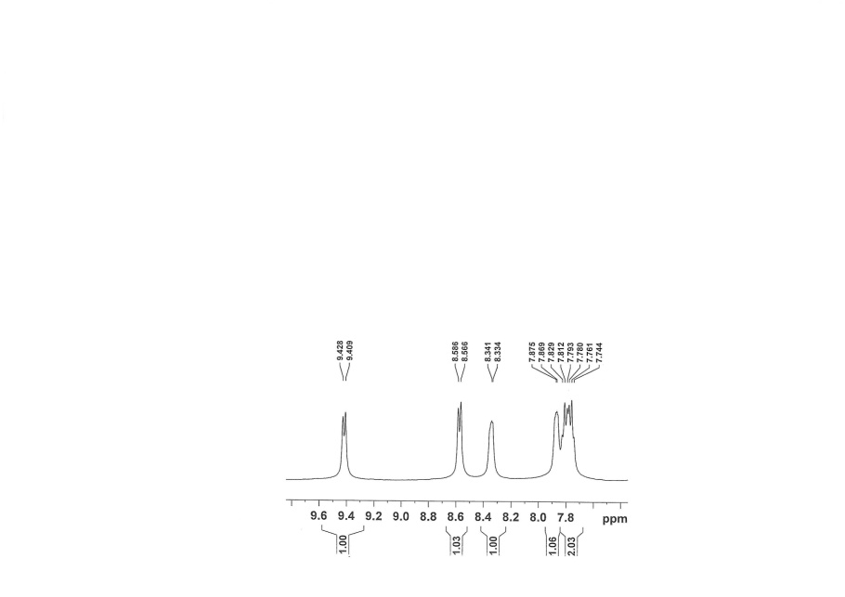

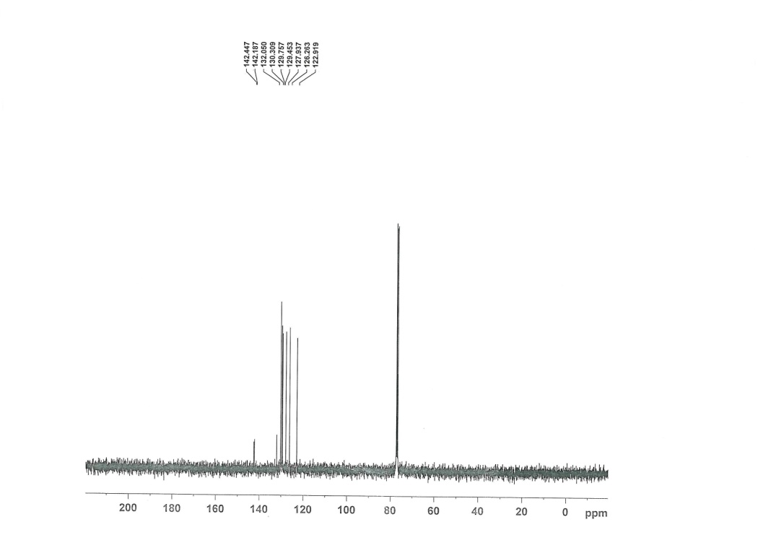

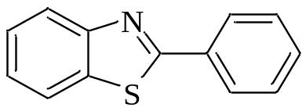
2-phenyl-benzothiazole (Table 6, entry 1): Yield: 97 %; m.p.: 112–114 °C (Lit. ^{[53]} 112-113 °C); ¹H-NMR (DMSO-d₆, 400 MHz): δ (ppm) = 8.24-8.25 (m, 1H, Ar), 8.16-8.18 (m, 1H, Ar), 8.05-8.10 (m, 2H, Ar), 7.77-7.79 (m, 1H, Ar), 7.47-7.59 (m, 4H, Ar). ¹³C-NMR (DMSO-d₆, 100 MHz): δ= 165.94, 153.79, 135.38, 135.09, 134.46, 132.07, 129.64, 127.33, 126.89, 126.37, 123.58, 123.02, 122.95.
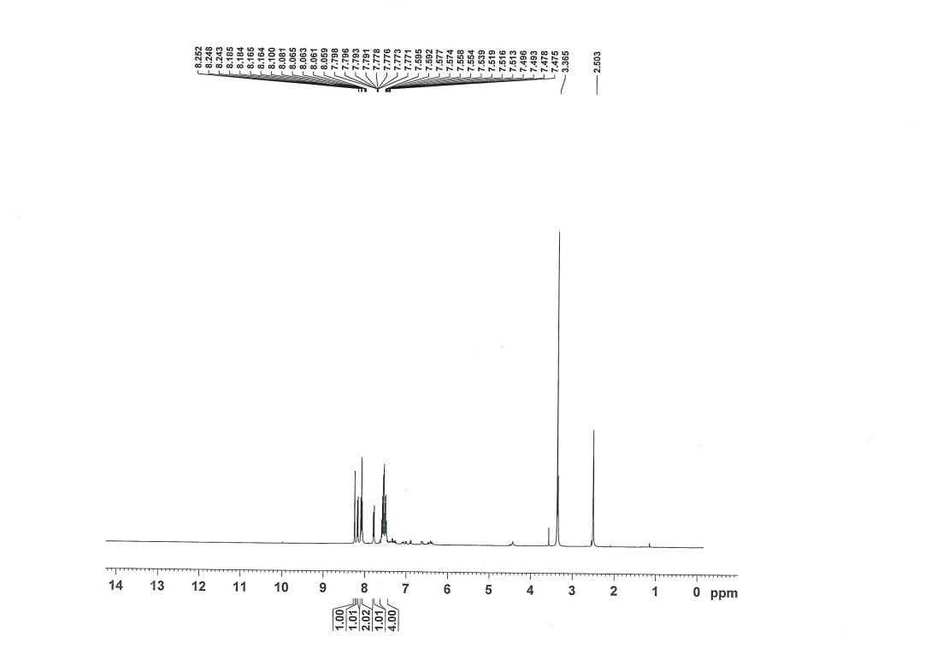
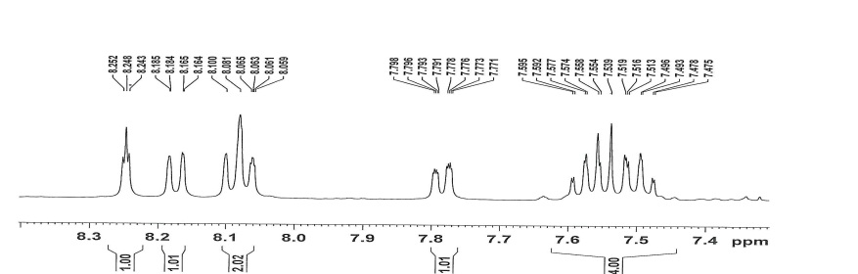
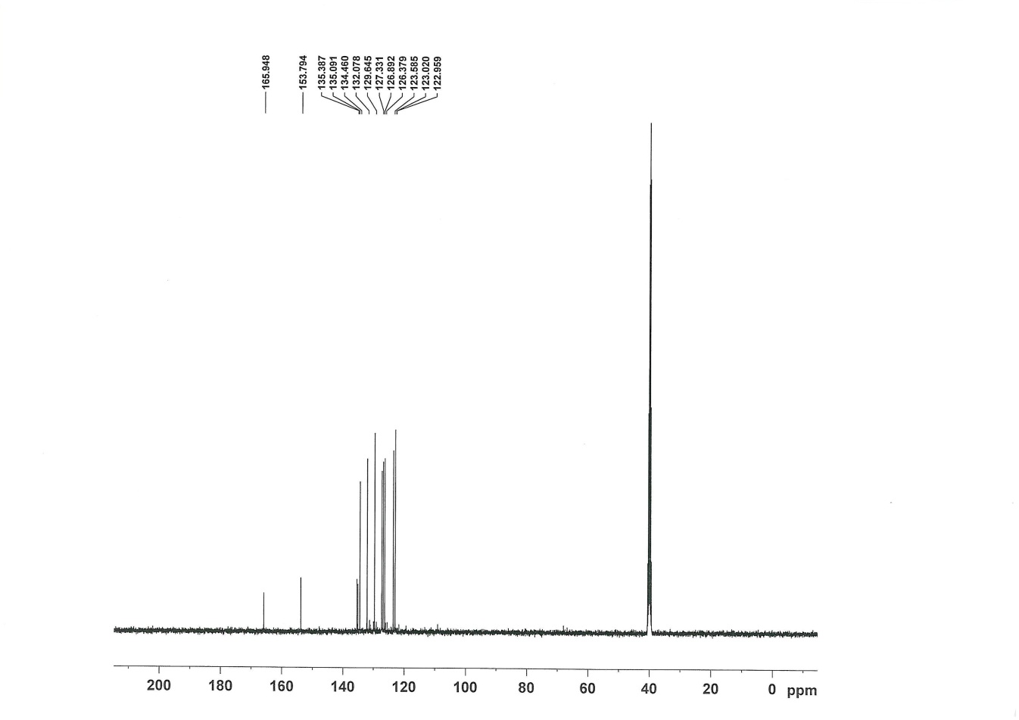
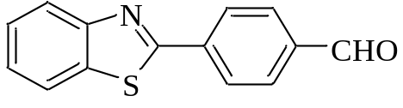
4-(benzo[d]thiazol-2-yl)benzaldehyde (Table 6, entry 3): Yield: 90 %; m.p.: 133 °C (Lit. ^{[54]} 132-133 °C); ¹H-NMR (CDCl₃, 400 MHz): δ (ppm) = 10.09 (s,1H,CH), 8.26 (d, J= 8.0 Hz, 1H, Ar), 8.17-8.21 (m,1H, Ar), 8.12 (dd, J= 7.6, 3.2 Hz, 1H, Ar), 7.99-8.05 (m, 2H, Ar), 7.94 (dd, J= 8.0, 4.4 Hz, 1H, Ar), 7.51-7.56 (m, 1H, Ar), 7.42-7.46 (m, 1H, Ar). ¹³C-NMR (CDCl₃, 100MHz): δ=191.51, 130.29, 128.07, 128.04, 126.74, 126.57, 125.92, 125.58, 123.72, 123.44, 121.78, 121.71.

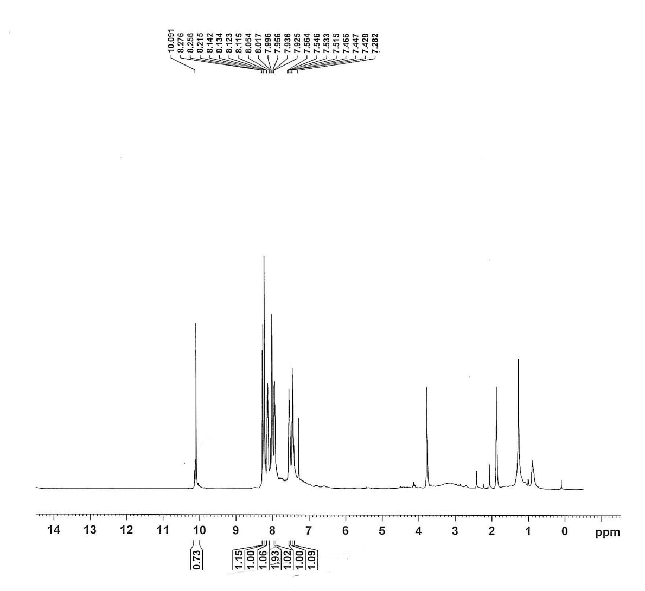
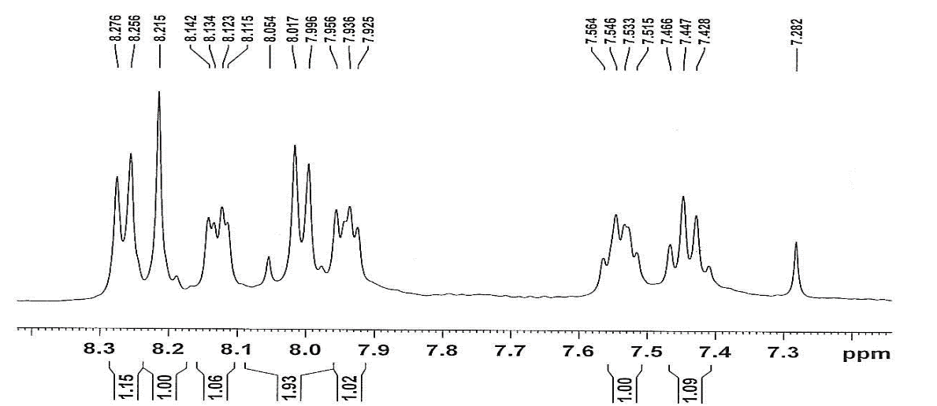

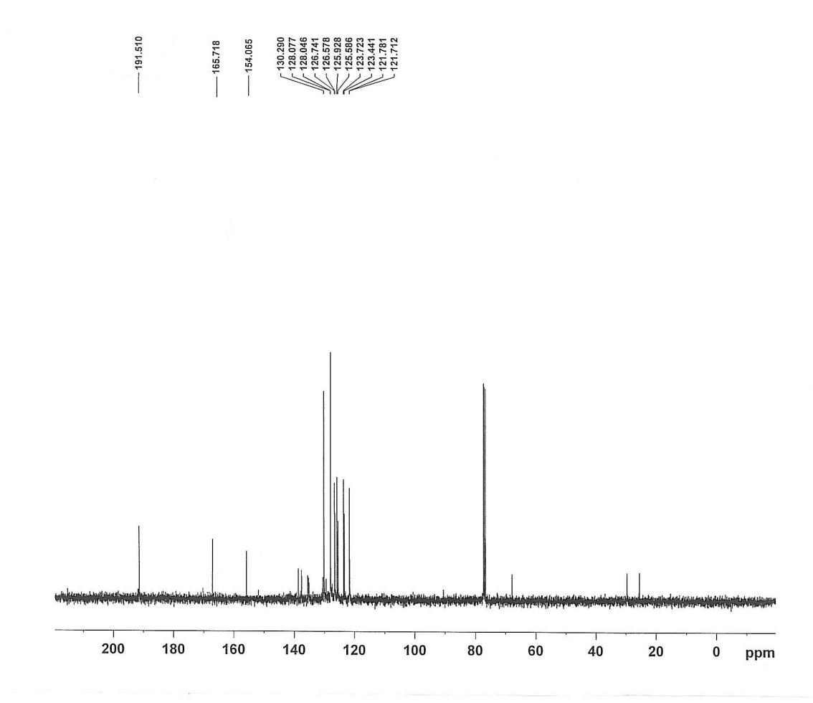
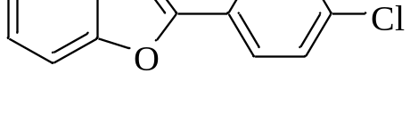
2-(4-chlorophenyl)benzoxazole (Table 6, entry 16): Yield: 95 %; m.p.: 133 °C (Lit. ^{[55]} 144-148 °C); ¹H-NMR (DMSO-d₆, 400 MHz): δ (ppm) = 7.87 (d, J= 8.0 Hz, 2H), 7.48 (d, J= 8.4 Hz, 2H), 7.32(d, J= 8.0 Hz, 1H), 7.28-7.21 (m, 1H), 7.04 (d, J= 8.0 Hz, 1H), 6.95-6.91 (m, 1H). ¹³C-NMR (DMSO-d₆, 100MHz): δ=165.5, 152.4, 137.7, 135.1, 134.3, 129.9, 129.3, 129.2, 120.17, 115.8, 115.2.

