Table 3 Synthesis of various quinoxaline derivatives from the reaction of 1,2-diamines and 1,2-diketones using Fe₃O₄@EDA-SO₃H as the catalyst ª
Entry | 1,2-diamine | 1,2-diketone | Product | Time (min) | Yield (%)^{b} | Ref.
1 | 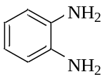 | 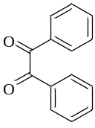 | 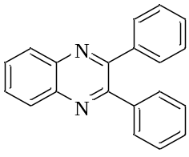 | immediately | 97 | [52]
2 |  | 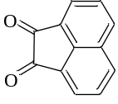 | 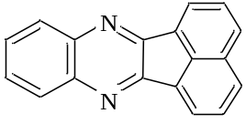 | 8 | 96 | [51]
3 | 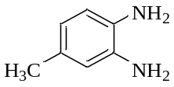 | 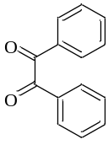 | 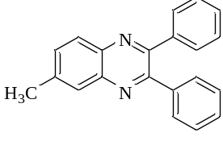 | 10 | 95 | [52]
4 |  |  | 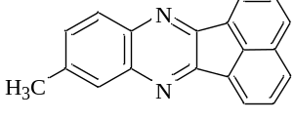 | 15 | 96 | [51]
5 |  | 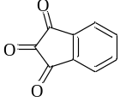 | 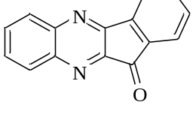 | 10 | 96 | [56]
6 |  | 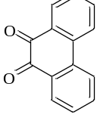 | 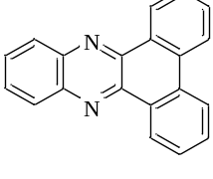 | immediately | 98 | [51]
7 |  |  | 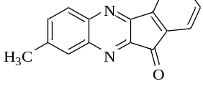 | 10 | 97 | [56]
8 |  | 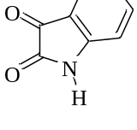 | 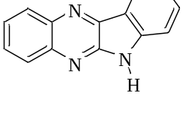 | 22 | 65 | [57]
9 | 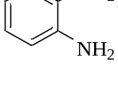 |  | 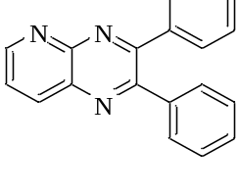 | 10 | 97 | [51]
10 | 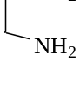 |  | 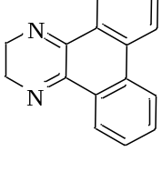 | 15 | 94 | [58]
11 | 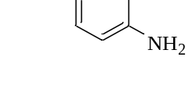 |  | 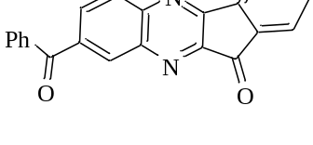 | immediately | 95 | [56]
12 | 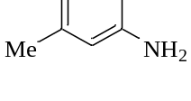 | 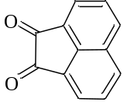 | 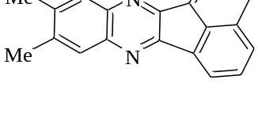 | immediately | 97 | [59]
13 |  |  | 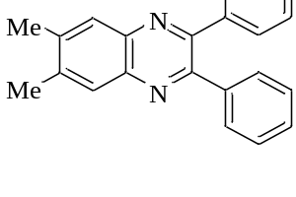 | immediately | 97 | [60]
14 |  |  | 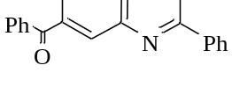 | 14 | 95 | [51]
15 | 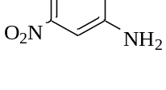 |  | 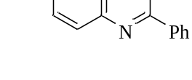 | 17 | 95 | [52]
Reaction conditions: 1,2-phenylenediamine (1 mmol), 1,2-diketone (1 mmol), Fe₃O₄@EDA-SO₃H (0.032 g), ethanol (3 mL), room temperature.
ª Isolated yield

Table 6 Synthesis of benzothiazole and benzoxazole derivatives from condensation reaction of 2-amino(thio)phenols with benzaldehydes using Fe₃O₄@EDA-SO₃H as the catalyst ª
Entry | 2-amino(thio)phenol | Aldehyde | Product | Time (min) | Yield (%) | Ref.
1 | 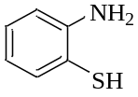 | 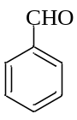 | 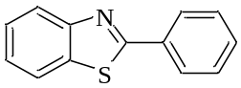 | 10 | 97 | [53]
2 |  | 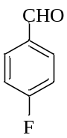 | 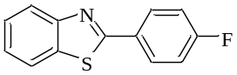 | 13 | 95 | [54]
3 |  | 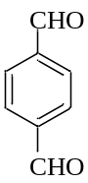 | 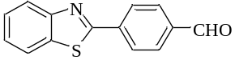 | 15 | 90 | [54]
4 |  | 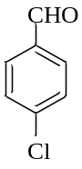 | 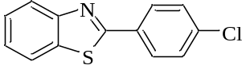 | 16 | 92 | [61]
5 |  | 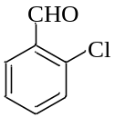 | 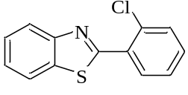 | 18 | 85 | [53]
6 |  | 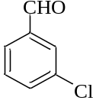 | 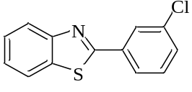 | 20 | 90 | [62]
7 |  | 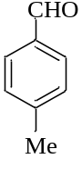 | 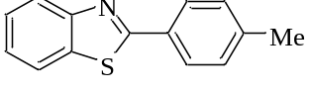 | 35 | 80 | [53]
8 |  | 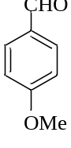 | 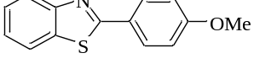 | 45 | 85 | [53]
9 |  | 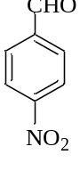 | 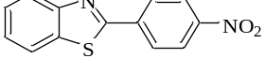 | 14 | 95 | [61]
10 |  | 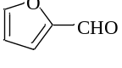 | 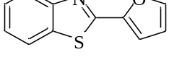 | 11 | 97 | [63]
11 |  | 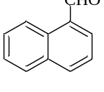 | 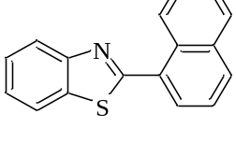 | 25 | 60 | [63]
12 |  | 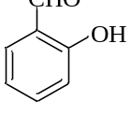 | 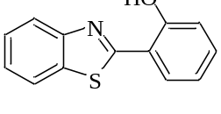 | 20 | 87 | [53]
13 |  | 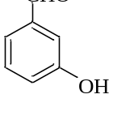 | 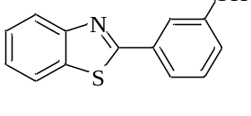 | 14 | 90 | [64]
14 |  | 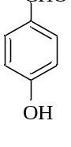 | 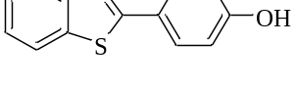 | 27 | 85 | [53]
15 |  | 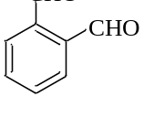 | 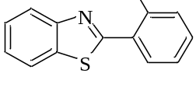 | 12 | 90 | [54]
16 | 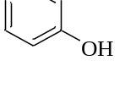 |  | 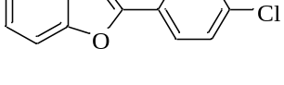 | 15 | 95 | [55]
17 |  |  | 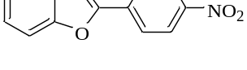 | 12 | 95 | [55]
18 |  | 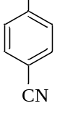 | 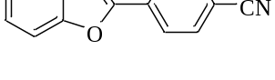 | 10 | 97 | [65]
19 |  | 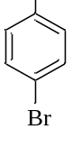 | 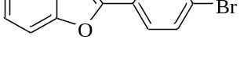 | 35 | 80 | [55]
20 |  | 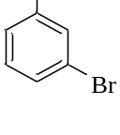 | 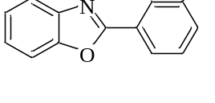 | 22 | 78 | [55]
21 |  | 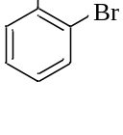 | 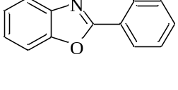 | 20 | 82 | [66]
22 |  | 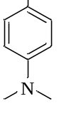 | 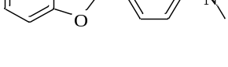 | 45 | 50 | [61]
Reaction conditions: 2-amino(thio)phenol (1 mmol), benzaldehyde (1 mmol), ethanol/water (3 mL), catalyst (0.032 g), 80º C (refluxing ethanol).
ªIsolated yields.

