Supplementary Material

Table of Contents
Supplementary Figures 2
sFigure 1: Fold change in perfusate (n=95) and airspace (n=68) biomarker concentrations after 4 hours of ex vivo lung perfusion in all experimental conditions combined. Biomarker fold change is presented on a Log₁₀ scale. 2
sFigure 2: Perfusate biomarkers at 0 and 4 hours stratified by experimental conditions. 3
A. IL-6 3
B. IL-8 3
C. sTNFR1 4
D. Ang-2 4
sFigure 3: Airspace biomarkers at 0 and 4 hours stratified by experimental conditions. 5
A. IL-6 5
B. IL-8 5
C. sTNFR1 6
D. Ang-2 6
sFigure 4: Experimental timeline. 7
Supplementary Tables 8
sTable 1: Perfusate biomarker kinetics stratified by experimental conditions. 8
sTable 2: Airspace biomarker kinetics stratified by experimental conditions. 9
sTable 3: Impact of exogenous fresh whole blood on perfusate and airspace biomarker change during 4 hours of ex vivo perfusion in control lungs and in lungs exposed to IV S. pneumoniae. 10
sTable 4: Impact of cold ischemia time and baseline AFC on relationship of perfusate and airspace biomarker change in lungs perfused with compared to without blood in control and IV S. pneumoniae exposed lungs. 11
sTable 5: Impact of bacteria on perfusate and airspace biomarker change during 4 hours of ex vivo perfusion in control lungs relative to lungs exposed to IV S. pneumoniae with blood, IV S. pneumoniae without blood, or airspace S. pneumoniae with blood. 12
sTable 6: Impact of cold ischemia time, baseline AFC, and pre-procurement antibiotics on relationship of perfusate and airspace biomarker change in control compared to IV S. pneumoniae exposed lungs perfused with and without blood. 13
sTable 7: Impact of cold ischemia time, baseline alveolar fluid clearance, and pre-procurement antibiotics on relationship of perfusate and airspace biomarker change in control compared to airspace S. pneumoniae exposed lungs perfused with blood. 14

Supplementary Figures

sFigure 1: Fold change in perfusate (n=95) and airspace (n=68) biomarker concentrations after 4 hours of ex vivo lung perfusion in all experimental conditions combined. Biomarker fold change is presented on a Log₁₀ scale.

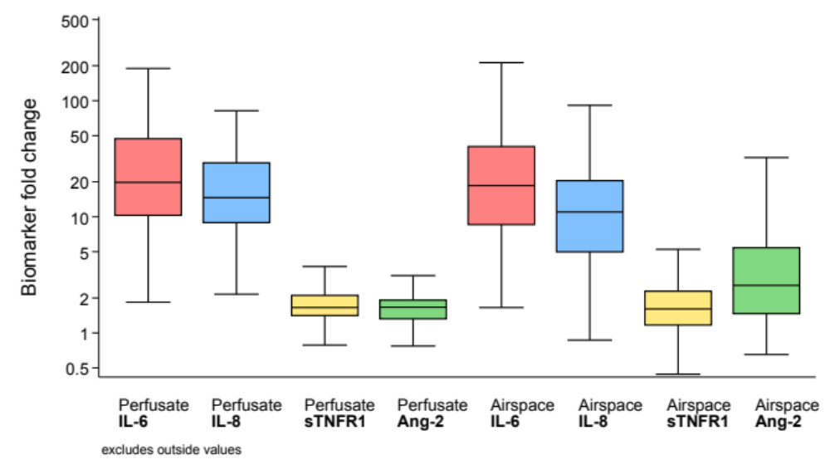

sFigure 2: Perfusate biomarkers at 0 and 4 hours stratified by experimental conditions.

IL-6
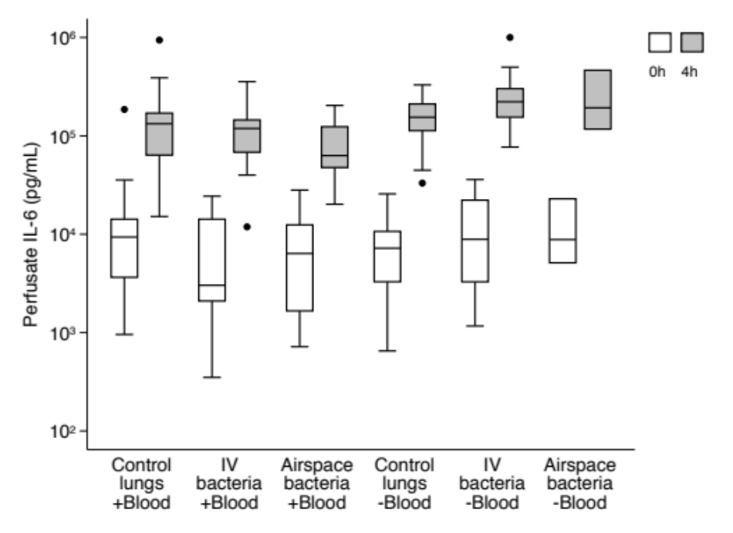

IL-8
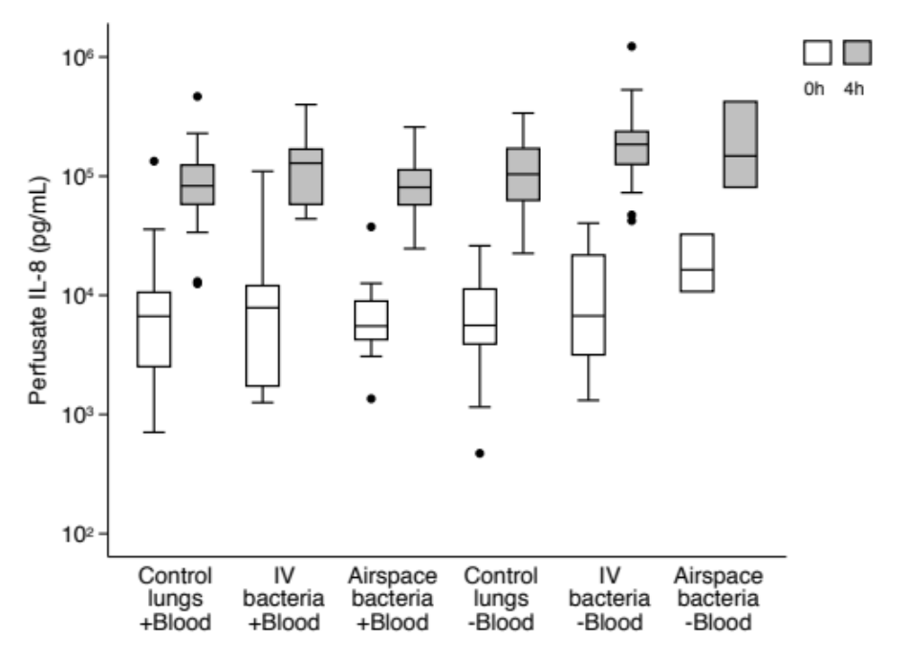

sTNFR1
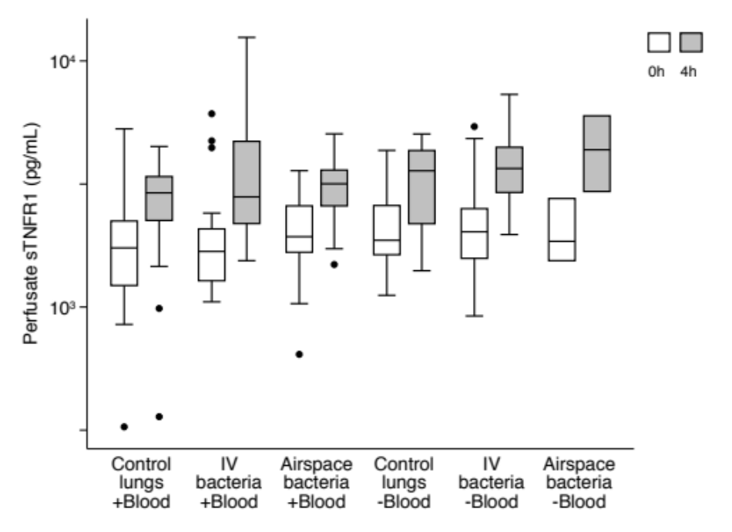

Ang-2
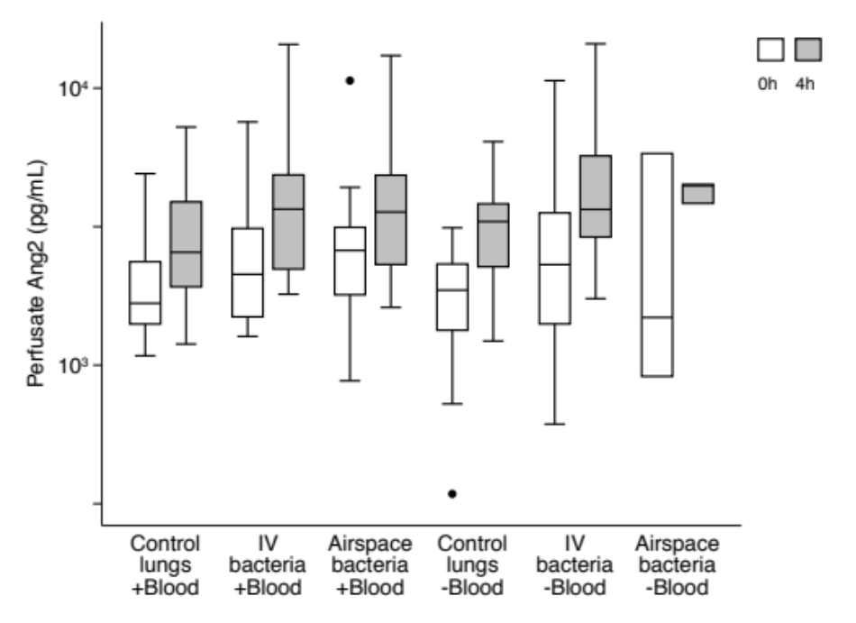

sFigure 3: Airspace biomarkers at 0 and 4 hours stratified by experimental conditions.

IL-6
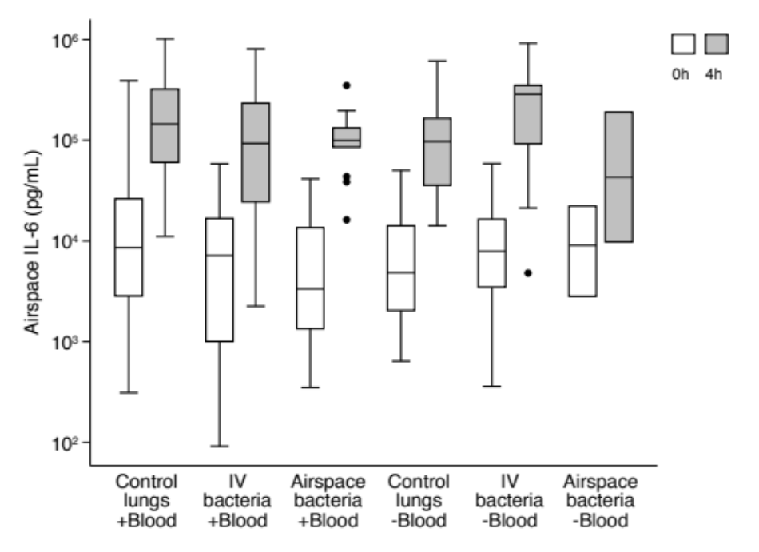

IL-8
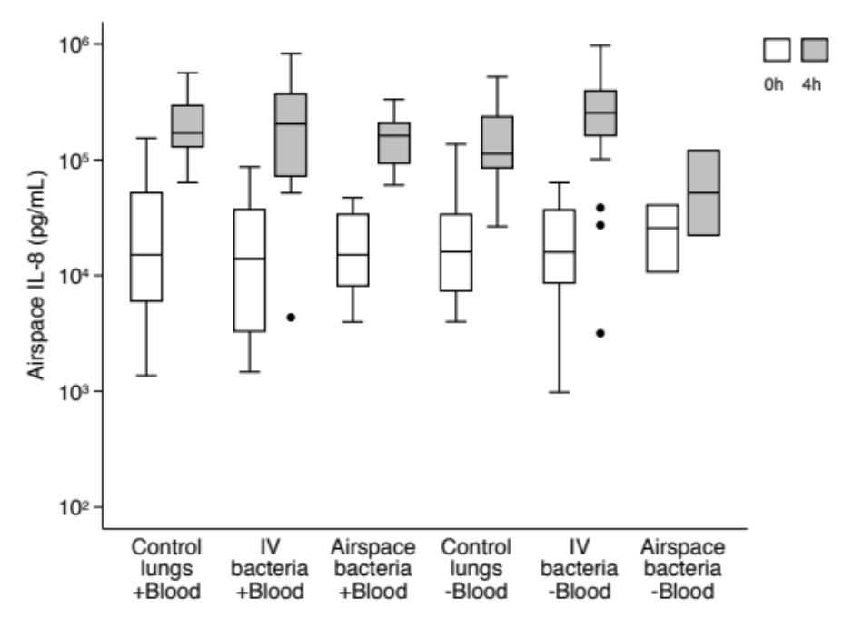

sTNFR1
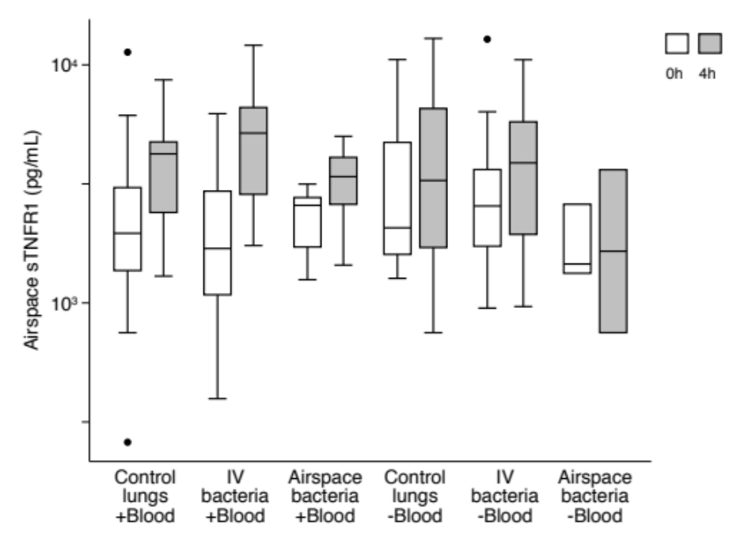

Ang-2
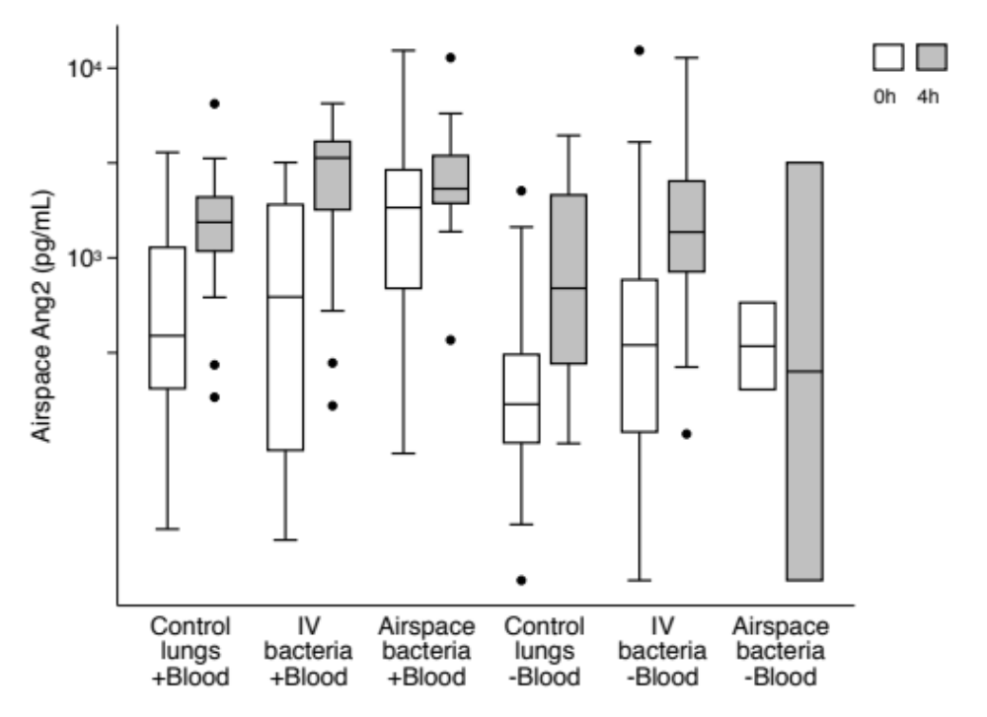

sFigure 4: Experimental timeline.

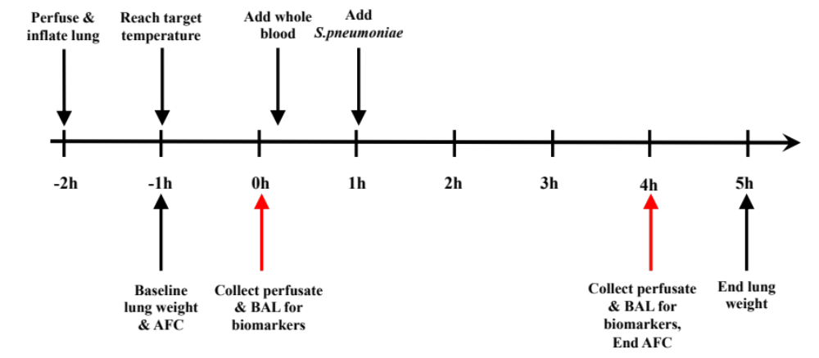

Supplementary Tables

sTable 1: Perfusate biomarker kinetics stratified by experimental conditions.
 |  |  | With blood  n=53 |  |  | Without blood  n=42
 |  | Control lungs | IV bacteria | Airspace bacteria | Control lungs | IV bacteria | Airspace bacteria
 |  | n=21 | n=19 | n=13 | n=17 | n=22 | n=3
IL-6 | 0h | 9545 (3641, 14199) | 3023 (2093, 14210) | 6365 (1660, 12437) | 7203 (3284, 10675) | 8874 (3280, 22195) | 8816 (5114, 22874)
 | 4h | 132746 (63735, 170308) | 118951 (68193, 145175) | 63003 (47642, 123715) | 154512 (112826, 210624) | 222067 (154782, 301572) | 192817 (117088, 464760)
 | Delta | 119862 (51705, 155378) | 108689 (65998, 138344) | 58087 (46662, 105947) | 151234 (102151, 204468) | 213124 (149948, 280306) | 169943 (108271, 459646)
 | Fold change | 10.7 (5.6, 25.1) | 28.5 (10.6, 55.3) | 12.8 (4.8, 32) | 28.5 (16.6, 44.1) | 26.9 (13.1, 65.9) | 13.3 (8.4, 90.9)
IL-8 | 0h | 6679 (2521, 10597) | 7859 (1732, 12050) | 5518 (4253, 8943) | 5587 (3901, 11270) | 6715 (3165, 21721) | 16363 (10749, 32502)
 | 4h | 82824 (58046, 123804) | 128380 (58003, 168450) | 80604 (57557, 112940) | 103785 (62702, 170550) | 184847 (125646, 236966) | 147788 (80640, 421859)
 | Delta | 63652 (50754, 114201) | 120522 (56390, 132177) | 73055 (53570, 104306) | 97426 (60670, 152688) | 176878 (120836, 222870) | 115287 (69891, 405496)
 | Fold change | 11.2 (7.2, 17.7) | 16.3 (12.5, 33.8) | 13.1 (9.2, 18.6) | 14.6 (12.2, 25.7) | 27.8 (13.2, 46.9) | 7.5 (4.5, 25.8)
sTNFR1 | 0h | 1739 (1224, 2237) | 1683 (1279, 2078) | 1932 (1670, 2577) | 1868 (1632, 2585) | 2023 (1577, 2511) | 1849 (1543, 2760)
 | 4h | 2912 (2249, 3390) | 2803 (2184, 4714) | 3168 (2577, 3602) | 3580 (2181, 4326) | 3658 (2923, 4460) | 4358 (2949, 5983)
 | Delta | 1066 (775, 1431) | 1274 (750, 2636) | 1147 (616, 1473) | 1136 (868, 1917) | 1539 (839, 2472) | 2509 (1405, 3223)
 | Fold change | 1.5 (1.3, 1.9) | 1.8 (1.5, 2.1) | 1.5 (1.4, 1.9) | 1.6 (1.4, 2) | 1.8 (1.4, 2.3) | 2.2 (1.9, 2.4)
Ang-2 | 0h | 1674 (1408, 2363) | 2128 (1494, 3115) | 2595 (1796, 3144) | 1865 (1337, 2317) | 2306 (1409, 3546) | 1486 (911, 5807)
 | 4h | 2556 (1918, 3884) | 3657 (2224, 4863) | 3571 (2308, 4851) | 3308 (2266, 3823) | 3663 (2900, 5691) | 4442 (3839, 4497)
 | Delta | 901 (398, 1205) | 1521 (730, 2025) | 850 (630, 1743) | 1294 (1075, 1958) | 1817 (1082, 2314) | 2956 (-1968, 3586)
 | Fold change | 1.5 (1.2, 1.7) | 1.6 (1.4, 1.9) | 1.4 (1.3, 1.7) | 1.9 (1.6, 2) | 1.9 (1.5, 2.2) | 3 (0.7, 4.9)

*Note: Data are presented as medians with interquartile range. Concentration is in pg/mL. Lungs lacking a sample from at the second time point (4h) were not included in the calculation of Delta and Fold change.

sTable 2: Airspace biomarker kinetics stratified by experimental conditions.
 |  |  | With blood |  |  | Without blood
 |  | Control lungs | IV bacteria | Airspace bacteria | Control lungs | IV bacteria | Airspace bacteria
 |  | n=16 | n=13 | n=10 | n=13 | n=14 | n=2
IL-6 | 0h | 8584 (2844, 26202) | 7656 (1014, 16786) | 3508 (1347, 13553) | 4851 (2040, 14136) | 7873 (3490, 16419) | 9064 (2816, 22161)
 | 4h | 144426 (60380, 321870) | 93138 (24499, 233784) | 99408 (85274, 132415) | 97447 (35704, 165436) | 287249 (92160, 349401) | 100046 (9755, 190336)
 | Delta | 120492 (50897, 297983) | 88284 (24043, 215755) | 85585 (41831, 131068) | 91702 (21261, 162189) | 284017 (89666, 327380) | 94106 (6940, 181272)
 | Fold change | 11.9 (5, 29.3) | 19.8 (13, 30.8) | 22.6 (8.4, 46.3) | 17.9 (8.7, 37.1) | 29.8 (9, 59) | 12.2 (3.5, 21)
IL-8 | 0h | 15269 (6002, 51883) | 13992 (3325, 37501) | 15163 (8150, 33755) | 16038 (7361, 33697) | 15931 (8993, 36918) | 25695 (10743, 40572)
 | 4h | 171119 (129343, 294532) | 203955 (72186, 370472) | 161653 (93230, 207251) | 112950 (85191, 235859) | 254521 (162061, 395160) | 71333 (22265, 120401)
 | Delta | 158751 (105567, 239020) | 156188 (60164, 328143) | 149328 (89263, 177742) | 96657 (56032, 228499) | 247643 (155816, 381142) | 53114 (-3430, 109658)
 | Fold change | 11.7 (5, 20.5) | 11.3 (8.8, 14.2) | 8.6 (6.1, 16.9) | 7.9 (3.9, 14.8) | 18 (4.8, 28.2) | 6 (0.9, 11.2)
sTNFR1 | 0h | 1962 (1368, 3049) | 1705 (1084, 2954) | 2571 (1717, 2770) | 2068 (1599, 4721) | 2555 (1738, 3639) | 1457 (1332, 2596)
 | 4h | 4236 (2406, 4742) | 5166 (2858, 6616) | 3391 (2594, 4085) | 3281 (1709, 6548) | 3874 (1940, 5759) | 2188 (750, 3626)
 | Delta | 1677 (415, 2281) | 3247 (1517, 3780) | 1196 (646, 1518) | 1217 (-30, 3454) | 909 (-184, 2119) | 162 (-1846, 2169)
 | Fold change | 1.7 (1.2, 2.5) | 2.1 (1.6, 2.7) | 1.5 (1.3, 1.6) | 1.8 (1, 2) | 1.3 (0.9, 2.4) | 1.4 (0.3, 2.5)
Ang-2 | 0h | 389 (205, 1135) | 638 (97, 1911) | 1842 (691, 2908) | 169 (106, 310) | 347 (141, 769) | 343 (202, 581)
 | 4h | 1547 (1092, 2108) | 3362 (1793, 4103) | 2313 (1938, 3453) | 692 (277, 2143) | 1367 (845, 2537) | 1596 (20, 3172)
 | Delta | 615 (185, 1320) | 1493 (882, 2534) | 361 (215, 1508) | 231 (27, 690) | 776 (254, 1046) | 1205 (-182, 2591)
 | Fold change | 3.5 (1.5, 5.8) | 2.2 (1.9, 3.6) | 1.6 (1.1, 3) | 2.6 (1.3, 5.4) | 3.9 (2.2, 7.3) | 2.8 (0.1, 5.5)

*Note: Data are presented as medians with interquartile range. Concentration is in pg/mL. Lungs lacking a sample from at the second time point (4h) were not included in the calculation of Delta and Fold change.

sTable 3: Impact of exogenous fresh whole blood on perfusate and airspace biomarker change during 4 hours of ex vivo perfusion in control lungs and in lungs exposed to IV S. pneumoniae.

 | Biomarker | Concentration change in lungs with blood  (95% CI) | Difference in concentration change without blood  (95% CI) | P value*
Control lungs
Perfusate | n | 21 | 17
 | IL-6 | 147022 (78821, 215223) | 15364 (-62318, 93047) | 0.39
 | IL-8 | 88869 (58062, 119676) | 29778 (-16706, 76262) | 0.21
 | sTNFR1 | 878 (440, 1316) | 398 (-151, 948) | 0.16
 | Ang-2 | 990 (567, 1414) | 524 (-50, 1098) | 0.07
Airspace | n | 16 | 13
 | IL-6 | 216148 (95734, 336561) | -73669 (-222783, 75445) | 0.33
 | IL-8 | 187736 (129999, 245474) | 33839 (-16304, 83982) | 0.58
 | sTNFR1 | 1332 (492, 2171) | 229 (-1388, 1847) | 0.78
 | Ang-2 | 934 (448, 1421) | -130 (-944, 683) | 0.75
Lungs exposed to IV S. Pneumoniae
Perfusate | n | 19 | 22
 | IL-6 | 121456 (83582, 159330) | 133885 (45431, 222339) | 0.003
 | IL-8 | 122667 (82749, 162585) | 101874 (-4981, 208728) | 0.06
 | sTNFR1 | 1843 (1052, 2634) | -221 (-1115, 674) | 0.63
 | Ang-2 | 1854 (1069, 2640) | 329 (-795, 1453) | 0.57
Airspace | n | 13 | 14
 | IL-6 | 171183 (56110, 286256) | 85258 (-68463, 238980) | 0.28
 | IL-8 | 218812 (108208, 329416) | 53807 (-103224, 210837) | 0.50
 | sTNFR1 | 2797 (1930, 3665) | -1793 (-3138, -448) | 0.009
 | Ang-2 | 1701 (1056, 2346) | -617 (-1702, 468) | 0.27

*P values obtained using generalized estimating equation models (GEE) using robust standard errors.

sTable 4: Impact of cold ischemia time and baseline AFC on relationship of perfusate and airspace biomarker change in lungs perfused with compared to without blood in control and IV S. pneumoniae exposed lungs.

 |  |  | Control lungs |  | IV S. pneumoniae
 | Biomarker | Adjustment variable | Concentration change  (95% CI) | P value* | Concentration change  (95% CI) | P value*
Perfusate | IL-6 | Cold ischemia time | -1029 (-3514, 1455) | 0.42 | -1085 (-2586, 416) | 0.16
 |  | Baseline AFC | 982 (-557, 2522) | 0.21 | 853 (-50, 1757) | 0.06
 | IL-8 | Cold ischemia time | -425 (-1927, 1077) | 0.58 | -2374 (-4337, -411) | 0.02
 |  | Baseline AFC | 594 (-274, 1461) | 0.18 | 421 (-702, 1544) | 0.46
 | sTNFR1 | Cold ischemia time | -6 (-29, 17) | 0.60 | -21 (-76, 34) | 0.45
 |  | Baseline AFC | 7 (-11, 24) | 0.47 | 1 (-24, 27) | 0.91
 | Ang-2 | Cold ischemia time | -1 (-32, 30) | 0.96 | 11 (-63, 85) | 0.78
 |  | Baseline AFC | 13 (-9, 36) | 0.24 | -10 (-69, 48) | 0.73
Airspace | IL-6 | Cold ischemia time | 1018 (-3344, 5380) | 0.65 | 909 (-1665, 3484) | 0.49
 |  | Baseline AFC | 3057 (264, 5849) | 0.03 | 2933 (280, 5586) | 0.03
 | IL-8 | Cold ischemia time | 1541 (-566, 3649) | 0.15 | -906 (-3961, 2149) | 0.56
 |  | Baseline AFC | 1747 (473, 3021) | 0.01 | 3280 (602, 5958) | 0.02
 | sTNFR1 | Cold ischemia time | -12 (-90, 66) | 0.77 | 0 (-62, 61) | 0.99
 |  | Baseline AFC | 46 (11, 82) | 0.01 | -6 (-41, 30) | 0.76
 | Ang-2 | Cold ischemia time | -13 (-35, 10) | 0.27 | 25 (-16, 67) | 0.23
 |  | Baseline AFC | -1 (-20, 18) | 0.92 | -21 (-58, 16) | 0.27

*P values obtained using generalized estimating equation models (GEE) using robust standard errors with interaction terms for cold ischemia time or baseline AFC.

sTable 5: Impact of bacteria on perfusate and airspace biomarker change during 4 hours of ex vivo perfusion in control lungs relative to lungs exposed to IV S. pneumoniae with blood, IV S. pneumoniae without blood, or airspace S. pneumoniae with blood.

 | Biomarker | Concentration change in control lungs  (95% CI) | Difference in concentration change with bacteria  (95% CI) | P value*
IV S. pneumoniae with exogenous blood
Perfusate | n | 21 | 19
 | IL-6 | 147030 (78843, 215217) | -25574 (-103579, 52431) | 0.52
 | IL-8 | 88844 (58066, 119622) | 33823 (-16592, 84238) | 0.19
 | sTNFR1 | 876 (438, 1314) | 967 (62, 1872) | 0.04
 | Ang-2 | 990 (567, 1414) | 864 (-28, 1757) | 0.06
Airspace | n | 16 | 13
 | IL-6 | 216385 (95700, 337069) | -45512 (-211978, 120954) | 0.59
 | IL-8 | 187610 (129984, 245235) | 30819 (-93566, 155203) | 0.63
 | sTNFR1 | 1318 (466, 2170) | 1492 (273, 2711) | 0.02
 | Ang-2 | 915 (431, 1400) | 823 (8, 1639) | 0.05
IV S. pneumoniae without exogenous blood
Perfusate | n | 17 | 22
 | IL-6 | 162600 (126063, 199138) | 92741 (4830, 180653) | 0.04
 | IL-8 | 120611 (85361, 155862) | 103915 (-1316, 209146) | 0.05
 | sTNFR1 | 1284 (955, 1613) | 338 (-193, 869) | 0.21
 | Ang-2 | 1514 (1126, 1902) | 671 (-222, 1563) | 0.14
Airspace | n | 13 | 14
 | IL-6 | 142415 (56441, 228389) | 114710 (-19905, 249324) | 0.10
 | IL-8 | 159922 (79321, 240523) | 112587 (-24578, 249751) | 0.11
 | sTNFR1 | 1590 (215, 2964) | -582 (-2290, 1126) | 0.50
 | Ang-2 | 772 (99, 1445) | 309 (-793, 1411) | 0.58
Airspace S. pneumoniae with exogenous blood
Perfusate | n | 21 | 13
 | IL-6 | 147005 (78693, 215317) | -70135 (-143563, 3294) | 0.06
 | IL-8 | 88830 (57997, 119664) | -2249 (-45635, 41137) | 0.92
 | sTNFR1 | 877 (438, 1316) | 163 (-393, 719) | 0.57
 | Ang-2 | 987 (563, 1410) | 266 (-344, 877) | 0.39
Airspace | n | 16 | 10
 | IL-6 | 215494 (95379, 335609) | -109136 (-236958, 18686) | 0.09
 | IL-8 | 187418 (129947, 244888) | -49560 (-117608, 18487) | 0.15
 | sTNFR1 | 1325 (478, 2172) | -184 (-1112, 744) | 0.70
 | Ang-2 | N/A | N/A | N/A

*P values obtained using generalized estimating equation models (GEE) using robust standard errors.

sTable 6: Impact of cold ischemia time, baseline AFC, and pre-procurement antibiotics on relationship of perfusate and airspace biomarker change in control compared to IV S. pneumoniae exposed lungs perfused with and without blood.

 |  |  | With blood |  | Without blood
 | Biomarker | Adjustment variable | Concentration change  (95% CI) | P value* | Concentration change  (95% CI) | P value*
Perfusate | IL-6 | Cold ischemia time | -1114 (-3195, 967) | 0.29 | -970 (-2759, 819) | 0.29
 |  | Baseline AFC | 1100 (-141, 2340) | 0.08 | 575 (-575, 1725) | 0.33
 |  | Pre-procurement antibiotics | -9553 (-72937, 53831) | 0.77 | -32498 (-90501, 25505) | 0.27
 | IL-8 | Cold ischemia time | -1371 (-2827, 85) | 0.07 | -1443 (-3699, 814) | 0.21
 |  | Baseline AFC | 657 (-144, 1458) | 0.11 | 227 (-1148, 1603) | 0.75
 |  | Pre-procurement antibiotics | -1358 (-39550, 36834) | 0.94 | -16598 (-89205, 56009) | 0.65
 | sTNFR1 | Cold ischemia time | -23 (-66, 19) | 0.28 | 4 (-26, 34) | 0.80
 |  | Baseline AFC | -4 (-24, 15) | 0.65 | 20 (1, 39) | 0.04
 |  | Pre-procurement antibiotics | -280 (-1081, 521) | 0.49 | -1003 (-1653, -353) | 0.002
 | Ang-2 | Cold ischemia time | 10 (-46, 66) | 0.72 | -4 (-52, 43) | 0.86
 |  | Baseline AFC | -5 (-36, 26) | 0.77 | 14 (-49, 77) | 0.66
 |  | Pre-procurement antibiotics | 150 (-950, 1249) | 0.79 | -1593 (-3361, 174) | 0.08
Airspace | IL-6 | Cold ischemia time | 799 (-2948, 4546) | 0.68 | 1319 (-1576, 4213) | 0.37
 |  | Baseline AFC | 4129 (1671, 6588) | 0.001 | 1023 (-1573, 3619) | 0.44
 |  | Pre-procurement antibiotics | 52662 (-44853, 150176) | 0.29 | -30953 (-111978, 50073) | 0.45
 | IL-8 | Cold ischemia time | 480 (-1673, 2632) | 0.66 | 100 (-3600, 3800) | 0.96
 |  | Baseline AFC | 3099 (1532, 4667) | <0.0001 | 1536 (-1159, 4231) | 0.26
 |  | Pre-procurement antibiotics | 38558 (-18093, 95209) | 0.18 | 4008 (-72793, 80809) | 0.92
 | sTNFR1 | Cold ischemia time | -51 (-102, 0) | 0.05 | 69 (-25, 163) | 0.15
 |  | Baseline AFC | 23 (-7, 53) | 0.13 | 17 (-30, 63) | 0.48
 |  | Pre-procurement antibiotics | 506 (-830, 1841) | 0.46 | -1601 (-3268, 66) | 0.06
 | Ang-2 | Cold ischemia time | -1 (-29, 28) | 0.96 | 16 (-23, 56) | 0.42
 |  | Baseline AFC | -4 (-23, 16) | 0.71 | -23 (-69, 23) | 0.32
 |  | Pre-procurement antibiotics | 392 (-396, 1180) | 0.33 | -1687 (-3395, 22) | 0.05

*P values obtained using generalized estimating equation models (GEE) using robust standard errors with interaction terms for cold ischemia time, baseline AFC, or administration of antibiotics prior to organ procurement.

sTable 7: Impact of cold ischemia time, baseline alveolar fluid clearance, and pre-procurement antibiotics on relationship of perfusate and airspace biomarker change in control compared to airspace S. pneumoniae exposed lungs perfused with blood.

 | Biomarker | Adjustment variable | Concentration change  (95% CI) | P value*
Perfusate | IL-6 | Cold ischemia time | -1157 (-3344, 1030) | 0.30
 |  | Baseline AFC | 859 (-692, 2410) | 0.28
 |  | Pre-procurement antibiotics | -30504 (-123272, 62264) | 0.52
 | IL-8 | Cold ischemia time | -641 (-1836, 555) | 0.29
 |  | Baseline AFC | 430 (-414, 1273) | 0.32
 |  | Pre-procurement antibiotics | -13048 (-62325, 36229) | 0.60
 | sTNFR1 | Cold ischemia time | 6 (-14, 26) | 0.55
 |  | Baseline AFC | -4 (-21, 13) | 0.67
 |  | Pre-procurement antibiotics | -165 (-858, 529) | 0.64
 | Ang-2 | Cold ischemia time | 15 (-17, 47) | 0.35
 |  | Baseline AFC | -5 (-28, 17) | 0.64
 |  | Pre-procurement antibiotics | -535 (-1647, 577) | 0.35
Airspace | IL-6 | Cold ischemia time | 312 (-3617, 4240) | 0.88
 |  | Baseline AFC | 3295 (464, 6127) | 0.02
 |  | Pre-procurement antibiotics | 22963 (-113740, 159666) | 0.74
 | IL-8 | Cold ischemia time | 703 (-1277, 2684) | 0.49
 |  | Baseline AFC | 1975 (760, 3190) | 0.001
 |  | Pre-procurement antibiotics | 6665 (-53989, 67319) | 0.83
 | sTNFR1 | Cold ischemia time | -28 (-69, 13) | 0.19
 |  | Baseline AFC | 24 (-7, 55) | 0.13
 |  | Pre-procurement antibiotics | 70 (-1603, 1744) | 0.93
 | Ang-2 | Cold ischemia time | N/A | N/A
 |  | Baseline AFC | N/A | N/A
 |  | Pre-procurement antibiotics | N/A | N/A

*P values obtained using generalized estimating equation models (GEE) using robust standard errors with interaction terms for cold ischemia time, baseline AFC, or administration of antibiotics prior to organ procurement.

