Cytotoxicity assay: Cytotoxicity of the compounds was determined on the basis of measurement of in vitro growth inhibition of tumor cell lines in 96 well plates by cell-mediated reduction of tetrazolium salt to water insoluble formazan crystals using 5-fluorouracil as a standard. The cytotoxicity was assessed using the MTT assay against a panel of five different human tumor cell lines: HeLa derived from human cervical cancer cells (ATCC No. CCL-2), COLO 205 derived from human colon cancer cells (ATCC No. CCL-222), HepG2 derived from human liver cancer cells (ATCC No. HB-8065), MCF7 derived from human breast adenocarcinoma cells (ATCC No. HTB-22). The IC₅₀ (50% inhibitory concentration) values were calculated from the plotted absorbance data for the dose-response curves. IC₅₀ values (in μM) are indicated as means ± SD of three independent experiments.
General information:
IR spectra were recorded on a Perkin-Elmer FT-IR 240-C spectrophotometer using KBr optics. ¹H NMR spectra were recorded on Bruker AV 300 MHz in CDCl₃ & DMSO-d₆ using TMS as internal standard. ESI spectra were recorded on Micro mass, Quattro LC using ESI+ software with capillary voltage 3.98 kV and ESI mode positive ion trap detector. All high-resolution spectra were recorded on QSTARXL hybrid MS/MS system (Applied Biosystems, USA) under electrospray ionization. All the reactions were monitored by thin layer chromatography (TLC) on precoated silica gel 60 F₂₅₄; spots were visualized with UV light. Merck silica gel (60-120 mesh) was used for column chromatography.
Preparation of 2-(4-chlorophenyl)-5-(trifluoromethyl)-4H-benzo[d][1,3]oxazin-4-one (2)
4-Chlorobenzoyl chloride (3 mml) was added to the 2-aminobenzoic acid 1 (3 mmol), to this homogeneous solution, pyridine 6-8 ml was slowly added. The reaction mixture was stirred at room temperature about 12 hours. After completion of the reaction by TLC confirmation, to the reaction mixture slowly added 2~3 % Aq. HCl to neutralize. After that added ethylacetate and water, organic layer was separated and added Sodium sulphate. Filtered to get dried organic layer solution and concentrated to get desired white solid product with yield 71%.
2-(4-Chlorophenyl)-5-(trifluoromethyl)-4H-benzo[d][1,3]oxazin-4-one (2)
White solid; Yield 71%; ¹H NMR (CDCl₃, 300 MHz): δ 7.42 (d, 2H, Ar-H), 7.58 (d, 2H, Ar-H), 7.65 (s, 1H, Ar-H), 7.78 (s, 1H, Ar-H), 7.85(s, 1H, Ar-H); MS (ESI): m/z [(M+H)⁺]: 326; Anal. calc. for C₁₅H₇ ClF₃NO₂: C 55.32, H 2.17, N 4.30 %. Found: C 55.33, H 2.18, N 4.31%.
2-(4-Chlorophenyl)-3-hydroxy-5-(trifluoromethyl)quinazolin-4(3H)-one (3)
2-(4-Chlorophenyl)-5-(trifluoromethyl)-4H-benzo[d][1,3]oxazin-4-one (1 mml) and hydroxyl amine (2 mml) was dissolved in Sodium acetate (10-15 ml) and this reaction mixture was allowed to heat upto 100 °C about 12-15 hours. After completion of the reaction, reactin mixture was poured on crushed ice and solid was filtered to obtain 2-(4-Chlorophenyl)-3-hydroxy-5-(trifluoromethyl)quinazolin-4(3H)-one 3.
White solid; Yield 65%; ¹H NMR (CDCl₃, 300 MHz): δ 7.42 (d, 2H, Ar-H), 7.58 (d, 2H, Ar-H), 7.62 (s, 1H, Ar-H), 7.72 (s, 1H, Ar-H), 7.89(s, 1H, Ar-H); MS (ESI): m/z [(M+H)⁺]: 341; Anal. calc. for C₁₅H₈ClF₃N₂O₂: C 52.88, H 2.37, N 8.22 %. Found: C 52.89, H 2.38, N 8.25%.
Ethyl 2-((2-(4-chlorophenyl)-4-oxo-5-(trifluoromethyl)quinazolin-3(4H)-yl)oxy)acetate (4)
2-(4-Chlorophenyl)-3-hydroxy-5-(trifluoromethyl)quinazolin-4(3H)-one 3 (3 mml) and bromoethyl actate 10-12 ml was taken in DMF and to this added K₂CO₃ this reaction mixture was allowed to heat at 120 °C for 15 hours. After completion of the reaction, reaction mixture was poured in water, white solid was formed. This solid was collected through filtration.
White solid; Yield 82%; ¹H NMR (CDCl₃, 300 MHz): δ 1.24 (t, 3H, -CH₃), 4.12 (q, 2H, -CH₂), 4.89 (s, 2H, -OCH₂), 7.43 (d, 2H, Ar-H), 7.60 (d, 2H, Ar-H), 7.69 (s, 1H, Ar-H), 7.79 (s, 1H, Ar-H), 7.89 (s, 1H, Ar-H); MS (ESI): m/z [(M+H)⁺]: 427; Anal. calc. for C₁₉H₁₄ClF₃N₂O₄: C 53.47, H 3.30, N 6.56 %. Found: C 53.48, H 3.32, N 6.57%.
2-((2-(4-Chlorophenyl)-4-oxo-5-(trifluoromethyl)quinazolin-3(4H)-yl)oxy)-N-methylacetamide (5a)
Ethyl 2-((2-(4-chlorophenyl)-4-oxo-5-(trifluoromethyl)quinazolin-3(4H)-yl)oxy)acetate 4 and primary amine was taken in sealed tube as 1:2 ratio, after sealing the reaction mixture was allowed to heat at primary amine refluxing point, after completion of the reaction, reaction mixture was poured on crushed ice and yellow solid was formed, this solid was filtered and dried to obtain amide derivative 5.
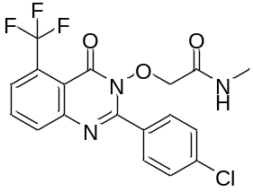
Yellow solid; Yield 89 %; m. p. 195-197 °C; IR: δ 3350 (-NHCO-), 1631 (-NHCO-); ¹H NMR (CDCl₃, 300 MHz): δ 3.02 (d, 3H, -CH₃), 6.35 (br. s, 1H, -CONH-), 4.90 (s, 2H, -OCH₂), 7.21 (d, 2H, Ar-H), 7.42 (d, 2H, Ar-H), 7.78 (s, 1H, Ar-H), 7.88 (d, 2H, Ar-H), 8.05 (s, 1H, Ar-H), 8.22 (s, 1H, Ar-H); ¹³C NMR (CDCl₃, 75 MHz): 24.6, 67.4, 123.0, 124.5, 125.8, 126.8, 127.7, 128.4, 129.5, 130.6, 131.9, 132.5, 133.5, 141.8, 158.4, 160.6; MS (ESI): m/z [(M+H)⁺]: 412; Anal. calc. for C₁₈H₁₃ClF₃N₃O₃: C 52.50, H 3.18, N 10.20 %. Found: C 52.52, H 3.20, N 10.23%.
2-((2-(4-Chlorophenyl)-4-oxo-5-(trifluoromethyl)quinazolin-3(4H)-yl)oxy)-N-ethylacetamide (5b)
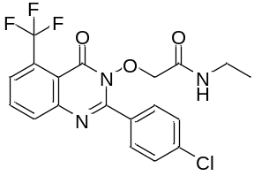
Yellow solid; Yield 90 %; m. p. 198-200 °C; IR: δ 3346 (-NHCO-), 1632 (-NHCO-); ¹H NMR (CDCl₃, 300 MHz): δ 1.13 (t, 3H, -CH₃), 3.51 (quintet, 2H, -CH₂-), 4.92 (s, 2H, -OCH₂), 6.31 (br. s, 1H, -CONH-), 7.25 (d, 2H, Ar-H), 7.39 (d, 2H, Ar-H), 7.62 (s, 1H, Ar-H), 7.72 (s, 1H, Ar-H), 8.23 (s, 1H, Ar-H); ¹³C NMR (CDCl₃, 75 MHz): 16.4, 35.4, 67.8, 122.8, 123.3, 124.4, 125.4, 126.5, 127.1, 128.0, 129.0, 130.6, 132.2, 133.8, 143.7, 158.4, 160.8; MS (ESI): m/z [(M+H)⁺]: 426; Anal. calc. for C₁₉H₁₅ClF₃N₃O₃: C 53.60, H 3.55, N 9.87 %. Found: C 53.61, H 3.56, N 9.88%.
2-((2-(4-Chlorophenyl)-4-oxo-5-(trifluoromethyl)quinazolin-3(4H)-yl)oxy)-N-propylacetamide (5c)
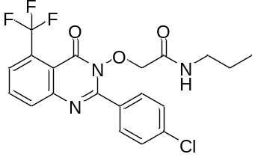
Yellow solid; Yield 86 %; m. p. 225-227 °C; IR: δ 3342 (-NHCO-), 1631 (-NHCO-); ¹H NMR (CDCl₃, 300 MHz): δ 1.12 (t, 3H, -CH₃), 1.65(m, 2H, -CH₂), 3.58 (quintet, 2H, -CH₂-), 4.94 (s, 2H, -OCH₂), 6.34 (br. s, 1H, -CONH-), 7.41 (d, 2H, Ar-H), 7.56 (d, 2H, Ar-H), 7.61 (s, 1H, Ar-H), 8.18 (s, 1H, Ar-H), 8.38 (s, 1H, Ar-H); ¹³C NMR (CDCl₃, 75 MHz): 10.2, 23.2, 41.5, 67.5, 122.9, 124.1, 125.0, 125.7, 126.3, 127.4, 129.3, 129.6, 130.6, 131.8, 133.0, 143.2, 159.8, 161.2; MS (ESI): m/z [(M+H)⁺]: 440; Anal. calc. for C₂₀H₁₇ClF₃N₃O₃: C 54.62, H 3.90, N 9.55 %. Found: C 54.63, H 3.91, N 9.57%.
2-((2-(4-Chlorophenyl)-4-oxo-5-(trifluoromethyl)quinazolin-3(4H)-yl)oxy)-N-cyclopropylacetamide (5d)
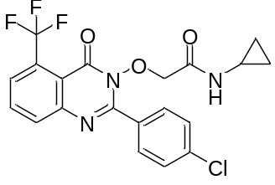
Yellow solid; Yield 72 %; m. p. 197-199 °C; IR (KBr, cm⁻¹): 3336 (-NHCO-), 1632 (-NHCO-); ¹H NMR (CDCl₃, 300 MHz): δ 0.35-0.51 (m, 2H, -CH₂-), 0.59-0.78 (m, 2H, -CH₂-), 3.81-3.86 (m, 1H, -CH-), 4.93 (s, 2H, -OCH₂), 6.32 (br. d, 1H, -NHCO-), 7.47 (d, 2H, Ar-H), 7.58 (d, 2H, Ar-H), 7.63 (s, 1H, Ar-H), 7.77 (s, 1H, Ar-H), 8.18 (s, 1H, Ar-H); ¹³C NMR (CDCl₃, 75 MHz): 10.4, 25.4, 67.2, 123.2, 124.8, 125.5, 126.3, 126.8, 128.0, 129.1, 130.5, 131.2, 131.4, 133.4, 143.4, 159.3, 161.4; MS (ESI): m/z [(M+H)⁺]: 438. Anal calcd.for C₂₀H₁₅ClF₃N₃O₃: C 54.87, H 3.45, N 9.60%. Found: C 54.88, H 3.46, N 9.62%.
2-((2-(4-Chlorophenyl)-4-oxo-5-(trifluoromethyl)quinazolin-3(4H)-yl)oxy)-N-cyclopentylacetamide (5e)
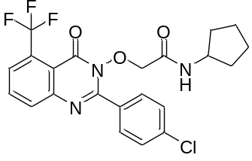
Yellow solid; Yield 89 %; m. p. 211-213 °C; IR (KBr, cm⁻¹): 3340 (-NHCO-), 1636 (-NHCO-); ¹H NMR (CDCl₃, 300 MHz): δ 0.51-0.62 (m, 4H, -CH₂-), 0.68-0.73 (m, 2H, -CH₂-), 0.83-0.98 (m, 2H, -CH₂-), 3.89-3.93 (m, 1H, -CH-), 4.95 (s, 2H, -OCH₂), 6.33 (br. d, 1H, -NHCO-), 7.42 (d, 2H, Ar-H), 7.58 (d, 2H, Ar-H), 7.65 (s, 1H, Ar-H), 8.08 (s, 1H, Ar-H), 8.22 (s, 1H, Ar-H); ¹³C NMR (CDCl₃, 75 MHz): 21.8, 31.3, 46.8, 67.3, 120.5, 121.0, 122.4, 123.0, 124.0, 124.9, 126.9, 129.6, 130.9, 133.3, 135.9, 143.5, 159.0, 161.4; MS (ESI): m/z [(M+H)⁺]: 466. Anal calcd.for C₂₂H₁₉ClF₃N₃O₃: C 56.72, H 4.11, N 9.02%. Found: C 56.73, H 4.12, N 9.04%.

2-((2-(4-chlorophenyl)-4-oxo-5-(trifluoromethyl)quinazolin-3(4H)-yl)oxy)-N-cyclohexylacetamide (5f)
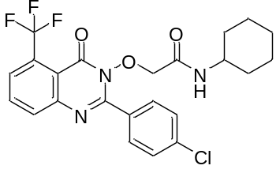
Yellow solid; Yield 74 %; m. p. 211-213 °C; IR (KBr, cm⁻¹): 3335 (-NHCO-), 1630 (-NHCO-); ¹H NMR (CDCl₃, 300 MHz): δ 0.62-0.81 (m, 4H, -CH₂-), 0.85-0.92 (m, 2H, -CH₂-), 1.02-1.18 (m, 2H, -CH₂-), 1.19-1.25 (m, 2H, -CH₂-), 3.95-4.02 (m, 1H, -CH-), 4.93 (s, 2H, -OCH₂), 6.35 (br. d, 1H, -NHCO-), 7.42 (d, 2H, Ar-H), 7.56 (d, 2H, Ar-H), 7.66 (s, 1H, Ar-H), 8.08 (s, 1H, Ar-H), 8.23 (s, 1H, Ar-H); ¹³C NMR (CDCl₃, 75 MHz): 21.3, 23.2, 32.8, 46.8, 67.3, 118.6, 120.0, 121.5, 122.2, 123.7, 124.4, 126.9, 129.9, 131.0, 133.3, 136.1, 137.7, 142.0, 160.0, 162.1; MS (ESI): m/z [(M+H)⁺]: 480. Anal calcd.for C₂₃H₂₁ClF₃N₃O₃: C 57.57, H 4.41, N 8.76%. Found: C 57.58, H 4.42, N 8.78%.

N-(2-Aminoethyl)-2-((2-(4-chlorophenyl)-4-oxo-5-(trifluoromethyl)quinazolin-3(4H)-yl)oxy)acetamide (5g)
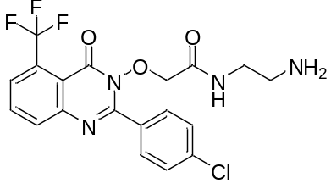
Yellow solid; Yield 62 %; m. p. 241-243 °C; IR (KBr, cm⁻¹): 3331 (-NHCO-), 1628 (-NHCO-); ¹H NMR (CDCl₃, 300 MHz): δ 2.72-2.78 (m, 2H, -CH₂-), 3.45-3.50 (m, 2H, -CH₂-N-), 3.98 (br., s, 2H, -NH₂), 4.94 (s, 2H, -OCH₂), -), 6.32 (br. d, 1H, -NHCO-), 7.43 (d, 2H, Ar-H), 7.55 (d, 2H, Ar-H), 7.62 (s, 1H, Ar-H), 8.18 (s, 1H, Ar-H), 8.22 (s, 1H, Ar-H); ¹³C NMR (CDCl₃, 75 MHz): 40.8, 42.4, 67.8, 120.0, 121.9, 122.8, 123.2, 124.3, 125.4, 125.9, 128.7, 129.9, 131.4, 132.0, 135.4, 138.0, 140.8, 143.7, 144.9, 158.9, 160.5; MS (ESI): m/z [(M+H)⁺]: 441. Anal calcd.for C₁₉H₁₆ClF₃N₄O₃: C 51.77, H 3.66, N 12.71%. Found: C 51.78, H 3.65, N 12.73%.

2-((2-(4-Chlorophenyl)-4-oxo-5-(trifluoromethyl)quinazolin-3(4H)-yl)oxy)-N-(2-hydroxyethyl)acetamide (5h)
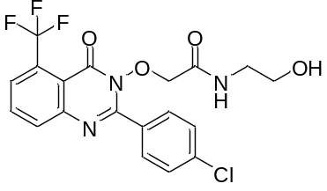
Yellow solid; Yield 52 %; m. p. 211-213 °C; IR (KBr, cm⁻¹): 3325 (-NHCO-), 1621 (-NHCO-); ¹H NMR (CDCl₃, 300 MHz): δ 2.72-2.78 (m, 2H, -CH₂-), 3.53-3.60 (m, 2H, -CH₂-N-), 4.68 (br., s, 1H, -OH), 4.91 (s, 2H, -OCH₂), 6.32 (br. d, 1H, -NHCO-), 7.43 (d, 2H, Ar-H), 7.55 (d, 2H, Ar-H), 7.62 (s, 1H, Ar-H), 8.08 (s, 1H, Ar-H), 8.23 (s, 1H, Ar-H); ¹³C NMR (CDCl₃, 75 MHz): 42.3, 62.1, 67.2, 123.6, 124.8, 125.6, 126.3, 127.3, 128.1, 129.4, 130.9, 132.2, 133.3, 135.8, 143.3, 158.7, 167.0; MS (ESI): m/z [(M+H)⁺]: 442. Anal calcd.for C₁₉H₁₅ClF₃N₃O₄: C 51.65, H 3.42, N 9.51%. Found: C 51.68, H 3.43, N 9.52%.
2-((2-(4-Chlorophenyl)-4-oxo-5-(trifluoromethyl)quinazolin-3(4H)-yl)oxy)-N-(furan-2-ylmethyl)acetamide (5i)
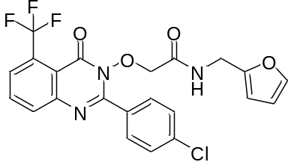
Yellow solid; Yield 58 %; m. p. 234-236 °C; IR (KBr, cm⁻¹): 3328 (-NHCO-), 1625 (-NHCO-); ¹H NMR (CDCl₃, 300 MHz): δ 4.28 (s, 2H, -NCH₂-), 5.12 (s, 2H, -O-CH₂-), 6.33 (br. d, 1H, -NHCO-), 7.33-7.38 (m, 3H, Ar-H), 7.43 (d, 2H, Ar-H), 7.48 (dd, 1H, Ar-H), 7.56 (d, 2H, Ar-H), 7.63 (s, 1H, Ar-H), 8.19 (s, 1H, Ar-H), 8.42 (s, 1H, Ar-H); ¹³C NMR (CDCl₃, 75 MHz): 40.5, 67.4, 121.5, 122.4, 123.2, 124.8, 125.5, 126.3, 126.8, 128.0, 129.1, 130.5, 131.2, 131.4, 133.4, 136.5, 137.4, 143.4, 159.3, 161.4; MS (ESI): m/z [(M+H)⁺]: 478. Anal. calcd. for C₂₂H₁₅ClF₃N₃O₄: C 55.30, H 3.16, N 8.79%. Found: C 55.32, H 3.17, N 8.81%.

N-Benzyl-2-((2-(4-chlorophenyl)-4-oxo-5-(trifluoromethyl)quinazolin-3(4H)-yl)oxy)acetamide (5j)
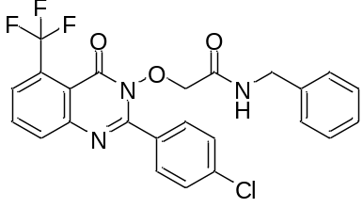
Yellow solid; Yield 69 %; m. p. >260 °C; IR (KBr, cm⁻¹): 3321 (-NHCO-), 1625 (-NHCO-); ¹H NMR (CDCl₃, 300 MHz): δ 4.21 (s, 2H, -N-CH₂-), 4.91 (s, 2H, -OCH₂-), 6.31 (br. d, 1H, -NHCO-), 7.26-7.29 (m, 3H, Ar-H), 7.35-7.39 (m, 3H, Ar-H), 7.42 (d, 3H, Ar-H), 7.63 (s, 1H, Ar-H), 8.19 (s, 1H, Ar-H), 8.26 (s, 1H, Ar-H); ¹³C NMR (CDCl₃, 75 MHz): 41.2, 67.3, 121.5, 122.4, 123.2, 124.8, 125.5, 126.3, 126.8, 128.0, 129.1, 130.5, 131.2, 131.4, 133.4, 136.5, 137.4, 143.4, 159.3, 161.4; MS (ESI): m/z [(M+H)⁺]: 488. Anal calcd.for C₂₄H₁₇ClF₃N₃O₃: C 59.09, H 3.51, N 8.61%. Found: C 59.11, H 3.52, N 8.62%.
2-((2-(4-Chlorophenyl)-4-oxo-5-(trifluoromethyl)quinazolin-3(4H)-yl)oxy)-N-(3-methylbenzyl)acetamide (5k)
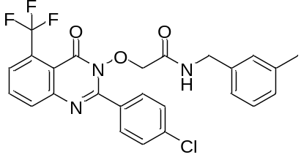
Yellow solid; Yield 62 %; m. p. 247-249 °C; IR (KBr, cm⁻¹): 3321 (-NHCO-), 1625 (-NHCO-); ¹H NMR (CDCl₃, 300 MHz): δ 2.32 (s, 3H, Ar-CH₃), 4.22 (s, 2H, -N-CH₂-), 4.93 (s, 2H, -OCH₂-), 6.35 (br. d, 1H, -NHCO-), 7.25-7.29 (m, 3H, Ar-H), 7.34-7.39 (m, 3H, Ar-H), 7.56 (d, 2H, Ar-H), 7.63 (s, 1H, Ar-H), 8.15 (s, 1H, Ar-H), 8.20 (s, 1H, Ar-H); ¹³C NMR (CDCl₃, 75 MHz): 21.0, 42.2, 67.4, 120.6, 121.0, 122.1, 122.9, 124.1, 125.0, 125.7, 126.3, 127.4, 129.5, 129.6, 130.6, 131.8, 133.0, 135.8, 137.0, 140.6, 143.2, 159.8, 161.2; MS (ESI): m/z [(M+H)⁺]: 502. Anal calcd.for C₂₅H₁₉ClF₃N₃O₃: C 59.83, H 3.82, N 8.37%. Found: C 59.84, H 3.81, N 8.38%.

2-((2-(4-Chlorophenyl)-4-oxo-5-(trifluoromethyl)quinazolin-3(4H)-yl)oxy)-N-(4-methoxybenzyl)acetamide (5l)
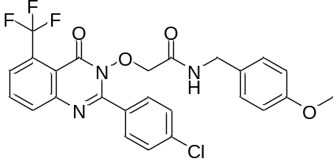
Yellow solid; Yield 78 %; m. p. >260 °C; IR (KBr, cm⁻¹): 3321 (-NHCO-), 1626 (-NHCO-); ¹H NMR (CDCl₃, 300 MHz): δ 3.83 (s, 3H, -OCH₃), 4.28 (s, 2H, -N-CH₂-), 4.91 (s, 2H, -OCH₂-), 6.36 (br. d, 1H, -NHCO-), 7.33 (d, 2H, Ar-H), 7.38 (d, 2H, Ar-H), 7.42 (d, 2H, Ar-H), 7.58 (d, 2H, Ar-H), 7.61 (s, 1H, Ar-H), 8.11 (s, 1H, Ar-H), 8.20 (s, 1H, Ar-H); ¹³C NMR (CDCl₃, 75 MHz): 42.8, 52.1, 67.2, 121.7, 123.0, 123.7, 124.5, 125.3, 126.4, 127.1, 129.0, 130.0, 130.6, 131.0, 133.8, 136.1, 139.0, 140.7, 142.4, 156.5, 161.2; MS (ESI): m/z [(M+H)⁺]: 518. Anal calcd.for C₂₅H₁₉ClF₃N₃O₃: C 57.98, H 3.70, N 8.11%. Found: C 57.99, H 3.71, N 8.13%.
2-((2-(4-Chlorophenyl)-4-oxo-5-(trifluoromethyl)quinazolin-3(4H)-yl)oxy)-N-(3-(trifluoromethyl)benzyl)acetamide (5m)
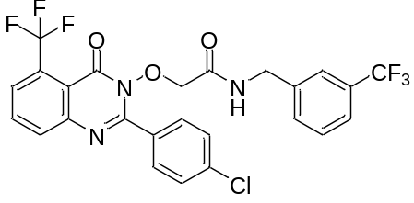
Yellow solid; Yield 79 %; m. p. >250 °C; IR (KBr, cm⁻¹): 3318 (-NHCO-), 1621 (-NHCO-); ¹H NMR (CDCl₃, 300 MHz): δ 4.28 (s, 2H, -N-CH₂-), 4.88 (s, 2H, -OCH₂-), 6.31 (br. s, 1H, -NHCO-), 7.25-7.27 (d, 2H, Ar-H), 7.34-7.39 (m, 3H, Ar-H), 7.43 (d, 2H, Ar-H), 7.57 (s, 1H, Ar-H), 8.05 (s, 1H, Ar-H), 8.26 (s, 1H, Ar-H), 8.42 (s, 1H, Ar-H); ¹³C NMR (CDCl₃, 75 MHz): 42.3, 67.3, 119.1, 119.8, 120.4, 121.7, 123.0, 123.6, 124.8, 125.6, 126.5, 127.3, 128.1, 129.4, 130.9, 132.3, 133.5, 135.78, 137.1, 139.9, 141.9, 143.3, 158.7, 161.0; MS (ESI): m/z [(M+H)⁺]: 556. Anal calcd.for C₂₅H₁₆ClF₆N₃O₃: C 54.02, H 2.90, N 7.56%. Found: C 54.03, H 2.91, N 7.57%.
N-(4-Chlorobenzyl)-2-((2-(4-chlorophenyl)-4-oxo-5-(trifluoromethyl)quinazolin-3(4H)-yl)oxy)acetamide (5n)
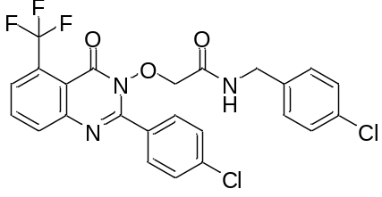
Yellow solid; Yield 80 %; m. p. 248-250 °C; IR (KBr, cm⁻¹): 3317 (-NHCO-), 1622 (-NHCO-); ¹H NMR (CDCl₃, 300 MHz): δ 4.22 (s, 2H, -N-CH₂-), 4.90 (s, 2H, -OCH₂-), 6.31 (br. d, 1H, -NHCO-), 7.34 (d, 2H, Ar-H), 7.38 (d, 2H, Ar-H), 7.43 (d, 2H, Ar-H), 7.59 (d, 2H, Ar-H), 8.01 (s, 1H, Ar-H), 8.18 (s, 1H, Ar-H), 8.25 (s, 1H, Ar-H); ¹³C NMR (CDCl₃, 75 MHz): 42.8, 67.2, 120.2, 121.6, 122.2, 123.7, 125.7, 126.3, 127.1, 128.4, 129.2, 130.2, 131.3, 132.6, 133.2, 135.9, 138.0, 143.6, 157.6, 160.0; MS (ESI): m/z [(M+H)⁺]: 522. Anal calcd. for C₂₄H₁₆Cl₂F₃N₃O₃: C 55.19, H 3.09, N 8.05%. Found: C 55.20, H 3.10, N 8.06%.

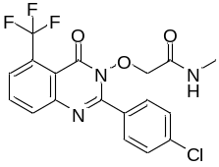2-((2-(4-Chlorophenyl)-4-oxo-5-(trifluoromethyl)quinazolin-3(4H)-yl)oxy)-N-methylacetamide (5a)
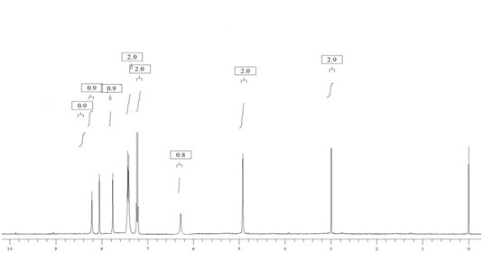

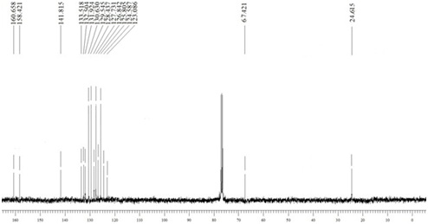

2-((2-(4-Chlorophenyl)-4-oxo-5-(trifluoromethyl)quinazolin-3(4H)-yl)oxy)-N-ethylacetamide (5b)
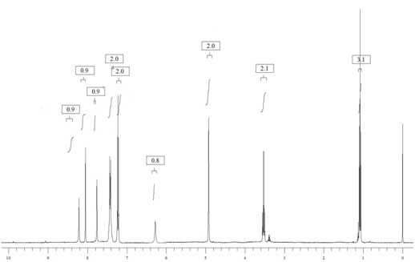

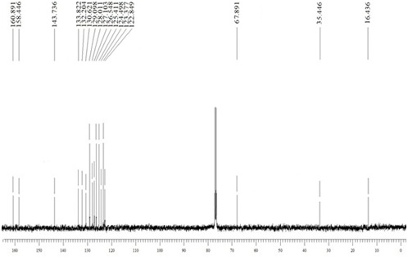

2-((2-(4-Chlorophenyl)-4-oxo-5-(trifluoromethyl)quinazolin-3(4H)-yl)oxy)-N-propylacetamide (5c)
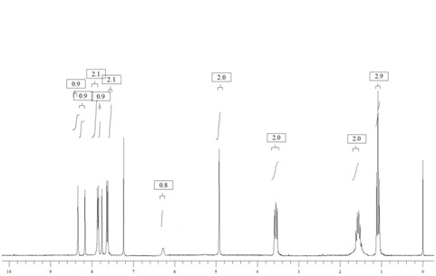

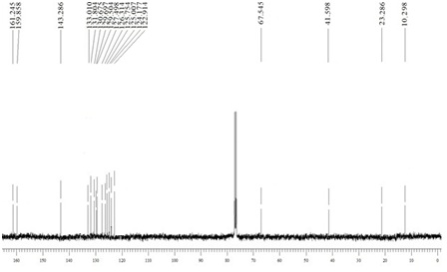

2-((2-(4-Chlorophenyl)-4-oxo-5-(trifluoromethyl)quinazolin-3(4H)-yl)oxy)-N-cyclopropylacetamide (5d)
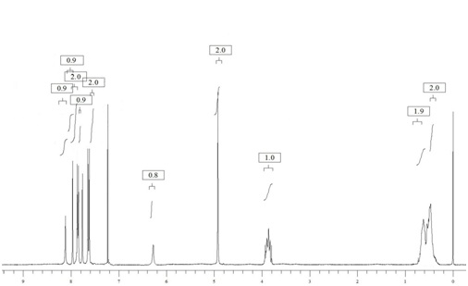

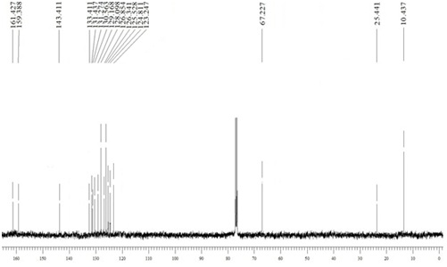

2-((2-(4-Chlorophenyl)-4-oxo-5-(trifluoromethyl)quinazolin-3(4H)-yl)oxy)-N-cyclopentylacetamide (5e)
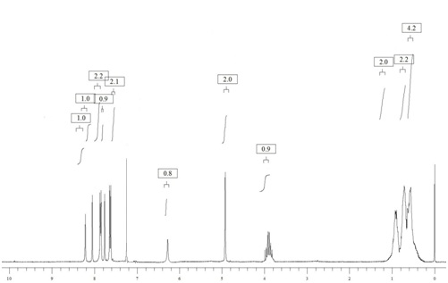

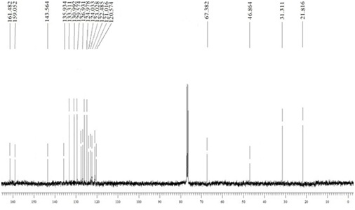

2-((2-(4-chlorophenyl)-4-oxo-5-(trifluoromethyl)quinazolin-3(4H)-yl)oxy)-N-cyclohexylacetamide (5f)
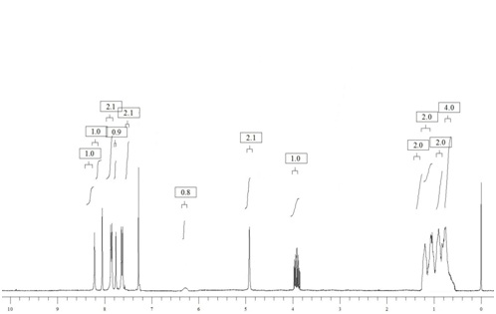

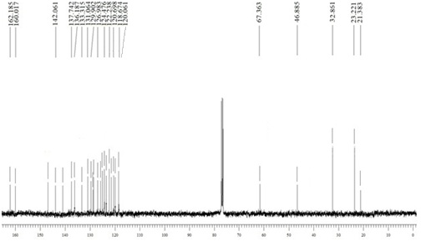

N-(2-Aminoethyl)-2-((2-(4-chlorophenyl)-4-oxo-5-(trifluoromethyl)quinazolin-3(4H)-yl)oxy)acetamide (5g)

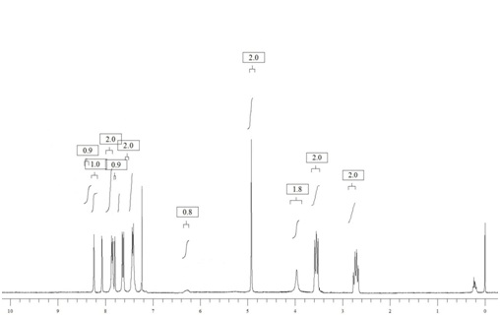

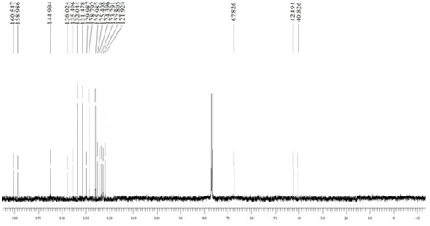

2-((2-(4-Chlorophenyl)-4-oxo-5-(trifluoromethyl)quinazolin-3(4H)-yl)oxy)-N-(2-hydroxyethyl)acetamide (5h)
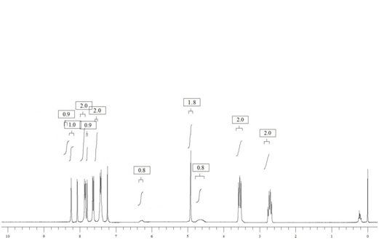

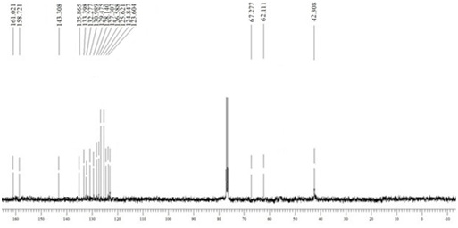

2-((2-(4-Chlorophenyl)-4-oxo-5-(trifluoromethyl)quinazolin-3(4H)-yl)oxy)-N-(furan-2-ylmethyl)acetamide (5i)
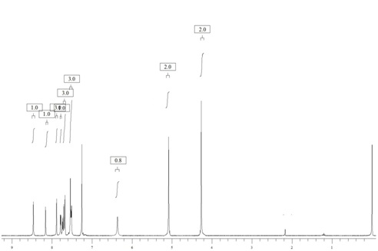

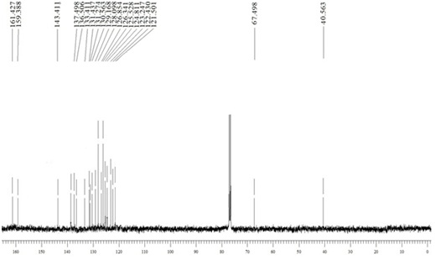

N-Benzyl-2-((2-(4-chlorophenyl)-4-oxo-5-(trifluoromethyl)quinazolin-3(4H)-yl)oxy)acetamide (5j)

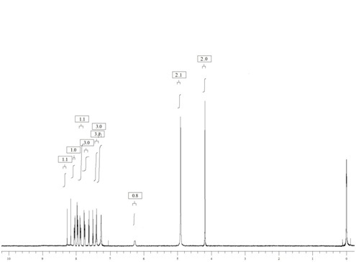

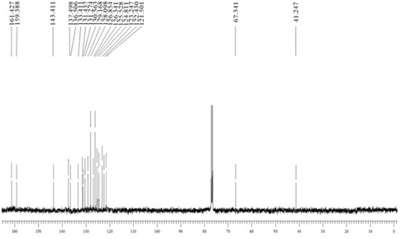

2-((2-(4-Chlorophenyl)-4-oxo-5-(trifluoromethyl)quinazolin-3(4H)-yl)oxy)-N-(3-methylbenzyl)acetamide (5k)
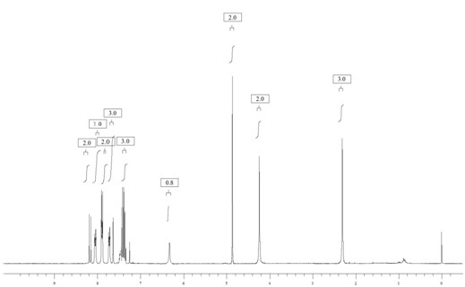

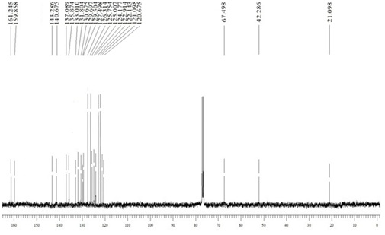

2-((2-(4-Chlorophenyl)-4-oxo-5-(trifluoromethyl)quinazolin-3(4H)-yl)oxy)-N-(4-methoxybenzyl)acetamide (5l)

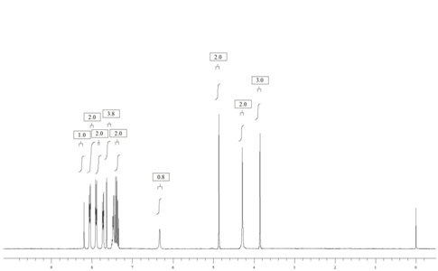

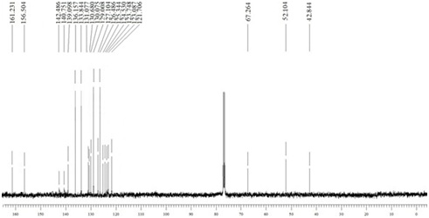

2-((2-(4-Chlorophenyl)-4-oxo-5-(trifluoromethyl)quinazolin-3(4H)-yl)oxy)-N-(3-(trifluoromethyl)benzyl)acetamide (5m)

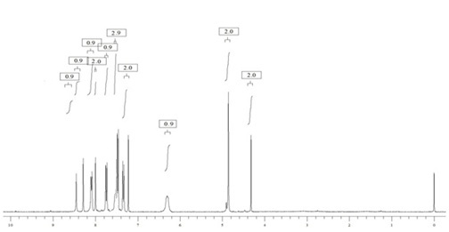

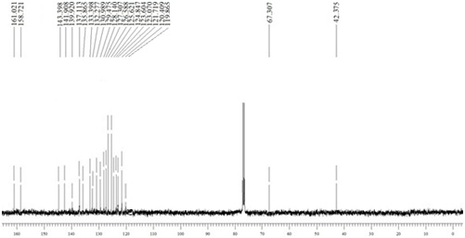

N-(4-Chlorobenzyl)-2-((2-(4-chlorophenyl)-4-oxo-5-(trifluoromethyl)quinazolin-3(4H)-yl)oxy)acetamide (5n)

