Supporting information

Cytotoxicity effect, network pharmacology, molecular docking, and molecular dynamics simulation of new mono-chalcone compounds for breast cancer

Noor Zafirah Ismail¹, Melati Khairuddean^{1,*}, Mohammad Murwih Alidmat², Sadiq Abubakar^{1,3}, Hasni Arsad⁴

¹School of Chemical Sciences, Universiti Sains Malaysia, 11800, Penang, Malaysia
²Faculty of Pharmacy, Jadara University, Irbid 21110, Jordan.
³Department of Pure and Industrial Chemistry, Bayero University Kano, 3011, Kano, Nigeria
⁴Advanced Medical and Dental Institute, Universiti Sains Malaysia, Bertam, 13200 Kepala Batas, Penang, Malaysia

Corresponding author:

Melati Khairuddean
School of Chemical Sciences, Universiti Sains Malaysia, 11800, Penang, Malaysia
Email: melati@usm.my

(E)-3-(2’’-chloro-4’’-fluorophenyl)-1-(2’,5’-dichlorothiophen-3’-yl)prop-2-en-1-one, 5
Yield: 76%. Colour: white solid; mp: 132-136°C. MW: 335.62. IR (ν, cm⁻¹): 3064 (Csp²-H str.); 2837 (Csp³-H str.), 1650 (C=O str.), 1588 (C=C aromatic str.), 1568 (C=C alkenyl str.), 811 (C-F), 765 (C-Cl). ¹H-NMR (500 MHz, CDCl3) δ, ppm: 8.10 (1H, d, J=15.5 Hz, H-2), 7.73 (1H, d, J=9.0 Hz, H-6’’); 7.33 (1H, d, J=15.5 Hz, H-3), 7.28 (1H, s, H-4’), 7.22 (1H, dd, J=7.3 Hz, 9.0 Hz, H-3’’), 7.07 (¹H, ddd, J=2.5 Hz, 8.5 Hz. 16.5 Hz, H-5’’). ¹³C NMR (125 MHz, CDCl₃) δ, ppm: 185.4 (C-1), 164.5 (C-4’’), 139.5 (C-2’’), 137.5 (C-1’’), 136.7 (C-6’’), 131.5 (C-5’), 129.2 (C-4’), 127.1 (C-2’), 125.6 (C-3), 117.8 (C-3’), 117.6 (C-3’’), 115.02 (C-5’’), 114.8 (C-2). CHN Elemental analysis for C₁₃H₆C_{l3}FOS: Calculated: C, 46.52%; H, 1.80%; Found: C, 46.71%; H, 1.74%.
(A)

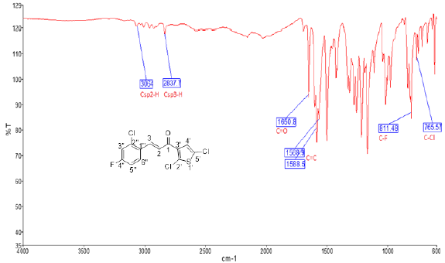

(B)

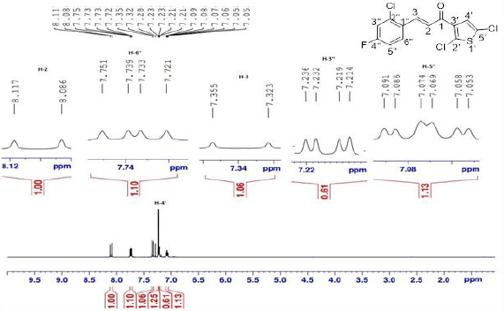
(C)

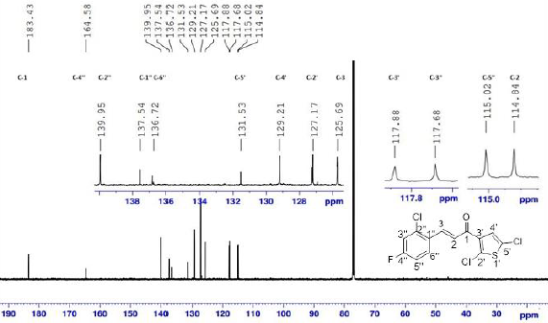

Fig. S1. Spectra of thienyl chalcone: (E)-3-(2’’-chloro-4’’-fluorophenyl)-1-(2’,5’-dichlorothiophen-3-yl)prop-2-en-1-one, 5: (A) FTIR; (B) ¹H-NMR (500 MHz, CDCl₃); (C) ¹³C-NMR (125 MHz, CDCl₃)

(E)-4-(3-(5’’-chlorothiophen-2’’-yl)-3’-oxoprop-1’-en-1’-yl) benzalde-hyde, 8
Yield: 82%. Colour: yellow solid; mp: 259-264°C. MW: 276.74. IR (ν, cm⁻¹): 3073 (Csp²-H str.); 1647 (C=O str.), 1588 (C=C aromatic str.), 1526 (C=C alkenyl str.), 719 (C-Cl). ¹H-NMR (500 MHz, CDCl₃) δ, ppm: 10.06 (¹H, s, H-1’’’); 7.95 (2H, d, J=8.25 Hz, H-2,6); 7.86 (1H, d, J=15.5 Hz, H-1’); 7.79 (2H, d, J=8.25 Hz, H-3,5); 7.69 (1H, d, J=4.0 Hz, H-3’); 7.43 (1H, d, J=15.5 Hz, H-2’); 7.05 (1H, d, J=4.0 Hz, H-4’’). ¹³C NMR (125 MHz, CDCl3) δ, ppm: 191.4 (C-1’’’), 180.5 (C-3’), 143.8 (C-2’’), 142.5 (C-1’), 140.5 ( C-4), 140.1 (C-5’’), 137.4 (C-1), 131.6 (C-3’’), 130.2 (C-3,5), 129.8 (C-4’’), 129.0 (C-2,6), 123.1 ( C-2’). CHN Elemental analysis for C₁₄H₉ClO₂S: Calculated: C, 60.76%; H, 3.28%; Found: C, 60.71%; H, 3.34%.

(A)

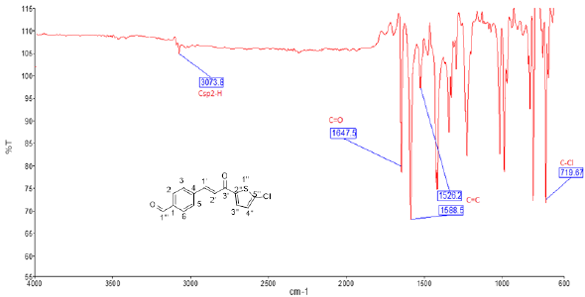

(B)

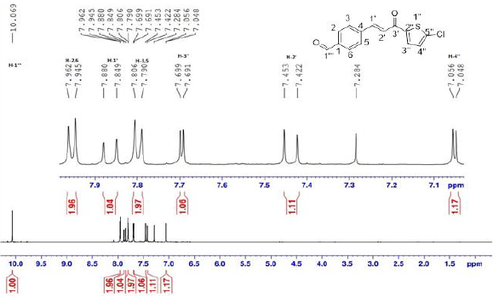
(C)

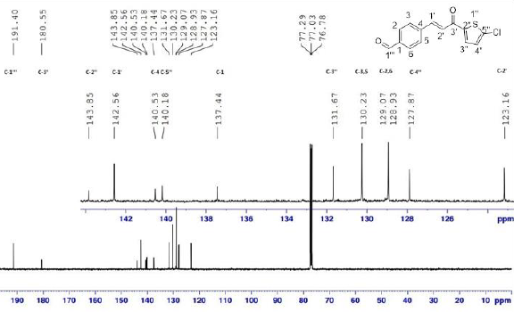

Fig. S2. Spectra of thienyl chalcone: (E)-4-(3-(5’’-chlorothiophen-2’’-yl)-3’-oxoprop-1’-en-1’-yl) benzaldehyde, 8: (A) FTIR; (B) ¹H-NMR (500 MHz, CDCl₃); (C) ¹³C-NMR (125 MHz, CDCl₃)

