Facile Assembly of Flexible Symmetric Micro-Supercapacitors with Wide Working Voltage Window

Xiangguang Han^{a, b, c}, Libo Zhao^{a, b, c}, Min Li^{a, b, c}*, Chen Jia^{a, b}*, Zhikang Li^{a, b, c}, Jiaqi Xie^{a, b}, Guoxi Luo^{a, b, c}*, Ping Yang^{a, b, c}, Rabah Boukherroub^{d}, Yurdanur Türker^{e}, Mert Umut Özkaynak^{e, f}, Koray Bahadır Dönmez^{e}, Zhuangde Jiang^{a, b, c}

ª State Key Laboratory for Manufacturing Systems Engineering, International Joint Laboratory for Micro/Nano Manufacturing and Measurement Technologies, Xi’an Jiaotong University (Yantai) Research Institute for Intelligent Sensing Technology and System, Xi’an Jiaotong University, Xi’an 710049, China
^{b} School of Instrument Science and Techonology, Xi’an Jiaotong University, Xi’an, 710049, China
^{c} Shandong Laboratory of Advanced Materials and Green Manufacturing at Yantai, Yantai, 264000, China
^{d} Univ. Lille, CNRS, Centrale Lille, Univ. Polytechnique Hauts-de-France, UMR 8520 - IEMN, F-59000 Lille, France
^{e} Sabanci University Nanotechnology Research and Application Center (SUNUM), Istanbul, Turkey
^{f} Department of Materials Science and Engineering, Istanbul Technical University, Istanbul, Turkey

*To whom correspondence should be addressed: limin@xjtu.edu.cn (M. Li), jiachen0224@stu.xjtu.edu.cn (C. Jia), luoguoxi@mail.xjtu.edu.cn (G. Luo).

EXPERIMENTAL SECTION
Materials and reagents. Phosphoric acid (H₃PO₄.H₂O; PA) with a purity of 99.99% was obtained from Sigma-Aldrich (China). Lauryl ether 23 was procured from JK Scientific (Turkey) with a purity of 100% and used as a non-ionic surfactant (NI). Polyimide (PI) film was purchased from Zhongshan Chenxi Technology Co., Ltd (China). Polydimethylsiloxane (PDMS) was bought from Sigma-Aldrich (China).
Preparation of the PA-NI LC gel electrolyte. The preparation of the phosphoric acid-non-ionic surfactant liquid crystal (PA-NI LC) gel electrolyte was performed according to our previous work^{S1}. Firstly, 1.0 g of lauryl ether 23 was heated at its melting point of 50 ºC. Then, it was mixed with 7.6 g of phosphoric acid (PA, 85.0% wt/wt) in a 20 mL glass vial. This mixture was homogenized at 80 ºC for 15 min to obtain the LC gel phases.
Characterization. The crystal structure was characterized by X-ray diffraction (XRD; D8 Advanced, Bruker) using Cu Kα radiation in the 2θ range of 10° to 80°. Raman spectroscopy measurements were performed on a Laser Raman spectrometer (HORIBA) using a 532-nm laser diode as excitation source. Visible light was focused by a 50× objective. The scattered light was collected by the same objective in backscattering configuration, dispersed by an 800 mm focal length monochromator and detected by a CCD camera. X-ray photoelectron spectra (XPS) were recorded on a photoelectron spectrometer (ESCALAB Xiþ, ThermoFisher Scientific) with Al Kα as the X-ray source. The laser confocal scanning microscope (LCSM) images were obtained by using OLS4000 microscope. SEM images were acquired to observe the morphology and structure of as-prepared samples using a field-emission scanning electron microscope (FESEM; Gemini SEM 500, Zeiss, 15 kV). Transmission electron microscopy (TEM) and high-resolution TEM (HRTEM) micrographs, and selected area electron diffraction (SAED) were recorded with a transmission electron microscope (TEM; JEM-F200, JEOL) operating at 200 kV. Elemental characterization was conducted with an energy dispersive X-ray spectrometer (EDS) through areal elemental mapping and analysis.
Electrochemical measurements. CV curves were collected at different scan rates (100 - 500 mV·s⁻¹). GCD measurements were recorded at various current densities ranging from 0.08 to 0.4 mA·cm⁻². Electrochemical impedance spectroscopy (EIS) was performed in the frequency range from 10⁻² Hz to 10⁵ Hz.

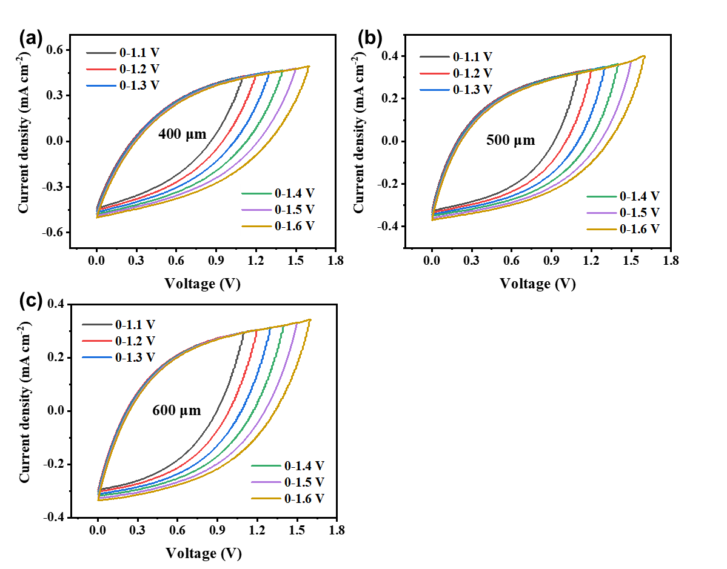
Figure S1. CV plots of LG-based MSCs devices with electrode widths of (a) 400 μm, (b) 500 μm and (c) 600 μm measured in PA-NI LC gel electrolyte at 500 mV·s⁻¹.
Figure S2. ‘Platform phenomenon’ in galvanostatic charging curve at 0.06 mA cm⁻².
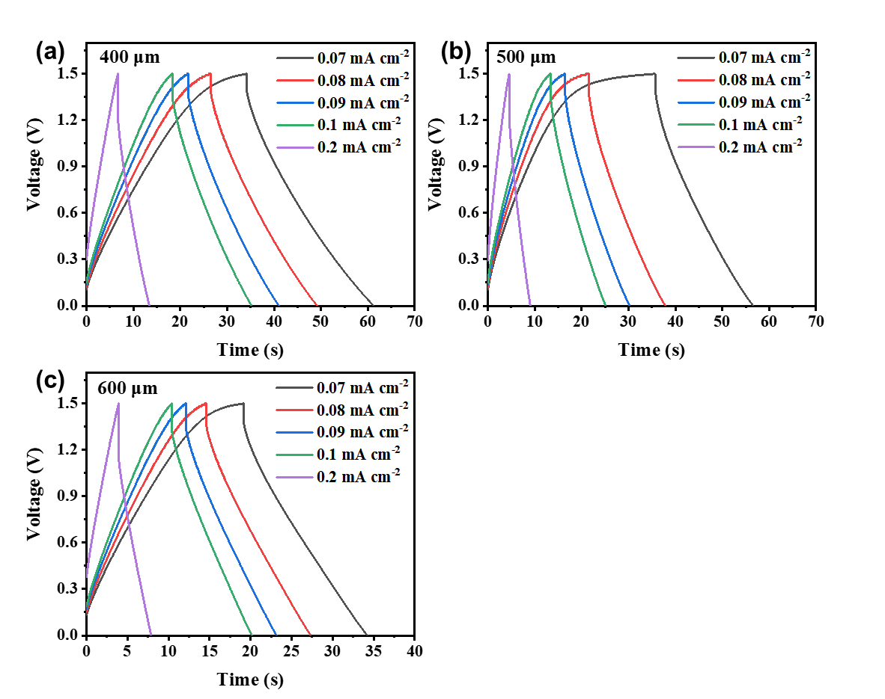
Figure S3. GCD profiles of LG-based MSCs devices with electrode widths of (a) 400 μm, (b) 500 μm and (c) 600 μm measured in PA-NI LC gel electrolyte at various current densities.

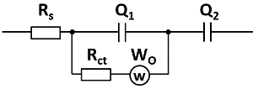
Figure S4. Electrochemical impedance spectra of LG-based MSCs with PA-NI LC gel electrolyte. The insert in upper-right corner is the corresponding equivalent circuit of the EIS results.
Table S1. Resistance values of as-prepared MSCs.
Electrode width (μm) | Intrinsic resistance  (R_{s}) / ohm cm⁻² | Charge transfer resistance (R_{ct}) / ohm cm⁻²
300 | 0.03 | 1121.0
400 | 0.07 | 1143.2
500 | 0.13 | 1163.2
600 | 0.18 | 1256
Reference
S1. Li, M. et al. An efficient cobalt-nickel phosphate positive electrode for high-performance hybrid microsupercapacitors. J. Energy Storage 64, 107144 (2023).

