Supporting Information for
Electrical on-chip detection of propagating surface plasmon with near-field coupling
Xiangqian Li^{1,#}, Weikang Liu^{1,#}, Huijie Wang¹, Li Chen³, Zhiqiang Guan^{1,*}, Hongxing Xu^{1,2,*}
¹School of Physics and Technology, Center for Nanoscience and Nanotechnology, and Key Laboratory of Artificial Micro- and Nano-structures of Ministry of Education, Wuhan University, Wuhan 430072, China
²The Institute for Advanced Studies, Wuhan University, Wuhan 430072, China
# Equal contributions * Corresponding authors

Authors’ email addresses:
Hongxing Xu: hxxu@whu.edu.cn. Phone: +8627 6875 2253.
Zhiqiang Guan: zhiqiang.guan@whu.edu.cn. Phone: +86186 2715 4793.

Sample fabrication process
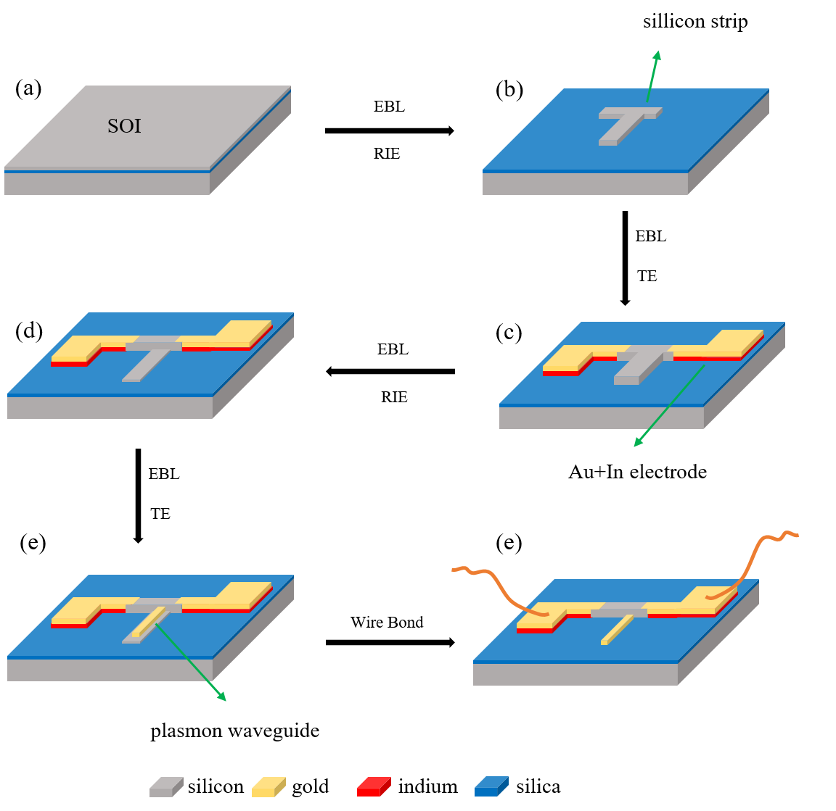
Figure S1. The microfabrication process of the device. EBL: Electron beam lithography. RIE: Reaction ion etching. TE: Thermal evaporation. We connect the device to PCB for test by wire bonding.

Optimization of plasmon waveguides
The high refractive index insertion layer can effectively reduce the leaky loss. Figure S2.a shows the optical detection of the end emission of the SPPs propagating in two gold nanowires with and without optimized silicon thickness. When we directly reduce the size of Au film to subwavelength nanowire, we can hardly detect any photocurrent or scattering photons. However, the end scattering spot is clear for the gold nanowire with 53 nm thick silicon layer insert (Figure S2.b). This proves the feasibility to improve the propagation length of plasmon modes by inserting a thin Si layer under Au nanowire.
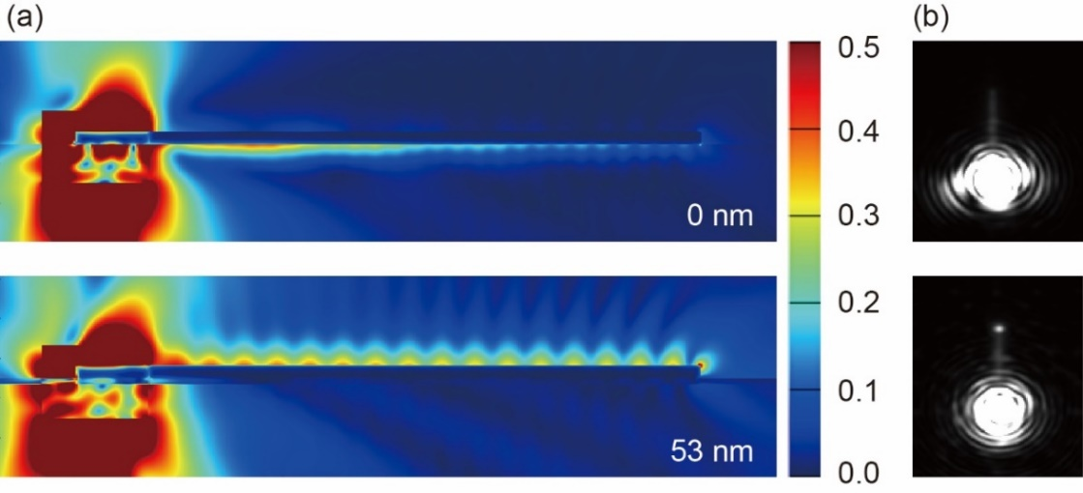
Figure S2. Optimization of the Au nanowire structure compatible with SOI substrate. (a) The electrical field distribution of Au nanowires with or without 53 nm silicon film underneath the nanowire by FDTD 3D simulations. (b) The corresponding scattering image taken by CCD camera. The comparison results confirm the significant waveguide optimization.

Normalization of photocurrent
The photocurrent is normalized by photocurrent response with laser directly illuminating on Si to eliminate the effect of changes in laser intensity. When the device is driven by external bias 20 mV voltage, Figure S3 shows the photocurrent when the laser illuminating on the coupling grating (red curve) and the photocurrent when the laser directly illuminating on Si (dark curve). Therefor the normalized photocurrent is calculated by I_{grating}/I_{si}.
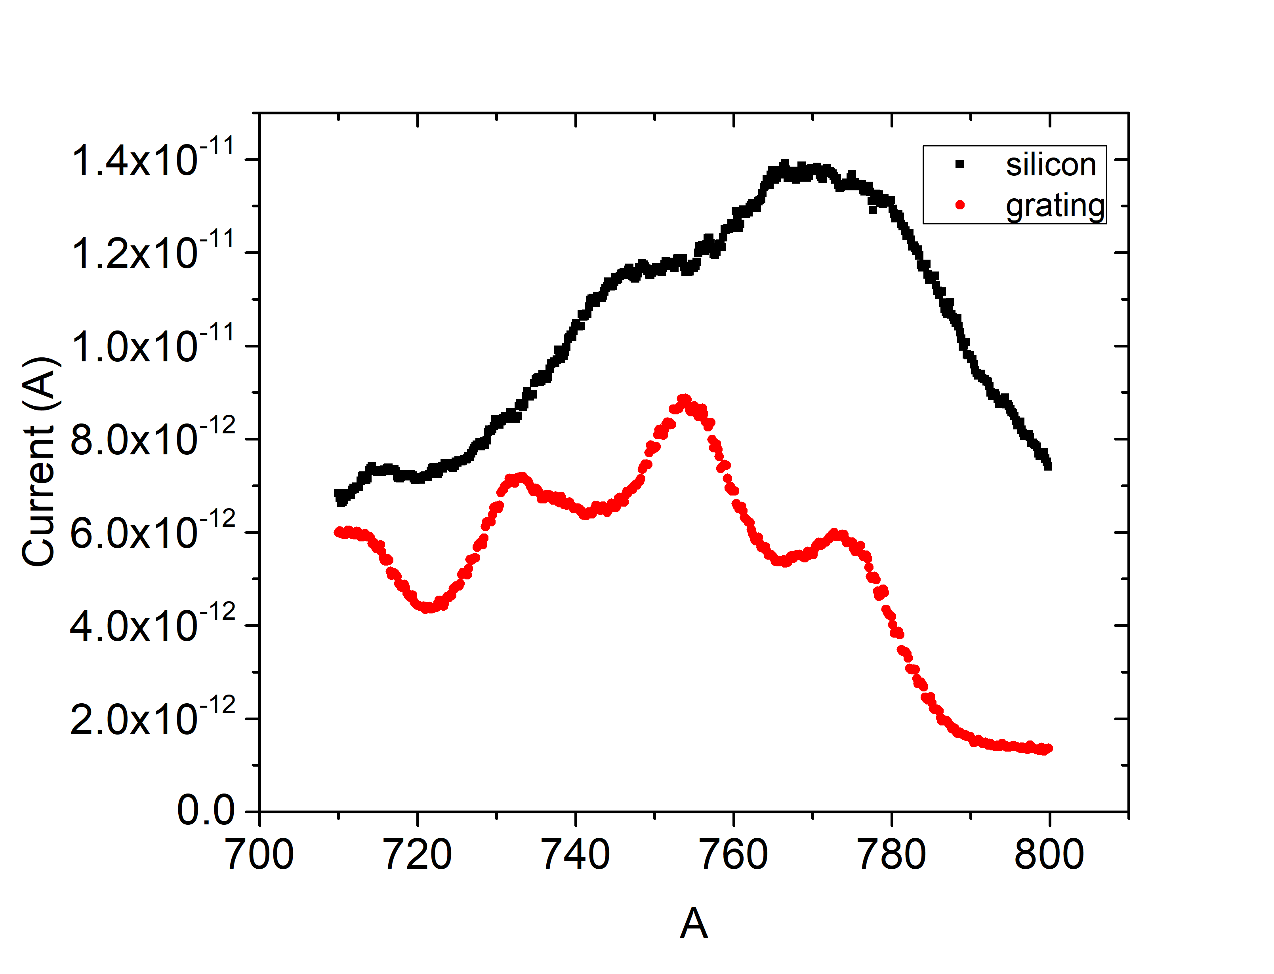
Figure S3. Photocurrent external bias 20 mV voltage

Absorption efficiency simulation in the silicon strip
When the thickness of the silicon strip is fixed at 220 nm, the absorption efficiency increases with the increase of the width, as shown in Figure S4.a. When the length of the silicon strip is above $\text{3 μm}$, the increase rate decreases, and the strip has a good absorption effect, for example greater than 55% at the wavelength of 710 nm. The strip has a higher absorption efficiency for the thicker silicon strip, as show in Figure S4.c. Although we are using SOI substrates with 220 nm top layer silicon in our experiments, it can be seen from the figure that when the thickness of the silicon strip is greater than 200 nm, the corresponding absorption efficiency is above 52%.

The change of the waveguide length has little effect on the absorption efficiency (Figure S4.b), but the gap width between the silicon strip and the gold waveguide matters a lot to the coupling efficiency. It can be seen in Figure S4.d that the smaller gap always lead to higher absorption efficiency, because the plasmon energy is more easily coupled into the silicon strip. As the gap decreases, the ratio of reflection back to the incident end and absorption into the silicon strip increases, while the energy scattered into the space decreases, the coupling efficiency increases. We can notice the peaks and valleys in the absorption curve, which are caused by the characteristic of the propagating surface plasmon，when the length of the gold waveguide is an integer multiple of 1/4 wavelength correspond to the valleys in the figure. The improvement of the coupling efficiency makes the influence of the plasmon oscillation on the absorption efficiency weakened, that is, the oscillation phenomenon in the figure is weakened. When the gap is 10 nm, there is almost no oscillation with wavelength.
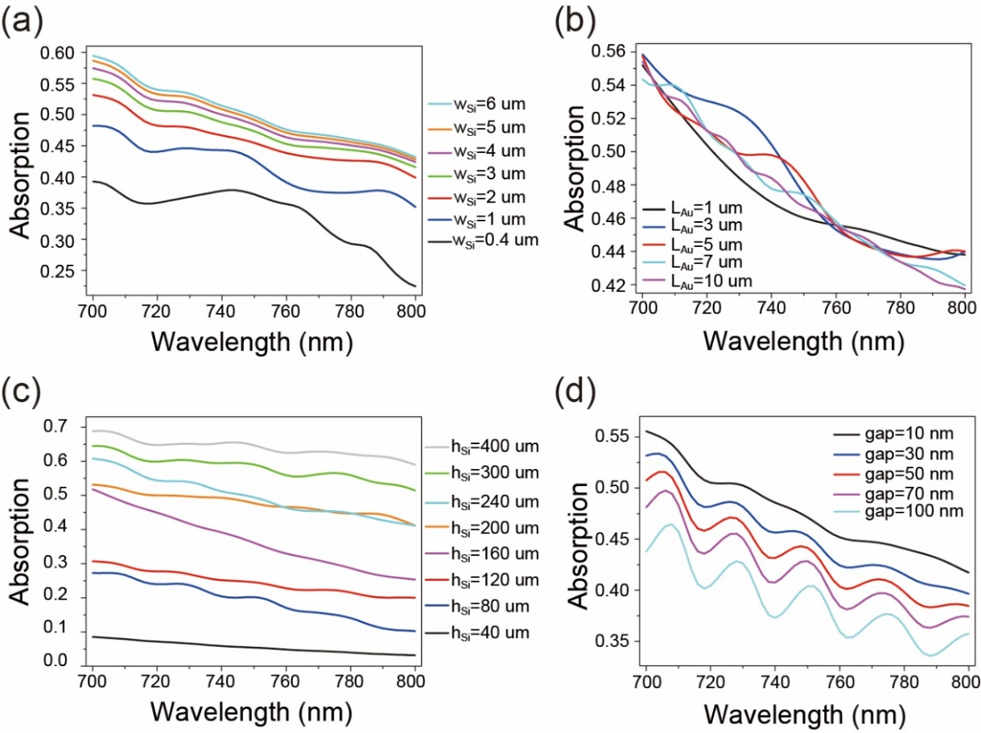
Figure S4. (a) The absorption efficiency when changing the width of the silicon strips. (b) The absorption efficiency curves of silicon for different length gold waveguide. They are almost intertwined, indicating that the effect on the absorption efficiency is faint. (c) The absorption efficiency of silicon strips with different thicknesses. (d) The absorption efficiency when change the gap size between silicon strip and gold waveguide. In the above cases, the fixed parameters are set to be consistent with the experiment, that is, the width of the silicon strip is 2.9 μm, the thickness is 220 nm, the gap is 10 nm, and the length of the waveguide is 6.5 μm, the thickness is 90 nm.

