Supplementary information

Supplementary figure 1: Error bars illustrating variability of mean prediction error at the best performance of the four models for 14 datasets
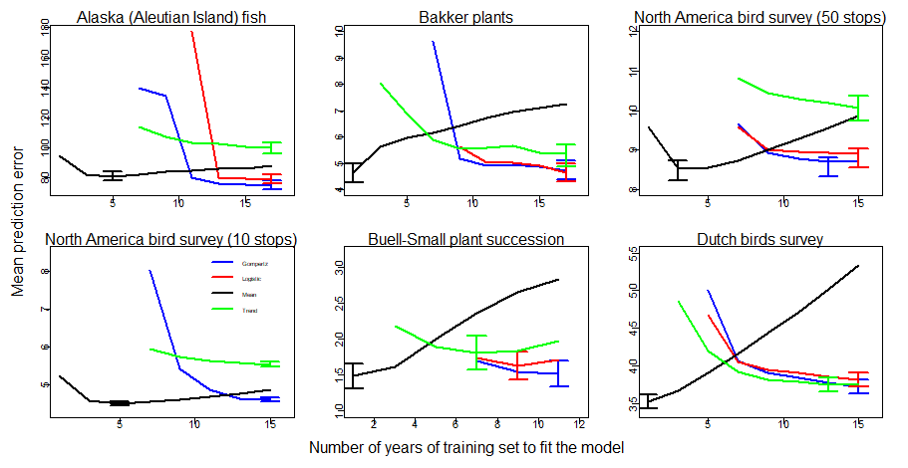
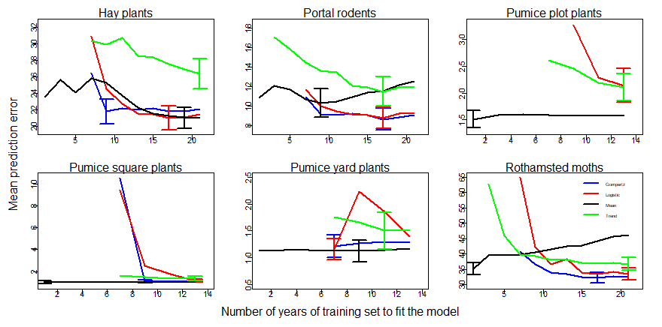

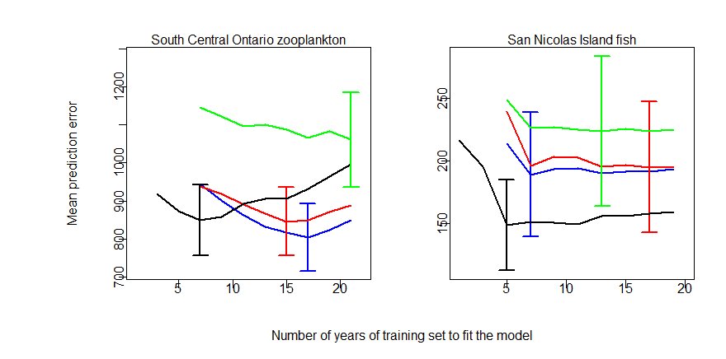

- The error bars in the graph illustrate the variability around the mean prediction error, indicating the performance of each model in the corresponding datasets. The standard error of the mean (SE) is used to quantify this variability.

Supplementary figure 2: Mean absolute prediction error using ‘best’ training set size with error bars for each of the 14 datasets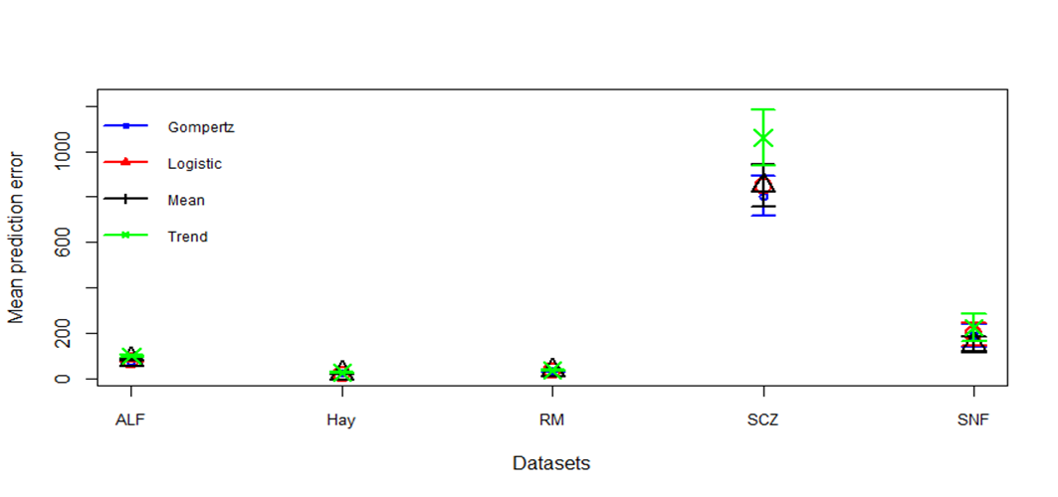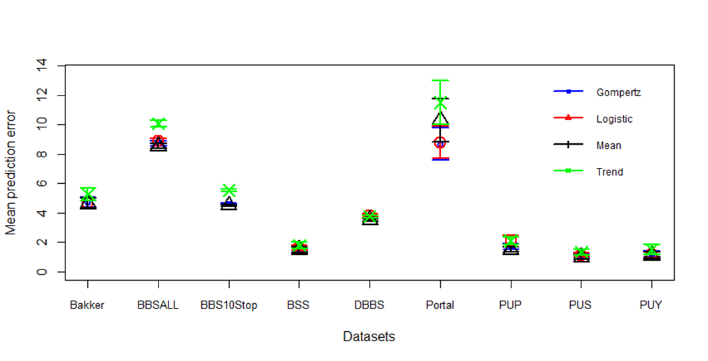

Supplementary table 1: Chi square significant test and pairwise comparison of the predictive ability of models in 14 datasets
Sites | Gompertz | Logistic | Mean | Trend | Total number of time series | p-value
ALF | 259 | 206 | 365 | 136 | 968 | p < 0.001
Bakker | 17 | 8 | 41 | 12 | 78 | p < 0.001
BBSALL | 1016 | 956 | 2968 | 651 | 5591 | p < 0.001
BBS10Stop | 1483 | 1406 | 3895 | 666 | 7450 | p < 0.001
BSS | 15 | 4 | 16 | 5 | 40 | p < 0.05
DBBS | 115 | 97 | 391 | 123 | 726 | p < 0.001
Hay | 10 | 4 | 21 | 2 | 37 | p < 0.001
Portal | 3 | 3 | 4 | 1 | 11 | p > 0.05
PUP | 73 | 47 | 221 | 13 | 354 | p < 0.001
PUS | 58 | 54 | 165 | 16 | 293 | p < 0.001
PUY | 24 | 21 | 67 | 9 | 121 | p < 0.001
RM | 88 | 66 | 107 | 77 | 338 | p < 0.05
SCZ | 11 | 11 | 23 | 4 | 49 | p < 0.05
SNF | 4 | 6 | 10 | 3 | 23 | p > 0.05
- Table showing the number of time series where each model outperformed others across the total time series for each 14 datasets and its significance assessment.

Supplementary table 2: Description of 14 datasets used in the research project.
Datasets | Abbreviation | Location | Group | Number of  Species | Time series | Number of Training Set Years
Aleutian Islands Ground Fish Survey | ALF | Alaska, US | Fish | 16 | 968 | 17
Bakker Plant | Bakker | Netherlands | Plants | 22 | 78 | 17
North America Breeding Bird Survey (50 stops) | BBSALL | North America | Birds | 254 | 5591 | 15
North America Breeding Bird Survey (10 stops) | BBS10STOP | North America | Birds | 195 | 7450 | 15
Buell-Small Succession Study | BSS | New Jersey, USA | Plants | 18 | 21 | 11
Dutch Breeding Bird Survey | DBBS | Netherlands | Birds | 103 | 726 | 15
Hay Plants | Hay | Kansas, USA | Plants | 8 | 37 | 21
Portal Rodents | PR  Portal/PR | Arizona, USA | Rodents | 3 | 11 | 21
Pumice Plot | PUP | Mt. St. Helens, USA | Plants | 16 | 344 | 13
Pumice Square | PUS | Mt. St. Helens, USA | Plants | 18 | 293 | 13
Pumice Yard | PUY | Mt. St. Helens, USA | Plants | 20 | 121 | 13
Rothamsted Moths | RM | UK | Moths | 144 | 338 | 21
South Central Ontario Lakes Zooplankton | SCZ | South Central Lakes, Canada | Zooplankton | 14 | 49 | 21
San Nicolas Island Fish | SNF | California, US | Fish | 10 | 23 | 19

