Supplementary Information

Title: Global Trends and Research Progress of Occupational Exposure to Formaldehyde and Cancer: A Bibliometric Analysis (1991-2022)
Reza Pourbabaki ^{1, 2}, Hossein Abbaslou ³, Mohsen Sadeghi-Yarandi ³, Esmaeel Soleimani ¹, Jooyeon Hwang ^{4, 5} *
¹ Department of Occupational Health, School of Health, Shiraz University of Medical Sciences, Shiraz, Iran
² Student Research Committee, Shiraz University of Medical Sciences, Shiraz, Iran
³ Department of Occupational Health, School of Health, Tehran University of Medical Sciences, Tehran, Iran
⁴ Department of Epidemiology, Human Genetics and Environmental Sciences, School of Public Health, The University of Texas Health Science Center, Houston, Texas, USA
⁵ Southwest Center for Occupational and Environmental Health, The University of Texas Health Science Center, Houston, Texas, USA

*Corresponding author: Jooyeon Hwang, Associate Professor, The University of Texas Health Science Center, 1200 Pressler St. RAS E607, Houston, TX 77030-3900, USA | Tel: 713-500-9274 |
Email address: jooyeon.hwang@uth.tmc.edu

Table S1. Search query used in WOS to retrieve relevant publications from initiation up to 2022
Search | Query | Items found
#1 | TS=(formaldehyde OR “methyl aldehyde”) | 64,439
#2 | TS=(Cancer* OR neoplas* OR tumour* OR tumor* OR carcinoma* OR adenocarcinoma OR leukemia OR leukaemia OR sarcoma OR lymphoma OR malignan* OR oncology OR metastasis OR oncogene OR chemotherapy) | 5,472,845
#3 | TS=(Occupation* OR worker* OR technician* OR Staff* OR Personnel* OR Job* OR resident OR specialist* OR industr* OR workplace) | 3,345,060
#4 | #1 AND #2 AND #3 | 758

Table S2. The top 10 co-occurrence keywords for “CFA”
Keyword | Occurrence | Total Link Strength *
Formaldehyde | 186 | 1173
Workers | 83 | 554
Mortality | 77 | 523
Occupational exposure | 65 | 408
Cancer | 68 | 398
leukemia | 49 | 334
Nasopharyngeal cancer | 27 | 230
Lymphohematopoietic malignancies | 22 | 192
Protein cross-links | 21 | 181
DNA damage | 23 | 134
* The total link strength indicates the total strength of the co-occurrence links of a given keyword with other keywords.

Fig. S1 Annual publication number between 1991 and 2022
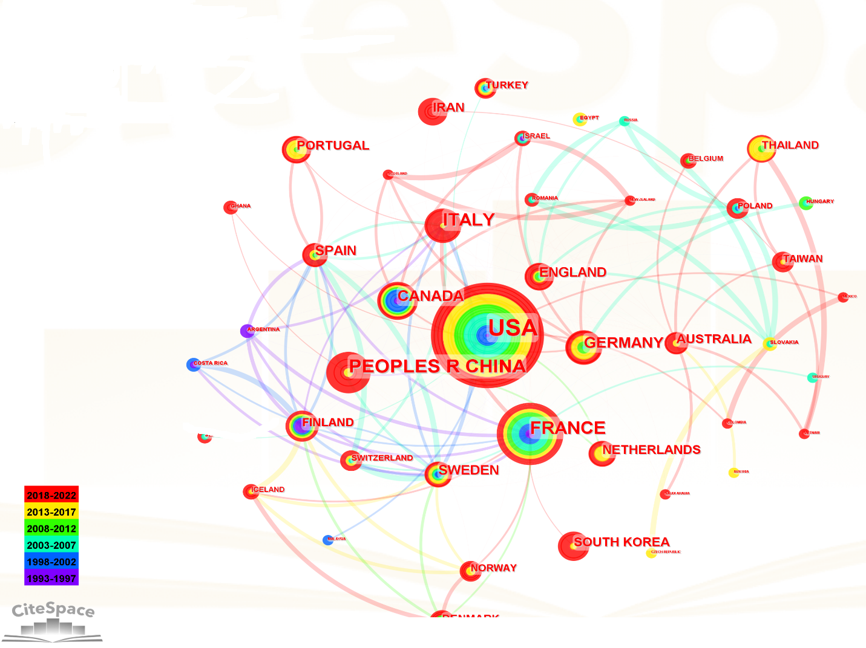
Fig. S2 The visualization map of main countries participating in CFA research
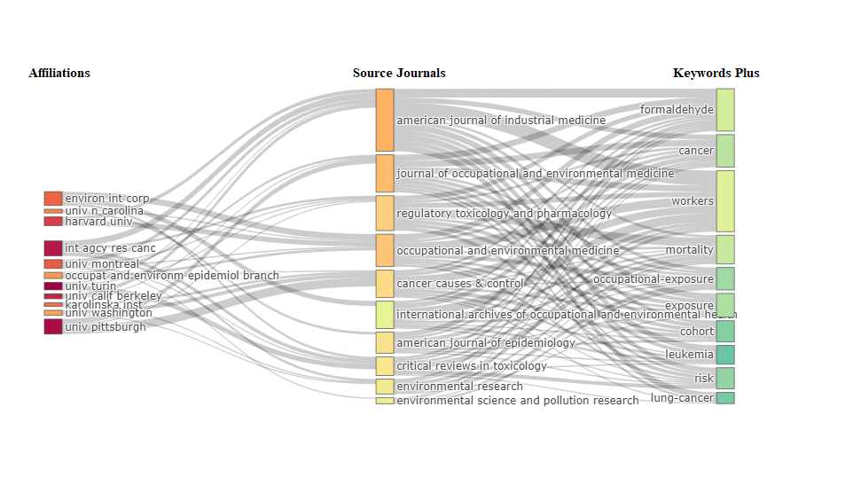
Fig. S3 Affiliation, journal, and keyword flow of CFA –related articles in the Web of Science Core Collection

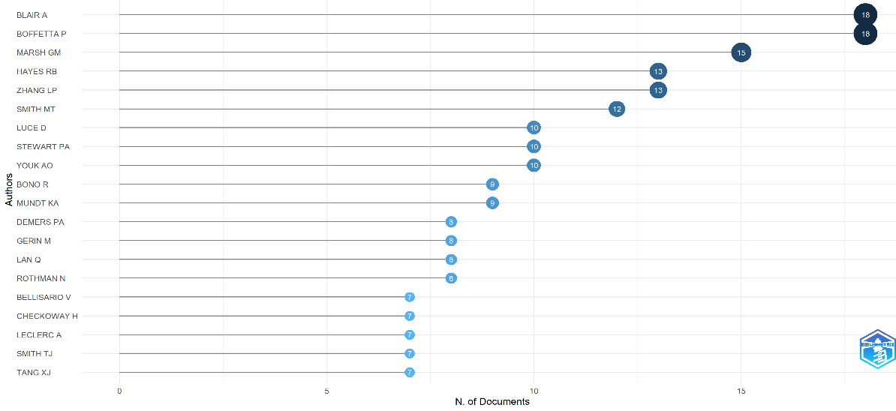
Fig. S4 Most relevant authors in CFA research based on the number of documents.

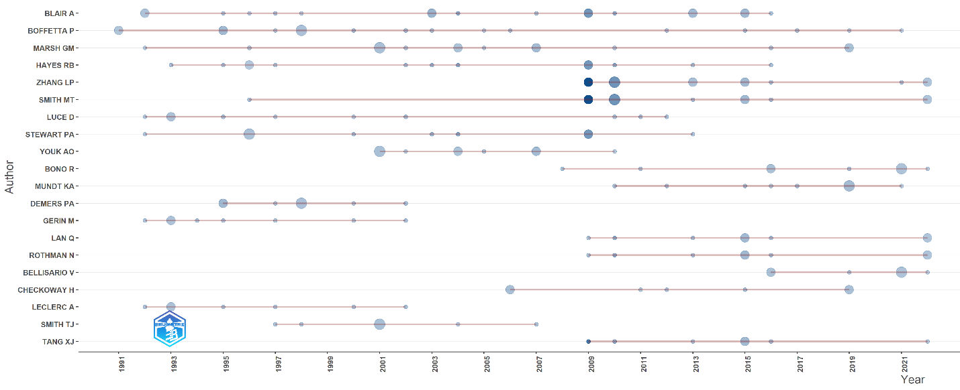
Fig. S5 Authors’ production over time.

