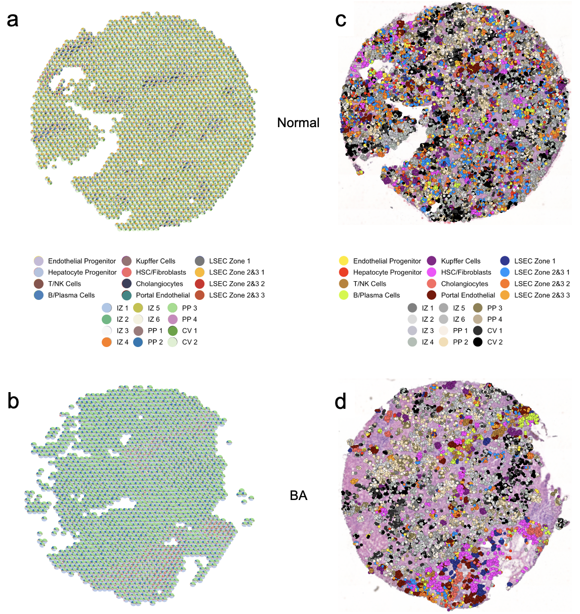
Supplemental Figure 1 | Comparison of deconvolution techniques demonstrates that mapping individual snRNASeq nuclei to Visium spatial transcriptomic ‘spots’ improves interpretability and downstream analysis in liver tissue. (a,b) Deconvolution of normal liver (a) and BA with advanced fibrosis (b) samples using CARD, a technique that maps cell type proportion to a single spot. Each Visium spot becomes a pie chart showing the percentage of different cell types in that spot. (c,d) Deconvolution of normal liver (c) and BA with advanced fibrosis (d) samples using Celltrek, which maps individual cell types to specific Visium spots, creating one new spot for each individual nuclei. This technique makes it easier to interpret the deconvolution output and use in any downstream analysis. CV = central-venous hepatocytes. HSC = hepatic stellate cells. IZ = interzonal hepatocytes. LSEC = liver sinusoidal endothelial cells. NK = natural killer cells. PP = periportal hepatocytes.

