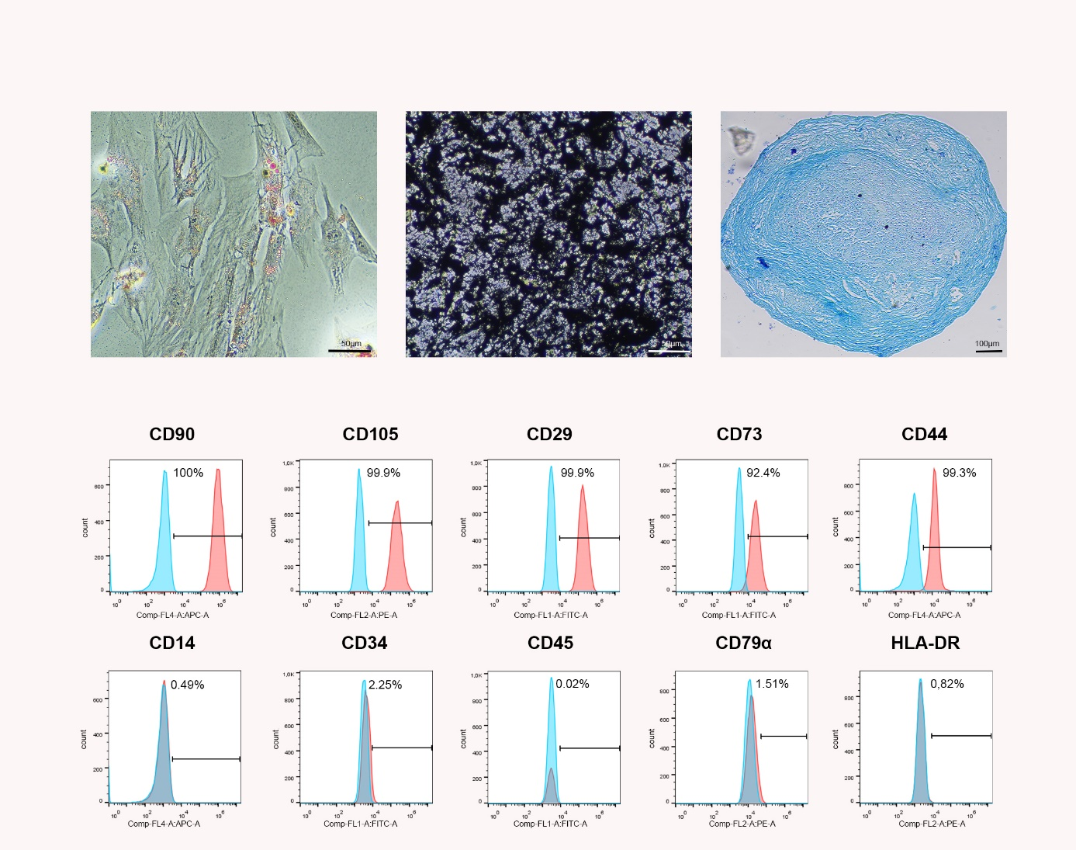
Supplementary Figure 1
Trilineage differentiation and surface marker expression. Representative images show adipogenic, osteogenic and chondrogenic differentiation after oil red O, von Kossa and Alcian blue staining, respectively. The histograms display the surface antigen expression as determined by flow cytometry in a representative sample (blue: isotype control; red: respective antibody staining).
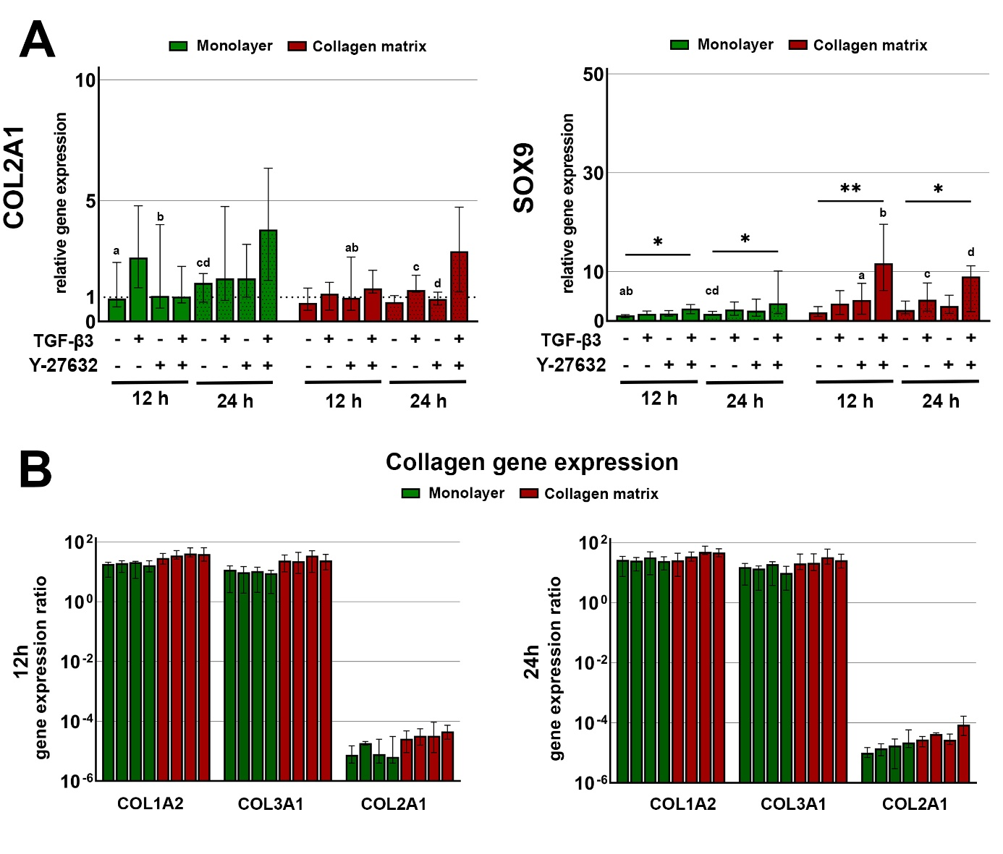Supplementary Figure 2
Gene expression of the chondrogenic markers COL2A1 and SOX9 (A). Cells cultured on monolayer or collagen matrix were incubated with 10 ng/ml TGF-β3 and/ or 10 µM Y-27632 for 12 h and 24 h. Asterisks mark differences between the stimulation groups with p < 0.05 and letters mark differences between monolayer and collagen matrix groups sharing the same letter with p < 0.05. (B) Relative gene expression ratios of COL1A2, COL3A1 and COL2A1, demonstrating the negligible expression levels of COL2A1 as compared to the other collagen types. The groups have the following order control, TGF-β3, Y-27632, TGF-β3 + Y-27632. Bars represent the median values and error bars the 95% confidence intervals.

Supplementary Figure 3
CD29^{-/-} knockout cells. Knockout of CD29 was tested by gene sequencing, immunofluorescence and western blot. Representative images and sequences of the cell clone chosen for the experiments.

Antigen | Clone | Reactivity | Species | Isotype | Company | Dilution | Fluorophore
CD90 | 5E10 | human | mouse | IgG1 | BD | 1:100 | APC
CD105 | SN6 | human | mouse | IgG1 | Serotec | 1:50 | PE
CD73 | 606112 | human | mouse | IgG2b | R&D | 1:40 | Alexa488
CD44 | IM7 | rat | rat | IgG2b | BD | 1:400 | APC
CD29 | TS2/16 | human | mouse | IgG1 | Biolegend | 1:100 | Alexa488
CD45 | F10-89-4 | human | mouse | IgG2a | Serotec | 1:400 | Alexa488
CD34 | 43A1 | human | mouse | IgG3 | Santa Cruz | 1:100 | FITC
CD14 | 134620 | human | mouse | IgG1 | R&D | 1:100 | APC
CD79α | HM57 | human | mouse | IgG1 | Serotec | 1:10 | PE
HLA-DR | L243 | human | mouse | IgG2a | Biolegend | 1:25 | -
HLA-DR | sec. ab | mouse | rabbit |  | Serotec | 1:25 | PE

Supplementary Table 1
Monoclonal antibodies used for immunophenotyping.

