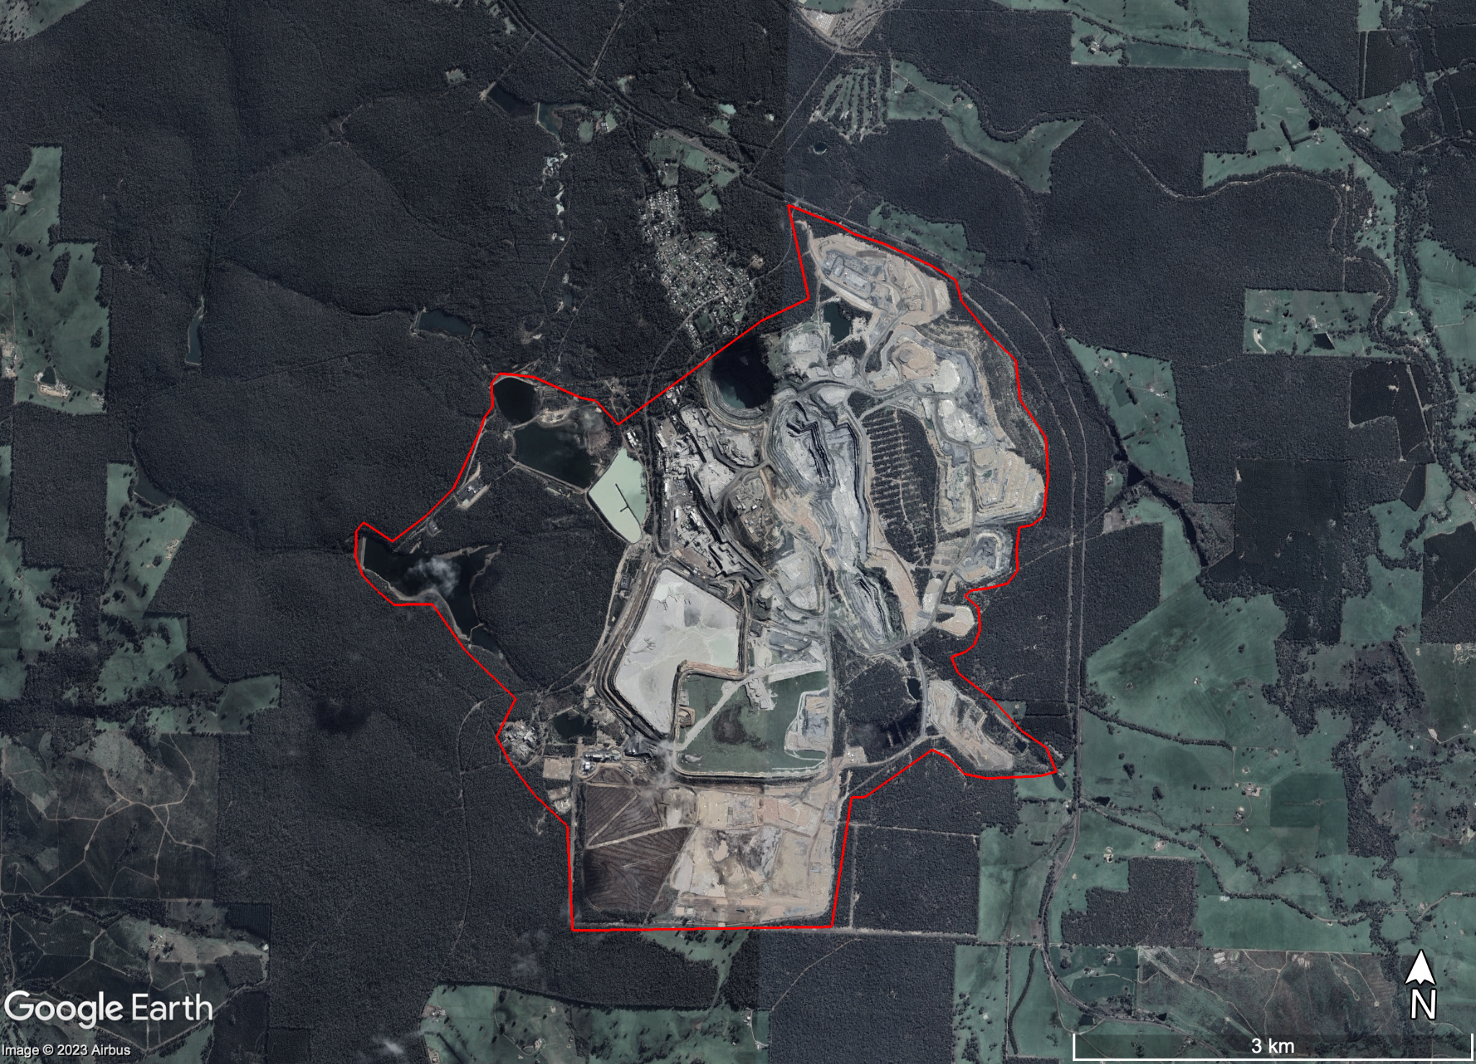
Figure S1. Example area calculation for a Western Australian lithium mine

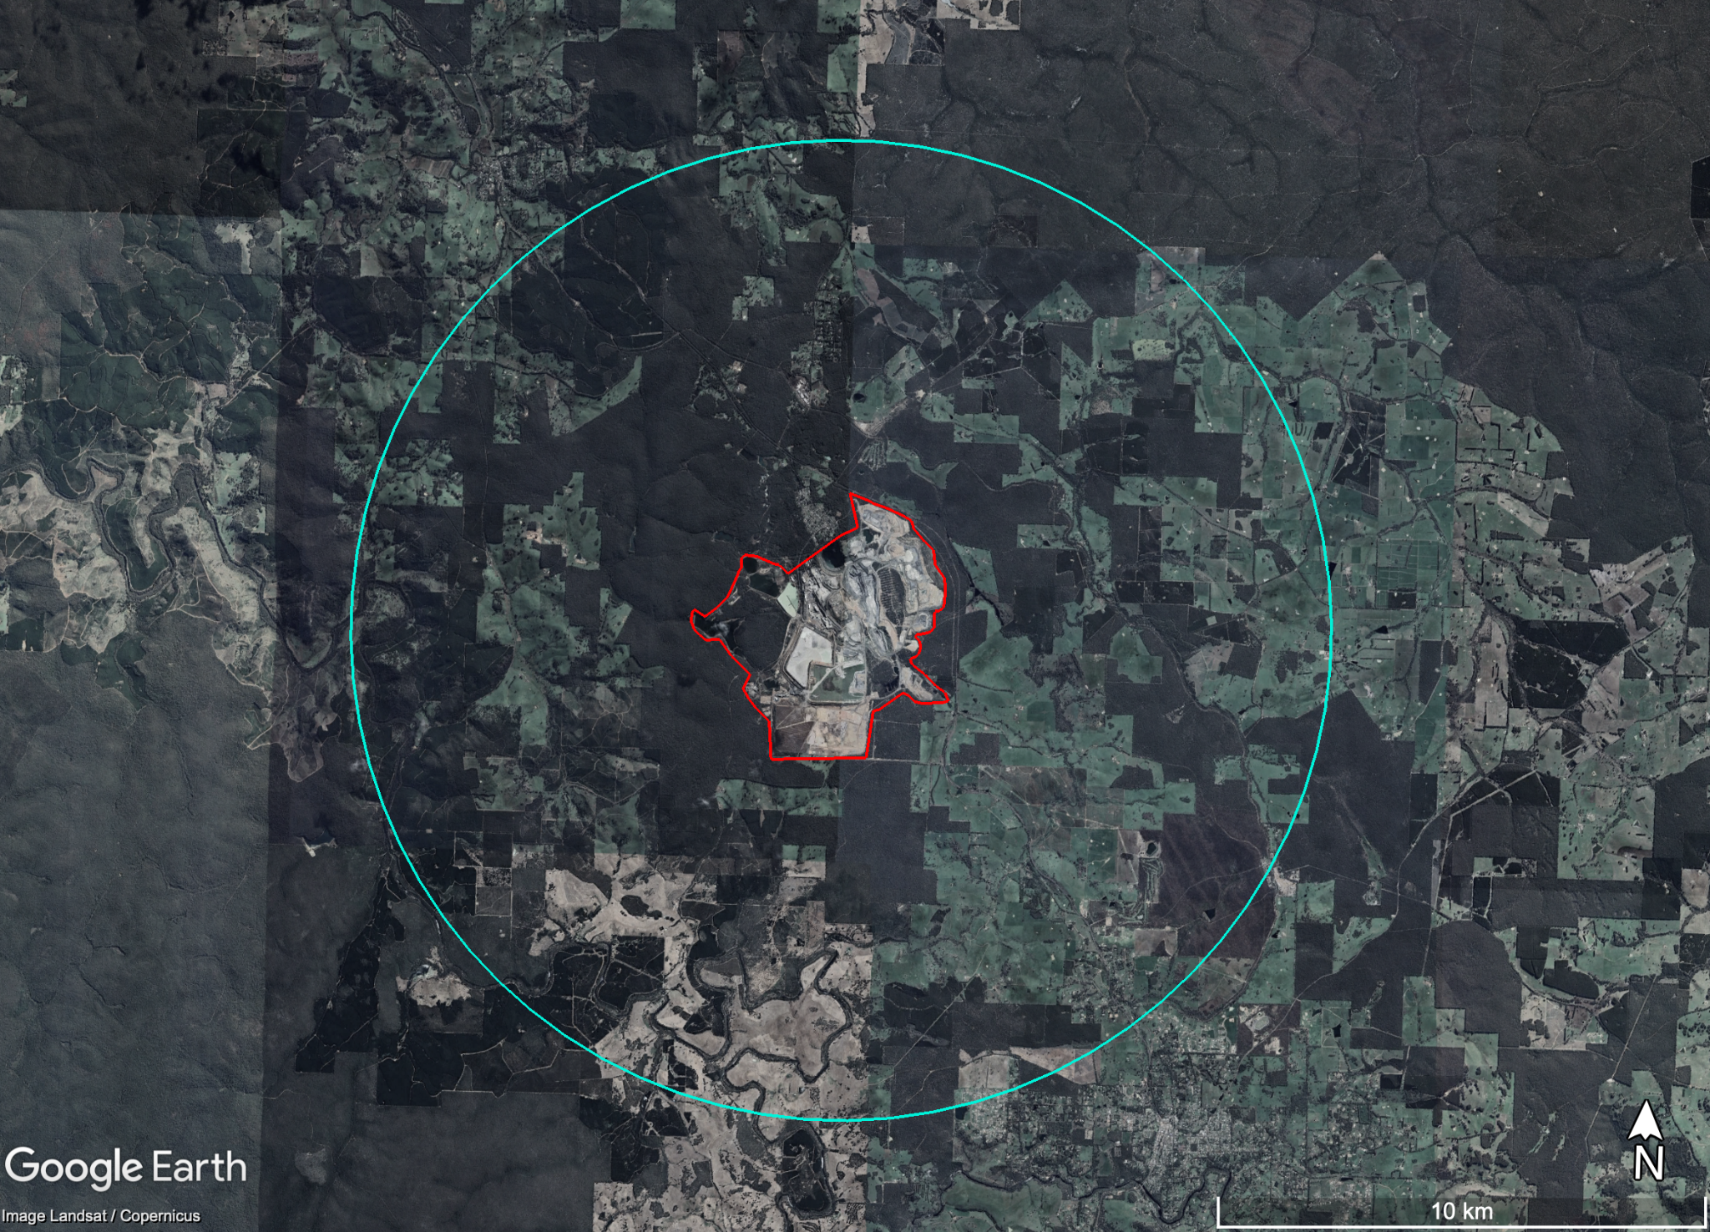

Figure S2. Example biodiversity impact area for a Western Australia lithium mine

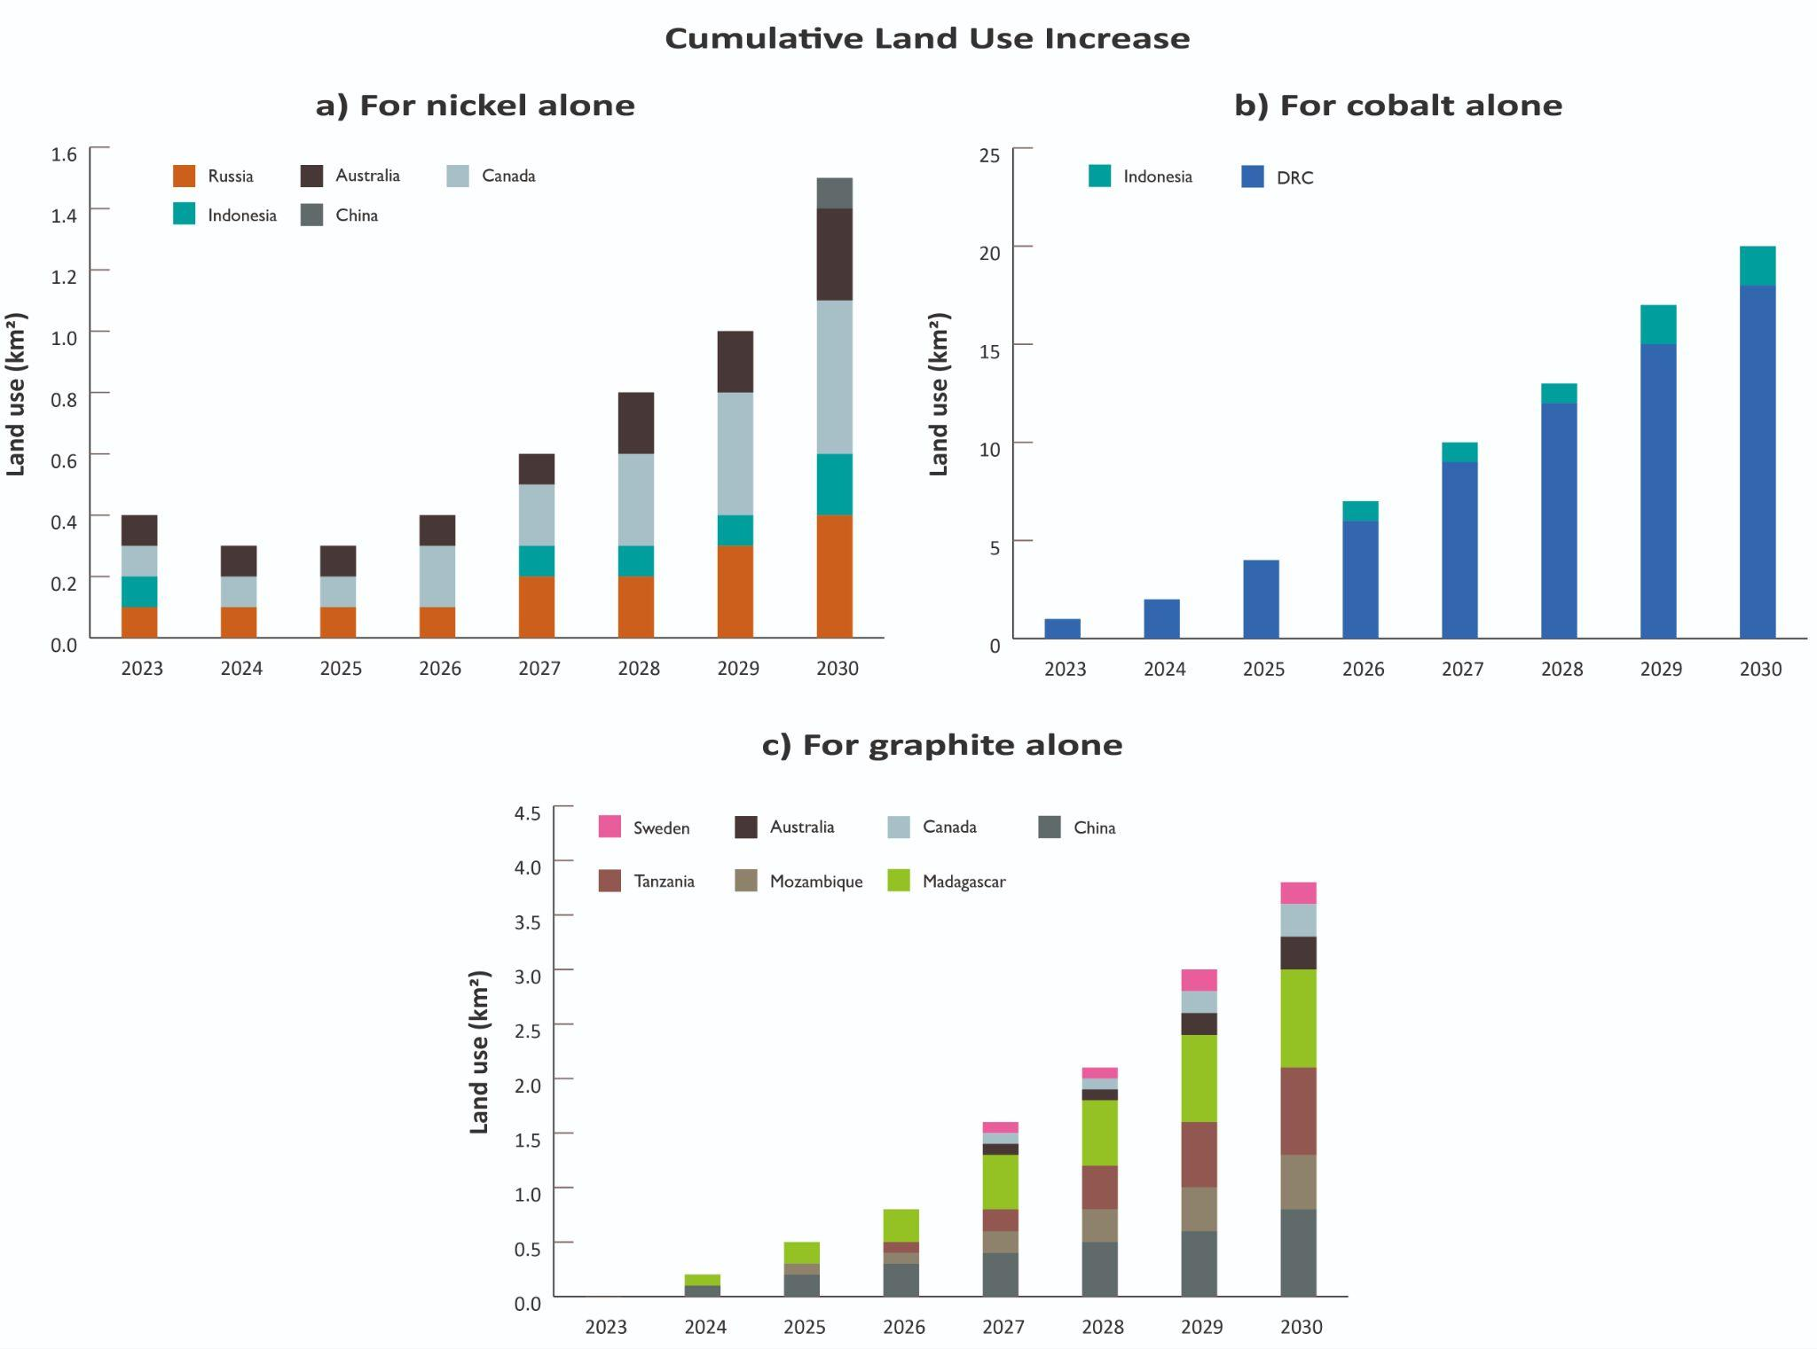
Figure S3. Cumulative land use increase (km²) for nickel, cobalt, and graphite mines

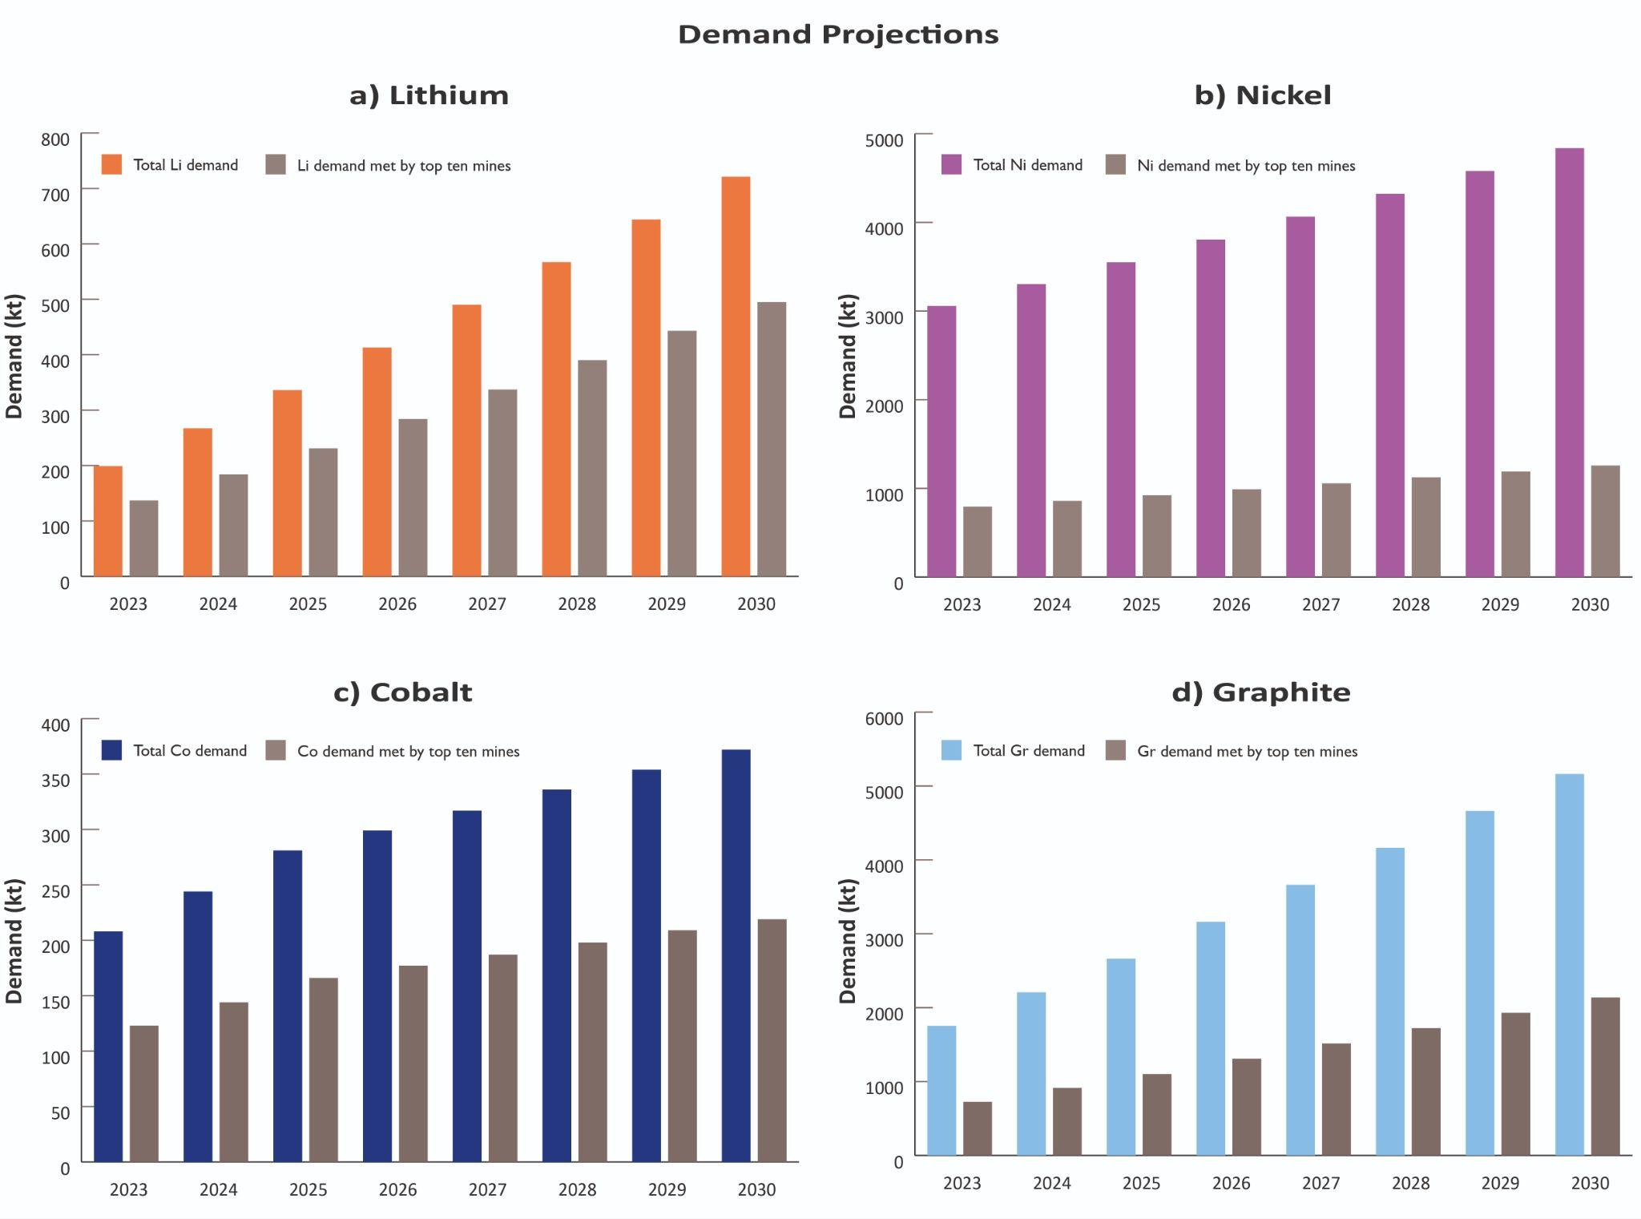
Figure S4. Mineral demand projections per mineral in kt (both total global demand and demand met by top ten mines in this study): a) Lithium, b) Nickel, c) Cobalt, d) Graphite

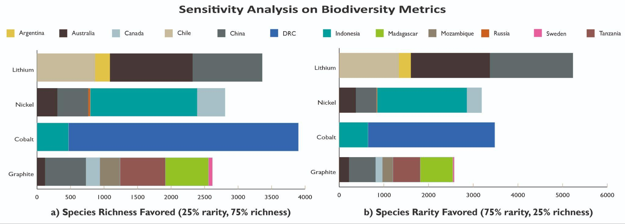
Figure S5. Biodiversity impact sensitivity analysis for the four minerals (in km2 weighted by species richness and rarity): a) Assuming a 25:75 weighting between species rarity and richness on biodiversity impact, b) Assuming a 75:25 weighting between species rarity and richness on biodiversity impact

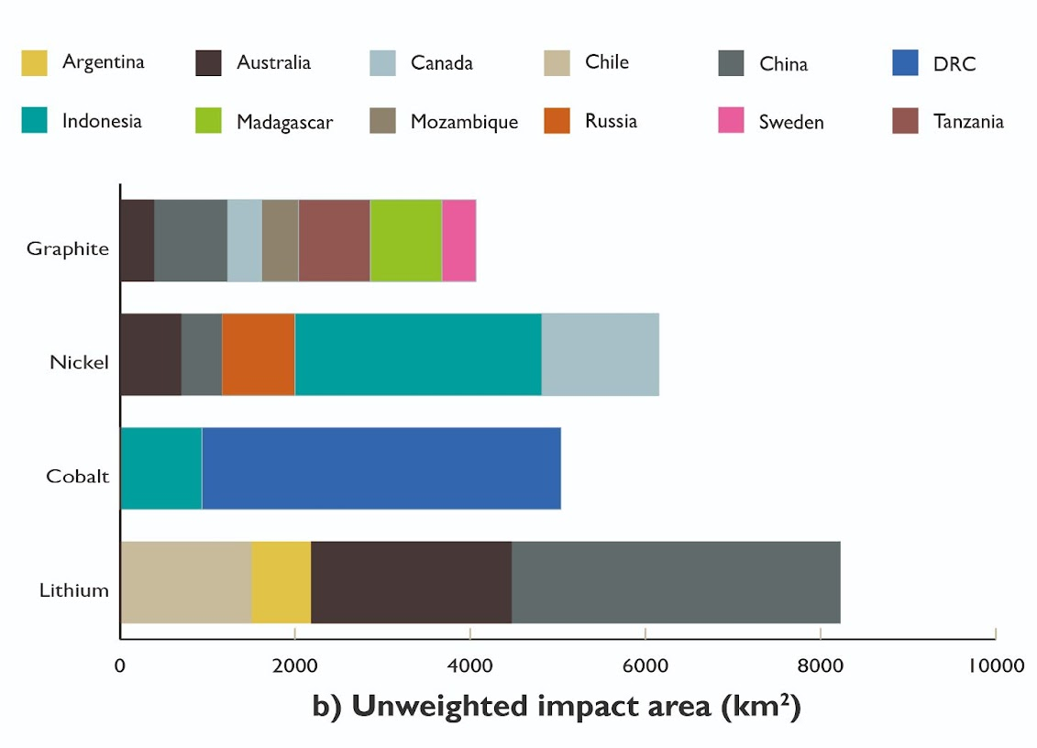
Figure S6. Unweighted impact area for all minerals and mine sites

Table S1. Average mine yields for each mineral
Mineral | Average mine yield (kt mineral per km²)
Lithium | 209
Nickel | 795
Cobalt | 209
Graphite | 4,628

