Sub-Volt High-Speed Silicon MOSCAP Microring Modulator Driven by High Mobility Conductive Oxide (Supplementary Information)
Wei-Che Hsu^{1,2}, Nabila Nujhat¹, Benjamin Kupp¹, John F. Conley, Jr¹, Haisheng Rong³, Ranjeet Kumar³, and Alan X. Wang^{1,2,*}
¹School of Electrical Engineering and Computer Science, Oregon State University, Corvallis, Oregon 97331, USA
²Department of Electrical and Computer Engineering, Baylor University, One Bear Place #97356, Waco, Texas 76798, USA
³Intel Corporation, 3600 Juliette Ln, Santa Clara, CA 95054
*alan_wang@baylor.edu
I. Review of High-Speed Si Microring Modulators Driven by Various Structures
Table 1 summarizes published state-of-the-art Si microring modulators (Si-MRM). Typically, the Q-factor of Si-MRM is designed below 5000 to achieve an optical bandwidth above 40 GHz. Most Si-MRMs require a high driving voltage (V_{pp}) for electro-optic (E-O) modulation due to their low E-O efficiency. Higher insertion loss results in a sharper resonance. Therefore, some existing Si-MRMs sacrifice the insertion loss to lower the driving voltage. Integrating the plasmonic/E-O polymer phase shifter into the Si-MRM achieved exceptionally high E-O efficiency. However, the plasmonic structure is inherently lossy and reduces the Q-factor of the Si-MRM. Our work on titanium-doped indium oxide (ITiO)-gated MOSCAP Si-MRM not only offers enhanced E-O-efficiency but also maintains a sufficient Q-factor to achieve a low driving voltage and support a large optical bandwidth.
Table 1: Comparison of performance of the high-speed MRM.
Modulator structure | Operation  band | Q-factor | E-O efficiency (pm/V) | V_{pp} (V) | V_{π}L (V•cm) | Energy efficiency (fJ/bit) | IL (dB) | f_{3dB}  (GHz) | Data rate (Gb/s) | Ref.
Reversed PN junction | O | 4200 | ~40 | 0.8  (~2) | 0.53 | 5.3 | 9  (~3) | 58 | 128 | ¹
Reversed PN junction | O | 4500 | 26.4 | 3 | 0.825 | ~85.5 | 3 | >60 | 120 | ²
MOSCAP-Si | C | 3500 | 130 | 1.5 | 0.24 | 180 | 3 | 1.7 | 3 | ³
MOSCAP-Si | C | 4600 | 40 | 1.6 | 0.7 | ~24.32 | 9 | 50 | 112 | ⁴
MOSCAP-III-V | O | 8143 | ~20 | 4 | 1 | ~250 | 2 | 15 | 28 | ⁵
MOSCAP-graphene | C | 3396 | ~33 | 6 | - | 21 | 5.8 | 52 | 40 | ⁶
Plasmonic-Polymer | C | 700 | 178 | 4 | 0.015 | 12.3 | 4 | 176 | 220 | ⁷
MOSCAP-ITiO | O | 4600 | 116 | 0.8 | 0.12 | 53 | 3 | 10 | 25 | This work

~ Didn't mention it in the article. Measured from spectra or calculated based on other parameters in the articles.
- Not available in the article
II. Optimizing Radius for ITiO-Gated MRM
The ITiO-gated MOSCAP Si-MRM is designed to achieve a Q-factor ranging from 5000 to 6000 that ensures sufficient optical bandwidth while minimizing the driving voltage. Once the ITiO is deposited on the Si ring waveguide, it introduces optical absorption losses that can decrease the Q-factor. To maintain the Q-factor after ITiO deposition, it is crucial to ensure that the loss from the Si ring waveguide is negligible compared to the optical absorption from ITiO. In other words, the Q-factor of the passive Si microring resonator should be significantly higher than 5000, for instance, around 20000. To determine the appropriate radius for the design, Fig. S1 presents the simulated loss of the bent passive Si waveguide at various radii. The geometry and doping profiles of the Si waveguide remain consistent with the design illustrated in Fig. 1. Since the waveguide is designed to be 300 nm wide, it exhibits significant bending losses at small radii. As the radius increases, the loss decreases accordingly. It is observed that when the radius exceeds 8 μm, the loss of the passive Si microring becomes sufficiently low to support a Q-factor greater than 20000. Based on the simulation results, the radius of 8 µm is chosen for the ITiO-gated MOSCAP Si-MRM design. It ensures that the passive Si microring resonator maintains a high Q-factor, even after the deposition of ITiO, enabling the desired performance.
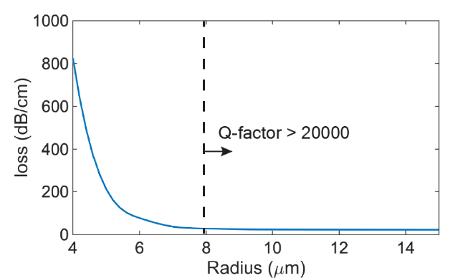
Fig. S1: Simulated optical loss of bent Si waveguide at various radii.

III. ITiO Thin Film Characterization
The ITiO material was characterized by RF-sputtering it onto lime glass in the same batch as the device. The sputtering process maintained consistent conditions, including a high substrate heating temperature of 500 °C. The thickness of the ITiO layer was determined by an ellipsometer (Film Sense FS-1). To evaluate the mobility and carrier concentration of the ITiO material, Hall measurements were performed using a Lake Shore M91 FastHall system. Furthermore, to obtain the carrier concentration, the planar carrier density obtained from the Hall measurement was divided by the thickness of the ITiO layer. Table 2 provides a summary of the ITiO material characterization results.
Table 2: Comparison of performance of the high-speed MRM.
Material | Type | Thickness  (nm) | Mobility  (cm²/(V⋅s)) | Carrier concentration (1/cm²)* | Carrier concentration (1/cm³)**
ITiO | N | 14 | 62.61 | 172.42×10¹² | 1.23×10²⁰

* Carrier concentration measurement obtained from hall measurement.
** Calculate carrier concentration per unit volume by dividing the measured planar carrier density by the thickness of the ITiO layer.
IV. C-V and I-V Characterization of the ITiO-gated Si-MRM
Fig. S2(a) illustrates the cross-sectional view of the ITiO-gated MOSCAP Si-MRM. To characterize the electrical properties of the ITiO-gated MOSCAP Si-MRM, the gate bias on ITiO varied while Si was grounded. As depicted in Fig. S2(b), the experimental capacitance of the device was measured as a function of the gate bias. When the device was biased at -1.9 V for modulation, the capacitance was found to be 500 fF. This capacitance corresponds to a dielectric constant (κ) of 12, calculated based on the 62.5% active region of the microring. However, as shown in Fig. S2(a), the device includes a 500 nm wide Si slab attached to the inner ring. Although this slab increases the device's total capacitance, it does not contribute to the effective index modulation, which will be discussed later (Supplementary Information V). To accurately calculate the dynamic power consumption of the ITiO-gated MOSCAP Si-MRM, it is necessary to eliminate such parasitic capacitance. It can be determined by subtracting the contribution of the slab from the total capacitance, resulting in 333 fF. Using the formula (CV²/4), the dynamic power consumption can be further calculated to be 53 fJ/bit. On the other hand, the static power consumption of the ITiO-gated MOSCAP Si-MRM is primarily determined by the leakage current (Fig. S2(c)). When the device is biased at -1.9V, the leakage current is measured to be 495 pA. The E-O tuning efficiency of 116 pm/V is employed to calculate the static power consumption, resulting in a value of 4.27 nW/nm.

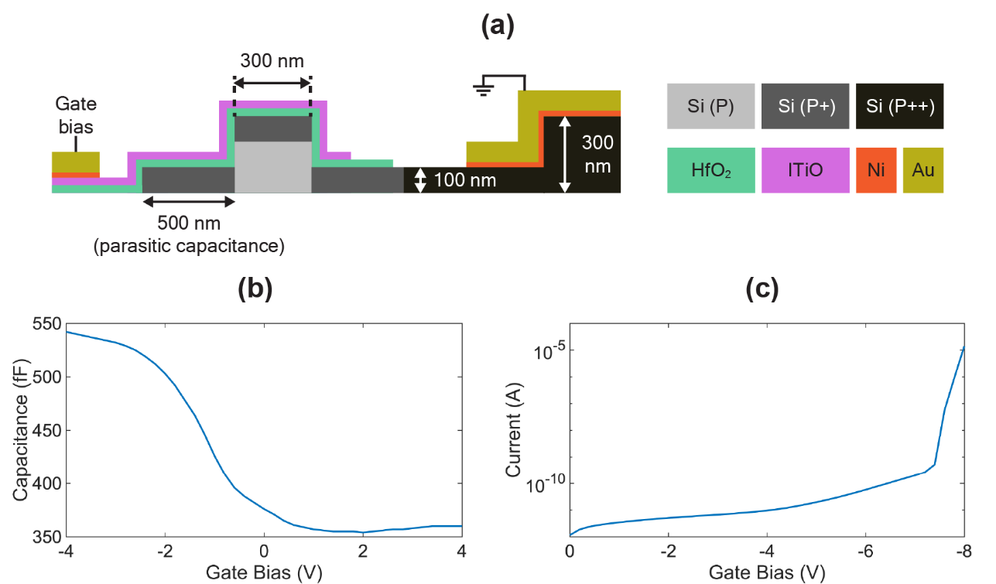
Fig. S2: Electrical characterization of the ITiO-gated MOSCAP Si-MRM with ITiO/HfO₂/Si MOSCAP. (a) Capacitance-Voltage (C-V) Curve and (b) Current-Voltage (I-V) Curve.
V. Analysis of Effective Index Modulation Contribution in ITiO-Gated Si-MRM
In Fig. 2(b), the optical mode in the ring waveguide undergoes a shift towards the ring's outer edge due to the bending. This shift leads to varying degrees of overlap between the optical mode and different sides of the ring waveguide, affecting the effective index modulation (Δn_{eff}). To analyze the contributions of each side of the ITiO-gated MOSCAP Si-MRM to Δn_{eff}, the ITiO coverage region is divided into four sections, as shown in Fig. S3(a): (1) the top of the ring, (2) the outer sidewall, (3) the inner sidewall, and (4) the slab. Fig. S3(b) presents a comparison of the simulated effective index modulation per applied bias (∂n_{eff}/∂V) for each section. Narrowing the waveguide increases the overlap with the sidewalls, leading to a significant ∂n_{eff}/∂V on both sidewalls (sections 2 and 3). Additionally, due to the optical mode shifting towards the outer edge of the ring, section 2 exhibits a stronger ∂n_{eff}/∂V compared to section 3. Since the optical mode is primarily confined within the ring, the top of the ring (section 1) still contributes a small extent to ∂n_{eff}/∂V. On the other hand, the contribution of ∂n_{eff}/∂V from the slab (section 4) is nearly negligible.
While sections 1 and 4 collectively contribute approximately 10% of the total ∂n_{eff}/∂V, they account for 42.9% of the total capacitance. In contrast, sections 2 and 3 contribute about 90% of the total ∂n_{eff}/∂V while only contributing 57.1% of the total capacitance. As results, sections 1 and 4, particularly section 4, behave more like parasitic capacitance.
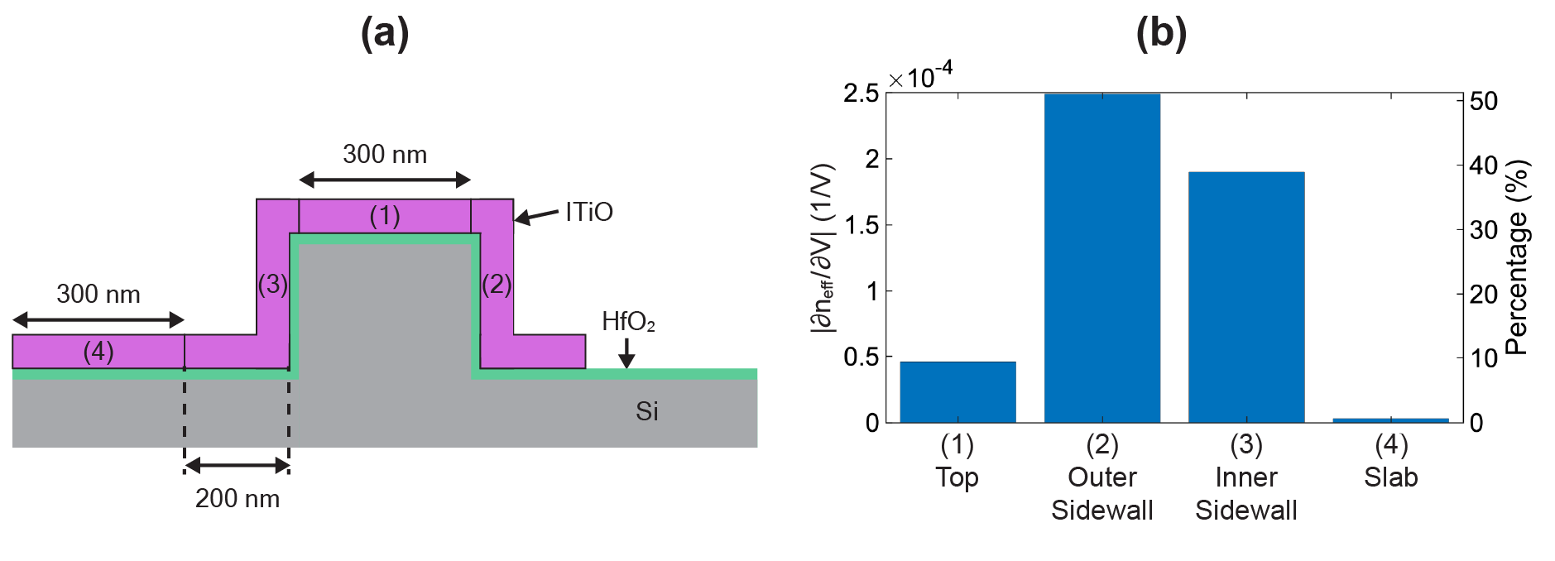
Fig. S3: (a) Illustration for the division of ITiO coverage sections in the MRM waveguide, including (1) the top side of the ring, (2) outer ring sidewall with 200 nm slab, (3) inner ring sidewall with 200 nm slab, and (4) 300 nm slab only. (b) Comparison of simulated effective index modulation per applied bias (∂n_{eff}/∂V) among the different sections.
References
1. Sakib, M. et al. A high-speed micro-ring modulator for next-generation energy-efficient optical networks beyond 100 Gbaud. in CLEO SF1C.3 (2021).
2. Zhang, Y. et al. 240 Gb/s optical transmission based on an ultrafast silicon microring modulator. Photonics Res. 10, 1127–1133 (2022).
3. Campenhout, J. Van et al. Low-voltage, low-loss, multi-Gb/s silicon micro-ring modulator based on a MOS capacitor. in OFC/NFOEC 1–3 (2012).
4. Zhang, W. et al. Harnessing plasma absorption in silicon MOS ring modulators. Nat. Photonics 17, 273–279 (2023).
5. Liang, D. et al. An Energy-Efficient and Bandwidth-Scalable DWDM Heterogeneous Silicon Photonics Integration Platform. IEEE J. Sel. Top. Quantum Electron. 28, 1–19 (2022).
6. Kong, D., Liu, Y., Ding, Y., Hu, H. & Luan, C. Ultrahigh-modulation-efficiency graphene-silicon micro-ring modulator. (2023). doi:10.21203/rs.3.rs-2921645/v1.
7. Eppenberger, M. et al. Resonant plasmonic micro-racetrack modulators with high bandwidth and high temperature tolerance. Nat. Photonics 17, 360–367 (2023).

