Supplementary Table 1. Qualitative model performance in the test set for report generation.
 | Incorrect content |  |  |  | Missing content
 | O1 | O2 | O3 | Kappa | O1 | O2 | O3 | Kappa
No | 67% | 67% | 71% | 0.746 | 62% | 60% | 65% | 0.739
Yes, little clinical significance | 28% | 25% | 24% | 0.746 | 33% | 30% | 30% | 0.739
Yes, great clinical significance | 5% | 8% | 5% | 0.746 | 5% | 10% | 5% | 0.739

Supplementary Table 2. Qualitative model performance in the test set for medical question answering.
A
Incorrect Content | O1 | O2 | O3 | Kappa
No | 74% | 71% | 67% | 0.764
Yes, little clinical significance | 23% | 24% | 27% | 0.764
Yes, great clinical significance | 3% | 5% | 6% | 0.764

B
Missing Content | O1 | O2 | O3 | Kappa
No | 83% | 85% | 84% | 0.806
Yes, little clinical significance | 15% | 12% | 14% | 0.806
Yes, great clinical significance | 2% | 3% | 2% | 0.806

C
Extent of Possible Harm | O1 | O2 | O3 | Kappa
No harm | 93% | 95% | 93% | 0.834
Moderate or mild harm | 5% | 3% | 5% | 0.834
Death or severe harm | 2% | 2% | 2% | 0.834

Supplementary Table 3. The question lists for visual question answering.

- Is there any abnormality?
- What is the diagnosis?
- Where is the abnormality?
- Is this condition severe?
- Can this condition cause blindness?
- Will this condition progress?
- What is the outcome of this condition?
- What is the prognosis for this condition?
- What might be the cause of this condition?
- What are some common complications that can occur?
- What should I do?
- What is your suggestion for me?
- What kind of further testing might be necessary?
- What might be the treatment options for this condition?
- How can I prevent this condition?
- Can you explain how FFA works and what it can detect?
- What is the arterial/venous/late phase of FFA?
- How long does an FFA test usually take to complete?
- Is there anything I should avoid doing after an FFA test?
- Will the contrast dye used in angiography remain in my body?

Supplementary Table 4. Examples of generated answers with great clinical significance in accuracy, completeness and harmfulness.
Aspect | Report | Question | Answer
Accuracy | Familial exudative vitreoretinopathy in the left eye.  Left eye fundus fluorescein angiography (FFA): Arterial filling and venous return are mostly normal. There is increased vascularization of the retina, with vascular stiffness. Mild leakage is observed from clustered small vessels in the temporal side of the macula. Temporal, superotemporal, and inferotemporal regions show straightened and prematurely terminating blood vessels, with residual arcuate areas of non-perfusion. Within these non-perfusion areas, there are visible signs of old laser spots. On the nasal side, there are straightened blood vessels and circular laser spots. The optic disc shows patchy areas of hyperfluorescence in an arcuate spot. | What is the prognosis for this condition? | Based on the findings in the left eye, the prognosis for Familial Exudative Vitreoretinopathy (FEVR) is guarded. The increased vascularization of the retina, with vascular stiffness, suggests that the disease is progressing. The mild leakage from clustered small vessels in the temporal side of the macula may indicate that the retinal layers are thinning, which can lead to further vision loss.  The straightened and prematurely terminating blood vessels in the temporal, superotemporal, and inferotemporal regions are a hallmark of FEVR and can lead to non-perfusion areas, which can result in permanent vision loss. The presence of residual arcuate areas of non-perfusion and visible signs of old laser spots within these areas suggests that the disease has been present for some time.  The patchy areas of hyperfluorescence in the optic disc may indicate that the retina is still functioning, but the degree of damage is significant. The presence of circular laser spots on the nasal side may indicate that previous laser treatment has been unsuccessful in stopping the progression of the disease.  Overall, the prognosis for FEVR is poor, with significant vision loss and potential for further progression of the disease. Early detection and treatment are crucial to minimize vision loss and improve the chances of preserving some vision.
Completeness | Branch retinal vein occlusion Left eye .  There was a arteriovenous crossing sign beneath the optic disc, resulting in the distal branch vein showed delayed reflux in its side branch. Within the affected area, there was venous congestion and leakage from the microvasculature, leading to the formation of numerous small non-perfused areas. Additionally, there was cystoid macular edema present along the arcades and its adjacent and below margins in the left eye. No significant abnormal fluorescence was observed in the optic disc of the left eye. | What might be the cause of this condition? | Based on the findings described in the vascular ultrasound report, the likely cause of the branch retinal vein occlusion in the left eye is:  1. Arteriovenous crossing sign beneath the optic disc: This sign indicates the presence of a connection between the artery and vein beneath the optic disc, which can lead to venous congestion and retinal vein occlusion.  2. Delayed reflux in the distal branch vein: The delayed reflux in the distal branch vein can cause venous congestion and lead to retinal vein occlusion.  3. Venous congestion and leakage from the microvasculature: The venous congestion and leakage from the microvasculature can lead to the formation of numerous small non-perfused areas in the affected eye.  4. Cystoid macular edema: The presence of cystoid macular edema in the left eye can cause vision loss and distortion.  5. No significant abnormal fluorescein angiography findings in the optic disc: The absence of significant abnormal findings in the optic disc suggests that the occlusion is not due to a central retinal vein occlusion.  Based on these findings, the likely cause of the branch retinal vein occlusion in the left eye is a combination of venous congestion, leakage from the microvasculature, and cystoid macular edema.  [No information about common causes associated with BRVO, such as thrombosis, arteriosclerosis, hypertension, and diabetes. ]
Harmfulness | Branch retinal vein occlusion Left eye .  There was a arteriovenous crossing sign beneath the optic disc, resulting in the distal branch vein showed delayed reflux in its side branch. Within the affected area, there was venous congestion and leakage from the microvasculature, leading to the formation of numerous small non-perfused areas. Additionally, there was cystoid macular edema present along the arcades and its adjacent and below margins in the left eye. No significant abnormal fluorescence was observed in the optic disc of the left eye. | What should I do? | Based on the findings of the retinal vein occlusion in your left eye, it is important to seek immediate medical attention from an ophthalmologist. This condition can cause vision loss if left untreated, so it is crucial to receive prompt medical care.  Here are some potential treatment options for branch retinal vein occlusion:  1. Observation: In some cases, the occlusion may resolve on its own within a few days to weeks without any treatment. However, close monitoring by an ophthalmologist is necessary to ensure that the vision does not worsen.  2. Intravitreal injections: Injecting a medication called triamcinolone into the vitreous cavity can help reduce the swelling and inflammation caused by the occlusion. This can help improve vision and prevent further damage.  3. Laser treatment: A laser can be used to create a channel in the occluded vein to help restore blood flow. This can help improve vision and prevent further damage.  4. Vitrectomy: In severe cases, a vitrectomy may be necessary to remove the blood and debris from the vitreous cavity. This can help improve vision and prevent further damage.  It is important to note that these treatments are not always successful and may not restore vision completely. However, they can help slow down or stop the progression of vision loss.  In addition to these medical treatments, there are some things you can do at home to help manage the symptoms of branch retinal vein occlusion:  1. Rest: Resting your eyes and avoiding any strenuous activities can help reduce eye strain and fatigue.  2. Cold compress: Applying a cold compress to the affected eye can help reduce swelling and discomfort.  3. Eye drops: Using artificial tears or other eye drops can help keep the eye moist and reduce discomfort.  4. Light therapy: Exposure to bright light can help reduce the risk of further vision loss.  It is important to work closely with your ophthalmologist to determine the best course of treatment for your specific condition. With prompt and appropriate treatment, many people with branch retinal vein occlusion can recover some or all of their vision.

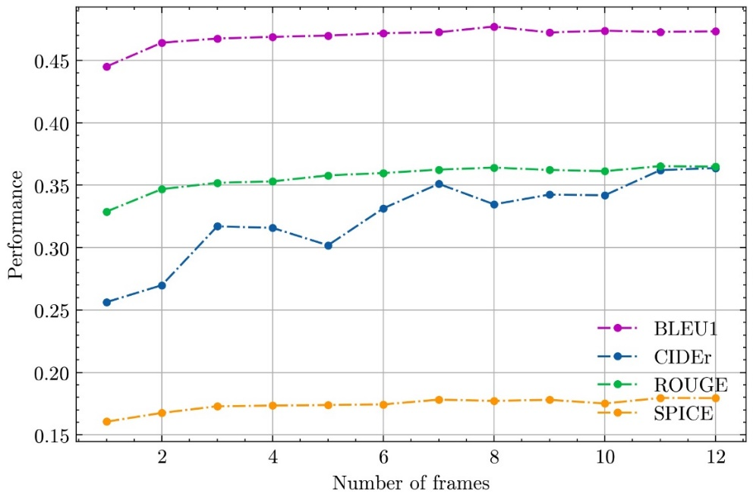

Supplementary Figure 1. A. Impact of input FFA frame number on the report generation performance of FFA-GPT. FFA=fundus fluorescein angiography, GPT=generative pre-trained transformer
A
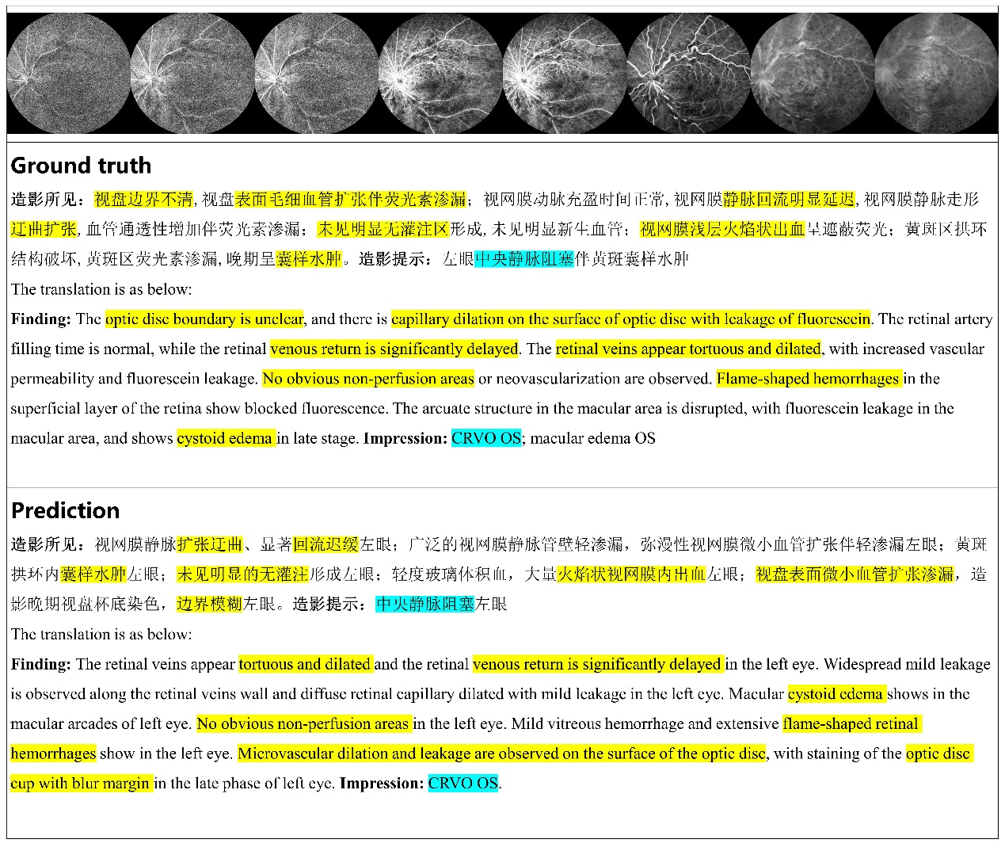
B
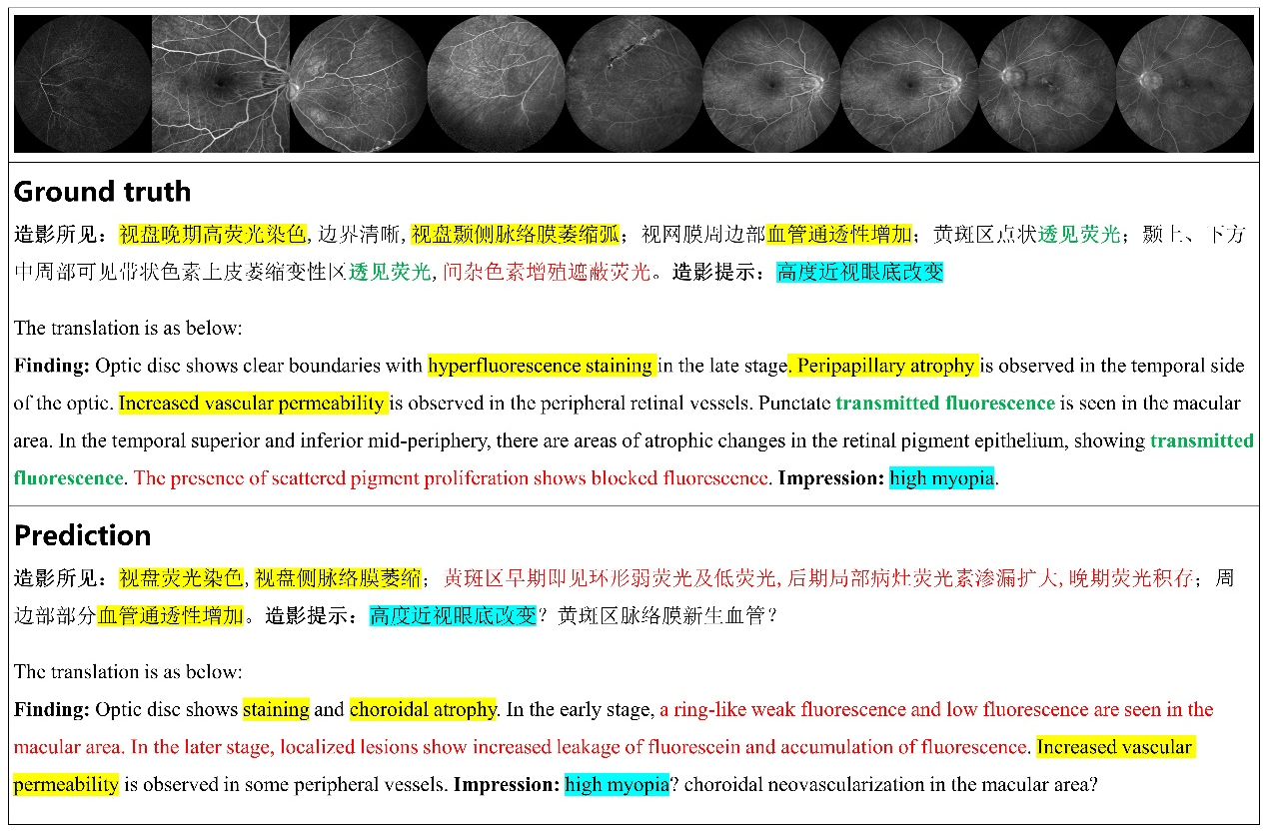
C
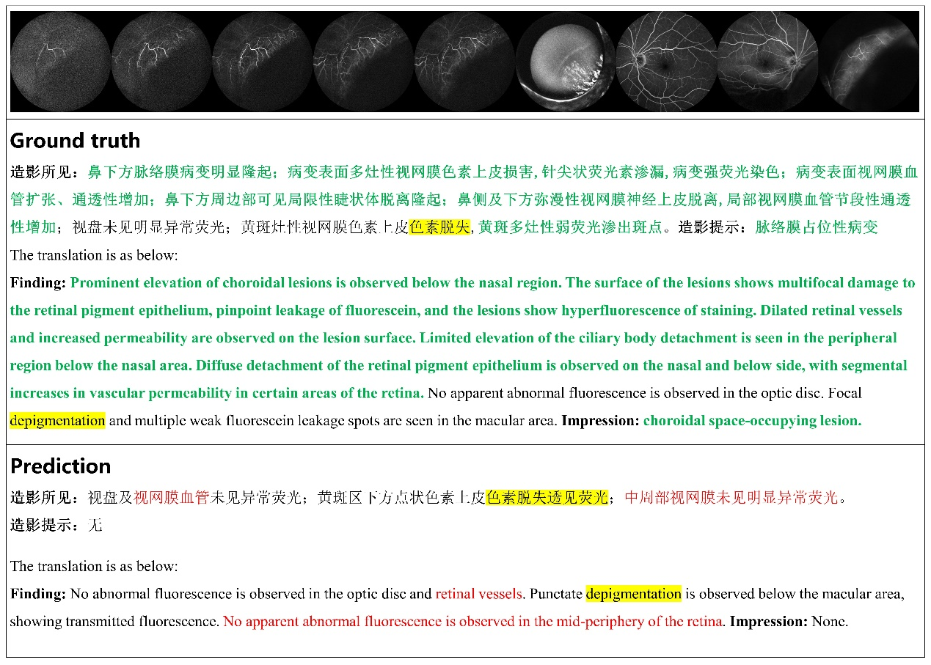
Supplementary Figure 2. Examples of generated reports in different grades. A. No incorrect or missing content. B. With little clinical significance in accuracy and completeness. C. With great clinical significance in accuracy and completeness.

