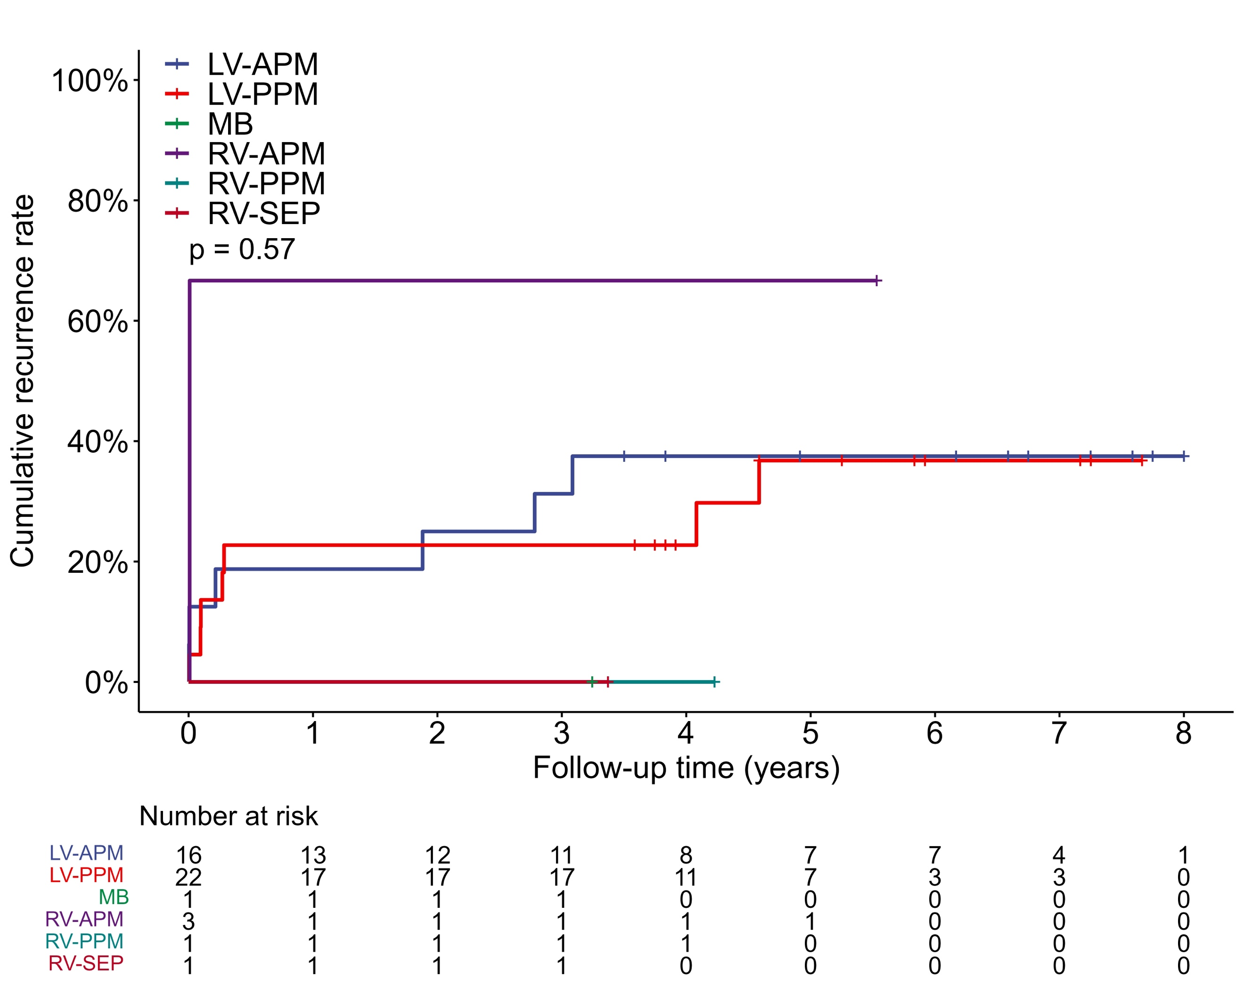
Figure S1. Kaplan-Meier analysis of recurrence of single procedure in patients with different VA origins within the PM/MB.

