supplementary
1. figure 1
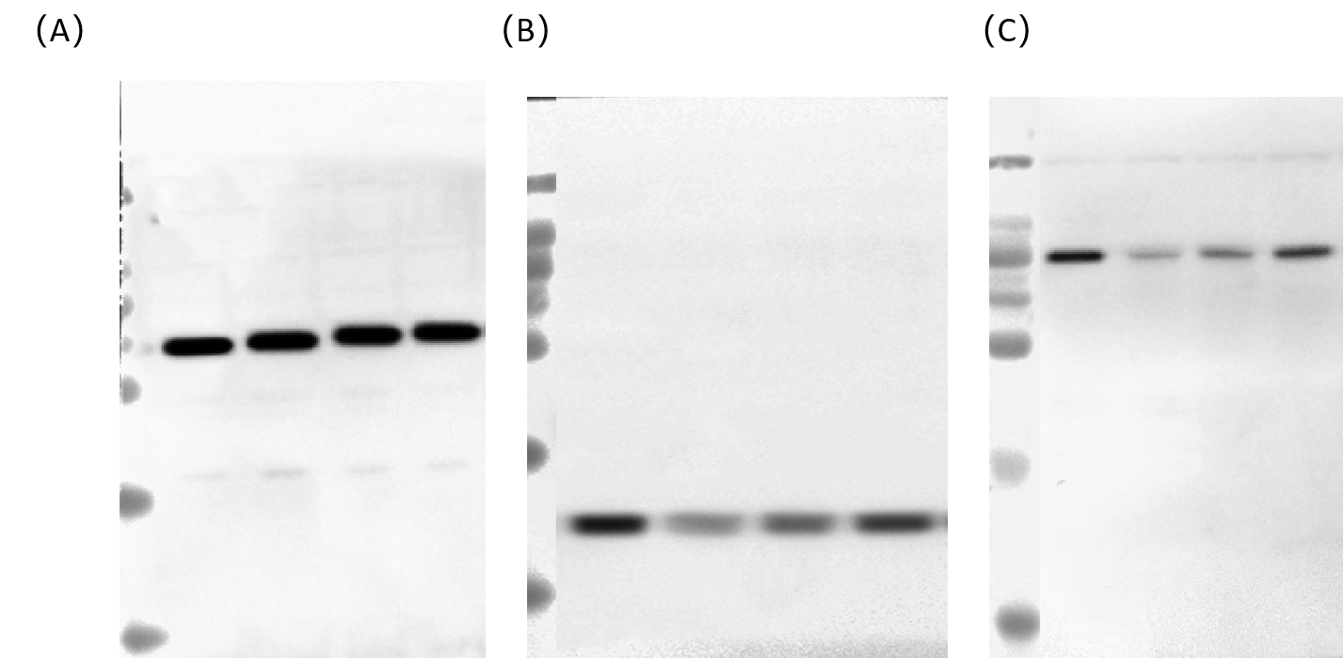
Electrophoresis bands of SLC7A11 and GPX4 protein expression in hippocampus of rats in each group. (A) β-actin, (B) GPX4, (C) SLC7A11.

2. figure2
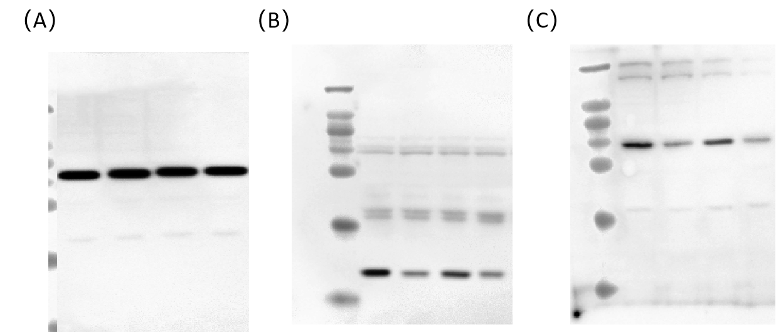
Detection of GPX4 and SLC7A11 protein expression levels in each group. (A) β-actin, (B) GPX4, (C) SLC7A11.

