Supporting Information
Full-Components Utilization of Cellulose Nanofibrils and Artificial Stone Wastes for Cement Enhancement
Bo Zhou ª, Xin Huang ª, Xin Yang ª, Jize Liu ª, Zhuo Huang ª, Feifan Yu ª, Xinxing Zhang ^{a,} *
ª State Key Laboratory of Polymer Materials Engineering, Polymer Research Institute of Sichuan University, Chengdu 610065, P. R. China.
* Corresponding author. E-mail addresses: xxzwwh@scu.edu.cn

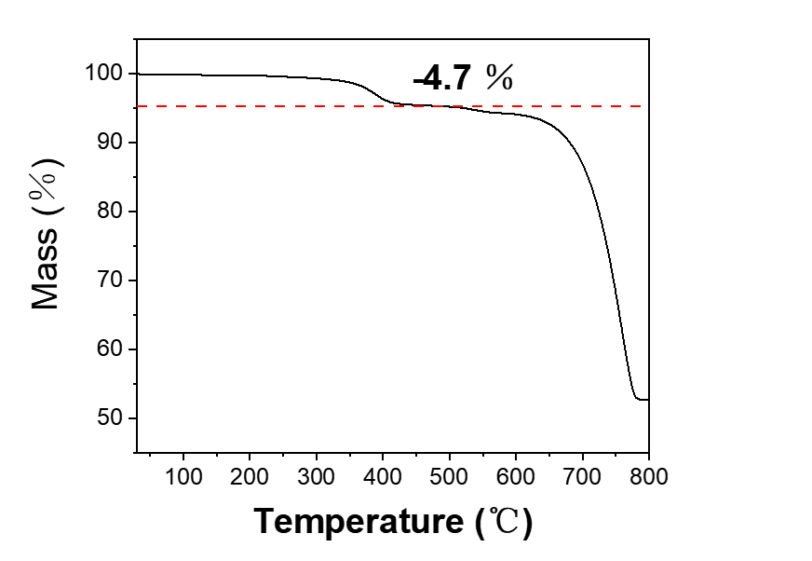
Figure.S1. TG of ASWs.

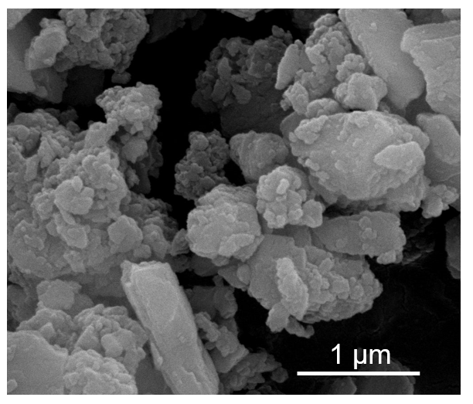
Figure.S2. SEM image of ASWs powder.

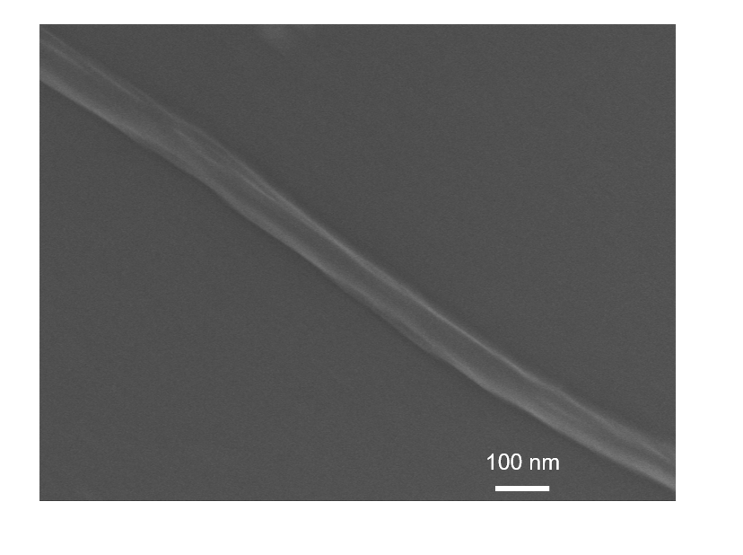
Figure.S3. SEM image of ASWs-assisted CNFs.

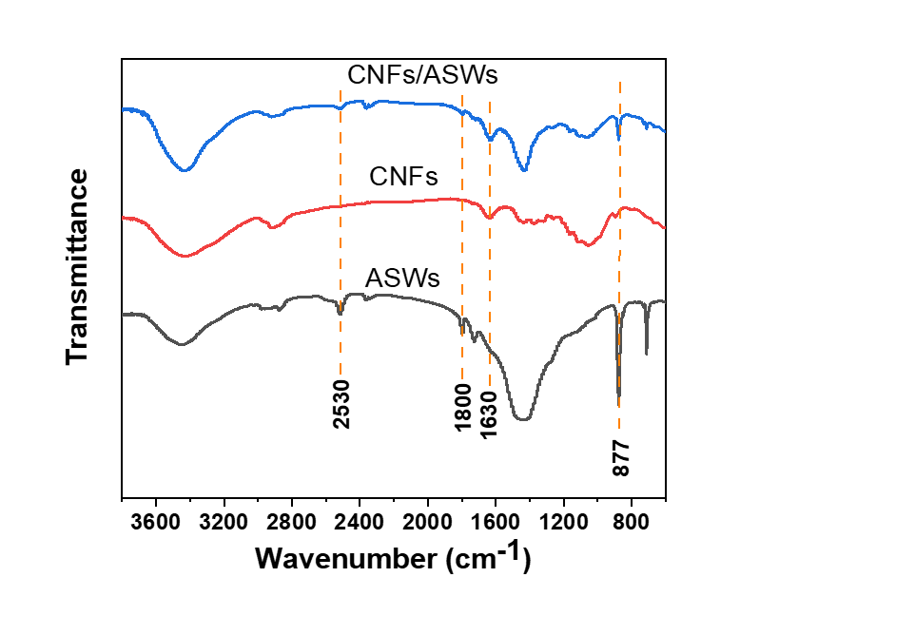
Figure.S4. FTIR spectra of ASWs, CNFs and CNFs/ASWs.

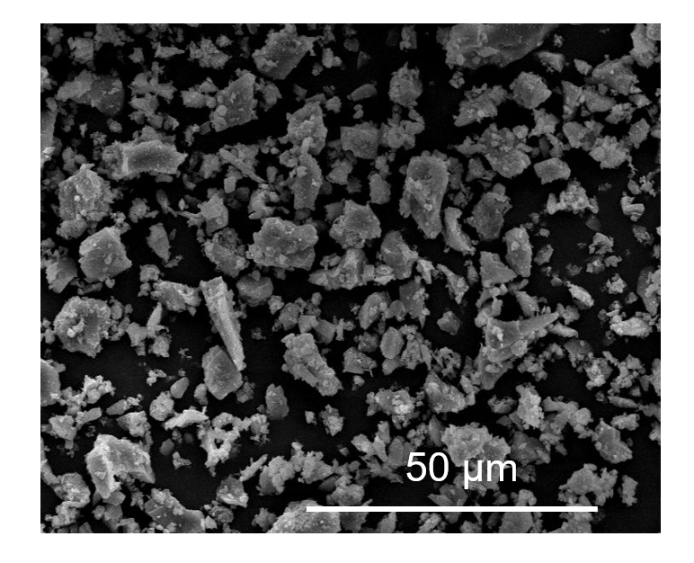
Figure.S5. SEM image of cement powder.

