Supplementary Information

All-natural 2D nanofluidics as high-efficient osmotic energy generator

Jiadong Tang¹, Yun Wang¹, Hongyang Yang², Qianqian Zhang¹*, Ce Wang¹, Leyuan Li¹, Zilong Zheng¹*, Yuhong Jin¹, Hao Wang¹, Yifan Gu²*, Tieyong Zuo²

¹Key Laboratory for New Functional Materials of Ministry of Education, Faculty of Materials and Manufacturing, Beijing University of Technology, Beijing 100124, P. R. China
E-mail: zhangqianqian@bjut.edu.cn; zilong.zheng@bjut.edu.cn
²Institute of Circular Economy, Faculty of Materials and Manufacturing, Beijing University of Technology, Beijing 100124, P. R. China
E-mail: guyifan@bjut.edu.cn

The file includes:
Supplementary Notes 2-4
Supplementary Figures 5-17
Supplementary Table 18-22
References

Supplementary Notes
Supplementary Note 1: Calculation of the layer spacing
An example of studying the layer spacing of 2D-NNF, an intense peak can be detected at ~6.84° which is ascribed to the (002) peak corresponding to the interplanar spacing between the nanosheets¹. According to Bragg’s law:
$2dsin=n$ (S1)
d is the layer spacing; θ is the angle between the incident wave and the scattering plane, λ is the wavelength (~0.154) of the incident wave and n=1. Here, 2θ (002) = 4.61° and the corresponding d (002) = 1.90 nm. So, the fully hydrated lamellar structure of the membrane is with a layer spacing of 0.90 nm considering of the thickness of single-layer MMT nanosheet. Therefore, according to the difference of the 2θ angle in ambient dried and fully hydrated of 2D-NNF, the layer spacing under different states can be obtained.
Supplementary Note 2: Calculation of the surface charge
The surface charge density (σ, C m⁻²) of the 2D-NNF was calculated with the zeta potential according to the equation^{2,3}:
$=\frac{{}_{0}{}_{r}}{{}_{D}}$ （S2）
where ε₀, ε_{r}, and ξ were the permittivity of a vacuum, the permittivity of water and zeta potential of 2D-NNF, respectively. λ_{D} is the Debye screening length, which can be obtained according equation⁴:
${}_{D}=\sqrt{\frac{{}_{0}{}_{r}K_{B}T}{2n_{bulk}z^{2}e^{2}}}$ （S3）
where k_{B} is the Boltzmann constant, and T is the absolute temperature; n_{bulk}, z and e represented the concentration of bulk solution, valence charge and elementary charge. It can be seen from the above formula that the higher the phase concentration, the shorter the Debye length. When the nanochannel spacing is equal to or smaller than Debye length, opposite ion enrichment occurs in the channel, which repels homogenous ions, thus achieving selective ion transport. Supplementary Table 1 shows the variation of Debye length with electrolyte concentration (KCl) at room temperature.
Supplementary Note 3: Cyclic voltammetry analyses
The cyclic voltammetry measurements were conducted with the electrochemical workstation (CHI-600E, Chenhua, Shanghai) with a three-electrode system. And the testing solution by mixing 5 mM [Ru(NH₃)₆]³⁺ or [Fe(CN)₆]³⁻ into 10 mM KCl solution (pH=7.0)⁵. The ITO-supported 2D-NNF as the working electrode, and the ITO-covered glass was washed with ethanol and H₂O before supporting. Besides, a platinum wire was used as the counter electrode and an Ag/AgCl wire was used as the reference electrode.
Supplementary Note 4: Electrode calibration
The energy conversion properties of the 2D-NNF are studied by measuring I−V curves in presence of a transmembrane salinity gradient. The Fig. 3b shows the equivalent circuit of the membrane. V_{OC}, V_{redox}, E_{diff}, and R_{2D-NNF} represent the measured open-circuit voltage, the redox potential generated by the unequal potential drop at the electrode-solution interface, the diffusion potential contributed by the cation selective 2D-NNF, and the internal resistance of the membrane, respectively. The measured V_{OC} actually consists of two parts: V_{redox} and E_{diff}, which satisfy the following equation:
$V_{OC}=V_{redox}+E_{diff}$ (S4)
In this work, the value of V_{redox} was measured using an experimental method. The 2D-NNF were replaced by a nonselective silicon membrane containing a single micro-window. In this case, the measured potential was contributed solely by the asymmetric redox reactions on the electrodes (V_{redox}). For the electrode calibration, the I–V curves were recorded by applying a sweeping voltage (−0.4 V, +0.4 V) at 20 mV steps.
Supplementary Note 5: Ion selectivity of 2D-NNF
The transference number t_{n} is calculated following the equation⁶.
$t_{+}=\frac{1}{2}(\frac{E_{diff}}{\frac{RT}{zF}n\left(\frac{{}_{c_{H}}c_{H}}{{}_{c_{L}}c_{L}}\right)}+1)$ (S5)
where t₊ is the cation transference number; E_{diff} refers to the diffusion potential; R, T, Ζ, F, refer to the universal gas constant, absolute temperature, valence charge and Faraday constant, respectively; 𝛾 and c refer to ion activity coefficient and concentration.
Supplementary Note 6: Energy conversion efficiency
Normally, the energy conversion efficiency is defined as the ratio of the output energy (electrical energy) to the input energy (Gibbs free energy of mixing), the energy conversion efficiency corresponding to the maximum power generation (η_{max}) in the system can be calculated by the equation^{7,8}:
${}_{max}=\frac{1}{2}({2t}_{+}-1)^{2}$ (S6)
Supplementary Note 7: Molecular dynamics simulation
The molecular dynamics (MD) simulation in this study uses GROMACS (version 2020.3_GPU) software Berendsen thermostat, and the coupling time constant is 0.5 ps. The periodic boundary conditions and the ClayFF force field are used for calculation, the long-range electrostatic Particle-Mesh Ewald (PME) electrostatic calculation method is adopted. In this study, the short-range electrostatic and van der Waals cut off distance are set to 1 nm, and the concentration of K⁺ and Cl⁻ ions is set to 1 mol L⁻¹.
Basis of modeling: The surface negative charge of MMT is mainly derived from the substitution of some trivalent Al³⁺ by divalent cations like Mg²⁺, Fe²⁺ in the aluminum oxygen octahedron. The negative charge and layer spacing in 2D-NNF further increase compared to the pristine MMT. In order to simplify the model, the theoretical surface charge is close to the experimental value of 2D-NNF by adjusting the atomic ratio of Mg:Al, and the channel spacing was set according to the experimental value.
The transport of ions and charges is theoretically studied by MD simulation. The first is to establish a system with the theme of aqueous solution, at which time no ions exist. Step 2, replace some water molecules according to the concentration required by the experiment to make the ion concentration in the solution consistent with the experimental value, and set it as 1 mol L⁻¹. After NVT (N: number of particles, v: volume, t: temperature) balance at 450 K, NPT (N: number of particles, p: pressure, t: temperature) balance at 300 K for 5 ns annealing. The last step is to statistically analyze the ion migration number, ion migration speed and binding with VMD.
Supplementary Note 8: Details of technoeconomic analysis
we first analyzed the material flow in each stage from material procurement to laboratory exfoliation. The feeding quantity and yield were determined based on previous literature⁹⁻¹³ and investigation of relevant production. To facilitate calculation, material losses during intermediate processes were not take into account, ensuring the maintenance of material balance before and after.
The cost of raw materials and chemical reagents was estimated using the ton price of industrial grade purity reagents (Table S7). For labor costs, equipment depreciation, and other fixed costs were not considered at present. When calculating the costs of materials, reagents and energy consumption, the price differences MMT, GO, and MXene powder were reasonable and close to the enterprise prices provided through our investigated. Of course, this value was mainly for reference and guidance, and the actual costs must be determined after a large-scale practical production. Additionally, energy consumption was worth concerning. To make the estimation of energy consumption close to reality, we made estimates based on the equipment specifications and required service time for small-scale production in experimental and industrial settings.
To conduct an environmental impact assessment, the life cycle assessment (LCA) method was used to quantify the environmental impact of five production lines: MMT, GO, MXene, ANF and CNF (Table S6). This assessment involved determining the input and output amounts of materials using GaBi software (an environmental impact analysis software designed in accordance with the principles of LCA methodology was jointly developed by the LBP Institute of the University of Stuttgart and PE Company), including index: GWP (global warming potential), AP (acidification potential), ADP (abiotic depletion fossil), HTP (human toxicity potential), MAETP (marine aquatic eco-toxicity potential), FAETP (freshwater eco-toxicity potential), POCP (photochemical ozone creation potential), EP (eutrophication potential).
Supplementary Figures
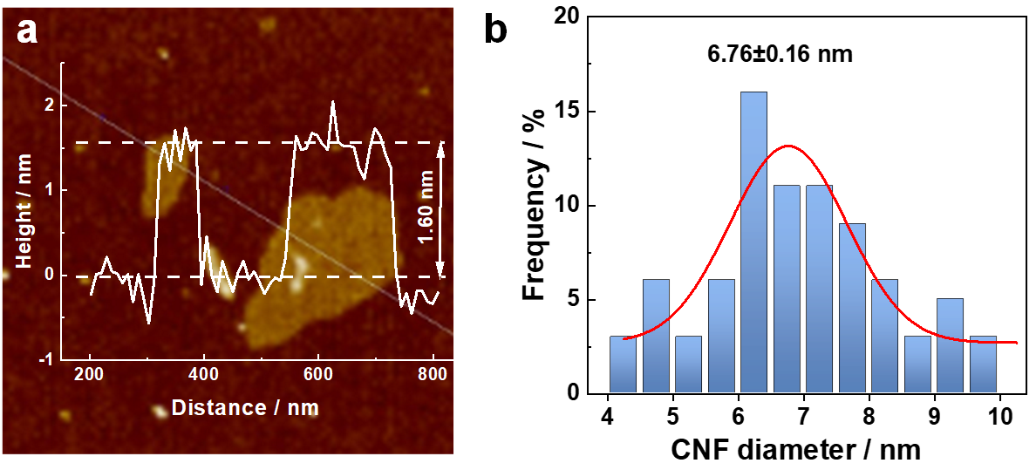
Fig. S1 (a) AFM images and corresponding height profiles of MMT nanosheets. (b) Diameter distributions of cellulose nanofibers.

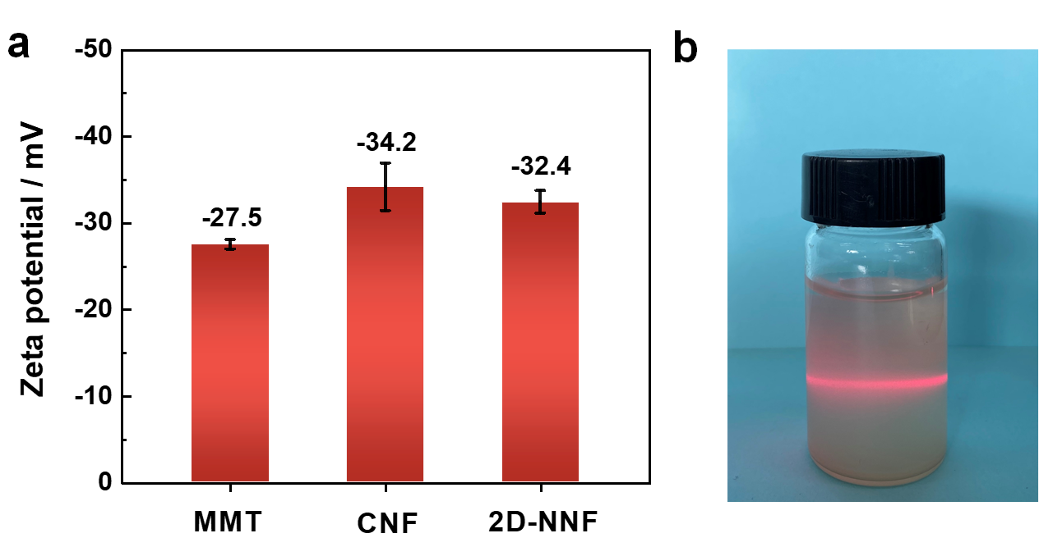
Fig. S2 (a) The surface zeta potential comparison of MMT, CNF and 2D-NNF. (b) The Tyndall scattering effect of the as-prepared 2D-NNF colloidal suspension, indicating the good dispersion in water.

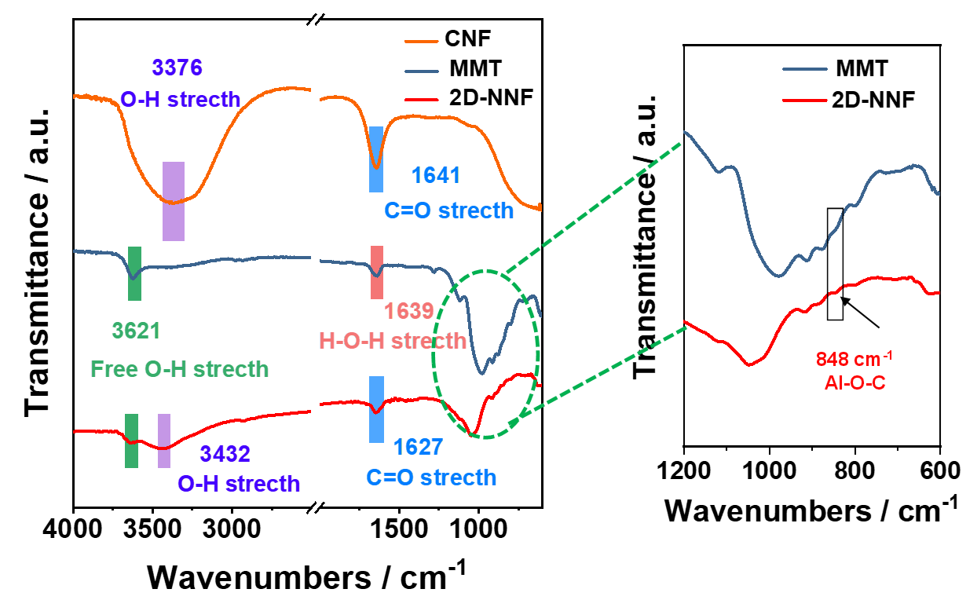
Fig. S3 FTIR spectrum of CNF, pristine MMT nanofluidics and 2D-NNF, the marked characteristic peaks correspond to the functional groups. The enhanced emerged peak at 3432 cm⁻¹ and 1627 cm⁻¹ corresponds to -OH and C=O group vibrations, respective, which confirmed the successful introduction of CNFs. Besides, the decrease of free OH on the surface of 2D-NNF at 3621 cm⁻¹ indicates the occurrence of dehydration condensation reaction. Consequently, the enhanced emerged peak at 848 cm⁻¹ corresponds to Al-O-C vibrations, indicating the covalent bond formed between MMT nanosheets and CNFs.

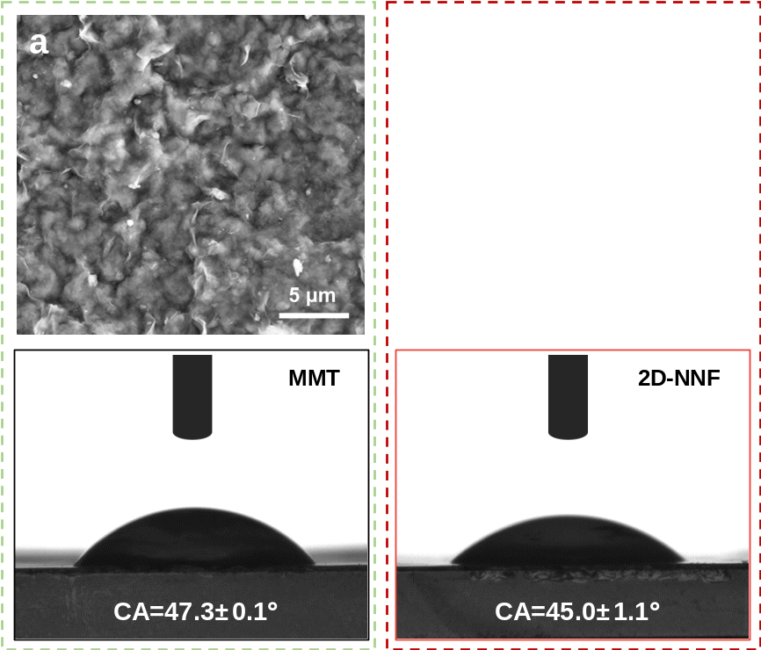
Fig. S4 Top-view SEM images and surface contact angles of KCl electrolyte for (a) MMT nanofluidics and (b) 2D-NNF.

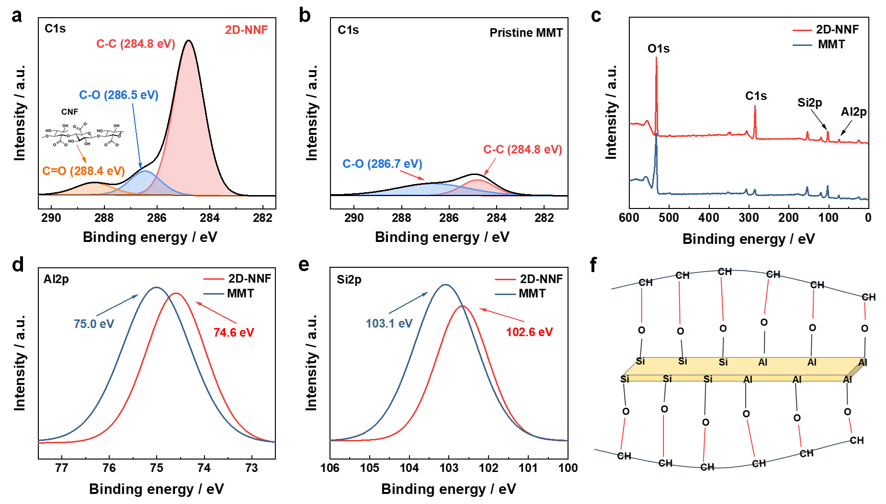
Fig. S5 XPS spectra of C1s of (a) 2D-NNF and (b) pristine MMT nanofluidics. (c) The survey XPS of 2D-NNF and MMT nanofluidics. For the 2D-NNF, C1s and O1s peak enhancement due to the introduction of CNFs. For pristine MMT nanofluidics, the appearance of carbon may be due to surface adsorption with weak strength and there is no obvious C=O peak in C1s region, while for the 2D-NNF, the fitted peak located at ~288.4 eV correspond to negatively charged carboxyl groups on CNFs. High spectra of 2D-NNF and MMT for (d) Al2p and (e) Si2p region. The characteristic peak Si 2p originated from Si-O-Si/Si-O-Al, and the main peak of Al 2p was attributed to the Al-OH and Al-O-Si. The binding energy displacement of Al 2p and Si 2p compared with pristine MMT membrane, which was mainly attributed to the formation of covalent bonds between MMT and CNFs. (f) Schematic of the covalent bonds formed between Si-OH or Al-OH at the edge of MMT and CNFs.

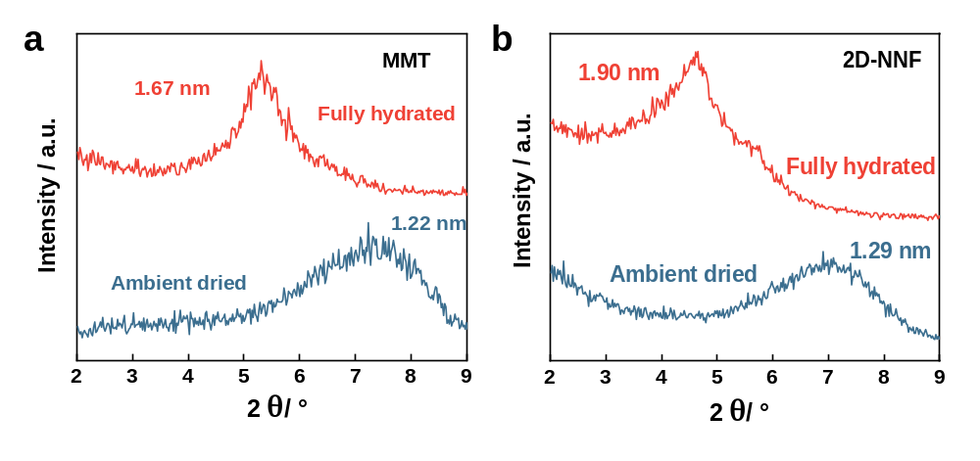
Fig. S6 Variation of nanochannel space of (a) pristine MMT nanofluidics and (b) 2D-NNF (10%-CNF content) under ambient dried and fully hydrated conditions at room temperature, indicating that the introduction of nanofibers enlarges the nanochannel space.

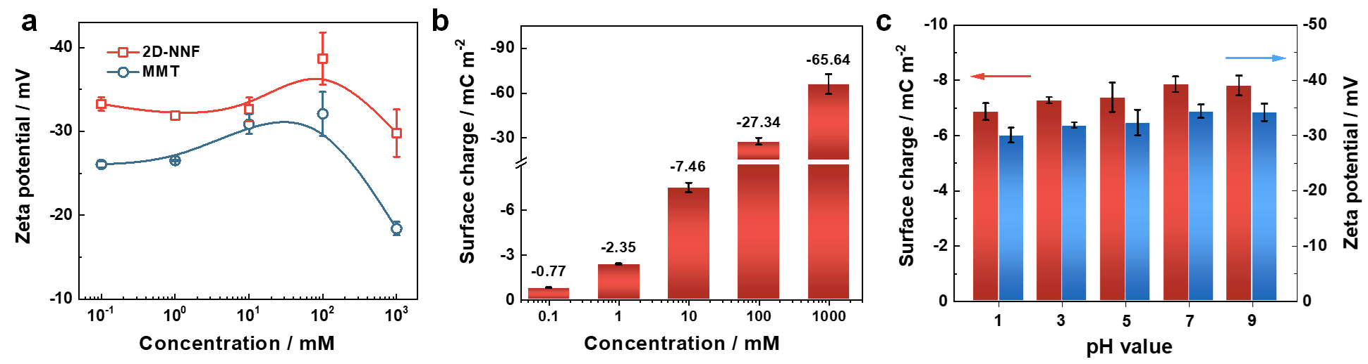
Fig. S7 (a) The surface zeta potential measurement of MMT and 2D-NNF at various KCl electrolyte concentration, suggesting that the negative charge of 2D-NNF is higher than MMT in the whole concentration range from 0.1 mM to 1000 mM. (b) The surface charge as a function of concentration for KCl at ambient temperature. (c) The surface charge and zeta potential of the 2D-NNF as a function of pH for KCl 10 mM at ambient temperature. Error bars represent S.D.

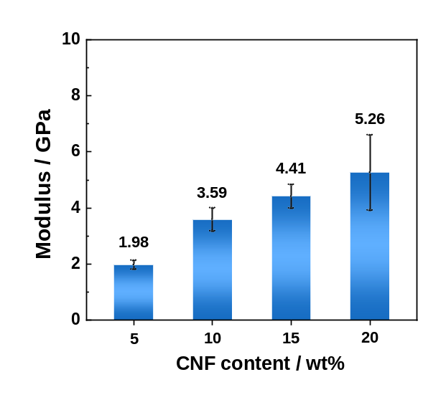
Fig. S8 The Young’s modulus of the 2D-NNF with different CNF contents. Error bars represent S.D.

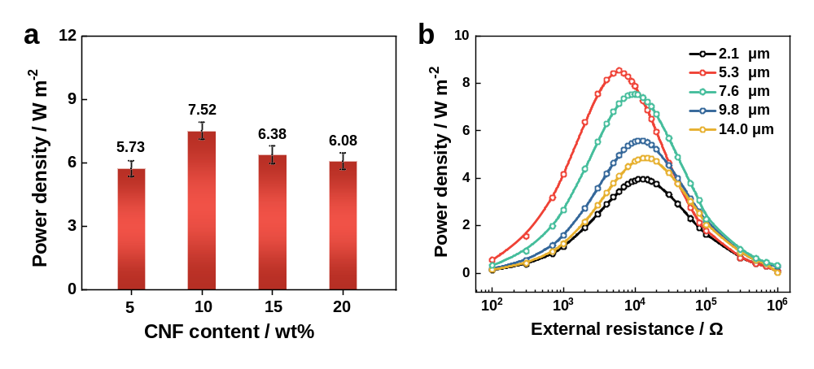
Fig. S9 Osmotic energy conversion performance under an artificial seawater and river water salinity gradient. (a) Influence of the CNFs weight content and (b) the membrane thickness on osmotic energy generation. Error bars represent S.D. The above results confirm that reduce the membrane thickness can improve the power density due to the decreased internal resistance and the shorten ion diffusion path of the 2D-NNF, but when the membrane thickness was further reduced to 2.1 μm, the membrane became fragile and less dense, results in a power density as low as 3.95 W m⁻² owing to the lower ion permeability.

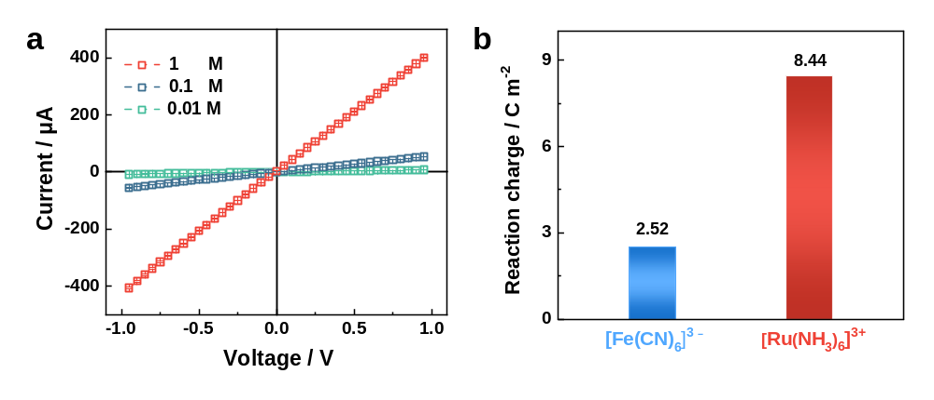
Fig. S10 (a) I–V curves of 2D-NNF recorded in KCl electrolyte (PH~5.7) with the concentration from 0.01 to 1 M. Error bars represent S.D. (b) Reaction charge corresponding redox peak area when using [Ru(NH₃)₆]³⁺ and [Fe(CN)₆]³⁻ probes.

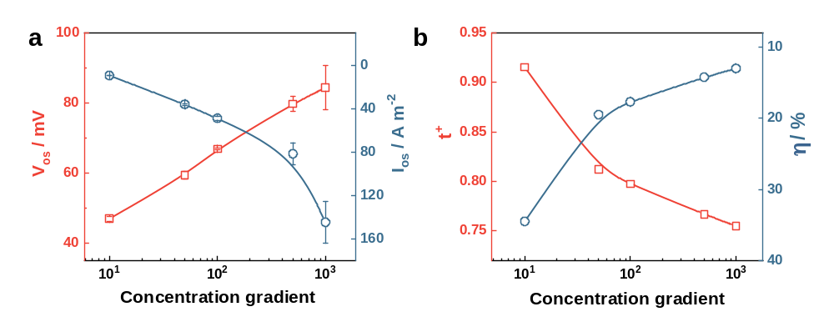
Fig. S11 (a) The recorded diffusion potential and diffusion current under a series of KCl concentration gradients, where the low concentration side is fixed at 1 mM. Error bars represent S.D. (b) The calculated transmembrane ion transference number (t⁺) and ion selectivity (α) under the same range of electrolyte concentrations.

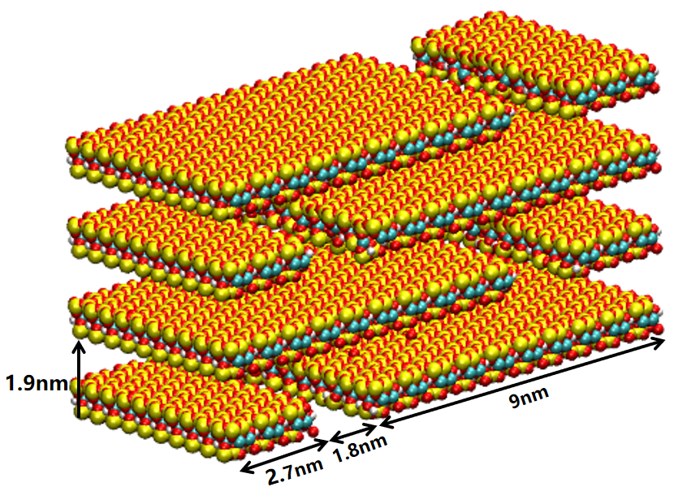
Fig. S12 The simulation model of a single slit of 2D-NNF flakes. The flake space is set according to the experimental value (Fig. S6).

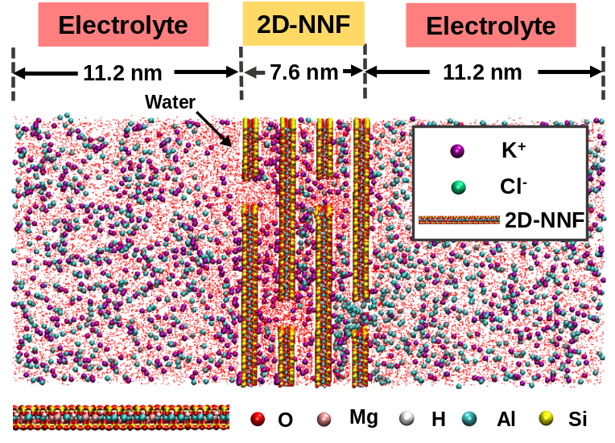
Fig. S13 The theoretical model for MD simulations consists of 2D-NNF between two cell electrolyte layers. A 7.6 nm-thick nanosheet layer within the black dotted lines represents the major part of the membrane for the calculations. The model part demonstrates the distribution of ions at the 15th ns after diffusion equilibrium.

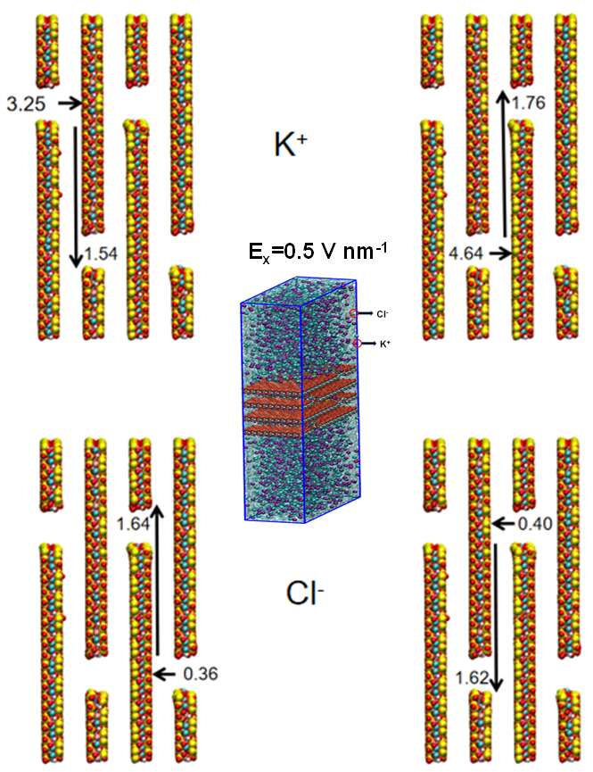
Fig. S14 Evolution of the vertical and horizontal transport rates (m s⁻¹) of K⁺ ions and Cl⁻ ions were calculated under a transmembrane electric field of 0.5 V nm⁻¹ (inset).

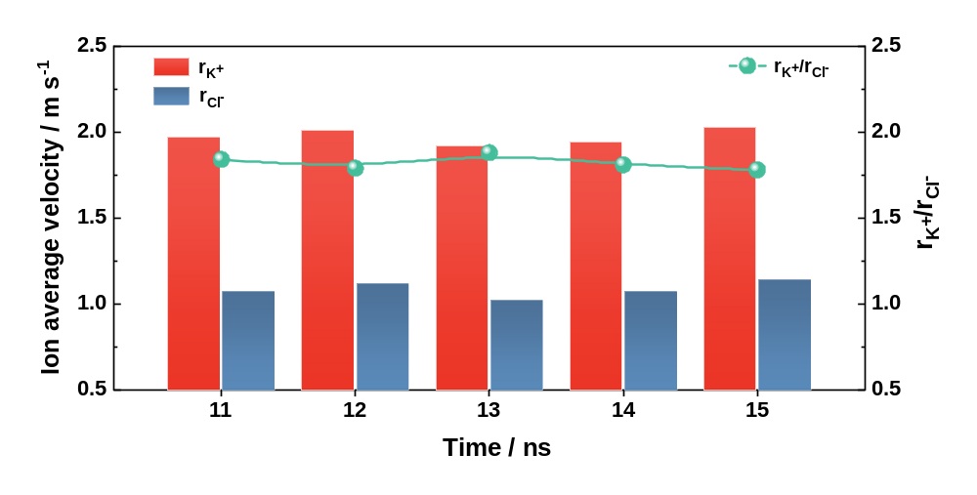
Fig. S15 Evolution of the calculated ratio between average transmission rate of K⁺ ions and Cl⁻ ions over time after diffusion equilibrium.

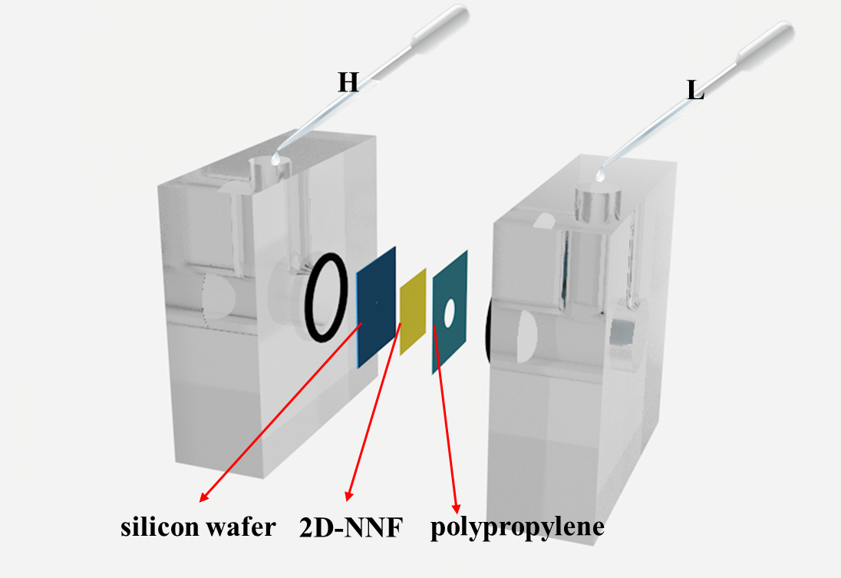
Fig. S16 Schematic diagram of the concentration cell system, which contains a perforated silicon wafer, 2D-NNF, and a perforated polypropylene protective layer.

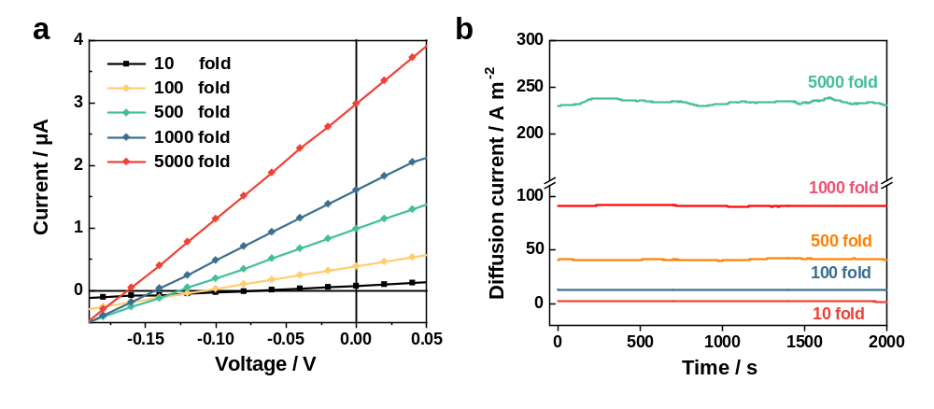
Fig. S17 (a) I–V curves under varied NaCl concentrations gradients, with the high-concentration (HC) side was ranging from 1 mM to 0.5 M, while the low-concentration (LC) side was fixed at 0.1 mM. (b) Diffusion current density-time curves under the same range of electrolyte concentrations.

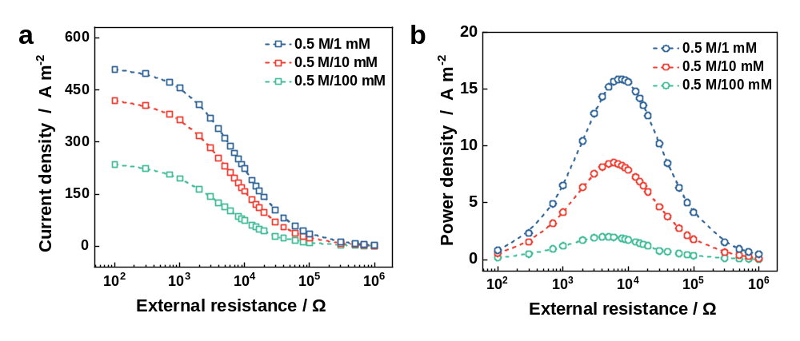
Fig. S18 (a) Under three salinity gradients, the measured current densities all gradually decrease with the increasing external resistance. (b) The corresponding output power achieves the maximum values of 1.99, 8.61, and 15.84 W m⁻², respectively, for the 5-fold, 50-fold, and 500-fold salinity gradient (NaCl).

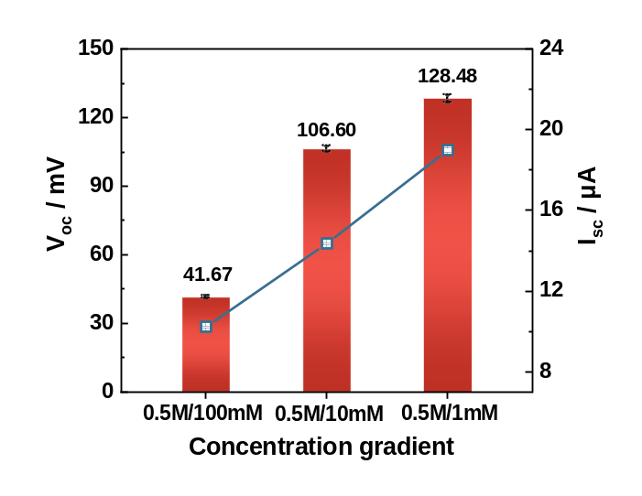
Fig. S19 Open-circuit voltage (V_{OC}) and short-circuit current (I_{SC}) of 2D-NNF under different concentration gradient (NaCl).

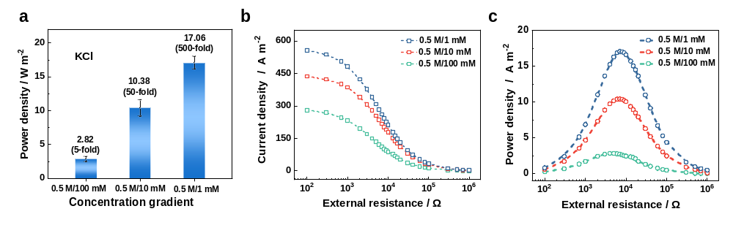
Fig. S20 (a) The output power densities at different concentration folds. The high-salinity solution is fixed at 0.5 M KCl, and low-salinity is varied from 1 mM to 100 mM. The maximum value is 17.06 W m⁻². (b) The current densities and (c) power density at different concentration folds as a function of the external resistance.

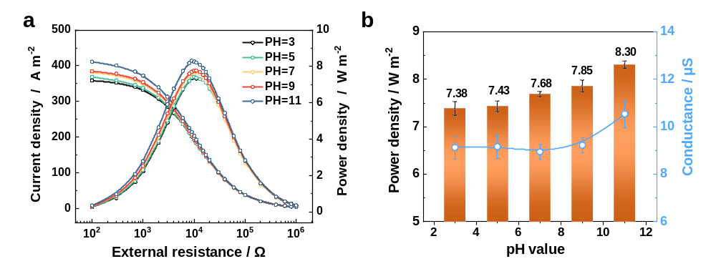
Fig. S21 (a) The current density and power density of 2D-NNF (9.8 μm) at different pH. The salinity electrolyte system is 0.5 M/0.01 M KCl. (b) Maximum output power density of 2D-NNF under different pH, and conductance of 2D-NNF in 0.01 M KCl with different pH. Error bars represent S.D.

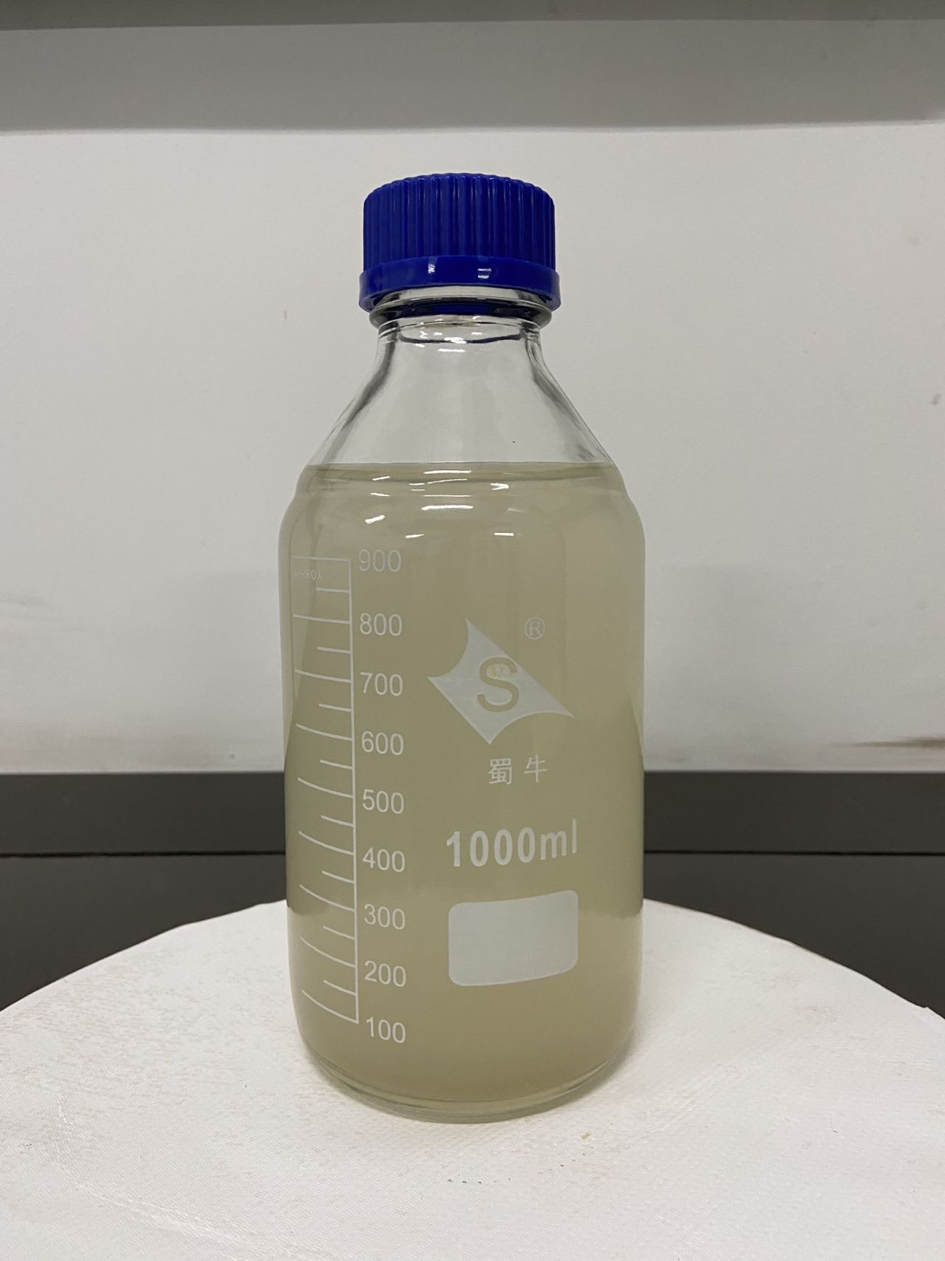
Fig. S22 Photograph of the precursor solution of 2D-NNF.

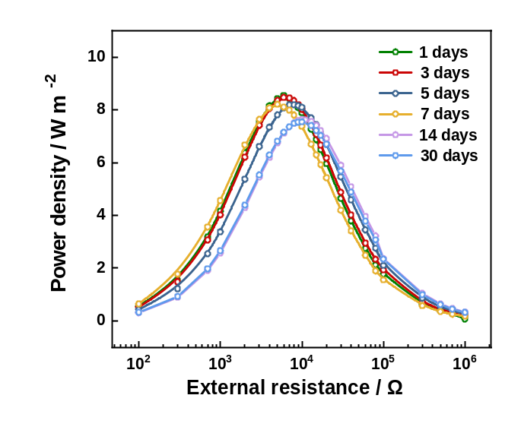
Fig. S23 The power output stability of the 2D-NNF.

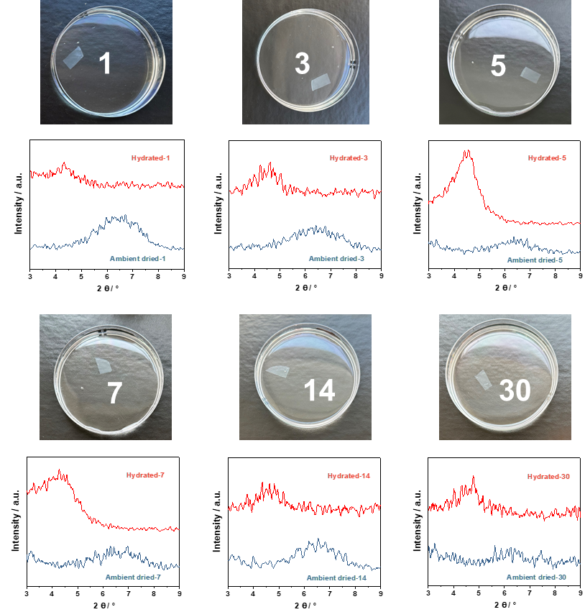
Fig. S24 The stability of the 2D-NNF in aqueous solution and the XRD patterns of the nanofluidics after hydration and dried, indicating that the nanofluidics structure has a good reversible stability.

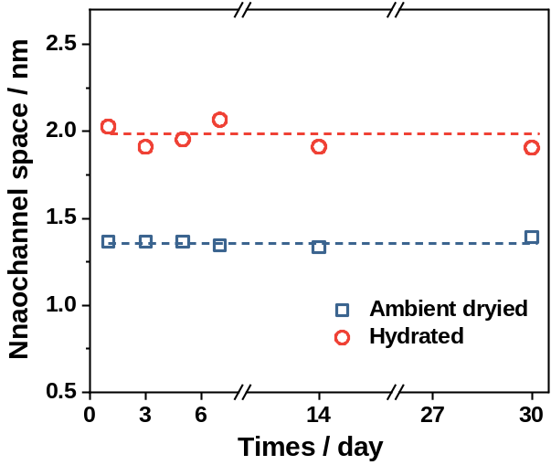
Fig. S25 The change of nanochannel space of the 2D-NNF before and after hydration, implying that the 2D-NNF have a long-term stability in the osmotic energy harvesting.
Supplementary Tables
Table S1 Debye length varies with bulk solution concentration.
KCl concentration (mM) | Debye length λ_{D} (nm)
0.1 | 30.5
1 | 9.6
10 | 3.1
100 | 1.0
1000 | 0.3

Table S2 The corresponding values of V_{OS} and V_{thero} under different KCl electrolyte concentration gradient conditions.
Concentration gradient (mM/mM) | 1/10 | 1/50 | 1/100 | 1/500 | 1/1000
V_{OS} (mV) | 48 | 60 | 67 | 80 | 84
V_{thero} (mV) | 57 | 96 | 112 | 150 | 165
Transference number (t⁺) | 0.92 | 0.81 | 0.80 | 0.77 | 0.75
Conversion efficiency η(%) | 35 | 20 | 18 | 14 | 13

Table S3 Ion migration rate (m s⁻¹) statistics in horizontal and vertical directions by a MD simulation.
Simulation time  (ns) | 11 | 12 | 13 | 14 | 15 | Average rate
V_{K}+ (out) | 3.29 | 3.22 | 3.17 | 3.3 | 3.27 | 3.25
V_{K}+ (in) | 4.71 | 4.64 | 4.68 | 4.52 | 4.65 | 4.64
V_{Cl}- (out) | 0.33 | 0.28 | 0.38 | 0.37 | 0.44 | 0.36
V_{Cl}- (in) | 0.42 | 0.45 | 0.38 | 0.39 | 0.36 | 0.40
H_{K}+ (out) | 1.47 | 1.55 | 1.42 | 1.58 | 1.68 | 1.54
H_{K}+ (in) | 1.76 | 1.77 | 1.64 | 1.77 | 1.86 | 1.76
H_{Cl}- (out) | 1.64 | 1.58 | 1.62 | 1.66 | 1.7 | 1.64
H_{Cl}- (in) | 1.65 | 1.62 | 1.58 | 1.68 | 1.57 | 1.62
Here, “out” or “in” represents the positions of outer and inner pores of the nanosheet as shown in Fig. S12, and the statistics of ion average migration rate are also shown in the picture.

Table S4 Comparison with the two-dimensional (2D) nanofluidic membranes and 3D porous membrane in the literatures. All the measurements were carried out by mixing artificial seawter and river water (0.5 M / 0.01 M NaCl).
Membrane | Resistance  (kΩ) | Power density  (W/m²) | Thickness (μm) |  | Ref.
Oppsite-MXene | 5 | 4.6 | 8.5 |  | ¹⁴
BN/ANF | 10 | 5.5 | 1 |  | ¹⁵
GOM Pairs | 10 | 0.77 | 10 |  | ¹⁶
MXene | 11 | 0.53 | 15 |  | ¹⁷
MXene/CNF | 13 | 4.84 | 5 |  | ¹
WS₂/CNF | 13 | 1.99 | 3 |  | ¹⁸
GO/ANF | 20 | 5.06 | 2.2 |  | ¹⁹
MoS₂/CNF | 24 | 5.2 | 4 |  | ²⁰
GO/CNF | 27 | 4.19 | 9 |  | ²¹
MXene/ANF | 27 | 3.7 | 4.5 |  | ²²
GO/SNF/GO | 40 | 5.07 | 5 |  | ²³
MXene/BN | 60 | 2.3 | 10 |  | ²⁴
GO/BP | 200 | 3.4 | 8 |  | ²⁵
BP | 250 | 1.6 | 8 |  | ²⁵
GO/PPSU-Py | 300 | 0.76 | 31 |  | ²⁶
Carbon/AAO | 10 | 3.46 | 64 |  | ²⁷
MCS/AAO | 10 | 5.04 | — |  | ²⁸
HEMAP hydrogel | 15 | 5.38 | 25 |  | ²⁹
ZW-M7N1 | 17 | 6.2 | 17 |  | ³⁰
SNF/AAO | 23 | 2.86 | 65 |  | ⁸
ANF/Gel | 23 | 3.9 | 210 |  | ³¹
Fusiform-GOMs | 26 | 4.94 | 2 |  | ³²
Hydrogel hybrid | 36 | 3.18 | 25 |  | ³³
2D-NNF | 6 | 8.61 |  | 5.3 | This work

Table S5 Comparison with the two-dimensional (2D) materials nanofiber-based nanofluidics in the literatures (0.01 M/0.05 M NaCl).
Nanofluidic | Ion selectivity | Power density  (W/m²) | Resistance（kΩ） |  | Mechanical  strength  (MPa) | Conversion  Efficiency  (%) | Stability  (days) | Ref
GO/CNF | 0.82  (0.01-100 mM) | 4.19 | 27 | — |  | 20  15 | 30 | ²¹
GO/ANF | 0.77  (0.01-100 mM) | 5.06 | 17 | 93 |  | 20  15 | — | ¹⁹
MXene/CNF | — | 4.84 | 20 | — |  | —  18 | — | ¹
MXene/ANF | 0.80  (0.1-500 mM) | 3.7 | 27 | 101 |  | —  18 | 30 | ²²
MoS₂/CNF | 0.90  (10-500 mM) | 5.2 | 23 | — |  | 32 | — | ²⁰
BN/ANF | 0.80  (10-500 mM) | 5.5 | 10 | 370 |  | 18 | — | ¹⁵
g-C₃N₄/CNF | — | 0.15 | — | 65 |  | — | 30 | ³⁴
WS₂/CNF | — | 1.99 |  | 70 |  | — | — | ¹⁸
2D-NNF | 0.82  (10-500 mM) | 8.61 | 6 | 115 |  | 21 | 30 | This work
Here, ion selectivity data are based on the maximum that can be reached at high concentrations (KCl or NaCl). The representative materials GO and MXene were selected for complete information comparison in the Fig. 5f.

Table S6 Comparison of environmental impact assessment characterization results of different two-dimensional materials and nanofiber materials.
Index | Units | MMT |  | GO |  | MXene |  | ANF |  | CNF
GWP | kg CO₂-Equiv. | 7.60E+01 |  | 6.26E+02 |  | 4.72E+02 |  | 6.69E+02 |  | 6.66E+01
AP | kg SO₂-Equiv. | 3.59E−01 |  | 4.68E+00 |  | 1.50E+00 |  | 1.36E+00 |  | 1.32E−01
ADP | kg MJ-Equiv. | 1.03E+03 |  | 1.45E+04 |  | 6.45E+03 |  | 1.44E+04 |  | 1.15E+03
HTP | kg DCB-Equiv. | 2.64E+00 |  | 4.08E+01 |  | 1.83E+02 |  | 2.13E+01 |  | 4.12E+00
MAETP | kg DCB-Equiv. | 2.68E+03 |  | 3.17E+04 |  | 1.32E+05 |  | 1.65E+04 |  | 3.47E+03
FAETP | kg DCB-Equiv. | 2.44E−01 |  | 3.35E+00 |  | 1.81E+00 |  | 1.88E+00 |  | 2.18E−01
POCP | kg Ethene-Equiv. | 2.30E−02 |  | 2.66E−01 |  | 1.70E−01 |  | 1.13E−01 |  | 1.03E−02
EP | kg PO₄³⁻-Equiv. | 4.91E−02 |  | 1.40E−01 | 1.26E−01 |  | 1.50E−01 |  | 2.09E−02
Table S7 The specific price of different materials involved in cost analysis.
Materials | Price ($/t)
Na⁺-bentonite |  | 188.4
natural graphite | 652.2
Ti powder | 34782.6
Al powder | 14492.7
(NaPO₃)₆ | 1449.3
HCl | 57.9
H₂SO₄ | 86.9
NaNO₃ | 507.2
KMnO₄ | 2681.2
H₂O₂ | 289.8
NaOH | 521.7
NaBr | 4057.9
NMP | 2608.7
PPDA | 4347.8
CaCl₂ | 231.9
DMSO | 4347.8
TPC | 2608.7
KOH | 1594.2

Table S8 Comparison with the 2D materials nanofiber-based nanofluidics from resource, environment and economy.
Nanofluidic Membrane | 2D-NNF | GO/ANF | MXene/CNF
GWP (kg CO₂e) | 82.7 | 759.8 | 478.7
AP (kg SO₂e) | 0.372 | 4.81 | 1.51
HTP (kg DCBe) | 3.01 | 45.1 | 183.4
MAETP (kg DCBe) | 3.03*10³ | 3.33*10⁴ | 1.35*10⁵
FAETP (kg DCBe) | 0.244 | 3.35 | 1.81
Energy consumption (kWh) | 30.1 | 196.9 | 307.3
ADP (MJ) | 1.14*10³ | 1.59*10⁴ | 6.56*10³
Corrosive reagent consumption (kg) | 3.1 | 830.1 | 191.0
Cost (USD) | 100.9 | 341.6 | 1319.3
The above statistics are based on the production of 100 m² of nanofluidic membrane
Reference
1 Liu, P. et al. Synergy of light and acid–base reaction in energy conversion based on cellulose nanofiber intercalated titanium carbide composite nanofluidics. Energy Environ. Sci. 14, 4400-4409 (2021).
2 Sheng, N. et al. TEMPO-oxidized bacterial cellulose nanofibers/graphene oxide fibers for osmotic energy conversion. ACS Appl. Mater. Interf. 13, 22416-22425 (2021).
3 Li, T. et al. A nanofluidic ion regulation membrane with aligned cellulose nanofibers. Sci. Adv. 5, eaau4238 (2019).
4 Daiguji, H. Ion transport in nanofluidic channels. Chem. Soc. Rev. 39, 901-911 (2010).
5 Li, C. et al. Large-scale, robust mushroom-shaped nanochannel array membrane for ultrahigh osmotic energy conversion. Sci. Adv. 7, eabg2183 (2021).
6 Ding, L. et al. Ultrathin and ultrastrong kevlar aramid nanofiber membranes for highly stable osmotic energy conversion. Adv. Sci. 9, 2202869 (2022).
7 Mei, Y. & Tang, C. Y. Recent developments and future perspectives of reverse electrodialysis technology: A review. Desalination 425, 156-174 (2018).
8 Xin, W. et al. High-performance silk-based hybrid membranes employed for osmotic energy conversion. Nat. Commun. 10, 1-10 (2019).
9 Ge, P., Wang, H.-j., Zhao, J., Xie, L. & Zhang, Q. Preparation of high purity graphite by an alkaline roasting–leaching method. Carbon 7, 2123-2124 (2010).
10 Zhang, T. et al. Synthesis of two-dimensional Ti₃C₂T_{x} MXene using HCl+ LiF etchant: enhanced exfoliation and delamination. J. Alloys Compd. 695, 818-826 (2017).
11 Wang, Z. et al. The purification process of bentonite. Modern Minin 03, 26-29 (2013).
12 Saito, T., Kimura, S., Nishiyama, Y. & Isogai, A. Cellulose nanofibers prepared by TEMPO-mediated oxidation of native cellulose. Biomacromolecules 8, 2485-2491 (2007).
13 Wu, G. c., Tanaka, H., Sanui, K. & Ogata, N. Synthesis of aromatic polyamide by a direct polycondensation with triphenylphosphine. J Polym Sci B Polym Phys 19, 343-346 (1981).
14 Ding, L. et al. Oppositely charged Ti₃C₂T_{x} MXene membranes with 2D nanofluidic channels for osmotic energy harvesting. Angew. Chem. Int. Ed. 59, 8720-8726 (2020).
15 Chen, C. et al. Bio-inspired nanocomposite membranes for osmotic energy harvesting. Joule 4, 247-261 (2020).
16 Ji, J. et al. Osmotic power generation with positively and negatively charged 2D nanofluidic membrane pairs. Adv. Funct. Mater. 27, 1603623 (2017).
17 Liu, P. et al. Neutralization reaction assisted chemical-potential-driven ion transport through layered titanium carbides membrane for energy harvesting. Nano Lett. 20, 3593-3601 (2020).
18 Gao, Z. et al. Design of metallic phase WS₂/cellulose nanofibers composite membranes for light-boosted osmotic energy conversion. Carbohydr. Polym. 296, 119847 (2022).
19 Chen, J. et al. Biomimetic nanocomposite membranes with ultrahigh ion selectivity for osmotic power conversion. ACS cent. sci. 7, 1486-1492 (2021).
20 Zhu, C. et al. Metallic two-dimensional MoS₂ composites as high-performance osmotic energy conversion membranes. J. Am. Chem. Soc. 143, 1932-1940 (2021).
21 Wu, Y. et al. Enhanced ion transport by graphene oxide/cellulose nanofibers assembled membranes for high-performance osmotic energy harvesting. Mater. Horizons 7, 2702-2709 (2020).
22 Zhang, Z. et al. Mechanically strong MXene/Kevlar nanofiber composite membranes as high-performance nanofluidic osmotic power generators. Nat. Commun. 10, 1-9 (2019).
23 Xin, W. et al. Biomimetic nacre-like silk-crosslinked membranes for osmotic energy harvesting. ACS Nano 14, 9701-9710 (2020).
24 Yang, G. et al. Stable Ti₃C₂T_{x} MXene–boron nitride membranes with low internal resistance for enhanced salinity gradient energy harvesting. ACS Nano 15, 6594-6603 (2021).
25 Zhang, Z. et al. Oxidation promoted osmotic energy conversion in black phosphorus membranes. Proc. Natl. Acad. Sci. 117, 13959-13966 (2020).
26 Zhu, X. et al. A charge-density-tunable three/two-dimensional polymer/graphene oxide heterogeneous nanoporous membrane for ion transport. ACS Nano 11, 10816-10824 (2017).
27 Gao, J. et al. High-performance ionic diode membrane for salinity gradient power generation. J. Am. Chem. Soc. 136, 12265-12272 (2014).
28 Zhou, S. et al. Interfacial super‐assembly of ordered mesoporous carbon‐silica/AAO hybrid membrane with enhanced permselectivity for temperature‐and pH‐sensitive smart ion transport. Angew. Chem. Int. Ed. 133, 26371-26380 (2021).
29 Chen, W. et al. Improved ion transport and high energy conversion through hydrogel membrane with 3D interconnected nanopores. Nano Lett. 20, 5705-5713 (2020).
30 Sun, Y. et al. Tailoring a poly (ether sulfone) bipolar membrane: osmotic‐energy generator with high power density. Angew. Chem. Int. Ed. 132, 17576-17581 (2020).
31 Zhang, Z. et al. Improved osmotic energy conversion in heterogeneous membrane boosted by three-dimensional hydrogel interface. Nat. Commun. 11, 1-8 (2020).
32 Qian, Y. et al. Two‐dimensional membranes with highly charged nanochannels for osmotic energy conversion. ChemSusChem 15, e202200933 (2022).
33 Chen, W. et al. Improved ion transport in hydrogel-based nanofluidics for osmotic energy conversion. ACS cent. sci. 6, 2097-2104 (2020).
34 Gao, Z. et al. Increased ion transport and high-efficient osmotic energy conversion through aqueous stable graphitic carbon nitride/cellulose nanofiber composite membrane. Carbohydr. Polym. 280, 119023 (2022).

