Ssemuyiga Charles*^{1 ID}, Ssemanda Paul², Mulumba Pius Edgar³, Ndugwa Anthony Kasoma⁴, Ntambi Saidi⁵.

¹School of Biotechnology, KIIT Deemed to be University, Bhubaneswar, Odisha, India; ²Department of Biology and Chemistry, Universitat Bremen, Bremen, Germany; ³Department of microbiology, St. Francis Hospital Nsambya p.o.box 7146 Kampala; ⁴Department of Microbiology, Biotechnology and Plant Sciences, School of Biological Sciences, Makerere University, Kampala, Uganda; ⁵Department of Epidemiology and Tropical Diseases, Universitas Diponegoro, Semarang, Indonesia.

Corresponding author (ssemuyigacharles11@gmail.com)

The Hunt for antipox compounds against Monkeypox Virus Thymidylate Kinase and scaffolding protein leveraging Pharmacophore modeling, molecular docking, ADMET Studies, and molecular dynamics simulation studies.

TMPK: Thymidylate Kinase, MTMPK: Monkeypox virus Thymidylate Kinase, and VTMPK: Vaccinia virus Thymidylate Kinase, hTMPK: Human Thymidylate Kinase, D13: Scaffolding Protein, MD13: Monkeypox virus scaffolding protein, and VD13: Vaccinia virus scaffolding protein.
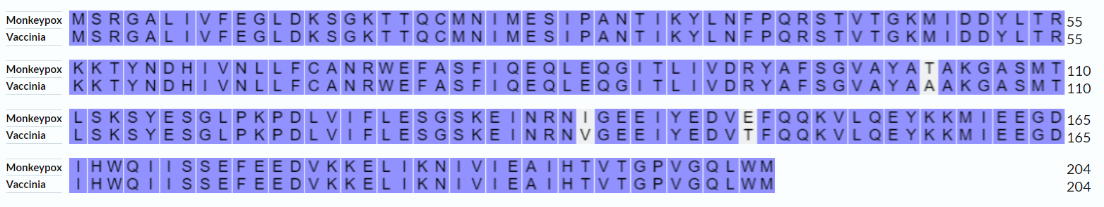
Figure S1: The pairwise sequence alignment of the two TMPKs. The identities are colored as compared to mismatches.
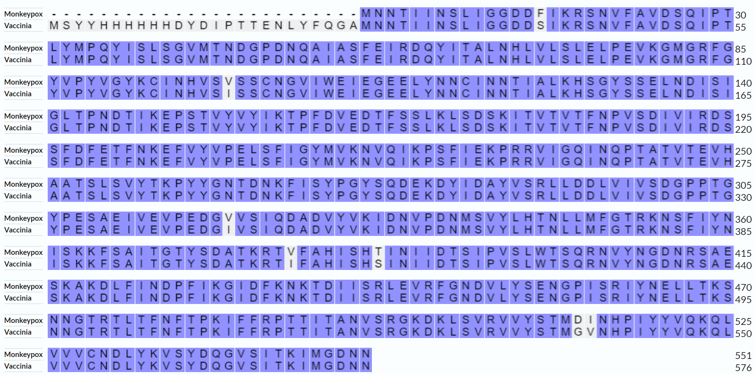
Figure S2: The results of pairwise sequence alignment of the two scaffolding proteins. The identities are colored as compared to mismatches.
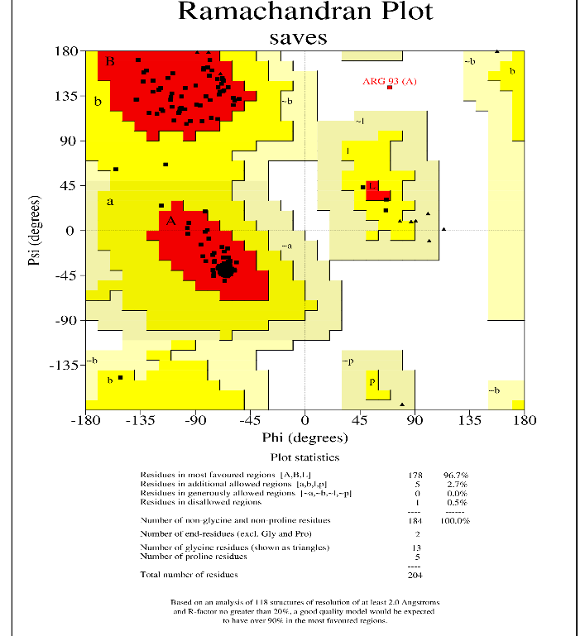
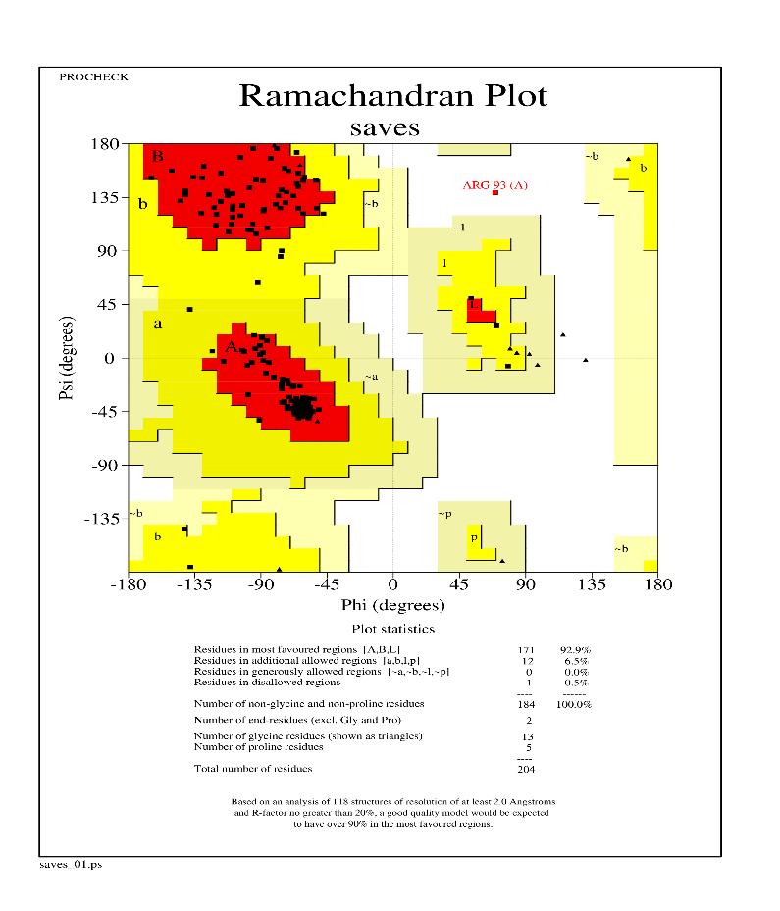

B
A
Figure S3: The Ramachandran plots of the initial model (A) and refined model (B) of monkeypox virus TMPK.

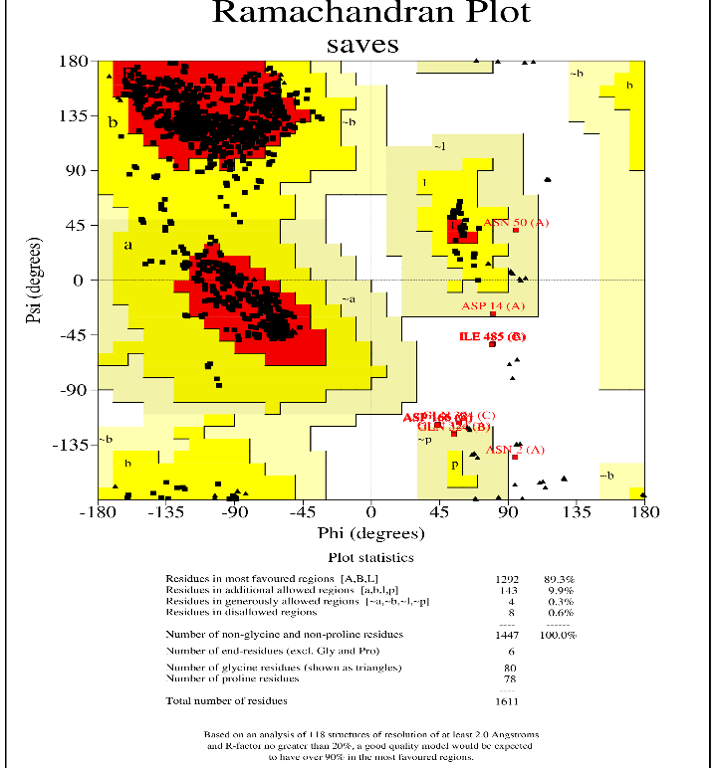
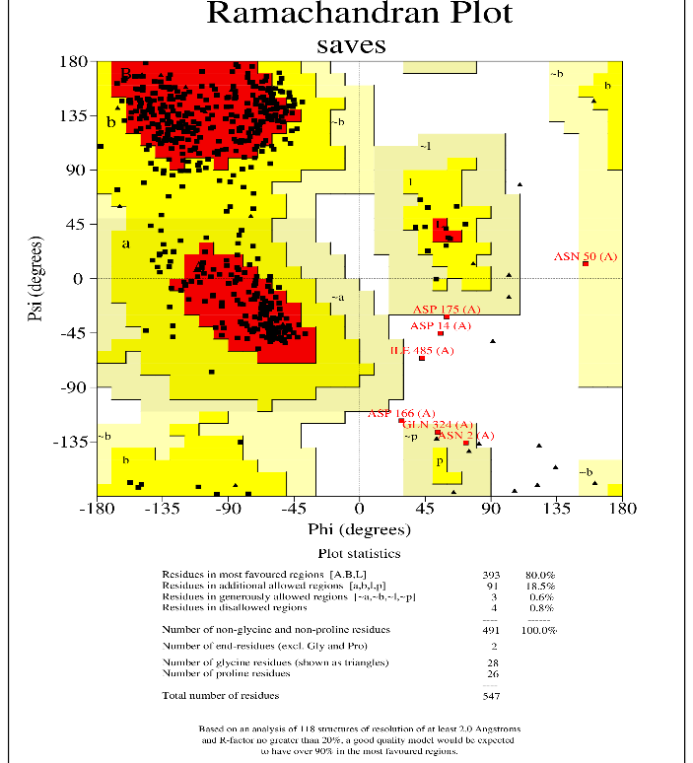
A
Figure S4: The Ramachandran plots of the initial model (A) and refined model (B) of monkeypox virus D13.

B

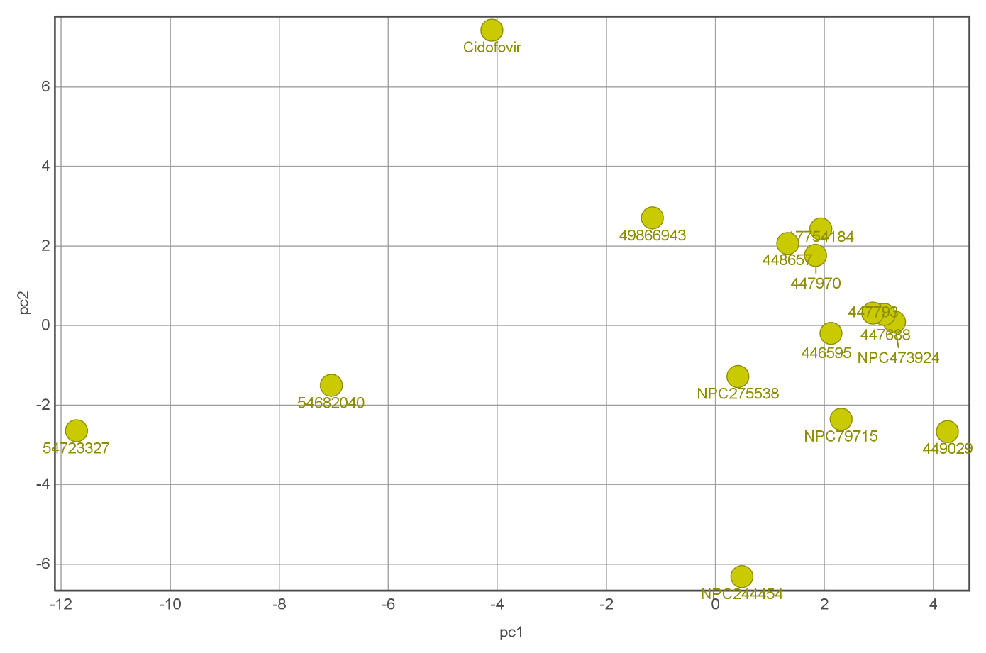

Figure S5:The Figure shows the PCA results for TMPK hits based on their ADMET profiles in Table S4. PCA: Principal Component analysis.

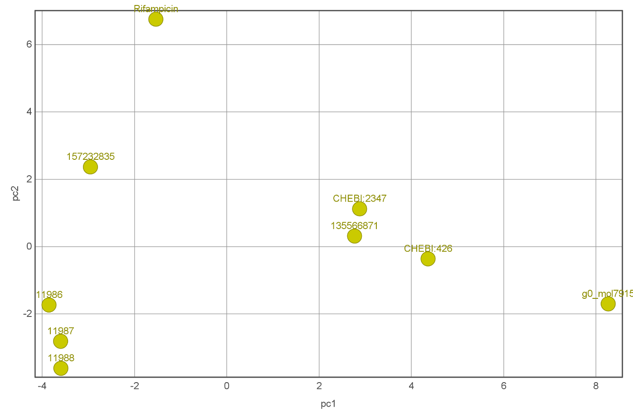

Figure S6:The PCA results for D13 ligands based on their ADMET profiles presented in Table S4. PCA: Principal Component Analysis.
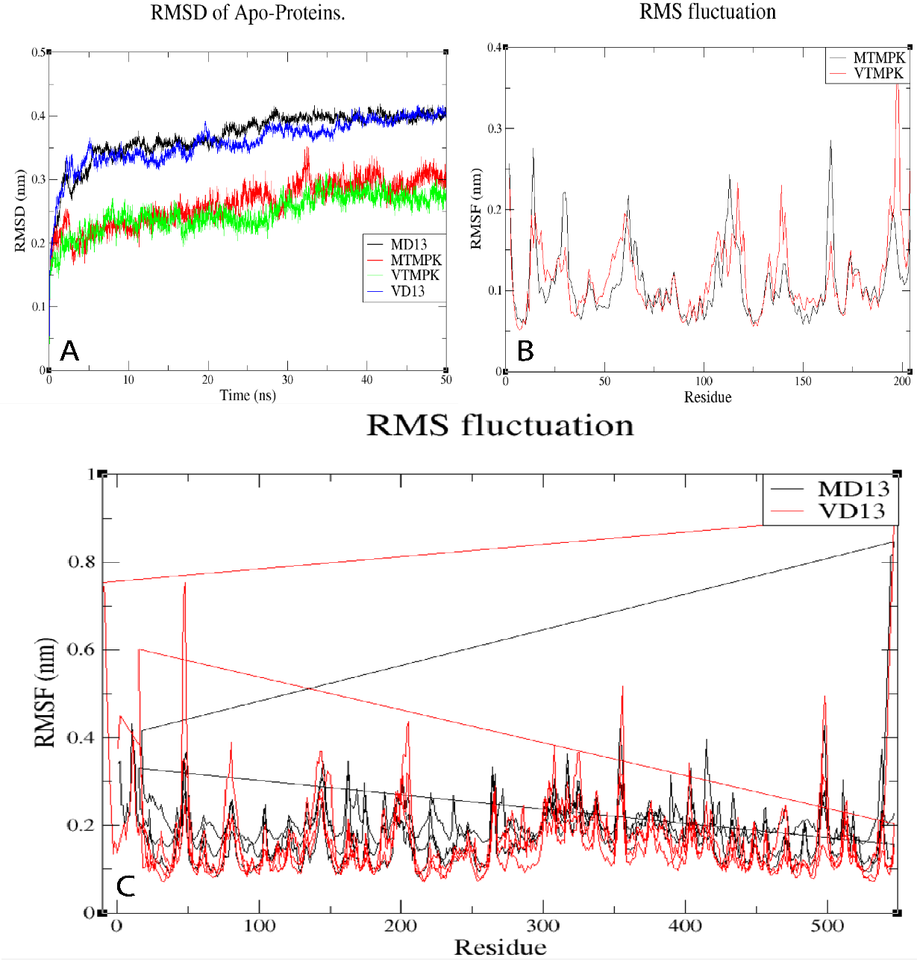

Figure S7: The RMSDs (A) and RMSFs (B and C) of the apo-proteins used in this study, show the stability of the proteins without ligands docked to them and meant to validate the used models.

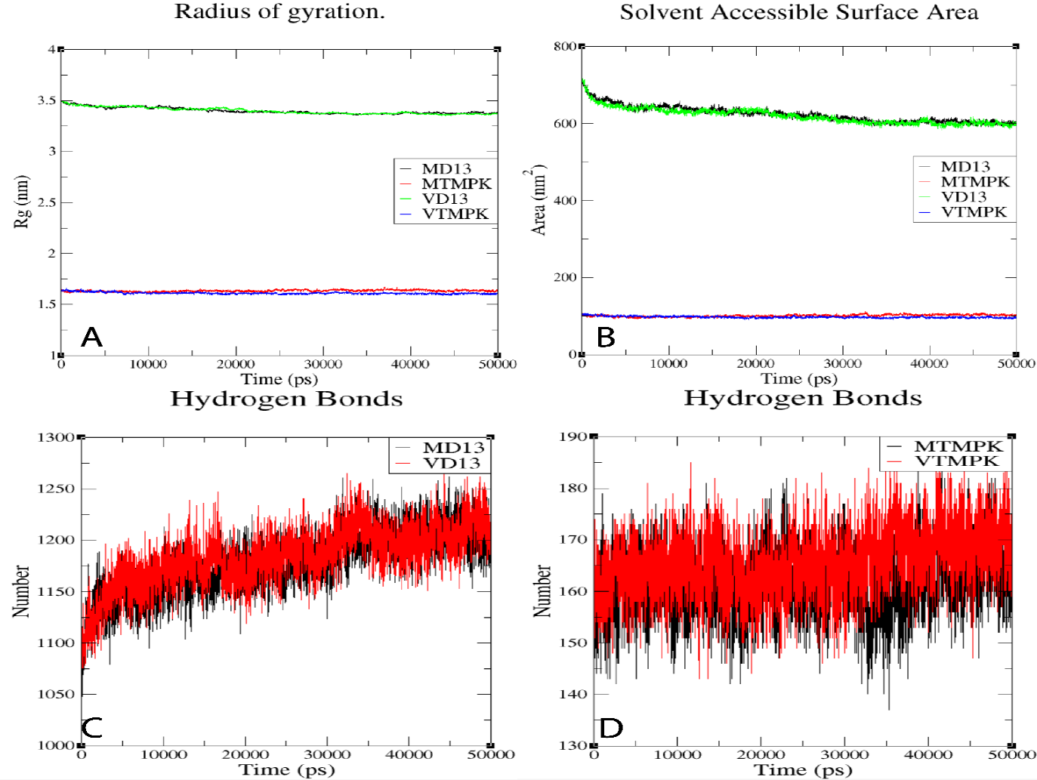

Figure S8:The Figure shows the variation of the Radius of gyration (A), Solvent Accessible Surface Area (B), and Intra-Hydrogen Bonds of Apo-Proteins.
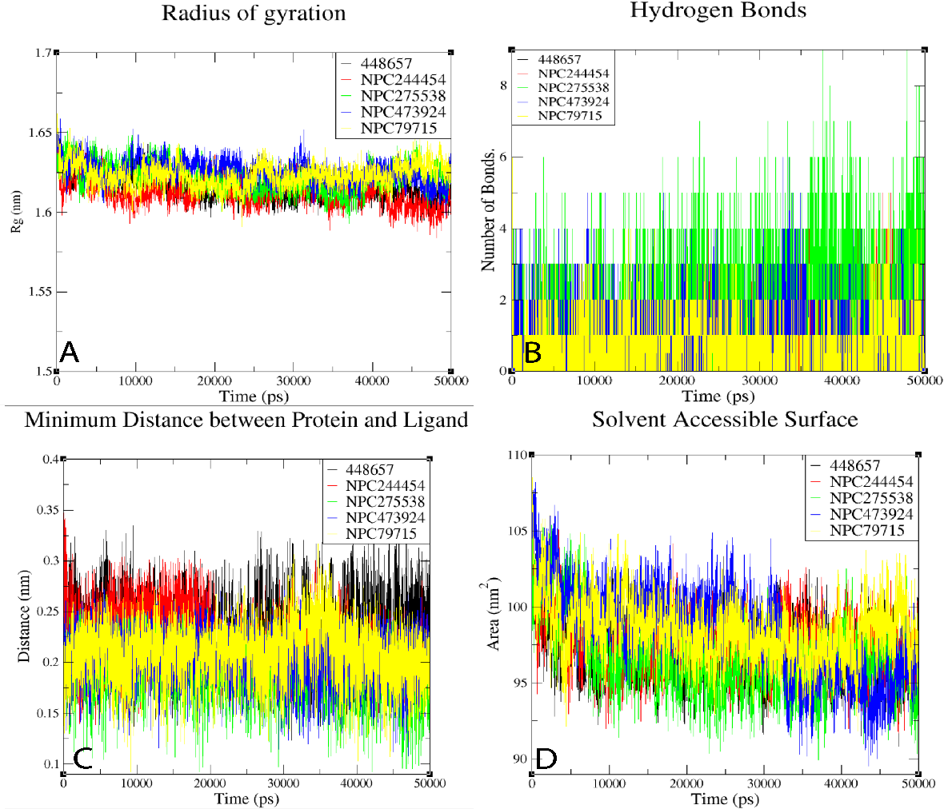

Figure S9:The Figure shows the results of MD analysis for MTMPK. (A) Shows the variation of the Radius of gyration over simulation. (B) Shows the Hydrogen Bonds formed with different Ligands. (C) Shows the variation of the minimum distance between Ligands and their Target and (D) Shows the variation of SASA with time over the simulation.

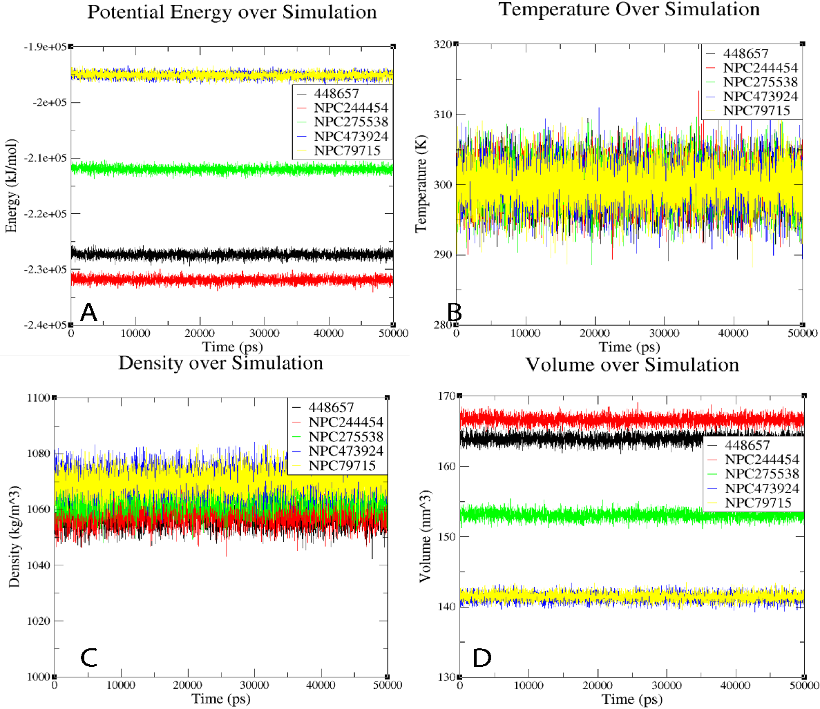

Figure S10: The Figure shows the variation of physical properties with time for MTMPK complexes. (A) Shows a variation in Potential energy. (B) Shows the variation of Temperature. (C) Shows the variation of Density and (D) Shows the variation of volume with time over simulation.

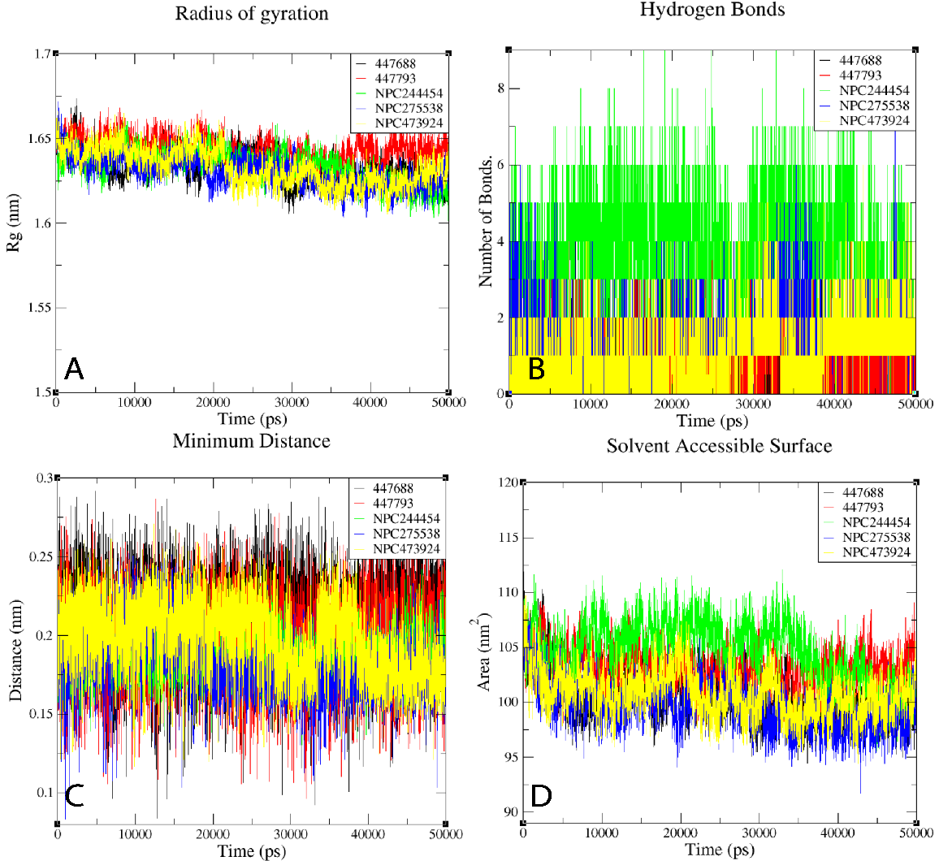

Figure S11: The Figure shows the results of MD analysis for VTMPK. (A) Shows the variation of the Radius of gyration over simulation. (B) Shows the Hydrogen Bonds formed with different Ligands. (C) Shows the variation of the minimum distance between Ligands and their Target and (D) Shows the variation of SASA with time over simulation.

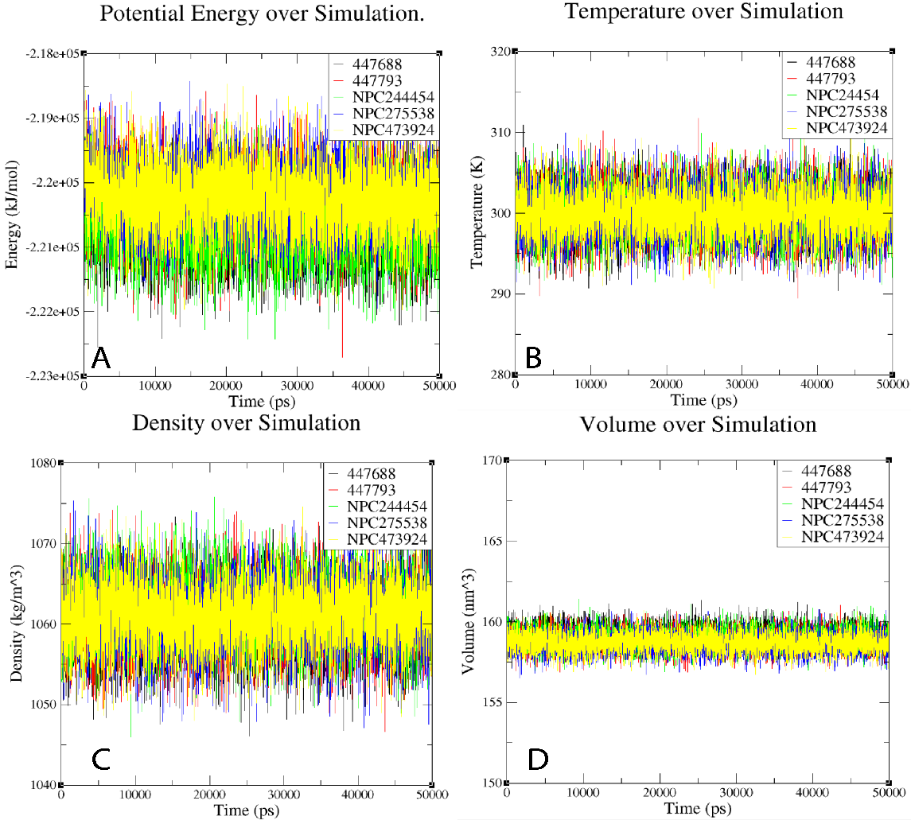

Figure S12: The Figure shows the variation of physical properties with time for VTMPK complexes. (A) Shows a variation in Potential energy. (B) Shows a variation in Temperature. (C) Shows the variation of Density and (D) Shows the variation of volume with time over the simulation.

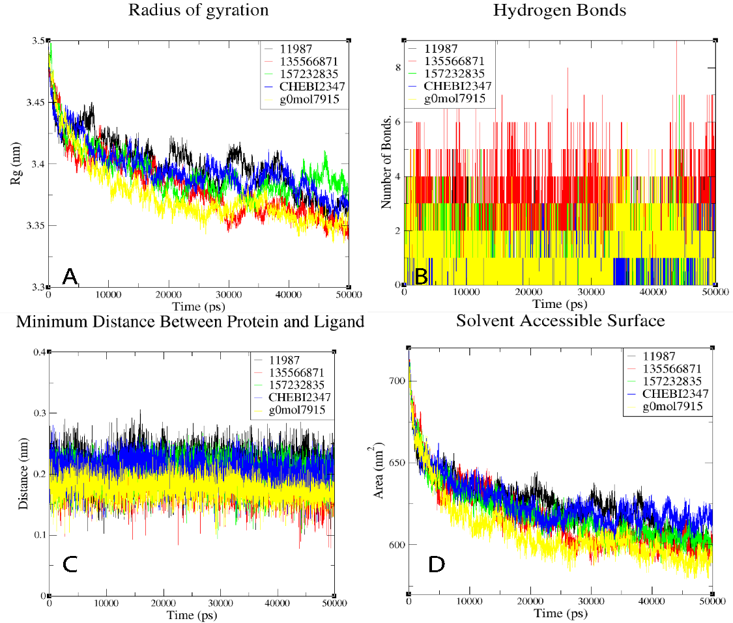

Figure S13: The Figure shows the results of MD analysis for MD13. (A) Shows the variation of the Radius of gyration over simulation. (B) Shows the Hydrogen Bonds formed with different Ligands. (C) Shows the variation of the minimum distance between Ligands and their Target and (D) Shows the variation of SASA with time over simulation.

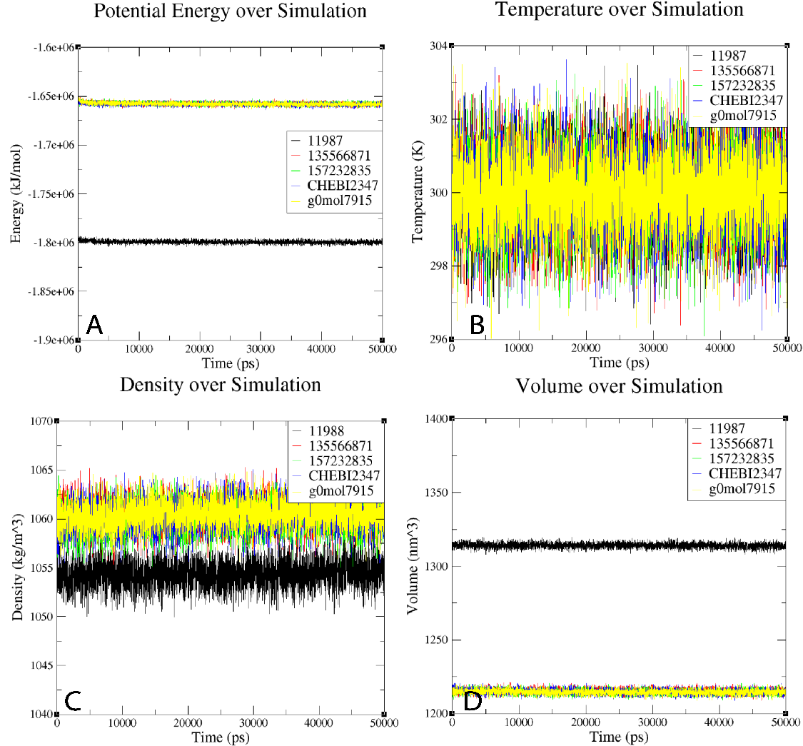

Figure S14: The Figure shows the variation of physical properties with time for MD13 complexes. (A) Shows a variation in Potential energy. (B) Shows a variation in Temperature. (C) Shows a variation in Density and (D) Shows the variation of volume with time over the simulation.

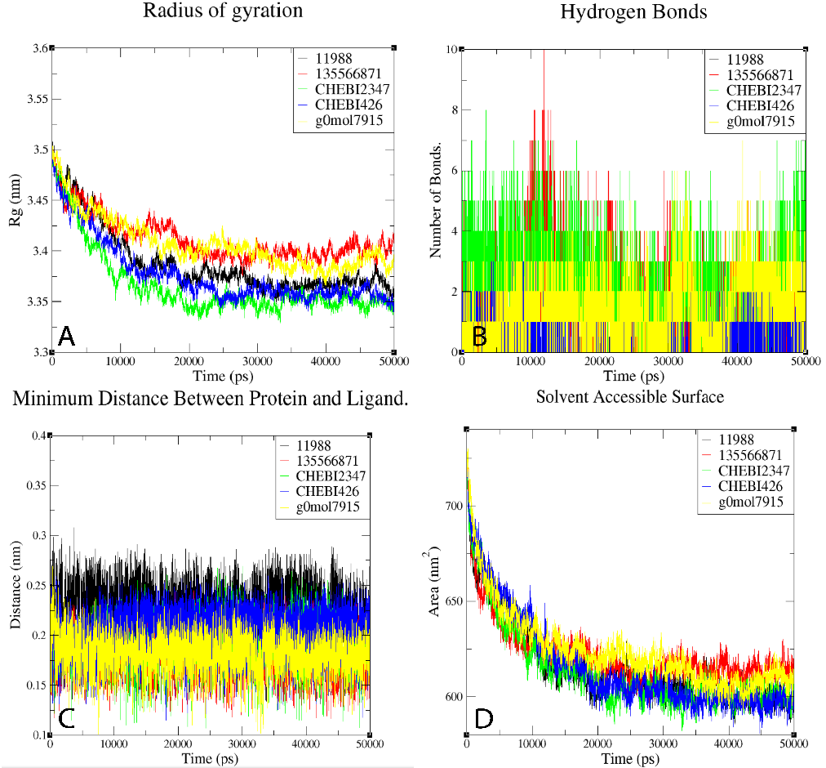

Figure S15: The Figure shows the results of MD analysis for VD13. (A) Shows the variation of the Radius of gyration over simulation. (B) Shows the Hydrogen Bonds formed with different Ligands. (C) Shows the variation of the minimum distance between Ligands and their Target and (D) Shows the variation of SASA with time over simulation.

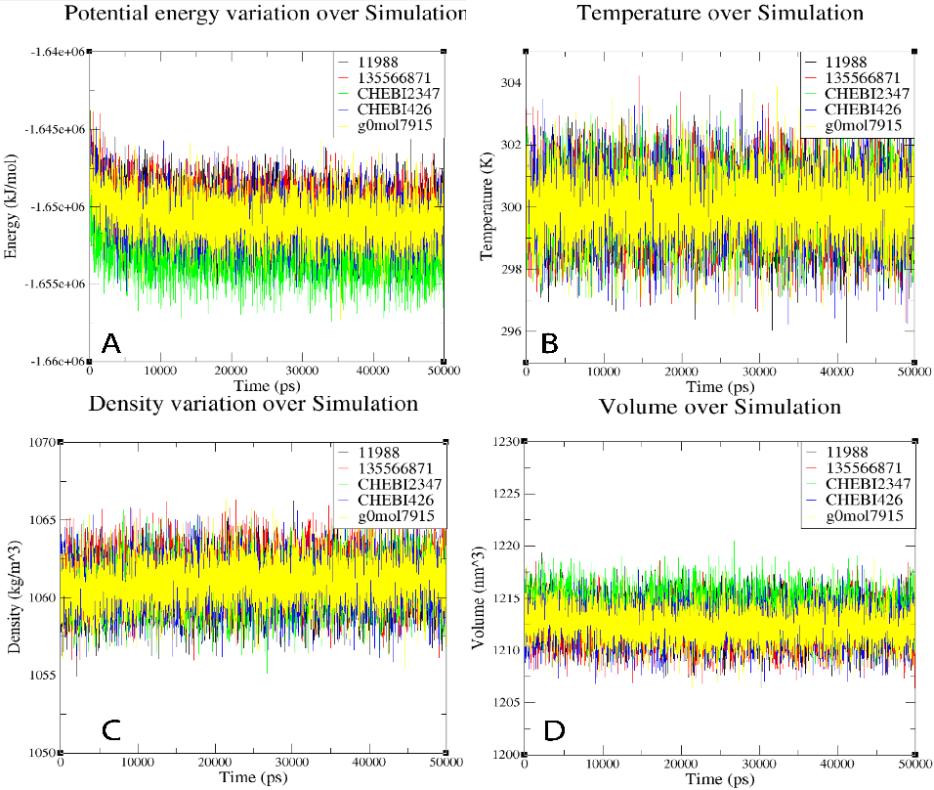

Figure S16: The Figure shows the variation of physical properties with time for VD13 complexes. (A) Shows the variation of Potential energy. (B) Shows a variation in Temperature. (C) Shows the variation of Density and (D) Shows the variation of volume with time over the simulation.

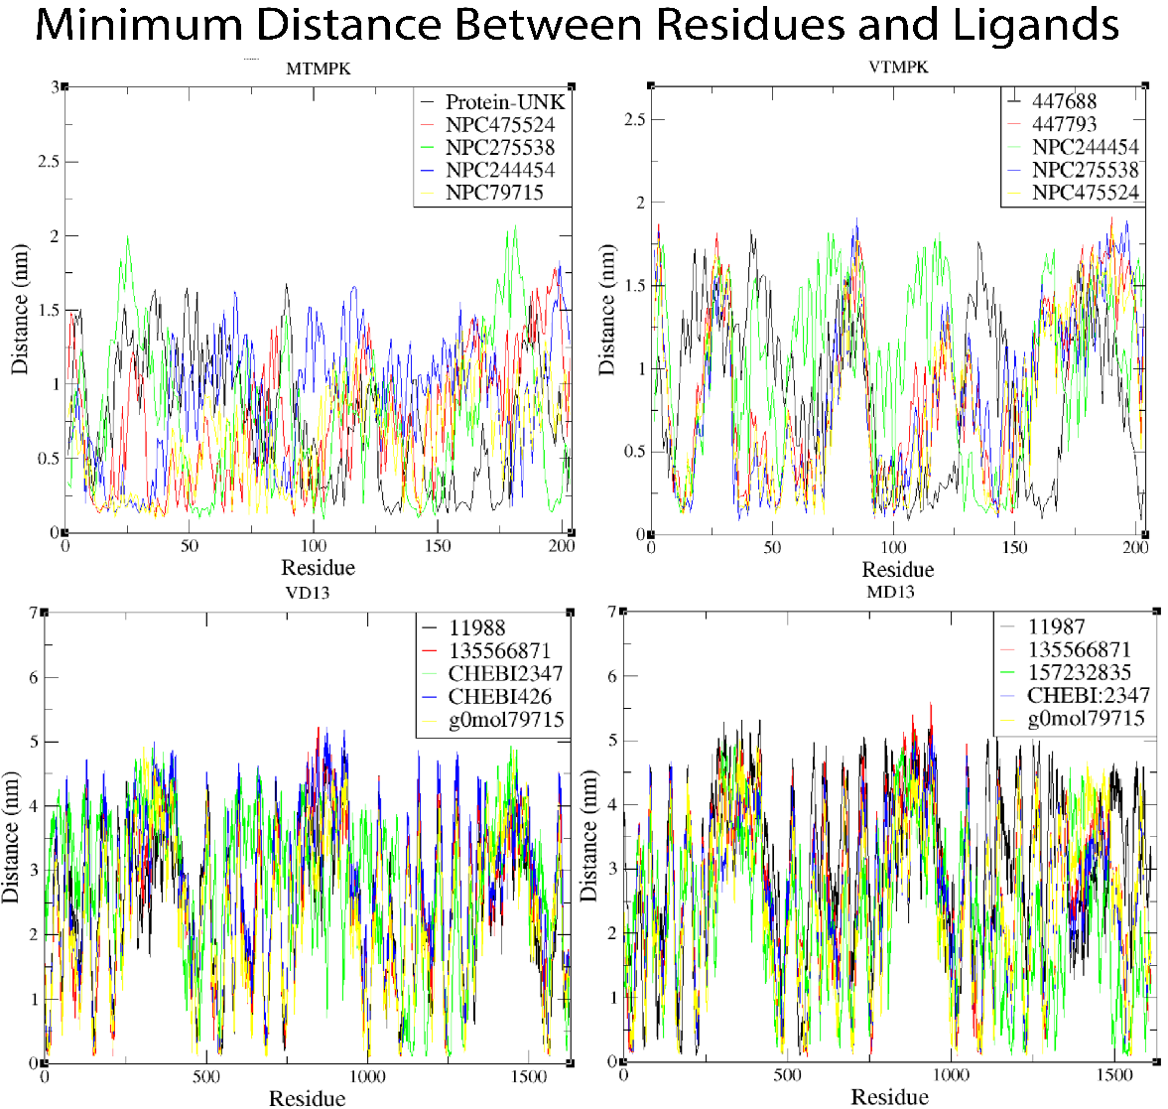

Figure S17:The Figure Shows the variation of minimum distances between Protein residues and respective Ligands over simulation.

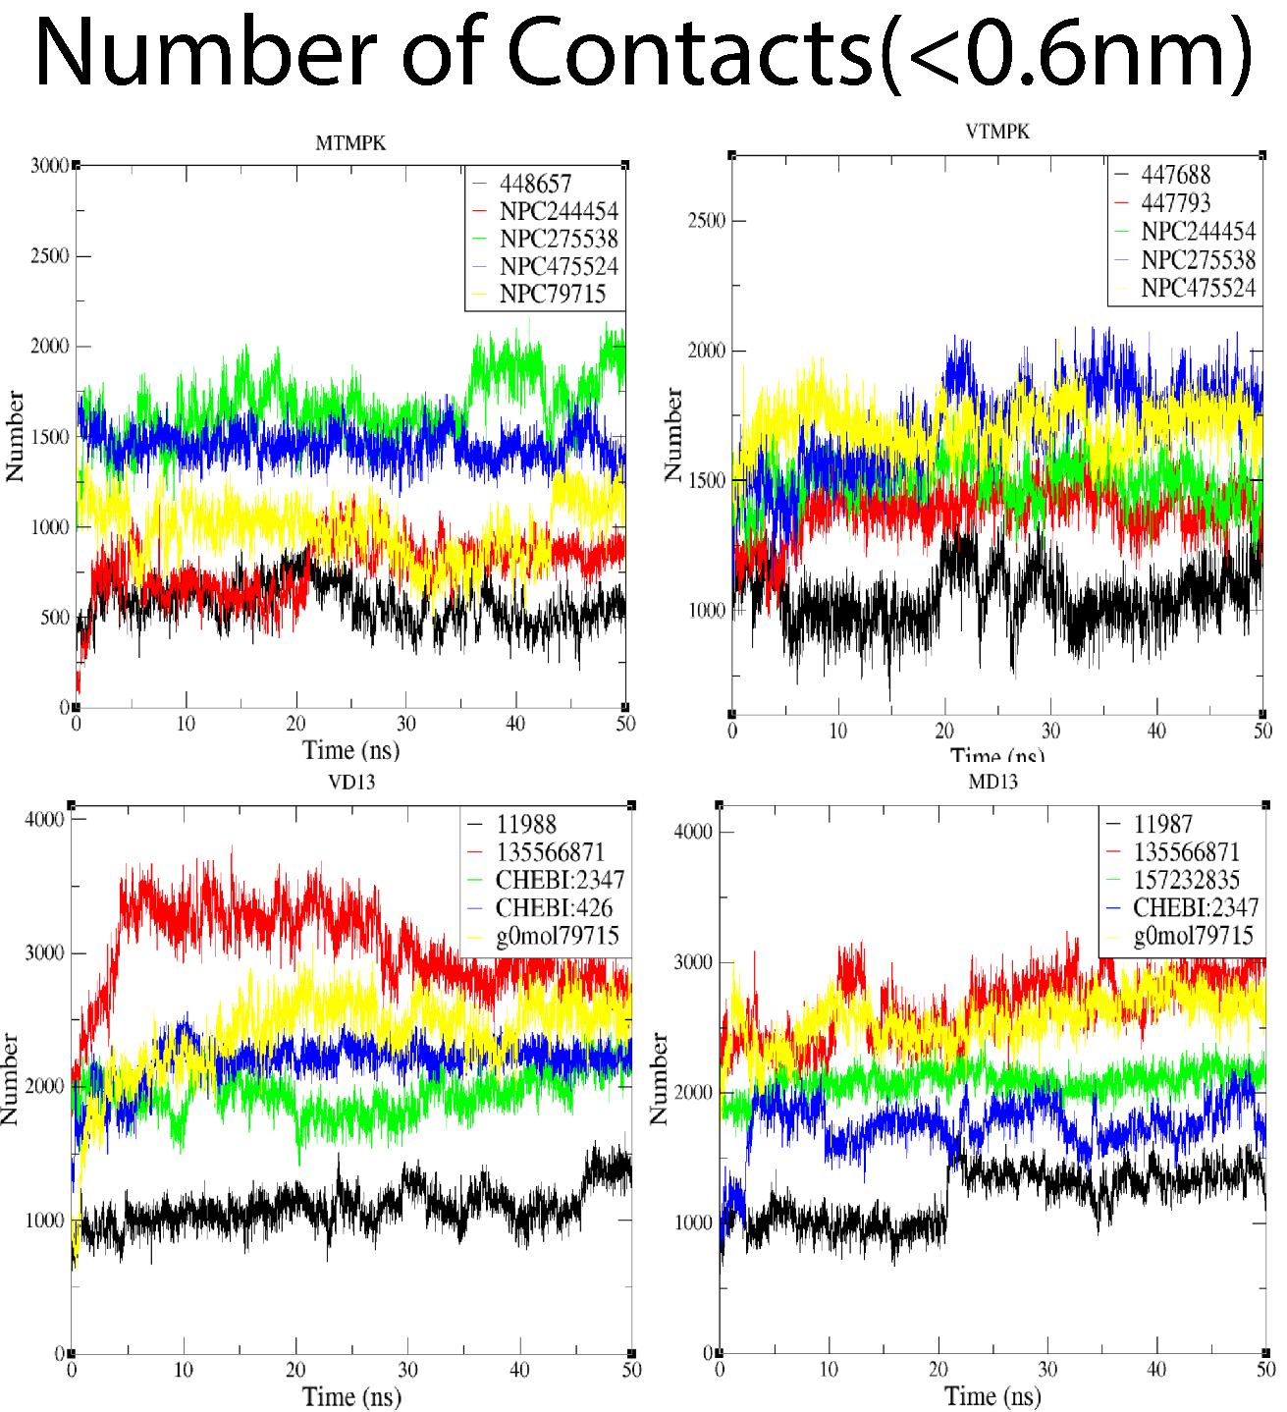

Figure S18: The Figure shows the number of contacts between the respective targets and their Ligands with the cut-off distance below 0.6nm.

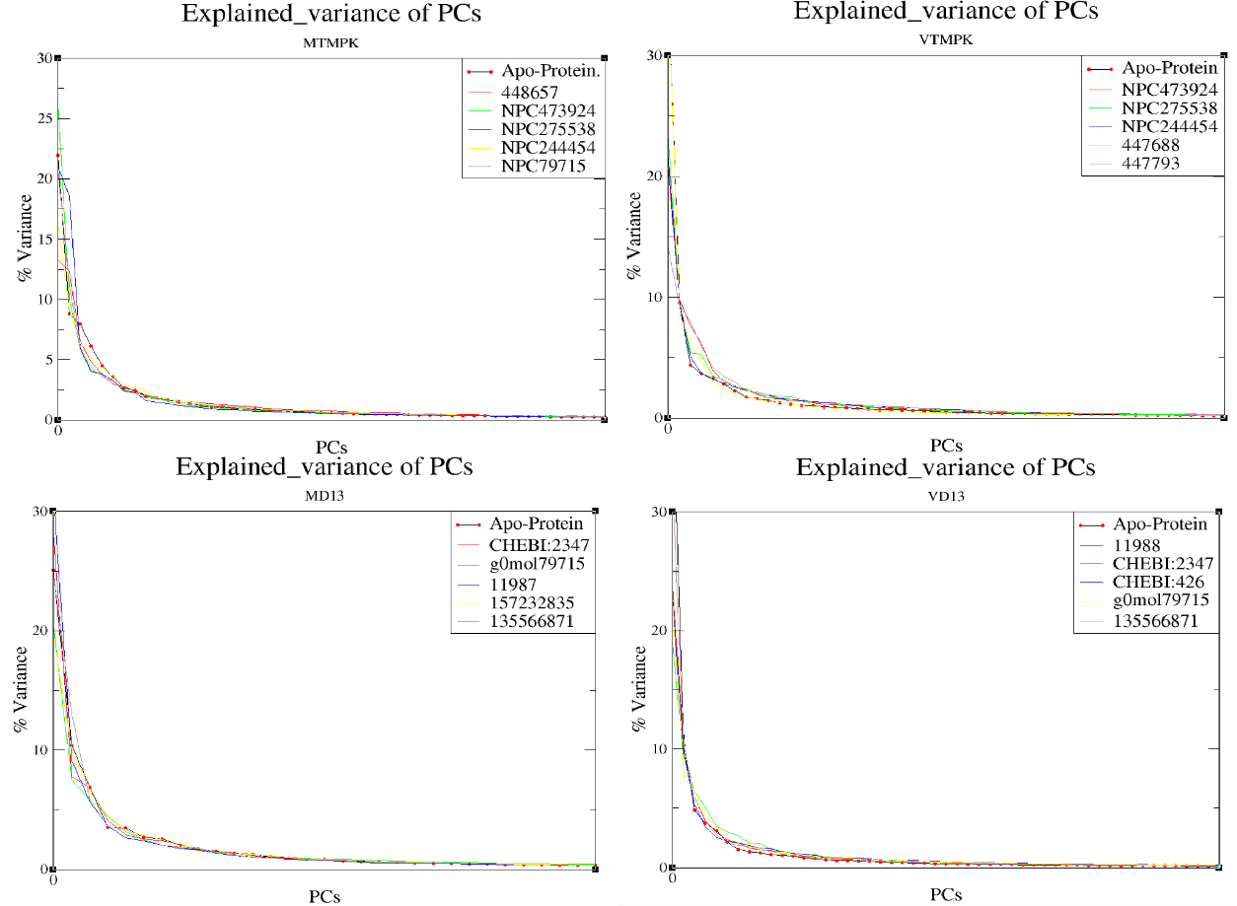

Figure S19:The Figure shows the percentage variance of the first 50 PCs for all the simulated systems.

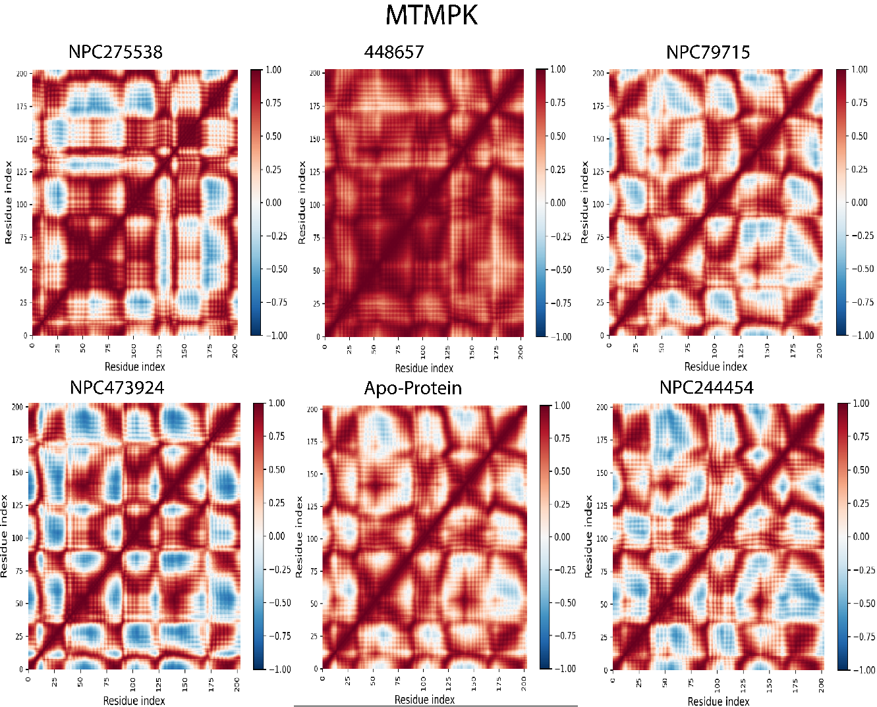

Figure S20:Dynamic Cross-Correlation results for MTMPK simulated complexes. The strength of the residue correlation is color coded.
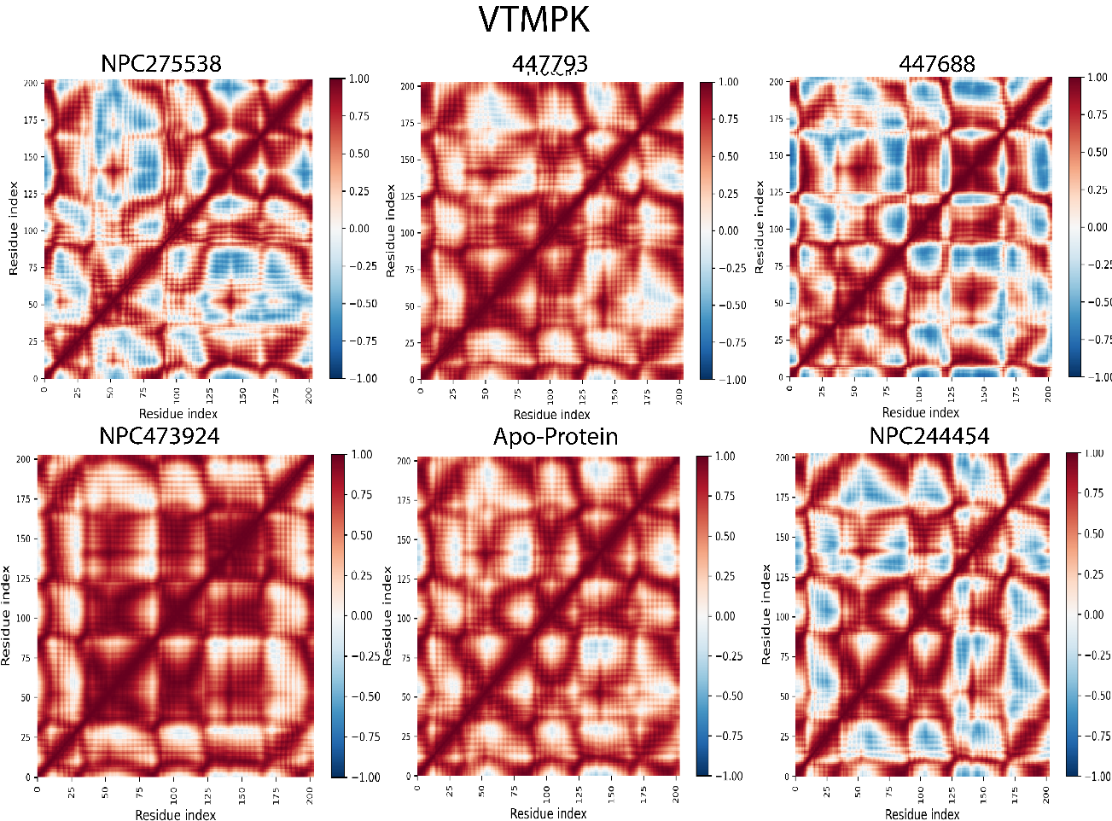

Figure S21: Dynamic Cross-Correlation results for VTMPK simulated complexes. The strength of the residue corrolation is color coded.

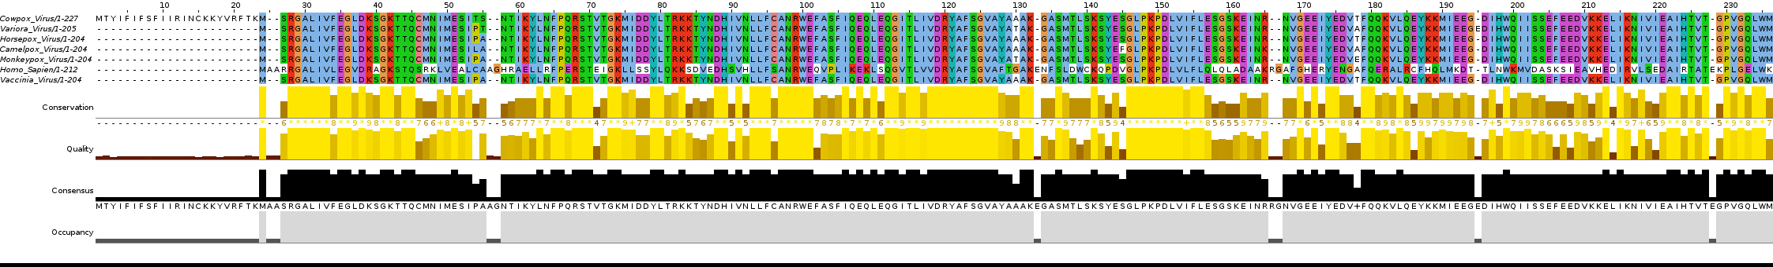

Figure S22:The results of Multiple sequence analysis (MSA) of TMPK proteins from some OPVs and homo sapiens.
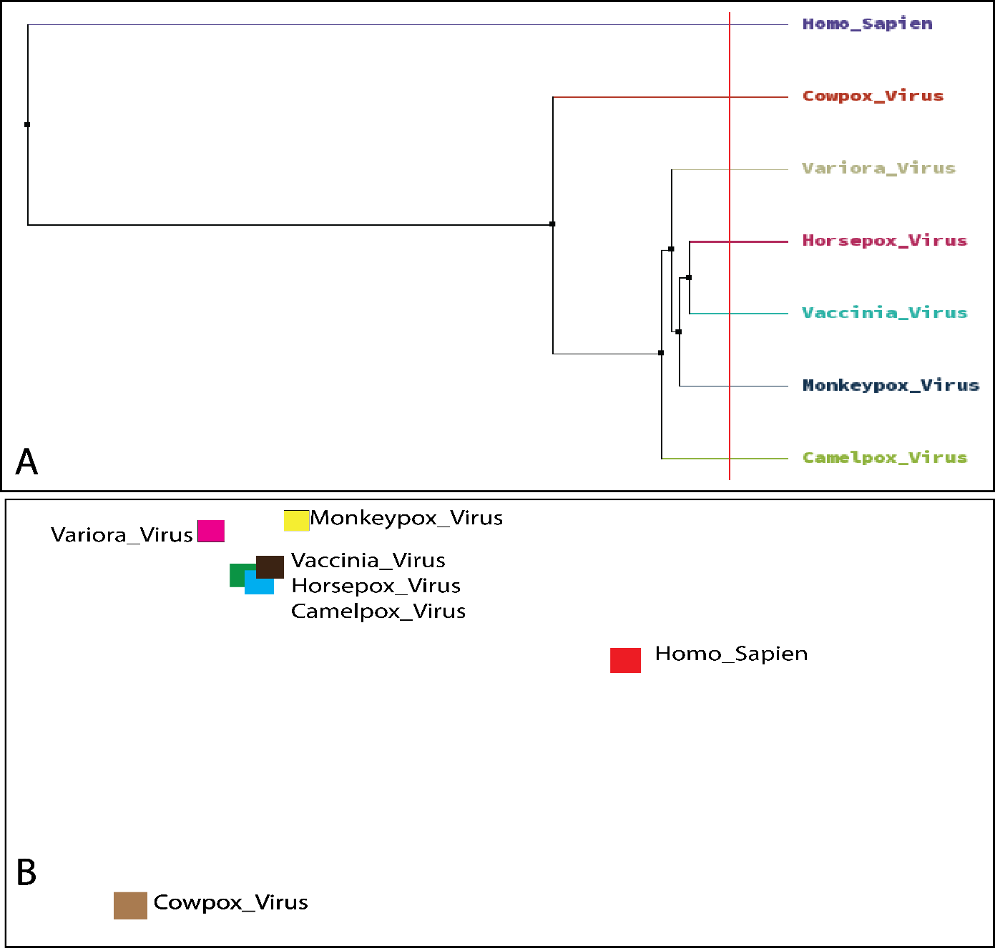

Figure S23: Figure Shows (A) a phylogenetic tree showing the relationship between TMPKs of some OPVs and that of homo sapiens. In Figure B, the sequences have been clustered to further map the similarity between them.

Table S1: The molecular docking results when identified MTMPK and VTMPK inhibitors were docked in the active site of human TMPK (hTMPK).
Name | docking score | Interacting Residues
NPC79715 | -9.29954 | ARG150  ARG97  GLU152  ARG76  PHE42  ARG16
NPC473924 | -9.04534 | ARG97  ARG76  PHE72  ARG16
NPC244454 | -8.30688 | ARG150  ARG45  ARG97  ARG16  ARG76  SER101
447793 | -7.71937 | SER20  ARG97  THR21  ARG24
447688 | -7.71873 | ARG97  ARG16  GLY18  SER20  ARG24  THR21
17754184 | -7.20482 | ARG45  GLU152  ARG150  ARG97  ARG16
448657 | -7.06878 | ARG45  ARG16  SER20  ARG97
49866943 | -5.61268 | ARG45  ARG16  LYS19  SER20
449029 | -5.44239 | LYS19  ASP15  SER101  ARG97  ARG45  ARG16
NPC275538 | -4.55229 | PHE105  ARG97  ASP15  ARG16  PRO43
449129 | -4.45782 | ARG16  ASP15  ARG45
54682040 | -4.21191 | ARG45  ARG97  PHE105
447970 | -2.93253 | ARG97  ARG45,  ARG16  GLU152
446595 | -2.83736 | ASP15  PHE72  ARG97
54723327 | -2.81603 | ARG16  PHE72

Table S2: The Results of molecular docking of potential identified compounds with CDV-R MTMPK. CDV-R MTMPK: Cidofovir Resistant Monkeypox virus Thymidylate kinase.
Name | docking score | Interacting residues
449029 | -12.4053 | THR18  LYS17  SER15  LYS14  ARG93  ASP13  PHE69  SER97
NPC473924 | -12.3749 | GLY16  THR19  THR18  ARG41  ARG93  PHE69
446595 | -11.942 | LYS17  THR18  ARG93  ASP13
448657 | -10.8284 | THR18  ASN37  ARG41  ARG93
54723327 | -10.3993 | ARG41  ARG93  LYS17  PHE68
447793 | -9.94831 | LYS14  GLY16  THR18  ARG41
447970 | -9.37618 | ARG93  ARG41  ASN37  LYS14
54682040 | -9.26757 | TYR101  ARG41  LYS14  LYS17  ARG93
NPC79715 | -9.21071 | GLU142  ASN37  SER97  PHE68
17754184 | -9.06651 | ASP92  PHE38
NPC275538 | -8.98417 | THR18  GLYS16  PHE68  SER97
NPC244454 | -8.85513 | TYR101  ARG41  GLU141  LYS14  ARG93  GLY16  THR18  LYS17  THR19
447688 | -8.63324 | LYS17  GLY16  ARG93
49866943 | -8.39454 | ARG41  ARG93  LYS14  GLY16  LYS17  GLU142
449129 | -6.66834 | TYR101  ARG93  LYS17  ASN37

Table S3: The Table Shows the results of docking D13 mutant proteins (Rifampicin-Resistant) with ligands identified in this study.
Ligands | Docking score (Kcal/mol)
Ligands | MD13 | VD13
11986 | -5.489 | -4.623
11987 | -5.112 | -6.924
11988 | -6.227 | -4.539
CHEBI:426 | -10.457 | -10.552
CHEBI:2347 | -9.181 | -9.153
g0_mol7915 | -7.263 | -6.734
135566871 | -8.345 | -8.034
157232835 | -6.534 | -7.863
Rifampicin | -2.275 | -2.177

Table S4: The Table below shows the results of the ADMET study on compounds presented in this study.

 | Title | 60613 | 446595 | 447688 | 447793 | 447970 | 448657 | 449029 | 17754184 | 54682040 | 54723327 | NPC79715 | NPC244454 | NPC275538 | NPC473924 | 49866943 | Rifampicin | 11986 | 11987 | 11988 | 157232835 | g0_mol7915 | CHEBI:426 | CHEBI:2347
#stars |  | 1 | 4 | 5 | 4 | 4 | 4 | 7 | 5 | 0 | 1 | 6 | 3 | 4 | 6 | 1 | 4 | 14 | 14 | 14 | 7 | 17 | 15 | 15
#amine |  | 0 | 1 | 0 | 0 | 0 | 0 | 1 | 0 | 0 | 0 | 0 | 0 | 0 | 0 | 0 | 0 | 0 | 0 | 0 | 4 | 0 | 0 | 0
#amidine |  | 0 | 0 | 0 | 0 | 0 | 0 | 0 | 0 | 0 | 0 | 0 | 0 | 0 | 0 | 0 | 0 | 0 | 0 | 0 | 0 | 1 | 0 | 0
#acid |  | 2 | 0 | 0 | 0 | 0 | 0 | 0 | 0 | 0 | 0 | 0 | 0 | 0 | 0 | 2 | 0 | 0 | 0 | 0 | 0 | 0 | 4 | 2
#amide |  | 0 | 0 | 0 | 0 | 0 | 0 | 0 | 0 | 0 | 0 | 0 | 0 | 0 | 0 | 0 | 1 | 0 | 0 | 0 | 0 | 11 | 2 | 1
#rotor |  | 10 | 11 | 19 | 22 | 19 | 19 | 12 | 20 | 4 | 6 | 19 | 14 | 19 | 16 | 10 | 25 | 33 | 35 | 39 | 25 | 34 | 41 | 42
#rtvFG |  | 0 | 0 | 2 | 2 | 3 | 3 | 1 | 2 | 0 | 2 | 1 | 4 | 2 | 3 | 1 | 2 | 0 | 0 | 0 | 0 | 0 | 5 | 4
CNS |  | -2 | -2 | -2 | -2 | -2 | -2 | -2 | -2 | -2 | -2 | -2 | -2 | -2 | -2 | -2 | -2 | -2 | -2 | -2 | -2 | -2 | -2 | -2
mol MW |  | 279.189 | 458.491 | 508.605 | 496.594 | 468.497 | 468.497 | 509.493 | 454.514 | 410.419 | 304.348 | 494.538 | 598.559 | 476.439 | 474.418 | 432.326 | 709.873 | 797.129 | 853.236 | 909.343 | 614.919 | 1196.330 | 1078.053 | 1018.037
dipole |  | 8.017 | 4.912 | 7.693 | 3.849 | 9.493 | 5.653 | 6.162 | 5.815 | 1.954 | 9.764 | 4.616 | 9.420 | 4.571 | 6.790 | 9.552 | 9.262 | 5.802 | 7.717 | 5.490 | 4.478 | 7.566 | 9.465 | 9.098
SASA |  | 481.951 | 737.487 | 799.727 | 864.414 | 748.479 | 718.429 | 789.098 | 721.002 | 661.493 | 615.369 | 803.504 | 843.333 | 750.496 | 720.132 | 654.662 | 829.489 | 1395.897 | 1586.290 | 1639.699 | 1164.371 | 1535.389 | 1666.270 | 1490.839
FOSA |  | 96.459 | 275.897 | 529.105 | 610.067 | 470.767 | 495.691 | 128.187 | 456.159 | 251.401 | 141.202 | 188.814 | 172.571 | 139.924 | 221.166 | 213.612 | 653.144 | 1168.416 | 1351.044 | 1396.212 | 773.389 | 644.053 | 977.270 | 995.876
FISA |  | 313.809 | 345.088 | 270.622 | 254.347 | 277.713 | 222.739 | 397.840 | 264.843 | 194.698 | 135.236 | 356.411 | 293.524 | 378.925 | 350.163 | 321.499 | 165.638 | 159.424 | 160.049 | 161.087 | 161.220 | 560.560 | 529.583 | 443.638
PISA |  | 68.294 | 116.113 | 0.000 | 0.000 | 0.000 | 0.000 | 263.070 | 0.000 | 167.064 | 338.931 | 258.280 | 377.238 | 231.646 | 148.803 | 116.039 | 10.707 | 68.056 | 75.198 | 82.401 | 229.762 | 330.776 | 100.249 | 50.032
WPSA |  | 3.390 | 0.389 | 0.000 | 0.000 | 0.000 | 0.000 | 0.000 | 0.000 | 48.329 | 0.000 | 0.000 | 0.000 | 0.000 | 0.000 | 3.511 | 0.000 | 0.000 | 0.000 | 0.000 | 0.000 | 0.000 | 59.168 | 1.293
volume |  | 813.482 | 1314.620 | 1543.392 | 1595.025 | 1433.942 | 1376.218 | 1404.053 | 1371.791 | 1172.887 | 1040.400 | 1500.936 | 1666.028 | 1391.756 | 1316.826 | 1196.696 | 1913.789 | 2715.026 | 2992.609 | 3169.971 | 2179.199 | 3348.639 | 3201.782 | 2964.150
donorHB |  | 5.000 | 7.000 | 7.000 | 7.000 | 7.000 | 7.000 | 8.000 | 8.000 | 1.000 | 1.000 | 8.000 | 2.000 | 4.000 | 8.000 | 4.000 | 7.000 | 6.000 | 6.000 | 6.000 | 6.000 | 11.250 | 8.000 | 6.000
accptHB |  | 12.400 | 14.600 | 18.700 | 18.700 | 17.100 | 17.100 | 15.850 | 16.800 | 10.750 | 3.750 | 14.150 | 14.600 | 12.300 | 17.850 | 15.600 | 16.950 | 7.500 | 7.500 | 7.500 | 9.000 | 26.200 | 29.800 | 27.600
dip^2/V |  | 0.0790017 | 0.0183497 | 0.0383427 | 0.0092905 | 0.0628466 | 0.0232225 | 0.0270474 | 0.0246496 | 0.0032556 | 0.0916352 | 0.0141969 | 0.0532674 | 0.0150156 | 0.0350100 | 0.0762446 | 0.0448280 | 0.0124010 | 0.0198988 | 0.0095075 | 0.0092017 | 0.0170958 | 0.0279809 | 0.0279262
ACxDN^.5/SA |  | 0.0575312 | 0.0523778 | 0.0618656 | 0.0572359 | 0.0604457 | 0.0629740 | 0.0568124 | 0.0659049 | 0.0162511 | 0.0060939 | 0.0498096 | 0.0244832 | 0.0327783 | 0.0701086 | 0.0476582 | 0.0540640 | 0.0131608 | 0.0115812 | 0.0112040 | 0.0189333 | 0.0572347 | 0.0505843 | 0.0453476
glob |  | 0.8744342 | 0.7869447 | 0.8076213 | 0.7637562 | 0.8216237 | 0.8328610 | 0.7684634 | 0.8281080 | 0.8130997 | 0.8069188 | 0.7890150 | 0.8059114 | 0.8032654 | 0.8068111 | 0.8326656 | 0.8987052 | 0.6742606 | 0.6331147 | 0.6364599 | 0.6981331 | 0.7050052 | 0.6304939 | 0.6693725
QPpolrz |  | 20.633 | 40.503 | 43.413 | 43.553 | 39.032 | 36.722 | 44.843 | 35.903 | 39.812 | 34.867 | 44.180 | 55.134 | 39.556 | 37.693 | 36.425 | 54.486 | 81.962 | 91.855 | 96.453 | 67.199 | 109.186 | 96.613 | 85.981
QPlogPC16 |  | 9.638 | 15.364 | 16.014 | 16.662 | 15.043 | 14.118 | 17.937 | 14.612 | 11.596 | 11.389 | 18.389 | 18.773 | 16.391 | 15.813 | 13.352 | 17.934 | 27.950 | 32.016 | 33.498 | 23.701 | 37.984 | 37.648 | 32.150
QPlogPoct |  | 21.972 | 32.190 | 35.053 | 34.313 | 33.045 | 31.445 | 36.359 | 32.623 | 20.819 | 16.140 | 34.723 | 30.819 | 26.397 | 34.643 | 27.822 | 38.021 | 39.352 | 42.520 | 43.988 | 35.482 | 69.735 | 61.265 | 52.976
QPlogPw |  | 20.810 | 26.838 | 27.965 | 27.348 | 26.314 | 25.867 | 30.796 | 27.108 | 14.960 | 8.260 | 27.297 | 20.533 | 19.461 | 30.616 | 23.290 | 26.185 | 13.522 | 13.592 | 12.894 | 17.319 | 59.687 | 43.300 | 33.374
QPlogPo/w |  | -1.432 | -1.792 | -0.971 | -0.727 | -1.018 | -0.902 | -2.115 | -1.246 | 1.165 | 3.688 | -0.158 | 1.951 | 0.288 | -2.345 | -0.625 | 2.066 | 11.116 | 12.861 | 14.003 | 5.215 | -2.827 | 3.005 | 2.803
QPlogS |  | -0.987 | -1.964 | -1.860 | -2.135 | -1.585 | -1.268 | -2.165 | -1.203 | -3.906 | -6.146 | -2.708 | -3.919 | -2.576 | -1.708 | -2.000 | -0.762 | -12.276 | -15.400 | -15.724 | -4.105 | -0.363 | -6.167 | -5.309
CIQPlogS |  | -1.017 | -2.195 | -2.187 | -2.019 | -2.094 | -2.094 | -2.943 | -1.926 | -3.994 | -5.418 | -4.104 | -6.432 | -4.648 | -2.267 | -2.665 | -6.144 | -13.050 | -14.205 | -15.364 | -4.547 | -6.106 | -7.713 | -8.079
QPlogHERG |  | -0.274 | -6.259 | -4.645 | -5.355 | -4.418 | -4.236 | -7.259 | -4.313 | -5.353 | -6.273 | -6.178 | -6.472 | -5.820 | -5.368 | -1.178 | -1.848 | -7.127 | -7.827 | -7.807 | -10.417 | 7.236 | 1.990 | -2.131
QPPCaco |  | 0.672 | 1.319 | 26.890 | 38.364 | 23.033 | 76.501 | 0.417 | 30.506 | 141.116 | 516.963 | 4.131 | 16.308 | 2.527 | 4.735 | 0.568 | 168.846 | 304.844 | 300.717 | 293.976 | 4.547 | 0.001 | 0.001 | 0.039
QPlogBB |  | -2.767 | -3.415 | -3.348 | -3.669 | -3.324 | -2.722 | -4.253 | -3.217 | -1.522 | -1.183 | -4.398 | -3.293 | -4.497 | -3.987 | -3.122 | -2.310 | -3.763 | -4.208 | -4.438 | -2.351 | -9.005 | -10.644 | -8.566
QPPMDCK |  | 0.311 | 0.424 | 9.929 | 14.579 | 8.399 | 30.742 | 0.122 | 11.380 | 109.620 | 242.457 | 1.311 | 5.783 | 0.771 | 1.519 | 0.260 | 118.308 | 136.993 | 134.990 | 131.722 | 1.969 | 0.011 | 0.000 | 0.014
QPlogKp |  | -6.102 | -8.477 | -4.683 | -4.095 | -4.814 | -3.800 | -8.835 | -4.480 | -4.135 | -2.242 | -5.354 | -4.256 | -5.863 | -5.913 | -6.076 | -2.134 | -1.050 | -0.844 | -0.454 | -5.406 | -9.484 | -6.990 | -5.487
IP(eV) |  | 9.035 | 8.664 | 10.477 | 10.481 | 10.304 | 10.611 | 8.428 | 10.598 | 9.159 | 8.852 | 8.844 | 9.312 | 9.200 | 8.923 | 9.239 | 9.056 | 7.943 | 7.964 | 8.007 | 8.075 | 8.057 | 8.013 | 9.277
EA(eV) |  | 0.220 | 0.963 | -1.481 | -1.650 | -0.954 | -1.034 | 1.391 | -1.520 | 1.116 | 0.797 | 0.061 | 1.159 | 0.792 | 0.895 | 0.181 | 0.174 | 0.905 | 0.994 | 0.880 | 0.509 | 0.151 | 0.721 | 0.185
#metab |  | 2 | 7 | 7 | 7 | 8 | 8 | 9 | 8 | 2 | 0 | 10 | 7 | 6 | 8 | 3 | 9 | 11 | 11 | 10 | 8 | 18 | 6 | 9
QPlogKhsa |  | -1.512 | -0.960 | -1.320 | -1.499 | -1.272 | -1.330 | -1.070 | -1.362 | -0.502 | 0.460 | -0.935 | -0.353 | -0.756 | -1.451 | -1.500 | -0.692 | 2.554 | 3.206 | 3.535 | 1.187 | -3.248 | -2.372 | -1.729
HumanOralAbsorption |  | 1 | 1 | 1 | 1 | 1 | 1 | 1 | 1 | 3 | 3 | 1 | 2 | 1 | 1 | 1 | 1 | 1 | 1 | 1 | 1 | 1 | 1 | 1
PercentHumanOralAbsorption |  | 15.471 | 0.000 | 7.974 | 25.124 | 19.454 | 29.464 | 0.000 | 20.303 | 72.242 | 100.000 | 24.089 | 34.149 | 9.919 | 0.000 | 5.931 | 40.032 | 100.000 | 100.000 | 100.000 | 30.377 | 0.000 | 0.000 | 0.000
SAfluorine |  | 0.000 | 0.000 | 0.000 | 0.000 | 0.000 | 0.000 | 0.000 | 0.000 | 47.023 | 0.000 | 0.000 | 0.000 | 0.000 | 0.000 | 0.000 | 0.000 | 0.000 | 0.000 | 0.000 | 0.000 | 0.000 | 0.000 | 0.000
SAamideO |  | 0.000 | 0.000 | 0.000 | 0.000 | 0.000 | 0.000 | 0.000 | 0.000 | 0.000 | 0.000 | 0.000 | 0.000 | 0.000 | 0.000 | 0.000 | 24.833 | 0.000 | 0.000 | 0.000 | 0.000 | 208.457 | 43.787 | 0.000
PSA |  | 161.227 | 220.247 | 175.963 | 170.465 | 192.955 | 187.028 | 243.089 | 178.864 | 134.189 | 78.287 | 188.150 | 235.182 | 221.262 | 227.188 | 189.521 | 182.687 | 131.244 | 125.365 | 123.156 | 107.306 | 519.332 | 389.006 | 339.324
#NandO |  | 9 | 14 | 11 | 11 | 12 | 12 | 15 | 11 | 9 | 4 | 10 | 13 | 12 | 13 | 13 | 13 | 8 | 8 | 8 | 8 | 30 | 25 | 23
RuleOfFive |  | 0 | 2 | 3 | 2 | 2 | 2 | 3 | 2 | 0 | 0 | 1 | 2 | 2 | 2 | 1 | 3 | 3 | 3 | 3 | 3 | 3 | 3 | 3
RuleOfThree |  | 1 | 2 | 1 | 1 | 1 | 1 | 2 | 1 | 0 | 1 | 2 | 2 | 1 | 2 | 1 | 1 | 2 | 2 | 2 | 2 | 2 | 2 | 2
#ringatoms |  | 6 | 14 | 18 | 12 | 11 | 11 | 20 | 11 | 18 | 15 | 18 | 24 | 12 | 17 | 16 | 13 | 20 | 20 | 20 | 19 | 30 | 14 | 17
#in34 |  | 0 | 0 | 0 | 0 | 0 | 0 | 0 | 0 | 0 | 3 | 0 | 0 | 0 | 0 | 0 | 0 | 0 | 0 | 0 | 0 | 0 | 0 | 0
#in56 |  | 6 | 14 | 18 | 12 | 11 | 11 | 20 | 11 | 18 | 12 | 18 | 24 | 12 | 17 | 16 | 13 | 20 | 20 | 20 | 19 | 30 | 14 | 17
#noncon |  | 0 | 4 | 16 | 10 | 9 | 9 | 4 | 9 | 5 | 3 | 5 | 7 | 0 | 9 | 4 | 6 | 0 | 0 | 0 | 0 | 7 | 4 | 9
#nonHatm |  | 18 | 31 | 35 | 34 | 32 | 32 | 35 | 31 | 28 | 23 | 35 | 43 | 34 | 33 | 29 | 50 | 58 | 62 | 66 | 45 | 86 | 70 | 68
Jm |  | 0.023 | 0.000 | 0.146 | 0.292 | 0.187 | 3.999 | 0.000 | 0.943 | 0.004 | 0.001 | 0.004 | 0.004 | 0.002 | 0.011 | 0.004 | 901.213 | 0.000 | 0.000 | 0.000 | 0.000 | 0.000 | 0.000 | 0.000
PAINS |  | NO | NO | NO | NO | NO | NO | NO | NO | NO | NO | NO | NO | NO | NO | NO | NO | NO | NO | NO | NO | NO | NO | NO

Table S5: The results of paired sample 2-tailed test to compare MTMPK and VTMPK docking scores.
t-Test: Paired Two Sample for Means
 | MTMPK | VTMPK
Mean | -10.0953 | -10.6528
Variance | 1.024134 | 0.723873
Observations | 15 | 15
Pearson Correlation | 0.624533
Hypothesized Mean Difference | 0
df | 14
t Stat | 2.633029
P(T<=t) one-tail | 0.009835
t Critical one-tail | 1.76131
P(T<=t) two-tail | 0.01967
t Critical two-tail | 2.144787

Table S6: The results of paired sample 2-tailed test to compare MTMPK and VTMPK PLP Fitness.
t-Test: Paired Two Sample for Means
 | MTMPK | VTMPK
Mean | 85.6556 | 162.8274
Variance | 119.2723 | 67573.02
Observations | 15 | 15
Pearson Correlation | 0.355297
Hypothesized Mean Difference | 0
df | 14
t Stat | -1.16628
P(T<=t) one-tail | 0.131492
t Critical one-tail | 1.76131
P(T<=t) two-tail | 0.262984
t Critical two-tail | 2.144787

Table S7: The results of paired sample 2-tailed test to compare MTMPK and VTMPK Binding Energies.
t-Test: Paired Two Sample for Means
 | MTMPK | VTMPK
Mean | -175.181 | -178.465
Variance | 845.1188 | 998.3347
Observations | 15 | 15
Pearson Correlation | 0.903999
Hypothesized Mean Difference | 0
df | 14
t Stat | 0.941031
P(T<=t) one-tail | 0.181322
t Critical one-tail | 1.76131
P(T<=t) two-tail | 0.362644
t Critical two-tail | 2.144787

Table S8: The results of paired sample 2-tailed test to compare MTMPK and hTMPK docking scores.
t-Test: Paired Two Sample for Means
 | MTMPK | hTMPK
Mean | -10.0953 | -5.94843
Variance | 1.024134 | 5.116338
Observations | 15 | 15
Pearson Correlation | 0.599819
Hypothesized Mean Difference | 0
df | 14
t Stat | -8.71725
P(T<=t) one-tail | 2.49E-07
t Critical one-tail | 1.76131
P(T<=t) two-tail | 4.97E-07
t Critical two-tail | 2.144787

Table S9: The results of paired sample 2-tailed test to compare wild-type MTMPK and CDV-R MTMPK docking scores. CDV-R MTMPK: Cidofovir Resistant Monkeypox virus Thymidylate kinase.
t-Test: Paired Two Sample for Means
 | MTMPK | CDV-R
Mean | -10.0953 | -9.75697
Variance | 1.024134 | 2.533395
Observations | 15 | 15
Pearson Correlation | 0.611896
Hypothesized Mean Difference | 0
df | 14
t Stat | -1.04027
P(T<=t) one-tail | 0.157923
t Critical one-tail | 1.76131
P(T<=t) two-tail | 0.315847
t Critical two-tail | 2.144787

Table S10: The results of paired sample 2-tailed test to compare MD13 and VD13 docking scores.
t-Test: Paired Two Sample for Means
 | MD13 | VD13
Mean | -7.66489 | -7.86289
Variance | 2.579497 | 1.612445
Observations | 9 | 9
Pearson Correlation | 0.911633
Hypothesized Mean Difference | 0
df | 8
t Stat | 0.863222
P(T<=t) one-tail | 0.206572
t Critical one-tail | 1.859548
P(T<=t) two-tail | 0.413145
t Critical two-tail | 2.306004

Table S11: The results of paired sample 2-tailed test to compare MD13 and VD13 Binding Affinities.
t-Test: Paired Two Sample for Means
 | MD13 | VD13
Mean | -195.271 | -202.631
Variance | 2091.253 | 3600.609
Observations | 9 | 9
Pearson Correlation | 0.949863
Hypothesized Mean Difference | 0
df | 8
t Stat | 1.008937
P(T<=t) one-tail | 0.171272
t Critical one-tail | 1.859548
P(T<=t) two-tail | 0.342544
t Critical two-tail | 2.306004

Table S12: The results of paired sample 2-tailed test to compare WT-MD13 and MD13-R docking scores. WT-MD13: Wild-Type Monkeypox virus scaffolding protein, and MD13-R: Monkeypox virus scaffolding protein containing substitutions for Rifampicin resistance.
t-Test: Paired Two Sample for Means
 | WT-MD13 | MD13-R
Mean | -7.66489 | -6.76478
Variance | 2.579497 | 5.884477
Observations | 9 | 9
Pearson Correlation | 0.448506
Hypothesized Mean Difference | 0
df | 8
t Stat | -1.21136
P(T<=t) one-tail | 0.130161
t Critical one-tail | 1.859548
P(T<=t) two-tail | 0.260321
t Critical two-tail | 2.306004

Table S13: The results of paired sample 2-tailed test to compare VD13 and VD13-R docking scores. WT-VD13: Wild-Type Vaccinia virus scaffolding protein, and VD13-R: Vaccinia virus scaffolding protein containing substitutions for Rifampicin resistance.
t-Test: Paired Two Sample for Means
 | WT-VD13 | VD13-R
Mean | -7.86289 | -6.73322
Variance | 1.612445 | 6.683752
Observations | 9 | 9
Pearson Correlation | 0.471494
Hypothesized Mean Difference | 0
df | 8
t Stat | -1.4861
P(T<=t) one-tail | 0.087779
t Critical one-tail | 1.859548
P(T<=t) two-tail | 0.175559
t Critical two-tail | 2.306004

