Table I: The table below shows the results of pharmacophore (Ligand-Based) screening for TMPK Inhibitors. CID: Compound Identity. The minimum and maximum Fitness score and align score values that can be obtained are -1.0 to 3.0 and 0.0 to 1.0 respectively.
Structure | CID | Fitness | Align score | Compound Data Base
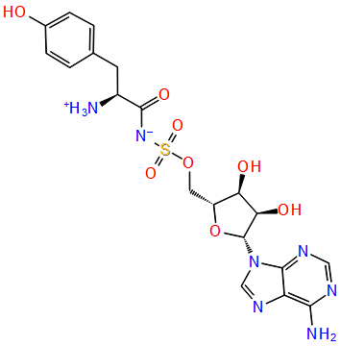 | 449029 | 1.407 | 0.784 | Drug bank
 | 448657 | 1.282 | 0.869 | Drug bank
  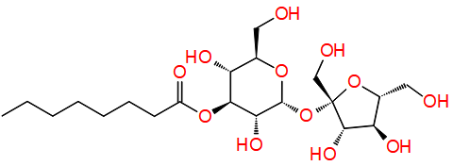
 | NPC473924 | 1.237 | 0.833 | NPASS
  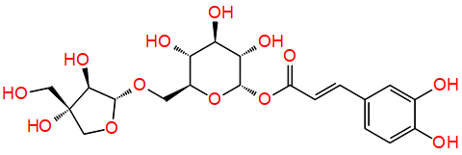
 | NPC79715 | 1.494 | 0.741 | NPASS
  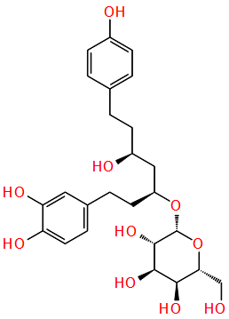
 | NPC275538 | 1.247 | 0.995 | NPASS
  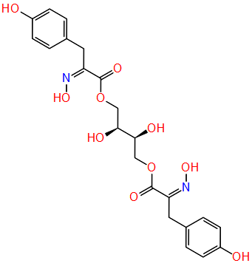
 | 17754184 | 1.288 | 0.849 | Drug bank
  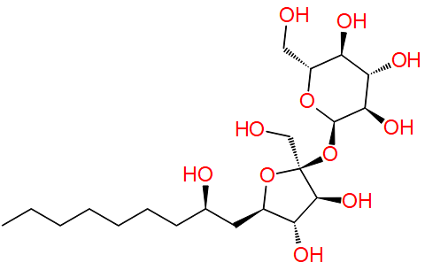
 | NPC244454 | 1.540 | 0.945 | NPASS
  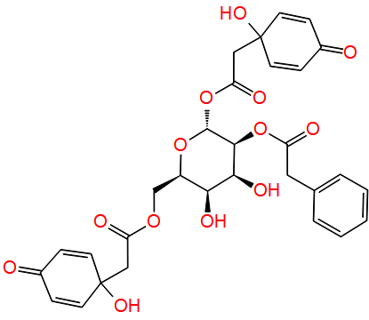
 | 54723327 | 1.414 | 0.473 | Drug bank
  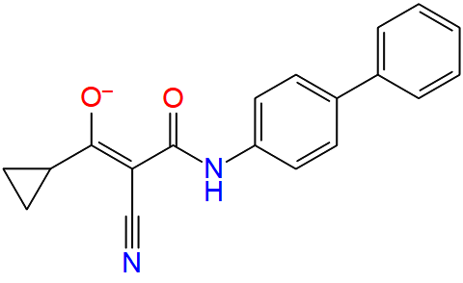
 | 447688 | 1.382 | 0.830 | Drug bank
  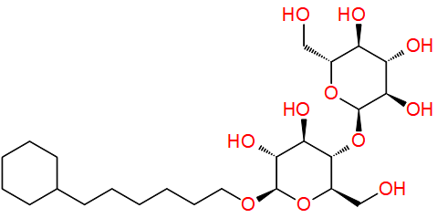
 | 49866943 | 2.582 | 0.000 | Drug bank
  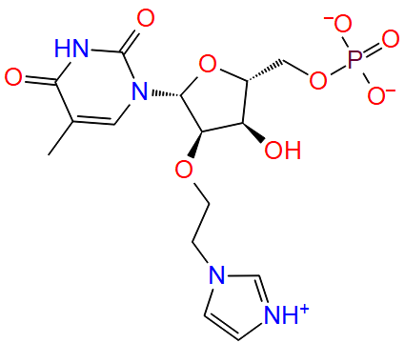
 | 446595 | 1.241 | 0.852 | Drug bank
  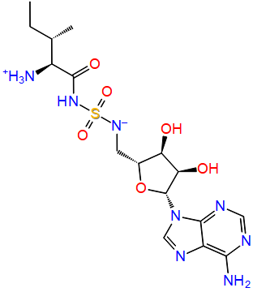
 | 447970 | 1.644 | 0.488 | Drug bank
  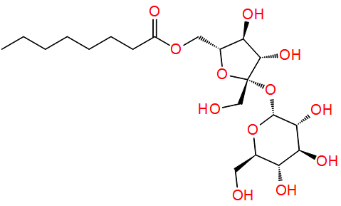
 | 54682040 | 1.258 | 0.527 | Drug bank
  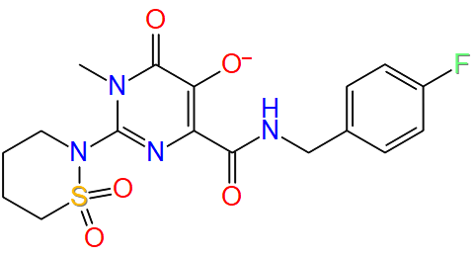
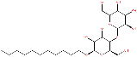 | 447793 | 1.567 | 0.945 | Drug Bank
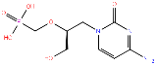 | Cidofovir | 1.345 | 0.765 | PubChem

Table III: The results of Molecular docking in the F-Ring of trimeric scaffolding proteins for monkeypox (MD13) and vaccinia (VD13) viruses.

Compound Structure and Identity | Glide XP Docking score (Kcalmol⁻¹) |  | Interacting Residues |  | Energy (Kcalmol⁻¹) |  | Re-Rank Score (Kcalmol⁻¹) |  | H-Bond Energy (Kcalmol⁻¹) |  | Compound Data Base
Compound Structure and Identity | MD13 | VD13 | MD13 | VD13 | MD13 | VD13 | MD13 | VD13 | MD13 | VD13 | Compound Data Base
 | -7.827 | -7.295 | VAL164(C) GLU165(C)  ASP166(A) VAL164(A)  GLU165(A) | ASP166(A) GLU165(A) VAL164(C) GLU165(C) | -148.375 | -159.669 | -23.583 | -76.512 | -4.966 | -1.303 | NCI
  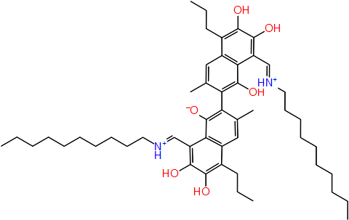
  11986
 | -7.915 | -7.685 | GLU165(B) VAL164(B) GLU165(C) | GLU165(A) GLU165(A) | -160.864 | -175.272 | -75.161 | -65.324 | -4.463 | 0 | NCI
  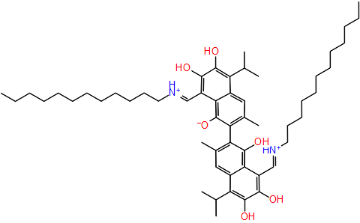
  11987
 | -6.157 | -7.243 | GLU165(A) GLU165(B) ASP166(B) | GLU165(A) GLU165(A) VAL164(C) | -170.423 | -158.068 | -48.928 | -35.009 | -0.590 | -4.499 | NCI
  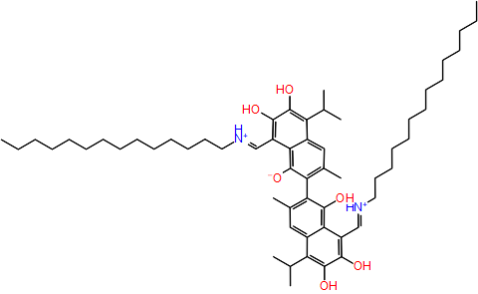
  11988
 | -7.308 | -7.110 | GLU165(B) ASP166(C) GLU165(C) | ASP166(A) GLU165(A) PHE168(B) GLU165(B) | -158.853 | -159.227 | -96.067 | -89.007 | -7.004 | -7.337 | PubChem
  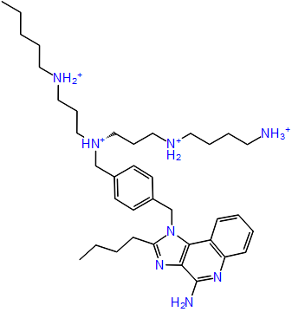
  157232835
 | -7.379 | -8.003 | ASN20(B) GLN27(B)  ASP166(C) GLU165(C)  ASP166(B) GLU165(B)  VAL164(B) | GLN27(A) GLN27(C) GLU165(C) ASP166(A) GLU165(A) GLU165(B) ASP166(B) | -285.341 | -306.365 | -42.527 | -130.192 | -4.904 | -6.106 | Tim Teck
  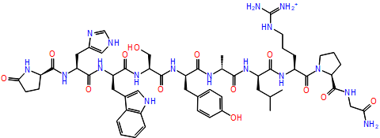
  g0_mol7915
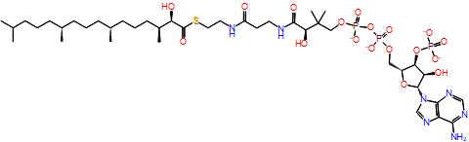 | -9.921 | -9.617 | GLU165(A) VAL164(A)  LYS469(B) LYS159(A)  LYS484(A) | GLN27(B) GLN27(C) ASP25(C) LYS225(A) ASN20(C) LYS17(B) | -205.069 | -225.491 | -86.384 | -100.709 | -3.928 | -6.970 | CHEBI
  CHEBI:426
 | -10.304 | -9.894 | ASP25(C) GLN27(A)  ASN20(B) | ASP25(C) PHE486(A) LYS225(C) GLN27(C) LYS225(A) GLN27(A) ASP20(C) | -203.413 | -186.685 | -101.506 | -89.016 | -1.215 | -6.955 | CHEBI
  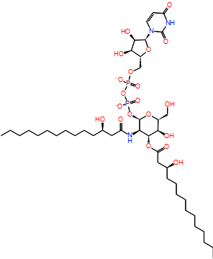
  CHEBI:2347
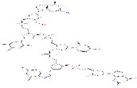  135566871 | -6.803 | -8.130 | GLU165(A) GLU165(C)  ASP166(B) GLN27(A)  LYS225(B) ASN20(A)  GLN27(B) | SER19(C) ASP25(C) GLN27(C) ASN20(B) GLN27(B) GLN27(A) PHE486(A) ASP166(B) | -248.126 | -295.98 | -137.35 | -95.963 | -10.714 | -9.616 | PubChem
Rifampicin  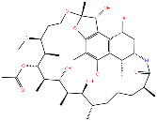 | -5.37 | -5.789 | GLN27(B) | GLN27(B) | -176.976 | -156.923 | -56.871 | -47.205 | -7.861 | -6.906 | PubChem

