Table S1. Strains and plasmids used in this study
Strains or plasmids | Characteristics | Source of reference
Strain
E. coli DH5$α$ | F-, Φ80dlacZΔM15, Δ(lacZYA-argF)U169, deoR, recA1, endA1, hsdR17(rK-, mK+), phoA, supE44, λ-, thi-1, gyrA96, relA1 | Novagen
E. coli BL21(DE3) | F– ompT hsdS_{B}(r_{B}–, m_{B}–) gal dcm λ(DE3) | Novagen
Plasmid
pETDuet-1 (pDuet) | pBR322 ori; Amp^{R}; P_{T7-1}::MCS; P_{T7-2}::MCS | Novagen
pDuet_PgsA-SC | pBR322 ori; Amp^{R}; P_{T7-1}::PgsA-SpyCatcher;  P_{T7-2}::MCS | This study
pDuet_PgsA-SC_PETase-ST-Myc | pBR322 ori; Amp^{R}; P_{T7-1}::PgsA-SpyCatcher;  P_{T7-2}::PETase-SpyTag-Myc | This study
pDuet_PETase-Myc | pBR322 ori; Amp^{R}; P_{T7-1}::MCS; P_{T7-2}::PETase-Myc | This study
pDuet_PETase-His | pBR322 ori; Amp^{R}; P_{T7-1}::PETase-His; P_{T7-2}::MCS | This study
pDuet_PgsA-PETase-Myc | pBR322 ori; Amp^{R}; P_{T7-1}::PgsA-PETase-Myc;  P_{T7-2}::MCS | This study
pHLA | pBR322 ori; Amp^{R}; P_{HCE}::MCS | (29)

Table S2. Primers used in this study
No. | Primer name | Sequence
1 | PgsA_fwd | actttaagaaggagatatacATGAAAAAAGAACTGAGCTTTC
2 | PgsA_rev | caccgccgccTTTAGATTTTAGTTTGTCACTATG
3 | GS-SpyC_fwd_b | aaaatctaaaGGCGGCGGTGGCAGCGTG
4 | GS-SpyC_rev | tgatggtgatggctgctgccttaAATATGGGCATCGCCTTTGGTCGCTTTGC
5 | PETase_fwd_a | gtataagaaggagatatacaatgCAGACCAACCCGTATGCTC
6 | PETase-Myc_rev1 | ttacaaatcttcttcagaaatcaatttttgttcgccGGAGCAATTCGCAGTGCG
7 | PETase-Myc_rev2 | tatccaattgagatctgccaTTACAAATCTTCTTCAGAAA
8 | PgsA-GS_rev | cgagcatacgggttggtctgGCTGCCACCGCCGCCTTTAG
9 | PETase_fwd_c | ctaaaggcggcggtggcagcCAGACCAACCCGTATGCTC
10 | Myc_rev | tgatggtgatggctgctgccttaCAAATCTTCTTCAGAAATCA
11 | PETase-GS-SpyT-Myc_rev1 | tccaccatcacaatatgcgcgctgccaccgccgccGGAGCAATTCGCAGTGCG
12 | PETase-GS-SpyT-Myc_rev2 | tcaatttttgttcgcctttggtcggtttatacgcaTCCACCATCACAATATGCGC
13 | PETase-GS-SpyT-Myc_rev3 | atccaattgagatctgccattacaaatcttcttcagaaaTCAATTTTTGTTCGCCTTTG
14 | PETase_fwd_d | actttaagaaggagatatacatgCAGACCAACCCGTATGCTC
15 | PETase-His_rev | tcagcggtggcagcagcttagtggtggtggtggtggtggccGGAGCAATTCGCAGTGCG

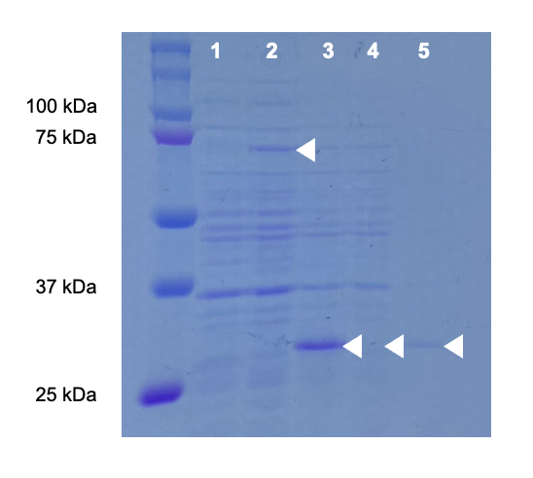
Fig. S1 SDS-PAGE results of whole-cell fractions of BL21/pDuet (lane 1), BL21/pDuet_PgsA-PETase (lane 2: PgsA-PETase-Myc, 71.9 kDa), BL21/pDuet_PETase (lane 3), of soluble fraction of BL21/pDuet_PETase (lane 4), of insoluble fraction of BL21/pDuet_PETase (lane5: PETase-His, 28.6 kDa)

