Electronic Supplementary Information (ESI) for

VO2 Nanowires Based Composite Films with Broadband and High Tunable Electromagnetic Interference Shielding Performance

Shuhui Liangª, Huan Guan^{b}, Hainan Zhangª, Xiangge Han, Sue Haoª∗, Shuliang Dou^{b*}, Haoxin Zhou^{b}, Chenchen Geng^{b}, Tao Zhao^{b}, Jinxin Guª, Hang Wei^{b}, Yao Li^{b}∗

ª School of Chemical Engineering and Technology, Harbin Institute of Technology, 150001 Harbin, China

^{b} Center for Composite Materials and Structure, Harbin Institute of Technology, 150001 Harbin, China

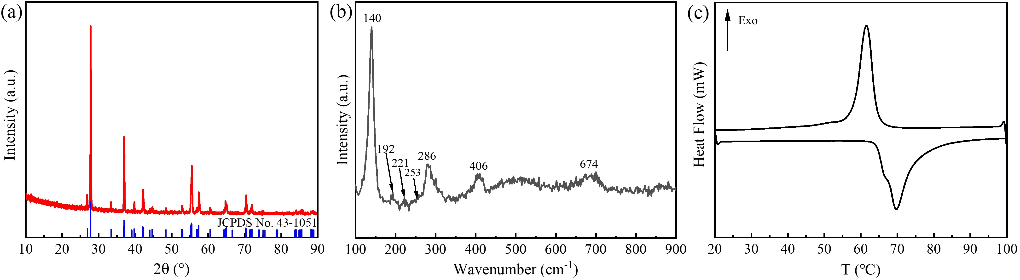
Fig. S1 (a) XRD pattern, (b) Raman spectrum, (c) DSC curve of VO₂(M)

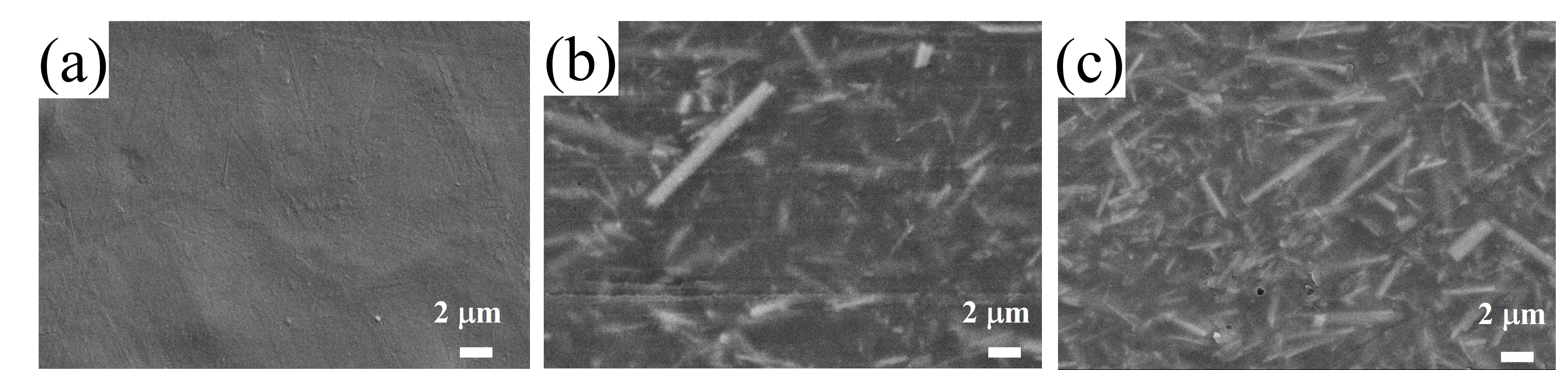
Fig. S2 SEM images of surface for PVDF-HFP and VO₂/PVDF-HFP composite films: (a) PVDF-HFP, (b) VP-2, (c) VP-4
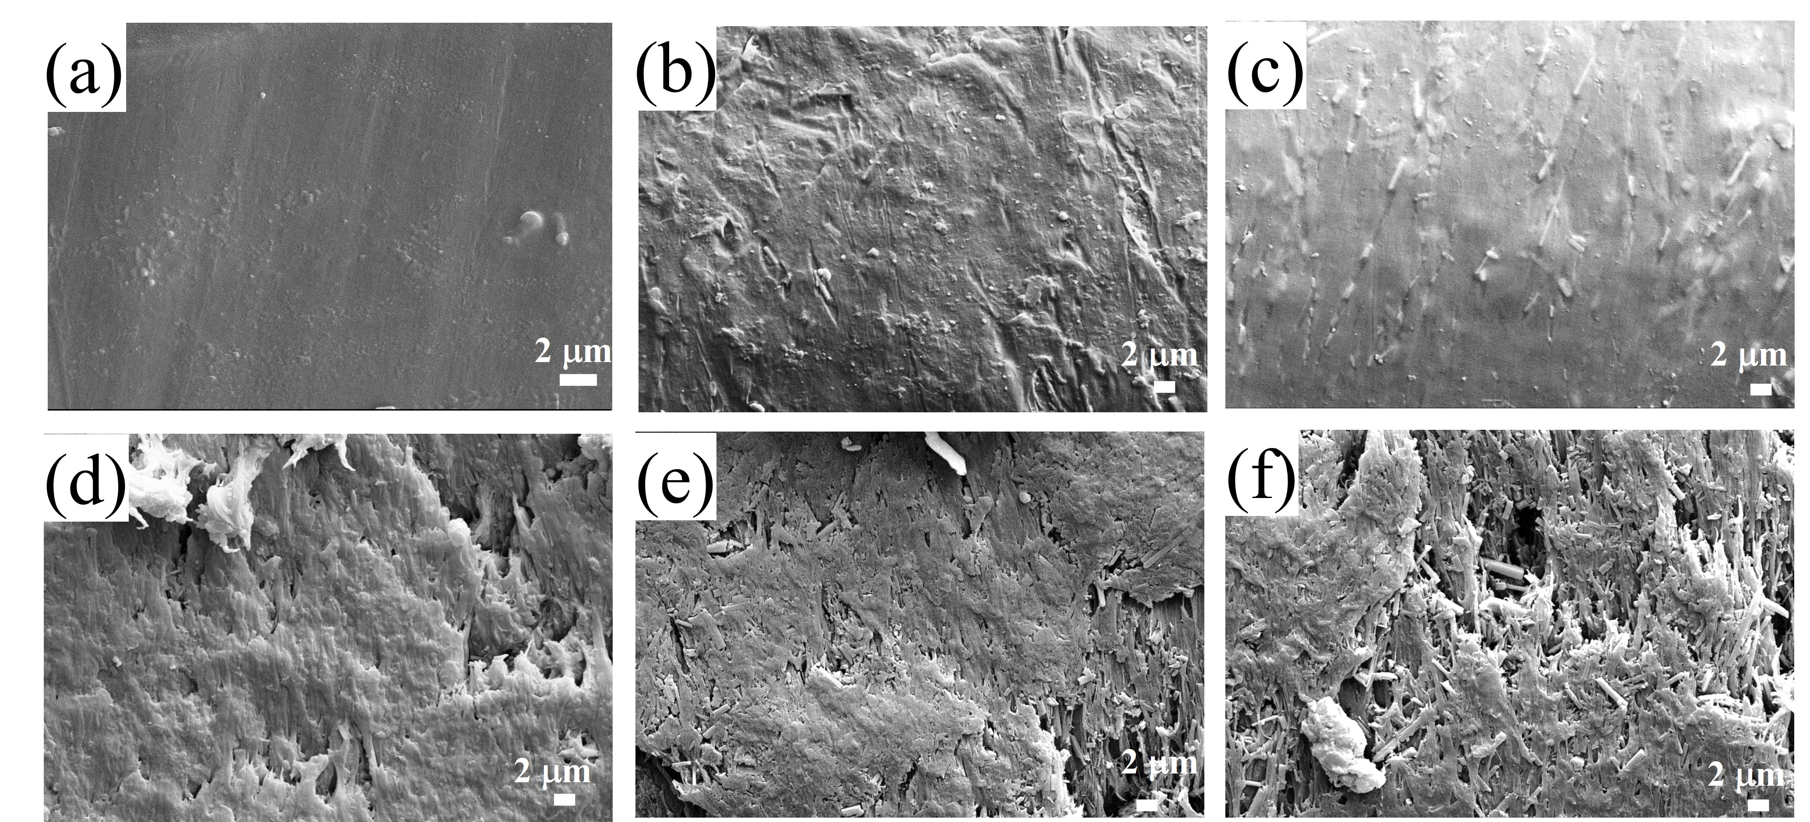
Fig. S3 SEM images of cross-fracture of various films: (a) PVDF-HFP, (b) VP-1, (c) VP-2, (d) VP-3, (e) VP-4 and (f) VP-5
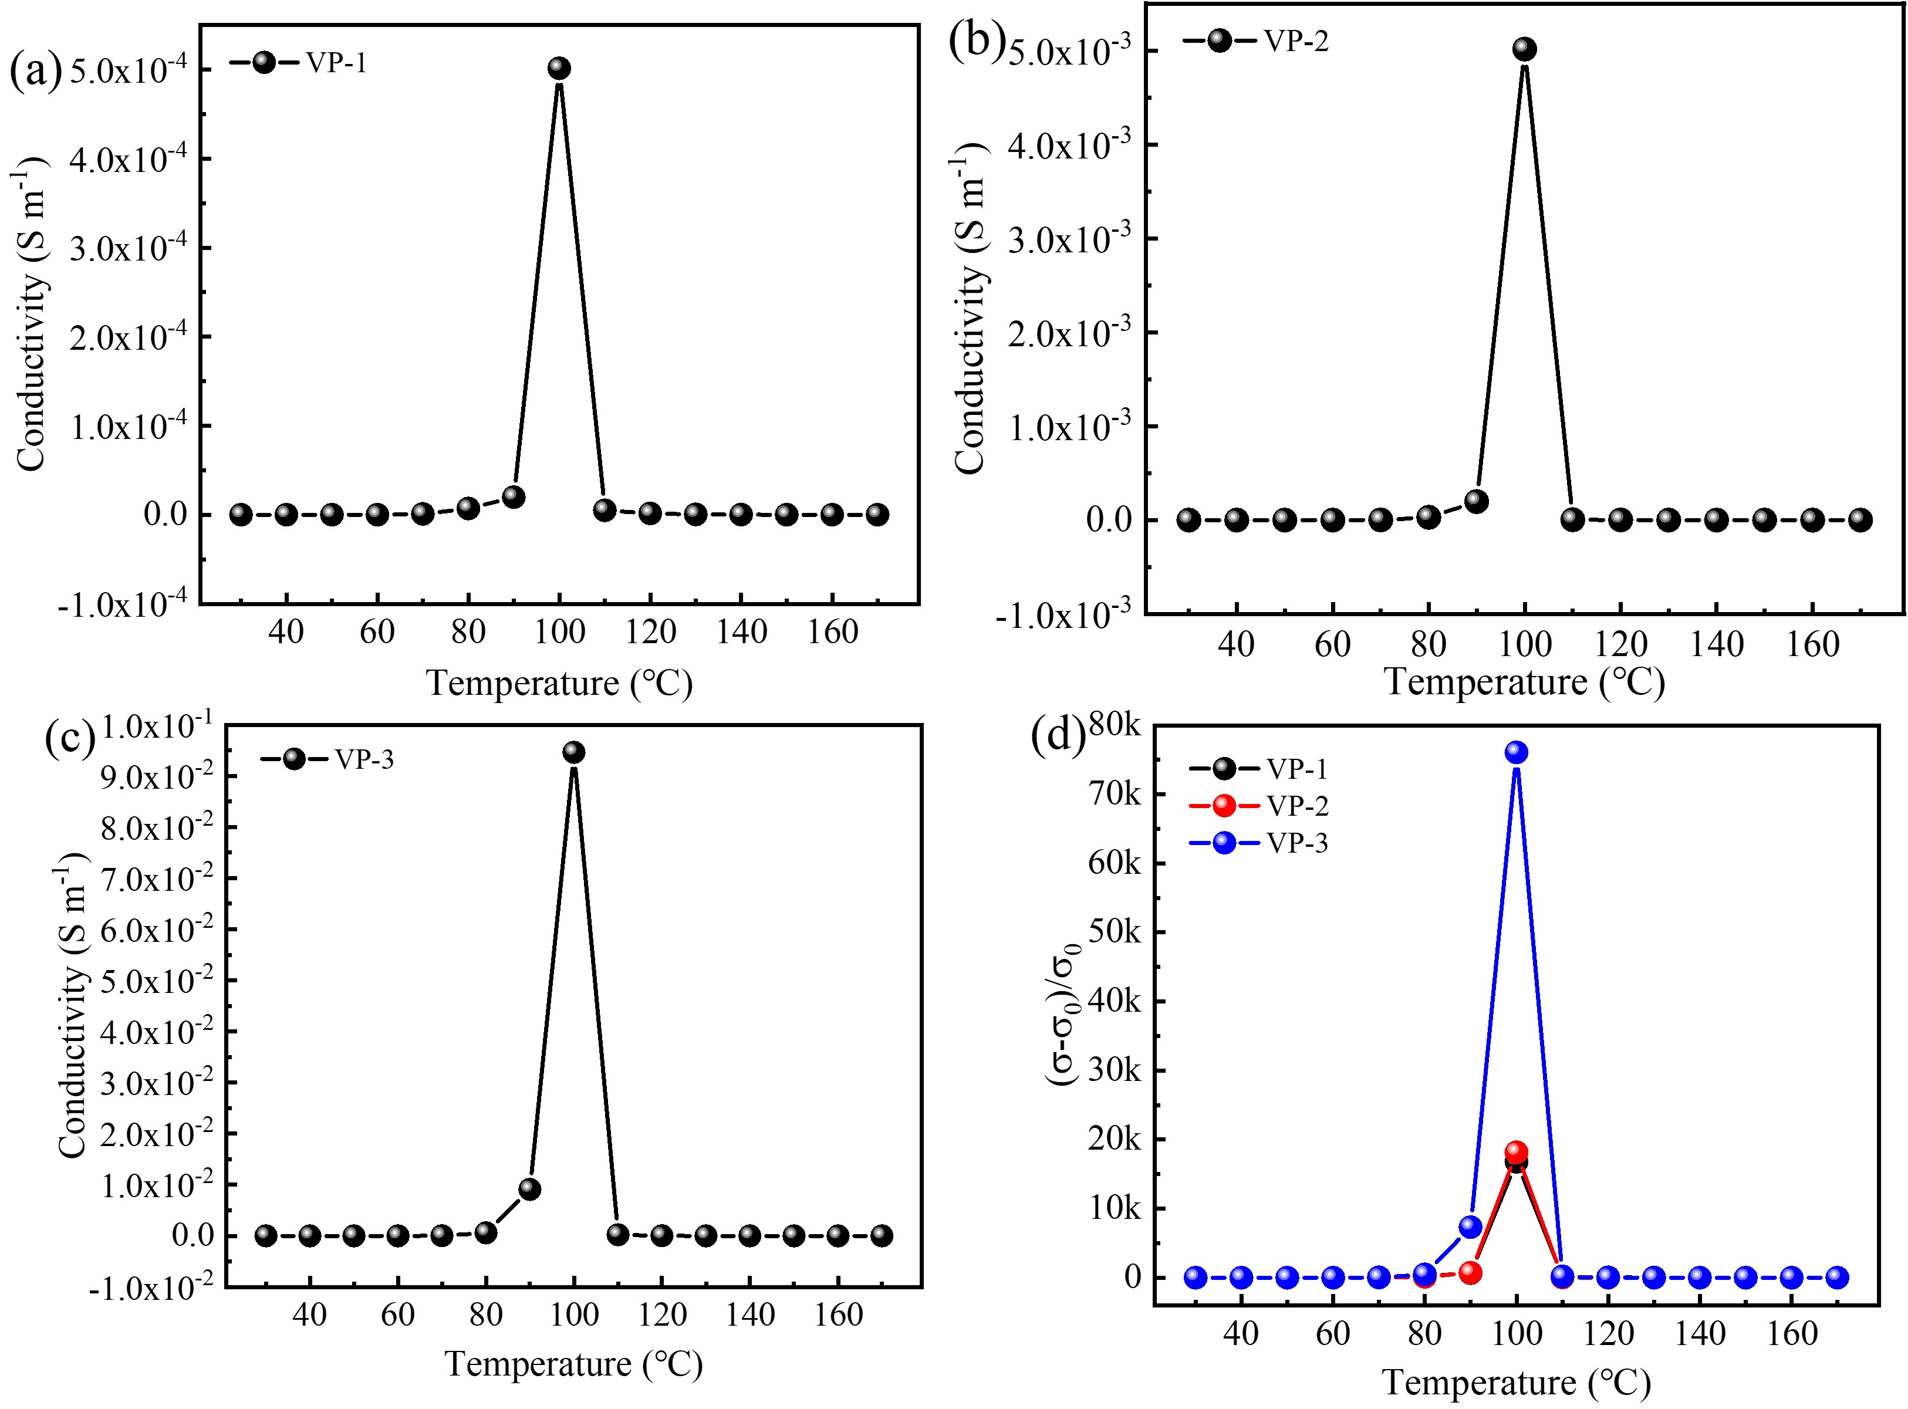
Fig. S4 Conductivity of VO₂/PVDF-HFP composite films at a different temperature: (a) VP-1, (b) VP-2, (c) VP-3, and (d) Relative conductivity change versus temperature

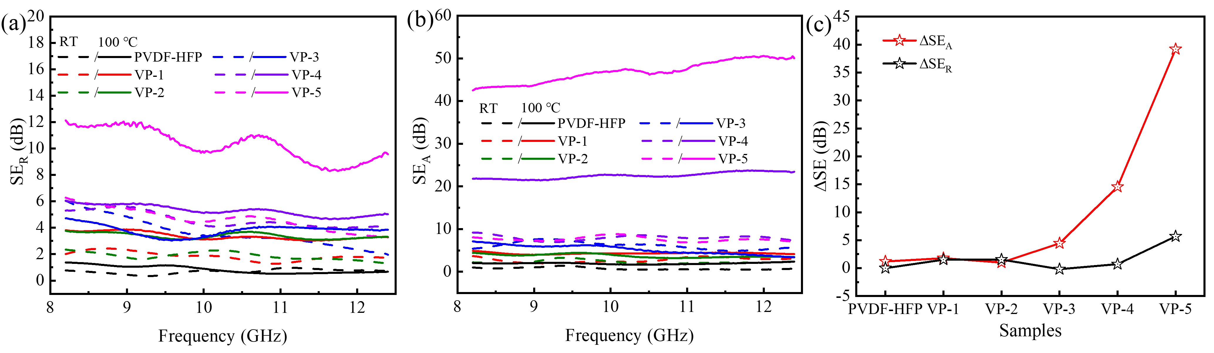
Fig. S5 (a) SE_{R}, (b) SE_{A} and (c) ΔSE_{T} in X-band of PVDF -HFP and VO₂/PVDF-HFP composite films (thickness of 1.8 mm) under different temperatures.

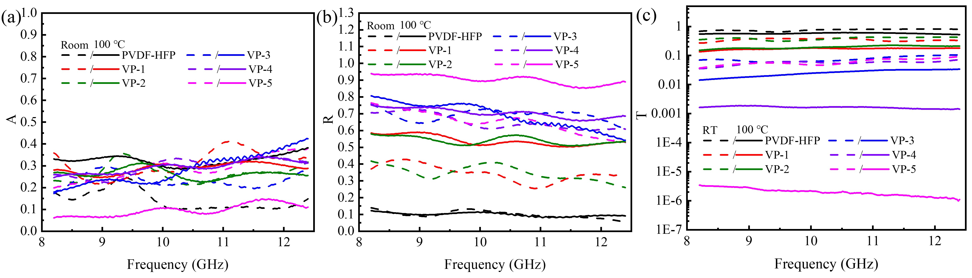
Fig. S6 Power coefficient (a) A, (b) R and (c) T in X-band of PVDF -HFP and VO₂/PVDF-HFP composite films (thickness of 1.8 mm) under different temperatures

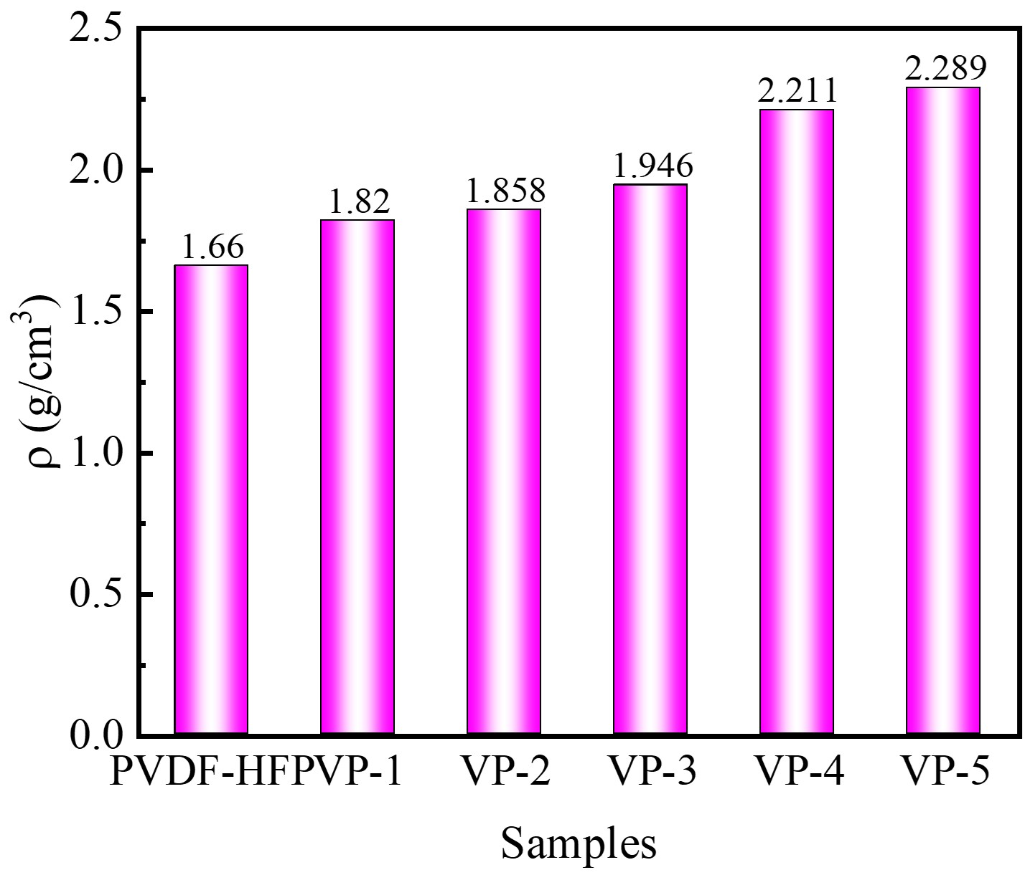
Fig. S7 Density of PVDF -HFP and VO₂/PVDF-HFP composite films (thickness of 1.8 mm) under different temperatures

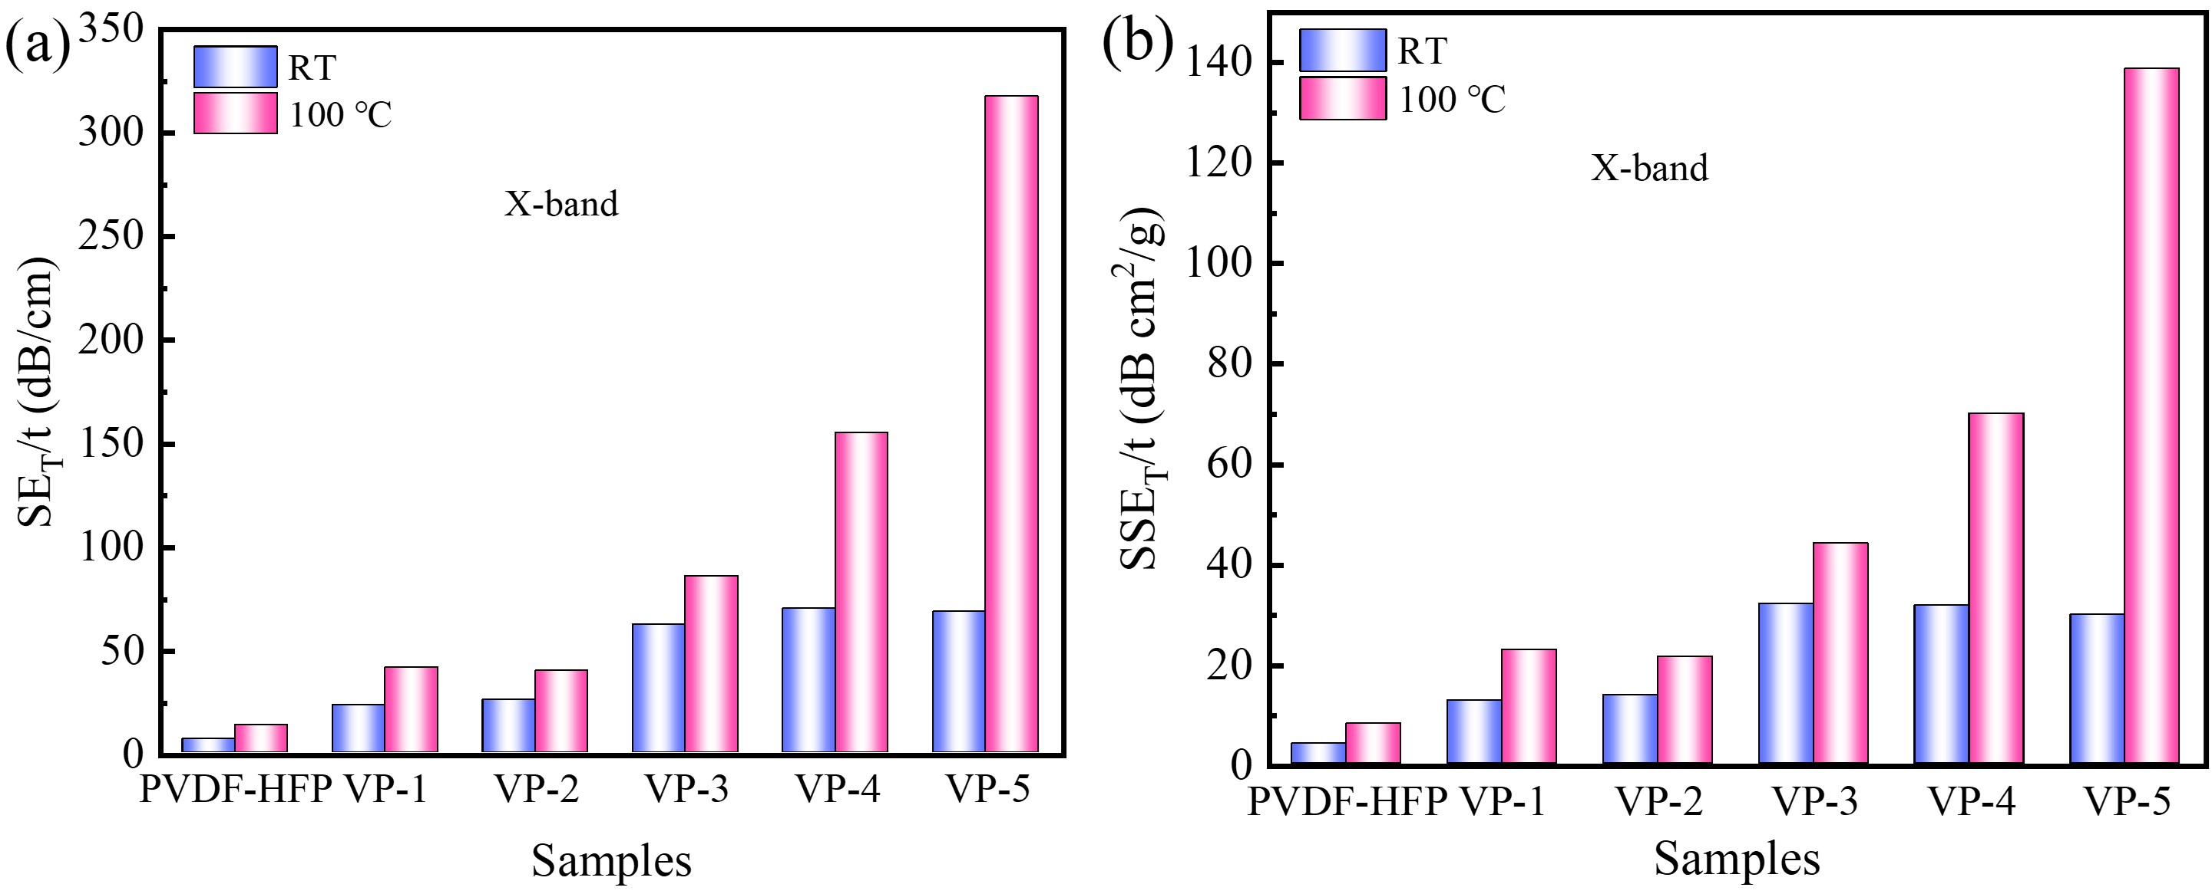
Fig. S8 (a) SE_{T}/t, (b) SSE_{T}/t in X-band of PVDF-HFP and VO₂/PVDF-HFP composite films (thickness of 1.8 mm) under different temperatures

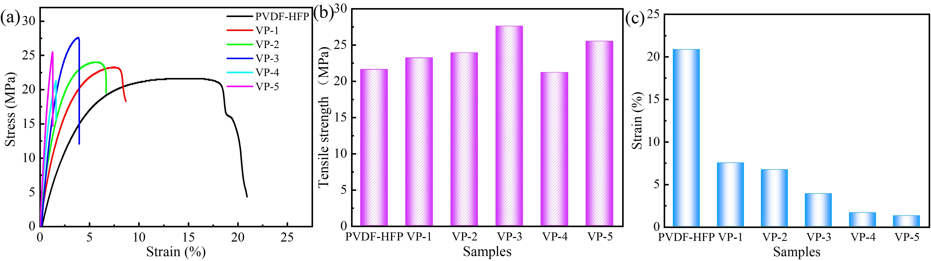
Fig. S9 (a) tensile stress-strain curves (b) Tensile strength and (c) fracture strain of pure PVDF-HFP and VO₂/PVDF-HFP composite films

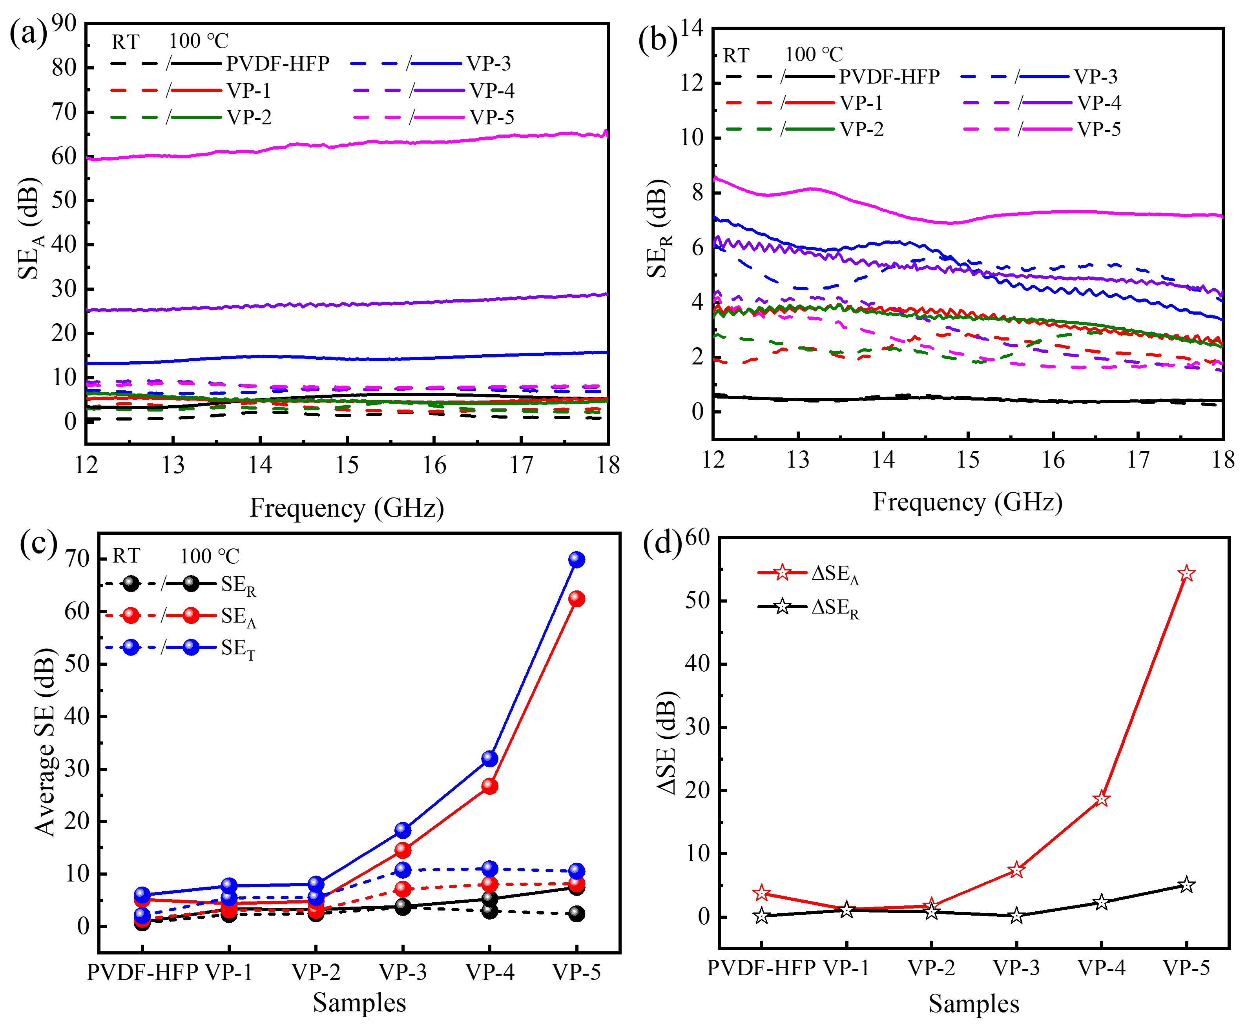
Fig. S10 (a) SE_{R}, (b) SE_{A}, (c) the average SE_{T}, SE_{R}, and SE_{A} and (d) ΔSE_{T} in Ku-band of PVDF -HFP and VO₂/PVDF-HFP composite films (thickness of 1.8 mm) under different temperatures
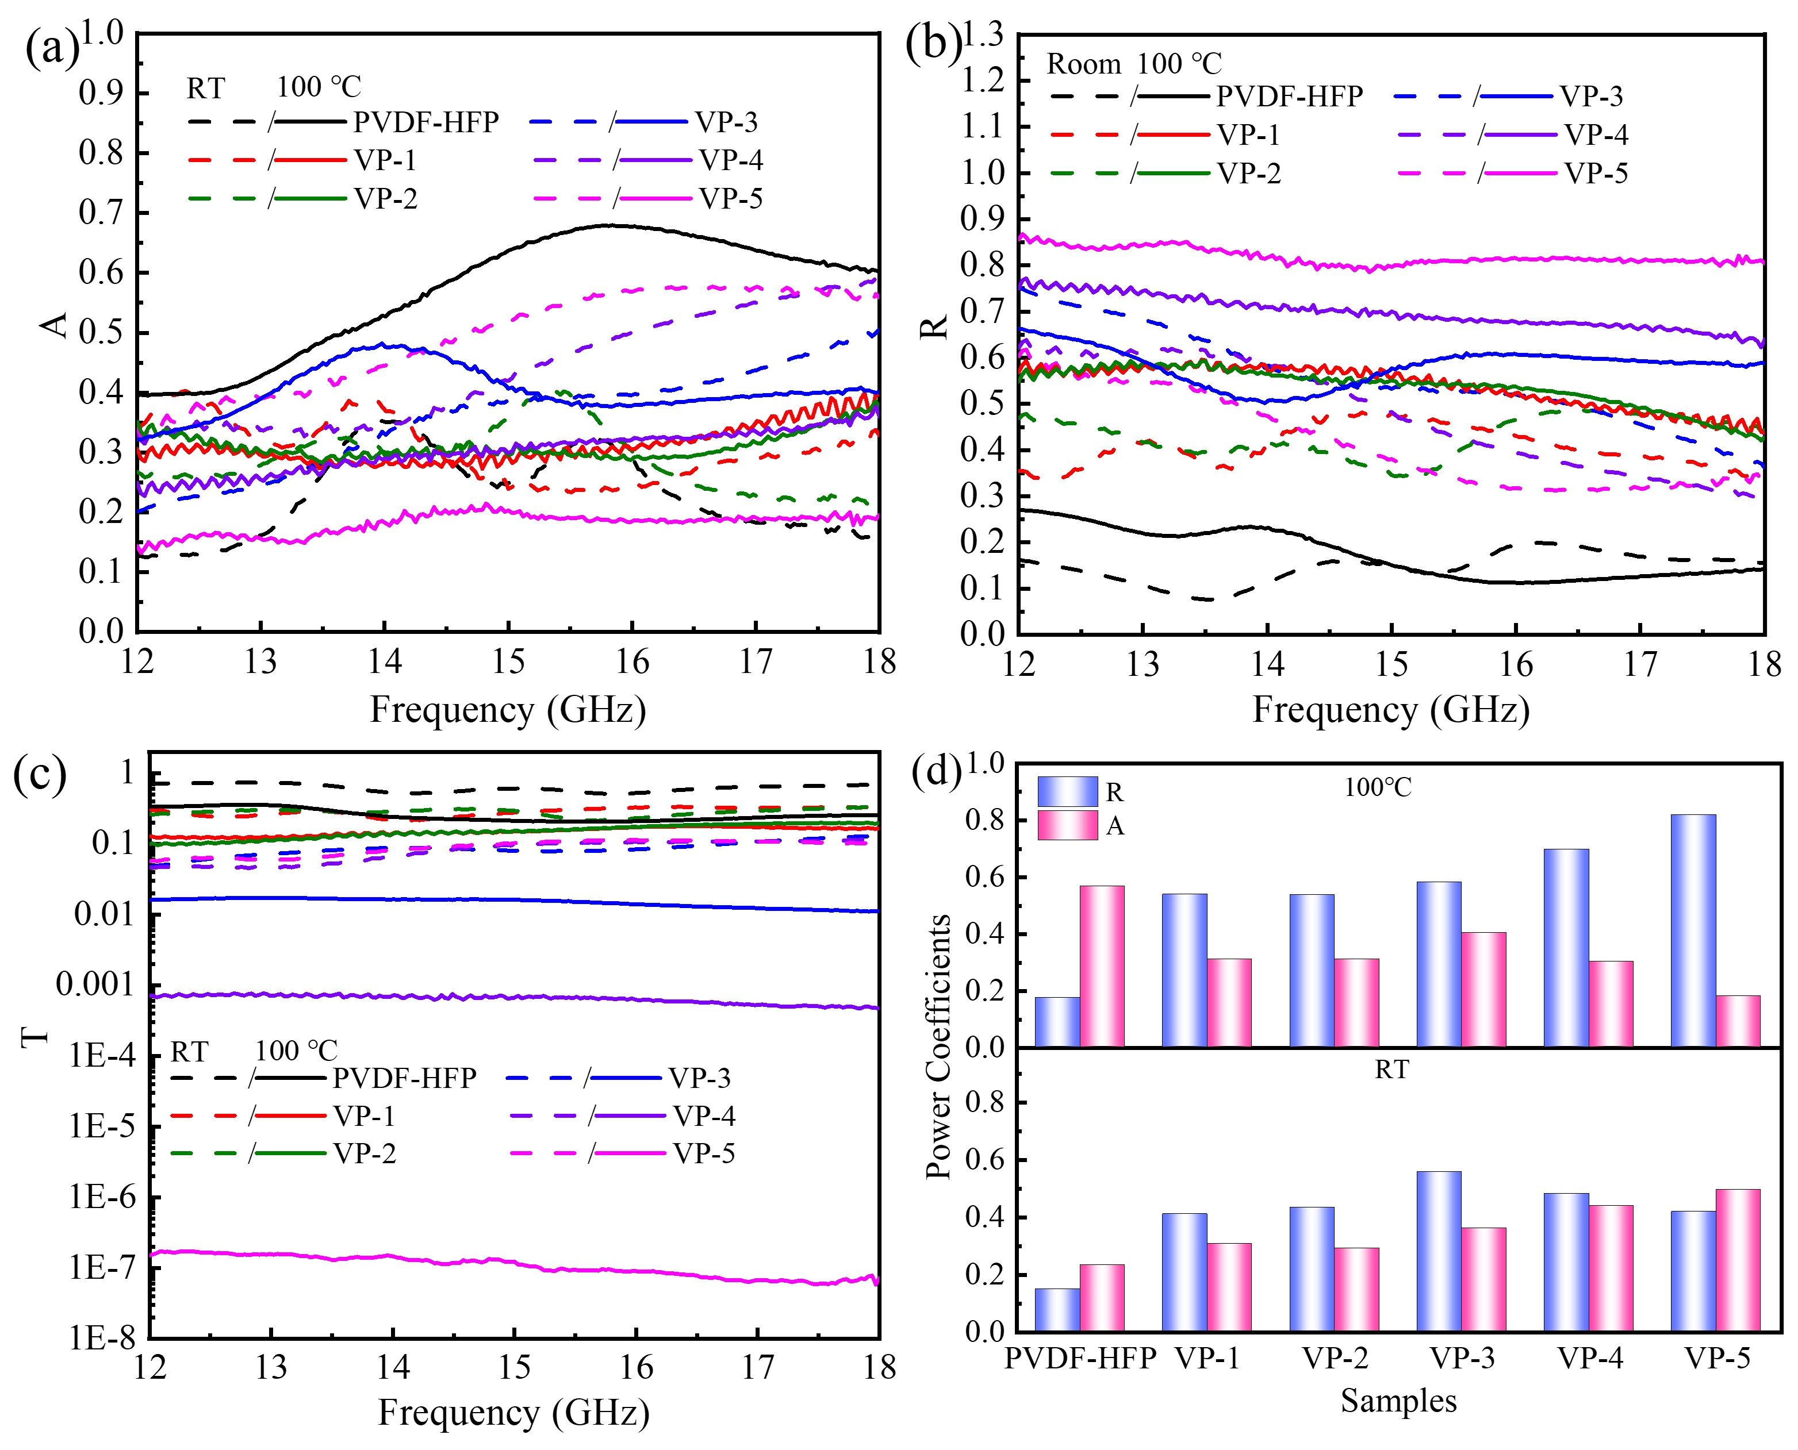
Fig. S11 Power coefficient (a) A, (b) R and (c) T, and (d) average power coefficients in Ku-band of PVDF-HFP and VO₂/PVDF-HFP composite films (thickness of 1.8 mm) under different temperatures
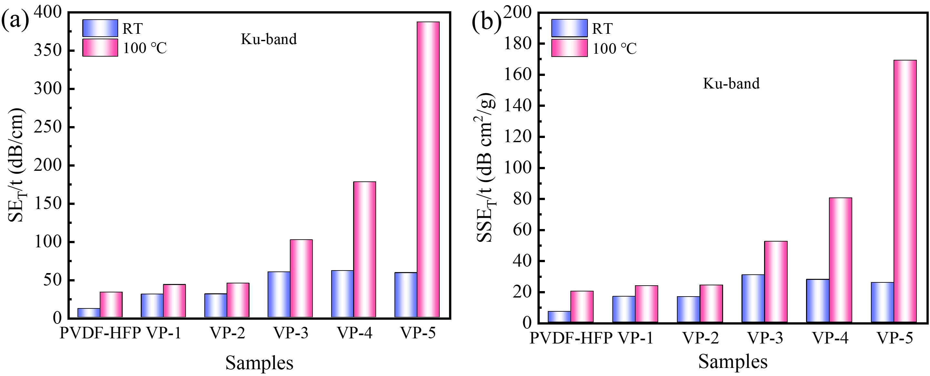
Fig. S12 (a) SE_{T}/t, (b) SSE_{T}/t in Ku-band of PVDF-HFP and VO₂/PVDF-HFP composite films (thickness of 1.8 mm) under different temperatures

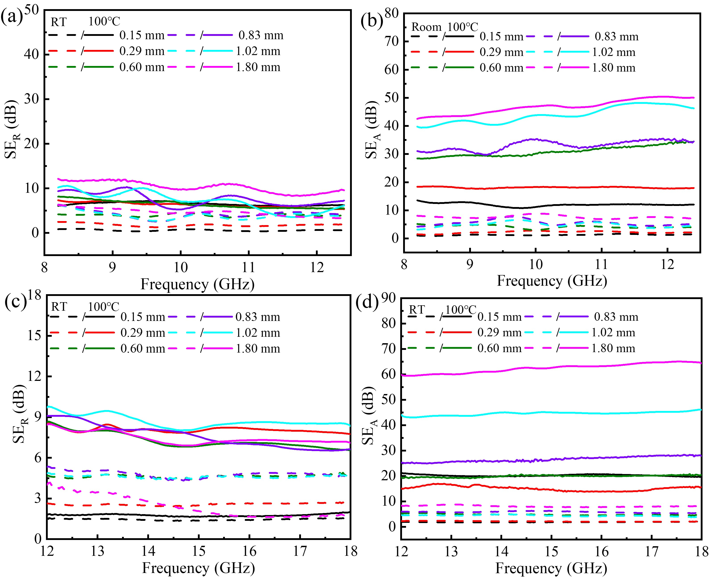
Fig. S13 (a) SE_{R}, (b) SE_{A} in X-band; (c) SE_{R}, (d) SE_{A} in Ku-band of VP-5 film under different temperatures
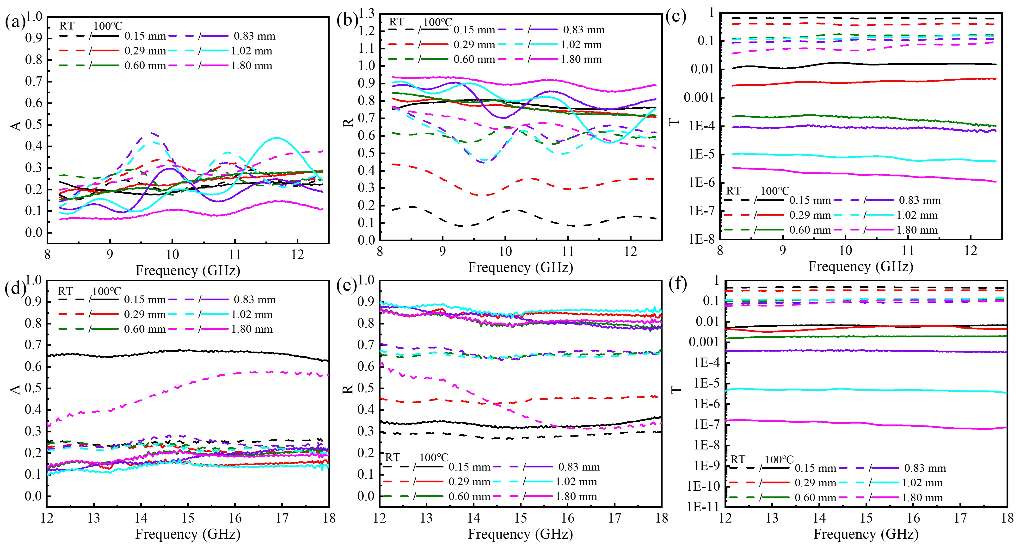
Fig. S14 Power coefficient (a) A, (b) R and (c) T in X-band of VP-5 film under different temperatures; (d) A, (e) R and (f) T in Ku-band of VP-5 film under different temperatures

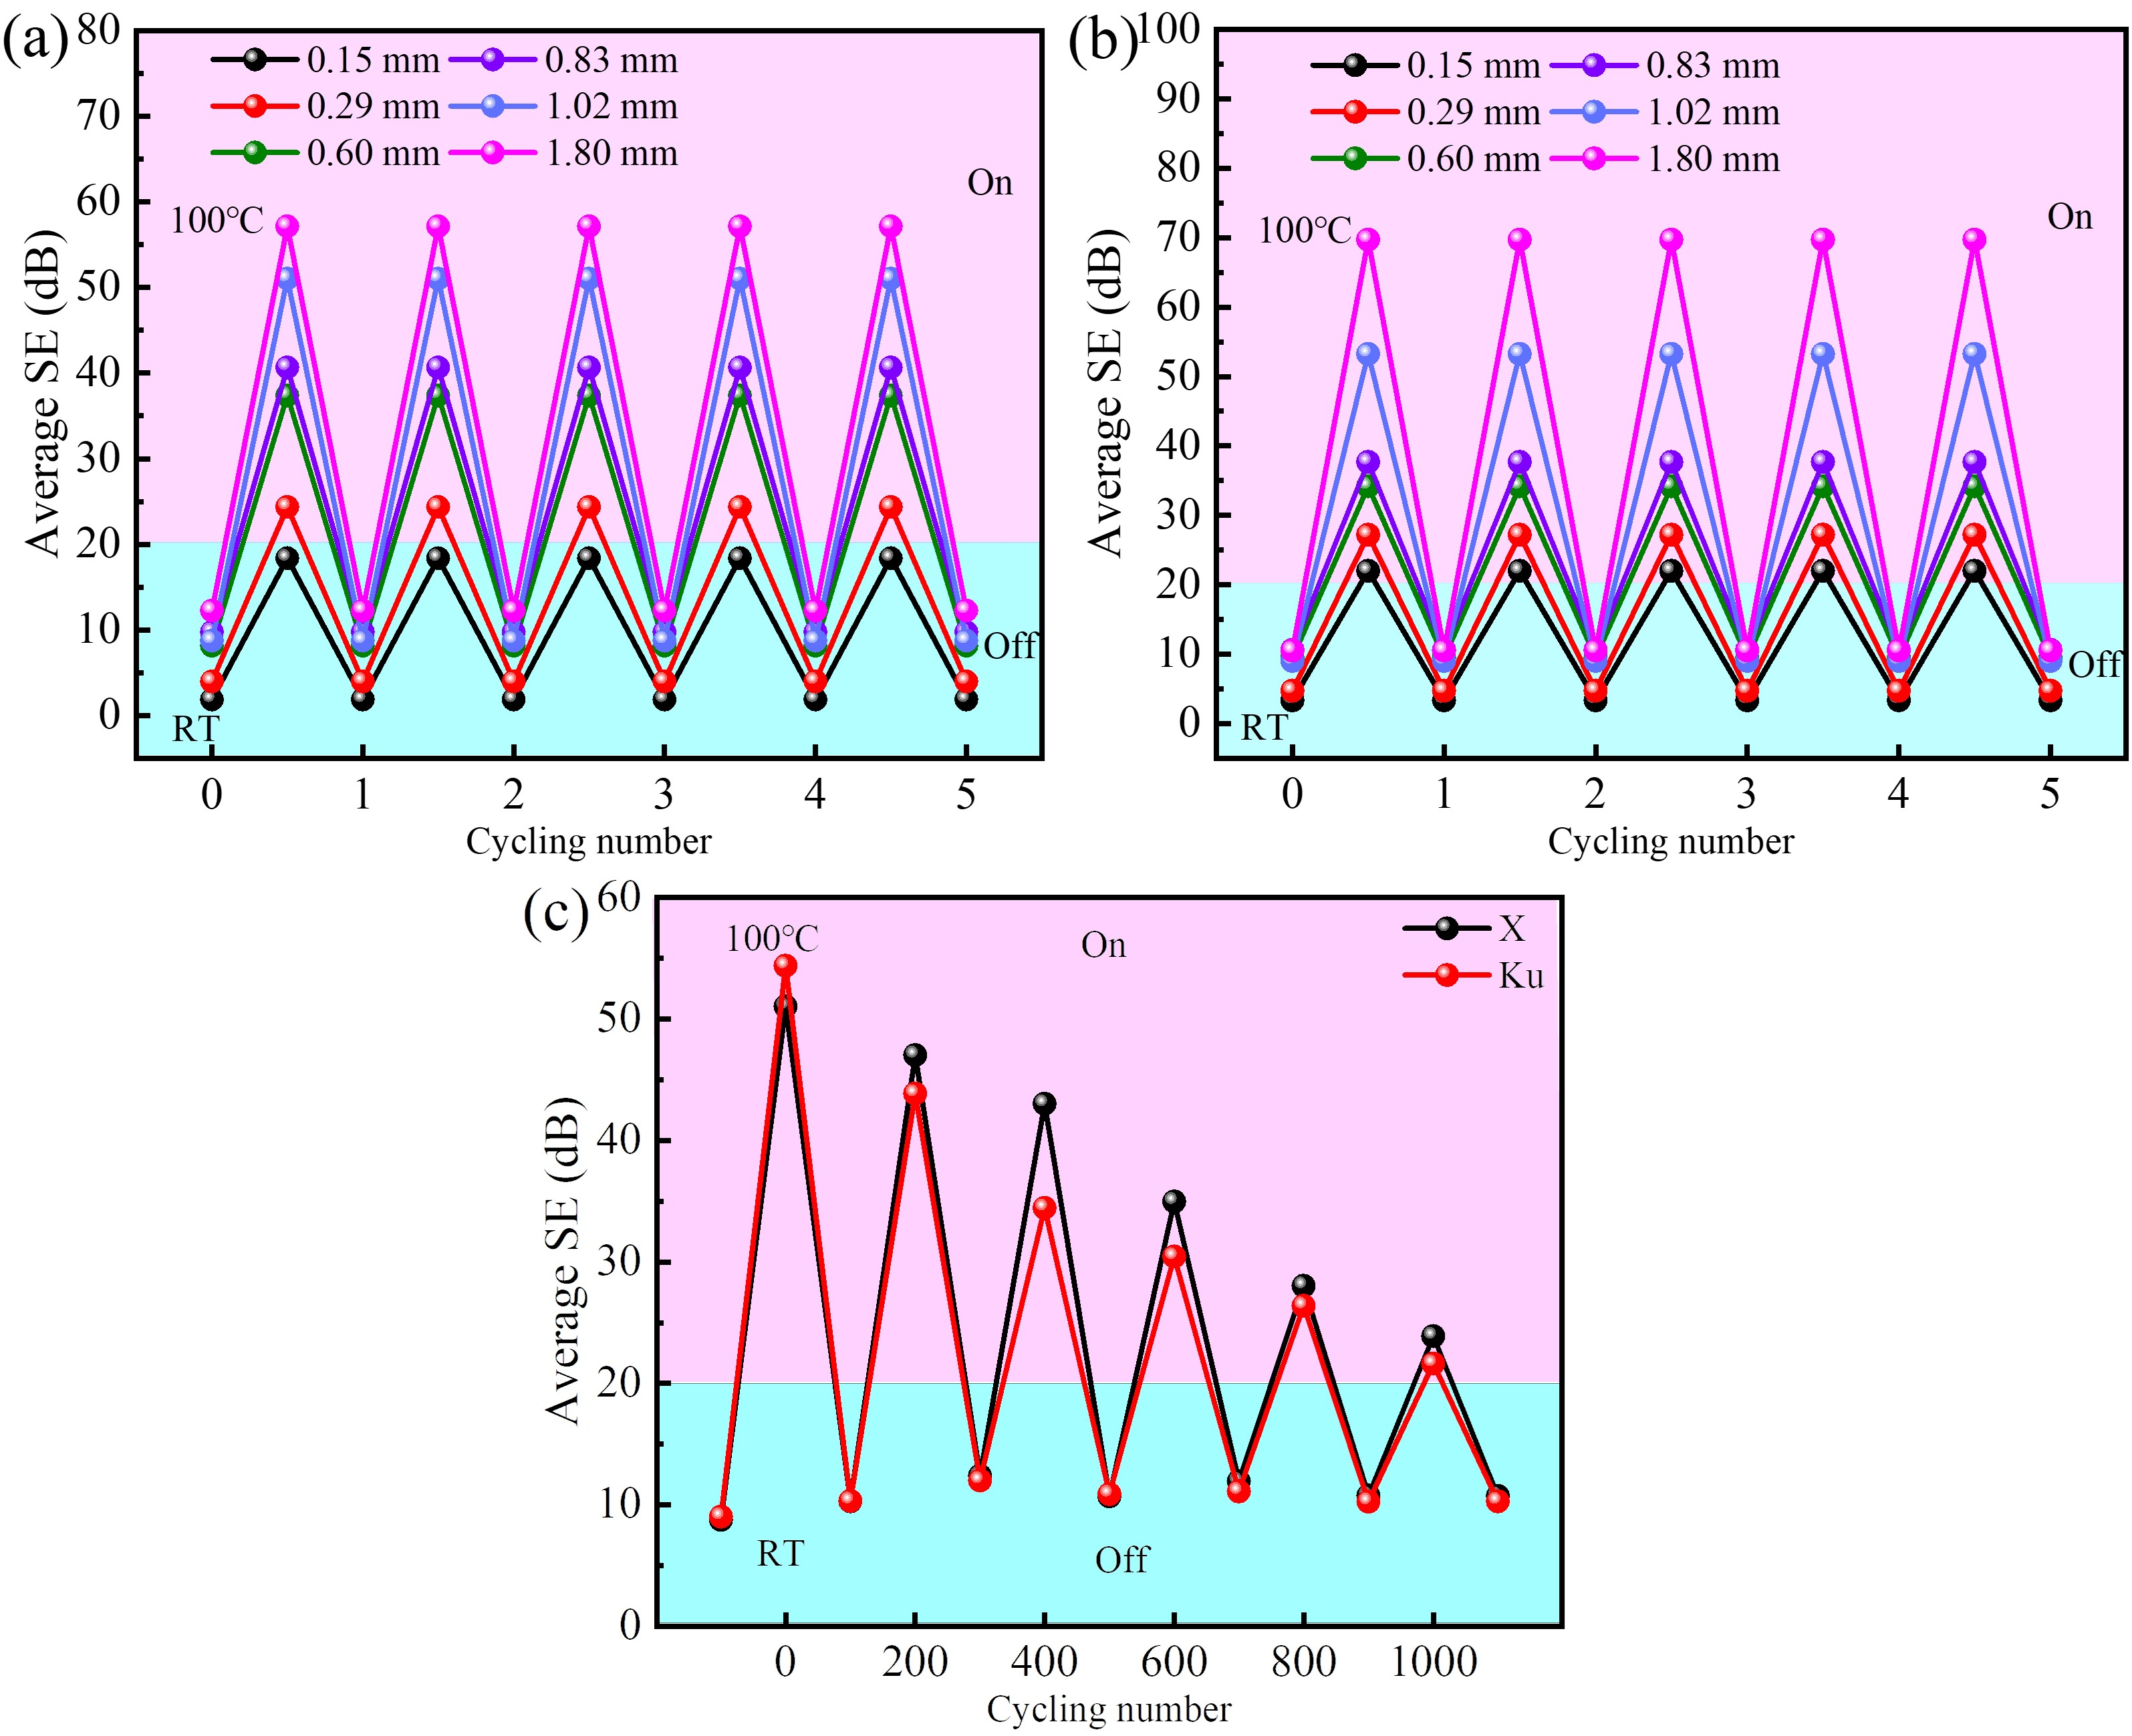
Fig. S15 Cyclicity of ‘‘off’’ and ‘‘on’’ states of EMI shielding for the VO₂/PVDF-HFP composite films with different thicknesses in X and Ku band (a, b) 5 times, (c) 1000 times
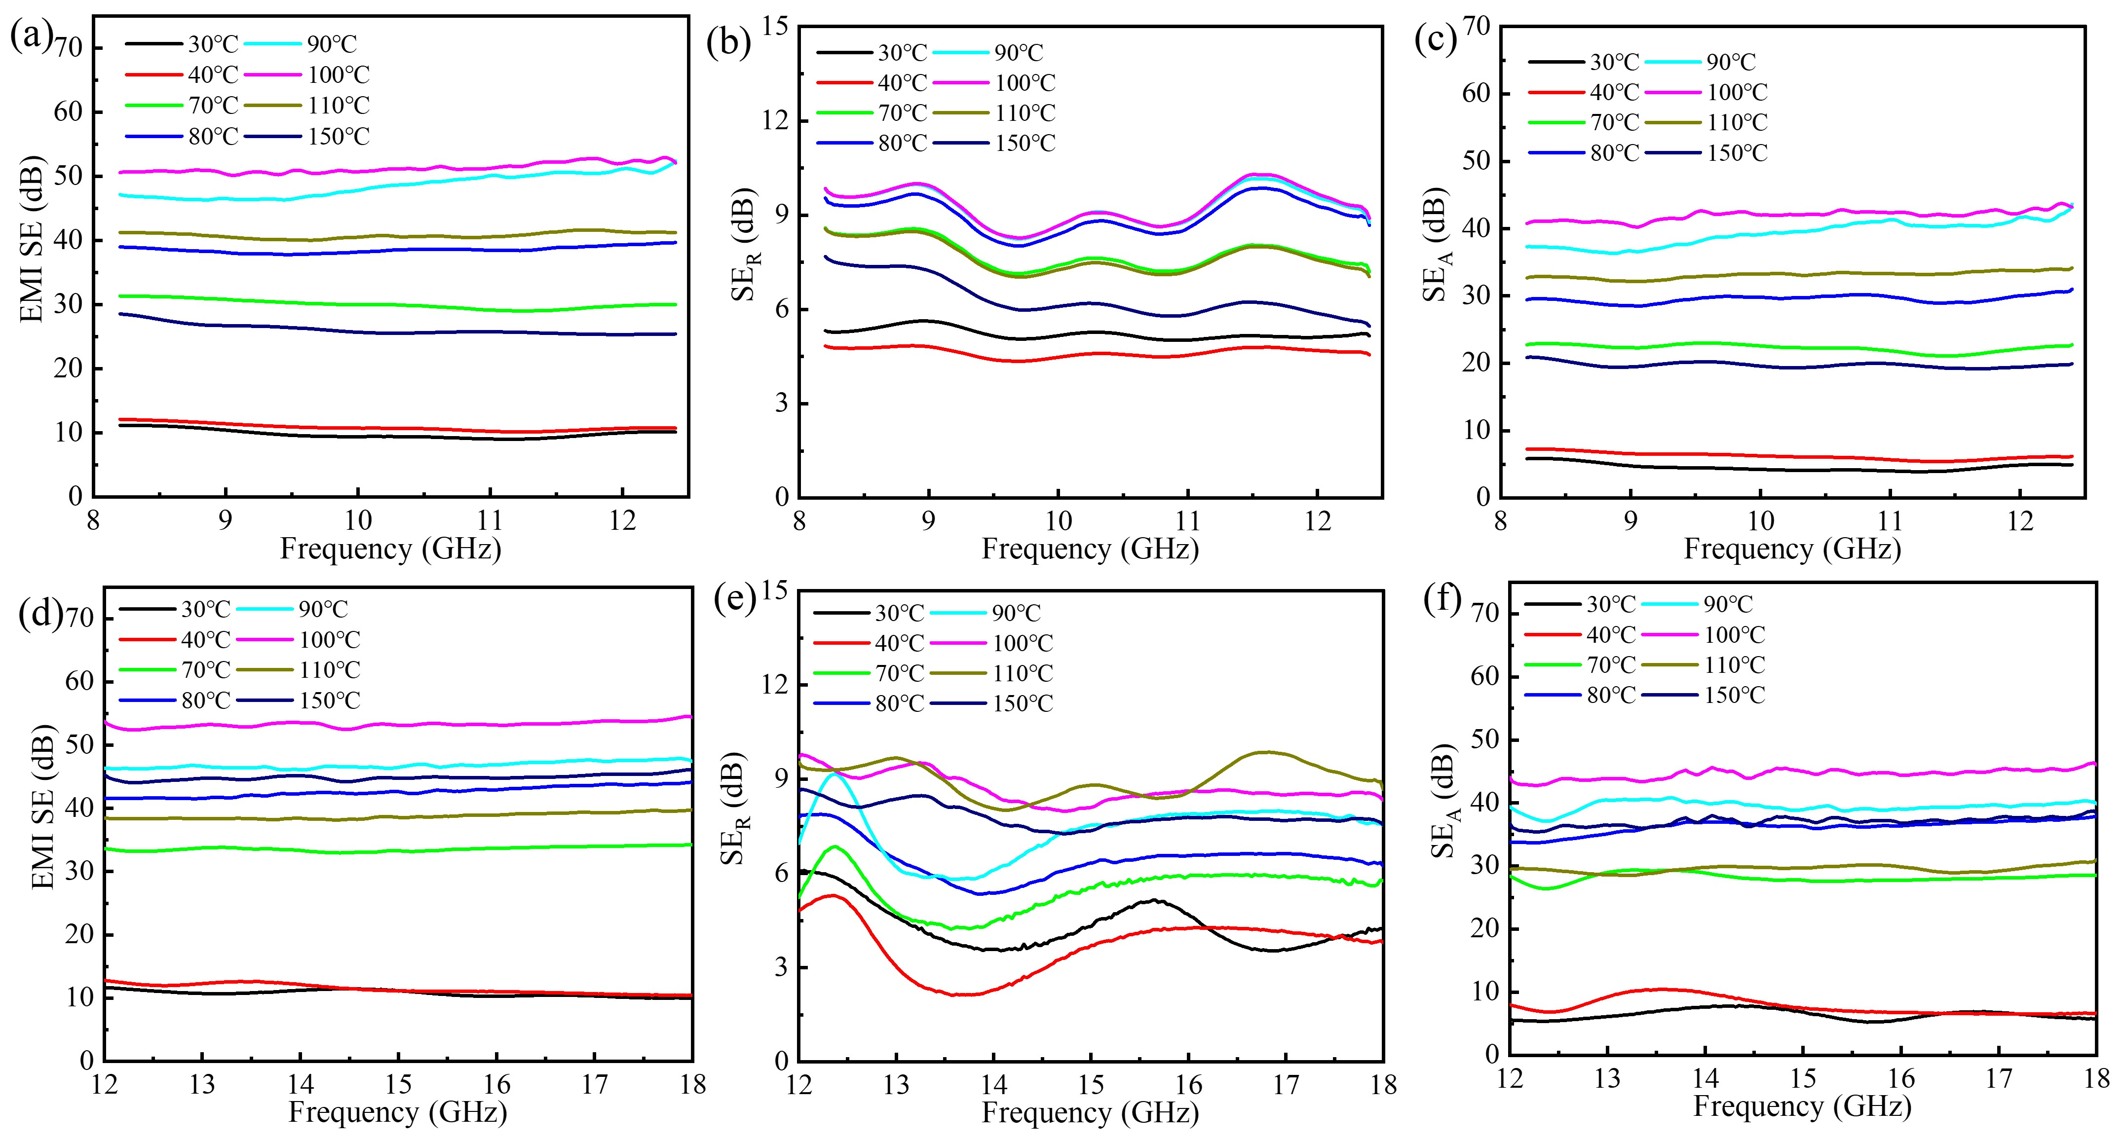
Fig. S16 Effect of the temperature on (a) EMI SE, (b) reflection EMI SE, (c) absorption EMI SE in X-band of VP-5 film; Effect of the temperature on (d) EMI SE, (e) reflection EMI SE, (f) absorption EMI SE in Ku-band of VP-5 film
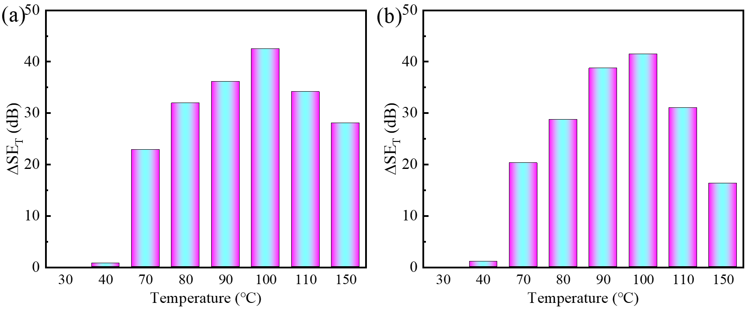
Fig.S17 Effect of the temperature on (a) ΔSE_{T} in X band, (b) ΔSE_{T} in Ku band of VP-5 film

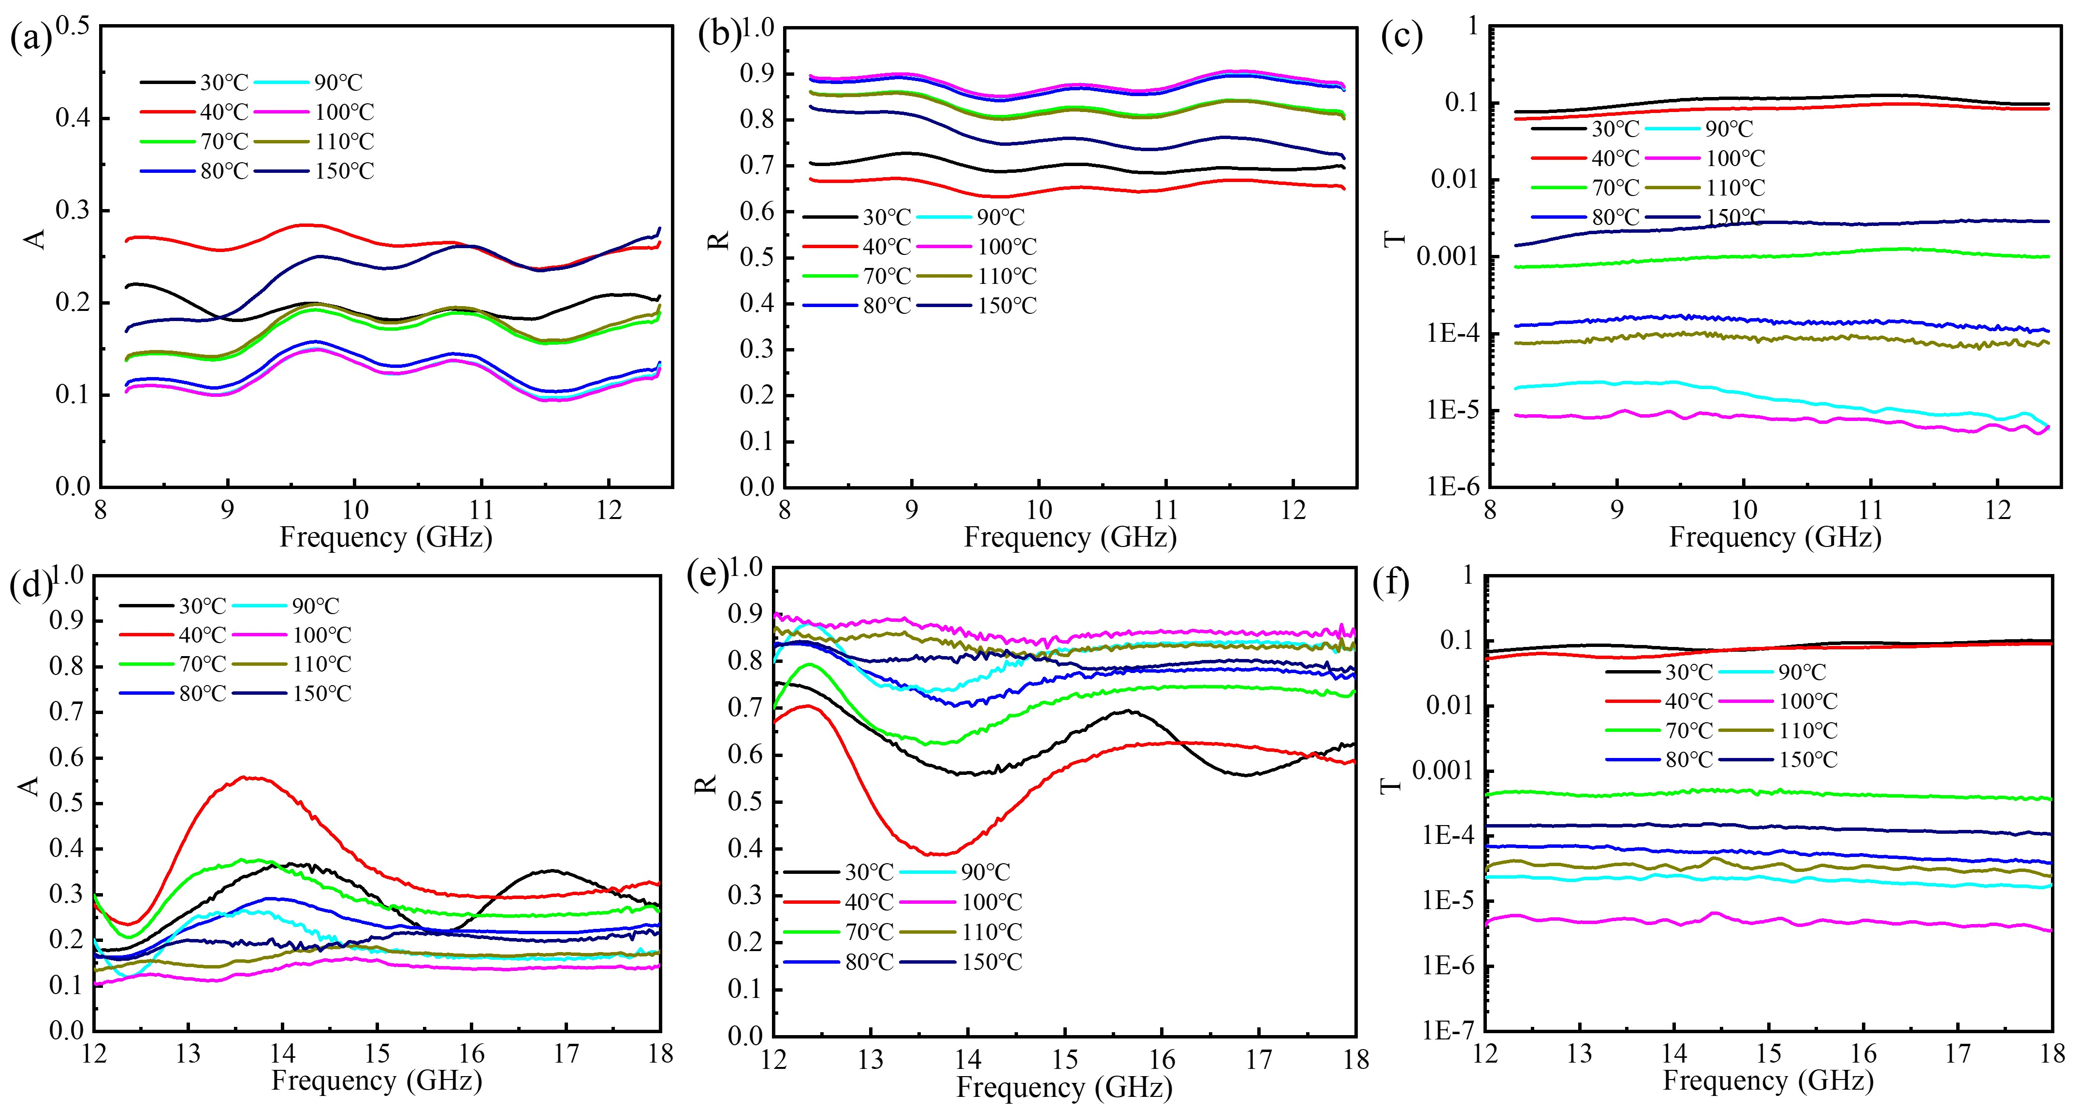
Fig.S18 Effect of the temperature on power coefficient (a) absorption, (b) reflection and (c) transmission in X-band of VP-5 film; (d) absorption, (e) reflection and (f) transmission in Ku-band of VP-5 film
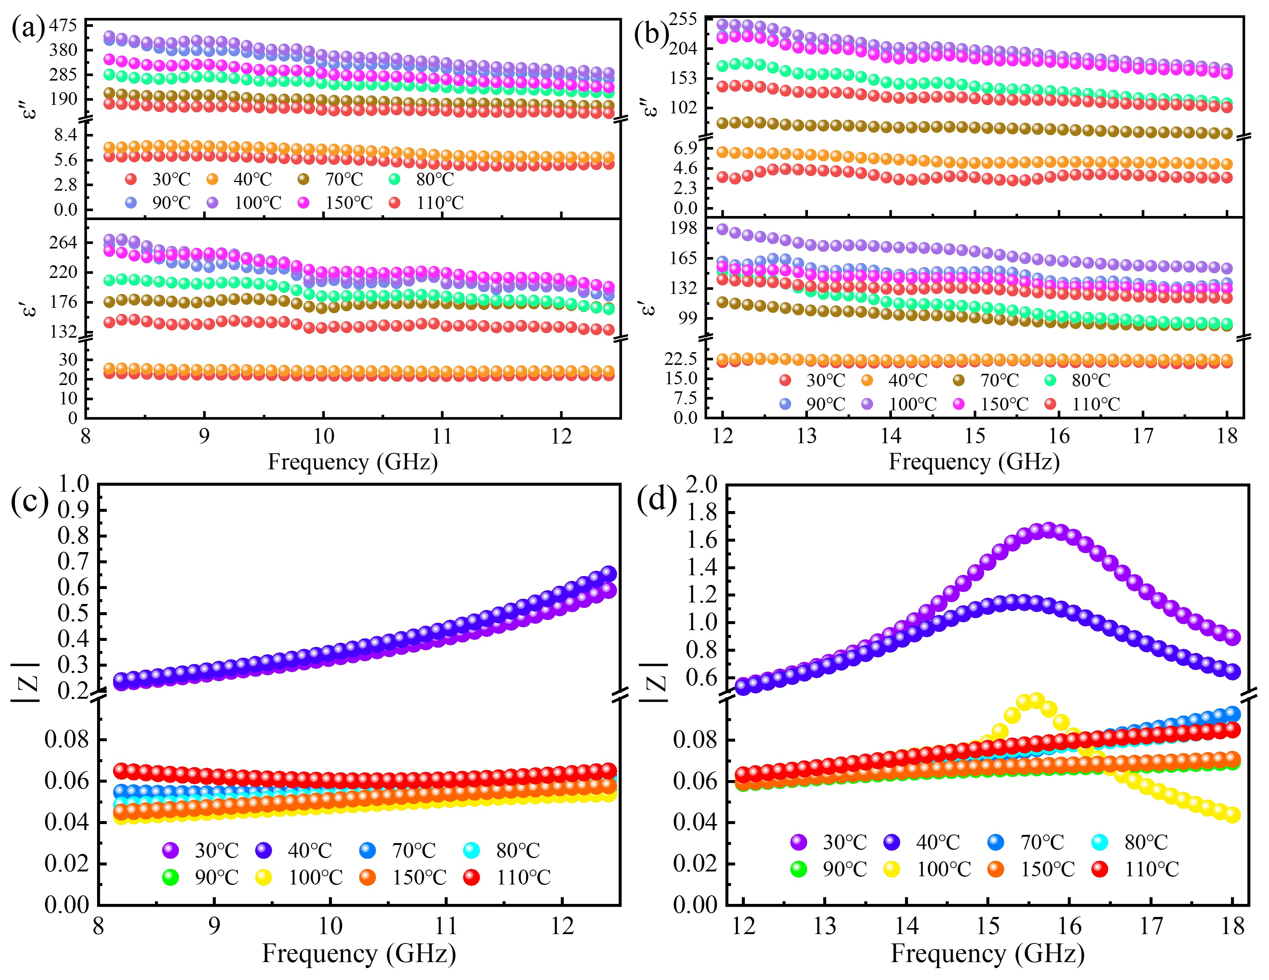
Fig.S19 Complex permittivity and of impedance matching of VP-5 film (thickness of 1.02 mm) at different temperatures: (a, c) X-band, (b, d) Ku-band
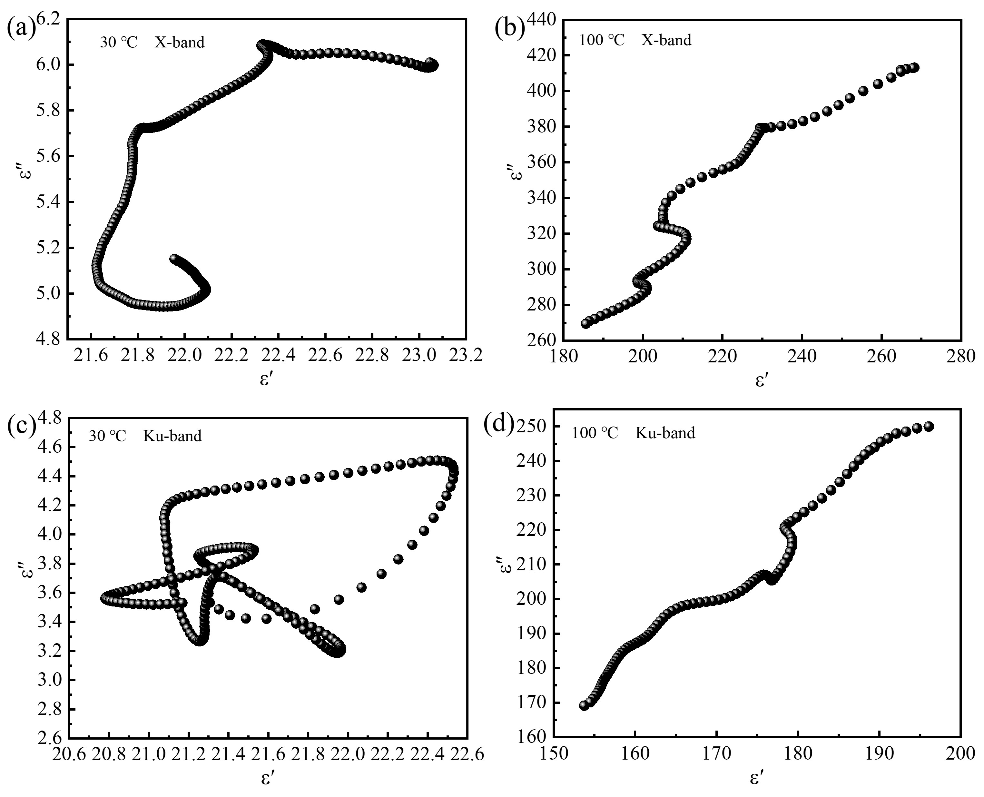
Fig.S20 Cole-Cole plots of ε" versus ε′ of VP-5 film (thickness of 1.02 mm): (a, c) before and (b, d) after phase transition

Table S1 Conductivity of VP composite films at 30℃ and 100℃
Samples | VP-1 | VP-2 | VP-3 | VP-4 | VP-5
σ_{30℃} (S m⁻¹) | 2.99E-08 | 2.76E-07 | 1.24E-06 | 0.07 | 0.13
σ_{100℃} (S m⁻¹) | 5.02E-04 | 0.00501 | 0.0946 | 32.73 | 199.90

Table S2 Average EMI SE, ΔSE_{T}, thickness and temperature range of existing variable EMI shielding materials with temperature responsiveness
Composites | EMI SE (dB) | ΔSE_{T} (dB) | Thickness (mm) | Range | Ref.
CF/SiO₂ | 11.7-12.4 | 0.7 | 2.5 | 30-600 ℃ | [1]
r-GO/SiO₂ | 34.5-37.5 | 3 | 1.5 | 50-200 ℃ | [2]
GN/Al₂O₃ | 22.8-37.4 | 14.6 | 1.5 | 25-400 ℃ | [3]
PDMS/TSM/CNT | 42.3-36.5 | -5.8 | 1.9 | RT-120 ℃ | [4]
Sb₂Te₃ | 55.5-74.8 | 19.3 | 1.36 | 40-300 ℃ | [5]
SiC/Ti₃SiC₂ | 20-46 | 26 | 3.0 | 25-600 ℃ | [6]
Ti₃C₂Tx MXene/aramid nanofiber | 49.7-63.2 | 13.5 | 0.07 | 25-300 ℃ | [7]
SiO₂/MWCNT | 23.5-24.5 | 1 | 2.5 | 100-500 ℃ | [8]
ZrB₂/Al₂O₃ | 31-44 | 13 | 1.2 | 25-600 ℃ | [9]
G@MgO/PVA | 20.6-27.5 | 5.9 | 1 | 30-120 ℃ | [10]
β-MnO₂ | 20.9-21.5 | 0.6 | 2.18 | 20-500 ℃ | [11]
VO₂/CNF | 18.7-53.6 | 35.2 | 1.9 | 25-70 ℃ | [12]
This work | 1.9-18.4 (X)  3.3-22.0 (Ku) | 16.5  18.7 | 0.15 | RT-100 ℃ | /
This work | 4.0-24.4 (X)  4.8-27.2 (Ku) | 20.4  22.4 | 0.29 | RT-100 ℃ | /
This work | 8.2-37.4 (X)  9.5-34.2 (Ku) | 29.2  24.7 | 0.60 | RT-100 ℃ | /
This work | 9.8-40.6 (X)  10.6-37.7 (Ku) | 30.8  27.1 | 0.83 | RT-100 ℃ | /
This work | 8.7-51.0 (X)  9.0-53.3 (Ku) | 42.3  44.3 | 1.02 | RT-100 ℃ | /
This work | 12.3-57.1 (X)  10.5-69.9 (Ku) | 44.8  59.4 | 1.80 | RT-100 ℃ | /

Table S3 Comparison of average EMI SE and maximum ΔSE_{T}, of existing variable EMI shielding materials
Composites | EMI SE (dB) | ΔSE_{T} (dB) | Stimuli | Range | Ref.
PANI/MXene/cotton fabrics | 24-15 | 9 | Acid/Alkali | / | [13]
graphene/non-woven spacer | 20-35 | 15 | Humidity | 0-6 wt% | [14]
polyimide/CNT foam | 17.7-37.8 | 20.1 | Humidity | 0-35 wt% | [15]
CNT/CNF foam | 72-33.5 | 38.5 | Angle | 0-90 ° | [16]
CNF/MXene aerogel | 63.1-36.5 | 26.6 | Angle | 0-90 ° | [17]
MXene@AgNW/PEG | 30.5-12.4 | 18.1 | compression | 0 - 50% | [18]
wood/CNT sponge | 1.4-27.6 | 26.2 | compression | 0 - 75% | [19]
WF/CNT foam | 40.1-13.9 | 26.2 | compression | 0-75% | [20]
liquid metal/PDMS | 20.6-80.7 | 60.1 | Stretching | 0-400% | [21]
MXene organohydrogel | 32.8-37  37-20 | 4.2  17 | Stretching | 0-0%  30%-100% | [22]
PU@Cu Film | 52.31-0 | 52.31 | Stretching | 0-50% | [23]
liquid metal/EcoFlex | 41.5 - 81.6 | 40.1 | Stretching | 0-400% | [24]
CNT | 38-25 | 13 | Stretching | 0-30% | [25]
TPU/CNT | 34.57-12.8 | 21.77 | Stretching | 0-200% | [26]
This work | 12.3-57.1 (X)  10.5-69.7 (Ku) | 44.8  59.2 | Temperature | RT-100℃ | /

References:
1. Cao M, Song W, Hou Z, Wen B, Yuan J (2010) The effects of temperature and frequency on the dielectric properties, electromagnetic interference shielding and microwave-absorption of short carbon fiber/silica composites. Carbon 48(3):788-796. https://doi.org/10.1016/j.carbon.2009.10.028
2. Wen B, Cao M, Lu M, Cao W, Shi H, Liu J, Wang X, Jin H, Fang X, Wang W, Yuan J (2014) Reduced Graphene Oxides: Light-Weight and High-Efficiency Electromagnetic Interference Shielding at Elevated Temperatures. Adv Mater 26(21):3484-3489. https://doi.org/10.1002/adma.201400108
3. Qing Y, Wen Q, Luo F, Zhou W (2016) Temperature dependence of the electromagnetic properties of graphene nanosheet reinforced alumina ceramics in the X-band. J Mater Chem C 4(22):4853-4862. https://doi.org/10.1039/c6tc01163b
4. Cai J, Tang X, Chen X, Wang M (2021) Temperature and strain-induced tunable electromagnetic interference shielding in polydimethylsiloxane/multi-walled carbon nanotube composites with temperature-sensitive microspheres. Compos Part A-Appl S 140(106188):106188. https://doi.org/10.1016/j.compositesa.2020.106188
5. Chen X, Zhang J, Du K, Xie Q, Hou Z (2021) Sb₂Te₃ nanosheets: Topological insulators with extraordinary electromagnetic response behaviors. Chem Eng J 414:128036. https://doi.org/10.1016/j.cej.2020.128036
6. Mu Y, Zhou W, Wan F, Ding D, Hu Y, Luo F (2015) High-temperature dielectric and electromagnetic interference shielding properties of SiC_{f}/SiC composites using Ti₃SiC₂ as inert filler. Compos Part A-Appl S 77:195-203. https://doi.org/10.1016/j.compositesa.2015.07.004
7. Yao J, Zhang L, Yang F, Jiao Z, Tao X, Yao Z, Zheng Y, Zhou J (2022) Superhydrophobic Ti₃C₂T_{x} MXene/aramid nanofiber films for high-performance electromagnetic interference shielding in thermal environment. Chem Eng J 446:136945. https://doi.org/10.1016/j.cej.2022.136945
8. Wen B, Cao M, Hou Z, Song W, Zhang L, Lu M, Jin H, Fang X, Wang W, Yuan J (2013) Temperature dependent microwave attenuation behavior for carbon-nanotube/silica composites. Carbon 65:124-139. https://doi.org/10.1016/j.carbon.2013.07.110
9. Qing Y, Yao H, Li Y, Luo F (2021) Plasma-sprayed ZrB₂/Al₂O₃ ceramics with excellent high temperature electromagnetic interference shielding properties. J Eur Ceram Soc 41(2):1071-1075. https://doi.org/10.1016/j.jeurceramsoc.2020.10.031
10. Marka SK, Srikanth VVSS, Sindam B, Hazra BK, Raju KCJ, Srinath S (2019) Graphene-Wrapped MgO/Poly(vinyl alcohol) Composite Sheets: Dielectric and Electromagnetic Interference Shielding Properties at Elevated Temperatures. ACS Appl Mater Inter 11(26):23714-23730. https://doi.org/10.1021/acsami.9b05137
11. Song W, Cao M, Hou Z, Lu M, Wang C, Yuan J, Fan L (2014) Beta-manganese dioxide nanorods for sufficient high-temperature electromagnetic interference shielding in X-band. Appl Phys a-Mater 116(4):1779-1783. https://doi.org/10.1007/s00339-014-8327-1
12. Liao S, Wang X, Huang H, Shi Y, Wang Q, Hu Y, Zhu P, Sun R, Wong C, Wan Y (2023) Intelligent shielding material based on VO₂ with tunable near-field and far-field electromagnetic response. Chem Eng J 464:142596. https://doi.org/10.1016/j.cej.2023.142596
13. Li D, Liu L, Wang Q, Zhang H, Chen W, Yin G, Yu Z (2022) Functional Polyaniline/MXene/Cotton Fabrics with Acid/Alkali-Responsive and Tunable Electromagnetic Interference Shielding Performances. ACS Appl Mater Inter 14(10):12703-12712. https://doi.org/10.1021/acsami.2c00797
14. Wang Y, Cheng X, Song W, Ma C, Bian X, Chen M (2018) Hydro-sensitive sandwich structures for self-tunable smart electromagnetic shielding. Chem Eng J 344:342-352. https://doi.org/10.1016/j.cej.2018.03.097
15. Sun Z, Chen J, Jia X, Wang G, Shen B, Zheng W (2021) Humidification of high-performance and multifunctional polyimide/carbon nanotube composite foams for enhanced electromagnetic shielding. Mater Today Phys 21:100521. https://doi.org/10.1016/j.mtphys.2021.100521
16. Zeng Z, Wang C, Wu T, Han D, Luković M, Pan F, Siqueira G, Nyström G (2020) Nanocellulose assisted preparation of ambient dried, large-scale and mechanically robust carbon nanotube foams for electromagnetic interference shielding. J Mater Chem A 8(35):17969-17979. https://doi.org/10.1039/D0TA05961G
17. Zeng Z, Wang C, Siqueira G, Han D, Huch A, Abdolhosseinzadeh S, Heier J, Nueesch F, Zhang CJ, Nystroem G (2020) Nanocellulose-MXene Biomimetic Aerogels with Orientation-Tunable Electromagnetic Interference Shielding Performance. Adv Sci 7(15):2000979. https://doi.org/10.1002/advs.202000979
18. He Y, Shao Y, Xiao Y, Yang J, Qi X, Wang Y (2022) Multifunctional Phase Change Composites Based on Elastic MXene/Silver Nanowire Sponges for Excellent Thermal/Solar/Electric Energy Storage, Shape Memory, and Adjustable Electromagnetic Interference Shielding Functions. ACS Appl Mater Inter 14(4):6057-6070. https://doi.org/10.1021/acsami.1c23303
19. Liu X, Li Y, Sun X, Tang W, Deng G, Liu Y, Song Z, Yu Y, Yu R, Dai L, Shui J (2021) Off/on switchable smart electromagnetic interference shielding aerogel. Matter 4(5):1735-1747. https://doi.org/10.1016/j.matt.2021.02.022
20. Chen Y, Liu Y, Li Y, Qi H (2021) Highly Sensitive, Flexible, Stable, and Hydrophobic Biofoam Based on Wheat Flour for Multifunctional Sensor and Adjustable EMI Shielding Applications. ACS Appl Mater Inter 13(25):30020-30029. https://doi.org/10.1021/acsami.1c05803
21. Zhu R, Li Z, Deng G, Yu Y, Shui J, Yu R, Pan C, Liu X (2022) Anisotropic magnetic liquid metal film for wearable wireless electromagnetic sensing and smart electromagnetic interference shielding. Nano Energy 92:106700. https://doi.org/10.1016/j.nanoen.2021.106700
22. Yu Y, Yi P, Xu W, Sun X, Deng G, Liu X, Shui J, Yu R (2022) Environmentally Tough and Stretchable MXene Organohydrogel with Exceptionally Enhanced Electromagnetic Interference Shielding Performances. Nano-Micro Lett 14(1):15. https://doi.org/10.1007/s40820-022-00819-3
23. Xia S, Wei C, Tang J, Yan J (2021) Tensile Stress-Gated Electromagnetic Interference Shielding Fabrics with Real-Time Adjustable Shielding Efficiency. ACS Sustain Chem Eng 9(42):13999-14005. https://doi.org/10.1021/acssuschemeng.1c05589
24. Liu C, Cai J, Dang P, Li X, Zhang D (2020) Highly Stretchable Electromagnetic Interference Shielding Materials Made with Conductive Microcoils Confined to a Honeycomb Structure. ACS Appl Mater Inter 12(10):12101-12108. https://doi.org/10.1021/acsami.0c00034
25. Huang K, Chen M, He G, Hu X, He W, Zhou X, Huang Y, Liu Z (2020) Stretchable microwave absorbing and electromagnetic interference shielding foam with hierarchical buckling induced by solvent swelling. Carbon 157:466-477. https://doi.org/10.1016/j.carbon.2019.10.059
26. Feng D, Xu D, Wang Q, Liu P (2019) Highly stretchable electromagnetic interference (EMI) shielding segregated polyurethane/carbon nanotube composites fabricated by microwave selective sintering. J Mater Chem C 7(26):7938-7946. https://doi.org/10.1039/c9tc02311a

∗Corresponding author: E-mail addresses: haosue@hit.edu.cn (S. Hao), dousl@hit.edu.cn, yaoli@hit.edu.cn (Y. Li).

