Supplementary material

A bidirectional causality between type 2 diabetes and hypertension in Korean general population: A Mendelian Randomization Study
Supplementary Table 1. Selected genetic variants for fasting glucose levels (N=91)
Supplementary Table 2. Selected genetic variants for Systolic blood pressure (N=68)
Supplementary table 3. Odds ratios of FBS on prevalents of T2D / hypertension from Observational and Mendelian randomization analyses testing
Supplementary table 4. Odds ratios of SBP on prevalents of T2D / hypertension from Observational and Mendelian randomization analyses testing
Supplementary Figure 1. Manhattan plots for fasting glucose levels and systolic blood pressure from KCPS-II
Supplementary Figure 2. A schematic frame for 2 sample MR analysis
Supplementary Figure 3. The study population for mendelian randomization analysis
Supplementary Figure 4. The effects per 1-SD genetically determined FBS on metabolic components from Observational and Mendelian randomization analyses testing by sex
Supplementary Figure 5. The effects per 1-SD genetically determined SBP on metabolic components from Observational and Mendelian randomization analyses testing by sex
Supplementary Table 1. Selected genetic variants for fasting glucose levels (N=91)
No | SNP | CHR | BP | Reference allele | Alternative allele | GWAS
 |  |  |  |  |  | KCPS-II |  |  | KoGES
 |  |  |  |  |  | beta | SE | P | beta | SE | P
1 | rs10124848 | 9 | 623485 | T | A | 0.67489 | 0.08819 | 1.97625E-14 | -0.05505 | 0.10399 | 0.596503
2 | rs10259649 | 7 | 44219705 | T | C | 0.92814 | 0.10501 | 9.79149E-19 | 0.19952 | 0.12280 | 0.104204
3 | rs10440833 | 6 | 20688121 | T | A | 1.21820 | 0.06709 | 1.35108E-73 | 0.02687 | 0.07844 | 0.7319
4 | rs10814921 | 9 | 4307572 | T | C | -0.44064 | 0.06727 | 5.77025E-11 | 0.09565 | 0.07876 | 0.22458
5 | rs10830964 | 11 | 92719681 | C | T | -0.80733 | 0.07710 | 1.19966E-25 | -0.05723 | 0.09159 | 0.532086
6 | rs10849920 | 12 | 1.11E+08 | C | T | 0.47766 | 0.06780 | 1.85881E-12 | 0.32684 | 0.07915 | 3.64E-05
7 | rs10955807 | 8 | 1.18E+08 | A | G | 0.57419 | 0.06707 | 1.12299E-17 | 0.03293 | 0.07838 | 0.674445
8 | rs10965241 | 9 | 22129594 | G | C | 0.78648 | 0.11748 | 2.17358E-11 | -0.17465 | 0.13778 | 0.204951
9 | rs10965250 | 9 | 22133284 | G | A | -1.22340 | 0.06751 | 2.58177E-73 | -0.10269 | 0.07915 | 0.194516
10 | rs10965251 | 9 | 22134029 | G | A | -0.93675 | 0.12931 | 4.36984E-13 | 0.08368 | 0.14656 | 0.568021
11 | rs11020106 | 11 | 92667147 | T | A | -0.68198 | 0.06700 | 2.51849E-24 | -0.08943 | 0.07879 | 0.256335
12 | rs11065836 | 12 | 1.12E+08 | G | A | -0.53834 | 0.06765 | 1.75874E-15 | -0.29544 | 0.07941 | 0.000199
13 | rs11071655 | 15 | 62427973 | T | C | -0.43768 | 0.06741 | 8.43155E-11 | -0.00070 | 0.07864 | 0.992883
14 | rs11187078 | 10 | 94340705 | G | C | 0.69814 | 0.06973 | 1.38272E-23 | -0.09938 | 0.08162 | 0.223363
15 | rs11187146 | 10 | 94478355 | C | G | 0.52254 | 0.07136 | 2.4467E-13 | -0.09138 | 0.08299 | 0.270827
16 | rs11187165 | 10 | 94515985 | T | C | 0.81087 | 0.12577 | 1.14262E-10 | -0.05755 | 0.14531 | 0.692048
17 | rs113748381 | 17 | 6953155 | G | A | 0.74878 | 0.11388 | 4.8792E-11 | 0.22172 | 0.12977 | 0.087529
18 | rs113767488 | 7 | 44214513 | T | C | -0.73508 | 0.07909 | 1.5046E-20 | -0.09204 | 0.09327 | 0.323783
19 | rs11753021 | 6 | 20735394 | C | T | -0.58638 | 0.07455 | 3.7078E-15 | -0.14640 | 0.08745 | 0.094125
20 | rs12053049 | 2 | 1.7E+08 | T | C | 0.80614 | 0.07003 | 1.19171E-30 | 0.18681 | 0.08215 | 0.022965
21 | rs12219514 | 10 | 94466439 | G | A | 0.80591 | 0.09456 | 1.56658E-17 | -0.11745 | 0.11049 | 0.287769
22 | rs12297293 | 12 | 1.13E+08 | G | C | -0.55517 | 0.06886 | 7.53735E-16 | -0.35273 | 0.08064 | 1.22E-05
23 | rs12472643 | 2 | 27739306 | C | T | 0.73858 | 0.09960 | 1.22013E-13 | -0.13979 | 0.11713 | 0.232713
24 | rs1260326 | 2 | 27730940 | T | C | 1.20910 | 0.06730 | 4.19189E-72 | -0.28932 | 0.07911 | 0.000255
25 | rs12712928 | 2 | 45192080 | G | C | 0.70970 | 0.06915 | 1.05668E-24 | -0.01336 | 0.08089 | 0.868771
26 | rs13266634 | 8 | 1.18E+08 | C | T | -0.96601 | 0.06845 | 3.34705E-45 | 0.01364 | 0.08025 | 0.865025
27 | rs13383793 | 2 | 45176962 | T | C | 0.38747 | 0.07073 | 4.30447E-08 | 0.14163 | 0.08244 | 0.0858
28 | rs1376556 | 2 | 1.74E+08 | C | G | -0.57386 | 0.09096 | 2.81997E-10 | -0.07401 | 0.10490 | 0.480461
29 | rs1377186 | 18 | 31523975 | T | C | -0.37394 | 0.06728 | 2.73599E-08 | 0.03872 | 0.07941 | 0.625802
30 | rs142190217 | 12 | 1.1E+08 | G | A | -0.84611 | 0.11942 | 1.39268E-12 | -0.39647 | 0.14927 | 0.007906
31 | rs144934275 | 5 | 1.51E+08 | G | A | 0.73739 | 0.13288 | 2.87235E-08 | -0.04671 | 0.15549 | 0.763865
32 | rs1574285 | 9 | 4283137 | T | G | 0.73026 | 0.06777 | 4.60297E-27 | 0.04842 | 0.07920 | 0.540947
33 | rs1680054 | 4 | 1221136 | C | T | -0.47746 | 0.07563 | 2.73829E-10 | -0.02055 | 0.08904 | 0.817467
34 | rs16940688 | 12 | 1.1E+08 | G | A | -1.00660 | 0.12097 | 8.79808E-17 | -0.75716 | 0.14995 | 4.44E-07
35 | rs17168486 | 7 | 14898282 | C | T | 0.70878 | 0.06794 | 1.80603E-25 | 0.06318 | 0.07947 | 0.426624
36 | rs1881395 | 2 | 27838549 | G | A | 0.77687 | 0.07117 | 9.92294E-28 | -0.23136 | 0.08296 | 0.00529
37 | rs2043880 | 15 | 90432526 | A | G | 0.52258 | 0.08582 | 1.13787E-09 | 0.08127 | 0.09974 | 0.415163
38 | rs2072134 | 12 | 1.13E+08 | G | A | -1.32246 | 0.10521 | 3.22962E-36 | -0.85419 | 0.12471 | 7.48E-12
39 | rs2072137 | 12 | 1.13E+08 | T | C | -0.47856 | 0.06750 | 1.35008E-12 | -0.19040 | 0.07919 | 0.016201
40 | rs2106464 | 11 | 2639233 | C | T | -0.66177 | 0.11227 | 3.76553E-09 | 0.05497 | 0.12414 | 0.657924
41 | rs217554 | 7 | 14905933 | G | A | -0.54403 | 0.07461 | 3.07942E-13 | -0.07709 | 0.08842 | 0.383273
42 | rs2237897 | 11 | 2858546 | C | T | -1.15337 | 0.06857 | 1.98518E-63 | -0.06849 | 0.08079 | 0.396547
43 | rs2239614 | 7 | 44143124 | C | T | -0.52649 | 0.06704 | 4.0886E-15 | -0.24179 | 0.07845 | 0.002056
44 | rs2290203 | 15 | 91512067 | A | G | -0.40620 | 0.06681 | 1.20766E-09 | 0.14444 | 0.07887 | 0.067069
45 | rs231361 | 11 | 2691500 | A | G | -0.56513 | 0.08479 | 2.65764E-11 | 0.01305 | 0.09898 | 0.895126
46 | rs243018 | 2 | 60586707 | G | C | -0.50934 | 0.07056 | 5.27013E-13 | 0.03891 | 0.08276 | 0.638272
47 | rs2466294 | 8 | 1.18E+08 | G | C | 0.62125 | 0.08181 | 3.13013E-14 | 0.13676 | 0.09704 | 0.158742
48 | rs2497309 | 10 | 94483976 | T | C | 1.13163 | 0.12271 | 2.94766E-20 | 0.04221 | 0.14320 | 0.76818
49 | rs2815650 | 10 | 12558035 | G | A | -0.36767 | 0.06700 | 4.08243E-08 | 0.06559 | 0.07847 | 0.403188
50 | rs2971670 | 7 | 44226101 | C | T | 1.04096 | 0.08629 | 1.70136E-33 | -0.03708 | 0.10074 | 0.712812
51 | rs2971672 | 7 | 44205906 | A | C | 0.63990 | 0.06706 | 1.41718E-21 | 0.16303 | 0.07820 | 0.0371
52 | rs3852527 | 11 | 2826603 | G | A | 0.39989 | 0.06831 | 4.82007E-09 | 0.00574 | 0.08051 | 0.943186
53 | rs3937435 | 12 | 1.13E+08 | A | G | -0.61507 | 0.07230 | 1.80569E-17 | -0.31793 | 0.08489 | 0.00018
54 | rs4331050 | 11 | 92696014 | G | T | 1.42506 | 0.06749 | 7.8039E-99 | 0.11341 | 0.07897 | 0.150982
55 | rs4340647 | 3 | 23471072 | T | G | -0.43069 | 0.07535 | 1.0936E-08 | 0.25290 | 0.08787 | 0.004001
56 | rs4712530 | 6 | 20713914 | T | C | 0.83610 | 0.11789 | 1.32557E-12 | -0.05123 | 0.12950 | 0.692404
57 | rs4731419 | 7 | 1.28E+08 | T | C | 0.46196 | 0.08310 | 2.71926E-08 | -0.10102 | 0.09783 | 0.301824
58 | rs4775468 | 15 | 62401926 | C | T | -0.52517 | 0.08545 | 7.95788E-10 | -0.07782 | 0.09984 | 0.435755
59 | rs4886511 | 15 | 77448838 | T | C | 0.51180 | 0.06799 | 5.19174E-14 | -0.07842 | 0.07947 | 0.323761
60 | rs4923864 | 15 | 40634717 | A | G | 0.53566 | 0.07189 | 9.27205E-14 | 0.02793 | 0.08419 | 0.740043
61 | rs55716278 | 10 | 94198194 | A | G | 1.10136 | 0.14738 | 7.88357E-14 | -0.01286 | 0.17740 | 0.942213
62 | rs57195659 | 12 | 27964928 | G | A | -0.50827 | 0.07084 | 7.26281E-13 | 0.01613 | 0.08286 | 0.84565
63 | rs6048249 | 20 | 22660111 | C | G | -0.74271 | 0.10745 | 4.78514E-12 | -0.17270 | 0.12875 | 0.179831
64 | rs6456354 | 6 | 20519390 | A | G | -0.57752 | 0.08995 | 1.35986E-10 | 0.12232 | 0.10554 | 0.246489
65 | rs671 | 12 | 1.12E+08 | G | A | -1.79427 | 0.09101 | 2.05772E-86 | -1.17308 | 0.10835 | 2.71E-27
66 | rs67320261 | 6 | 20609451 | C | T | -0.71876 | 0.06860 | 1.12381E-25 | -0.00045 | 0.07990 | 0.995547
67 | rs6741646 | 2 | 27348198 | C | T | -0.42715 | 0.06969 | 8.85377E-10 | 0.27789 | 0.08154 | 0.000655
68 | rs7090695 | 10 | 1.13E+08 | C | G | -0.39417 | 0.06706 | 4.15616E-09 | 0.01887 | 0.07926 | 0.811781
69 | rs7161785 | 15 | 62395224 | G | C | -0.68603 | 0.06707 | 1.50798E-24 | -0.06254 | 0.07842 | 0.42517
70 | rs72657615 | 6 | 20671084 | A | C | -0.73974 | 0.10431 | 1.3329E-12 | 0.17230 | 0.11905 | 0.147822
71 | rs72832313 | 6 | 20741680 | T | C | 0.63761 | 0.06865 | 1.60181E-20 | 0.12050 | 0.08051 | 0.134463
72 | rs73016223 | 3 | 1.53E+08 | T | C | 0.40494 | 0.07419 | 4.81713E-08 | 0.12533 | 0.08693 | 0.149405
73 | rs7314904 | 12 | 1.12E+08 | G | A | 0.56435 | 0.10098 | 2.29335E-08 | 0.22241 | 0.11813 | 0.059734
74 | rs73199895 | 12 | 1.12E+08 | G | A | 0.39807 | 0.06967 | 1.10653E-08 | 0.15965 | 0.08237 | 0.052585
75 | rs742761 | 6 | 39046655 | C | T | -0.58649 | 0.08160 | 6.63422E-13 | -0.15958 | 0.09638 | 0.097793
76 | rs74770198 | 15 | 62431368 | C | G | -0.67734 | 0.12233 | 3.07954E-08 | -0.08788 | 0.14250 | 0.537419
77 | rs75628519 | 12 | 1.1E+08 | A | G | -0.69036 | 0.12569 | 3.96708E-08 | -0.32905 | 0.14620 | 0.024405
78 | rs7656416 | 4 | 1254535 | C | T | -0.51959 | 0.07122 | 2.97775E-13 | 0.03080 | 0.08390 | 0.713575
79 | rs76924981 | 6 | 20572355 | G | C | 0.93094 | 0.13913 | 2.21859E-11 | 0.01756 | 0.16397 | 0.914732
80 | rs77466626 | 11 | 61631690 | C | T | -0.37336 | 0.06797 | 3.96266E-08 | -0.12348 | 0.08039 | 0.12453
81 | rs77853892 | 2 | 28067559 | C | A | -0.59294 | 0.10249 | 7.25035E-09 | -0.04430 | 0.11855 | 0.708635
82 | rs7875253 | 9 | 4285707 | A | C | -0.41135 | 0.07300 | 1.7564E-08 | 0.13505 | 0.08523 | 0.113093
83 | rs7997912 | 13 | 33562505 | T | C | 0.64650 | 0.09055 | 9.40243E-13 | 0.00079 | 0.10679 | 0.994068
84 | rs836598 | 2 | 1.74E+08 | T | C | -0.57690 | 0.08187 | 1.83782E-12 | -0.11695 | 0.09504 | 0.218499
85 | rs912175 | 9 | 712137 | G | C | 0.52043 | 0.09376 | 2.84627E-08 | -0.03806 | 0.10917 | 0.727399
86 | rs926091 | 10 | 89721412 | C | T | 0.44178 | 0.07067 | 4.08702E-10 | 0.02735 | 0.08245 | 0.740067
87 | rs932443 | 6 | 39042334 | T | C | 0.40267 | 0.06851 | 4.16383E-09 | -0.01752 | 0.08035 | 0.827394
88 | rs9358341 | 6 | 20525488 | C | A | -0.56315 | 0.06697 | 4.19016E-17 | 0.03718 | 0.07867 | 0.636525
89 | rs9465844 | 6 | 20630472 | A | G | -0.62125 | 0.07115 | 2.52967E-18 | -0.00915 | 0.08406 | 0.913344
90 | rs9788635 | 15 | 62133674 | C | T | -0.55222 | 0.07689 | 6.89629E-13 | -0.08712 | 0.09035 | 0.334933
91 | rs9842724 | 3 | 63804761 | C | T | -0.40990 | 0.06944 | 3.58346E-09 | -0.05187 | 0.08113 | 0.522548
Abbreviations: SNP, single nucleotide polymorphisms; CHR, chromosome; GWAS, genome-wide association study; KCPS-II, Korean cancer prevention study-II; KoGES, korean genome and epidemiology study; SE, standard error

Supplementary Table 2. Selected genetic variants for Systolic blood pressure (N=68)
No | SNP | CHR | BP | Reference allele | Alternative allele | GWAS
 |  |  |  |  |  | KCPS2 |  |  | KoGES
 |  |  |  |  |  | beta | SE | P | beta | SE | P
1 | rs10190857 | 2 | 50678471 | G | A | 0.301385 | 0.048327 | 4.49E-10 | -0.09686 | 0.10431 | 0.353125
2 | rs10434005 | 4 | 1.11E+08 | G | A | 0.264832 | 0.048189 | 3.9E-08 | 0.093422 | 0.104033 | 0.369186
3 | rs10774611 | 12 | 1.11E+08 | A | G | 0.340194 | 0.052252 | 7.5E-11 | 0.244519 | 0.112698 | 0.030035
4 | rs10947434 | 6 | 33691501 | T | G | 0.325512 | 0.058321 | 2.39E-08 | 0.123521 | 0.125655 | 0.325603
5 | rs1106393 | 10 | 1.05E+08 | C | A | -0.40395 | 0.051683 | 5.49E-15 | -0.23285 | 0.111821 | 0.037317
6 | rs11066344 | 12 | 1.13E+08 | T | A | 0.340699 | 0.05675 | 1.93E-09 | 0.497995 | 0.123145 | 5.26E-05
7 | rs11066453 | 12 | 1.13E+08 | A | G | -0.96852 | 0.073024 | 4E-40 | -1.0977 | 0.159051 | 5.19E-12
8 | rs11072506 | 15 | 75052994 | G | A | 0.278528 | 0.048947 | 1.27E-08 | 0.068959 | 0.105943 | 0.515106
9 | rs115379475 | 6 | 32200681 | G | A | -0.40152 | 0.070775 | 1.4E-08 | -0.37114 | 0.152851 | 0.015181
10 | rs11870849 | 17 | 78411073 | C | T | 0.430145 | 0.071051 | 1.42E-09 | 0.214328 | 0.152655 | 0.160323
11 | rs12066994 | 1 | 77930043 | C | T | -0.274 | 0.048406 | 1.51E-08 | 0.059813 | 0.104864 | 0.568417
12 | rs12537566 | 7 | 1.31E+08 | G | C | 0.27579 | 0.048705 | 1.49E-08 | -0.00876 | 0.10578 | 0.934011
13 | rs12571461 | 10 | 95974495 | G | A | 0.321614 | 0.05464 | 3.96E-09 | -0.10485 | 0.117237 | 0.371122
14 | rs12579052 | 12 | 90132147 | G | A | -0.42854 | 0.060348 | 1.24E-12 | -0.08796 | 0.13125 | 0.502762
15 | rs12656497 | 5 | 32831939 | C | T | -0.41211 | 0.04931 | 6.46E-17 | -0.04342 | 0.107017 | 0.684964
16 | rs13139571 | 4 | 1.57E+08 | C | A | -0.35092 | 0.057842 | 1.31E-09 | 0.238633 | 0.125437 | 0.057122
17 | rs139037971 | 19 | 11518552 | G | A | 0.407336 | 0.060801 | 2.1E-11 | 0.014802 | 0.12963 | 0.909089
18 | rs139141104 | 6 | 30989021 | A | G | 0.552844 | 0.091042 | 1.26E-09 | 0.195878 | 0.195884 | 0.317327
19 | rs1408820 | 10 | 96013824 | C | T | -0.44323 | 0.053516 | 1.22E-16 | 0.046317 | 0.115357 | 0.688048
20 | rs141965732 | 12 | 1.11E+08 | C | T | -0.68197 | 0.083773 | 3.96E-16 | -1.45706 | 0.189952 | 1.73E-14
21 | rs144253733 | 3 | 1.69E+08 | G | A | 0.485431 | 0.078417 | 6.02E-10 | -0.54567 | 0.169129 | 0.001255
22 | rs1635133 | 12 | 1.13E+08 | T | C | 0.326805 | 0.048369 | 1.42E-11 | 0.239404 | 0.104556 | 0.02204
23 | rs16998073 | 4 | 81184341 | A | T | 0.747457 | 0.050772 | 5.06E-49 | 0.029437 | 0.109757 | 0.788543
24 | rs17011002 | 4 | 86731385 | C | G | 0.51326 | 0.059634 | 7.59E-18 | 0.26304 | 0.12835 | 0.040427
25 | rs17011215 | 4 | 86856588 | A | G | 0.31568 | 0.05409 | 5.35E-09 | 0.128739 | 0.117181 | 0.27193
26 | rs1750480 | 10 | 1.05E+08 | T | G | 0.377998 | 0.048244 | 4.71E-15 | 0.176469 | 0.104339 | 0.090781
27 | rs17637472 | 17 | 47461433 | G | A | 0.393514 | 0.068629 | 9.83E-09 | 0.296541 | 0.147034 | 0.043719
28 | rs1860509 | 7 | 1.39E+08 | T | G | -0.31022 | 0.051367 | 1.55E-09 | -0.06445 | 0.111553 | 0.563422
29 | rs1887320 | 20 | 10965998 | A | G | -0.26362 | 0.048244 | 4.66E-08 | -0.03671 | 0.104399 | 0.725108
30 | rs2239193 | 12 | 1.13E+08 | A | G | -0.51507 | 0.052194 | 5.81E-23 | -0.53602 | 0.113362 | 2.27E-06
31 | rs2290573 | 15 | 75129594 | G | A | -0.46924 | 0.066223 | 1.39E-12 | -0.07856 | 0.145609 | 0.589537
32 | rs232927 | 12 | 1.13E+08 | A | G | 0.323134 | 0.051367 | 3.17E-10 | 0.32375 | 0.110422 | 0.00337
33 | rs233722 | 12 | 1.13E+08 | G | A | 0.389463 | 0.049603 | 4.13E-15 | 0.529597 | 0.106747 | 7.02E-07
34 | rs2398770 | 7 | 1.31E+08 | T | G | 0.284994 | 0.04815 | 3.25E-09 | 0.084642 | 0.104336 | 0.417227
35 | rs2681492 | 12 | 90013089 | T | C | -0.68051 | 0.049981 | 3.43E-42 | -0.10769 | 0.107808 | 0.317857
36 | rs268263 | 2 | 1.65E+08 | A | T | -0.57146 | 0.04885 | 1.34E-31 | 0.05449 | 0.106265 | 0.60811
37 | rs2880099 | 4 | 1.56E+08 | A | C | -0.26743 | 0.048797 | 4.25E-08 | 0.082864 | 0.105762 | 0.433337
38 | rs2943810 | 11 | 61279799 | G | C | -0.41931 | 0.048255 | 3.67E-18 | -0.19498 | 0.104271 | 0.061494
39 | rs357305 | 2 | 1.65E+08 | C | T | -0.26762 | 0.048416 | 3.25E-08 | -0.02849 | 0.10465 | 0.785415
40 | rs373894 | 11 | 9763094 | A | C | 0.406373 | 0.048862 | 9.11E-17 | -0.19071 | 0.105513 | 0.070692
41 | rs3860432 | 2 | 1.65E+08 | T | C | -0.33006 | 0.053727 | 8.1E-10 | 0.070174 | 0.116383 | 0.546539
42 | rs3931703 | 2 | 51013453 | C | G | 0.313462 | 0.054398 | 8.31E-09 | 0.009283 | 0.118669 | 0.937646
43 | rs438885 | 2 | 1.65E+08 | T | A | -0.33476 | 0.050782 | 4.35E-11 | 0.144143 | 0.109394 | 0.187624
44 | rs4693128 | 4 | 86730714 | C | T | 0.298365 | 0.048338 | 6.74E-10 | 0.245279 | 0.104324 | 0.01872
45 | rs4757380 | 11 | 16035345 | T | G | 0.304343 | 0.054331 | 2.13E-08 | 0.042563 | 0.118034 | 0.718399
46 | rs4767014 | 12 | 1.13E+08 | T | C | -0.4155 | 0.05396 | 1.37E-14 | -0.41963 | 0.11913 | 0.000428
47 | rs4767366 | 12 | 1.16E+08 | T | C | -0.33563 | 0.051836 | 9.52E-11 | -0.09634 | 0.112903 | 0.393482
48 | rs55651363 | 9 | 1.3E+08 | C | T | -0.5977 | 0.108076 | 3.2E-08 | -0.49012 | 0.234292 | 0.036451
49 | rs55946641 | 6 | 25456913 | C | T | 0.423732 | 0.067679 | 3.84E-10 | 0.191191 | 0.146357 | 0.191444
50 | rs57625069 | 3 | 23438574 | A | C | 0.419102 | 0.060008 | 2.88E-12 | -0.57492 | 0.127495 | 6.51E-06
51 | rs57931766 | 12 | 1.16E+08 | T | C | -0.27612 | 0.048688 | 1.42E-08 | 0.047305 | 0.105235 | 0.65306
52 | rs58274947 | 6 | 1.27E+08 | C | T | 0.273472 | 0.048326 | 1.53E-08 | -0.17658 | 0.104828 | 0.09209
53 | rs62033408 | 16 | 53827962 | A | G | 0.521087 | 0.07312 | 1.03E-12 | 0.763422 | 0.158537 | 1.47E-06
54 | rs6483656 | 11 | 9771687 | C | G | -0.32515 | 0.053739 | 1.45E-09 | 0.095647 | 0.116363 | 0.411094
55 | rs6489885 | 12 | 1.13E+08 | A | G | 0.276815 | 0.048874 | 1.48E-08 | 0.250284 | 0.105833 | 0.018038
56 | rs6489979 | 12 | 1.12E+08 | C | T | 0.31316 | 0.054918 | 1.18E-08 | 0.267553 | 0.118016 | 0.023388
57 | rs6504411 | 17 | 46672154 | C | T | -0.34896 | 0.062001 | 1.82E-08 | 0.108007 | 0.134476 | 0.421881
58 | rs671 | 12 | 1.12E+08 | G | A | -1.29641 | 0.065532 | 5.41E-87 | -1.69679 | 0.14402 | 5.21E-32
59 | rs68047333 | 8 | 25914085 | T | G | 0.301588 | 0.048945 | 7.21E-10 | 0.066378 | 0.106026 | 0.53128
60 | rs7131442 | 11 | 16348061 | A | T | 0.385314 | 0.053987 | 9.57E-13 | -0.08954 | 0.116447 | 0.441914
61 | rs74157561 | 10 | 1.16E+08 | A | G | 0.459817 | 0.074267 | 5.98E-10 | -0.00291 | 0.160742 | 0.98556
62 | rs74601708 | 7 | 995724 | T | C | 0.337936 | 0.051583 | 5.72E-11 | 0.051024 | 0.111513 | 0.647268
63 | rs74661587 | 5 | 1.22E+08 | G | A | -0.41757 | 0.048607 | 8.73E-18 | -0.09781 | 0.106001 | 0.356162
64 | rs75642389 | 12 | 1.13E+08 | C | G | 0.445016 | 0.08031 | 3.01E-08 | 0.204914 | 0.161026 | 0.203182
65 | rs7686601 | 4 | 81160632 | G | C | -0.36526 | 0.050084 | 3.05E-13 | 0.024542 | 0.10876 | 0.821472
66 | rs77180047 | 10 | 1.05E+08 | G | A | -0.55376 | 0.055676 | 2.66E-23 | -0.19802 | 0.120199 | 0.099467
67 | rs80111044 | 4 | 81168104 | A | G | -0.40642 | 0.053415 | 2.78E-14 | 0.07835 | 0.115331 | 0.496921
68 | rs9687065 | 5 | 1.48E+08 | A | G | -0.31836 | 0.055107 | 7.61E-09 | -0.08657 | 0.119002 | 0.466942
Abbreviations: SNP, single nucleotide polymorphisms; CHR, chromosome; GWAS, genome-wide association study; KCPS-II, Korean cancer prevention study-II; KoGES, korean genome and epidemiology study; SE, standard error

- fasting glucose levels | - systolic blood pressure
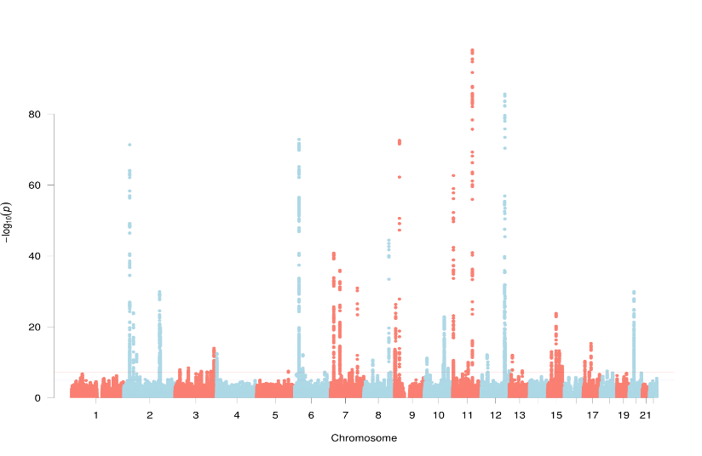 | 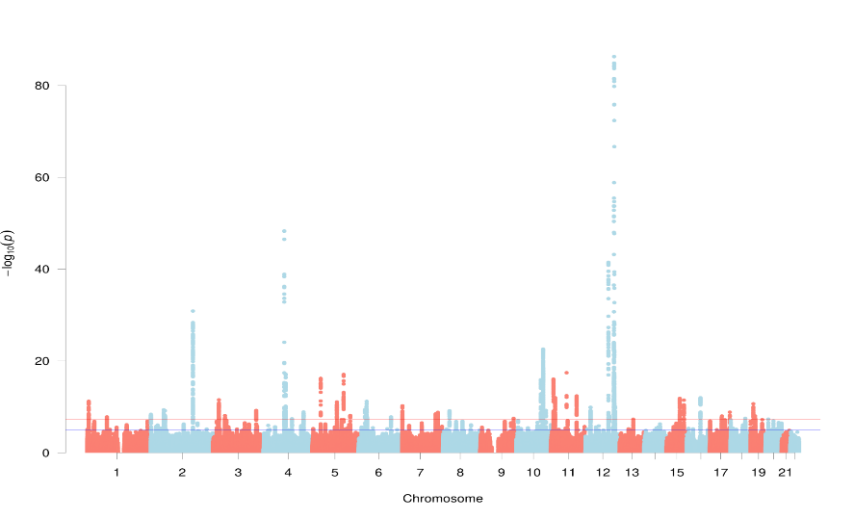
Supplementary Figure 1. Manhattan plots for fasting glucose levels and systolic blood pressure from KCPS-II
Plot for fasting glucose levels and systolic blood pressure showing the –log10 transformed p-value of SNPs.
P values of the y-axis were adjusted for age and sex

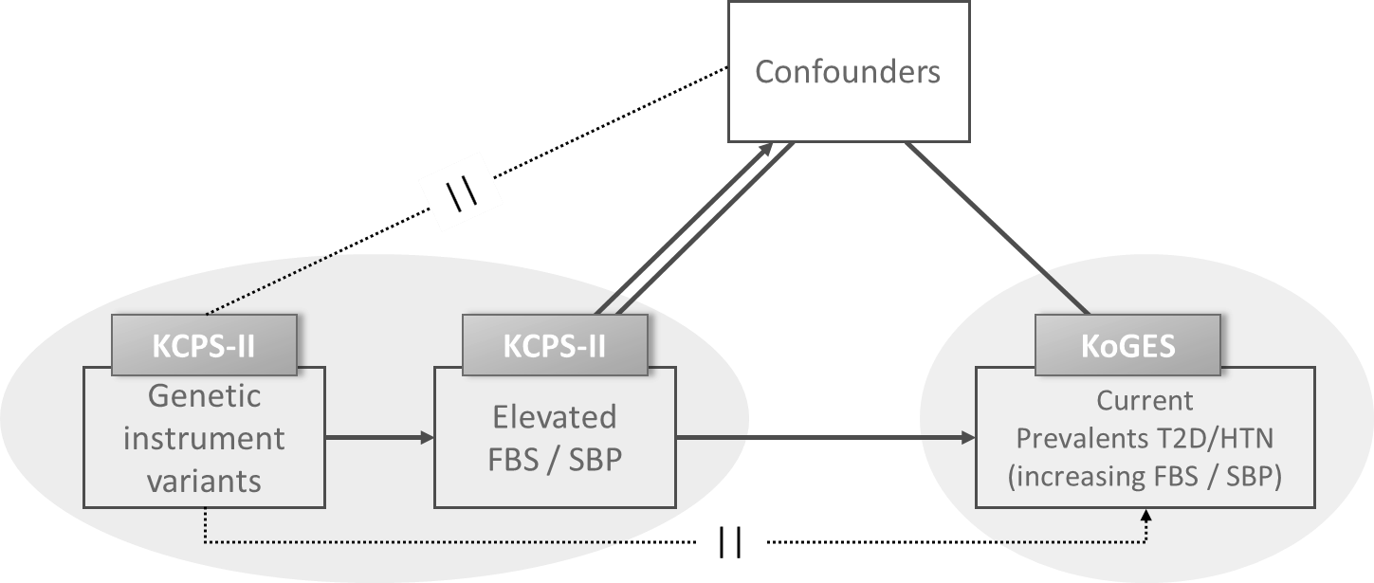

Supplementary Figure 2. A schematic frame for 2 sample MR analysis
A schematic figure of the bidirectional association between FBS and SBP inferred from Mendelian randomization. Genetically determined high FBS would be significantly associated with an increase in SBP risk without the influence of confounders and vice versa.

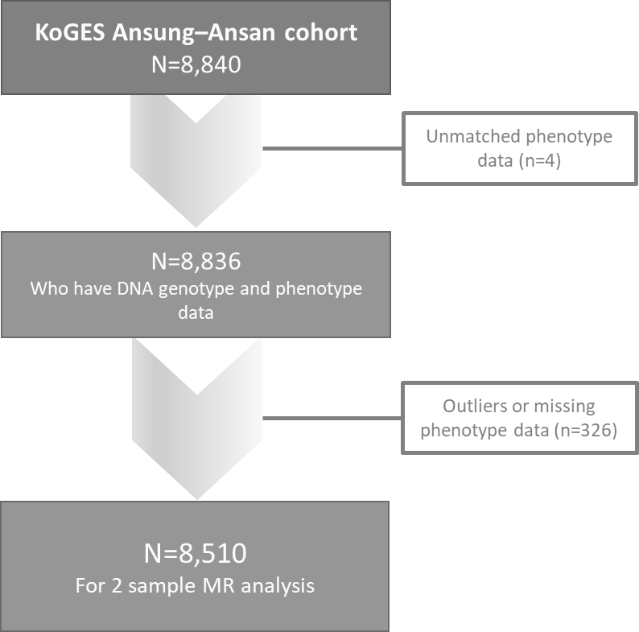
Supplementary Figure 3. The study population for mendelian randomization analysis

Supplementary Figure 4. The effects per 1-SD genetically determined FBS on metabolic components from Observational and Mendelian randomization analyses testing by sex
Abbreviations: FBS, fasting blood sugar; DBP, diastolic blood pressure; S.E., standard error; SD, standard deviation
Supplementary Figure 5. The effects per 1-SD genetically determined SBP on metabolic components from Observational and Mendelian randomization analyses testing by sex
Abbreviations: SBP, systolic blood pressure; HbA1c, glycated hemoglobin; S.E., standard error; SD, standard deviation

Supplementary table 3. Odds ratios of FBS on prevalents of T2D / hypertension from Observational and Mendelian randomization analyses testing
 |  |  | Observational multivariable  regression analysis X-Y |  |  |  | Mendelian randomization analysis
 |  |  | OR | LC | UC | p | F-statistic  G-X | P for  endogenous  test† | OR | LC | UC | p
FBST2D  (per  10 mg/dL) | wGRS for FBS  (N=91) | Total* | 3.908 | 3.604 | 4.238 | <.0001 | 157.39 | 0.0101 | 3.122 | 2.479 | 3.932 | <.0001
FBST2D  (per  10 mg/dL) | wGRS for FBS  (N=91) | Men | 3.648 | 2.324 | 4.074 | <.0001 | 109.25 | 0.3836 | 3.123 | 2.288 | 4.263 | <.0001
FBST2D  (per  10 mg/dL) | wGRS for FBS  (N=91) | Women | 4.215 | 3.745 | 4.743 | <.0001 | 51.65 | 0.0050 | 3.086 | 2.188 | 4.352 | <.0001
FBSHTN  (per  10 mg/dL) | wGRS for FBS  (N=91) | Total* | 1.115 | 1.089 | 1.142 | <.0001 | 157.39 | 0.9184 | 1.144 | 0.956 | 1.370 | 0.143
FBSHTN  (per  10 mg/dL) | wGRS for FBS  (N=91) | Men | 1.102 | 1.067 | 1.138 | <.0001 | 109.25 | 0.7338 | 1.142 | 0.879 | 1.483 | 0.321
FBSHTN  (per  10 mg/dL) | wGRS for FBS  (N=91) | Women | 1.128 | 1.089 | 1.169 | <.0001 | 51.65 | 0.6866 | 1.131 | 0.887 | 1.451 | 0.334
Abbreviations: FBS, fasting blood sugar; GRS, genetic risk score; OR, odds ratio; LC, lower confidence interval; UC, upper confidence interval; G, genetic variant; X, dependent variable
*Adjusted for age and sex (Adjusted for age only when model was stratified into men and women)
†Tests of endogeneity is Wu-Hausman test, Ho: variables are exogenous

Supplementary table 4. Odds ratios of SBP on prevalents of T2D / hypertension from Observational and Mendelian randomization analyses testing
 |  |  | Observational multivariable  regression analysis X-Y |  |  |  | Mendelian randomization analysis
 |  |  | OR | LC | UC | p | F-statistic  G-X | P for  endogenous  test† | OR | LC | UC | p
SBPHTN  (per  10 mm/Hg) | wGRS for SBP  (N=68) | Total* | 2.271 | 2.163 | 2.385 | <.0001 | 40.64 | 0.2829 | 2.721 | 1.748 | 4.237 | <.0001
SBPHTN  (per  10 mm/Hg) | wGRS for SBP  (N=68) | Men | 2.286 | 2.124 | 2.460 | <.0001 | 39.54 | 0.1007 | 4.621 | 2.438 | 8.760 | <.0001
SBPHTN  (per  10 mm/Hg) | wGRS for SBP  (N=68) | Women | 2.252 | 2.110 | 2.404 | <.0001 | 10.16 | 0.9834 | 1.740 | 0.942 | 3.212 | <.0001
SBPT2D  (per  10 mm/Hg) | wGRS for SBP  (N=68) | Total* | 1.158 | 1.113 | 1.204 | <.0001 | 40.64 | 0.0195 | 1.715 | 0.975 | 3.014 | 0.061
SBPT2D  (per  10 mm/Hg) | wGRS for SBP  (N=68) | Men | 1.111 | 1.049 | 1.177 | <.0001 | 39.54 | 0.0068 | 3.392 | 1.593 | 7.218 | 0.002
SBPT2D  (per  10 mm/Hg) | wGRS for SBP  (N=68) | Women | 1.190 | 1.128 | 1.256 | <.0001 | 10.16 | 0.6062 | 0.790 | 0.341 | 1.827 | 0.581
Abbreviations: SBP, systolic blood pressure; GRS, genetic risk score; OR, odds ratio; LC, lower confidence interval; UC, upper confidence interval; G, genetic variant; X, dependent variable
*Adjusted for age and sex (adjusted for age only when model was stratified into men and women)
†Tests of endogeneity is Wu-Hausman test, Ho: variables are exogenous

