Supplementary information
Spectrum-dependent image convolutional processing via a 2D polarization-sensitive photodetector
Yali Yu^{1,2}, Tao Xiong^{1,2}, Ziqi Zhou^{1,2}, Duanyang Liu¹, Yue-Yang Liu¹, Juehan Yang¹, Zhongming Wei^{1,2,}*
¹State Key Laboratory of Superlattices and Microstructures, Institute of Semiconductors, Chinese Academy of Sciences, Beijing 100083, China
²Center of Materials Science and Optoelectronic Engineering, University of Chinese Academy of Sciences, Beijing 100049, China
*Correspondence: zmwei@semi.ac.cn

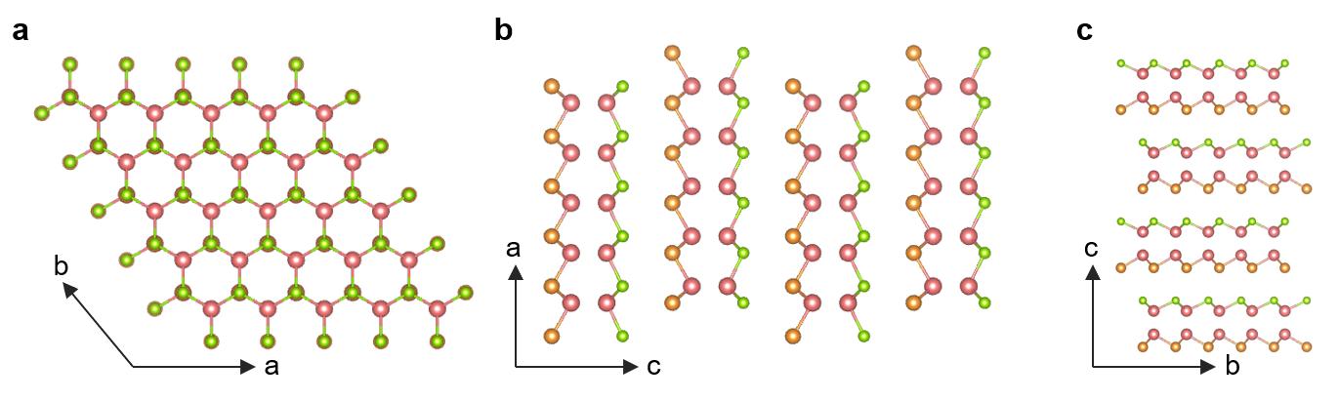
Fig. S1 The projected atomic models of GaTe_{0.5}Se_{0.5} in different planes. a a-b plane. b a-c planes. c b-c plane.

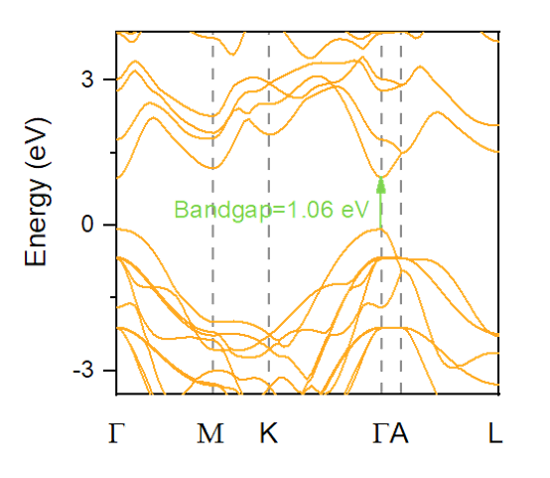
Fig. S2 The theoretical calculated energy band structure of bulk GaTe_{0.5}Se_{0.5}.

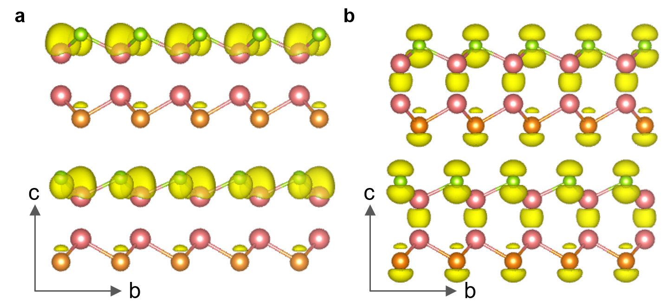
Fig. S3 Iso-plots of the charge density distribution of GaTe_{0.5}Se_{0.5} within the b-c plane. a CBM state. b VBM state.
Table S1 The optoelectrical performance of GaTe_{0.5}Se_{0.5}-based photodetector under illumination within the range of 255-1064 nm.
Wavelength  (nm) | Power density (mW/cm²) | Responsivity  (mA/W) | Detectivity  (*10⁸ Jones)
255 | 22.5 | 150 | 3.42
360 | 22.5 | 164 | 3.73
450 | 22.5 | 82 | 1.91
520 | 22.5 | 40 | 0.92
638 | 22.5 | 30 | 0.71
808 | 22.5 | 20 | 0.49
1064 | 22.5 | 4 | 0.09

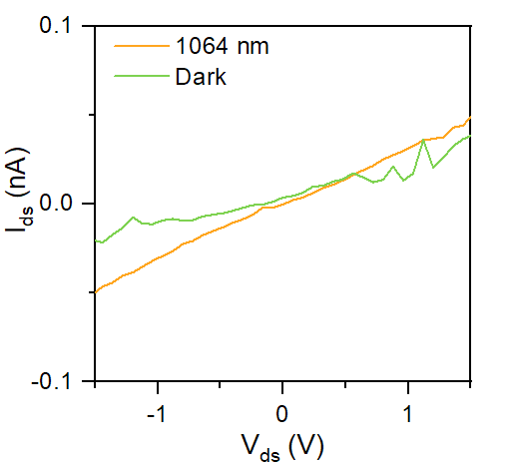
Fig. S4 I_{ds}-V_{ds} curves tested under both dark condition and the illumination of 1064 nm laser.

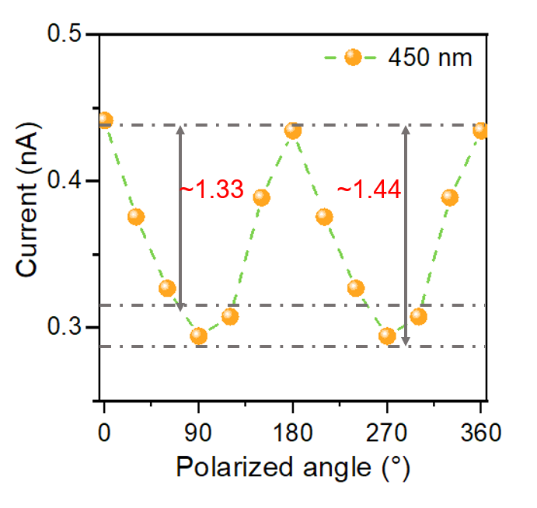
Fig. S5 Polarization-sensitive photoresponse captured under 450 nm laser illumination, with the polarization angle systematically adjusted from 0° to 360°.

Table S2 The relationship between the polarization-sensitive photocurrent values corresponding to the convolution kernels utilized for image convolutional processing and their corresponding color-coded schematic.
