Submitted to Tectonophysics

Appendix. Supplementary materials

Spatiotemporal variations in seismic activity in and around the focal region of the 2021 $M$7.3 and 2022 $M$7.4 Fukushima-Oki earthquakes, Japan

Keita Chiba

This file includes Figures S1–S13.

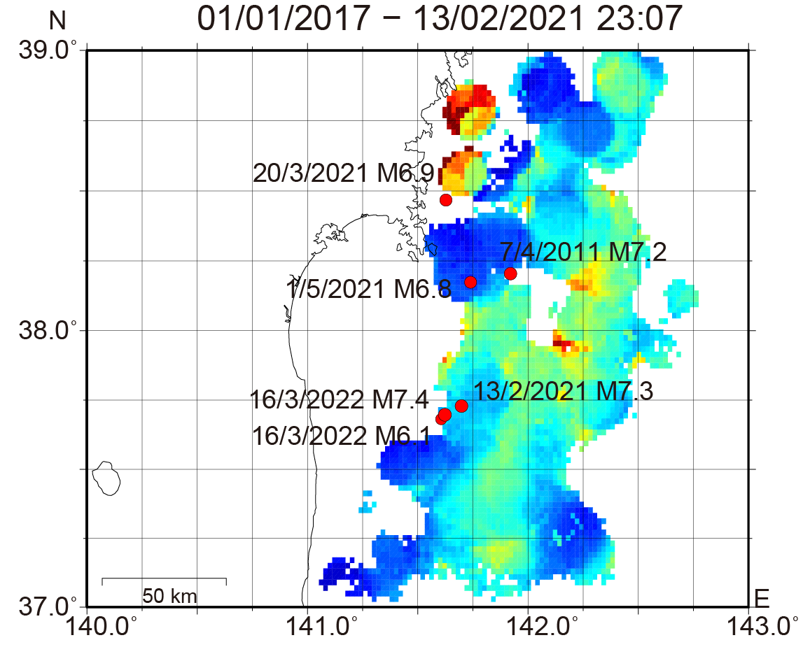
- (c)
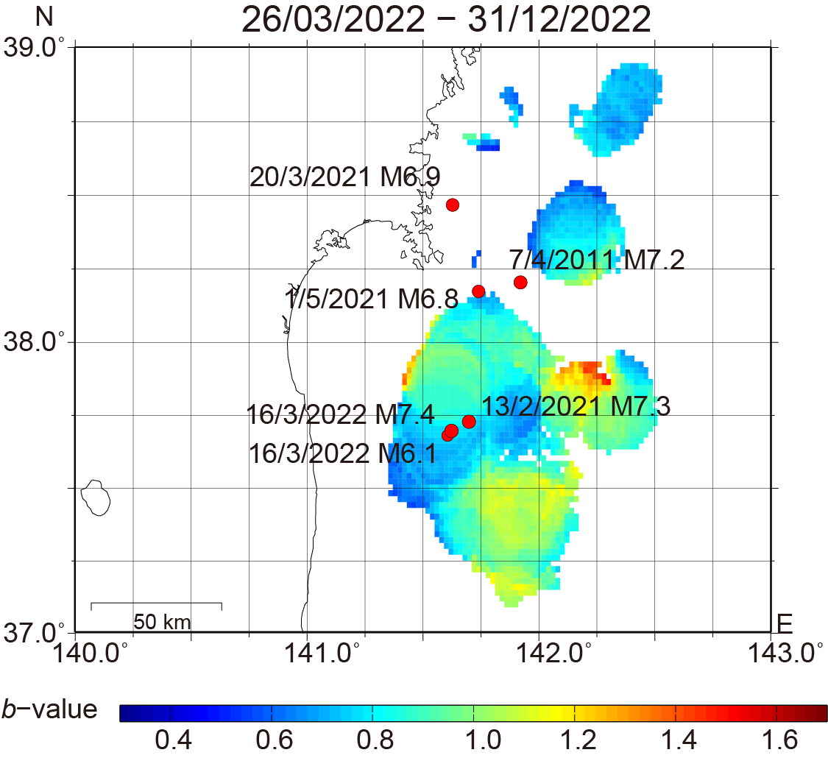

(b)
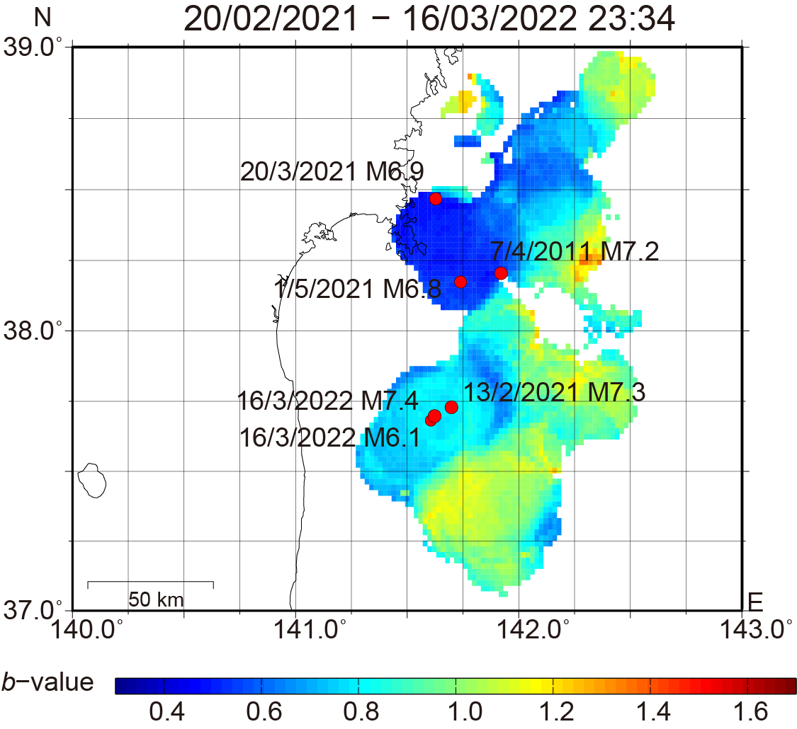

Figure. S1. Spatial $b$-value distributions for the $M ≥1.7$ events in the shallower section (from 5 km above the plate interface to 10 km below it) for (a) period 1, (b) period 2, and (c) period 3. A grid with a 0.02° spacing was used for the $b$-value calculations. The sampling radii were determined to be 10, 15, and 15 km for (a), (b), and (c), respectively. Red circles denote the major thrust-type events on the plate interface and within the subducting slab in the study region.
(a) (c)
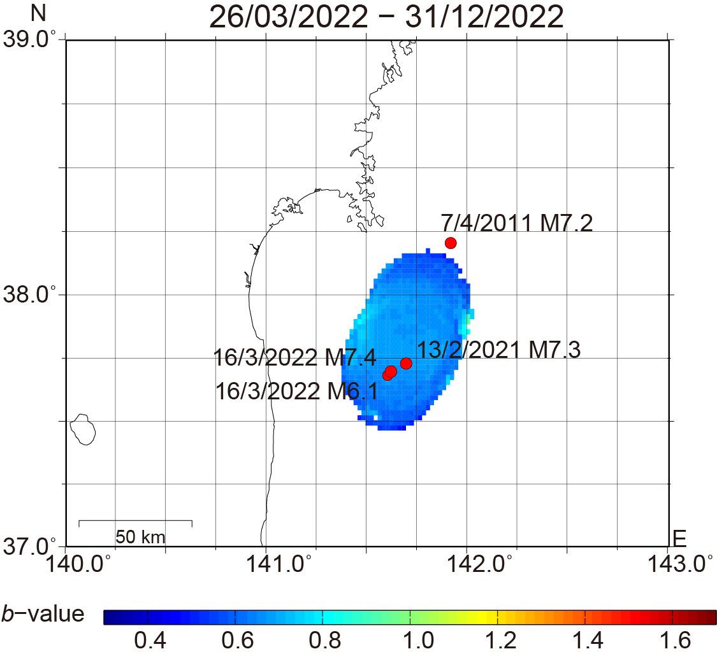
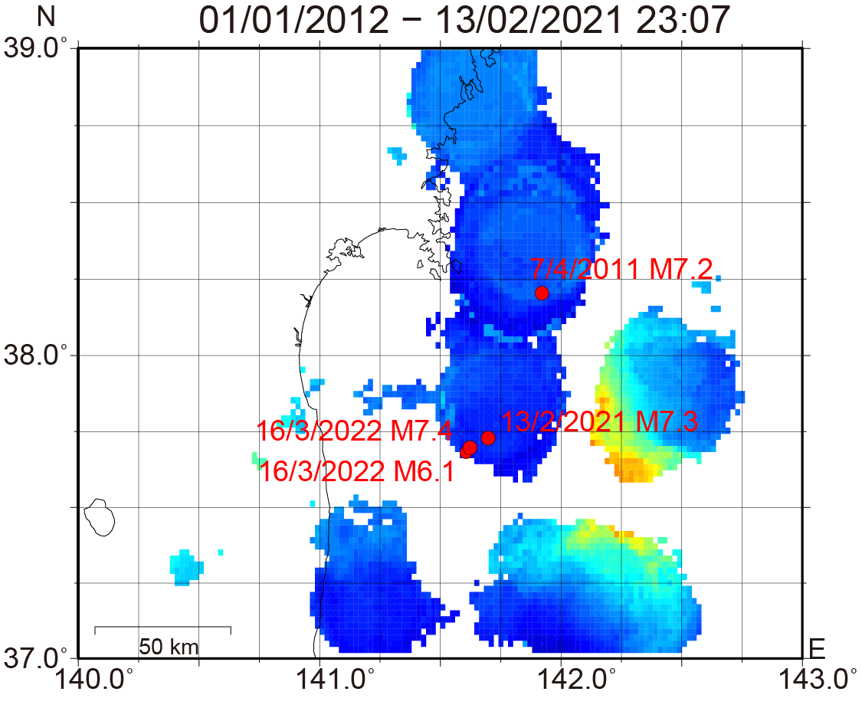

(b)
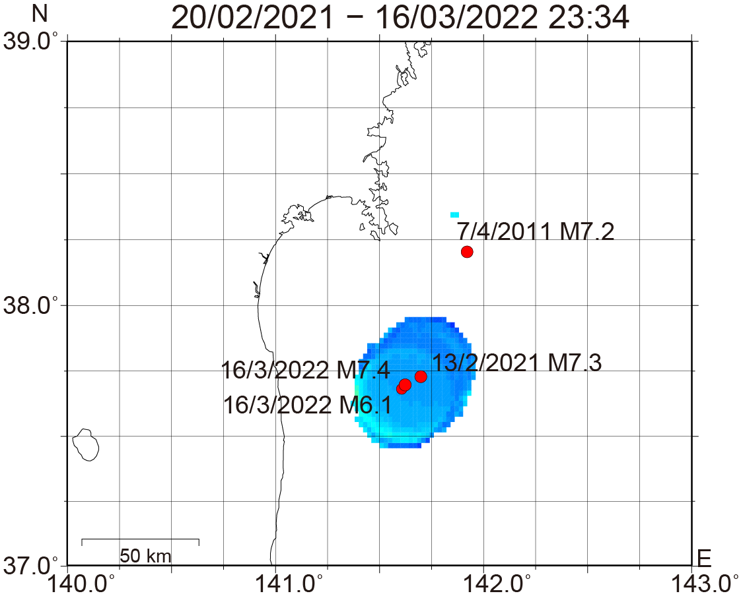

Figure. S2. Spatial $b$-value distributions for the $M ≥1.7$ events in the deeper section (10–20 km below the plate interface) for (a) period 1, (b) period 2, and (c) period 3. A grid with a 0.02° spacing was used for the $b$-value calculations. The sampling radius was determined to be 20 km for each analysis period. Red circles denote the major thrust-type events within the subducting slab in the study region.

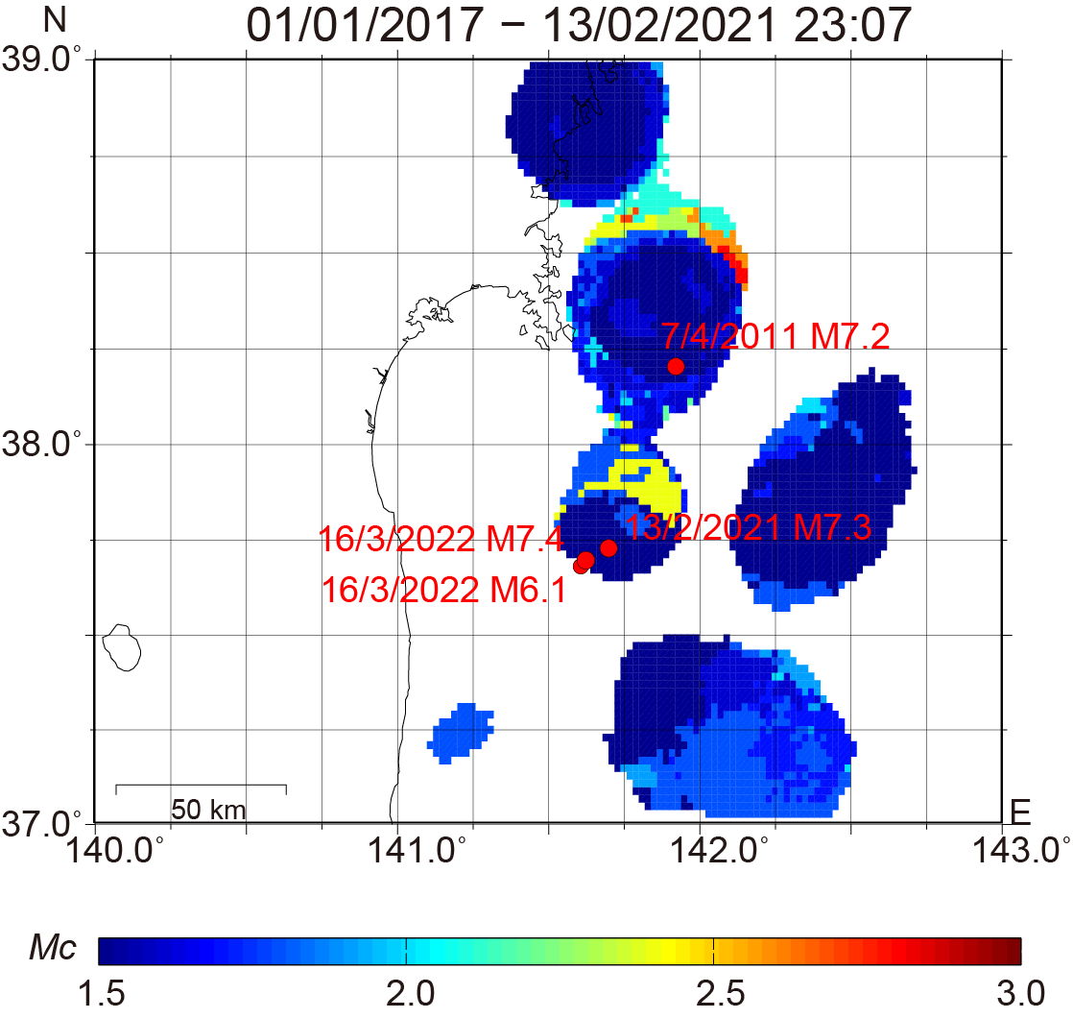
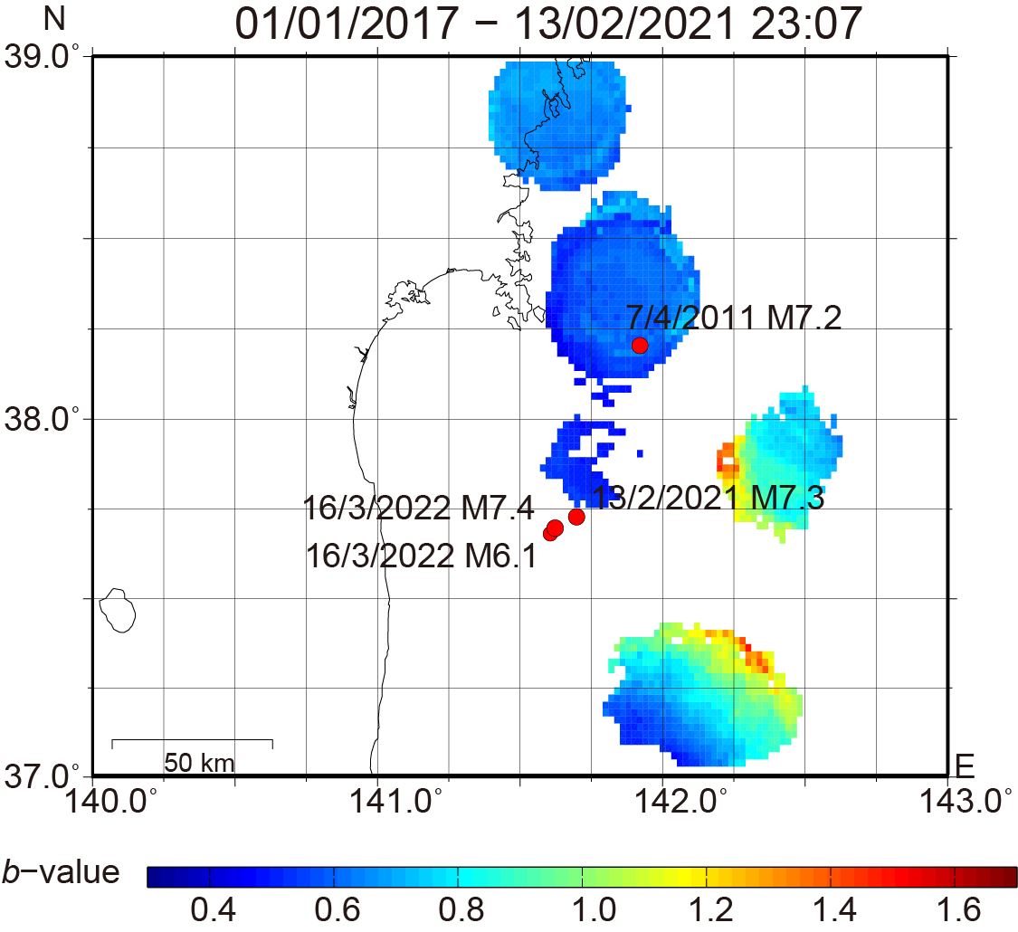
- (c)

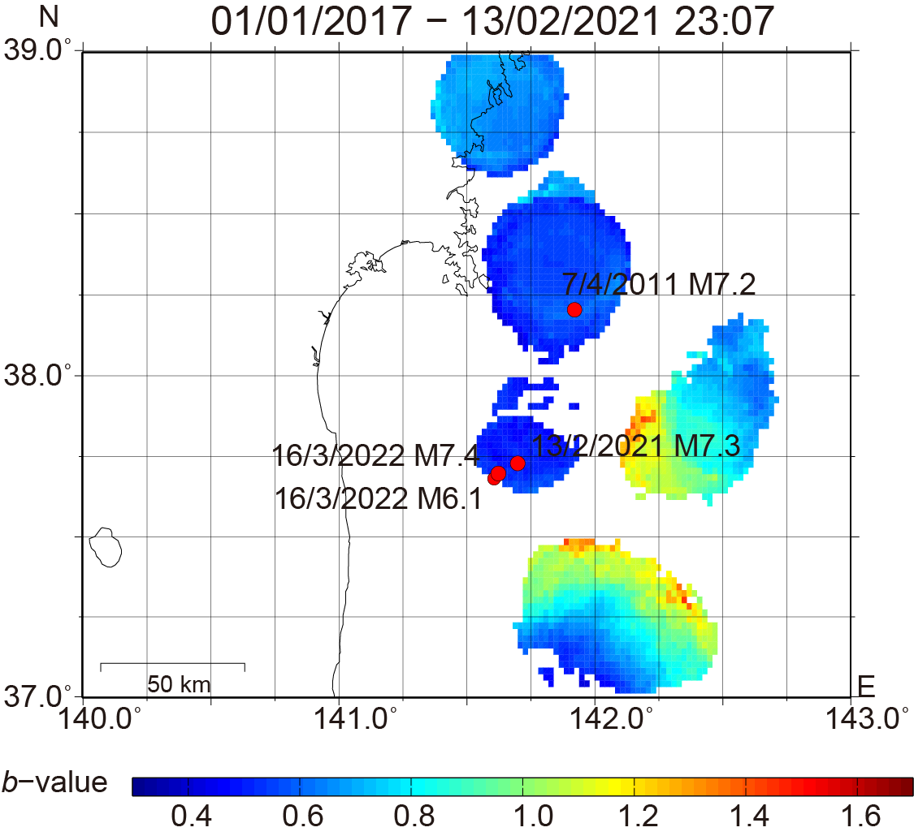
(b)

Figure. S3. Spatial $M_{c}$ (a) and $b$-value distributions for the (b) $M ≥1.5$ and (c) $M ≥1.7$events in the deeper section (10–20 km beneath the plate interface) from 00:00 JST on 1 January 2017 to immediately before the $M$7.3 event (23:07 JST) on 13 February 2021. A grid with a 0.02° spacing and a sampling radius of 20 km were used for the calculations. Red circles denote the major thrust-type events within the subducting slab in the study region.
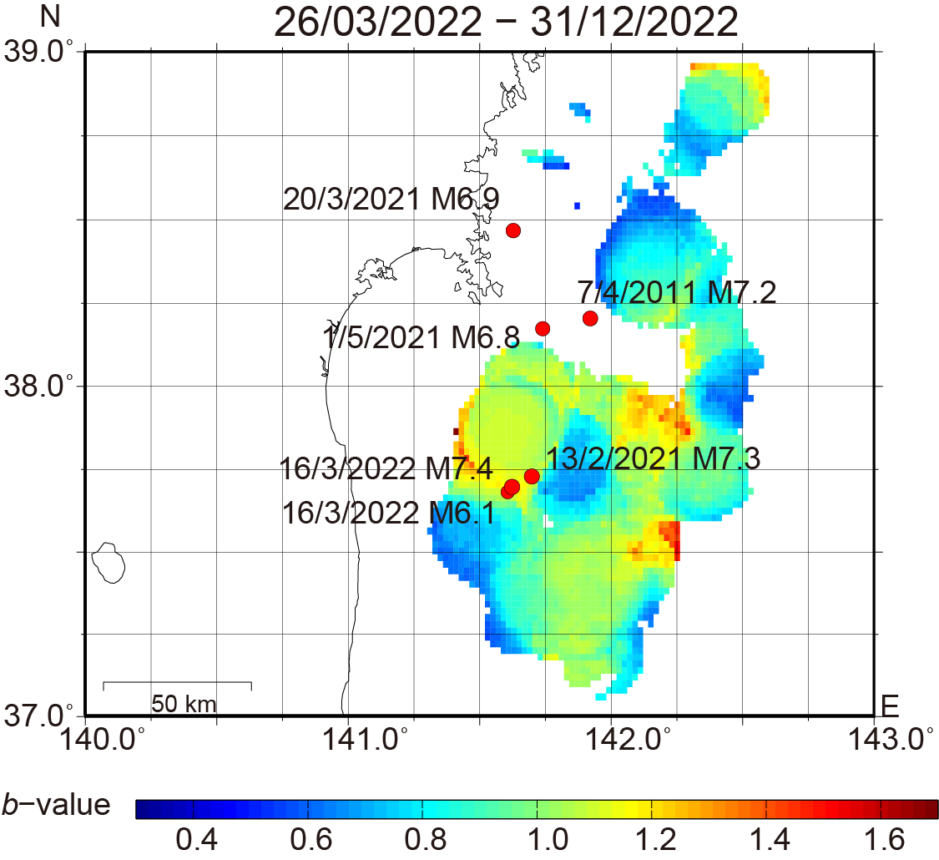
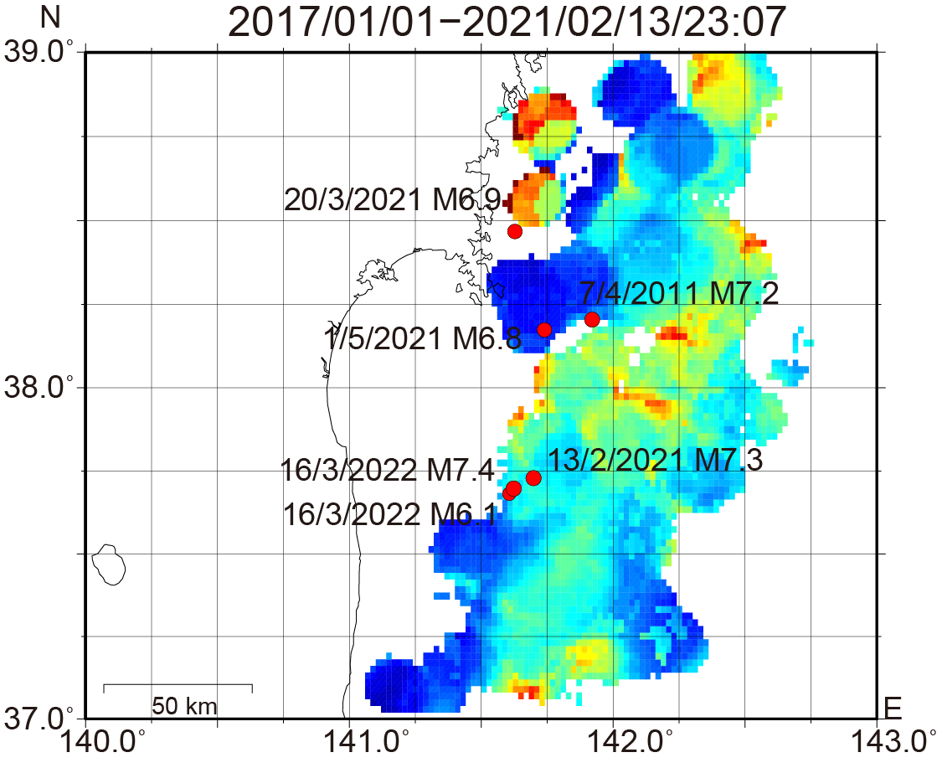
- (c)

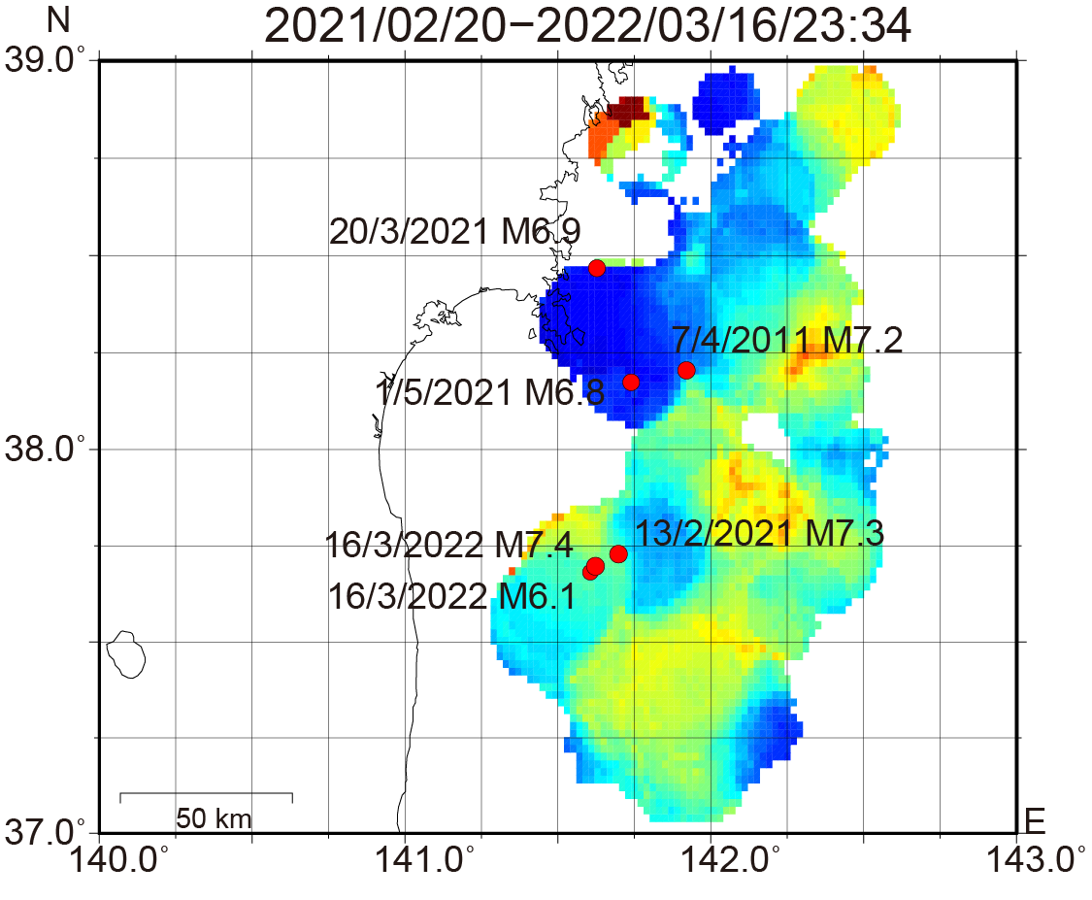
(b)

Figure. S4. Spatial $b$-value distributions for the $M ≥1.5$events in the shallower section (from 5 km above the plate interface to 6 km below it) for (a) period 1, (b) period 2, and (c) period 3. A grid with a 0.02° spacing was used for the $b$-value calculations. The sampling radii were determined to be 10, 15, and 15 km for (a), (b), and (c), respectively. Red circles denote the major thrust-type events on the plate interface and within the subducting slab in the study region.
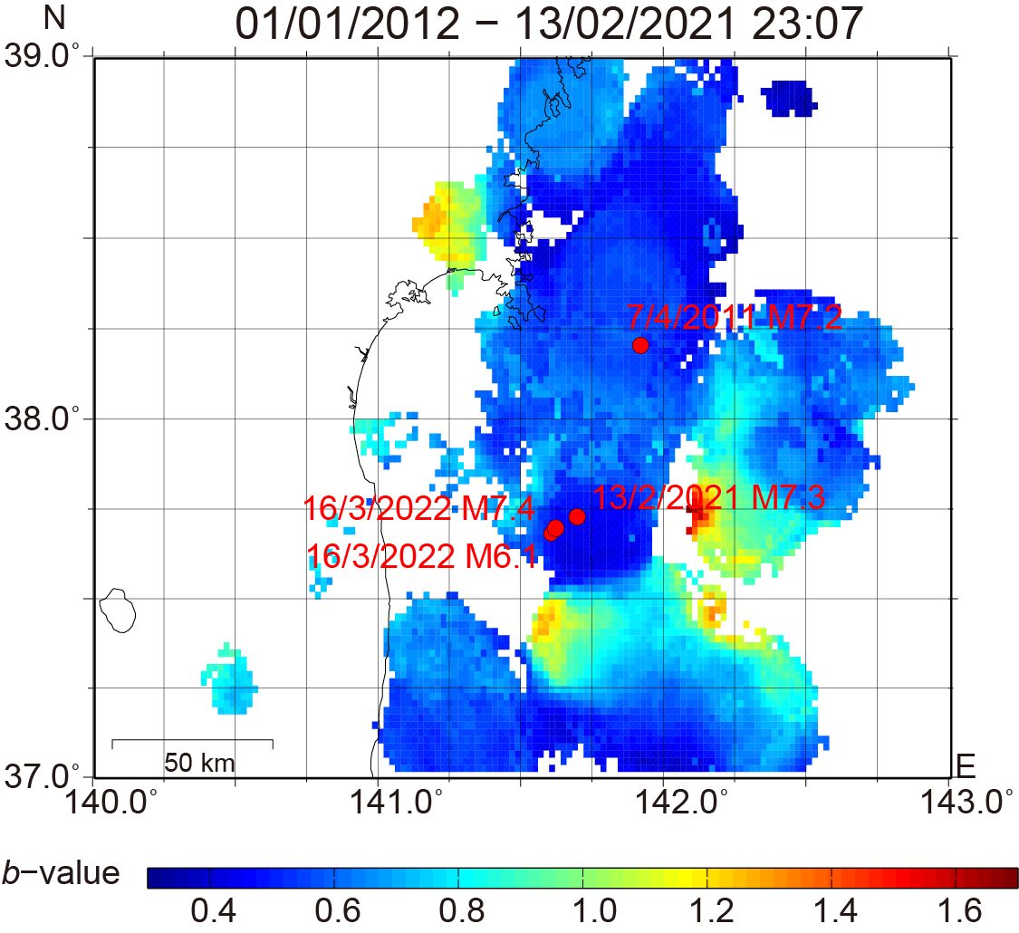
- (c)
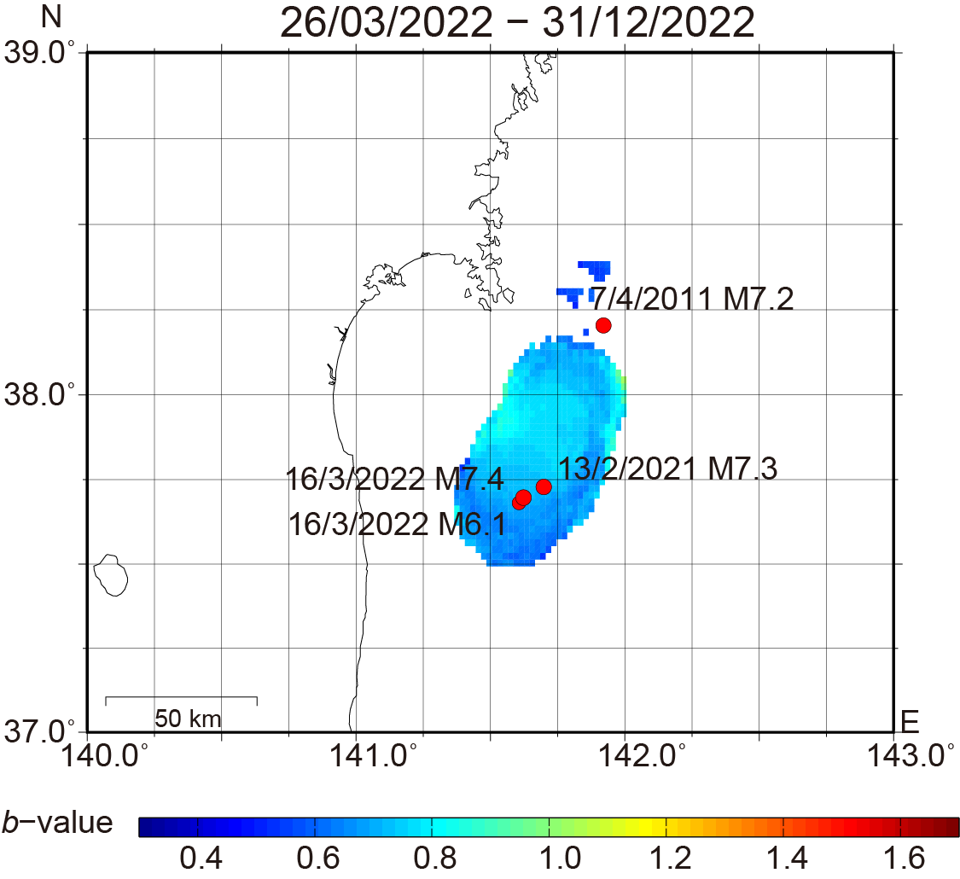

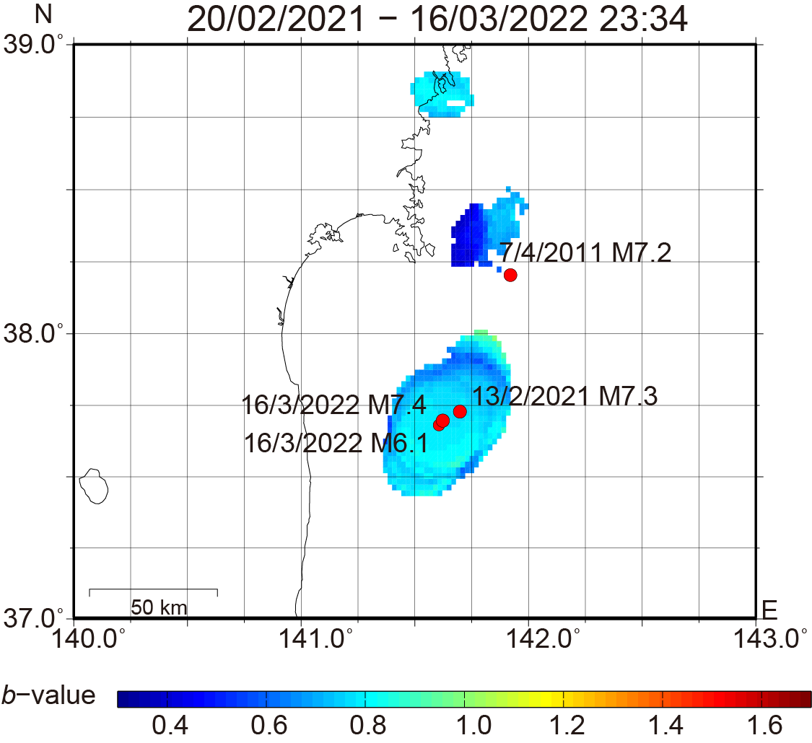
(b)

Figure. S5. Spatial $b$-value distributions for the $M ≥1.5$ events in the deeper section (6–20 km below the plate interface) for (a) period 1, (b) period 2, and (c) period 3. A grid with a 0.02° spacing was used for the $b$-value calculations. The sampling radius was determined to be 15 km for (a)–(c). Red circles denote the major thrust-type events within the subducting slab in the study region.

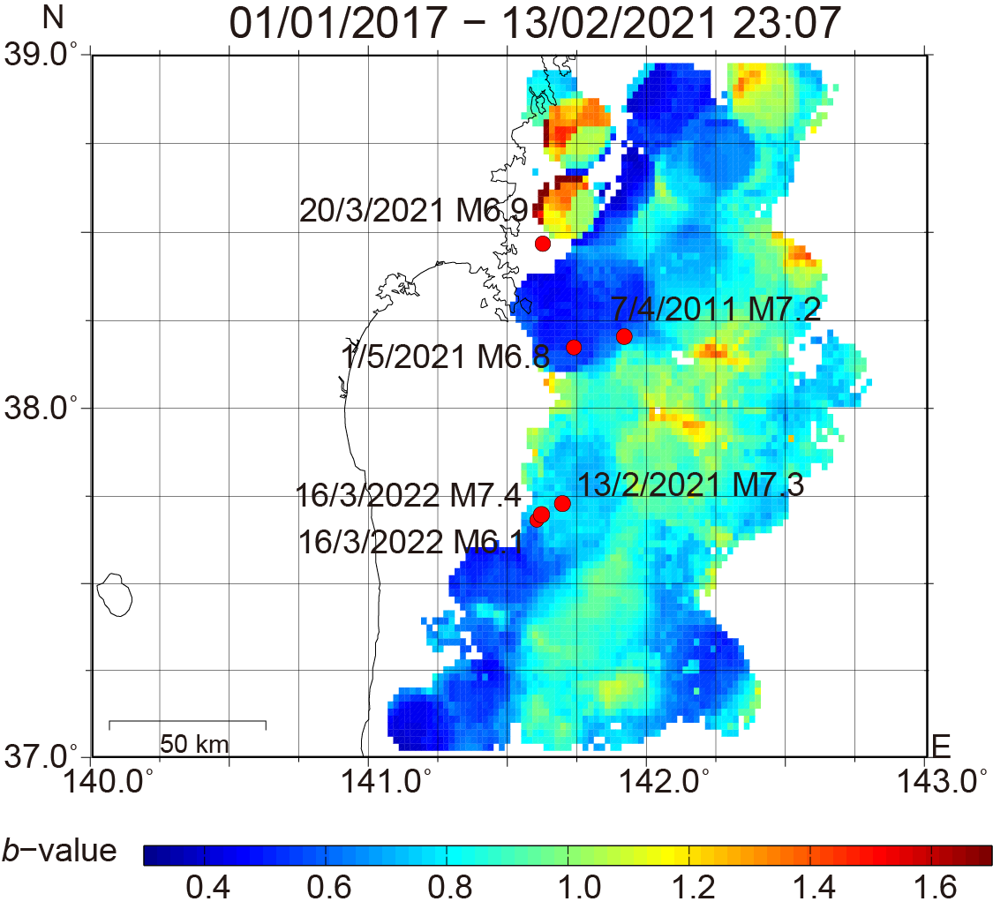
- (c)
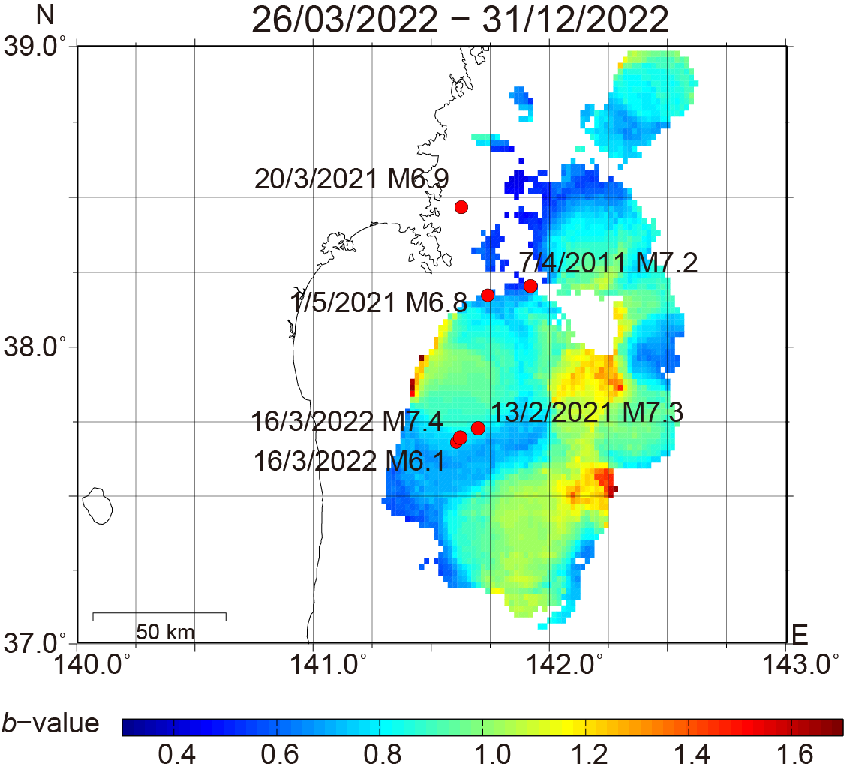

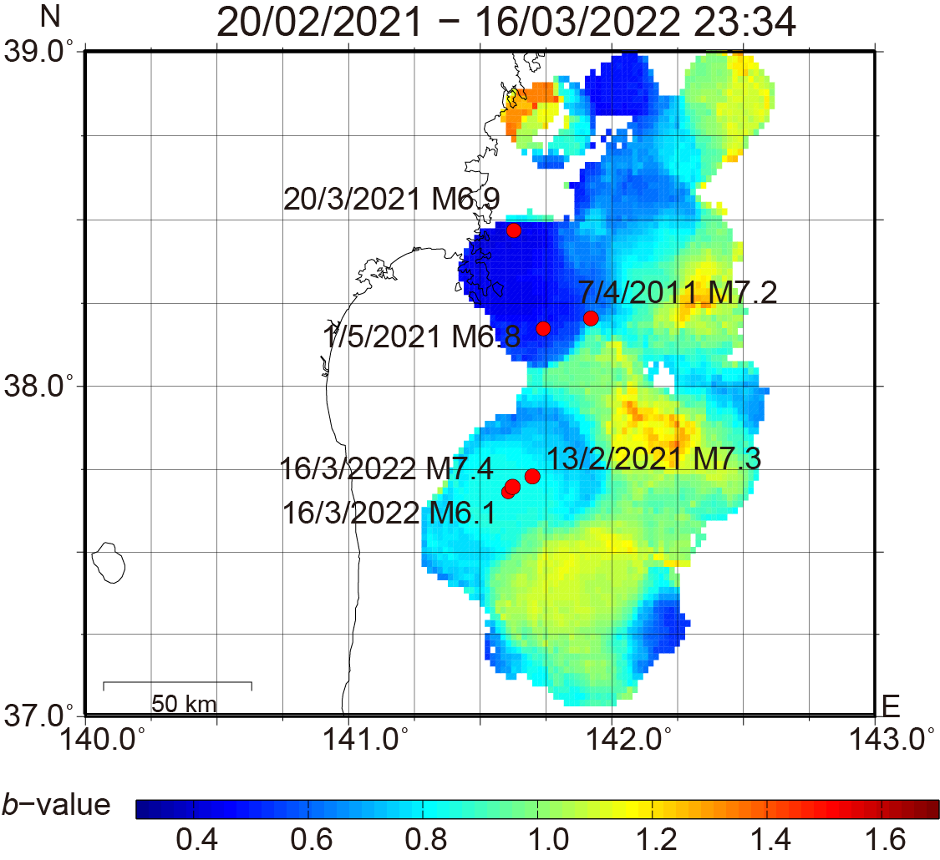
(b)

Figure. S6. Spatial $b$-value distributions for the $M ≥1.5$ events in the shallower section (from 5 km above the plate interface to 12 km below it) for (a) period 1, (b) period 2, and (c) period 3. A grid with a 0.02° spacing was used for the $b$-value calculations. The sampling radii were determined to be 10, 15, and 15 km for (a), (b), and (c), respectively. Red circles denote the major thrust-type events on the plate interface and within the subducting slab in the study region.

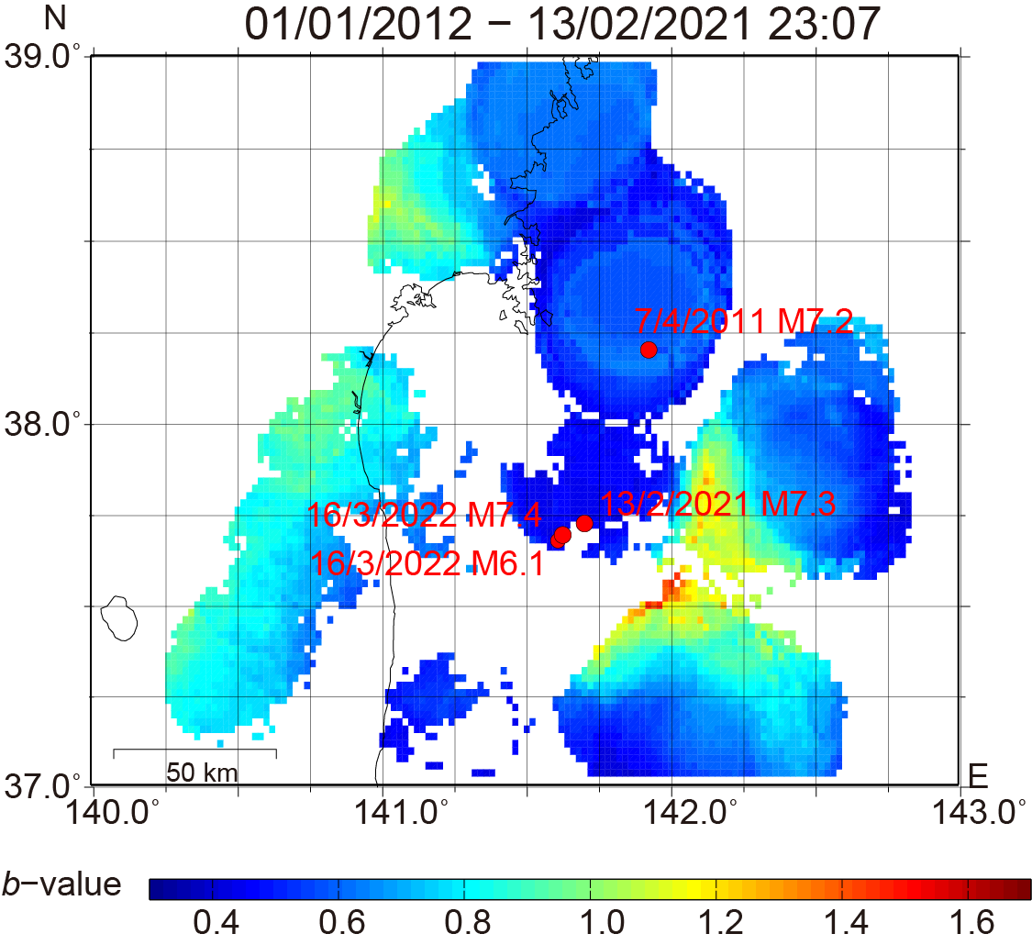
- (c)
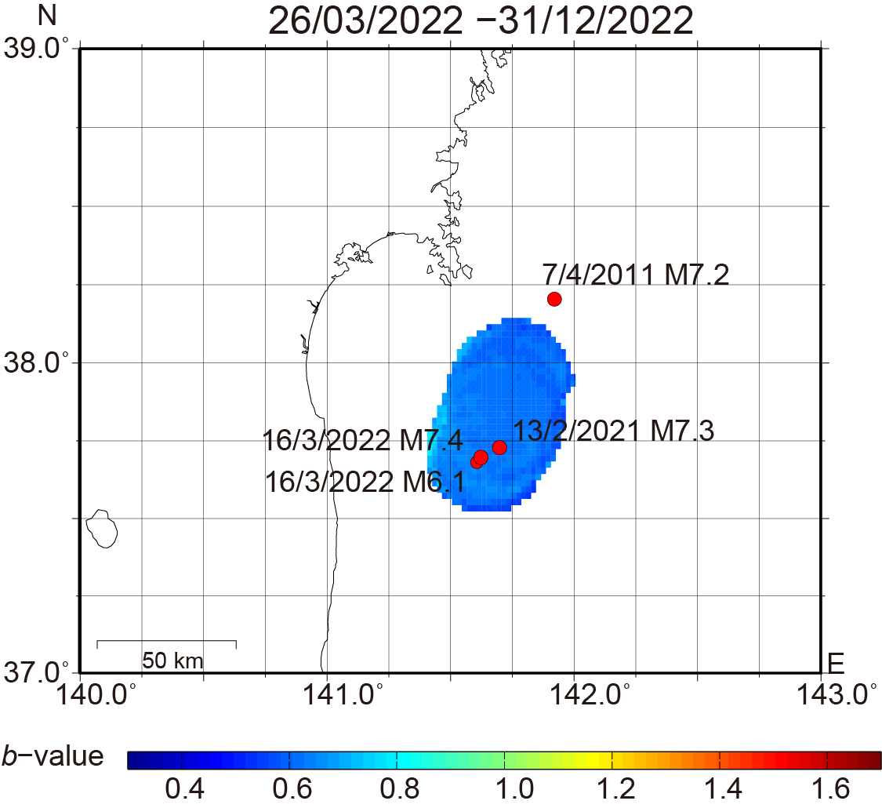

(b)
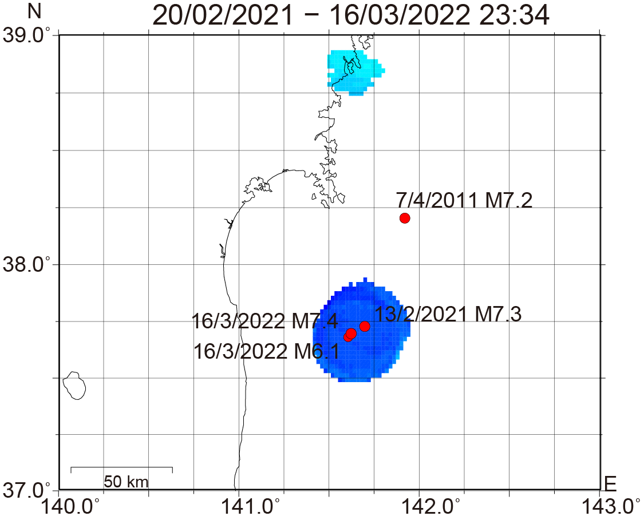

Figure. S7. Spatial $b$-value distributions for the $M ≥1.5$ events in the deeper section (12–20 km below the plate interface) for (a) period 1, (b) period 2, and (c) period 3. A grid with a 0.02° spacing was used for the $b$-value calculations. The sampling radii were determined to be 25, 20, and 20 km for (a), (b), and (c), respectively. Red circles denote the major thrust-type events within the subducting slab in the study region.

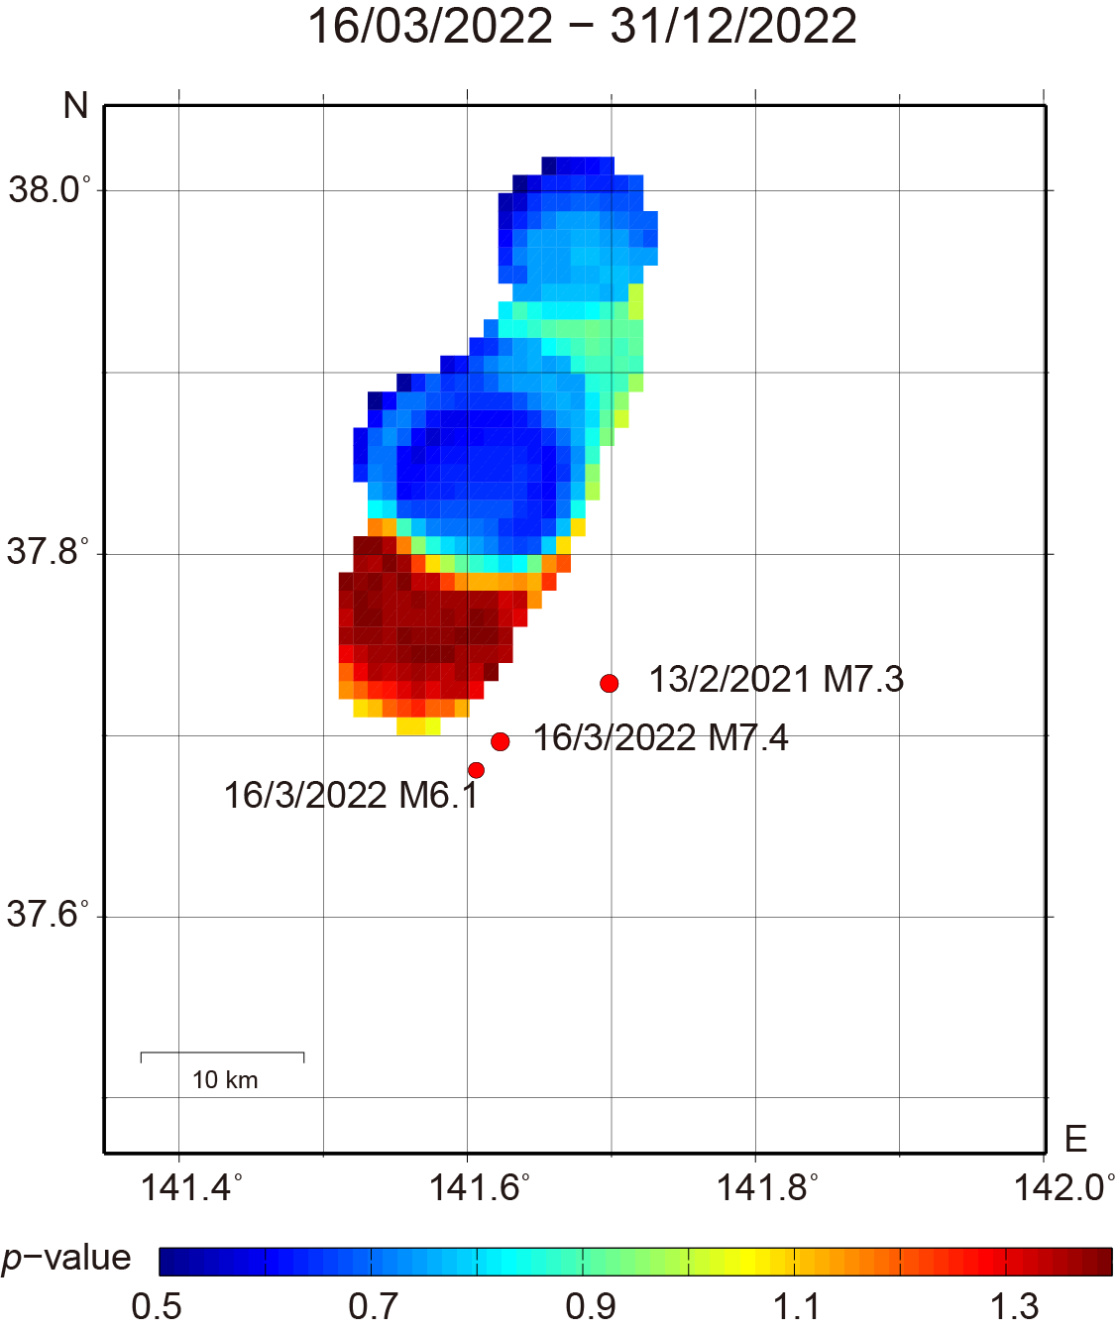
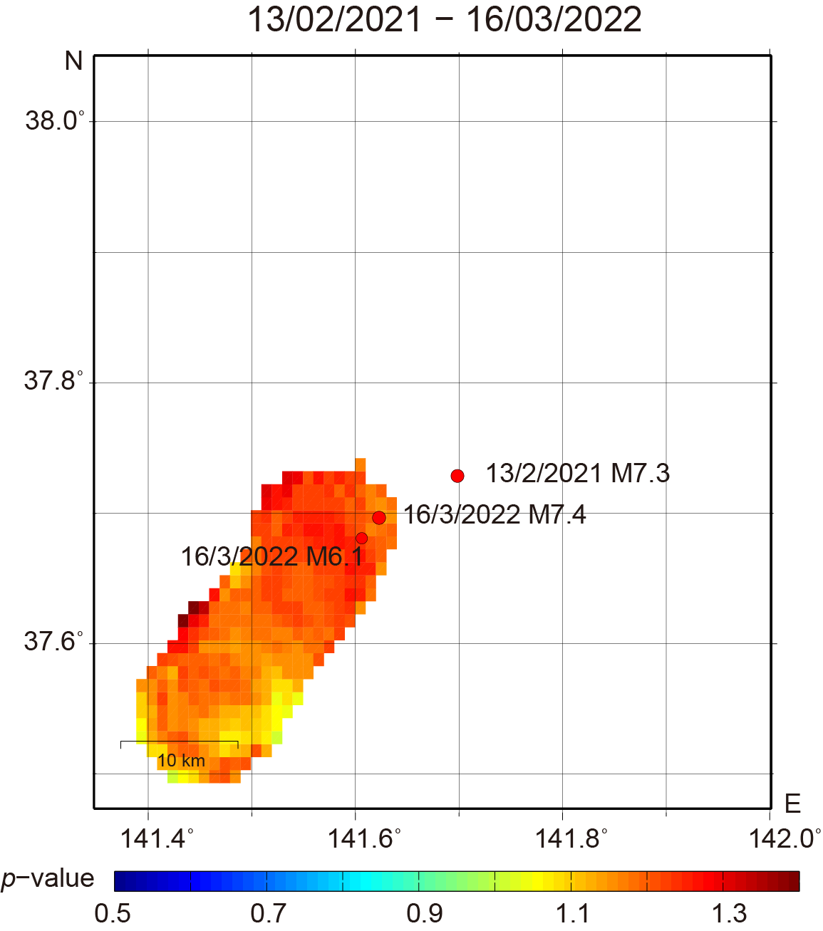
(a) (c)

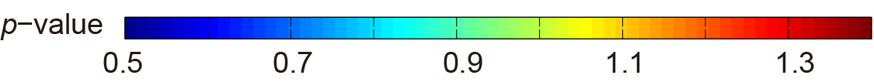
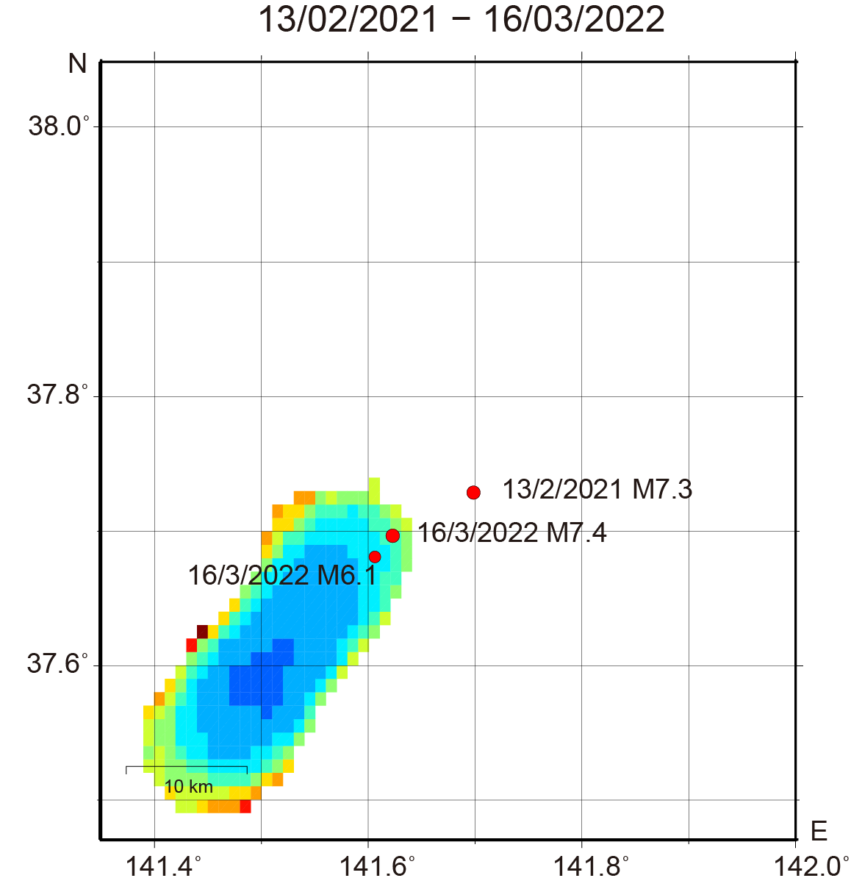
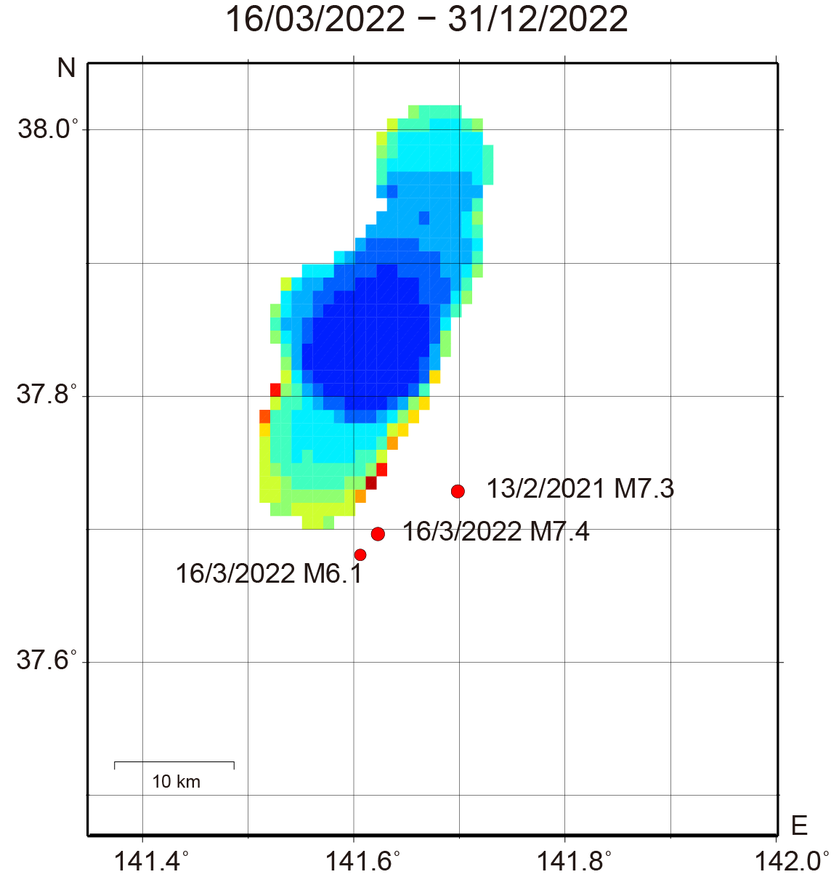
(b) (d)

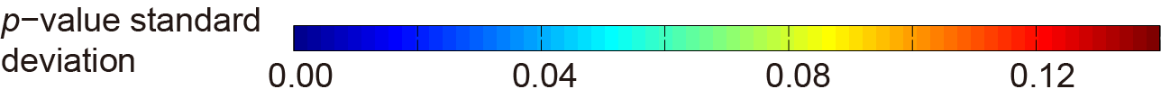
Figure. S8. Spatial $p$-value distributions in the shallower section (from 5 km above the plate interface to 6 km below it) for (a) period 2 and (c) period 3, with their associated standard deviations shown in (b) and (d), respectively. A grid with a 0.01° spacing was used for the $p$-value calculations. The sampling radius was determined to be 5 km for (a) and (c). Red circles denote the major thrust-type events within the subducting slab in the study region.

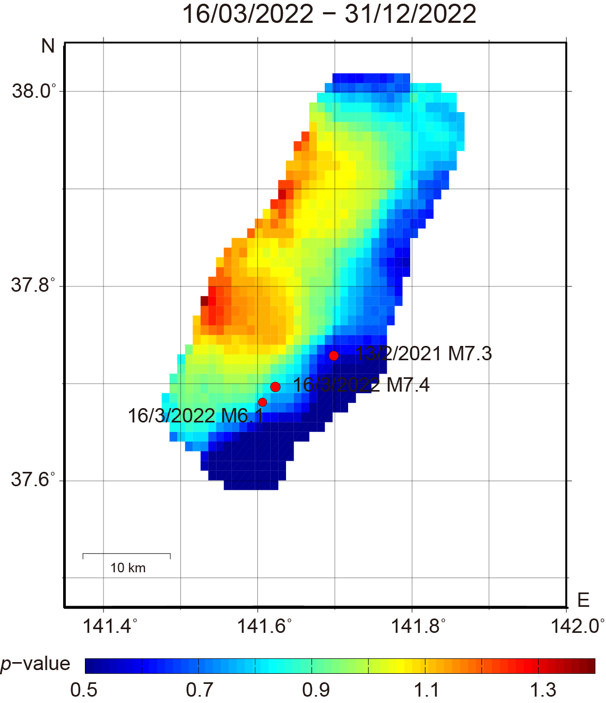
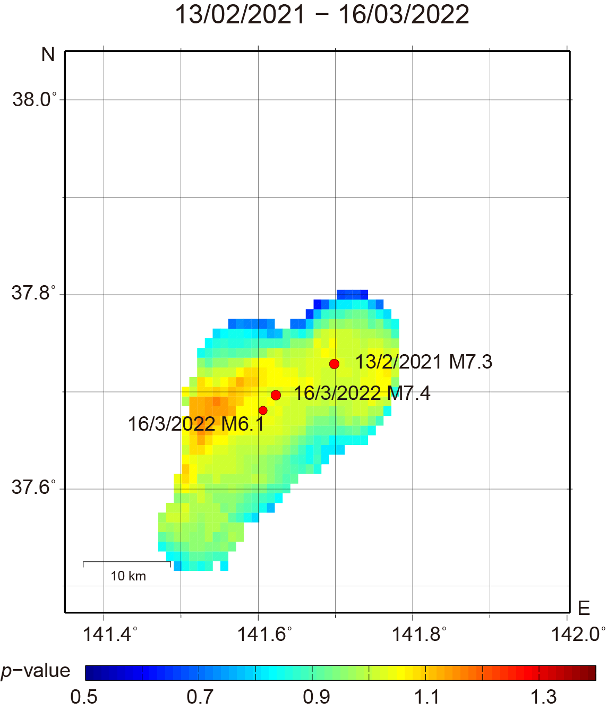
(a) (c)

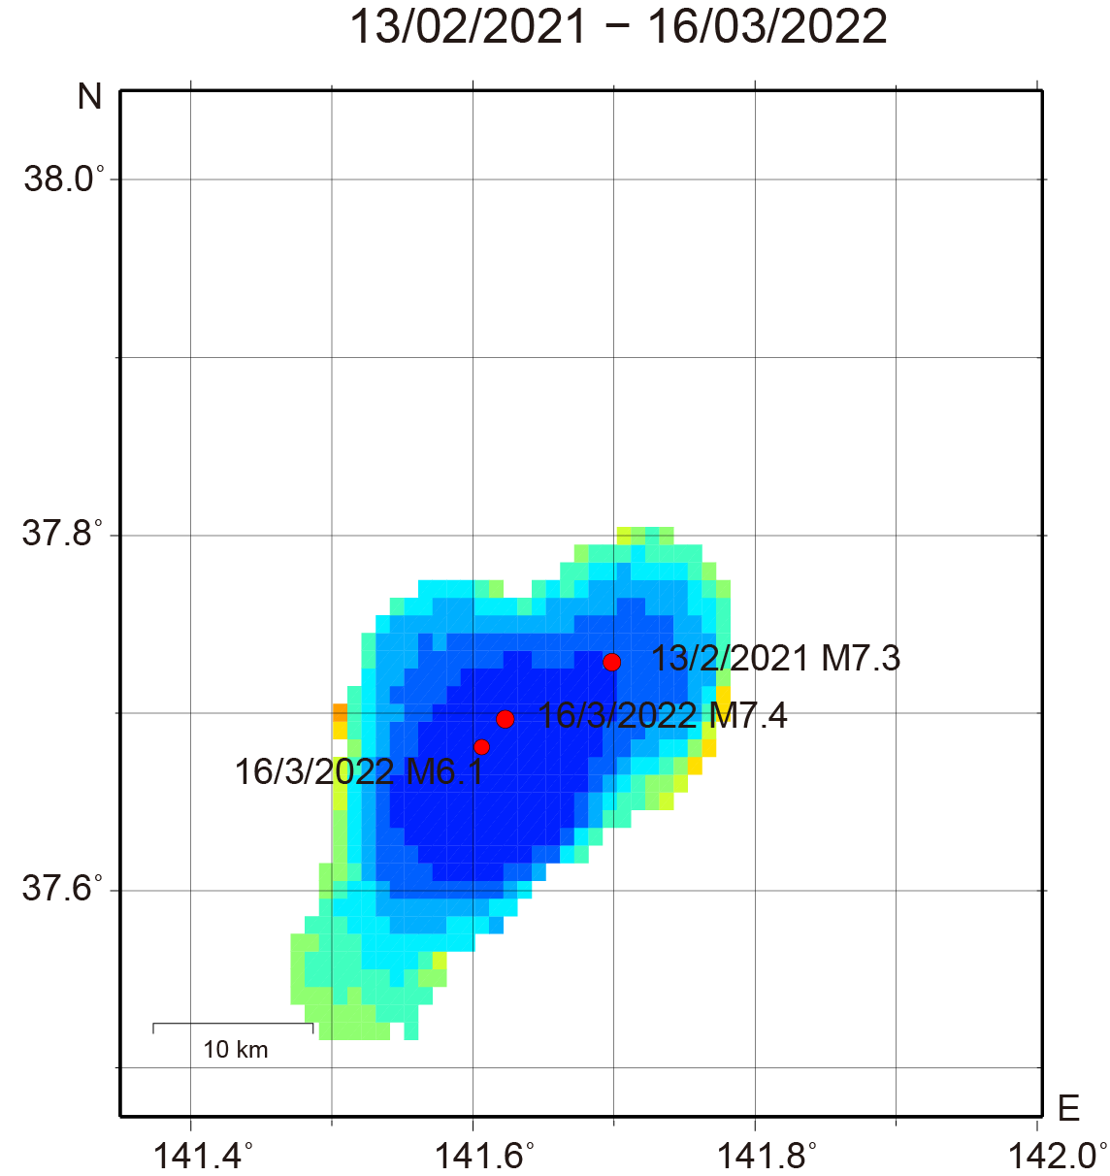
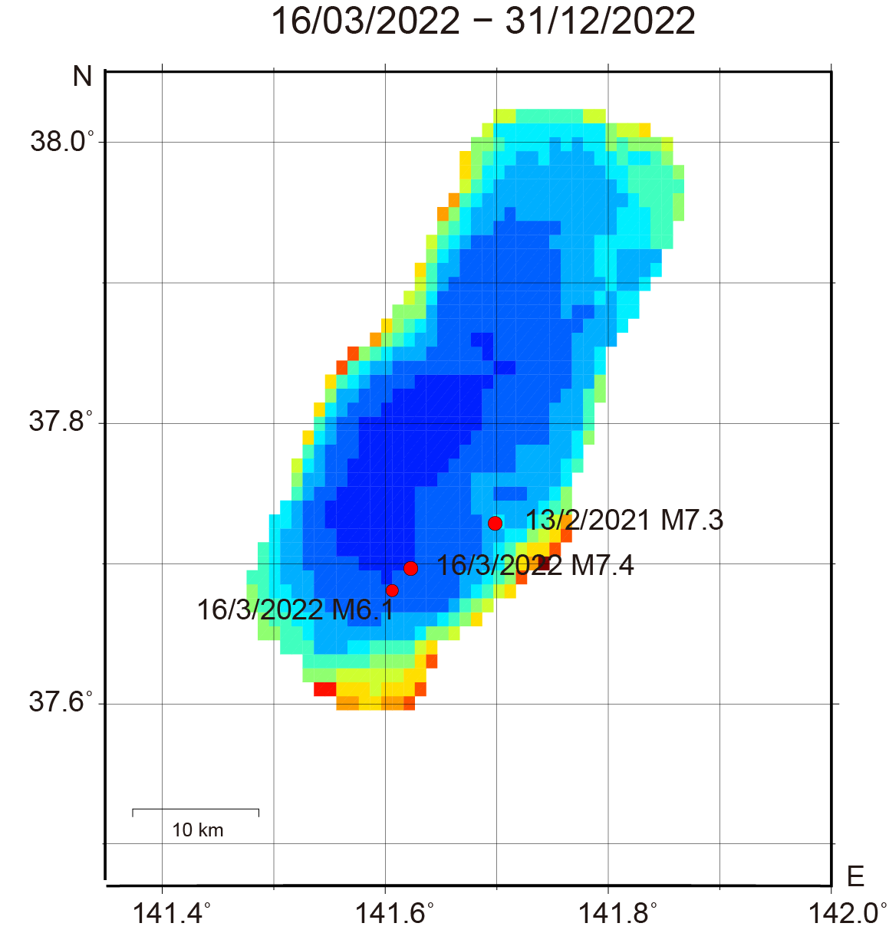
(b) (d)

Figure. S9. Spatial $p$-value distributions in the deeper section (6–20 km below the plate interface) for (a) period 2 and (c) period 3, with their associated standard deviations shown in (b) and (d), respectively. A grid with a 0.01° spacing was used for the $p$-value calculations. The sampling radius was determined to be 5 km for (a) and (c). Red circles denote the major thrust-type events within the subducting slab in the study region.

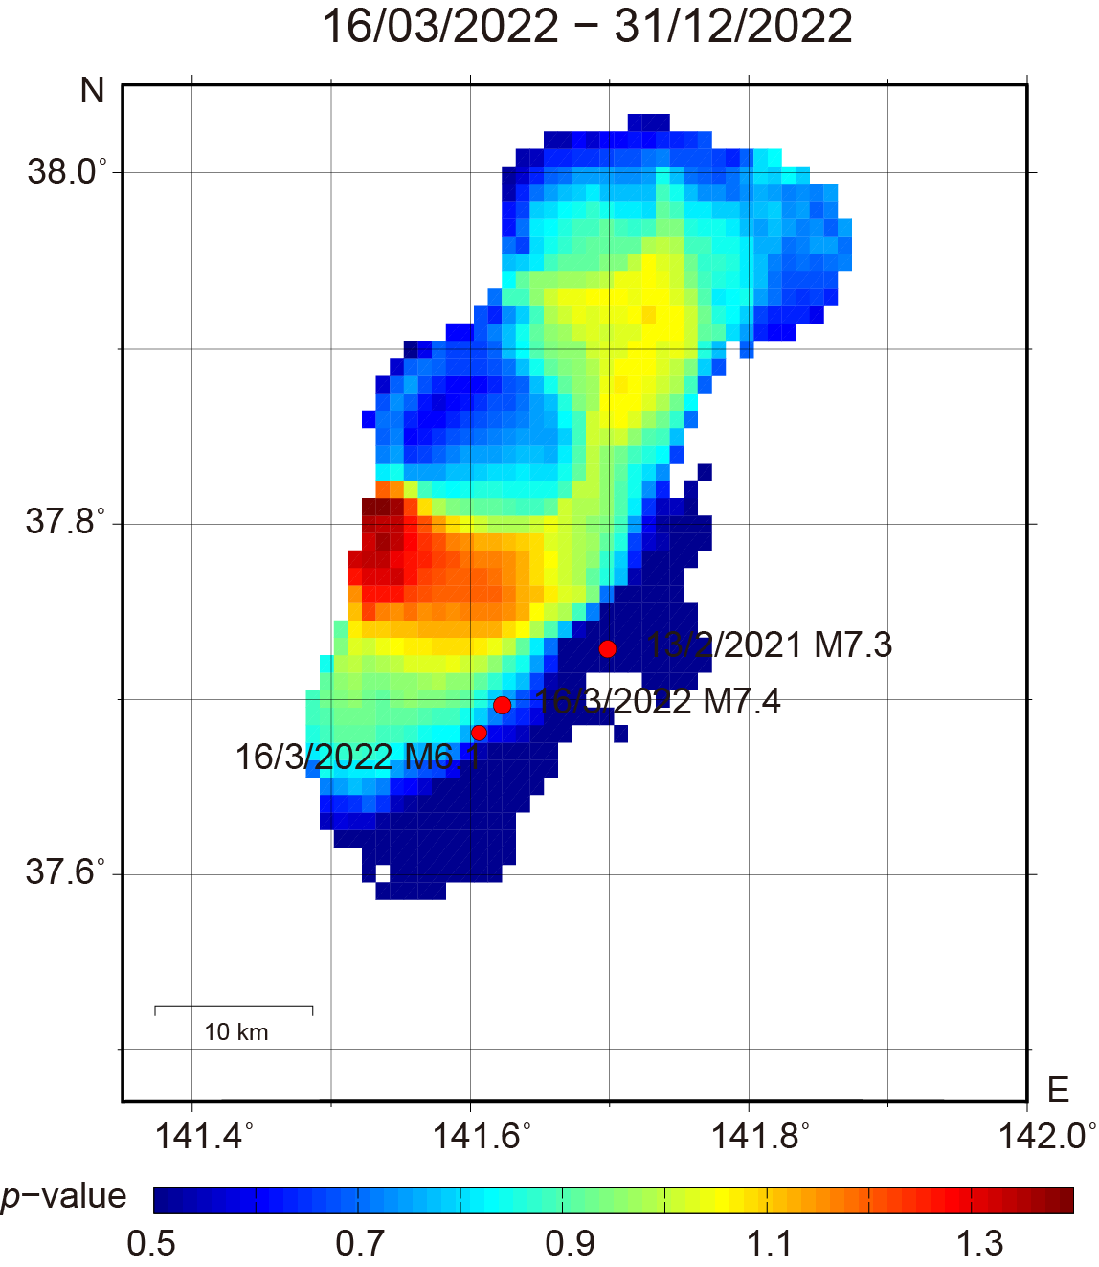
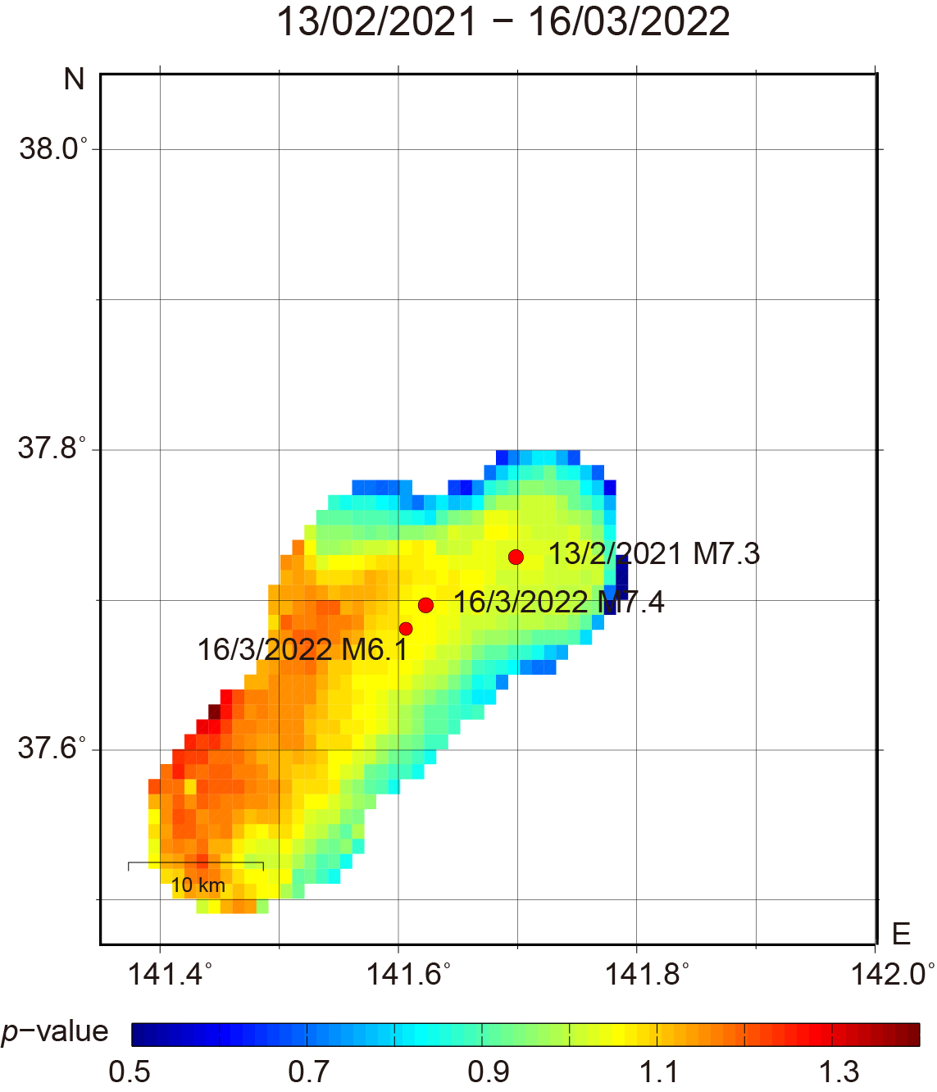
- (c)

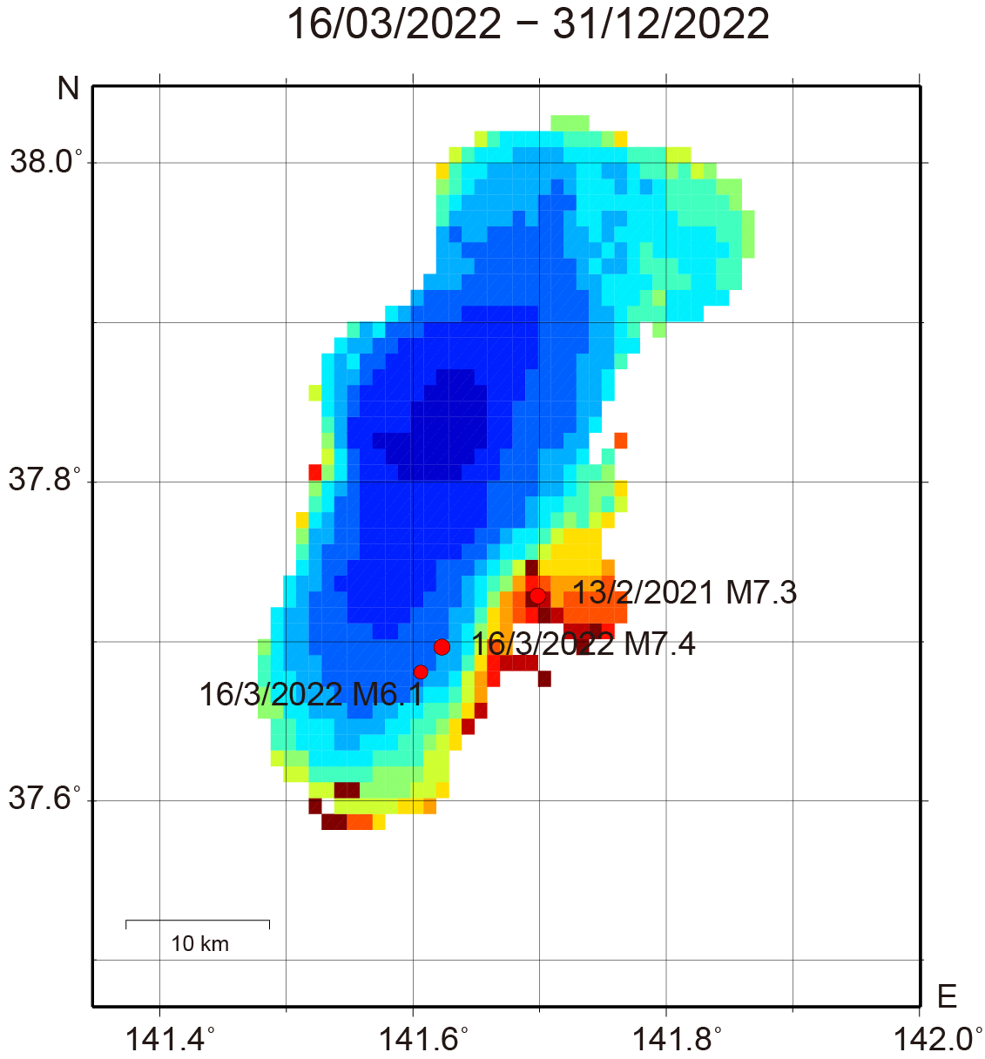
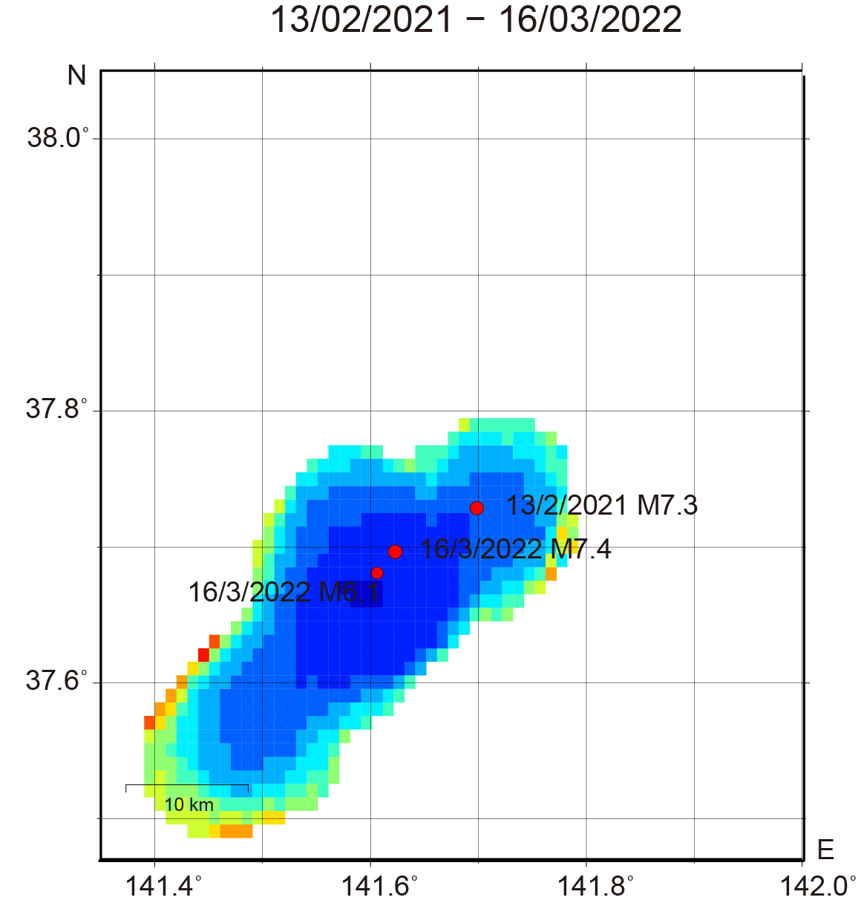
(b) (d)

Figure. S10. Spatial $p$-value distributions in the shallower section (from 5 km above the plate interface to 12 km below it) for (a) period 2 and (c) period 3, with their associated standard deviations shown in (b) and (d), respectively. A grid with a 0.01° spacing was used for the $p$-value calculations. The sampling radius was determined to be 5 km for (a) and (c). Red circles denote the major thrust-type events within the subducting slab in the study region.
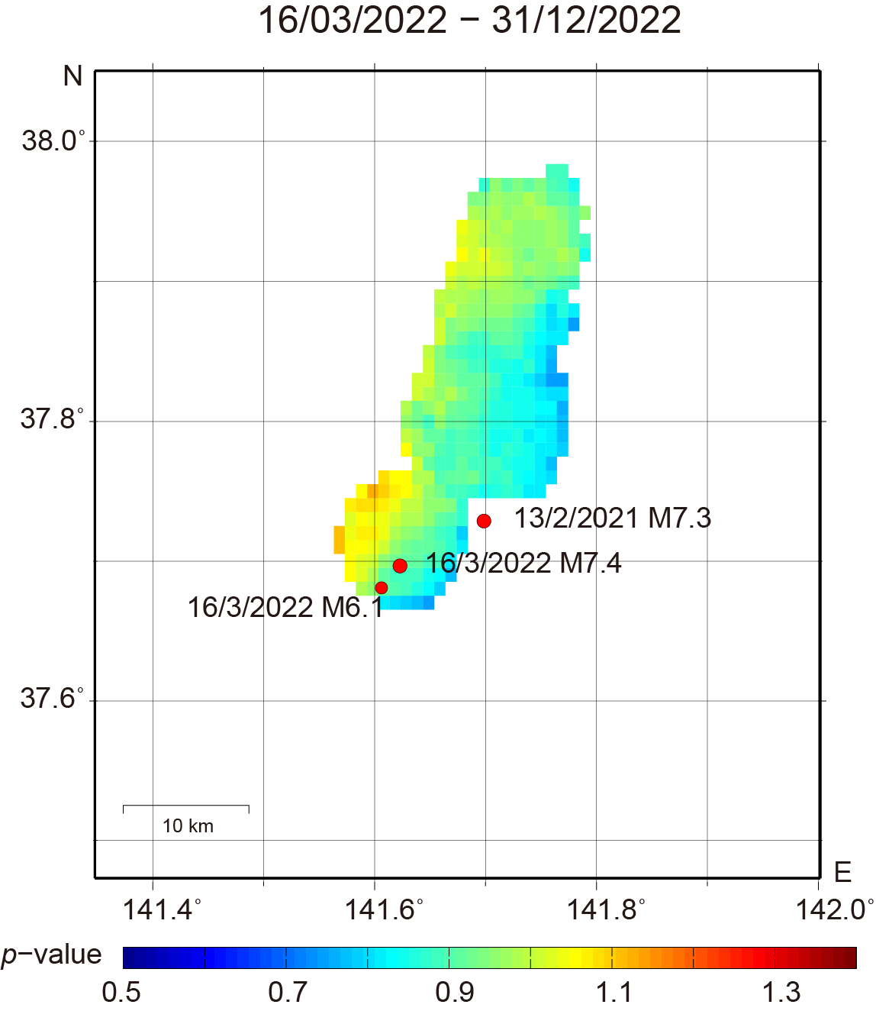
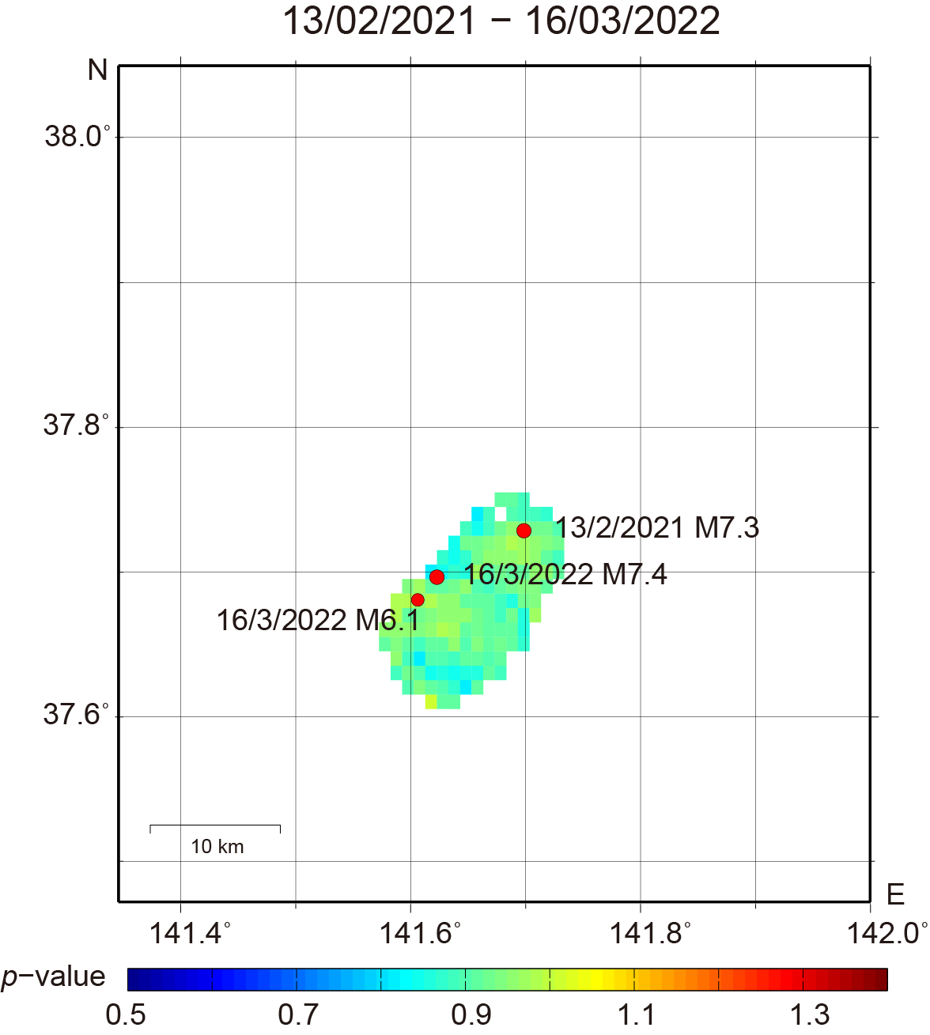
- (c)

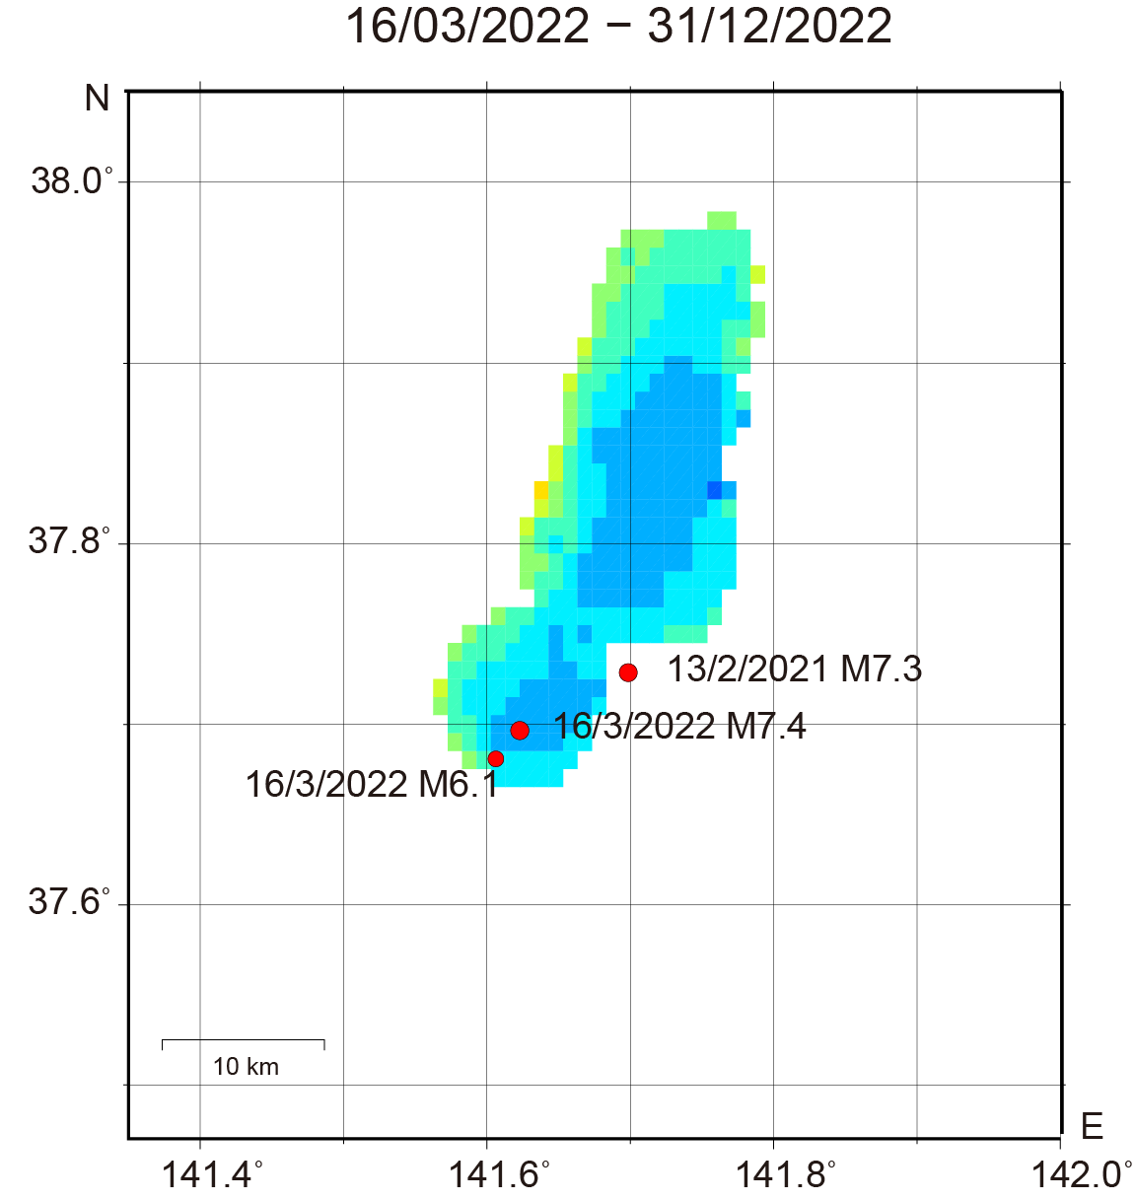
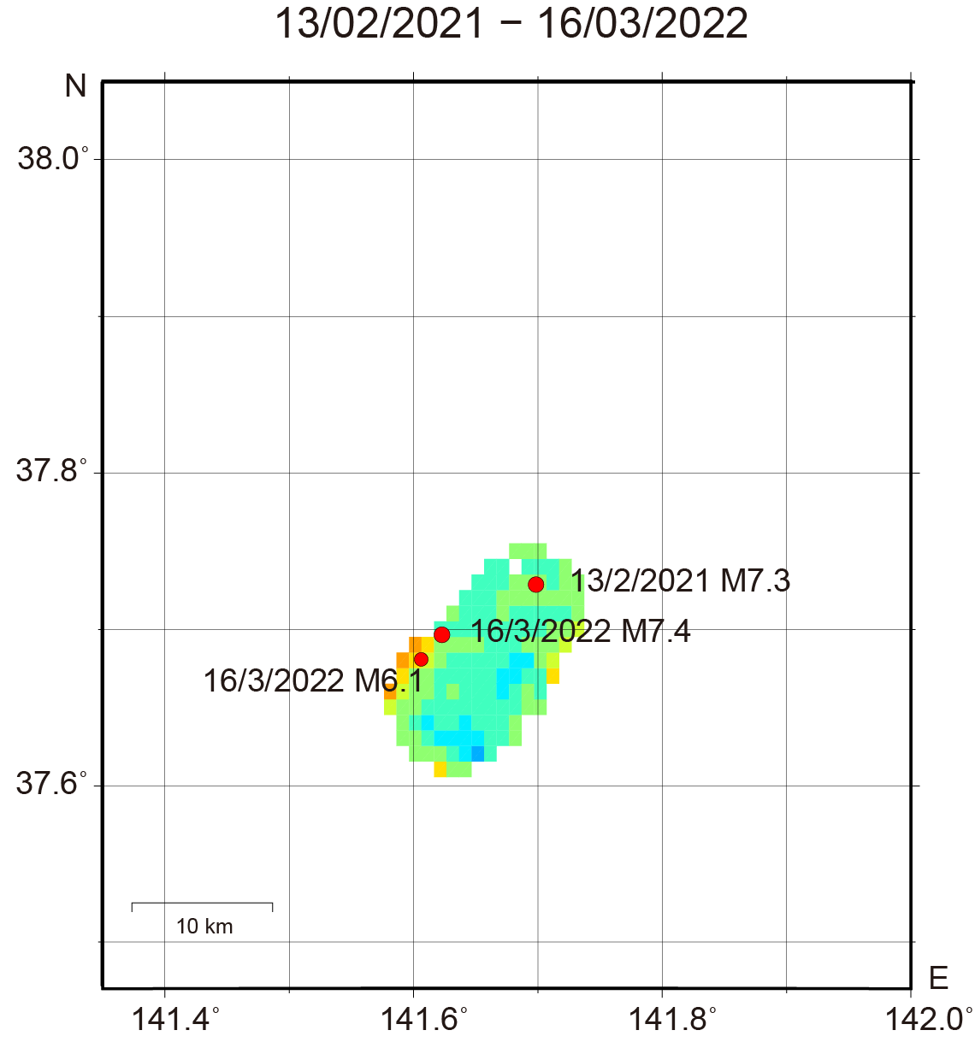
(b) (d)

Figure. S11. Spatial $p$-value distributions in the deeper section (12–20 km below the plate interface) for (a) period 2 and (c) period 3, with their associated standard deviations shown in (b) and (d), respectively. A grid with a 0.01° spacing was used for the $p$-value calculations. The sampling radius was determined to be 5 km for (a) and (c). Red circles denote the major thrust-type events within the subducting slab in the study region.

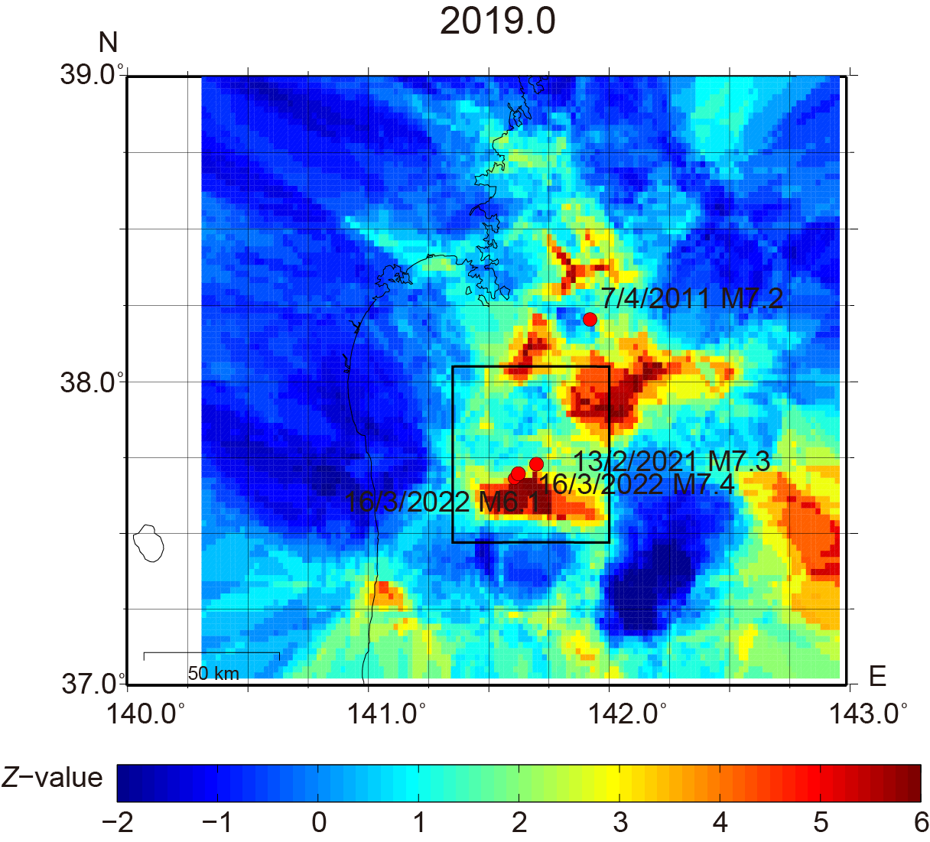
(a)

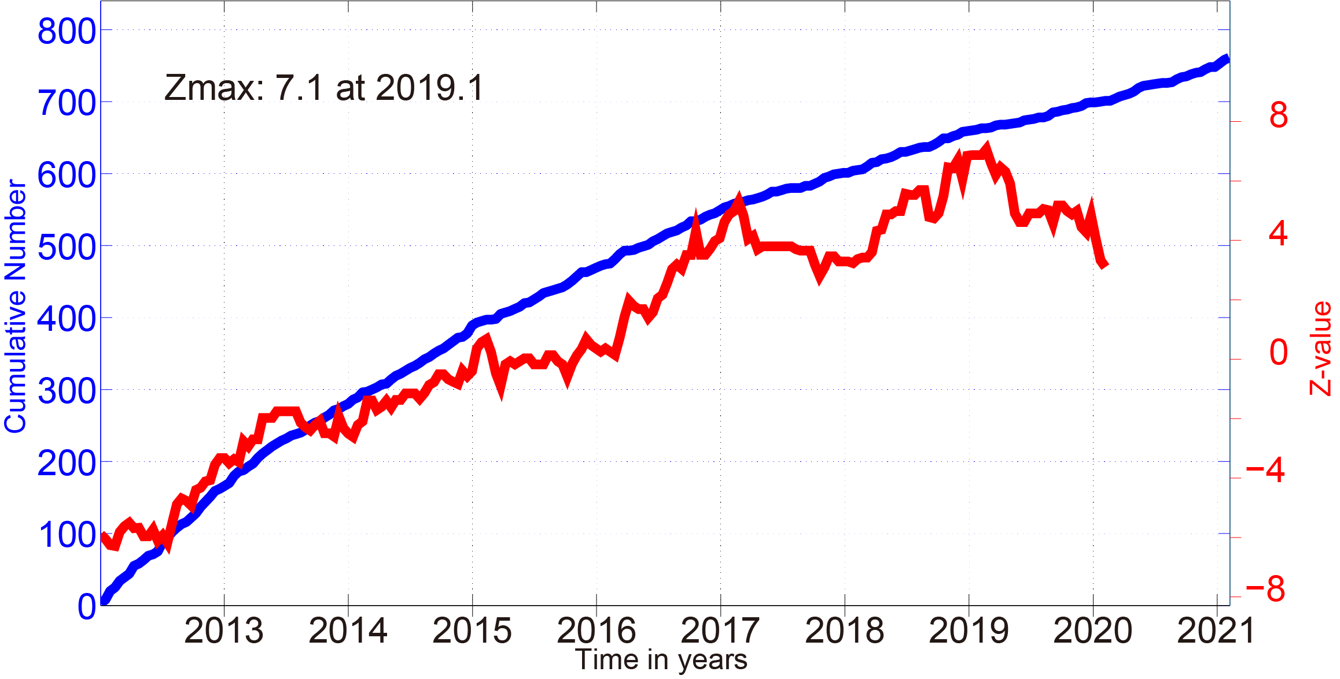
(b)

Figure. S12. (a) Spatial $Z$-value distribution in the deeper section (6–20 km below the plate interface) at 2019.0 after applying the declustering method. The black rectangle represents the region where the temporal $Z$-value variations are investigated in (b). Only $M$ ≥ 2.0 events were used for the $Z$-value analysis. A grid with a 0.02° spacing was used for the $Z$-value calculations. One hundred events were sampled within a sphere that was centered at each node, whereby the radius length was increased until 100 events were within the sphere. Red circles denote the major thrust-type events within the subducting slab in the study region. (b) Temporal $Z$-value variations (red line) and cumulative number of events (blue line) in the black rectangle in (a).

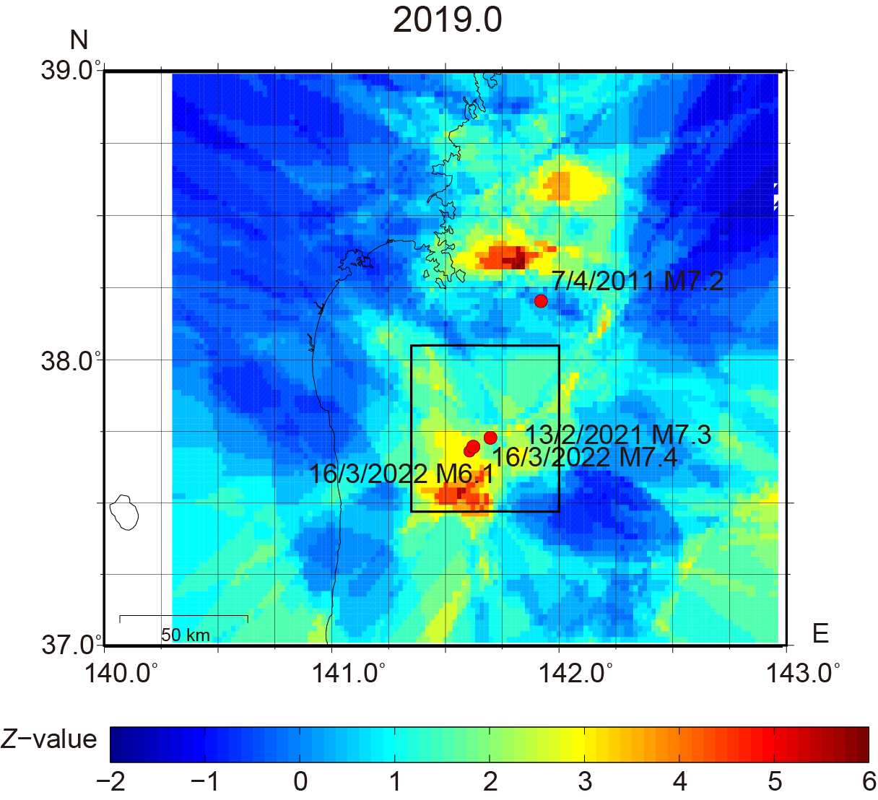
(a)

(b)
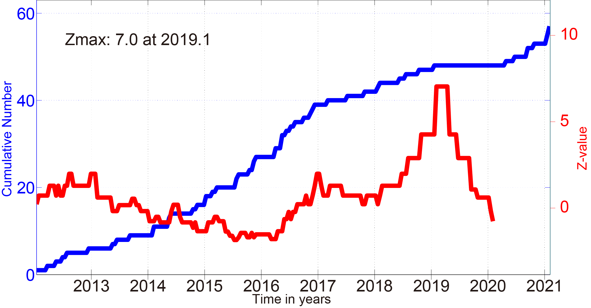

Figure. S13. (a) Spatial $Z$-value distribution in the deeper section (12–20 km below the plate interface) at 2019.0 after applying the declustering method. The black rectangle represents the region where the temporal $Z$-value variations are investigated in (b). Only $M$ ≥ 2.0 events were used for the $Z$-value analysis. A grid with a 0.02° spacing was used for the $Z$-value calculations. One hundred events were sampled within a sphere that was centered at each node, whereby the radius length was increased until 100 events were within the sphere. Red circles denote the major thrust-type events within the subducting slab in the study region. (b) Temporal $Z$-value variations (red line) and cumulative number of events (blue line) in the black rectangle in (a).

