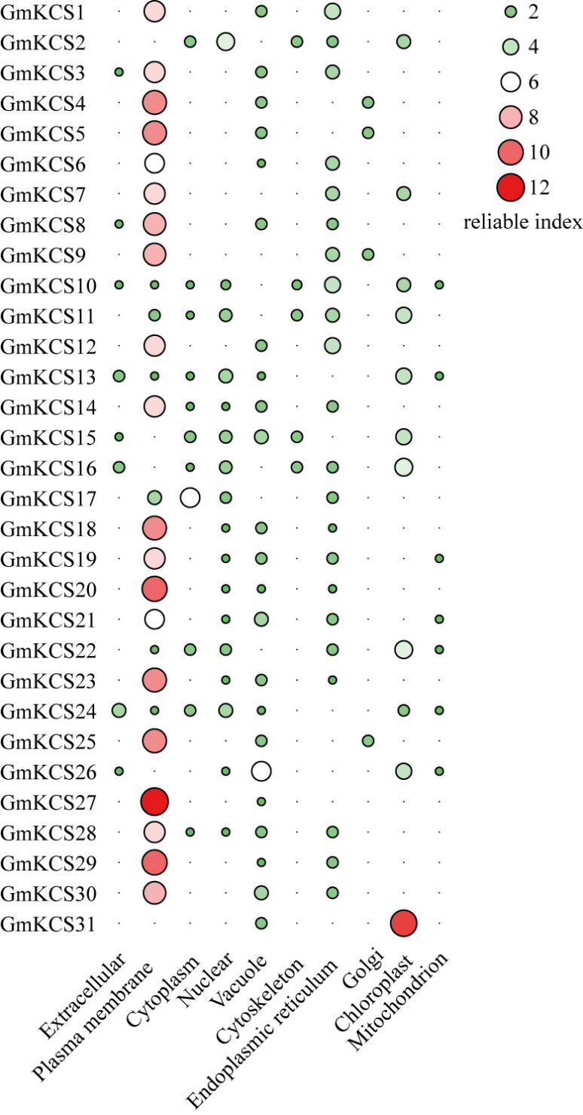
Fig. S1 The subcellular localization prediction for GmKCS proteins. The color and the size of the circles indicate the reliability of the prediction results. The name of each protein is shown on the left. The site name for the predicted subcellular localization of each GmKCS protein is shown at the bottom.

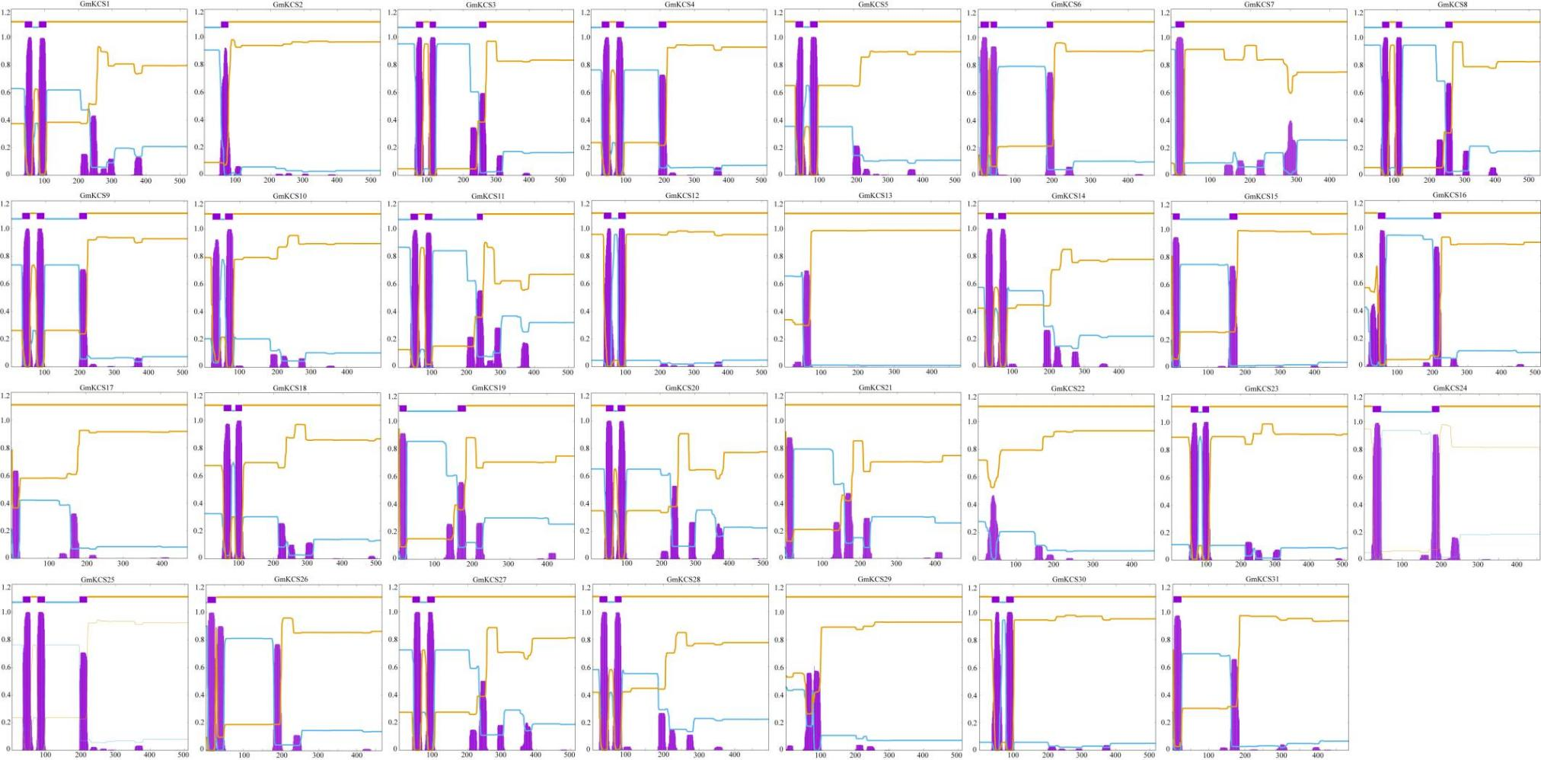
Fig. S2 Transmembrane alpha helix structure of GmKCS proteins. The red rectangles represent the transmembrane alpha helixes, the blue thickened lines represent the amino acids in this segment that are located inside the membrane, the pink thickened lines represent the amino acids in this segment that are located outside the membrane, the scale on the left side indicates the probability of correct prediction.
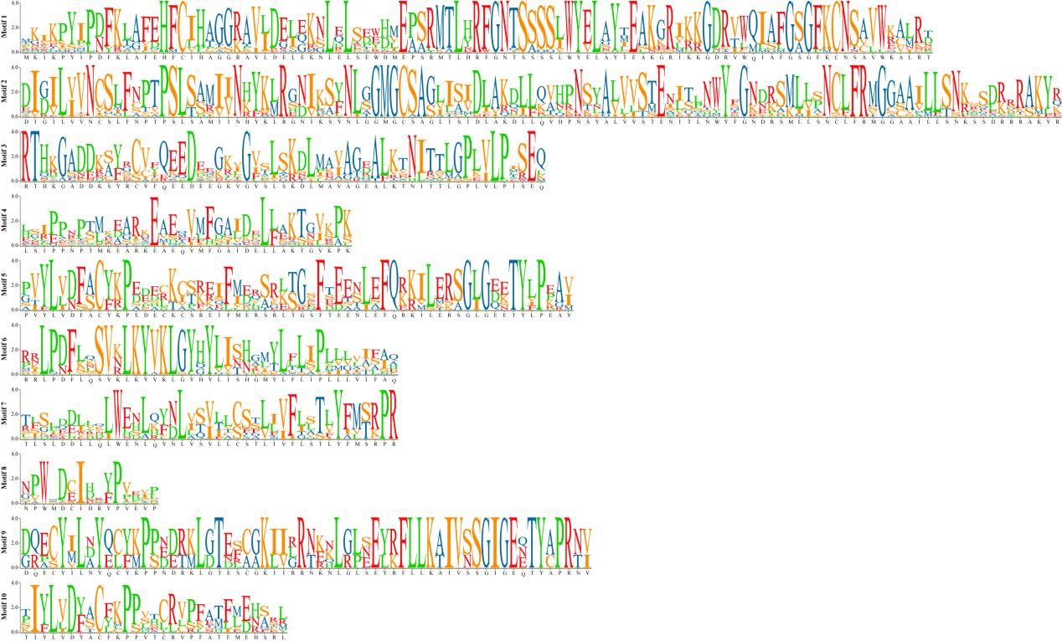
Fig. S3 The sequences information of 10 conserved motifs identified in GmKCS proteins.

