Supplementary Information for,
Tandem of conduction and radiation for solar-adaptive cooling blocks composed of recycled fabric
Sudip Kumar Pal¹, Tohid Otoufat^{1,3}, Hoyeon Bae¹, Sungkwon Lee¹, Hoik Lee² and Gunwoo Kim^{1†}
- Biomedical Manufacturing Technology Center, Korea Institute of Industrial Technology, Yeongcheon 38822, Republic of Korea
- Advanced Textile R&D Department, Korea Institute of Industrial Technology, Ansan-si 15588, Republic of Korea
- Seoul National University of Science and Technology, Seoul, 01811, Republic of Korea
†Corresponding author. Email: gunwoo@kitech.re.kr (G.K.)

Table of Content
Supplementary text
- Computing solar and IR absorptivity of the porous recycle fiber block by finite element method
- Thermal calculation methodology.
- Calculation of temperature coefficient, ‘m’.
Figure S1. Analysis of thermal conductivity coefficient (K) variation with the fiber block porosity
Figure S2. Fabrication method of fiber blocks
Figure S3. Microscope images of surfaces of fiber blocks at various processing temperatures
Figure S4. FT-IR data of the fiber block
Figure S5. Porosities of fiber blocks
Figure S6. Mechanical strength measurement of the fiber block
Figure S7. Thermal measurement setup and IR camera image
FigureS8. Outdoor thermal assessment of the fiber block
Figure S9. Variation of the coefficient of determination (R² value) over time

Supplementary text:
S1. Computing solar and IR scattering of the porous recycle fiber block by finite element method
The model considers a spherical cross-section made of recycled fibers with varying porosity. This cross-section is filled with air and PET fiber, which has a width equal to half the wavelength in free space. Outside this fiber block, there is a Perfectly Matched Layer (PML) domain that absorbs any scattered field. To ensure effective absorption, the PML is positioned at a distance of at least half a wavelength away from the scatterer's reactive near-field. The primary objective is to compute the scattering pattern within the fiber structure, accounting for different air spaces.
To address this, Maxwell's equations are formulated and solved in their differential form, incorporating initial and boundary conditions. This task is accomplished using the RF Module, which is specifically employed for this purpose. The equations are tackled using the finite element method, employing a numerically stable edge element discretization approach along with state-of-the-art preconditioning and solution techniques.
For the computation, a frequency domain formulation is adopted to establish and solve the model. The electric field is polarized along the y-axis and propagates with the incident plane wave in the positive y direction. The governing equation for the frequency domain takes the form the following equation.
$∇×\left(μ_{r}^{-1}∇×\left(E_{i}+E_{sc}\right)\right)-k_{0}^{2}ε_{rc}\left(E_{i}+E_{sc}\right)$ (Equation S1)
where the scattered field E_{sc} is the dependent variable and the incident field E_{i}= (0, E_{y}, 0), with the following equation.
$E_{y}=1\left[V/m\right]e^{-jk_{0}x}$ (Equation S2)
It's widely recognized that achieving a well-resolved wave field requires aiming for at least 10 discretization points per wavelength. While this criterion is somewhat met by employing second-order elements with 8 elements per wavelength, a finer mesh is essential on the surface of the scattered (recycled fiber) to accurately represent longer wavelengths and adhere to the geometry. Along these boundaries, elements are constrained to a maximum size of half the radius. Additionally, the meshing for the perfectly matched layer (PML) region is determined.
S2. Thermal Calculation methodology
Parameters utilized for the steady state thermal transfer model. For the thermal model simulation of cooling power with the variation of ambient temperature, following values were utilized.
Ambient temperature (T_{a}) = 10 °C to 50 °C
Given heat (Q) = 0, 50, 100, 150 W/m²
Conduction coefficient (K) = 0.088 W/mK
Convection coefficient (h) = 4 W/m²K
For the thermal model simulation of cooling power with the variation of conduction coefficient (K), following values were utilized.
Ambient temperature (T_{a}) = 30 °C
Given heat (Q) = 0, 50, 100, 150 W/m²
Conduction coefficient (K) = 0.025 to 0.15 W/mK
Convection coefficient (h) = 4 W/m²K
S3. Calculation of temperature coefficient, ‘m’:
The cooling power calculation employs a linear regression model to offer a deeper understanding of the extent to which the independent variable within the model elucidate the observed variability in the dependent variable. In order to quantify this explanatory capability, the temperature coefficient of determination (m) has been calculated. This evaluation has been accomplished using the following equation for the computation of cooling power on a daily basis, as illustrated in Figure S9.
$m=\frac{{\left(\sum_{i=1}^{3}{(x_{i}-\overline{x})(y_{i}-\overline{y})}\right)}^{2}}{\sum_{i=1}^{3}{{(x_{i}-\overline{x})}^{2}\sum_{i=1}^{3}{{(y}_{i}-\overline{y}})^{2}}}$ (Equation S3)
Here, the variables x1, x2 and x3 correspond to the provided heat flux values of 200, 400, and 600 W/m² respectively. Similarly, the variables y1, y2, and y3 represent the temperature difference between the fiber block core temperature and ambient temperature associated with the respective heat flux levels. x ̅ corresponds to the mean of the heat flux values (x1, x2 and x3), while y ̅ indicates the mean of the temperature difference values (y1, y2, and y3).

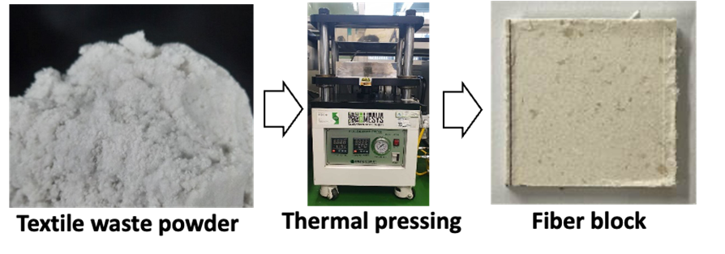
Figure S1. Fabrication method of fiber blocks: production of textile waste powder, thermal-pressing of textile waste powder and analysis of the fiber block

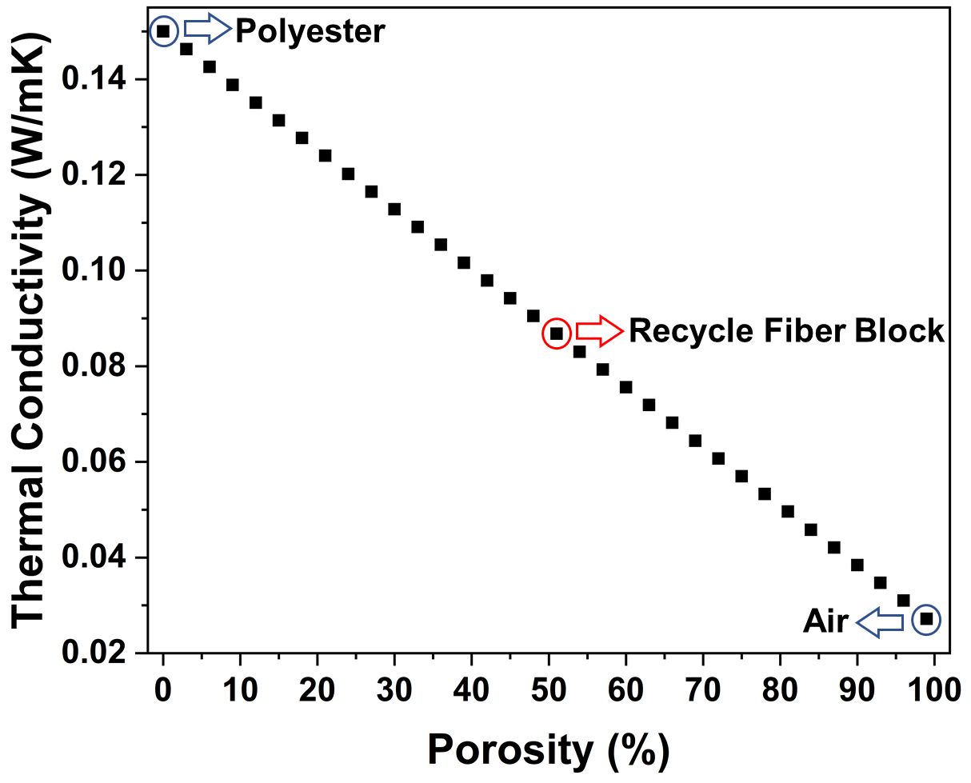
Figure S2. Analysis of thermal conductivity coefficient (K) variation with the fiber block porosity

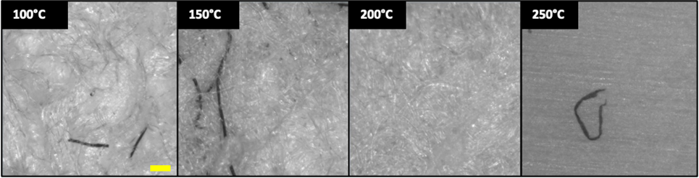
Figure S3. Microscope images of surfaces of fiber blocks at various processing temperatures. The scale bar stands for 100 μm

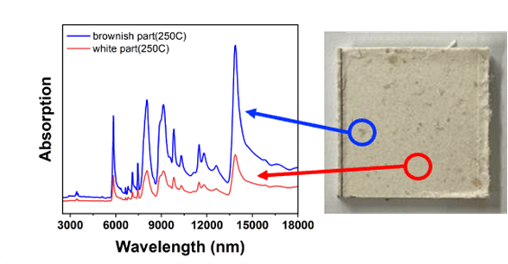
Figure S4. FT-IR data of white part (red circle and red line) and brownish part (blue circle and blue line) on the fiber block

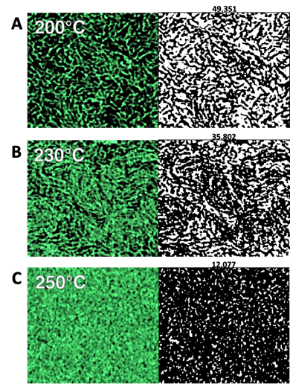
Figure S5. Porosities of fiber blocks. Computed tomography (CT) scan images of fiber blocks thermal-pressed at (A) 200 ℃, (B) 230 ℃ and (C) 250 ℃. Left images (green) are cross-sectional CT images and right images (black and white) are images-processed to calculate porosity ratio

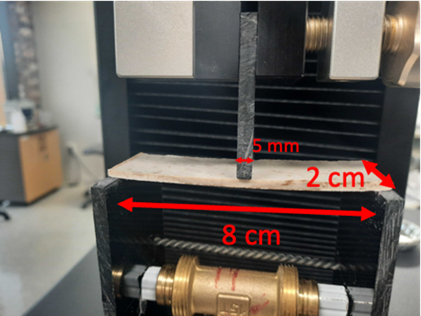
Figure S6. Mechanical strength measurement of the fiber block utilizing universal testing machine (UTM)

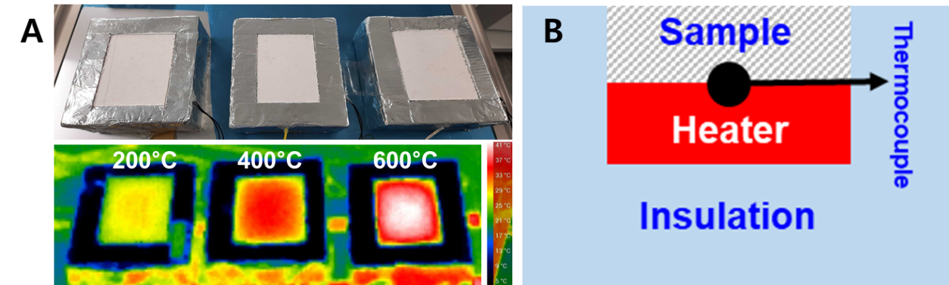
Figure S7. Infrared radiation images of thermal testing samples (A) and cross-sectional illustration of thermal measurement setup (B)

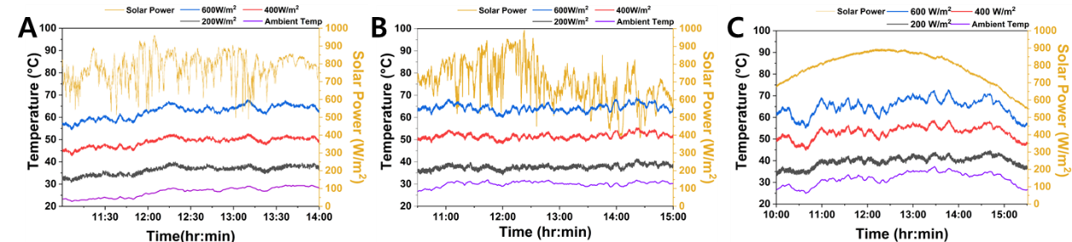
Figure S8. Outdoor thermal assessment of the fiber block at various ambient temperature and solar radiation conditions. The color-coded representation indicates heat flux levels from the heater: black (200 W/m²), red (400 W/m²), and blue (600 W/m²). Ambient temperature is denoted by the violet line while solar power is represented in orange colour. The extensive experimental study encompasses temperature variations under three heat flux settings and across different ambient temperature ranges: (A) below 30 °C, (B) around 30 °C, and (C) exceeding 30 °C.

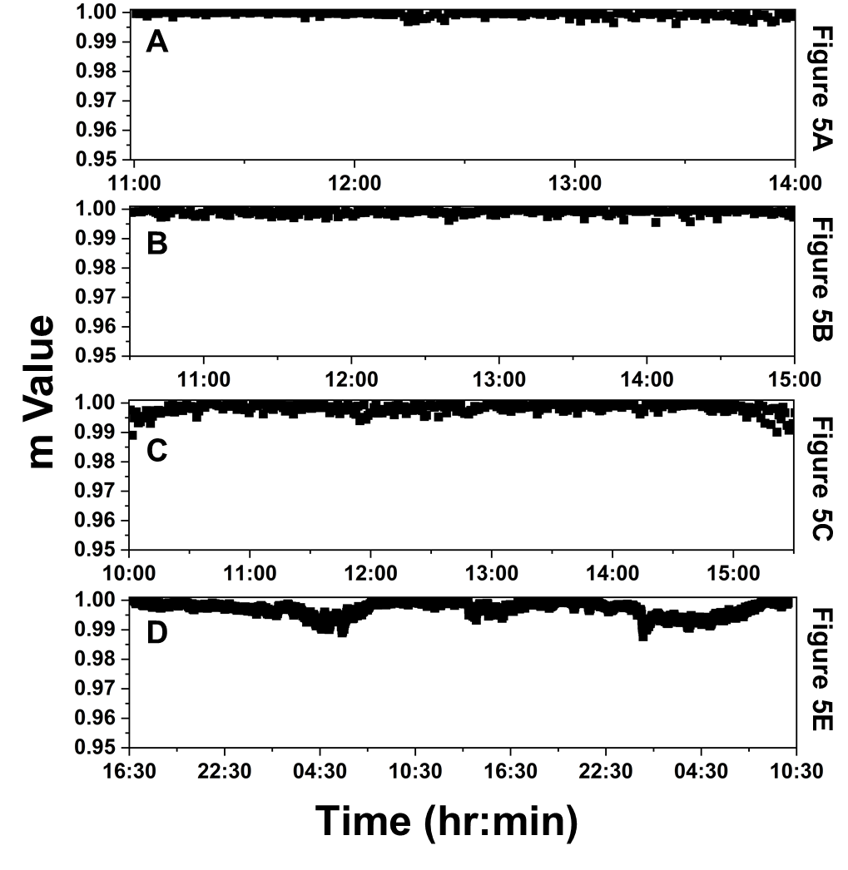
Figure S9. Variation of the coefficient of determination (m value) over time for cooling power calculation, as calculated for Figure 5A-C and E respectively.

