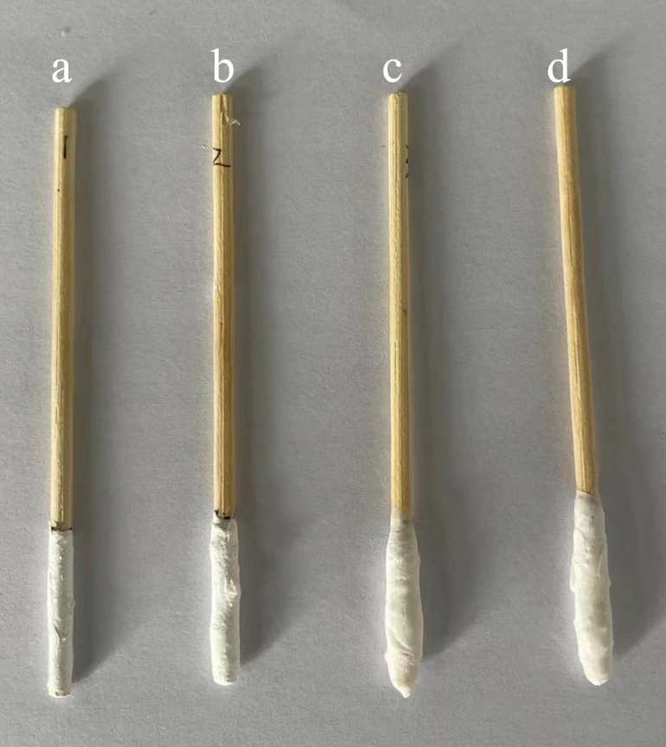
Figure S1 Wooden tips coated with PAN-MIP mixtures in different proportions

Table S1 The adsorption rates of 14 β-agonists by four SPME tips
Tips | Adsorption rates (%, n=3)
Tips | Salbutamol | Ractopmine | Clenbuterol | Terbutaline | Marpentello | Penbuterol | Brobuterol | Phenethanolamine A | Clorprenaline | Formoterol | Tobuterol | Bambuterol | Mabuterol | Cibuterol
a | 67 | 69 | 72 | 68 | 69 | 60 | 66 | 62 | 68 | 63 | 65 | 64 | 67 | 66
b | 71 | 79 | 82 | 69 | 78 | 81 | 72 | 76 | 78 | 69 | 70 | 71 | 73 | 74
c | 84 | 82 | 79 | 73 | 82 | 80 | 88 | 84 | 89 | 70 | 73 | 78 | 71 | 73
d | 83 | 82 | 87 | 78 | 79 | 75 | 83 | 85 | 87 | 84 | 80 | 82 | 75 | 77

Table S2 The desorption rates of 14 β-agonists on c in solvent (acetic acid: methanol= 1:9)
Tips | Adsorption rates (%, n=3)
Tips | Salbutamol | Ractopmine | Clenbuterol | Terbutaline | Marpentello | Penbuterol | Brobuterol | Phenethanolamine A | Clorprenaline | Formoterol | Tobuterol | Bambuterol | Mabuterol | Cibuterol
a | 95.0 | 95.5 | 85.6 | 89.2 | 97.0 | 96.2 | 89.7 | 93.3 | 89.2 | 91.4 | 93.6 | 86.6 | 89.8 | 93.3

