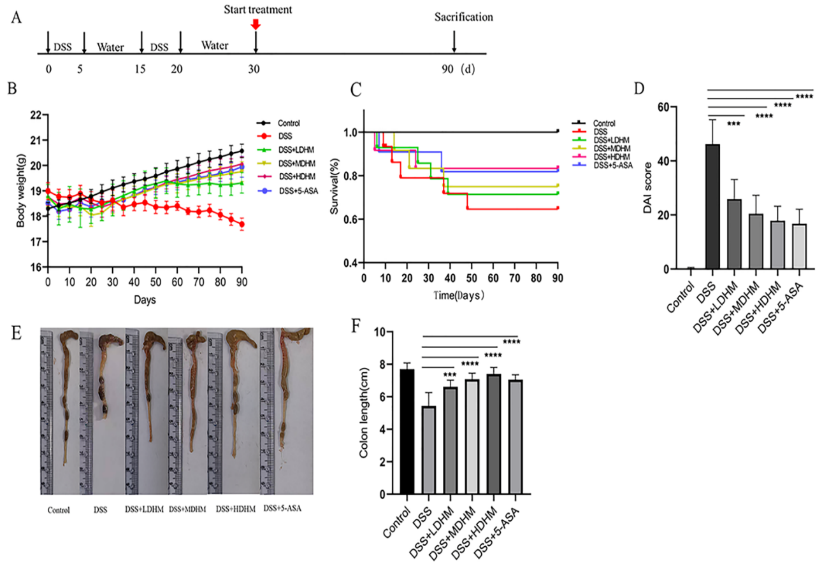
Fig. S1 DHM treatment alleviates DSS-induced chronic colitis in mice. (A) Therapeutic mouse model. (B) Changes in body weight. (C) Survival curves of mice in the six groups. (D) DAI score of mice in the six groups. (E) Macroscopic appearance of the colons of mice in the six groups. (F) Length of the colon of mice. (*, p ≤ 0.05; **, p ≤ 0.01; ***, p ≤ 0.001; ****, p ≤ 0.0001) (n = 10).
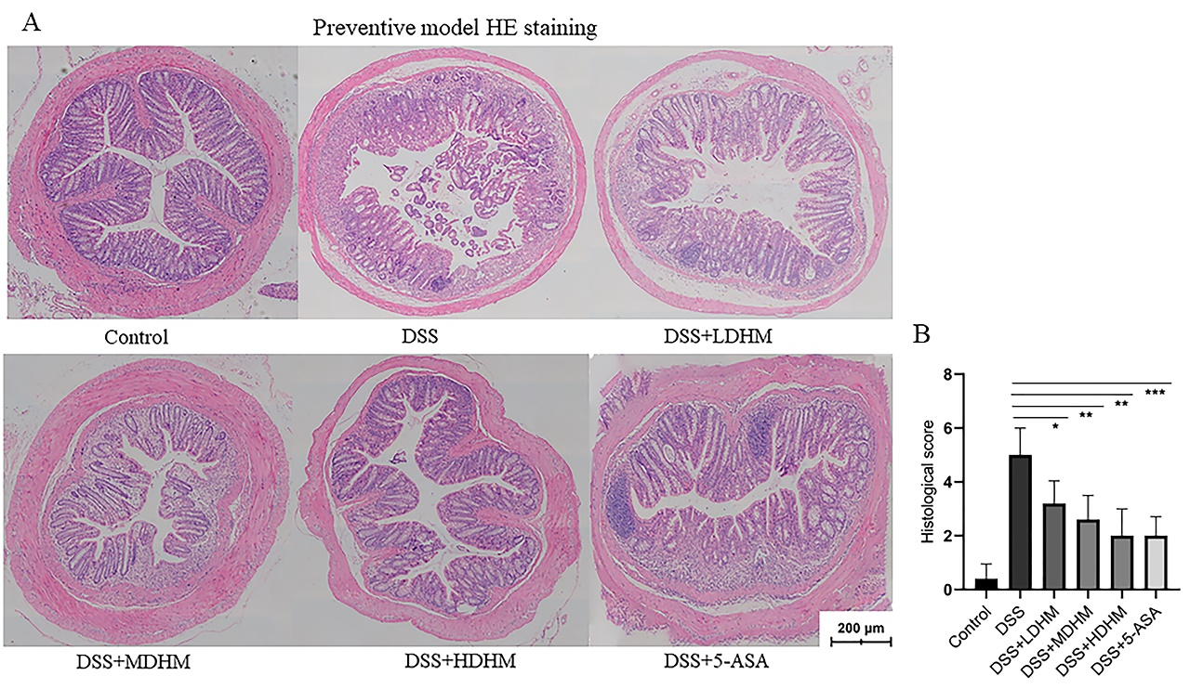

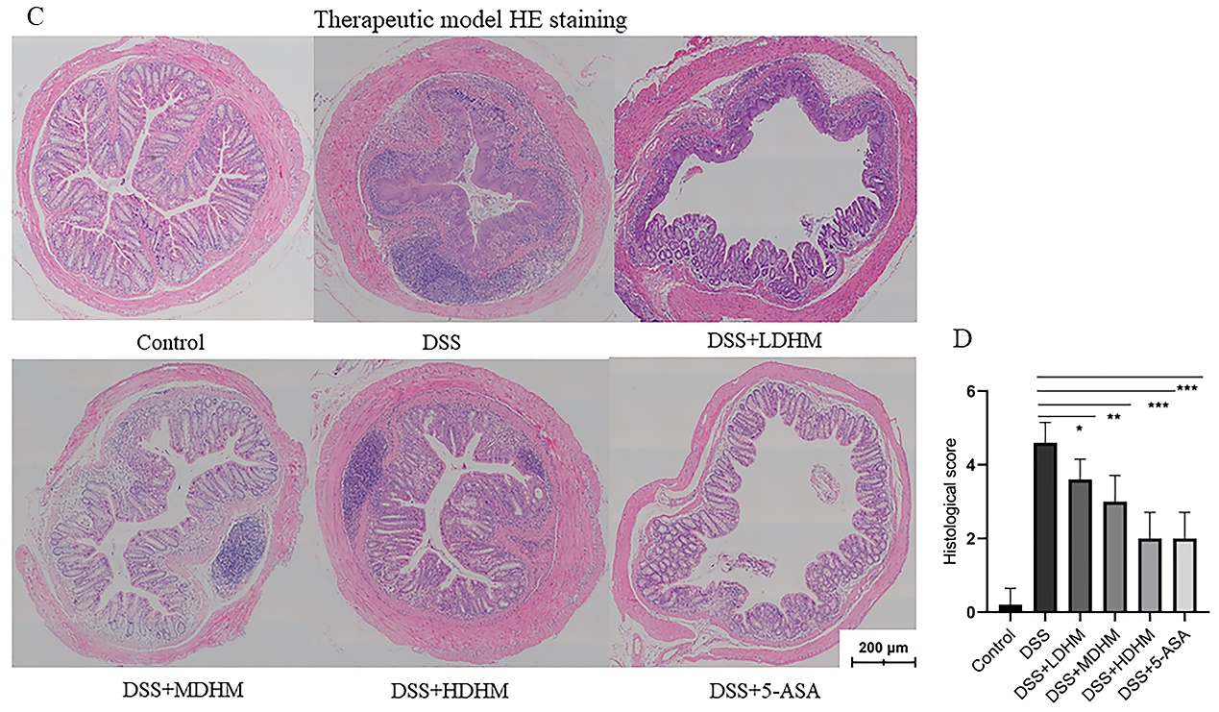
Fig.S2 DHM exerts anti-inflammatory effects on chronic colitis in mice.
(A,C) Representative H&E staining of colon tissues of mice in preventive model
and therapeutic model respectively. (B,D) Histological scores of H&E-stained colon
tissues of mice in preventive model and therapeutic model respectively.
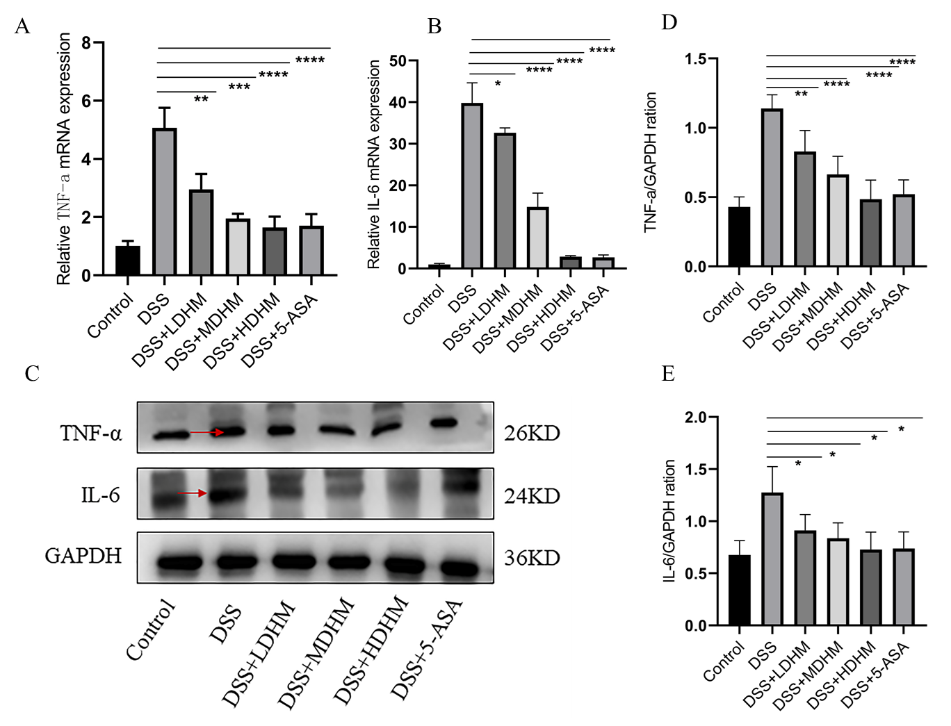
(Scale bar = 200 µm)(n=3).

Fig. S3 DHM exerts anti-inflammatory effects on chronic colitis in mice. (A,B) Production of colonic TNF-a and IL-6 in the six groups of therapeutic mouse models. (C-E) Representative images of Western blotting demonstrating changes in the expression of key pro-inflammatory proteins after DHM treatment in therapeutic models (*, p ≤ 0.05; **, p ≤ 0.01; ***, p ≤ 0.001; ****, p ≤ 0.0001) (n = 10).
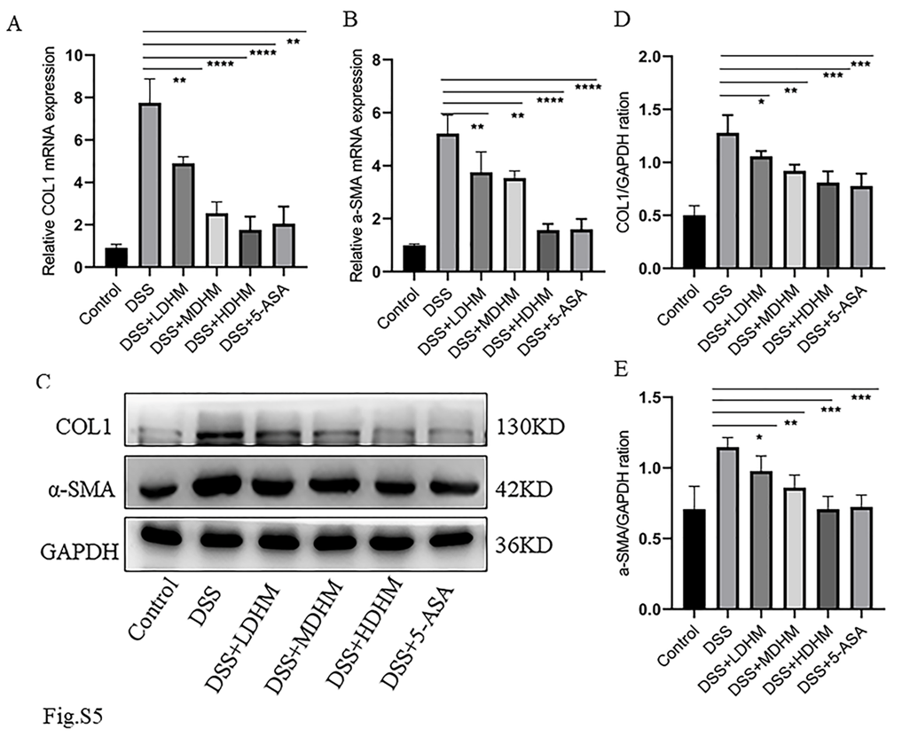
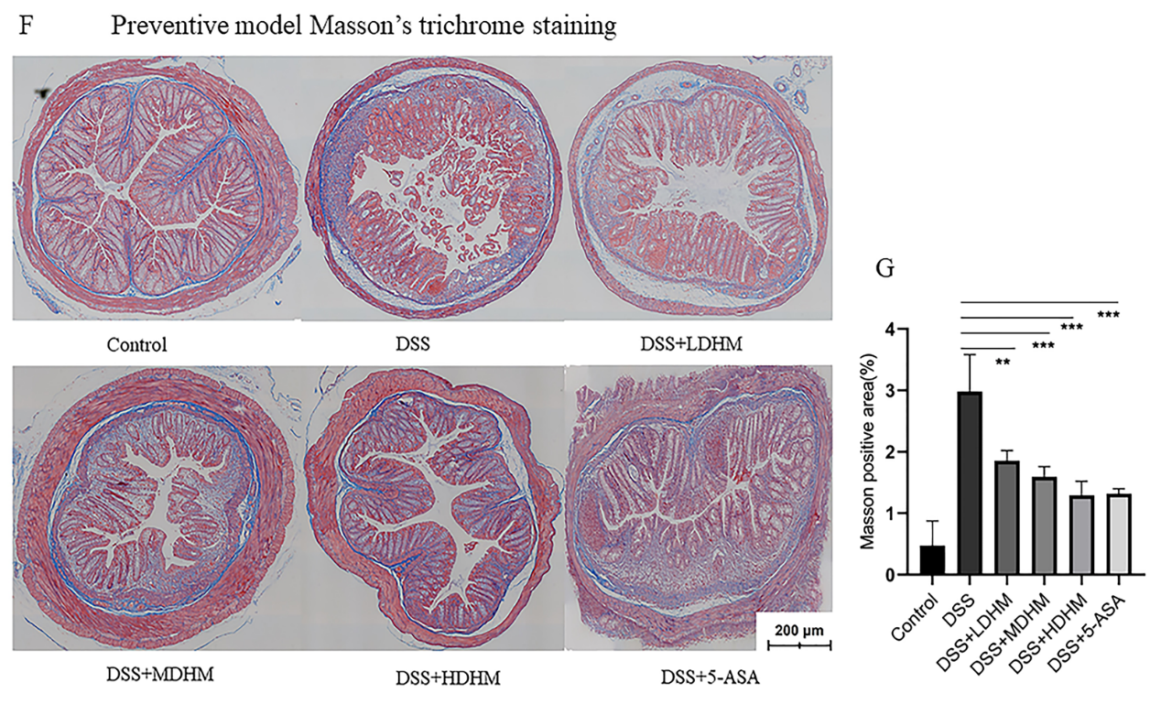
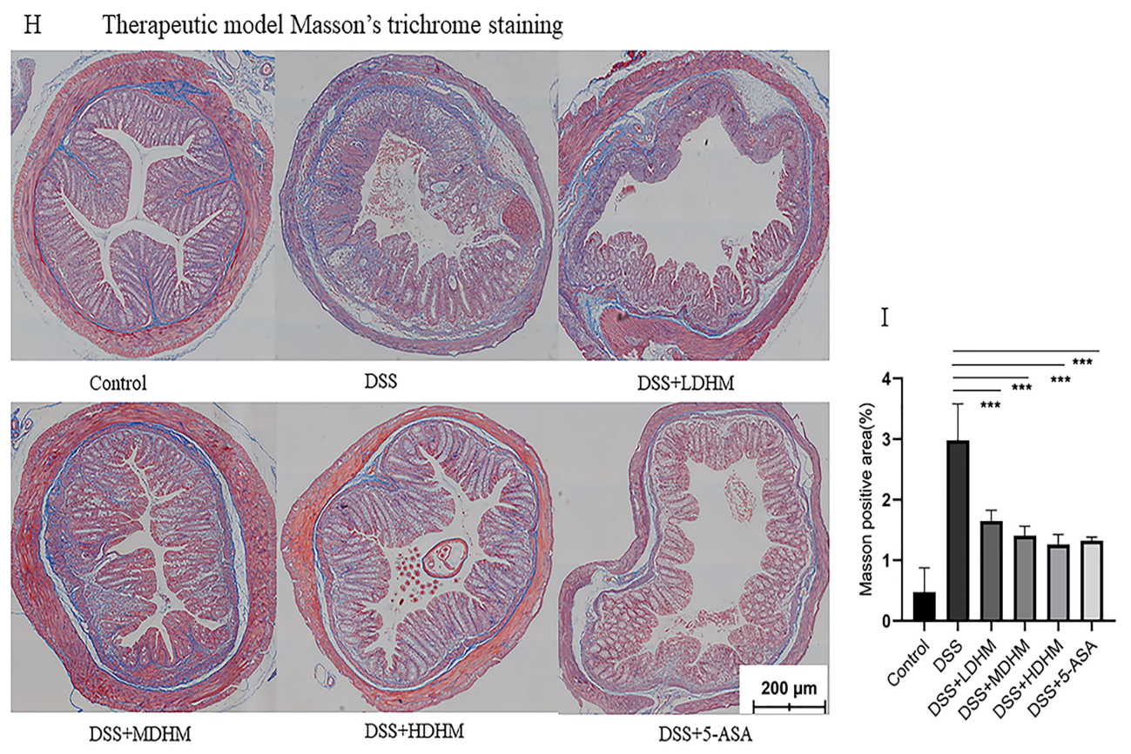
Fig.S4 DHM reduces IBD-associated intestinal fibrosis. (A,B) Representative images of q-PCR demonstrating changes in the mRNA expression of collagen I and α-SMA after DHM or 5-ASA treatment in therapeutic models. (C) Representative images of Western blotting demonstrating changes in the protein expression of collagen I and α-SMA after DHM or 5-ASA treatment in therapeutic models. (D,E) Quantitative analysis of the expression of collagen I and α-SMA(n = 10).(F,H) Representative images of Masson’s trichrome staining of colon tissues of mice in preventive model and therapeutic model respectively. (G,I) Quantitative analysis of the positively stained area in (F,H) (Scale bar = 200 μm) (**, p ≤ 0.01; ***, p ≤ 0.001) (n = 3)

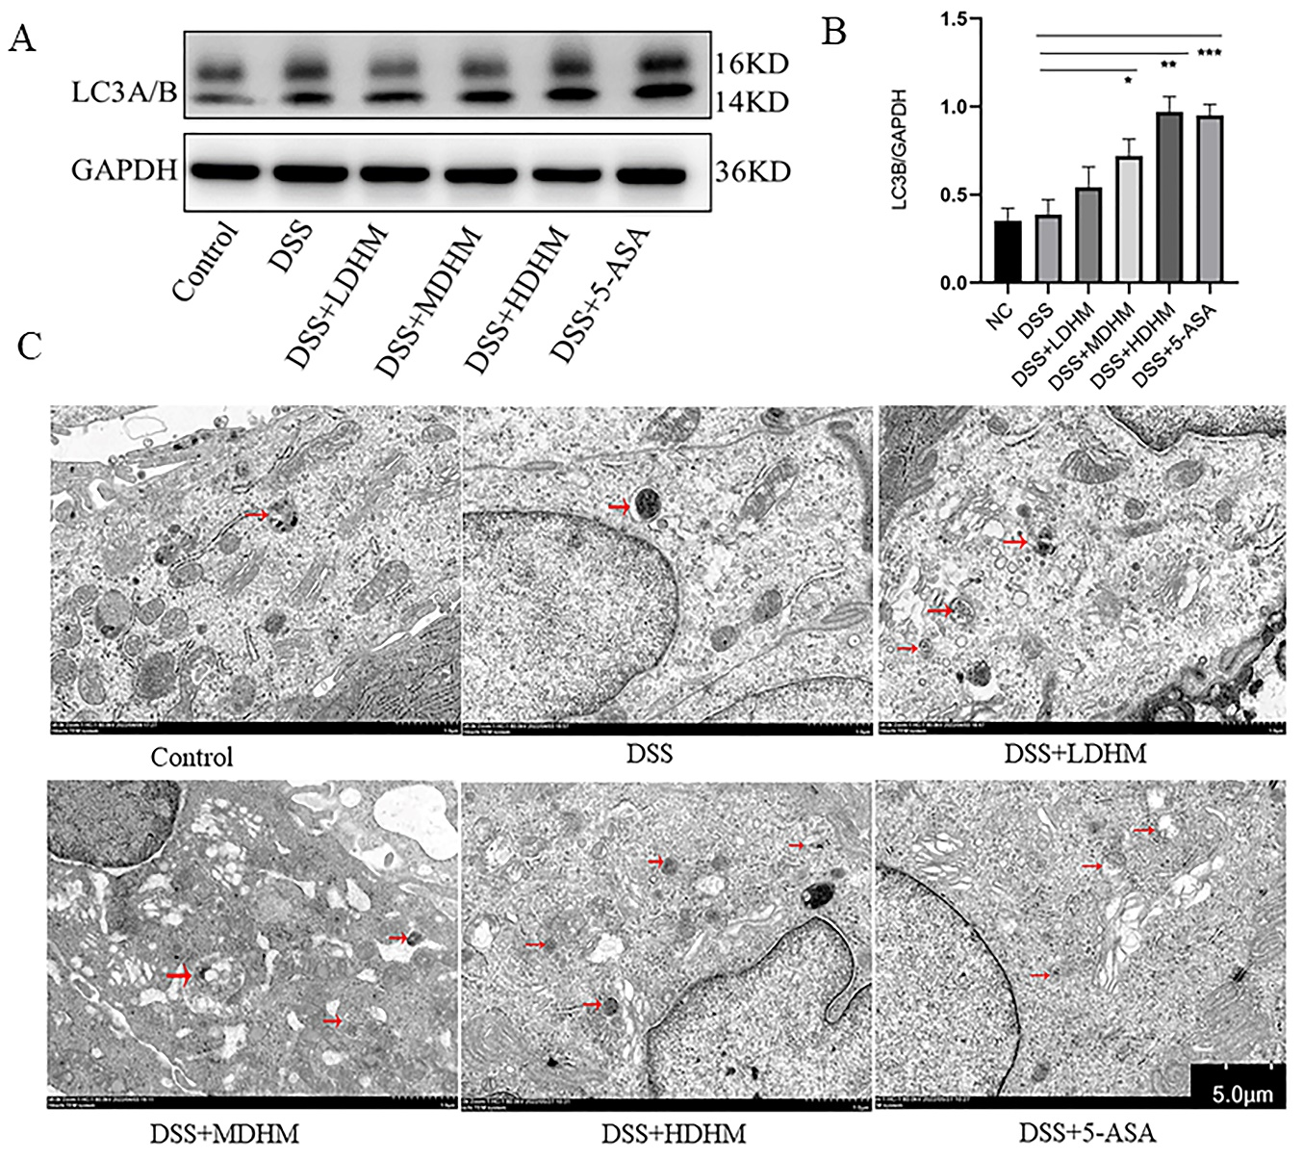
Fig.S5 DHM inhibits colonic fibroblast activation by inducing autophagy. (A) Representative images of Western blotting demonstrating the protein expression of LC3A/B in therapeutic models. (B) Quantification of LC3A/B expression; data are expressed as mean ± SEM (n = 10). (C) Representative images of transmission electron microscopy of colonic tissues in therapeutic models; red arrows indicate autophagosomes (*, p ≤ 0.05; **, p ≤ 0.01) (n=3).

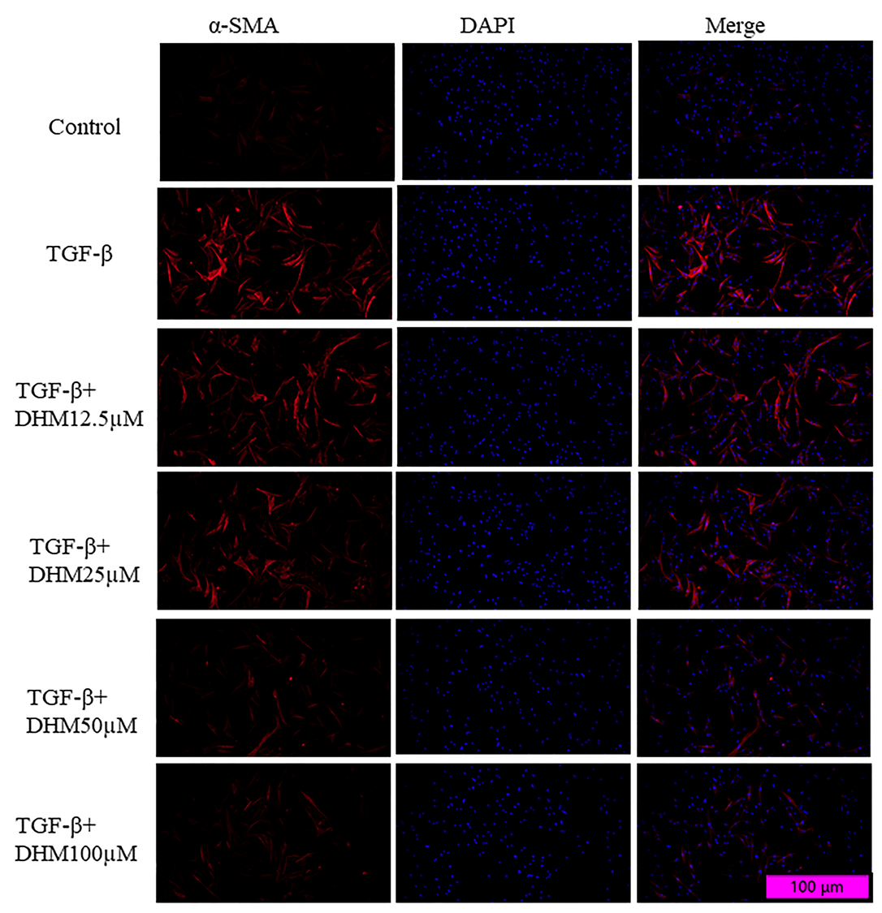
Fig.S6 Effects of DHM on inactivation of colonic fibroblasts in vitro. Representative images of immunofluorescence staining for α-SMA in CCD-18Co cells; red fluorescence represents the expression of α-SMA, whereas blue fluorescence with DAPI staining represents the cell nucleus.

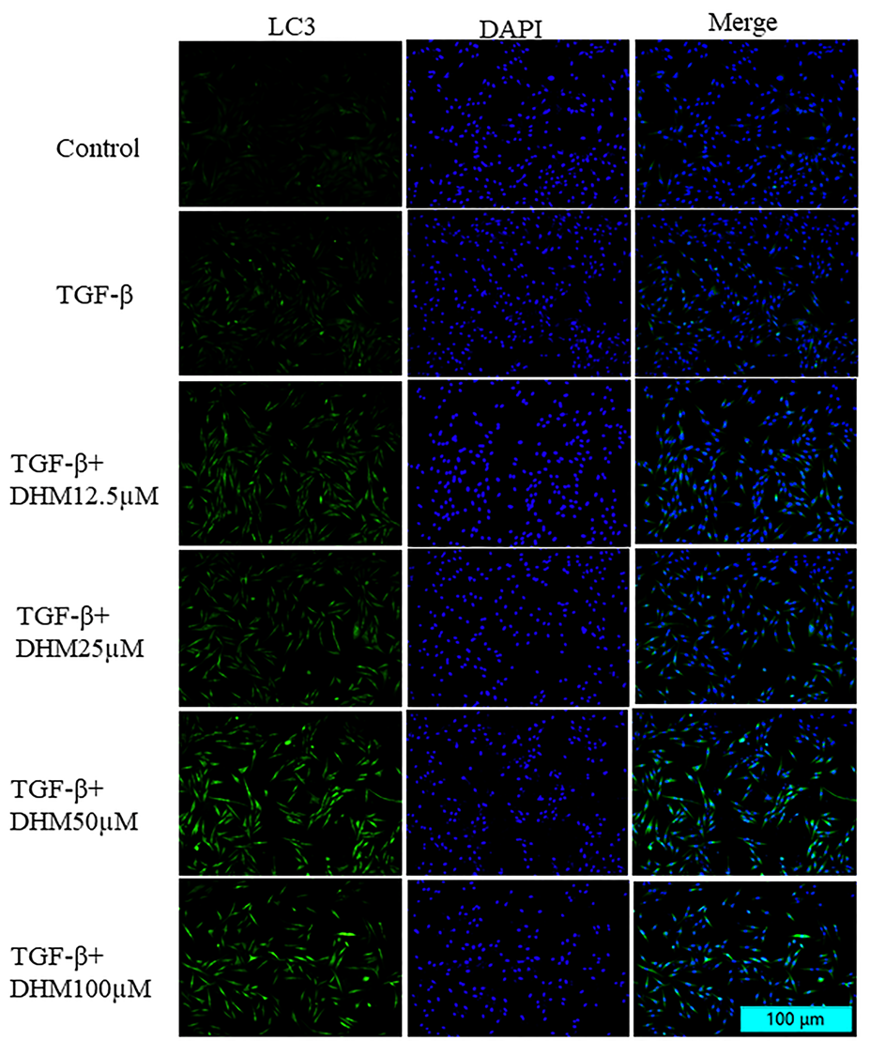
Fig.S7 DHM inhibits colonic fibroblast activation by inducing autophagy in vitro. Representative images of immunofluorescence staining for LC3 in CCD-18Co cells; green fluorescence represents the expression of LC3, whereas blue fluorescence with DAPI staining represents the cell nucleus.

