Supplementary Materials:
Supplementary Table1 Quality statistics of Reads
Sample name | Raw reads | Clean reads | Clean bases | Error rate (%) | Q30(%) | GC content (%)
TSNAs-1 | 14829808 | 14668674 | 2.2G | 0.02 | 94.62 | 47.71
TSNAs-2 | 15623970 | 15351610 | 2.3G | 0.02 | 94.56 | 52.28
TSNAs-3 | 15812922 | 15523450 | 2.3G | 0.02 | 94.41 | 47.49
CK-1 | 15217766 | 14985914 | 2.2G | 0.03 | 93.64 | 50.96
CK-2 | 15734208 | 15372596 | 2.3G | 0.02 | 94.79 | 54.7
CK-3 | 15351670 | 15076022 | 2.3G | 0.02 | 94.70 | 47.26
- b.
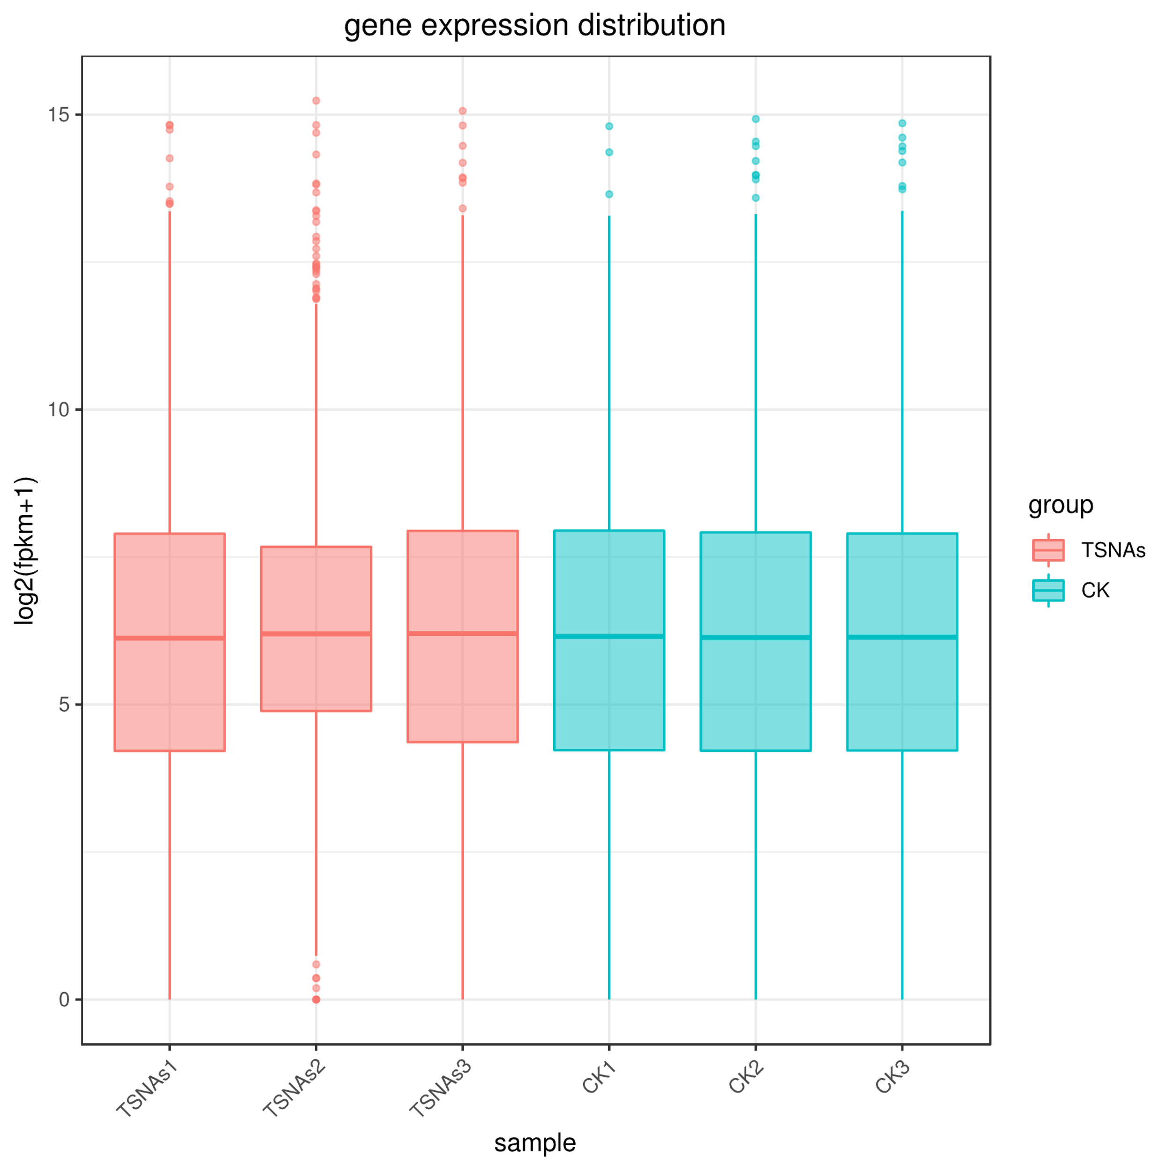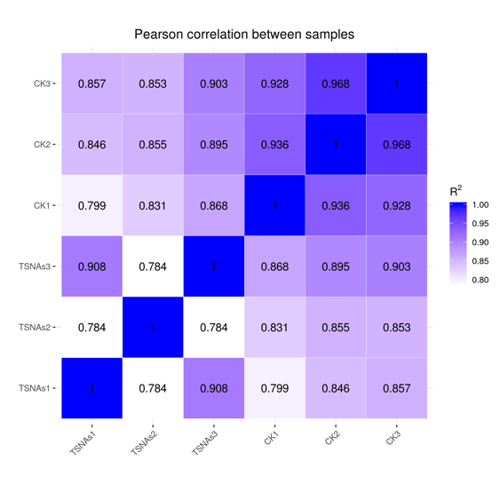
Supplementary Figure 1.
- Gene expression levels in samples. b. Heatmap of correlation between samples.

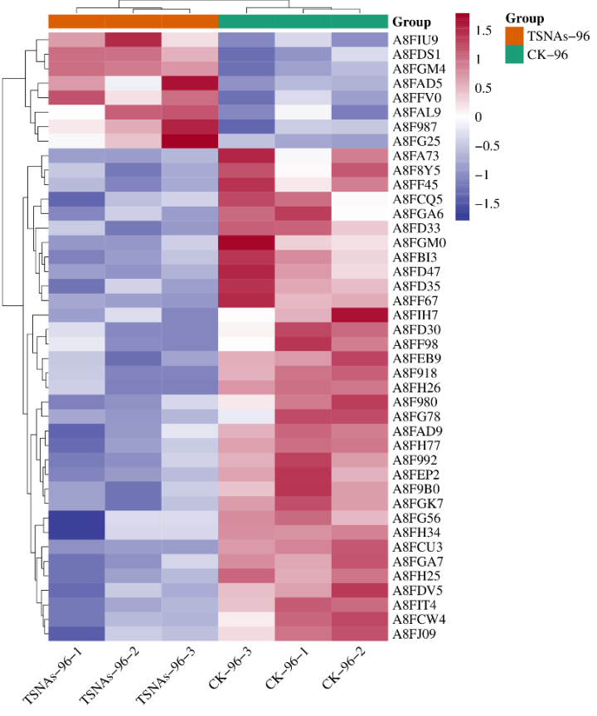
Supplementary Figure 2. The heat map results of DEPs

