Role of lung ornithine aminotransferase in Idiopathic Pulmonary Fibrosis: regulation of mitochondrial ROS generation and TGF-β1 activity

Authors: Jong-Uk Lee¹, Ki Sung Song¹, Jisu Hong¹, Hyesun Shin¹, Eunji Park¹, Junyeong Baek¹, Shinhee Park¹, Ae-Rin Baek¹, Junehyuk Lee¹, An Soo Jang¹, Do Jin Kim¹, Su Sie Chin², Sung Hwan Jeong³, Sung Woo Park¹*

¹Division of Allergy and Respiratory Medicine, Department of Internal Medicine, Soonchunhyang University Bucheon Hospital, 14584, Gyeonggi-Do, south Korea.
²Department of Pathology, Soonchunhyang University Bucheon Hospital, 14584, Gyeonggi-Do, south Korea.
³Department of Allergy, Pulmonary and Critical Care Medicine, Gachon University, Gil Medical Center, Incheon, South Korea.

Supplementary information

Supplemental Table. Clinical characteristics of the patients with IPF classified according to the levels of OAT
 | OAT ≤ 75.569 ng/mL (lower) | OAT > 75.569 ng/mL (higher)
No. | 43 | 16
Age (year) | 63 (59.22-68.81) | 64.77 (56.43-68.65)
Male sex | 31 (72.1) | 9 (56.25)
Ever Smoker | 20 (23.3) | 2 (12.5)
BMI, kg/m2 | 23.68 (22.19-25.97) | 25.11 (22.46-26.13)
Follow up duration (year) | 5 (2.51-5) | 2.45 (1.11-3.77)
Deaths | 6 (14.0) | 8 (50.0)
FVC (% pred) | 75.5 (65.25-85.25) | 64 (55.25-74) *
DLCO (% pred) | 64 (51-73.75) | 60 (53-66.5)
Treatment status
Anti-fibrotic agents | 16 (37.2) | 4 (25.0)
Anti-inflammatory agents | 25 (58.1) | 10 (62.5)
None | 10 (23.3) | 3 (18.8)
OAT(ng/mL) | 38.46 (29.37-49.53) | 116.79 (87.13-204.11) *
Data are presented as median median (25th-75th percentile) or number (%).
* : P < 0.05 compared with OAT ≤ 75.569 ng/mL

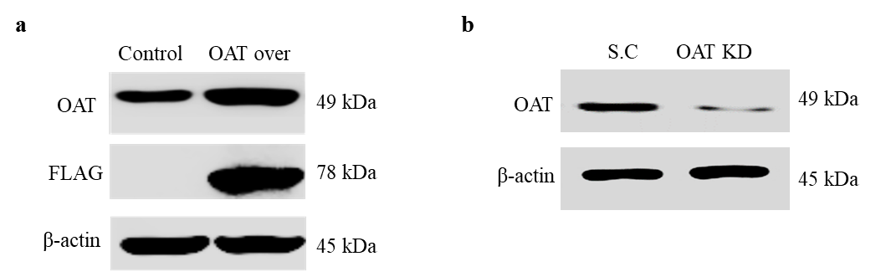
Supplementary Fig 1. Generation of OAT overexpressing and knockdown stable cells.
a. Overexpression of OAT-FLAG and b. OAT knockdown stable cells were confirmed by immunoblotting analysis.

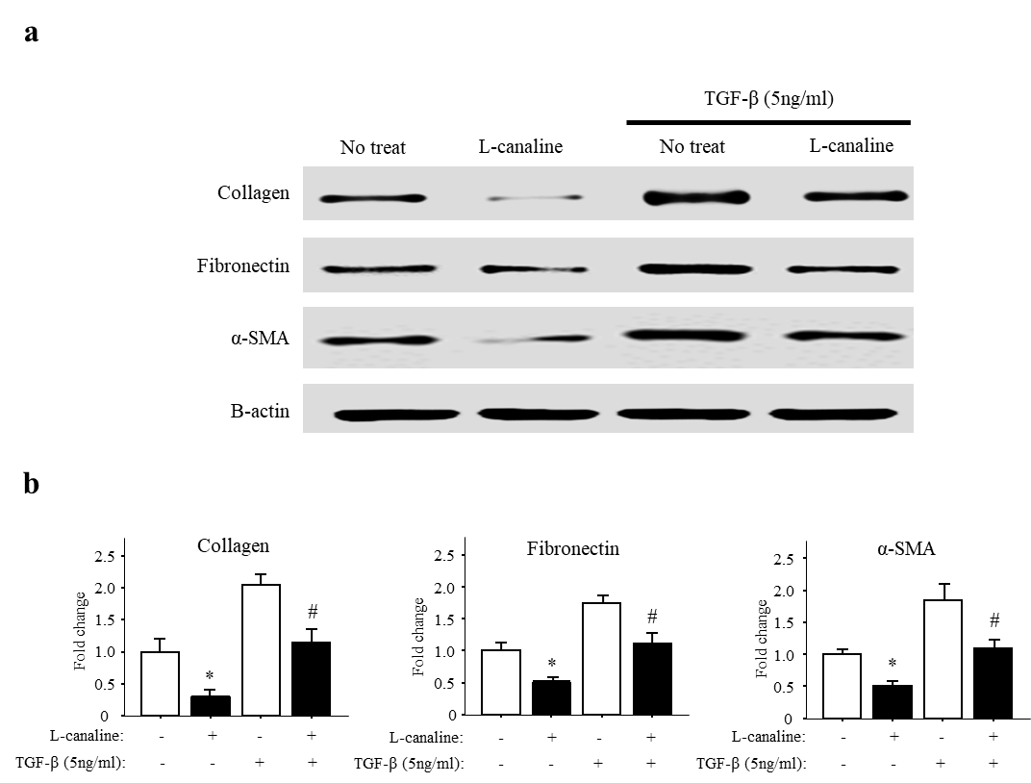
Supplementary Fig 2. The OAT inhibitor L-canaline suppresses the expression of major components of the extracellular matrix in fibroblasts
Effect of the OAT inhibitor L-canaline on collagen, fibronectin, alpha-smooth muscle actin, and MyoD expression in lung fibroblasts. a. Protein expression was quantified usingimmunoblotting and b. densitometry (n = 4 per group). *p < 0.05 versus the scramble group, and #p < 0.05 versus the L-canaline⁺/scramble group.

