Allosteric Site Mediates Inhibition of Tonic NMDA Receptor Activity by Low Dose Ketamine

AUTHORS:
Jamie A. Abbott^{1,3}, Han Wen^{2,3}, Beiying Liu¹, Sheila S. Gupta¹, Gary J Iacobucci¹, Wenjun Zheng², and Gabriela K. Popescu¹#

Affiliations:
¹ Department of Biochemistry, Jacobs School of Medicine and Biomedical Sciences, University at Buffalo, Buffalo, N.Y., 14203
² Department of Physics, College of Biological Sciences, Buffalo, N.Y., 14260
³ Equal contributions
# Correspondence to popescu@buffalo.edu

Supplementary Materials

Material and Methods
All electrophysiology reagents were of >99.0% purity and were purchased from Sigma-Aldrich. Racemic (R, S)-ketamine (item number: K2753-1; lot number: SLCD3830) was purchased from Sigma (CAS: 1867-66-9). Polyethylenimine (linear, mol. wt. 25,000) was purchased from Polysciences (Polysciences, Inc.). All reagents for tissue culture were purchased from ThermoFisher Scientific and Corning.

Cell culture and transfections
Human embryonic kidney (HEK) 293 cells (ATCC CRL-1573) were maintained in Dulbecco’s Modified Eagle Medium with 10% Fetal Bovine Serum and 1% penicillin-streptomycin, at 37 °C in 5% CO2 and 95% atmospheric air. Cells were transfected with plasmids expressing rat GluN1-1a (U08262.1), rat GluN2A (AF001423), or mutants as indicated, and GFP at a 1:1:1 ratio using polyethyleneimine, per manufacturer’s instructions. Transfected cells were grown in medium supplemented with 10 mM MgCl₂ to prevent excitotoxicity and used for experiments 24 – 48 hours thereafter. All mutations were engineered using the QuickChange and verified by full insert sequencing.

Whole-cell current recordings
Whole-cell currents were recorded with the patch-clamp method using electrodes fabricated in house from borosilicate glass capillaries (Sutter instruments) polished to a final resistance of 3 – 5 MΩ when filled with (intracellular) solution containing (in mM): 135 CsCl, 10 mM BAPTA, and 10 HEPES, adjusted to pH 7.2 (CsOH) and clamped at -100 mV. After achieving a high-resistance seal in the whole-cell configuration, cells were perfused with extracellular solutions containing (in mM): 150 NaCl, 2.5 KCl, 0.25 CaCl₂, 0.01 EDTA, 0.1 glycine, and 10 HEPES, adjusted at pH 7.2 (NaOH). Glutamate (1 mM) and ketamine were added to this solution as indicated. The pressurized perfusion system (BPS-8, ALA Scientific Instruments) exchanged solutions within 0.3 - 0.5 s. Sodium currents were amplified, and low-pass filtered at 2 kHz (Axopatch 200B; 4-pole Bessel), sampled at 5 kHz (Digidata, 1440A) and stored as digital files with pClamp 10.2 software (Molecular Devices, Sunnyvale, CA). Traces were inspected for stable baseline and absence of leak current and were used to measure levels of peak and steady-state current amplitudes.

Dose-response relationships
To determine dose-response relationships we represented the ratio of steady-state current measured with ketamine relative to the initial steady-state level observed without ketamine, as a function of ketamine concentration. For each receptor construct, data from all ketamine doses were pooled and fit with either a monophasic dose-response curve of form:
$$y=A_{1}+\frac{A_{2}-A_{1}}{1+{10}^{(\log_{10}{EC_{50}-x)p}}}$$
Or biphasic dose-response curve of form:
$$y=A_{1}+\left(A_{2}-A_{1}\right)\left[\frac{p}{1+{10}^{(\log_{10}{EC_{50,1}-x)h1}}}+\frac{1-p}{1+{10}^{(\log_{10}{EC_{50,2}-x)h2}}}\right]$$
Where each parameter was left unconstrained. If a model did not converge during the fit, it was rejected in favor of the other model. If both models converged, the superior fit was determined by calculating the F-statistic according to:
$$F=\frac{{\left(SSE_{1}-SSE_{2}\right)}/{\left(df_{1}-df_{2}\right)}}{{SSE_{2}}/{df_{2}}}$$
Where SSE is the residual sum of squared error and df is the degrees of freedom calculated as N – V where N is the number of data points and V is the number of model parameters. The resulting F-statistic was used to extract a p-value using the built-in fcdf function in MATLAB 2021b (MathWorks). Statistical significance was defined as p < 0.05.

Single-molecule current recordings.
Electrical signals from individual receptors were recorded with the cell-attached patch-clamp technique. Glass electrodes (O.D 1.5 mm, I.D 0.86 mm, Sutter Instruments) were fire polished to a final resistance of 12 – 24 MΩ when filled with (extracellular) solutions containing (in mM): 150 NaCl, 2.5 KCl, 1 EDTA, 10 HEPBS adjusted to pH 8.0 (NaOH) and saturating concentrations of agonist glycine (0.1 mM) and glutamate (1 mM), as optimized previously for adequate resolution of NMDA receptor gating events (1).
Inward sodium currents were recorded after applying +100 mV through the recording pipette (estimated final membrane-patch potential ~-120 mV). Currents were amplified and low-pass filtered at 10 kHz (Axopatch200B; 4-pole Bessel), sampled at 40 kHz (PCI-6229, M Series card, National Instruments, Austin, TX) and written into digital files with QuB acquisition software.
Single-channel currents were preprocessed off-line to correct for baseline drifts and spurious signals. Idealization was done with the segmental-k-mean (SKM) method in QuB with a 0.025 ms deadtime and no digital filtering to maximize event detection.

Kinetic modeling and simulations.
Kinetic modeling was done for data obtained from individual receptors using the maximum-interval likelihood (MIL) method in QuB software, by fitting user-defined state models to idealized data after imposing a 0.075 ms dead time. Models of increasing complexity were fitted individually to each data file and the best fitting model was selected based on optimal visual agreement between the predicted probability density function with the data and the maximum of the log-likelihood (LL) function. The optimal number of states was determined according to Akaike criterion requiring the LL to increase by at least 20 for a state to be necessary in the model. The arrangement of states within the model was imposed a priori based on previous work (2)
The microscopic ketamine binding and dissociation rates were derived by progressive building of a tiered kinetic model. First, gating rates were determined for the ketamine-free tier by fitting a 5-closed/1-open (5C1O) state model globally to pooled data files obtained in the absence of ketamine. Once determined, all rates in this model were fixed and served as the base ketamine-free tier. Next, we determined the ketamine binding rates for low doses (< 250 nM) by progressively adding states to the base model and globally fitting the resulting models simultaneously to data from multiple doses (25 nM, 2 files; 75 nM, 1 file; 100 nM, 2 files; 250 nM, 2 files) to build an additional 5CO1tier, representing ketamine-bound receptor states. Variants of the final two-tier model were made by changing the states that connected the two tiers.
Simulations of open probability over time in response to pulses of glutamate and ketamine were performed with the Q-matrices derived in QuB software for model variant using the built-in expm function in MATLAB 2021b (MathWorks). Glutamate binding steps were added to the final model post-hoc using rate constants derived previously (3). Glutamate binding was restricted to the C3 state of the ketamine-unbound tier of the model. All simulations were performed assuming constant, saturating levels of glycine.

Molecular docking and MD simulations.
For docking and MD simulations we used as templates four structures that capture four distinct NMDA receptor conformations: two structures were proposed to represent functionally inhibited states (PDB IDs: 4tlm, 6whs) (4, 5), one structure represents a semi-active state (PDB ID: 6wi1) (5), and one structure, which we modeled in a previous study, represents an open-pore active state (6). These structures were processed with the Swiss-Model homology modeling using sequences reported for GluN1-1a (P35439), and GluN2A (Q00959) sequences, omitting the intracellular C-terminal domain, which is lacking in all four structural models. We used the PPM server to align these structures by their transmembrane domains and used them as templates for docking and MD simulations.
Global docking was done after omitting the entire extracellular domains from the structural templates. We used the (0,0,7) coordinate as the center of a grid box of dimensions: 30 Å x 30 Å x 25 Å grid box.
Local docking was done using the crystal structure of S(+)-ketamine, or its mirror image for R(-)-ketamine, and the binding poses obtained for S(+)-ketamine from global docking as starting points for both the central and the lateral sites. The ketamine center of mass was used as the center of a 10 Å cubic grid box, and the exhaustiveness was set to 1000. The molecular docking was performed using AutoDock Vina(7) for all 3 sites in all 4 templates.
MD simulations were done on the four structures described above, from which the N-terminal domains were removed to save computation time. A total of 16 systems were set up using the two enantiomers of protonated ketamine (S or R) docked into site 1 or sites 2/3 in all four NMDA receptor structures. We performed 3 replica of 200-ns long MD simulations for each system. The forcefield for ketamine was prepared with the CHARMM General Force Field(8) and the charge parameters were modified and adopted from previous work (9). The simulation systems were prepared with the Membrane Builder function of the CHARMM-GUI webserver (10, 11) to embed the receptor in a bilayer of 1-palmitoyl-2-oleoyl phosphatidylcholine (POPC) lipids surrounded by a box of water, K+ and Cl- (with 0.15 M concentration), with 20 Å buffer of water/lipids extending from the protein in each direction. In the semi-active and active conformations, Cys mutations and disulfide bonds were introduced at GluN1 residues 499 and 686, and GluN2A residues 487 and 687, respectively, which mimic the binding of Gly and Glu (4). Harmonic positional restraints (with force constant of 1kcal/mol/nm2) were applied to the C-alpha atoms of LBD residues to prevent LBD distortion in the absence of NTD. The entire system has ~330,000 atoms in total. After energy minimization, six steps of equilibration were performed to gradually reduce harmonic restraints applied to the heavy atoms. We then conducted production MD runs in the NPT (isothermal-isobaric) ensemble using the Nosé-Hoover method (12, 13) at a temperature of 303K. For pressure coupling, we used the Parrinello–Rahman method (14); for non-bonded interactions, we used a 10-Å switching distance and a 12-Å cutoff distance. For electrostatics calculations, we used the particle mesh Ewald method (15). We constrained the hydrogen-containing bond lengths with the LINCS algorithm (16) to allow a 2-fs time step for the MD simulations. The MD simulations were performed by the GROMACS program (17) version 2018-GPU using the CHARMM36 force field (18, 19) and TIP3P water model (20). The binding free energy calculation was performed using the Uni-GBSA program with default settings (https://github.com/dptech-corp/Uni-GBSA) and the last 50ns of each trajectory. The steered MD simulation (21) was carried out with the PLUMED2 program (22-24) after equilibration, with a total of 40 Å RMSD bias linearly applied in 2 ns. The analysis and visualization of MD trajectories were carried out using the VMD program (25) and Ligplot+ (26).

Quantification and statistical analyses.
All data are presented as the mean ± S.E.M. The statistical approaches used to analyze the data and significance are noted in the figure legends. Two-tailed unpaired Student’s t tests were used for comparisons between two groups. Statistical significance was defined as follows: *P<0.05, **P<0.01, ***P<0.001 and ****P<0.000.

Supplementary FIGURES

Supplementary Figure 1
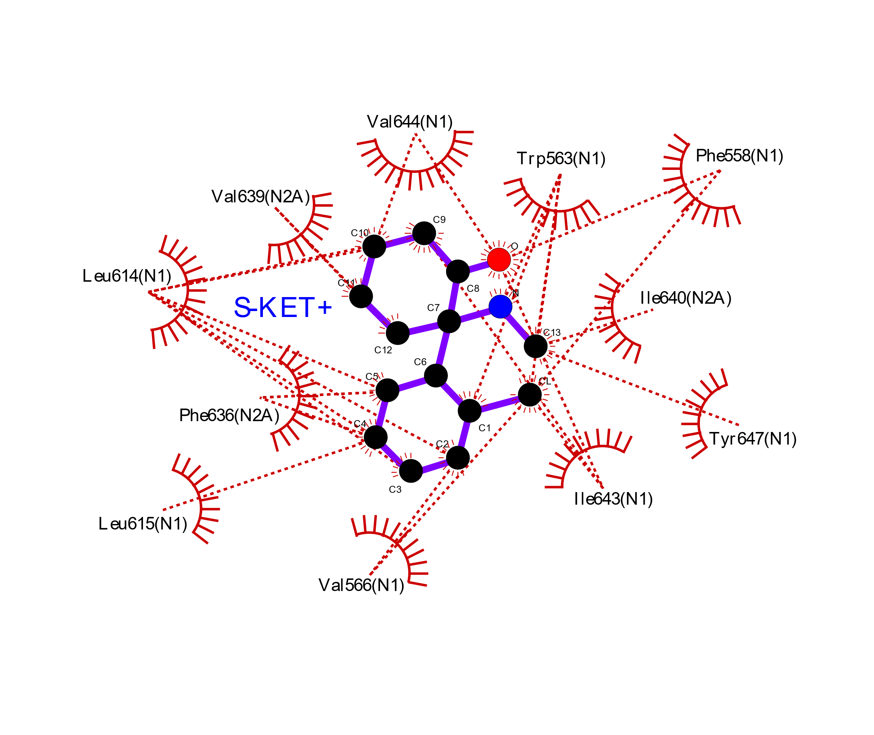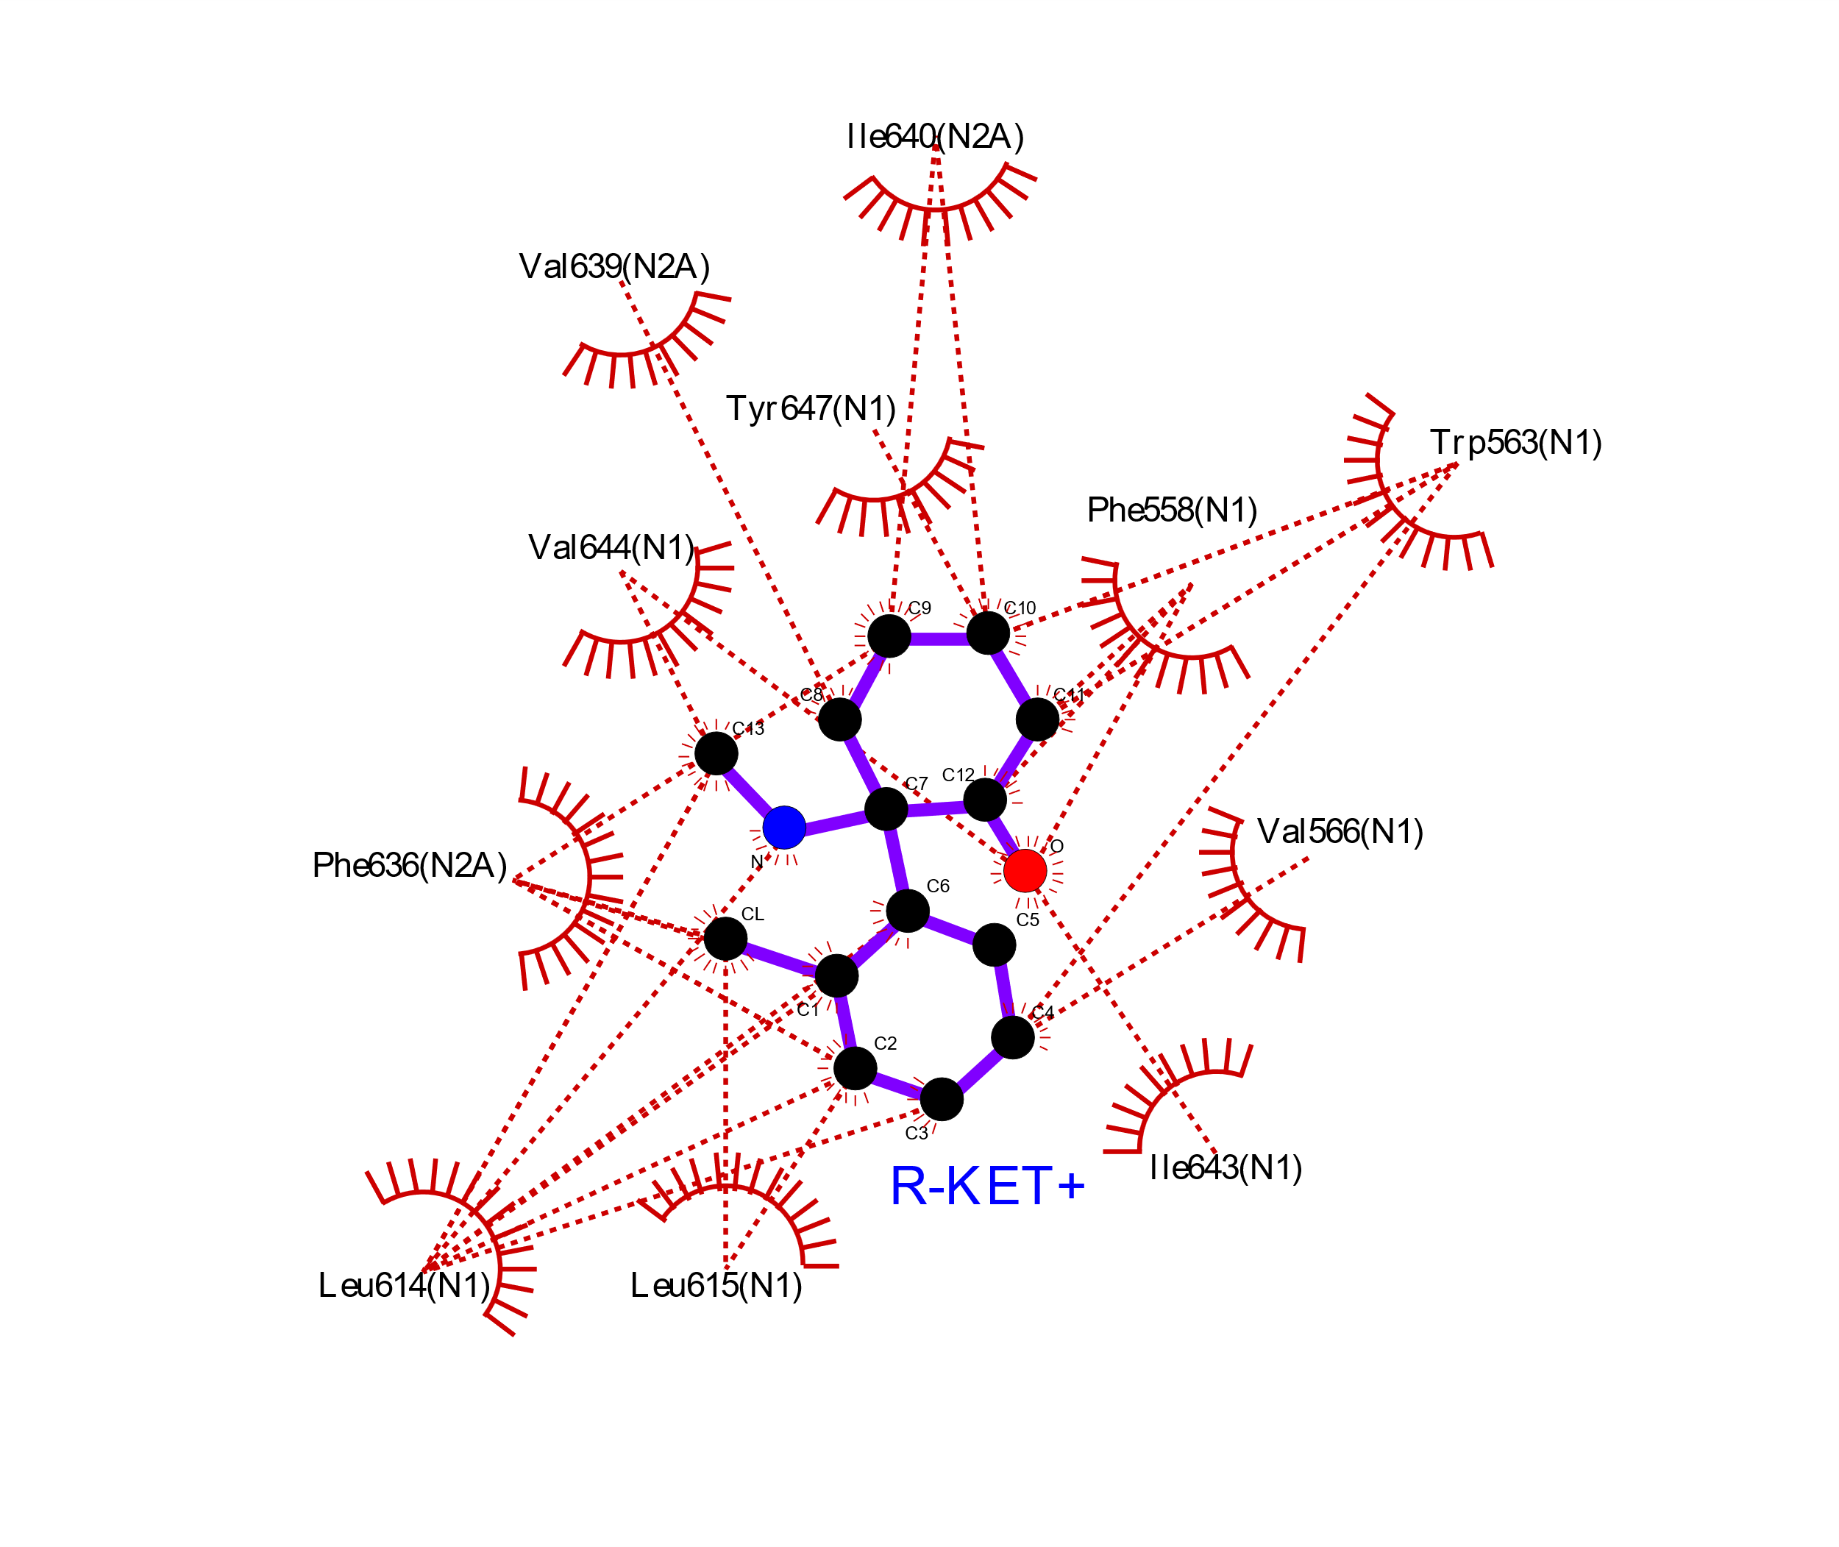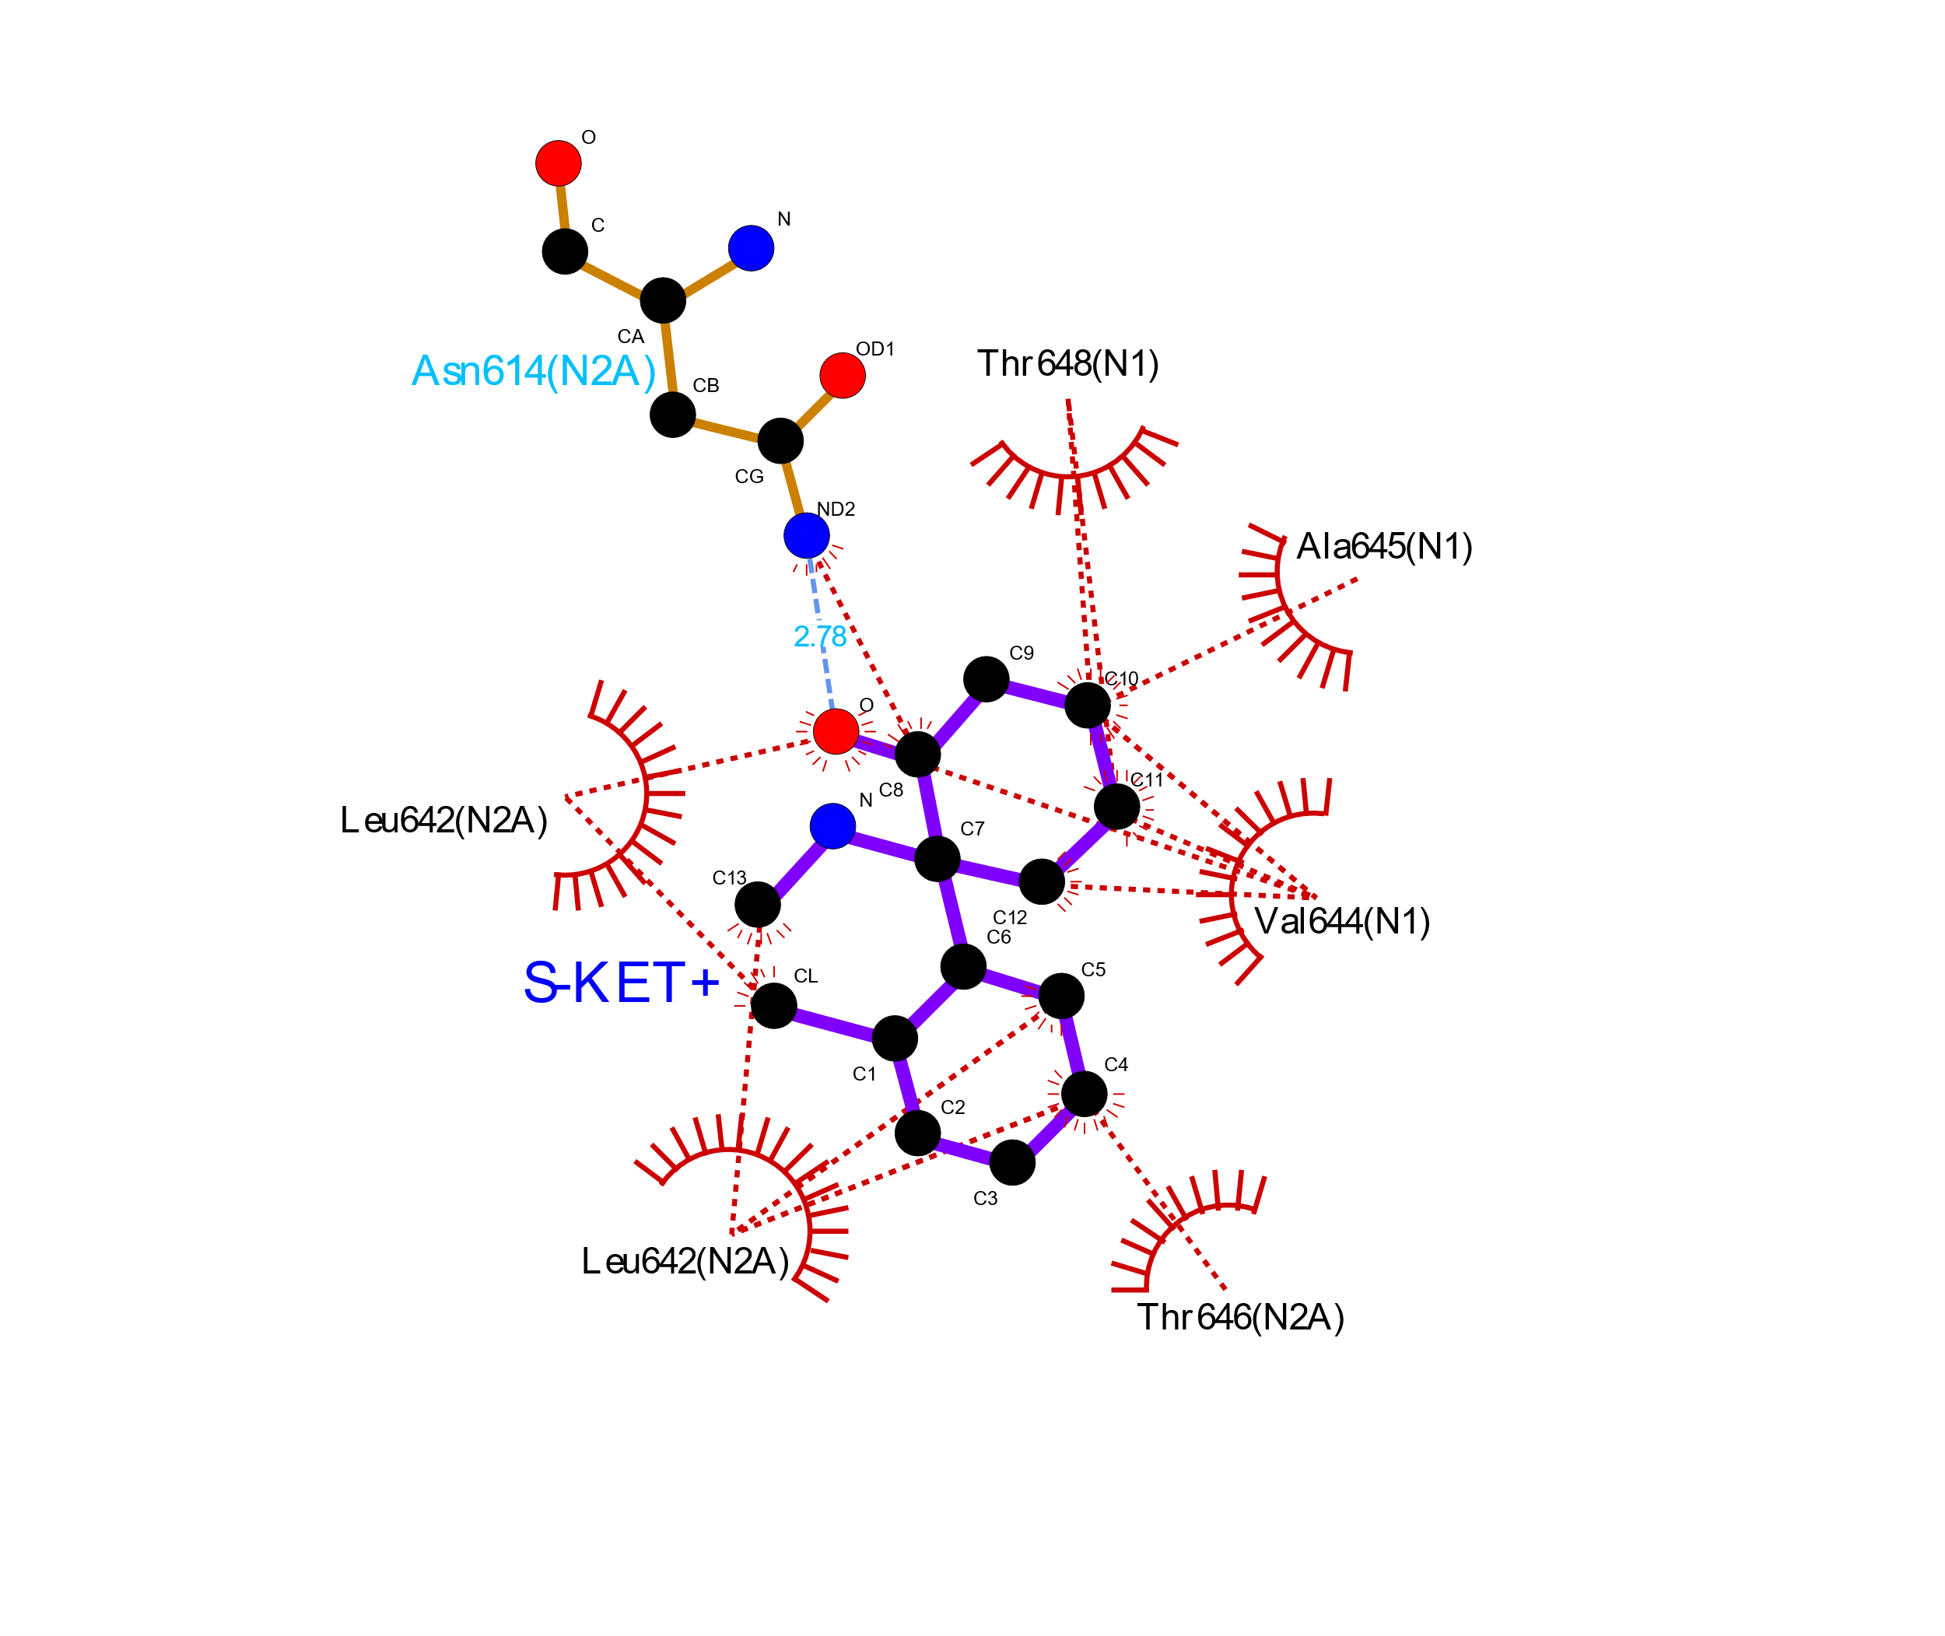
SITE 1
SITE 2
SITE 2
Figure S1: The contacts between S/R-KET+ with NMDA receptor at the central (site 1) and allosteric site (site 2). The S-KET+ at site1 shown on left, S-KET+ at site 2 in the middle, R-KET+ at site 2 on the right. Inactive NMDA receptor structure was used (PDB ID: 6whs), hydrophobic contacts shown in red and hydrogen bond shown in blue dash lines, analysis was performed using Ligplot⁺.

Supplementary Figure 2
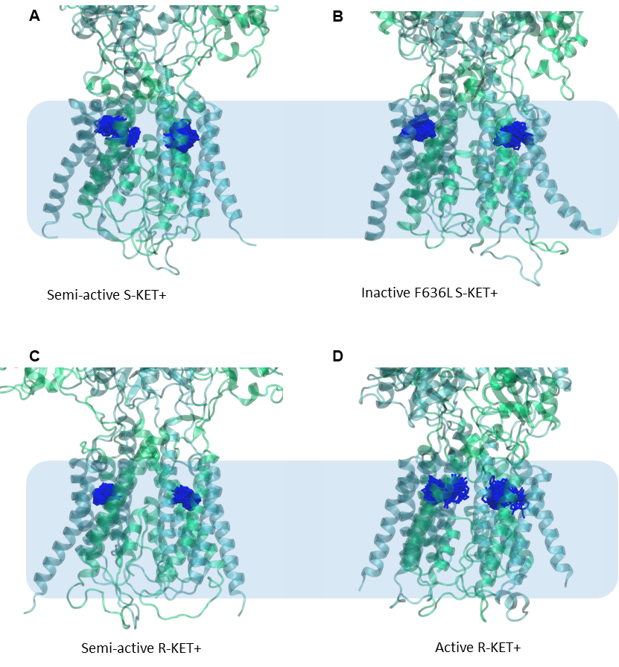
Supplementary Figure S2: Simulated interactions at the allosteric sites between S/R-KET+ and NMDA receptors of different states. (A) Results from MD simulation of S-KET+ with semi-active NMDA receptor (PDB ID: 6wi1), where the S-KET+ has a tendency to permeate into the pore (B) Results from MD simulation of S-KET+ with inactive NMDA receptor (PDB ID: 6whs) with GluN2A F636L mutation, where the S-KET+ displayed more flexible dynamics and a tendency to move towards the membrane (C) Results from MD simulation of R-KET+ with semi-active NMDA receptor (PDB ID: 6wi1), where the R-KET+ displayed more stable conformations without the tendency to permeate into the pore compared to S-KET+ (D) Results from MD simulation of R-KET+ with active NMDA receptor (see Methods), the R-KET+ displayed a tendency to permeate into the pore but not fully permeate compared to S-KET+

Supplementary Figure S3

Figure S3: Burst analysis of single-channel recordings with bath-applied KET. (A) Top, Example recording of single-channel activity illustrating burst activity. Full records can be subdivided into bursts with measured durations (BD) and interburst closures with measured durations (IBD). Bottom, Example closed event duration histograms fit with five exponential functions each representing a stable state within the kinetic model (lines). For each condition, a critical time constant (τ_{crit}, vertical red line) is statistically defined to optimally separate long, interburst closures (IBD) from bursts (BD). (B) Single-channel open probability (Po) measured from the indicated construct using the whole record (includes IBD) or restricted to bursts (excludes IBD). Values are quantified using activity >15 min after the bath KET application to ensure equilibration. All values are represented as normalized to activity prior to KET application. (C) Quantification of interburst durations (IBD) and burst durations (BD) normalized to pre-KET bath application. *p < 0.05 paired-student t-test relative to pre-KET bath application.

Supplementary TABLES

Supplementary Table 1: Inhibitory potency of ketamine on macroscopic NMDA receptor currents
Receptor | KET | Model | R² | EC_{50,1} (μM) | EC_{50,2} (μM) | h₁ | h₂ | df | F | P
WT | RS | Monophasic  Biphasic | 0.91  0.97 | 0.37  0.02 | -  0.67 | 1.79  8.30 | -  0.59 | 185  182 | 39.65 | < 10⁻⁵
WT | R | Monophasic  Biphasic | 0.80  0.87 | 0.42  0.06 | -  1.50 | 1.27  8.49 | -  1.09 | 53  50 | 9.58 | < 10⁻⁵
WT | S | Monophasic  Biphasic | 0.85  0.87 | 0.24  0.13 | -  1.31 | 2.22  6.91 | -  0.55 | 63  61 | 7.44 | < 10⁻⁵
F636A | RS | Monophasic  Biphasic | 0.95  d.n.c. | 0.66  - | -  - | 1.56  - | -  - | 109  - | - | -
F636L | RS | Monophasic  Biphasic | 0.99  d.n.c. | 0.49  - | -  - | 2.10  - | -  - | 80  - | - | -
L642A | RS | Monophasic  Biphasic | 0.98  d.n.c. | 18.46  - | -  - | 0.98  - | -  - | 220  - | - | -
N616A | RS | Monophasic  Biphasic | 0.94  d.n.c. | 7.53  - | -  - | 0.13  - | -  - | 102  - | - | -
Y647L | RS | Monophasic  Biphasic | 0.94  0.95 | 0.11  0.09 | -  0.13 | 11.10  3.08 | -  2.87 | 200  197 | 13.13 | < 10⁻⁵
d.n.c., did not converge.
df, degrees of freedom.

Supplementary Table 2 MD simulation binding free energy with MM-GBSA (Kcal/mol):
System | S-KET⁺ | S-KET⁺ | R-KET⁺ | S-KET⁺
System | site 1 (WT) | sites 2/3 (WT) | sites 2/3 (WT) | sites 2/3 (F636L)
Inactive(6whs) | -30.2 ± 0.4 | -31.6 ± 0.3 | -33.6 ± 0.2 | -29.1 ± 0.3
Semi-active | -29.1 ± 0.4 | -32.0 ± 0.2 | -32.8 ± 0.2
Inactive(4tlm) | -31.7 ± 0.3 | -30.6 ± 0.4 | -29.2 ± 0.3
Active | -21.8 ± 0.4 | -25.6 ± 0.4 | -26.9 ± 0.3

Supplementary Table 3 KET RMSD in MD simulation (RMSD(Å)):
System | S-KET⁺ | S-KET⁺ | R-KET⁺ | S-KET⁺
System | site 1 (WT) | sites 2/3 (WT) | sites 2/3 (WT) | sites 2/3 (F636L)
Inactive(6whs) | 3.79 ± 0.50 | 2.04 ± 0.50 | 1.43 ± 0.41 | 3.66 ± 0.63
Semi-active | 4.14 ± 0.94 | 4.33 ± 1.48 | 1.68 ± 0.36
Inactive(4tlm) | 3.48 ± 1.13 | 4.79 ± 0.52 | 4.86 ± 1.49
Active | 8.63 ± 4.52 | 8.25 ± 3.25 | 5.71 ± 1.47

Supplementary Table 4: Stationary kinetic parameters for WT receptors at pH 7.2
KET (nM) | N records | i (pA) | P_{o} | MOT  (ms) | MCT  (ms) | n_{event} | Record time (min) | τ_{crit} (ms)
0 | 6 | 7.8 ± 0.5 | 0.32 ± 0.12 | 3.4 ± 0.8 | 8.5 ± 3.7 | 1,175,310 | 234 | 44.0
25 | 3 | 7.0 ± 0.8 | 0.24 ± 0.17 | 2.3 ± 0.7 | 13 ± 12 | 446,499 | 87 | 20
75 | 4 | 8.1 ± 0.5 | 0.09 ± 0.06 | 2.0 ± 0.4 | 27 ± 15 | 266,210 | 110 | 22
100 | 5 | 8.2 ± 1.1 | 0.10 ± 0.06 | 3.7 ± 1.6 | 36 ± 23 | 256,175 | 176 | 41
250 | 5 | 8.4 ± 1.1 | 0.07 ± 0.02 | 2.9 ± 0.9 | 39 ± 4 | 170,490 | 116 | 43

Supplementary Table 5: Rate constants (s⁻¹) optimized from activity recorded from GuN1/GluN2A at pH 7.2.
Model | C₃C₂ | C₂C₃ | C₂C₁ | C₁C₂ | C₁O | OC₁ | C₂C₄ | C₄C₂ | C₃C₅ | C₅C₃ | k_{on} | k_{off} | k_{D} (nM)
KET-free | 365 | 160 | 691 | 3124 | 3031 | 318 | 8.3 | 44.8 | 1.9 | 0.24 | - | - | -
M_{B} | 338 | 362 | 629 | 2868 | 2075 | 582 | 20.2 | 32.4 | 3.1 | 0.23 | 9.1 | 1.9 | 216
M_{C1} | 339 | 363 | 628 | 2877 | 2079 | 584 | 20.4 | 32.5 | 3.1 | 0.23 | 90.4 | 7.2 | 80
M_{C2} | 343 | 375 | 639 | 2909 | 2087 | 5856 | 21.1 | 32.9 | 3.1 | 0.23 | 26.2 | 1.7 | 64
M_{C3} | 344 | 364 | 628 | 2892 | 2080 | 585 | 21.5 | 33.7 | 3.2 | 0.23 | 63.0 | 1.6 | 24
M_{C4} | 187 | 151 | 459 | 2554 | 1973 | 568 | 6.0 | 13.8 | 2.7 | 0.21 | 88.3 | 2.2 | 24
M_{C5} | 363 | 396 | 669 | 2936 | 2136 | 559 | 25 | 36.7 | 3.2 | 0.24 | 3.7 | 0.2 | 50

REFERENCES and Notes
1. G. Popescu, A. Auerbach, Modal gating of NMDA receptors and the shape of their synaptic response. Nat Neurosci 6, 476-483 (2003).
2. C. L. Kussius, N. Kaur, G. K. Popescu, Pregnanolone sulfate promotes desensitization of activated NMDA receptors. J Neurosci 29, 6819-6827 (2009).
3. G. Popescu, A. Robert, J. R. Howe, A. Auerbach, Reaction mechanism determines NMDA receptor response to repetitive stimulation. Nature 430, 790-793 (2004).
4. C. H. Lee et al., NMDA receptor structures reveal subunit arrangement and pore architecture. Nature 511, 191-197 (2014).
5. T. H. Chou, N. Tajima, A. Romero-Hernandez, H. Furukawa, Structural Basis of Functional Transitions in Mammalian NMDA Receptors. Cell 182, 357-371 e313 (2020).
6. G. J. Iacobucci et al., Cross-subunit interactions that stabilize open states mediate gating in NMDA receptors. Proc Natl Acad Sci U S A 118, (2021).
7. O. Trott, A. J. Olson, AutoDock Vina: improving the speed and accuracy of docking with a new scoring function, efficient optimization, and multithreading. J Comput Chem 31, 455-461 (2010).
8. K. Vanommeslaeghe, E. P. Raman, A. D. MacKerell, Jr., Automation of the CHARMM General Force Field (CGenFF) II: assignment of bonded parameters and partial atomic charges. J Chem Inf Model 52, 3155-3168 (2012).
9. B. F. Ion, M. M. Wells, Q. Chen, Y. Xu, P. Tang, Ketamine Inhibition of the Pentameric Ligand-Gated Ion Channel GLIC. Biophys J 113, 605-612 (2017).
10. S. Jo, T. Kim, V. G. Iyer, W. Im, CHARMM-GUI: a web-based graphical user interface for CHARMM. J Comput Chem 29, 1859-1865 (2008).
11. J. Lee et al., CHARMM-GUI Input Generator for NAMD, GROMACS, AMBER, OpenMM, and CHARMM/OpenMM Simulations Using the CHARMM36 Additive Force Field. J Chem Theory Comput 12, 405-413 (2016).
12. S. Nosé, A molecular dynamics method for simulations in the canonical ensemble. Mol Physics 52, 255-268 (1984).
13. W. G. Hoover, Canonical dynamics: Equilibrium phase-space distributions. Phys Rev A Gen Phys 31, 1695-1697 (1985).
14. M. Parrinello, A. Rahman, Polymorphic transitions in single crystals: A new molecular dynamics method. J Applied Physics 52, (1981).
15. T. Darden, D. York, L. Pedersen, Particle mesh Ewald: An Nlog(N) method for Ewald sums in large systems. J Chem Physics 98, 10089-10092 (1993).
16. B. Hess, H. Bekker, H. J. C. Berendsen, J. G. E. M. Fraaije, LINCS: A linear constraint solver for molecular simulations. J Comp Chem 18, 1463-1472 (1998).
17. S. Pronk et al., GROMACS 4.5: a high-throughput and highly parallel open source molecular simulation toolkit. Bioinformatics 29, 845-854 (2013).
18. J. B. Klauda et al., Update of the CHARMM all-atom additive force field for lipids: validation on six lipid types. J Phys Chem B 114, 7830-7843 (2010).
19. J. Huang, A. D. MacKerell, Jr., CHARMM36 all-atom additive protein force field: validation based on comparison to NMR data. J Comput Chem 34, 2135-2145 (2013).
20. W. Jorgensen, J. Chandrasekhar, J. Madura, Comparison of simple potential functions for simulating liquid water. J Chem Physics 79, 926-935 (1983).
21. S. Izrailev et al., in Computational Molecular Dynamics: Challenges, Methods, Ideas, P. Deuflhard et al., Eds. (Springer Berlin Heidelberg, Berlin, Heidelberg, 1999), pp. 39-65.
22. M. Bonomi et al., PLUMED: A portable plugin for free-energy calculations with molecular dynamics. Computer Physics Communications 180, 1961-1972 (2009).
23. G. A. Tribello, M. Bonomi, D. Branduardi, C. Camilloni, G. Bussi, PLUMED 2: New feathers for an old bird. Computer Physics Communications 185, 604-613 (2014).
24. M. Bonomi et al., Promoting transparency and reproducibility in enhanced molecular simulations. Nature Methods 16, 670-673 (2019).
25. W. Humphrey, A. Dalke, K. Schulten, VMD: Visual molecular dynamics. Journal of Molecular Graphics 14, 33-38 (1996).
26. R. A. Laskowski, M. B. Swindells, LigPlot+: multiple ligand-protein interaction diagrams for drug discovery. J Chem Inf Model 51, 2778-2786 (2011).

