Supplementary Material
New Butyl Shikimate Acetal Derivative from Aerial Parts of Acalypha wilkesiana Müll. Mosaica. extracts
Amal M. Youssef Moustafa^{1*}, Maha M. A. El-Damrany², Mamdouh Abdel-Mogib³, Magdy M. Youssef⁴
1 Chemistry Department, Faculty of Science, Port Said University, Port Said, 42511, Egypt
2 Chemistry Department, Faculty of Science, Port Said University, Port Said, 42511, Egypt
3 Chemistry Department, Faculty of Science, Mansoura University, Mansoura, 35516, Egypt
4 Chemistry Department, Faculty of Science, Mansoura University, Mansoura, 35516, Egypt

*Corresponding Author
Email: *moustafaamm@yahoo.com , a.moustafa@sci.psu.edu.eg
Maha M.A. El-Damrany- Email: mahameldmrany@gmail.com
Mamdouh Abdel-Mogib - Email: mamdouh_m@mans.edu.eg
Magdy M. Youssef - Email: mmm_youssef@mans.edu.eg

Abstract
The aerial parts of Acalypha wilkesiana gave undescribed potassium 2-butoxyacetimidate (1) and Butyl 3(S),4(S),5(R)-4-oxy-3-epishikimic acid carboxylate acetal [(1S,8S,9R)-8,9-dihydroxy-3-propyl-2,4-dioxabicyclo[4.2.2]dec-6-en-5-one] (2), and shikimic acid, as well as nineteen known glycosylated phenylpropanoids, benzoic acid derivatives and flavonoids. The structures of the isolated compounds were elucidated based on 1D, 2D NMR, and ES IMS.

Contents
Abstract…………………………………………………………………………….….1
List of Figures………………………………………………………………...…….…2
List of Tables……………………………………………………………...…….…….3
1. General Experimental Procedures……………………………………….…… ….30
2. Extraction, isolation, and identification………………………………….………..30
References………………………………………………………….……………...…36

List of Figures

Fig S1a. ¹H NMR spectrum of compound (1)……………………………. | 3
Fig S1b. ¹³C APT NMR spectrum of compound (1)……………………... | 4
Fig S1c. NOESY NMR spectrum of compound (1)……………………… | 5
Fig S1d. H, H COSY spectrum of compound (1)………………………… | 5
Fig S1e. HMBC spectrum compound (1)…………………………………. | 6
Fig S1f. HSQC spectrum of compound (1)………………………………. | 6
Fig S2a. ¹H NMR spectrum of compound (2)……………………………… | 8
Fig S2b. H, H COSY and HMBC correlations of compound (2)……….…. | 9
Fig S2c. H, H COSY of compound (2)……………………………………. | 9
Fig S2d. H, H COSY spectrum of compound (2)………………………….. | 10
Fig S2e. HMBC spectrum of compound (2)……………………………….. | 12
Fig S2f. HSQC spectrum of compound (2)……………………………….. | 13
Fig S3. Structure of compound (3)……………………………………….. | 14
Fig S4a. ¹H NMR spectrum of compound (3)……………………………. | 14
Fig S4b. ¹³C NMR spectrum of compound (3)…………………………… | 15
Fig S4c. H, H COSY spectrum of compound (3)…………………………. | 15
Fig S4d. HMBC spectrum of compound (3)……………………………… | 16
Fig S4e. HSQC spectrum of compound (3)………………………………. | 16
Fig S4f. ¹³C APT NMR spectrum of compound (3)…………………… | 17
Fig S4g. NOESY NMR spectrum of (3)……………………………….. | 17
Fig S4h. ESI MS spectrum of compound (3)…………………………….. | 18
Fig S5. Structure of compound (4)……………………………………….. | 18
Fig S6. ¹H NMR spectrum of compound (4)……………………………... | 19
Fig S7. Structures of compounds (5-7)……………………………………. | 19
Fig S8a. ¹H NMR spectrum of compounds (5-7)…………………………. | 20
Fig S8b. ¹³C NMR spectrum of compounds (5-7)………………………… | 21
Fig S9. Structures of compounds (8 & 9)…………………………………. | 21
Fig S10a. ¹H NMR spectrum of compounds (8 & 9)…………………….. | 22
Fig S10b. ¹³C NMR spectrum of compounds (8 & 9)……………………. | 22
Fig S11. Structures of compounds (10-13)…………………………………. | 22
Fig S12a. ¹H NMR spectrum of compounds (10-13)………………………. | 23
Fig S12b. ¹³C NMR spectrum of compounds (10-13)……………………… | 23
Fig S13. Structures of compounds (14-16)………………………………… | 23
Fig S14a. ¹H NMR spectrum of compounds (14-16)……………………… | 24
Fig S14b. ¹³C NMR spectrum of compounds (14-16)…………………….. | 24
Fig S15. Structures of compounds (17 & 18)……………………………… | 24
Fig S16a. ¹H NMR spectrum of compounds (17 & 18)…………………… | 25
Fig S16b. ¹³C NMR spectrum of compounds (17 & 18)………………….. | 25
Fig S17. Structure of compound (19)……………………………………… | 25
Fig S18a. ¹H NMR spectrum of compound (19)………………………….. | 26
Fig S18b. ¹³C NMR spectrum of compound (19)…………………………. | 26
Fig S19. Structures of compounds (20-22)………………………………… | 27
Fig S20a. ¹H NMR spectrum of compounds (20-22)……………………… | 27
Fig S20b. ¹³C NMR spectrum of compounds (20-22)…………………….. | 28

List of Tables
Table S1 Chromatographic behavior of phenolic compounds isolated from of
n- Butanol extract…………………………………………………….….…………28
Table S2 ¹H NMR and ¹³C NMR spectral data of compound (1)...…………...….29
Table S3 ¹H and ¹³C NMR spectral data of compound (2)…….………….………29

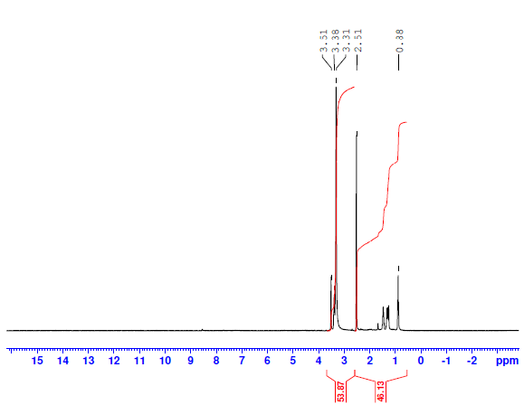
Fig S1a. ¹H NMR spectrum of compound (1)

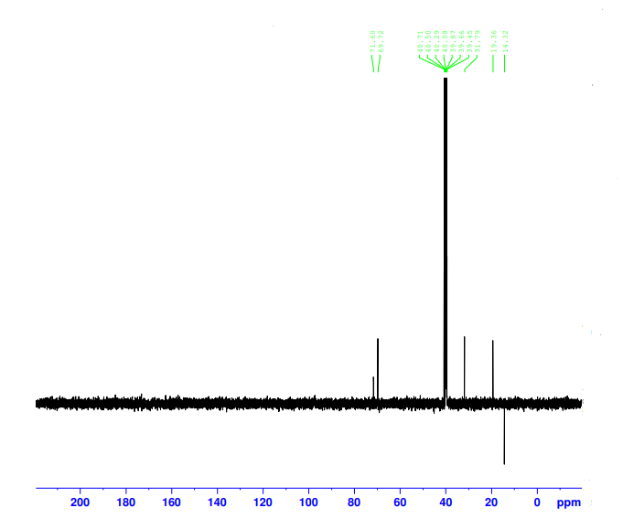
Fig S1b. ¹³C APT NMR spectrum of compound (1)

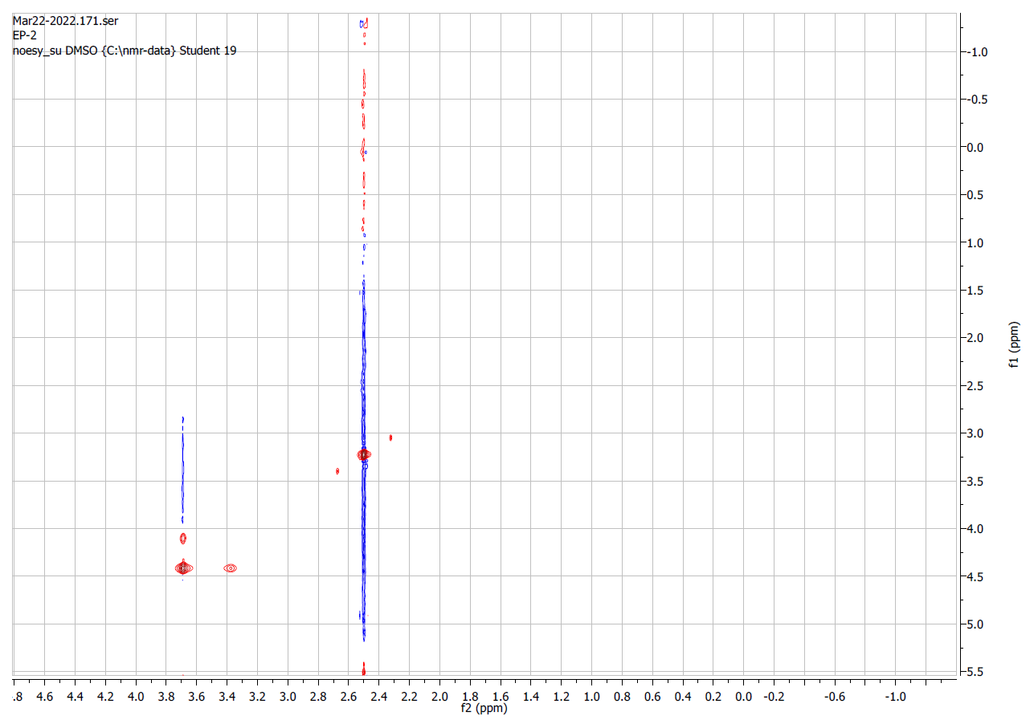
Fig S1c. NOESY spectrum of compound (1)

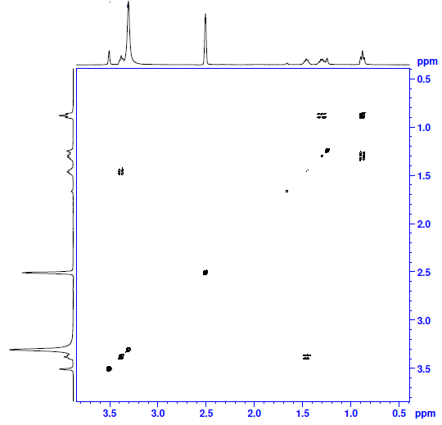
Fig S1d. H, H COSY spectrum of compound (1)
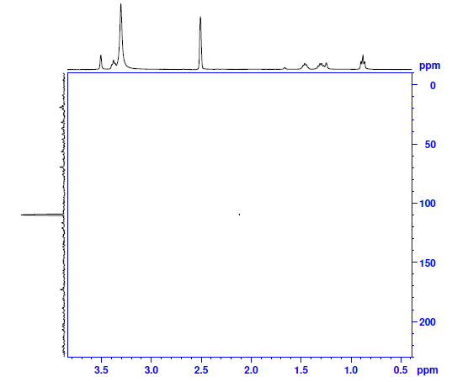
Fig S1e. HMBC spectrum of compound (1)

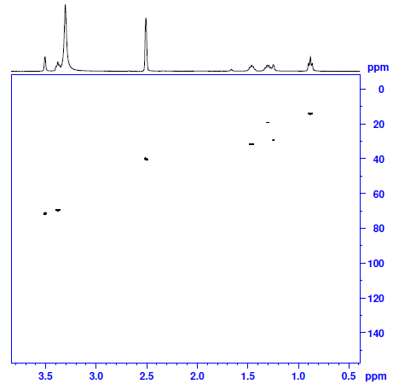
Fig S1f. HSQC spectrum of compound (1)

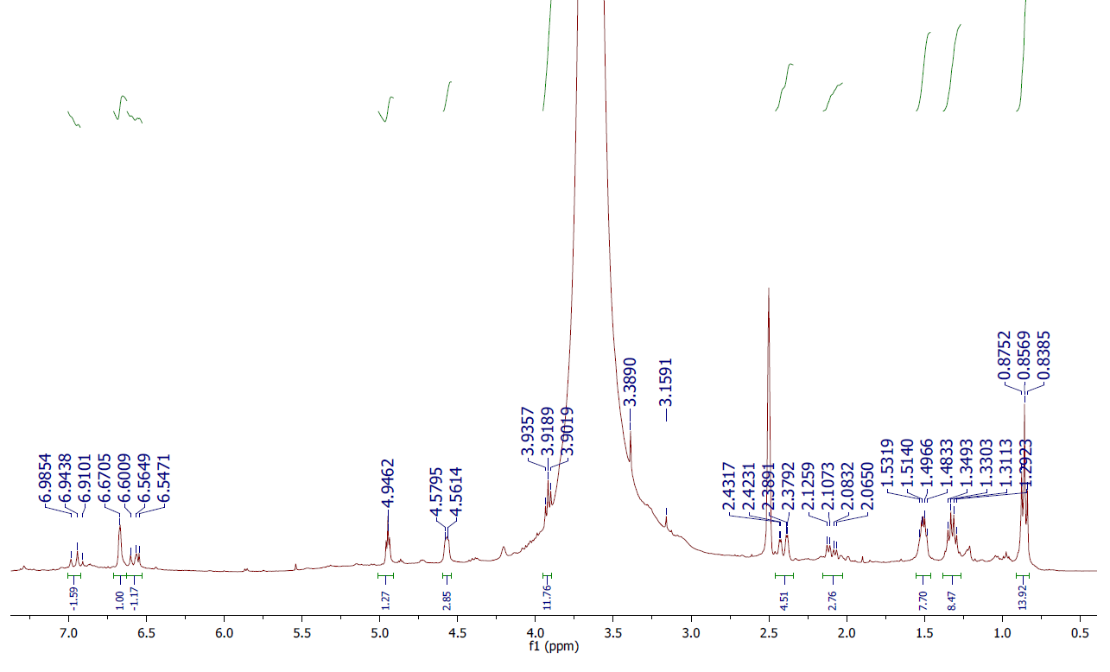
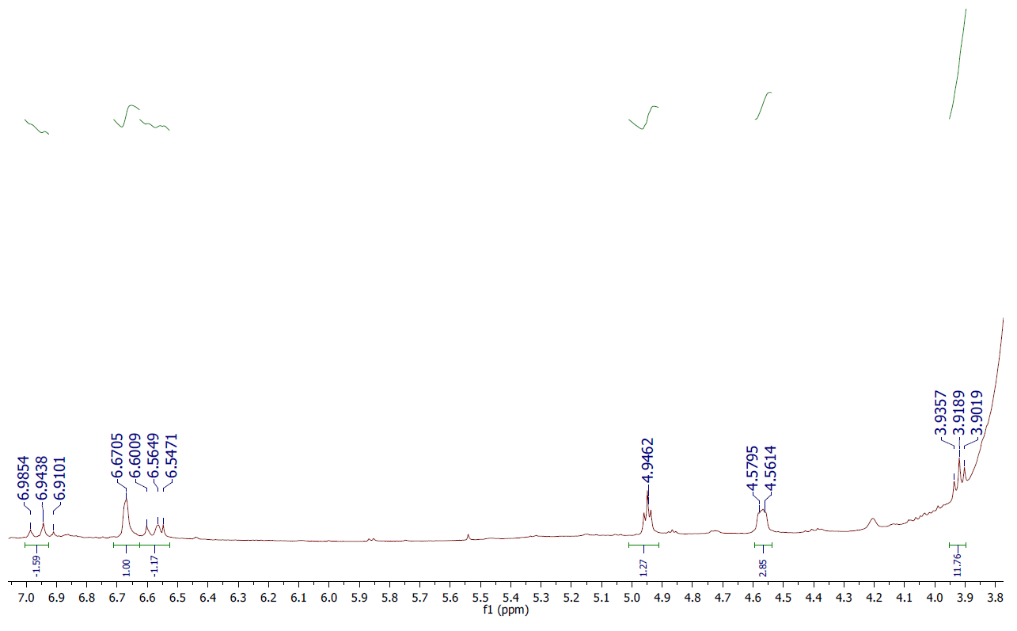

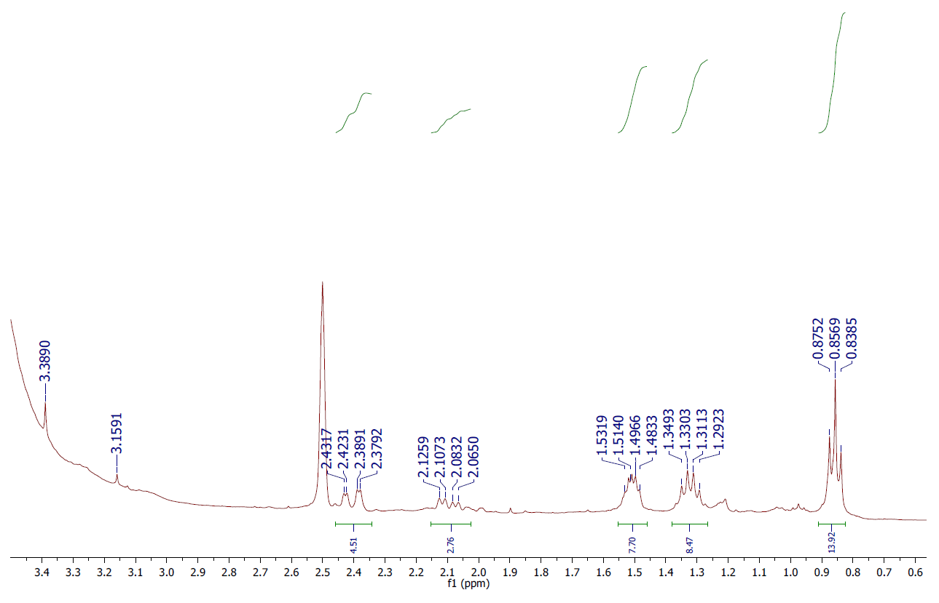

Fig S2a. ¹H NMR spectrum of compound (2)

Fig S2b. H, H COSY and HMBC correlations of compound (2)
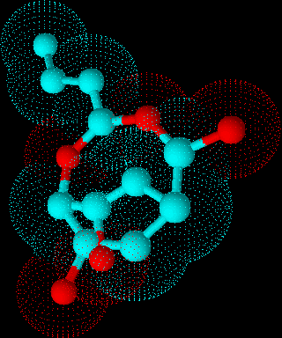
Fig S2c. H, H COSY of compound (2)

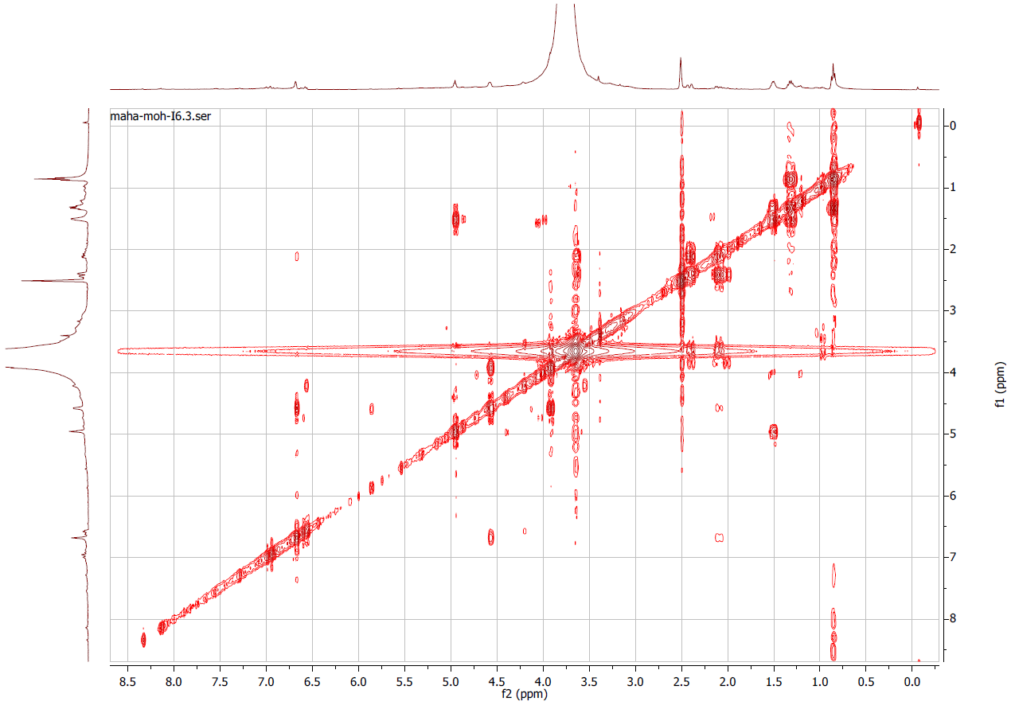
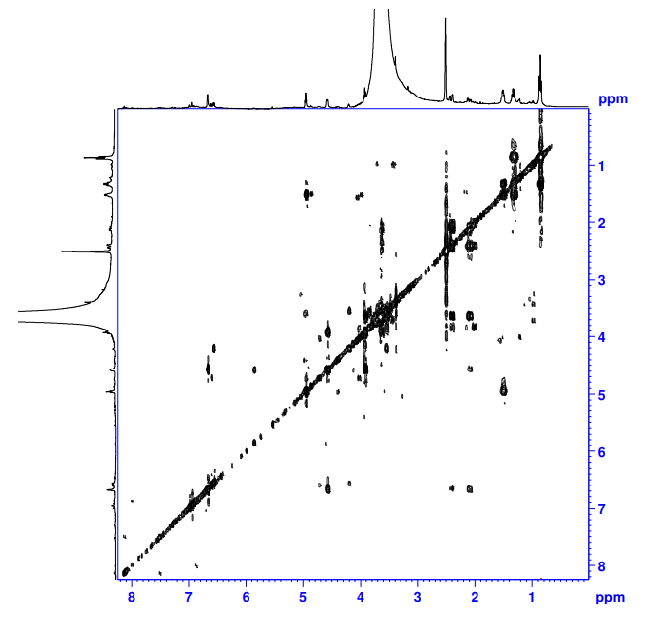
Fig S2d. H, H COSY spectrum of compound (2)

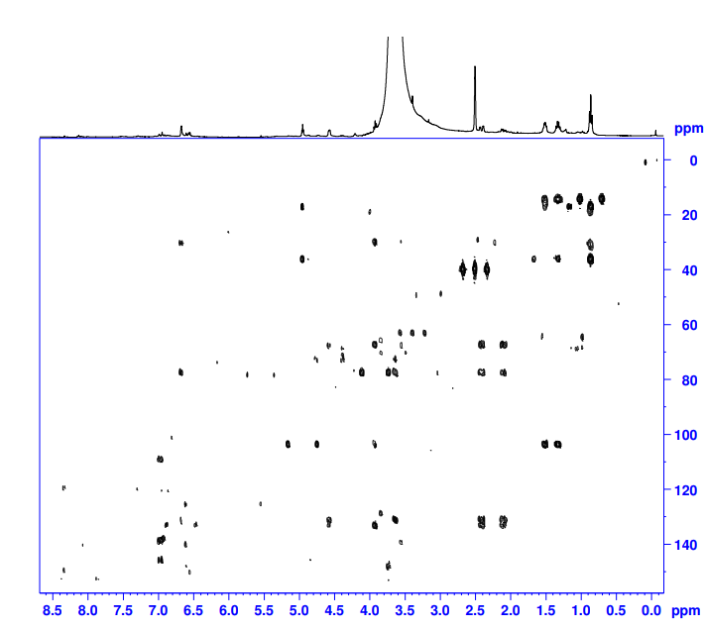
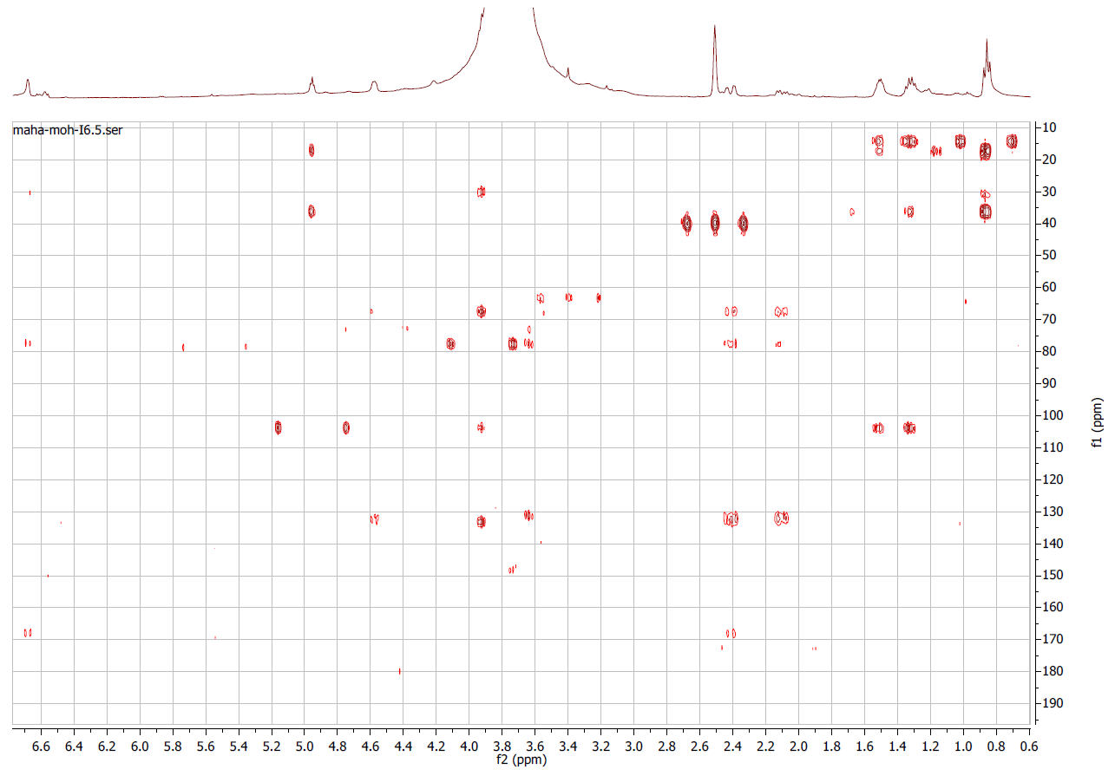
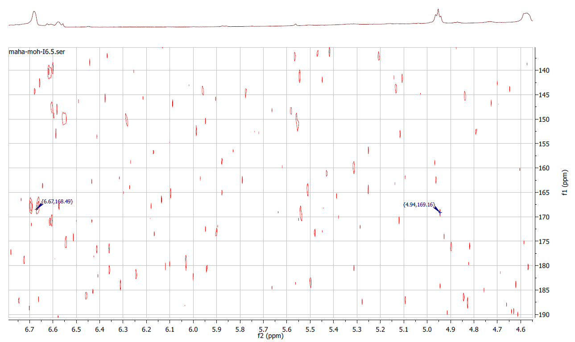
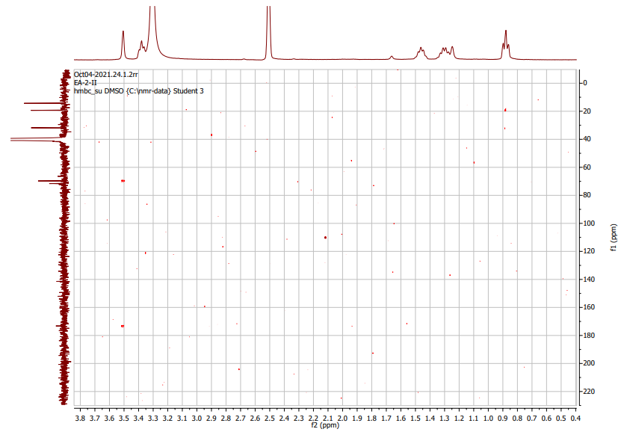

Fig S2e. HMBC spectrum of compound (2)
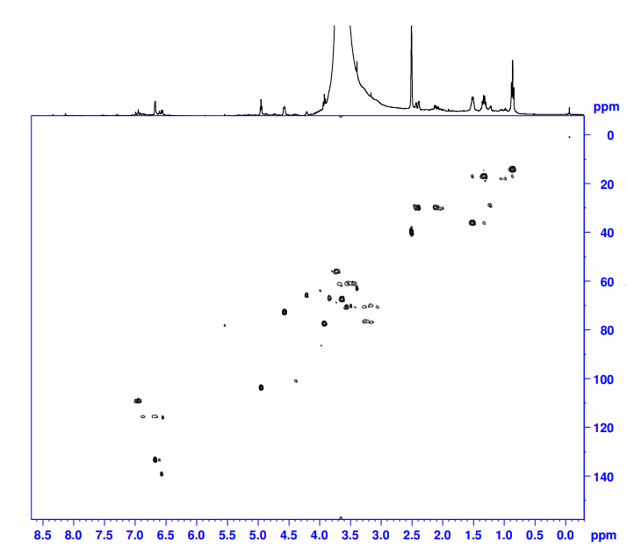
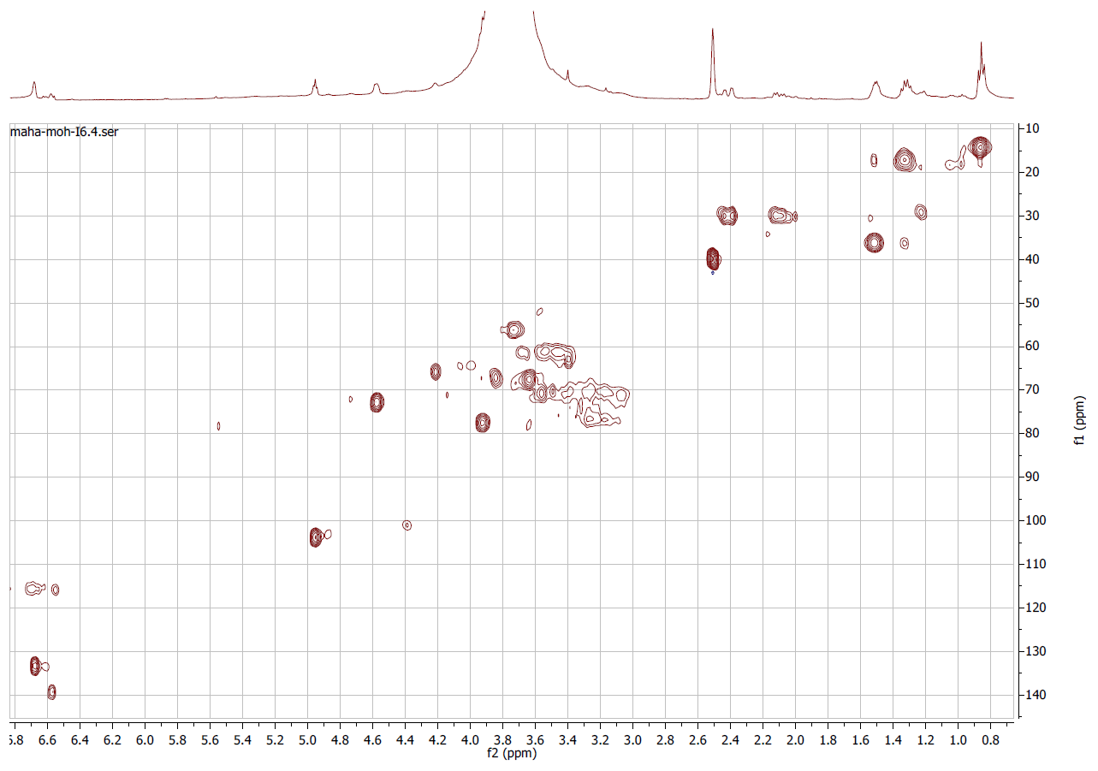
(The up-field region of ¹³C NMR spectrum of compound 2)
Fig S2f. HSQC spectrum of compound (2)

Fig S3. Structure of compound (3)

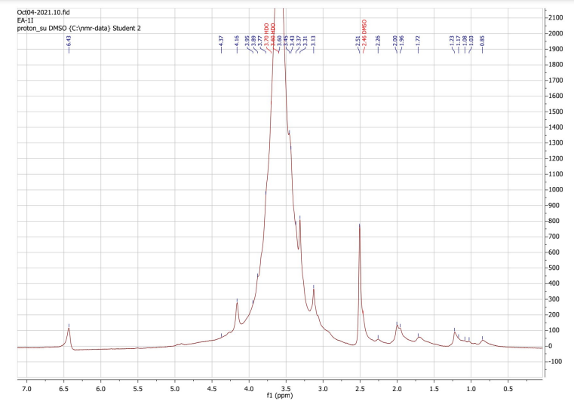
Fig S4a. ¹H NMR spectrum of compound (3)

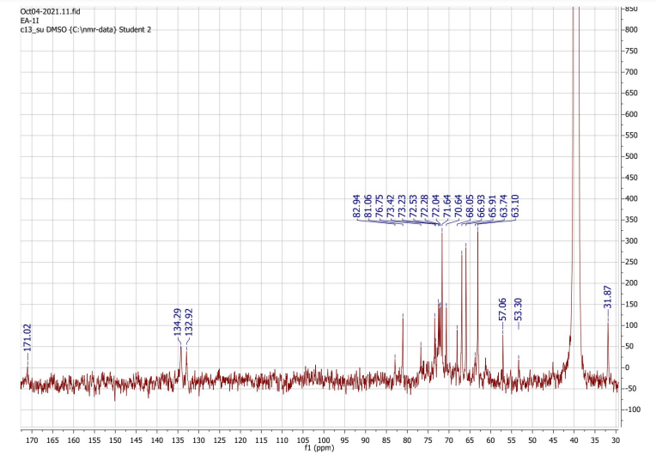
Fig S4b. ¹³C NMR spectrum of compound (3)
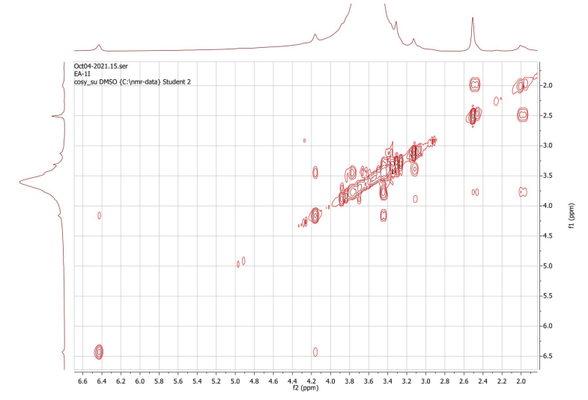
Fig S4c. H, H COSY spectrum of compound (3)
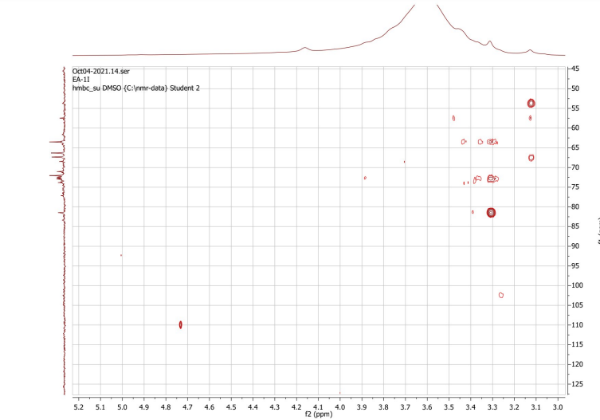
Fig S4d. HMBC spectrum of compound (3)
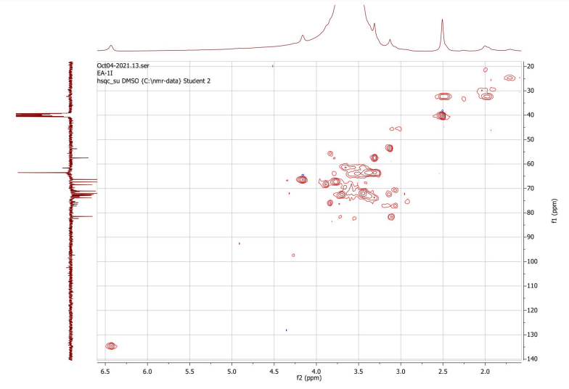
Fig S4e. HSQC spectrum of compound (3)
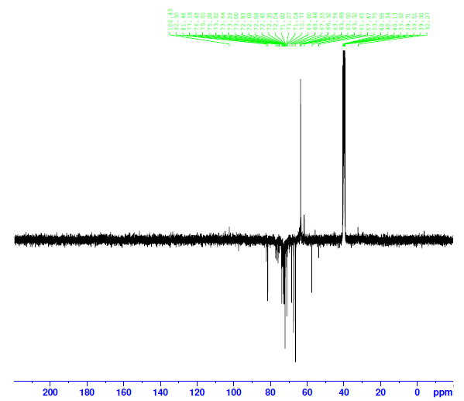
Fig S4f. ¹³C APT NMR spectrum of compound (3)

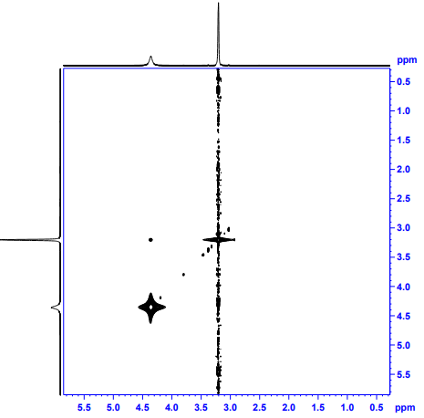
Fig S4g. NOESY NMR spectrum of (3)
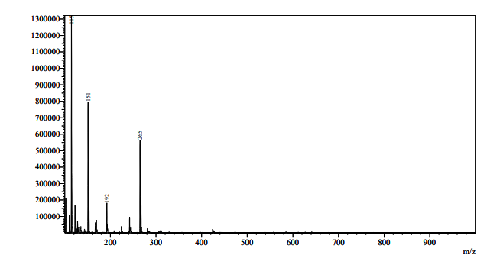
C₇H₁₁O₇, m/z 192 [M+NH₄]⁺
Fig S4h. ESI MS spectrum of compound (3)

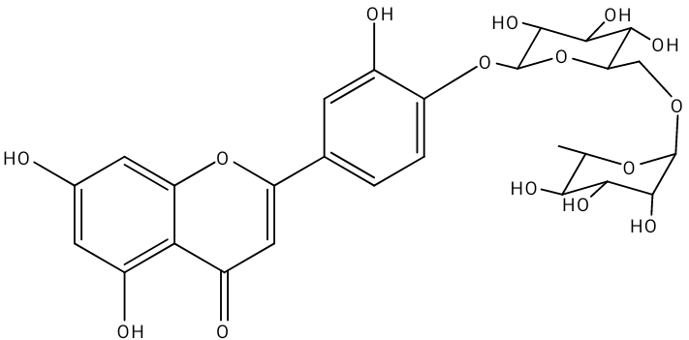

Fig S5. Structure of compound (4)

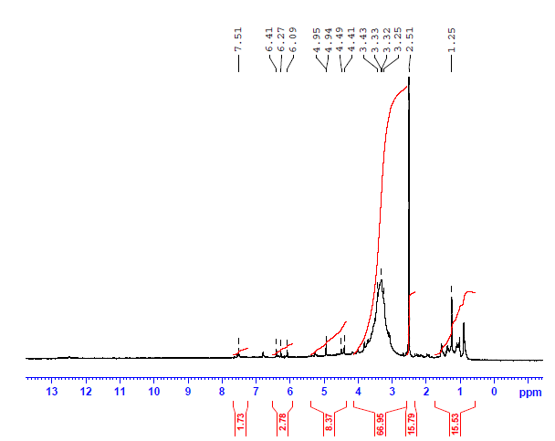
Fig S6. ¹H NMR spectrum of compound (4)

Fig S7. Structures of compounds (5-7)

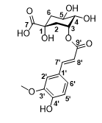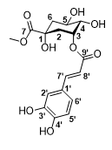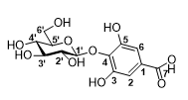
(5) (6) (7)

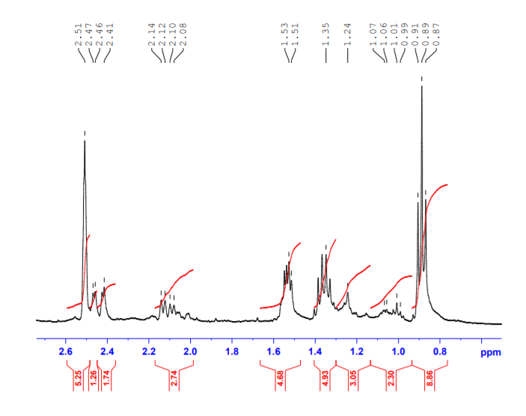

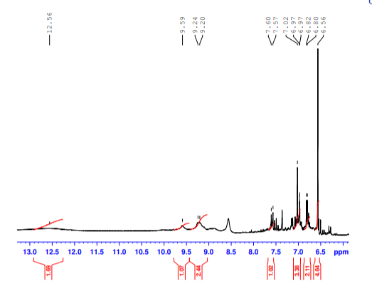
Fig S8a. ¹H NMR spectrum of compounds (5-7)

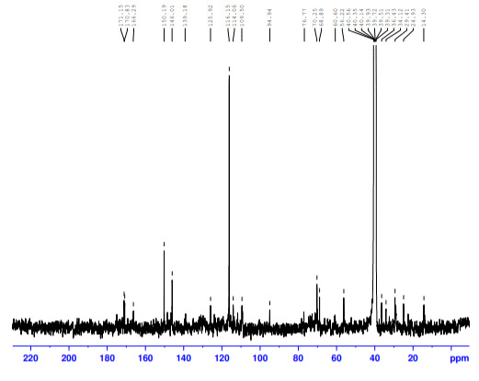
Fig S8b. ¹³C NMR spectrum of compounds (5-7)

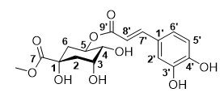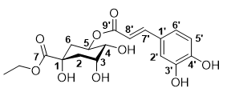
(8) (9)
Fig S9. Structures of compounds (8 & 9)
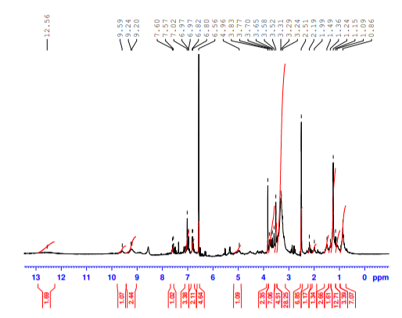
Fig S10a. ¹H NMR spectrum of compounds (8 & 9)
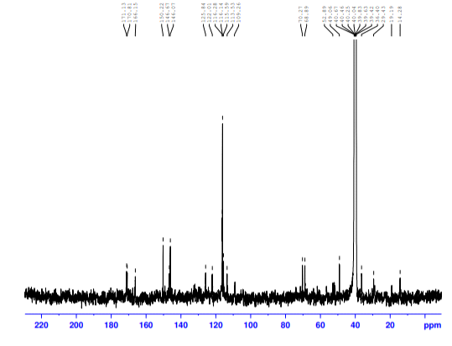
Fig S10b. ¹³C NMR spectrum of compounds (8 & 9)
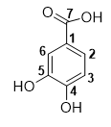
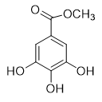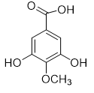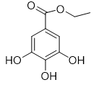
(10) (11) (12) (13)
Fig S11. Structures of compounds (10-13)
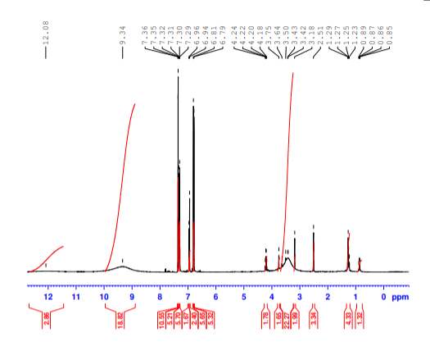
Fig S12a. ¹H NMR spectrum of compounds (10-13)
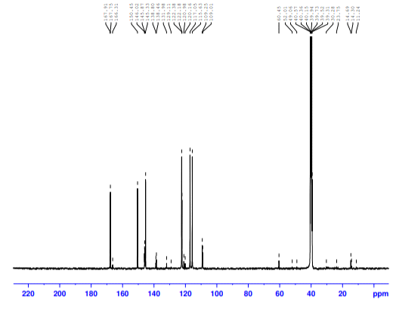
Fig S12b. ¹³C NMR spectrum of compounds (10-13)
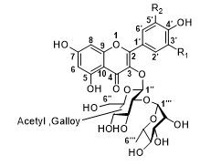
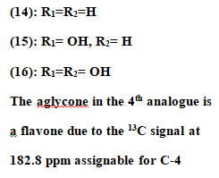
Fig S13. Structures of compounds (14-16)
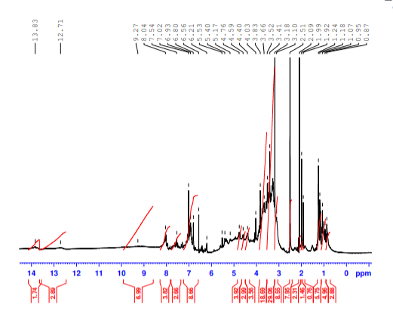
Fig S14a. ¹H NMR spectrum of compounds ((14-16)
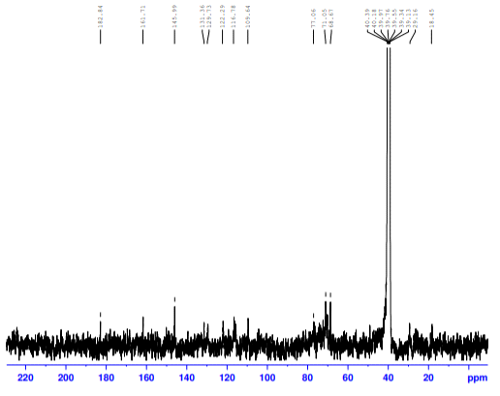
Fig S14b. ¹³C NMR spectrum of compounds (14-16)
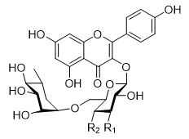
(17)_{maj}: R₁= -OSO₃H, R₂= OH
(18)_{min}: R₁= OH, R₂= -OSO₃H
Fig S15. Structures of compounds (17& 18)
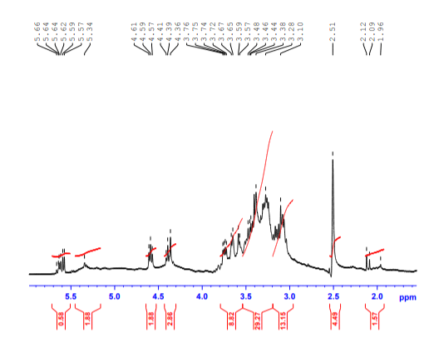
Fig S16a. ¹H NMR spectrum of compounds (17 & 18)
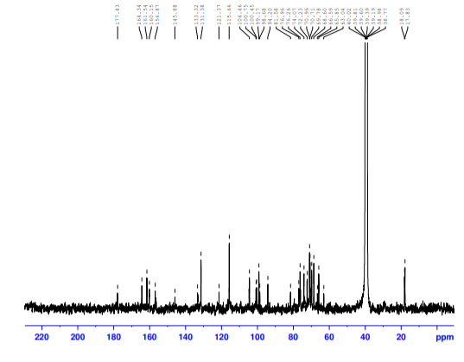
Fig S16b. ¹³C NMR spectrum of compounds (17 & 18)

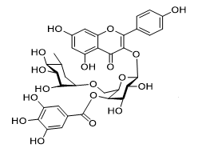
(19)
Fig S17. Structure of compound (19)
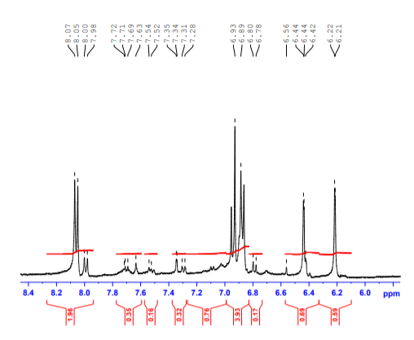
Fig S18a. ¹H NMR spectrum of compound (19)

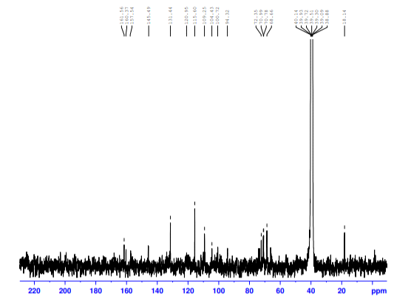
Fig S18b. ¹³C NMR spectrum of compound (19)

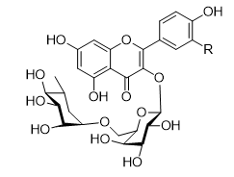
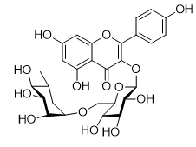
(20): R= H (22)
(21): R= OH
Fig S19. Structures of compounds (20-22)
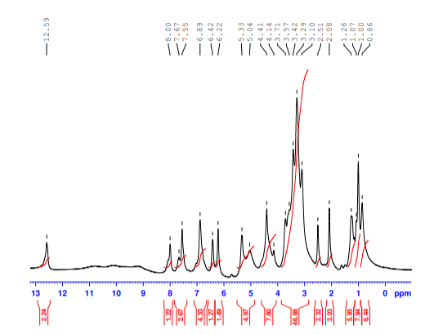

Fig S20a. ¹H NMR spectrum of compounds (20-22) (400 MHz, DMSO-d₆)

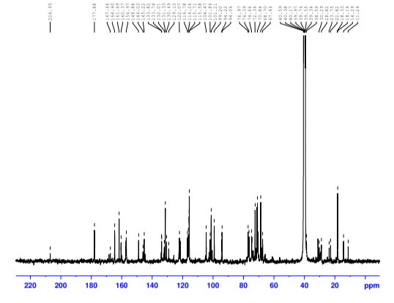
Fig S20b. ¹³C NMR spectrum of compounds (20-22) (100 MHz, DMSO-d₆)

Table S1 Chromatographic behavior of phenolic compounds isolated from n- Butanol extract
Collective Sub-Fractions  No. | Collective Fractions  No. | Isolated compounds | R_{f} values |  | UV Light  λ₃₆₅ /λ₂₅₄ | Colors with spraying reagent
Collective Sub-Fractions  No. | Collective Fractions  No. | Isolated compounds | BAW (S10)  (4:1:5) | G.A.A (S11)  (15%) | UV Light  λ₃₆₅ /λ₂₅₄ | FeCl₃ | AlCl₃ | NA-reagent
I | (1-6) (ButE-I) | 2 | 0.515 | 0.883 | Y | DBl | Y | DrPr
II | (7-10)  (ButE-II) | 14-16 (ppt) | 0.423 | 0.70 | Pr | Gr | Y | DrPr
III | (11-16)  (ButE-III) | 17, 18  (ppt) | 0.495 | 0.724 | DPr | Gr | GrY | DrPr
V | (22-23)  (ButE –V) | 19 | 0.577 | 0.542 | DPr | DGr | GrY | DrPr
IV | (24-29)  (ButE-VI) | 20-22 | 0.507 | 0.625 | DPr | Gr | Y | DrPr
VI | (30-33)  (ButE-VII) | 20-22 | 0.40 | 0.50 | Y | Y | Y | Y
VII | (30-33)  (ButE-VII) | 20-22 | 0.075 | 0.679 | Y | Y | Y | Y
VIII | (7-10)  (ButE-II) | 5-7 | 0.856 | 0.759 | Bl | Bl | GrBl | GrBl
IX | (11-16)  (ButE-III) | 8, 9  (ppt) | 0.784 | 0.713 | Bl/(Bl) | Bl | GrBl | GrBl
X | (19-20)  (ButE-IV) | 10-13 | 0.845 | 0.621 | VBl/(VBl) | DBl | VBl | V
Note; Bl: Blue, DBl: Deep Blue, Gr: Green, DGr: Deep Green, Y: Yellow,
GrY: Greenish yellow, V: Violet, DrPr: Dark Purple, GrBl: Greenish Blue

Table S2 ¹H NMR and ¹³C NMR spectral data of compound (1)
Atom  No. | δ_{H}, multiplicity (J, Hz) | Δ_{C} | HMBC
1 | - | 172.52 | H-2
2 | 3.50, s | 71.60 | -
3 | 3.37, t (6.9) | 69.72 | H-2
4 | 1.45, p (7.3) | 31.79 | H-6
5 | 1.36-1.22, m | 19.36 | H-3, H-6
6 | 0.87, t (7.2) | 14.32 | -

Table S3 ¹H and ¹³C NMR spectral data of compound (2)
Atom  No. | δ_{H} (J, Hz) | δ_{C} | HMBC
1 | --------- | 128.92 | ---------
2 | 6.67, br s | 133.18 | H-3, H-4, H-5, H-6
3 | 4.57, dd, 3.3, 7.5 | 72.79 | H-5
4 | 3.92, t, 6.7 | 77.66 | H-2, H-3, H-5, H-6
5 | 3.65, m | 67.48 | H-3, H-4, H-6
6_{ax} | 2.11, dd, 7.5, 17.0 | 30.01 | H-2, H-4
6_{eq} | 2.41, dd, 3.8, 17.0 | 30.01 | H-2, H-4
7 | -------- | 168.00 | H-2, H-6
1' | 4.94, t, 4.5 | 103.80 | H-2', H-3', H-4
2' | 1.51, m | 36.26 | H-1', H-3', H-4'
3' | 1.33, m | 17.05 | H-1', H-2', H-4'
4' | 0.86, t, 7.3 | 14.32 | H-2', H-3'

1. General Experimental Procedures
1.1. Plant material
In June 2017, A. wilkesiana was procured in Port Said, Egypt. It was recognized by the herbarium botany department of Cairo University's college of science in Giza, Egypt (12613). It was authenticated by doctor Ream Samir Hamdy, a professor in the department of plants and microbiology at Cairo University in Egypt. A voucher specimen of [A. wilkesiana Müll. Arg. (M-A1)] was deposited at the college of science's botany herbarium at Cairo University for future use.

1.2. Materials and methods
The solvents and chemicals used were of analytical grade. They were bought from Sigma Aldrich (St. Louis, USA) and Fisher Scientific Company (England). Paper chromatography, Whatman International Ltd. Maidstone, England, 46×57, Cat. No. 3030 917. 6mm, S polyamide is used for columns (Fluka Chemie, Switzerland). Sephadex® LH-20, Sigma-Aldrich.

1.3. Equipments
On an XEVO TQD triple quadruple instrument, ESI MS positive and negative ion acquisition mode was used. Mass spectrometer, Waters Corporation, Milford, MA01757, USA, Column: BEH C18 1.7 m - 2.1 × 50 mm ACQUITY UPLC. 0.2 mL/min is the flow rate. Acetonitrile and water, both containing 0.1% formic acid, were the components of the solvent system. NMR Analysis: Advance-III 400 MHz High performance FT-NMR spectrum BRUKER, BioSpin International AG-Switzerland. 0.5 ml of DMSO-d6-NMR Shimadzu Nexera 2040 Plus - ms 8045 was used to dissolve the samples. Uplc 3.7 µm C-18 column with gradient acetonitrile, water 5%-95% elution over 40 min. UV Lamp (365 nm/254 nm): Vilber lourmat Ultra Violet radiation 230 V, 50 Hz, 6W (365/254 nm) Tube, power 12 W, made in EEC, is used to visualize spots on TLC and paper chromatography. A Büchi Rotavapor II (Büchi, Switzerland).

2. Extraction, Isolation, and identification
2.1. Preparation of the plant extracts
The extraction process employed the ascending technique (Mishra et al. 2017). About 2.5 kg of dried powdered plant material (aerial part: flowers, fruits, leaves and stems) of A. wilkesiana were percolated with successive solvents; A. wilkesiana aerial parts, including dried powdered plant material weighing about 2.5 kg, was percolated with successive solvents; n-hexane (HE), methylene chloride (MCE), ethyl acetate (EA), n-butanol (ButE) and ethanol (EtE) (Mishra et al. 2017). By vacuum distillation in a rotary evaporator at 60°C, the solvents were eliminated. For the final drying, care is taken to reduce the temperature to 40°C, vacuum control is reduced from 380 mbar to 40 mbar as drying progresses, and the product is then chilled until usage. The extract yields were approximately 16 g (0.64%) of dark green residue from n-hexane extract (HE), 5.5 g (0.22%) of methylene chloride extract (MCE), 4.8 g (0.192%) of ethyl acetate extract (EA), 2 g (0.08%) of n-butanol extract (ButE), and 55 g (2.2%) of ethanol extract (EtE). Whatman 3 MM Chr (46×57); paper chromatography was used for the initial detection of (EA) and (ButE). The following solvent systems were employed: n-butanol-acetic acid-water (S10), 4:1:5, (S10) and glacial acetic acid 15 %, (S11). The results showed that terpenes, coumarins, and flavonoids were present.
Based on their chromatographic behaviour, (EA) and (ButE) are both complex polyphenol mixtures (primarily phenolic acids, flavonol glycosides, and caffeic acid esters) according to an analysis of the various fractions using two-dimensional paper chromatography (2DPC) (Pierce et al. 2015).

2.2. Column chromatographic separation of ethyl acetate extract
A polyamide column chromatography (170 x 4.5 cm) was used to separate around 4.5 g of EA (Wang 1961). Elution was carried out initially with 100% distilled water, then with various ratios of distilled water and methanol (MeOH), ending with 100% MeOH. Each 20 ml was used to gather the samples. The samples were detected using both paper chromatography and TLC. The ethyl acetate-MeOH-distilled water (8.5: 1.5: 0.5); silica gel F₂₅₄; S12; and ethyl acetate-MeOH-distilled water (5.5: 3: 1.5); silica gel F₂₅₄; S13 solvent systems were used on TLC. The paper chromatography solvent systems S10 and S11 demonstrated the best resolution for tracking the column fractionation. It was possible to obtain seven collective fractions (EA-I - EA-VII). Using 100% distilled water, the first fraction (EA-I) (1-3), weighing 0.49 g, was eluted.. Five spots were found with R_{f}: 0.05, 0.14, 0.25, 0.259, and 0.32 for S12, TLC; 0.43, 0.648, 0.67, 0.74, and 0.77 for S10, PC. Second fraction (EA-II) (4-19), 0.53 g, 9.5:0.5 distilled water: MeOH. Eight spots were found to have R_{f} values of (0.089, 0.1, 0.12, 0.14, 0.145, 0.21, 0.25, and 0.31; S12) and (0.693, 0.70, 0.73, 0.74, 0.77, 0.774, 0.83, and 0.839; S10). The third fraction (EA-III) (20-47), 0.46 g, was isolated using 9:1 distilled water: MeOH, with ten spots R_{f}; (0.089, 0.1, 0.12, 0.14, 0.145, 0.21, 0.25, 0.31, 0.32, 0.5; S10). Fourth fraction (EA-IV) (48-52), 0.52 g, isolated with the ratio 8.5:1.5 to 6.5:3.5, distilled water: MeOH. Five spots were isolated with R_{f}; (0.5, 0.51, 0.7, 3.6, 4.2; S10). Fifth fraction (EA-V) (53-72), 0.53 g, elution from 6:4 to 4:6 distilled water: MeOH, starting with a decreasing amount of distilled water. Six spots were detected with R_{f}; (0.12, 0.153, 0.283, 0.30, 0.369, 0.405; S10). Sixth fraction (EA-VI) (73-77), 0.52 g, isolated with a ratio of 3.5:6.5 to 0.5:9.5, distilled water: MeOH. Seven spots were detected with R_{f}; (0.30, 0.369, 0.405, 0.411, 0.50, 0.537, 0.604; S10). Seventh fraction (EA-VII) (80-86), 0.49 g, was isolated with 100% MeOH. Six spots were detected with R_{f}; (0.506, 0.537, 0.605, 0.735, 0.802, 0.826; S10). From fraction EA-I, two compounds were isolated: (3) R_{f}; (0.648, S10); R_{f}; (0.14, S12), and (1) R_{f}; (0.43, S10); Rf; (0.05; S12).
Using preparative TLC, silica gel F₂₅₄ with a 20 x 20 cm plate size, a 1 mm silica layer thickness, and a solvent system of ethyl acetate, MeOH, and distilled water (8.5: 1.5: 0.5), compound (4) R_{f}, (0.693, S10), (0.09, S12), was isolated from fraction (EA-II).
2.3. Column chromatographic separation of butanol extract
Through many tests, the n-BuOH extract was isolated utilizing first column chromatography with polyamide as an adsorbent.
On Sephadex LH-20, the final separation process was carried out (Ito et al. 2013). A glass column chromatography (170 x 4.5 cm) filled with Sephadex LH-20 was used to separate 1.5 g of (ButE).
Elution was carried out initially with 100% distilled water, then with increasing concentrations of MeOH until 100% MeOH. Each 40 ml of the samples were taken in order to obtain 40 distinct fractions. The column fractionation was observed using paper chromatography. The best resolution was displayed on S10 and S11. There were seven obtained collective fractions (ButE-I – ButE-VII). Using 100% distilled water, the first fraction (ButE-I) (1-6), weighing 0.23 g, was separated. There were three spots with R_{f}: 0.07, 0.515(I), and 0.58, S10. Using distilled water- MeOH 90:10, the second fraction (ButE-II) (7–10) was separated, weighing 0.20 g, until the distilled water to MeOH ratio is 7:3, using a decreasing amount of distilled water. There were found to be two sub-fractions with R_{f} of 0.423 (II) and 0.856 (VIII); S10.
Third fraction (ButE-III) (11–16), 0.21 g, eluted with 6.5:3.5 distilled water-MeOH at first, then with a progressively less amount of distilled water to 4.5:5.5 distilled water- MeOH at the end. There were found to be two sub-fractions with R_{f} of 0.494 (III) and 0.783 (IX); S10. Fourth fraction (But-IV) (19–20), 0.18 g, separated using distilled water and MeOH in a 1:1 ratio. It was possible to detect one sub-fraction with R_{f}; 0.845 (X); S10. The fifth fraction (But-V) (22-23), weighing 0.21 g, was eluted with 4.5:5.5 distilled water- MeOH. There was only one sub-fraction with R_{f} of 0.577 (V). The sixth fraction (BUT-VI) (24-29), 0.19 g, was eluted from 4:6 to 1:9 of distilled water – MeOH using a decreasing ratio of distilled water. There was one sub-fraction with R_{f} of 0.507 (IV). With 100% MeOH, the seventh fraction (BUT-VII) (30-33), weighing 0.20 g, was separated. There were found to be two sub-fractions with R_{f} of 0.4 (VI) and 0.075 (VII); S10. The collected fractions subsequently dried in a vacuum.
Seven fractions (ButE-I - ButE-VII) of the prior Sephadex column were divided into ten collective sub-fractions (I-X), as indicated in Table S1; based on their chromatographic characteristics. Sub-fraction I (R_{f}; 0.515) isolated from fraction (1-6; ButE-I), sub-fractions II (R_{f}; 0.423) and VIII (R_{f}; 0.856) from fraction (7-10; ButE-II), sub-fractions III (R_{f}; 0.495), and IX (R_{f}; 0.784) from fraction (11–16; ButE-III), sub-fraction X (R_{f}; 0.845) from fraction (19, 20; ButE-IV), sub-fraction IV (R_{f}; 0.507) from fraction (24-29; ButE-VI), sub-fraction V (R_{f}; 0.577) from fraction (22-23; ButE-V), and sub-fractions VI (R_{f}; 0.4) and VII (R_{f}; 0.075) from fraction (30-33; ButE-VII).

Direct NMR analysis was performed on sub-fractions I (1-6), X (19, 20), IV (24-29), and V (22-23). When the concentrated MeOH solutions of fractions 7–10 (ButE–II), 11–16 (ButE–III), and 30-33 (ButE–VII) were separately precipitated by diethyl ether, nineteen polyphenolic metabolites (2, 5–22) were identified.

Compound (2) (R_{f}; 0.515), (0.015 g) was identified from sub-fraction I (ButE-I), compounds (5–7) (R_{f}; 0.856) from mother liquor of VIII (7-10; ButE-II); (8) and (9) from mother liquor of 11–16 (ButE-III); (10-13) from 19, 20 (ButE-IV); (14–16) from precipitate of (7-10; ButE-II), (17) and (18) from precipitate of 11–16 (ButE-III), (19) from 22-23 (ButE –V) and (20–22) from 24-29 (ButE-VI) and 30–33 (ButE-VII).

2.4. Identification of isolated compounds
Compound (1) (new) [Potassium butoxyacetimidate]: Yellow amorphous powder (0.025 g); R_{f}-values; 0.14 (S12, TLC); (0.648, S10, PC) purple fluorescent spot (254/365nm), which changed to yellow fluorescence in the presence of ammonia vapours and AlCl₃ and green in the presence of FeCl₃. ¹H NMR (400 MHz, DMSO-d6): δ ppm 3.50 (s, H-2), 3.37 (t, J=6.9 Hz, H-3), 1.45 (p, J=7.3, H-4), 1.36 (m, 1.36-1.22, H-5), 0.87 (t, J=7.2Hz, H-6). ¹³C NMR (100 MHz, DMSO-d₆): δ ppm 172.52 (C-1), 71.46 (C-2), 69.16 (C-3), 31.23 (C-4), 18.80 (C-5), 13.76 (C-6), as shown in Table S2.

Compound (3) [Shikimic acid] (Figure S2): Yellowish brown oily drops (0.022 g); R_{f}-values: 0.43 (S10, PC), 0.05 (S12, TLC); deep purple fluorescence (254/365 nm), which changed to yellow fluorescence in the presence of ammonia vapors and AlCl₃ and to green when combined with FeCl₃. ¹H NMR (400 MHz, DMSO-d6): δ ppm 6.43 (br s, H-2), 4.16 (br s, H-3), 3.45 (br s, H-4), 3.77 (br s, H-5), 1.98 (br d, 18.0, H-6_{ax}), and 2.47 (br d, 18.0, H-6_{eq}). ¹³C NMR (100 MHz, DMSO-d₆): δ ppm 132.92 (C-1), 134.29 (C-2), 65.91 (C-3), 72.06 (C-4), 67.36 (C-5), 31.87 (C-6_{ax, eq}), 171.02 (C-7). The structure and all spectra were displayed in Figures S3a-h.

Compound (4) [luteolin-4'-O-rutinoside] (Figure S4): Yellow amorphous powder (0.023 g); R_{f}-values; 0.693 (S10, PC); 0.19 (S11, PC) on PC, 0.09 (S12, TLC); deep purple fluorescent spot (254/365 nm), which changed to yellow fluorescence in the presence of ammonia vapors and AlCl₃, and green color with FeCl₃.¹H NMR (400 MHz, DMSO-d6) Figure S5: δ ppm 7.51 (m, 2H, H-2'/6'), 6.81 (d, J= 8 Hz, 1H, H-5'), 6.41 (br s, 1H, aromatic-OH), 6.27 (br s, 1H, H-8), 6.09 (br s, 1H, H-6), 5.26 (d, J= 7,5 Hz, 1H, H-1''), 4.94 (t-like, J= 4 Hz, 1H, H-4''), 4.49 (br s, 1H, aliphatic-OH), 4.41 (br s, 1H, H-1'''), 3.85-3.05 (m, 9H, remaining sugar protons), 2.51 (t, hidden by DMSO-d6 signal, 2H, CH₂-2''''), 1.55 (m, 2H, CH₂-3''''), 1.38 (m, 2H, CH₂-4''''), 1.25 (br s, 4H, CH₂-5'''', 6''''), 1.08 (m, 2H, CH₂-7''''), 1.02 (d, J= 6 Hz, CH3-6'''), 0.95 (t, J= 8 Hz, CH₃-6'''').

Compound (2) (new) Butyl 3(S),4(S),5(R)-4-oxy-3-epishikimic acid carboxylate acetal was identified from sub-fraction I [fraction 1-6 (ButE-I)] as off-white amorphous powder (0.015 g); R_{f}-values: 0.515 (S10), 0.883 (S11) on PC; violet-blue fluorescent spot (254/365 nm), changed to yellow fluorescence in ammonia vapors, AlCl₃, NP/PE and blue color with FeCl₃. ¹H NMR (400 MHz, DMSO-d₆: δ ppm 6.67 (br s, H-2), 4.57 (dd, J=3.3, 7.5, H-3), 3.92 (t, J=6.7, H-4), 3.65 (m, H-5), 2.11 (dd, J=7.5, 17.0, H-6ax), 2.41 (dd, J= 3.8, 17.0, H=6eq), 4.95 (t, J= 4.5, H-1'), 1.51 (m, H-2'), 1.33 (m, H-3'), 0.86 (t, J=7.3, H-4'); ¹³C NMR (100 MHz, DMSO-d₆): δ ppm 128.92 (C-1), 133.18 (C-2), 72.79 (C-3), 77.66 (C-4), 67.48 (C-5), 30.01 (C-6_{ax,eq}), 168 (C-7), 103.80 (C-1'), 36.26 (C-2'), 17.05 (C-3'), 14.32 (C-4'), as shown in Table S3.

Compounds (5-7) [3-O-E-feruloylquinic acid (5), 3-O-E-caffeoylmethylquinate (6) and gallic acid 4-O-β-glucopyranoside (7)] (Figure S7): were isolated from mother liquor of sub-fraction VIII [fraction 7-10 (ButE-II)] as off-white amorphous powder (0.014g); R_{f}-values: 0.8556 (S10), 0.7586 (S11) on PC; blue fluorescent spot (254/365 nm), turned to greenish-blue fluorescence in ammonia vapors, AlCl₃, NP/PE (365 nm) and blue color with FeCl₃; ¹H NMR (400 MHz, DMSO-d₆), Figure S8a: δ ppm 9.69, 9.24, 9.20, 8.56 (each br s, each 1H, 4 x Ar-OH), 7.59 (d, J= 16 Hz, 1H, H-7'_{fer}), 7.51 (d, J= 16 Hz, 1H, H-7'_{caf}), 7.36 (br s, 1H, H-2'_{fer}), 7.14 (br d, J= 8 Hz, 1H, H-6'_{fer}), 7.02 (s, 2H, H-2/6_{gall}), 6.97 (m, 2H, H-2',6'_{caf}), 6.81 (d, J= 8 Hz, 1H, H-5'_{fer}), 6.78 (d, J= 8 Hz, 1H, H-5'_{caf}), 6.52 (d, J= 16 Hz, 1H, H-8'_{fer}), 6.30 (d, J= 16 Hz, 1H, H-8'_{caf}), 5.51 (d, J= 8 Hz, 1H, H-1'_{glu}), 5.31 (m, 2H, 2 x H-3_{qui}), 3.83 (s, 3H, -OCH_{3fer}), 3.52 (s, 3H, -OCOCH_{3qui-ester}), 3.80-3.15 (m, 2 x H-4,5_{qui}, 2-6_{gluc}), 2.80, 2.10 (each m, 2 x H-2e,6e_{qui} & 2 x H-2ax,6ax_{qui}); ¹³C NMR (100 MHz, DMSO-d₆), Figure S8b: δ ppm 171.3 (C-7_{fer.qui}), 170.9 (C-7_{caf.qui.ester}), 166.4 (2 x C-9'_{fer,caf}, C-7gall), 150.0 (C-3'_{fer}, 4'_{caf}), 148.4 (C-4'_{fer}), 146.0 (2 x C-7', 4_{gall}), 145.9 (C-3'_{caf},C-3/5_{gall}), depressed 127.0 (C-1'_{fer}), 125.0 (C-1'_{caf}), 122.5, 121.5 (C-6'_{fer}, C-6'_{caf}), 120.0 (C-1_{gall}), 116.0 (2 x C-5'_{caf,caff}), 113.0 (C-2'_{caf}, 2 x C-8'_{caf,fer}), 111.6 (C-2'_{fer}), 109.5 (C-2/6_{gall}), 95.0 (C-1'_{b}-_{gluc}), 78.0 (C-5'_{gluc}), 76.8 (C-3'_{gluc}), depressed 74.0 (2 x C-1_{qui}), 73.0 (C-4'_{gluc}), 73.0 (C-2'_{gluc}, 2 x C-3_{qui}), 71.1 (2 x C-4_{qui}), 70.0 (C-, 4 x 4'_{gluc}), 68.9 (2 x C-5_{qui}), depressed 60.5 (C-6'_{gluc}), 56.2 (C-OCH₃), depressed 52.0 (C-OCOCH₃ ester), 37.5 (2 x C-2_{qui}), 36.4 (2 x C-6).

Compounds (8 & 9) [5-E-caffeoylquinic acid methyl ester (chlorogenic acid methyl ester, 8) and 5-E-caffeoylquinic acid ethyl ester (chlorogenic acid ethyl ester) 9)] (Figure S9): were precipitated as an off-white, amorphous powder (0.045 g) from sub-fraction III (fraction 11–16 (ButE–III)); R_{f}–values: 0.7835 (S10), 0.7126 (S11) on PC; Blue fluorescent spot (254/365 nm), turned to greenish-blue fluorescence in ammonia vapors, AlCl₃, NP/PE (365 nm) and blue color with FeCl₃; ¹H NMR (400 MHz, DMSO-d₆), Figure S10a: δ ppm 9.59, 9.20, 9.10, 8.50 (each br s, each 1H, 4 x Ar-OH), 7.51 (d, J= 16 Hz, 2H, 2 x H-7'), 7.07 (br s, 2H, 2 x H-2'), 7.04 (br d, J= 8 Hz, 2H, H-6'), 6.78 (d, J= 8 Hz, 1H, H-5'), 6.31 (d, J= 16 Hz, 2H, 2 x H-8'), 5.41, 5.34 (m, 2H, 2 x H-5), 3.69 (s, 3H, -OCOCH₃), 3.85-3.25 (m, 2 x H-3,4, -OCOCH₂CH₃), 2.87, 2.79, 1.99 (each m, 2 x H-2e,6e & 2 x H-2ax,6ax), 1.07 (t, J= 7Hz, 3H, -OCOCH₂CH₃); ¹³C NMR (100 MHz, DMSO-d₆), Figure S10b: δ ppm 171.1, 170.8 (2 x C-7), 166.2 (2 x C-9'), 150.2 (2x 4'), 146.2 (2 x C-3', 2 x C-7'), 125.8 (2 x C-1'), 122.1 (2 x C-6'), 116.1 (2 x C-5'), 115.4 (2 x C-2'), 113.5 (2 x C-8'), depressed 74.0 (2 x C-1), 71.5 (2 x C-5), 70.3 (2 x C-4), 68.9 (2 x C-3), 61.0 (C-OCOCH₂CH₃), 52.8 (C-OCOCH₃), 38.0 (2 x C-2), 36.4 (2 x C-6), 14.3 (C-OCOCH₂CH₃).

Compounds (10-13) [protocatecheuic acid (10), methyl gallate (11), gallic acid 4-O-methyl ether (12) and ethyl gallate (13)] (Figure S11): were identified from sub-fraction X [fraction 19-20 (ButE-IV)] as off-white amorphous powder (0.016g); R_{f}-values: 0.8453 (S10), 0.6206 (S11) on PC; Shine violet fluorescent spot (254 nm), turned to more shining violet-blue fluorescence in ammonia vapors, and deep blue color with FeCl₃. ¹H NMR (400 MHz, DMSO-d₆), Figure S12a: Ethyl gallate: δ ppm 6.94 (2H, s, H-2/6), 4.21 (2H, q, J= 8 Hz, H-2'), 1.27 (3H, t, J= 8 Hz, H-2''), 4-Methoxygallic (or gallic acid 4-O-methyl ether): δ ppm 6.96 (2H, s, H-2/6), 3.75 (3H, s, O-CH₃), methyl gallate: δ ppm 6.95 (2H, s, H-2/6), 3.64 (3H, s, -OCO-CH₃), and 3,4-dihydroxybenzoic acid (protocatechuic acid): δ ppm 6.80 (1H, d, J= 8 Hz, H-5), 7.31 (1H, dd, J= 8, 2.5 Hz, H-6), 7.36 (1H, d, J= 2.5 Hz, H-2); ¹³C NMR (100 MHz, DMSO-d₆), Figure S12b: for Gallic acid derivatives δ ppm 167.9, 166.3 (3xC-7), 146.0, 145.9 (3xC-3/5), 138.8, 138.5 (2xC-4), 132.0 (C-4, ether), 121.0, 120.2 (3xC-1), 109.3, 109.6 (3xC-2/6), 60.5 (C-OCH₃ ether), 52.0 (C-OCOCH₃ ester), 49.1 (C-CH₂-CH₃), 14.7 (-C-CH₂CH₃).

Compounds (14-16) [kaempferol-, quercetin-, myrecetin 3-O-α-rhamnopyranosyl-(1'''→2'')-β-glucopyranoside] (Figure S13): were precipitated from sub-fraction II [fraction 7-10 (ButE-II)] as yellow amorphous powder (0.023 g); R_{f}-values: 0.4226 (S10), 0.7 (S11) on PC; purple fluorescent spot (254/365 nm), turned to yellow fluorescence in ammonia vapors, AlCl₃, NP/PE (360 nm) and green color with FeCl₃. ¹H NMR (400 MHz, DMSO-d₆), Figure S14a: δ ppm 12.71 (br s, 3 x OH-5), 8.10, 8.04 (each d, J= 8 Hz, 2 x H-2'/6'_{Ka}), 7.57 (br d, J= 8Hz, H-6'qu), 7.54 (br s, H-2'_{qu}), 7.02 (s, 2H, H-3'/5'_{Myr}); 7.00-6.82 (m, 2 x H-3'/5'_{Ka}, H-5'_{qu}), 6.80 (br s, 3 x H-3'/5'_{galloyl}), 6.44-6.40 (br s, 4 x H-8), 6.24-6.21 (br s, 4 x H-6), 5.56, 5.53 (d, J= 8 Hz, 4x H-1''), 5.4 (br s, 4 x H-1'''), 4.76, 4.59, 4.40 (each m, 4 x CH₂-6''), 4.05-3.05 (m, remaining sugar protons), 2.09, 1.99 (each s, 3H, 3 x –OC-CH₃ acetyl), 1.18, 1.07, 0.95, 0.87 (each d, J= 6 Hz, 4 x CH₃-6''); ¹³C NMR (100 MHz, DMSO-d₆), Figure S14b: δ ppm 182.8, 178.5, 177.0, 176.5 (4 x C-4), 169.0, 168.0, 167.0 (4 x C-7_{galloyl}), 164.0 (3 x C-7), 161.7 (3 x C-5), 159.5, 159.0 (2 x C-4'), 149.0 (C-4'_{qu}), 145.9 (C-3'_{qu}, C-3'/5'_{Myr}, 3'/5'_{gall}), 139.0 (3 x C-4_{gall}, C-4'_{Myr}), 133.4, 133.3 (4 x C-3), 131.4, 129.0 (2 x C-2'/6'_{Ka}), 122.3 (C-6'_{qu}), 121.5 (C-1'_{Myr}), 120.0 (C-1'_{Ka, qu}), 118.5 (C-1_{galloyl}), 116.8, 115.5 (C-5, 2'_{qu}), 109.6 (C-2'/6'_{Myr}, 2/6_{galloyl}), 104.4, 104.3 (C-10 aglycone), 101.0 (C-1''_{gluc}), 100.5 (C-1'''_{rh}),depressed 99.0 (C-6_{agly}), 94.0 depressed (C-8_{agly}), 81.7, 80.8 (C-2''_{gluc}), 77.1 (C-3''_{gluc}), 76.3 (C-5''_{gluc}), 72.4, 72.3 (C-4'''_{rh}), 71.1 (C-3'''_{rh}), 70.5 (C-2'''_{rh}), 70.0 (C-4''_{gluc}), 68.7 (C-5'''_{rh}), 62.5, 62.4 (C-6''_{gluc}), 18.6, 18.5 (C-6''_{rh}).

Compounds (17 & 18) [kaempferol 3-O-α-L-¹C₄-rhamnopyranosyl-(1'''→6'')-β-D-O-⁴C₁-glucopyranoside 3''-sulphate (kaempferol 3-O-β-D-rutinoside 3''-sulphate, 17) and kaempferol 3-O-α-L-¹C₄-rhamnopyranosyl-(1'''→6'')-β-D-O-⁴C₁-glucopyranoside 4''-sulphate (kaempferol 3-O-β-D-rutinoside 4''-sulphate, 18)] (Figure S15): were precipitated from sub-fraction III [fraction 11-16 (ButE-III)] as pale yellow amorphous powder (0.08 g); R_{f}-values: 0.4948 (S10), 0.7241 (S11) on PC; deep purple fluorescent spot (254/365 nm), turned to greenish-yellow fluorescence in ammonia vapors, AlCl₃, NP/PE (365 nm) and green color with FeCl₃; ¹H NMR (400 MHz, DMSO-d₆), Figure S16a: δ ppm 12.67 (br s, 2H, 2 x OH-5), 8.11 (d, J= 8 Hz, 2H, H-2'/6'_{min}), 8.03 (d, J= 8 Hz, 2H, H-2'/6'_{maj}), 6.90 (d, J= 8 Hz, 2H, H-3'/5'_{maj}), 6.89 (d, J= 8 Hz, 2H, H-3'/5'_{min}), 6.43 (d, J= 2 Hz, 1H, H-8_{min}), 6.41 (d, J= 2 Hz, 1H, H-8_{maj}), 6.19 (br s, 2H, 2 x H-8), 5.63 (d, J= 8 Hz, 1H, H-1''_{min}), 5.58 (d, J= 8 Hz, 1H, H-1''_{maj}), 4.59 (t-like, J= 8 Hz, 1H, H-3''_{maj}), 4.39 (br s hidden by t-like, 2H, H-1''',4''_{min}), 4.36 (br s, 1H, H-1'''_{maj}), 3.80-3.00 (m, 18H, remaining sugar protons), 1.06 (d, J= 6 Hz, CH₃-6'''_{min}), 0.95 (d, J= 6 Hz, CH₃-6'''_{maj}); ¹³C NMR (100 MHz, DMSO-d₆), Figure S16b: δ ppm 177.8 (2 x C-4), 164.3 (2 x C-7), 161.5 (2 x C-5), 160.2 (2 x C-4'), 156.9 (2 x C-2,9), 133.3 (2 x C-3), 131.4 (2 x C-2'/6'), 121.4 (2 x C-1'), 115.7 (2 x C-3'/5'), 104.5 (2 x C-10), 100.8, 100.5 (2 x C-1''), 99.2 (2 x C-1''', C-6_{min}), 98.7 (C-6_{maj}), 94.2 (2 x C-8), 81.6 (C-3''_{maj}), 76.9 (C-3''_{min}), 76.3 (2 x C-5''), 74.2 (C-2''_{maj}), 74.1 (C-2''_{min}, 4''_{maj}), 72.3 (C-4'''_{min}), 72.2 (C-4'''_{maj}), 70.9 (2 x C-3'''), 70.7 (2 x C-2'''), 69.8 (C-4''_{maj}), 68.6 (2 x C-5'''), 65.8 (2 x C-6''), 18.1 (CH₃-6'''min), 17.8 (CH₃-6'''maj).

Compound (19) [kaempferol 3-O-β-robinobioside 4''-gallate] (Figure S17): was isolated from sub-fraction V [fraction 22-23 (ButE-V)]; as pale yellow amorphous powder (0.09 g); R_{f}-values: 0.577 (S10), 0.542 (S11) on PC; deep purple fluorescent spot (254/365 nm), turned to greenish-yellow fluorescence in ammonia vapors, AlCl₃, NP/PE (365 nm) and deep green color with FeCl₃. ¹H NMR (400 MHz, DMSO-d₆), Figure S18a: δ ppm 12.57 (br s, 1H, OH-5), 8.06 (d, J= 8 Hz, 2H, H-2'/6'), 6.93 (s, 2H, H-2/6_{galloyl}), 6.88 (d, J= 8 Hz, 2H, H-3'/5'), 6.44 (d, J= 2 Hz, , 1H, H-8), 6.22 (d, J= 2 Hz, 1H, H-6), 5.32 (d, J= 8 Hz, 1H, H-1''), 5.13, 5.02, 4.86, 4.50 (each br s, each 1H, 4 x OH sugar), 4.41 (br s, 1H, H-1'''), 4.39 (br s, 1H, H-4''), 3.62 (br s, 1H, H-2'''), 3.41 (br d, J= 4 Hz, 1H, H-3'''), 3.11 (t-like, J= 9.5 Hz, H-4'''), 3.70, 3.20 (m, remaining sugar protons), 1.07 (d, J= 6 Hz, 3H, CH₃-6'''); ¹³C NMR (100 MHz, DMSO-d₆), Figure S18b: δ ppm 177.7 (C-4), 168.0 (C-7_{galloyl}), 164.5 (C-7), 161.6 (C-5), 160.4 (C-4'), 157.5 (C-9), 157.4 (C-2), 145.5 (C-3/5_{galloyl}), 133.5 (C-3), 131.4 (C-2'/6'), 121.0 (C-1'), 120.0 (C-1_{galloyl}), 115.6 (C-3'/5'), 109.3 (C-2/6_{galloyl}), 104.4 (C-10), 101.2 (C-1''), 100.7 (C-1'''), 99.3 (C-6), 94.3 (C-8), 74.1 (C-5''), 73.5 (C-3''), 72.4 (C-4''', 2''), 71.0 (C-3''', 4''), 70.8 (C-2'''), 68.7 (C-5'''), 66.2 (C-6''), 18.1 (C-6''').

Compounds (20-22) [kaempferol 3-O-β-D-robinobioside (20), quercetin 3-O-β-D-robinobioside (21) and kaempferol 3-O-β-D-rutinoside (22)] (Figure S19): were isolated from sub-fractions IV [fractions 24-29 (ButE-VI) and 30-33 (ButE-VII)] as yellow amorphous powder (0.026g); R_{f}-values: 0.507 (S10), 0.625 (S11) on PC; deep purple fluorescent spot (254/365nm), turned to yellow fluorescence in ammonia vapors, AlCl₃, NP/PE (365nm) and green color with FeCl₃. ¹H NMR (400 MHz, DMSO-d₆), Figure S20a: δ ppm 12.59 (br s, 3 x OH-5), 8.00 (br s, 2 x H-2'/6_{Ka}), 7.56 (m, 2H, H-2'/6'_{qu}), 6.90 (m, 2 x H-3'/5'_{Ka}, H-5'_{qu}), 6.42 (br s, 2 x H-8_{Ka}, 8_{qu}), 6.22 (br s, 2 x H-6_{Ka}, 6_{qu}), 5.33 (br s, 2 x H-1''_{gal}, H-1_{gluc}), 5.04 (br s- aliphatic sugar OHs), 4.41 (br s, 3 x H-1'''_{rh}), 3.90-3.00 (m, remaining sugar proton), 1.00 (br s, CH₃-6'''_{rh}), 0.86 (br s, CH₃-6'''rh); ¹³C NMR (100 MHz, DMSO-d₆), Figure S20b: δ ppm 177.6 (3 x C-4), 164.5 (3 x C-7), 160.3 (2 x C-4'_{ru}), 157.1, 157.0, 156.9 (3 x C-2/9), 148.8 (C-4'_{qu}), 145.2 (C-3'_{qu}), 133.8 (C-3_{qu}), 132.1, 132.0 (2 x C-3_{Ka}), 131.3 (2 x C-2'/6_{Ka}), 122.1 (C-6'_{qu}), 121.7, 121.4 (C-1'_{qu}, 2 x C-1'_{Ka}), 116.7 (C-5'_{qu}), 116.3 (C-2'_{qu}), 115.6 (2 x C-3'/5'_{Ka}), 104.5 (3 x C-10), 101.8, 101.7 (3 x C-1''_{glu,} _{2gal}), 101.2 (3 x C-1'''_{rh}), 99.2 (3 x C-6), 94.4, 94.1 (3 x C-8), 76.9 (C-5'', 3''_{glu}), 76.3, 76.2 (2 x C-5''_{gal}), 74.6, 74.5 (2xC-3''_{gal}), 72.3 (C-2''_{glu}, 3x C4'''), 71.1 (2 x C-2_{gal}, 3 x C-3'''), 70.8 (3 x C2'''), 70.5 (C-4''_{glu}), 68.7 (2 x C-4''_{gal}, 3 x C-5'''), 67.9 (C-6''_{glu}), 67.4 (2 x C-6''_{gal}), 18.2, 18.1 (3 x 6'''_{glu, 2gal}).

References
Y. Ito, M. Knight, T.M. Finn. J Chromatogr Sci. 51(7), 726–738 (2013) https://doi.org/10.1093/chromsci/bmt058.
Sh.K. Mishra, D. Kumar, N. Pandey, R. Tilak, B.L. Pandey, S. Purohit. Int J Green Pharm. 11(3), 180–187 (2017) https://www.researchgate.net/publication/320870406.
K.M. Pierce, B.A. Parsons, R.E. Synovec. Data Handling in Science and Technology. 29, 427–463 (2015) https://doi.org/10.1016/B978-0-444-63527-3.00010-2.
K.T. Wang. JCCS. 8(3), 241–250 (1961) https://doi.org/10.1002/jccs.196100026.

