Supplementary Materials
Materials and Methods
S1 Data
S2 Models
S3 Twitter
S4 Platform Comparisons
S5 Audience size and Influence
S6 Additional Charts
Figs. S1 to S30
Tables S1 to S34
References (35–37)

Supplementary Materials for

Polarized Speech on Online Platforms

Suyash Fulay, Deb Roy

Corresponding author. sfulay@mit.edu

The file includes:
Materials and Methods
S1 Data
S2 Models
S3 Twitter
S4 Platform Comparisons
S5 Audience size and Influence
S6 Additional Charts
Figs. S1 to S30
Tables S1 to S34
References (35–37)

Materials and Methods

Materials

Twitter Data

We collect our initial set of political partisans by following the method of Barbera et al. (23), which infers political orientation of a Twitter user based on their following patterns of a set of political elites. We see the expected bimodal distribution of our measure of partisanship theta (see S1.1). Then, we collect tweets in two ways. First, we use the User Timeline API, which allows us to collect the last 3200 tweets of each user. We find that 64.6% of users fall below this threshold, meaning we collect their entire timeline. Since for the temporal analysis the 3200-tweet limit could introduce bias, we also pull data from one day each month from 2006 onwards for a sample of users using the Historical Powertrack API, which has no restriction on the number of previous tweets. We additionally pull the tweets of politicians, media, and journalists using account IDs provided by (24) as well as the Ballotpedia dataset. We discard retweets; while previous work has studied engagement with polarized content, usually from political elites (24) our focus is on the polarization of original tweets.

To find relevant tweets, we use a set of keywords corresponding to major political groups and parties as well as the most popular political figures (35). See S1.2 for a list of keywords that were used.

Reddit Data

We use a similar method to Barbera et al. (23) to infer the political leaning of Reddit users. Instead of following patterns of political elites, we use commenting patterns in a set of political subreddits. Users that left at least ten comments in political subreddits are included in our sample. We see a similar bimodal distribution play out on Reddit like Twitter, in that users typically comment primarily in left-leaning or right-leaning subreddits. See S1.1 for more detail on inferring the political orientation of Reddit users. We then collect all comments from these users across all subreddits. While previous work has often studied interactions in specific political subreddits (36) it has recently been shown that a significant amount of political discourse on Reddit happens in non-political subreddits (7). Thus, we ensure to collect every comment made by a politically active user, even if that user is posting in non-political subreddits.

Methods

Labeling Polarized Speech

Previous work on polarized speech has typically labeled speech that attempts to create division between the speaker and an outgroup, or speech that attempts to show intra-party loyalty, as “polarized” speech (16). We adopt a similar approach, using Iyengar’s (13) definition of affective polarization as “expressing dislike or distrust” towards the outgroup or members of the outgroup as our standard for negatively polarized speech (conversely, comments exhibiting “like or trust” would be positively polarized). Annotators were asked to either label the comment as exhibiting explicit “affective polarization”, which could include ad-hominem attacks/compliments towards political group or person, or “partisan”, where the author exhibits (dis)like or (dis)trust towards a group but in the context of governance. However, we are careful to only label comments that are negative towards or lay blame on a specific group or person. See S1.6 for examples of polarized speech. A team of three annotators labeled 4500 examples of political speech, evenly split amongst user types (everyday Twitter, everyday Reddit, politicians, and journalists) with 800 overlapping tweets/comments. This number of examples is in line with other work measuring polarized speech using machine learning (14) and our reasonable out of sample accuracy and model agnostic results give us confidence that the results are robust. For labeling whether a comment contained either affectively polarized or partisan speech, the inter-annotator agreement was .77 using Krippendorf’s alpha.

Training Polarized Speech Classifier

Given the importance of the classifier in our analysis, we train three separate classifiers to ensure that our results are not driven by any one model. We use language models available from the HuggingFace library, which are BERT, GPT2, and a version of BERT further fine-tuned on a tweet sentiment task. The best performing individual model is the fine-tuned BERT sentiment classifier, which achieves an accuracy of 82% and we use for the main results and charts. Since we are primarily interested in group and temporal differences, we also run our analysis only based on the comments for which all three classifiers agree to ensure precise estimates. For that subset of comments, we achieve an accuracy of 89%. We use five-fold cross validation to measure these metrics out-of-sample. We also replicate our results with all the models individually using all available political comments and find that they agree. See S2.1 for details on model training, alternative metrics, and performance relative to various baselines. We also break down performance across different political orientations and reference groups to ensure that there are no major systematic errors.

Topic Classifier

We use a set of topics compiled by the Comparative Agendas Project (37) and have three annotators label the same examples outlined above. We only keep topics for which we see at least fifteen examples in the training set. On a set of 800 overlapping examples, the annotators agreed 87% of the time with a Krippendof’s alpha of .63. We achieve 91% out of sample accuracy using five-fold cross validation, and a macro F1 score of .67. See S2.2 for a detailed breakdown of performance over the different topics.

S1 Data

S1.1 Total number of comments, tweets, and authors

Group | Total Posts | Political Posts | Total Authors
Twitter | 988,344,411 | 66,791,701 | 1,188,080
Politicians | 2,197,330 | 197,295 | 1,361
Journalist | 2,129,798 | 442,967 | 1,165
Media | 251,065 | 33,503 | 93
Reddit | 1,514,559,439 | 29,513,175 | 467,438

Table S1

S1.2 Partisan Scores on Reddit and Twitter

After applying the method of Barbera et al. to Twitter and Reddit, we see a bimodal distribution of partisan scores in both cases. To translate the Barbera method to Reddit, instead of a binary entry in a matrix indicating a follow relationship, we insert the log number of positive scoring comments a user made in each subreddit. Then, the application of Barbera’s method would yield conceptually similar results; users that comment in similar subreddits would have similar values across the primary principal component. As expected on both platforms, there are more left leaning than right leaning users, and we use the same cutoffs as previous work (23) of -1.2 and 0 to determine left vs. right leaning users (we flipped the signs as necessary such that on both platforms, a higher theta meant more liberal, and a lower theta meant more conservative). We inspected some users as a sanity check for both Reddit and Twitter. As expected, on Reddit the high theta users primarily comment in r/politics and r/Liberal, while the low theta users comment primarily in r/Conservative. Likewise, on Twitter the users with higher theta primarily followed left-leaning politicians, and vice-versa for users with lower theta.
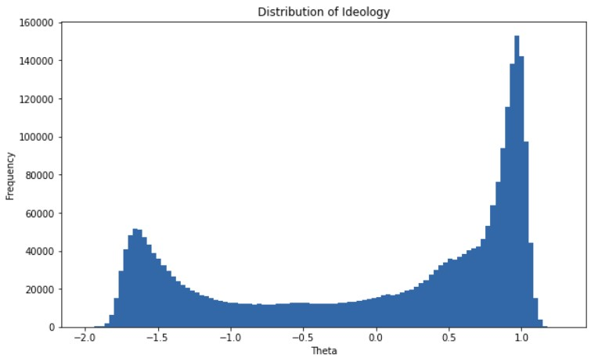

Figure S1. Distribution of Twitter partisan scores

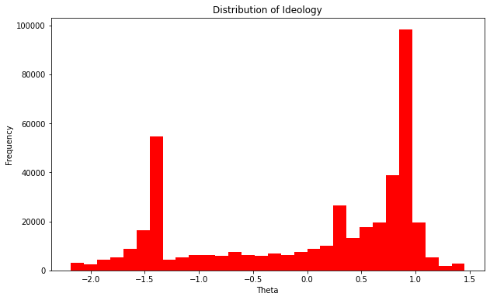

Figure S2. Distribution of Reddit partisan scores

S1.3 Subreddits to Infer Political Orientation
These were the subreddits we used to find “politically active” users and infer their political orientation using Barbera’s method.

Left | Right
AntiTrumpAlliance, PutinsBitch, socialanarchism, antifascism,  Delete_The_Donald, justicedemocrats, Egalitarianism, CornbreadLiberals, Drumpf, neoprogs, EnoughHillHate, NaziHunting, TinyTrumps, Trump_Watch, NeverTrump,  StillSandersForPres, BernTheConvention,  HillaryForAmerica, ShitThe_DonaldSays, SandersForPresident, Impeach_Trump, alltheleft, WayOfTheBern,  Enough_Sanders_Spam, EnoughTrumpSpam, liberalgunowners, hillaryclinton, Fuckthealtright, democrats, esist, centerleftpolitics, Political_Revolution,  MarchAgainstTrump, BlueMidterm2018,  Trumpgret, OurPresident,  Kossacks_for_Sanders, Liberal, TrumpCriticizesTrump, progressive, anarcho_socialism, chapotraphouse2, ChapoTrapHouse, AOC, obama, bidenbro, TinyhandsInc | randpaul, BenCarson, HillaryMeltdown, new_right, PresidentKushner, TheRightBoycott, AltRightChristian,  JohnKasich, Sorosforprison, Romney,  BobbyJindal, EnoughObamaSpam, TedCruz,  CarlyFiorina, TeaParty, MartinOMalley, ChrisChristie, presidentbannon, Mr_Trump, republicans, RickSantorum,  EnoughPaulSpam, trump, HillaryForPrison, ronpaul, tucker_carlson, The_Donald,  ConservativesOnly, Conservative,  Republican, conservatives

Table S2

S1.4 Average Polarization in Training Data

As a sanity check, we measure the polarization of the different groups in our training set. As expected, politicians are more polarized than everyday users and journalists, and Twitter users exhibit slightly more partisan alignment.
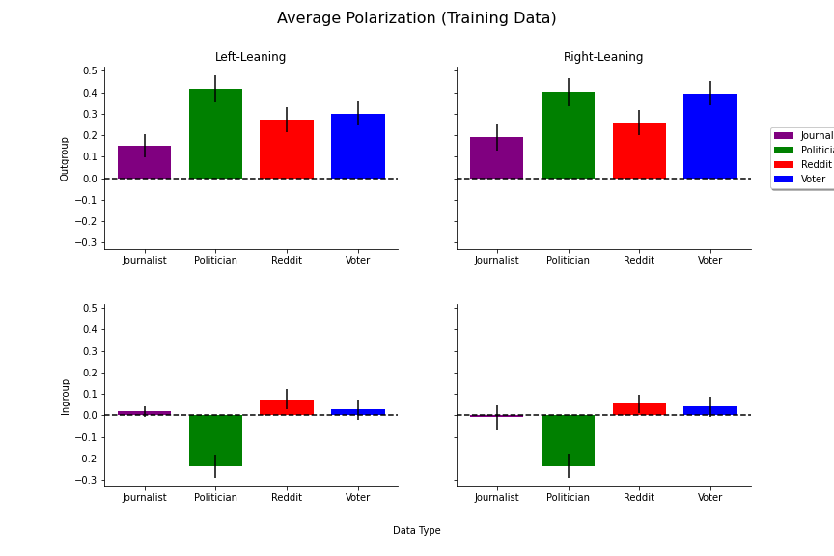

Figure S3

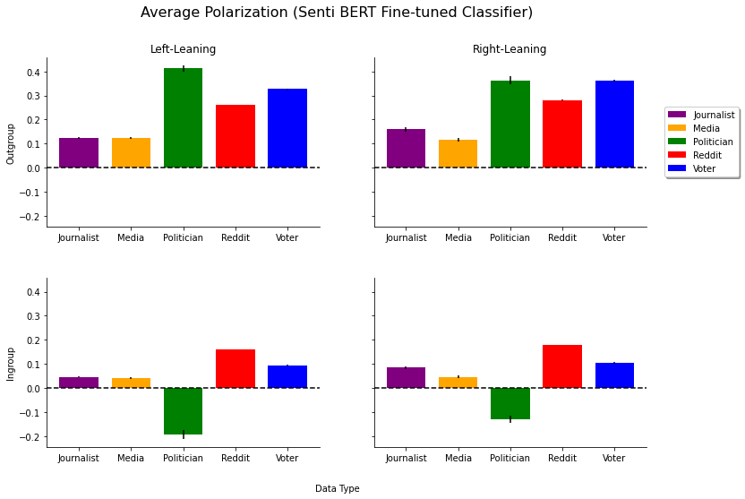

Figure S4

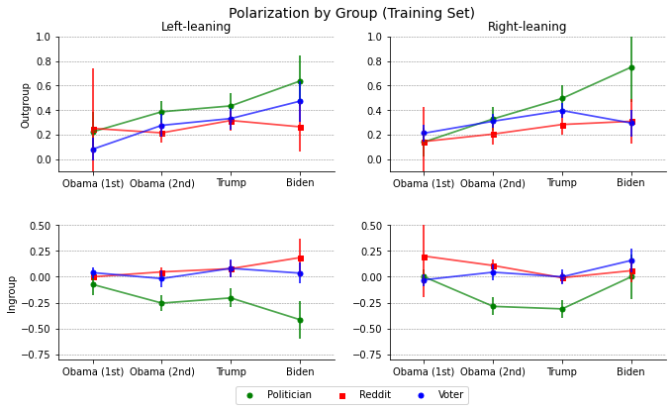

Figure S5

S1.5 List of political keywords
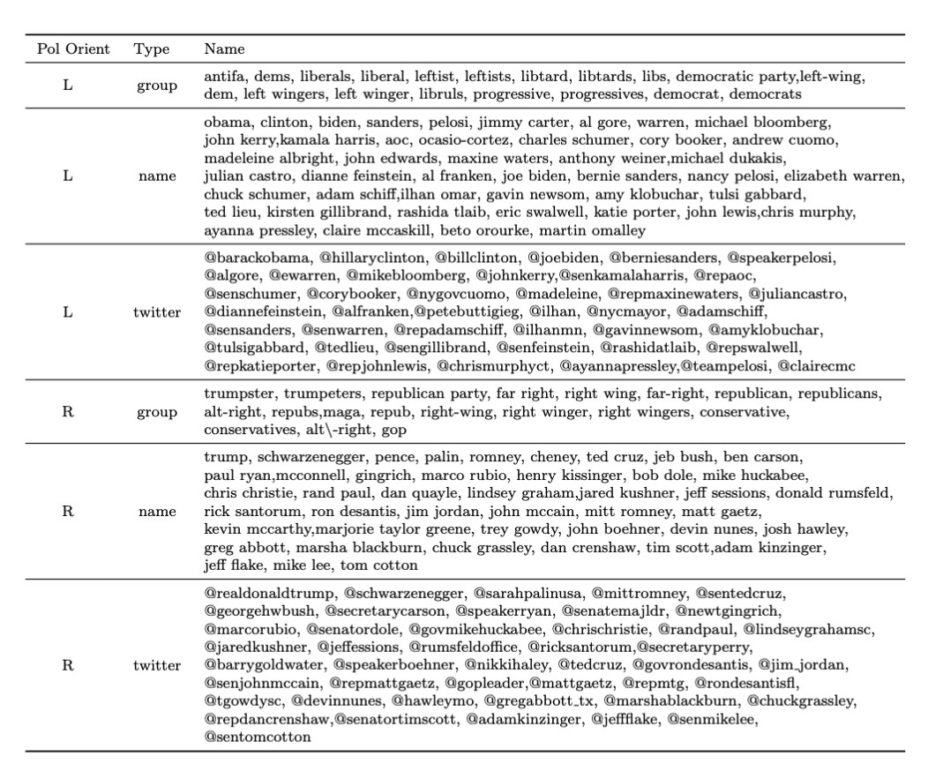
Table S3

S1.6 Polarized Speech Examples

Affectively Polarized Speech

Affectively polarized speech encompasses ad-hominem attacks as well as comments that express distrust that the group/party is doing what’s right (for themselves and the country). This is grounded in the feeling thermometer and trust questions that surveys use, as well as the general definition of affective polarization that is “dislike and distrust to those from the out party”.

Comment |  | Affect
i can’t stand you @aoc your green deal sucks ass like you suck as a politician | Negative
i'm not sure people grasp how far to the right gop is going and has gone. i'm not sure people | Negative
understand that their freedom, democracy is on the line.
@wikileaks @hillaryclinton haha!!!!! go wikileaks! good thing hillary can laugh at the mess she's made!” | Negative
at least they're admitting that blm was burning towns down and committing violence because obama told them it was | Negative
yes, the gop is a lawless party led by an asyet-unindicted criminal.” | Negative
@premr that was credit card reform measure signed into law by president obama.... | Neutral
obama was not the most leftist president in history. contextually (contrasting the politics of the time they were in office), the most leftist president in history was probably thomas jefferson. | Neutral
i don’t see why trump would pardon him. has he said anything on the matter? this isn’t even related to anything about trump either. | Neutral
Happy birthday joe biden! | Positive
i absolutely adore maxine waters. she doesn't pull any punches. | Positive
conservative women are level headed and actually use their head when they process information | Positive

Table S4

Partisan Speech

These comments are not necessarily ad-hominem attacks. However, they often blame negative outcomes on a group/person or criticize their governance. Sometimes they reference specific topics/policies, which often does not happen in “affectively polarized” comments. The comment explicitly blames/praises a certain group/person or clearly implying a positive/negative sentiment, and often attempts to criticize their competence.

Comment | Affect

there is one major political party in the world that doesn't believe in climate change. the republican party. as long as the party that continue to deny the problem is in power, we won't be able to make the changes necessary to solve it. #climatechange | Negative
the way to keep guns out of our schools is not to put guns in them. trumps suggestion today is absolutely unfathomable and must be stopped. | Negative
if gop senators spent more time doing their job, they'd realize america is broke and a health entitlement program is stupid! | Negative
the fact that the biden administration is spending $86 million to pay for hotel rooms for illegal immigrants is absurd. let’s take care  of our homeless veterans and hurting americans first. | Negative
over and over again, obama's foreign policy actions have proven reckless and not in our nation's best interest. | Negative
i mean, it makes sense. they are a publicly traded company subject to sec and congressional oversight. since all 3 houses are controlled by liberals, only makes sense to silence the opposing party. | Neutral
i don't refute that point. my point is that obama has taken more total below-the-belt punches than his predecessors, and that you'd have to be an, extremist, not a moderate, to believe/claim otherwise. | Neutral
not sure what to think of this..."hacker group claims to have romney's tax returns" http.//t.co/rdlbsrrf via @mashable | Neutral
sarah palin suggests she will get involved in kentucky senate race #politics | Neutral
thanks @realdonaldtrump for approving sd's disaster declaration for severe storms and flooding. this will help local units of | Positive
government &amp; certain non-profit organizations to rebuild critical infrastructure and facilities that have been severely damaged.
so glad that @debrarodman73, @vvfordelegate, @adamsfordel,  @pwcdanica, @chrishurstva and so many more progressive leaders are headed to the house of delegates! @vahousedems | Positive
@ingrahamangle i can’t think of a more important reason to support president trump in his re-election. | Positive
Table S5

S2 Models

S2.1 Polarization Model

We fine tune the cardiffnlp/twitter-roberta-base-sentiment, bert-base-uncased, and gpt2 classifiers from Huggingface on our 4500 labeled examples using five-fold cross validation to get a robust estimate of out of sample performance. For data cleaning, we keep all comments that are under 250 characters (the Twitter limit) and lowercase all text. We fine tune all the models for three epochs, with a batch size of eight and performance evaluation every 200 gradient updates. The only hyperparameter tuning we do is on the learning rate, which we adjust to 1.25e-5 for bertbase-uncased and gpt2 and 2.5e-5 for cardiffnlp/twitter-roberta-base-sentiment to ensure smooth training. We then use the weights of the model with the lowest evaluation cross entropy loss. We see that fine-tuning the base models allows us to reach the best performance across our outcomes, as measured by the macro F1 score. We benchmark it against an untrained BERT sentiment classifier as well as the VADER model, which only uses semantic information to create a sentiment score.

First, we report the macro F1 scores of all models as well as a set of baselines. We report all the models separately as well as the joint model’s performance on training examples that have the same prediction across all three models.
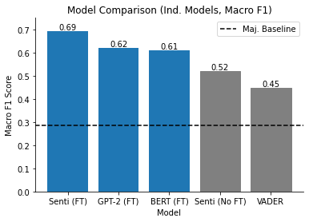

Figure S6

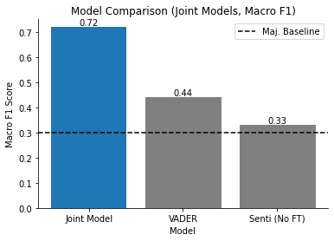

Figure S7

Additionally, we report the precision and recall breakdown by class for each classifier. We make two observations; first, the untuned sentiment model has high recall but low precision, likely due to the data distribution being different between the pre-training data (predicting sentiment) and the task predicting polarization. However, after fine-tuning the model we see a more reasonable balance between precision and recall is found that maximizes the F1-score. Additionally, since the fine-tuned sentiment model has better recall on polarized comments than the original BERT or GPT models, we see that this model is more likely to predict a comment as being polarized. However, while the models display different sensitivities to predicting whether a comment is polarized, we show that all our main findings are robust to the choice of model.
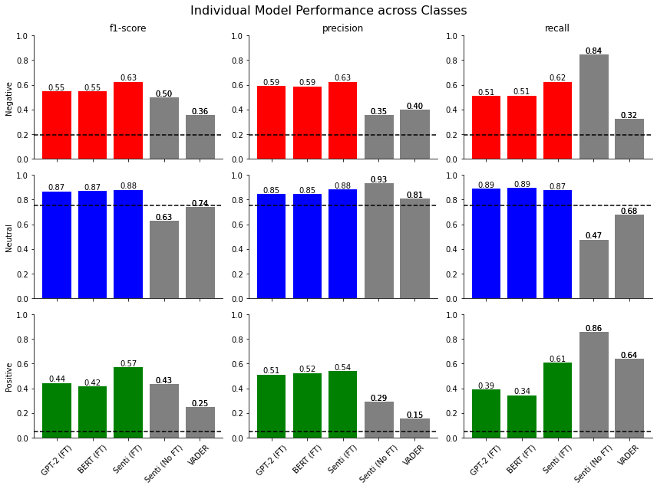

Figure S8

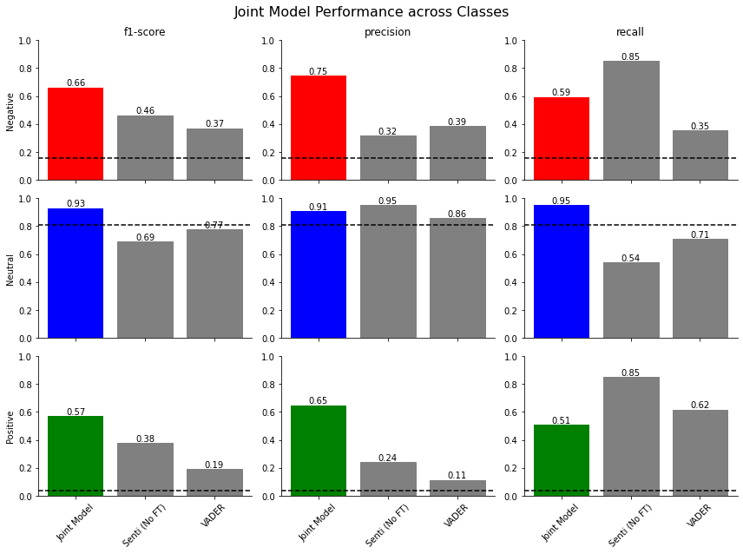

Figure S9

We also estimate the model performance across the different political orientations of users and the different reference groups to ensure that any biases in performance would not be materially impacting our results. We find very similar performance across political orientations and reference political groups, though the model is marginally better at predicting polarization of content by left-leaning users. However, we find that our main results are consistent regardless of model choice, giving us more confidence that they are accurate.

Metric | L | R
Macro F1 | 0.75 | 0.69
Orig F1 | 0.51 | 0.51
VADER F1 | 0.44 | 0.45
Baseline F1 | 0.3 | 0.3
Table S6. Joint Model performance across author political orientations

Metric | L | R
Macro F1 | 0.74 | 0.7
Orig F1 | 0.51 | 0.51
VADER F1 | 0.45 | 0.44
Baseline F1 | 0.3 | 0.3
Table S7. Joint Model performance across political reference groups

Metric | L | R
Macro F1 | 0.71 | 0.68
Orig F1 | 0.52 | 0.52
VADER F1 | 0.44 | 0.45
Baseline F1 | 0.29 | 0.28
Table S9. Fine-tuned sentiment model performance across author political orientations

Metric | L | R
Macro F1 | 0.7 | 0.69
Orig F1 | 0.52 | 0.52
VADER F1 | 0.44 | 0.45
Baseline F1 | 0.29 | 0.29
Table S10. Fine-tuned sentiment model performance across political reference groups

Metric | L | R
Macro F1 | 0.63 | 0.59
Orig F1 | 0.52 | 0.52
VADER F1 | 0.44 | 0.45
Baseline F1 | 0.29 | 0.28
Table S12. Fine-tuned BERT performance across author political orientations

Metric | L | R
Macro F1 | 0.63 | 0.59
Orig F1 | 0.52 | 0.52
VADER F1 | 0.44 | 0.45
Baseline F1 | 0.29 | 0.29
Table S13. Fine-tuned BERT performance across political reference groups

Metric | L | R
Macro F1 | 0.63 | 0.61
Orig F1 | 0.31 | 0.29
VADER F1 | 0.44 | 0.45
Baseline F1 | 0.29 | 0.28
Table S15. Fine-tuned GPT performance across author political orientations

Metric | L | R
Macro F1 | 0.64 | 0.6
Orig F1 | 0.29 | 0.3
VADER F1 | 0.44 | 0.45
Baseline F1 | 0.29 | 0.29
Table S16. Fine-tuned GPT performance across political reference groups

S2.2 Topic Model Performance

Although most comments did not contain any specific topic, we find that we can still reasonably classify the topics when they do occur. Our overall accuracy is 91% when including tweets with no topic and 66% when only considering tweets that contained a given topic. Given the large number of topics and their relative sparsity of occurrence, the classifier’s performance is modest. However, this seems roughly in line with other work that attempts to use topic classifiers on political social media data (21).
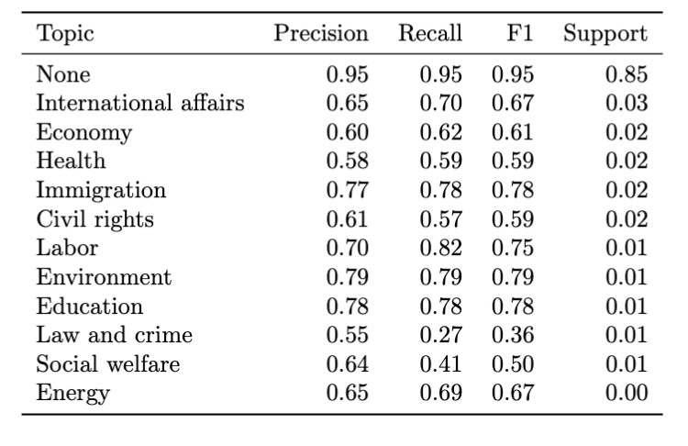
Table S18. Topic model performance

S3 Twitter

S3.1 Group Trends
We first test how group polarization has shifted by using an ordinal logistic regression where we regress the polarity of a comment on an indicator variable corresponding to the period the comment was posted, as well as an interaction between the period and the type of user. A higher coefficient corresponds to higher probability of a comment exhibiting negative polarization. We run separate models corresponding to the political orientation of the users as well as the reference group (ingroup or outgroup). The following regressions are all performed using the Historical Powertrack data, as it has the least probability of a temporal bias, and we also control for time using a covariate representing the year when necessary.
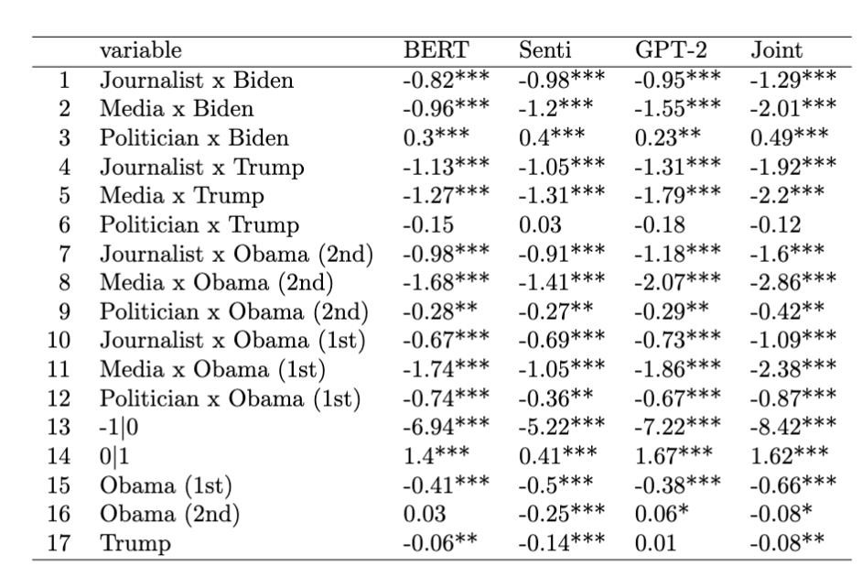
Table S19. Right-leaning outgroup. We highlight the coefficients of politicians in the red boxes. In the Obama era, right-leaning politicians were generally less polarized than the average right-leaning user (indicated by the negative coefficient). Then, in the Trump era they were roughly equal, indicated by non-significant coefficients. Finally, in the Biden era, politicians exceed everyday users in polarization as indicated by the positive coefficient.

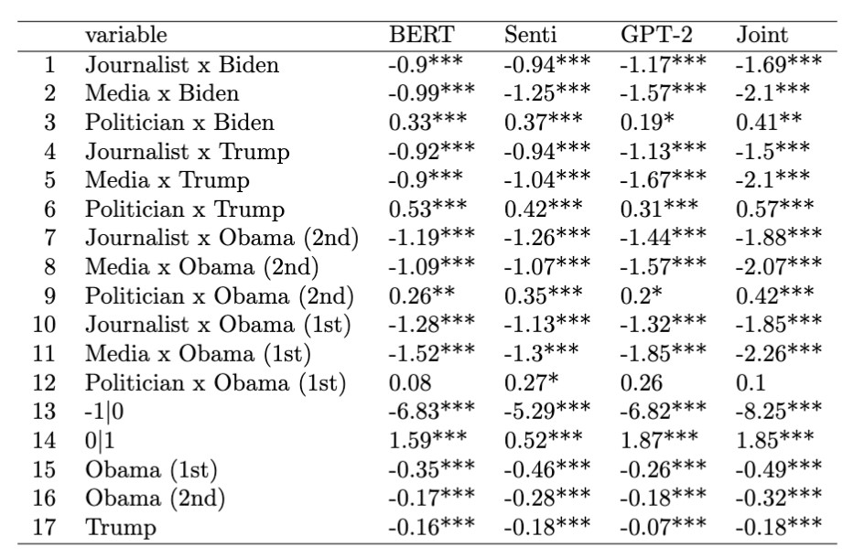
Table S20. Left-leaning outgroup. The positive coefficients on politicians indicates that left-leaning politicians have consistently been more polarized than everyday left-leaning users. However, the largest gap seems to appear during the Trump era, and the difference was not significant in the first Obama term.
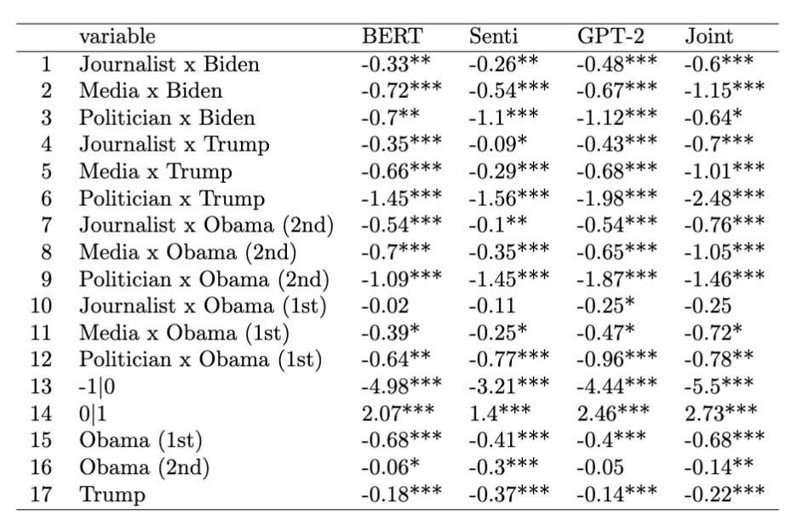
Table S21. Right-leaning ingroup. Negative coefficients on politicians indicates that right-leaning politicians were more positive towards their ingroups than everyday users. However, in the Biden era some of this reversed as right-leaning politicians became less favorable towards their ingroup.
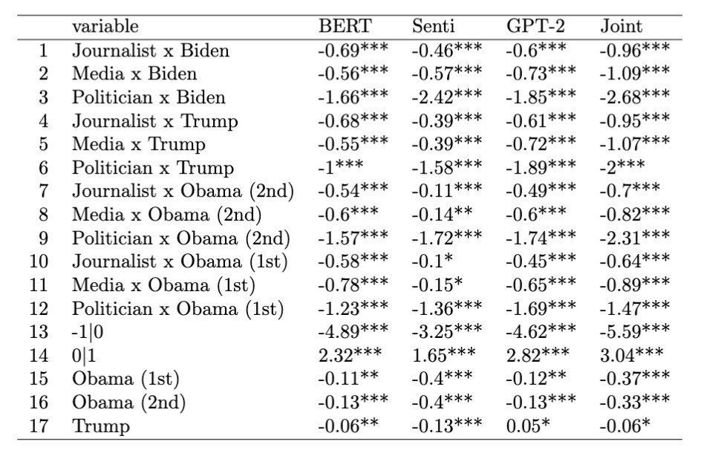
Table S22. Left-leaning ingroup. Left-leaning politicians are more favorable to their ingroups than everyday left-leaning users.

We then focus on confirming our findings that right-leaning politicians have become more negative towards their outgroups at a faster rate than other groups. We regress the polarity of a comment on an interaction between the year (represented as the number of years from the earliest comment) and the user type. A higher coefficient essentially corresponds to a higher rate of growth in negative polarization of the group relative to other groups. On the right, negative outgroup partisan speech by politicians also grew faster than the other right-leaning groups.

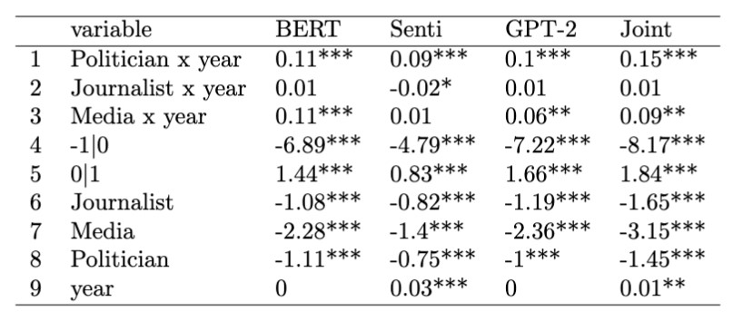
Table S23. Right-leaning outgroup. A positive coefficient indicates that the rate of growth in outgroup polarization of right-leaning politicians and media exceeded that of everyday users. However, we note that the overall polarization of media is low relative to all other groups.

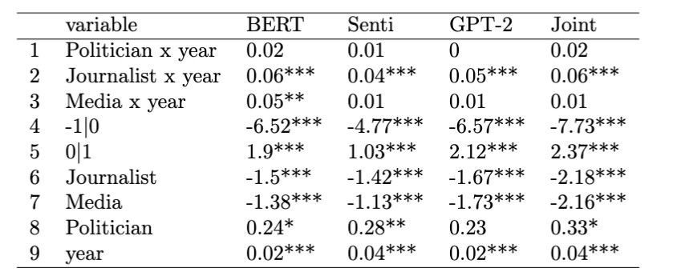
Table S23. Left-leaning outgroup. Left-leaning journalists grew more polarized faster than any group, albeit at lower levels.
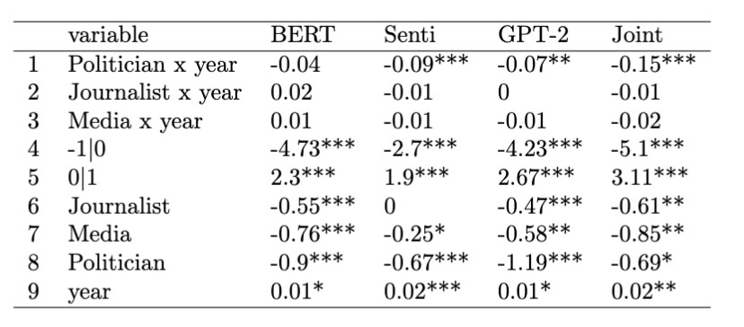
Table S24. Right-leaning ingroup. Right-leaning politicians generally grew more positive towards their ingroups than everyday users as indicated by the negative coefficients on “Politician x year”. However, we note that this trend has reversed during the Biden years, with more ingroup negativity amongst right-leaning politicians.
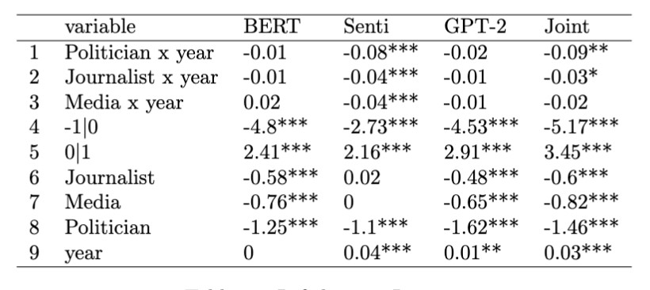
Table S25. Left-leaning ingroup

S4 Platform Comparisons

To confirm that indeed from our chosen sample of users, Twitter users show more partisan alignment than Reddit, we run a series of multinomial logistic regressions. We regress the polarity of a comment on the reference group (outgroup or ingroup), the platform (Reddit or Twitter), an interaction between the two variables, and our measure of partisanship theta. If the interaction term is negative, this means that the partisan gap is larger on Twitter versus Reddit. We test this model including and excluding users that solely commented in r/TheDonald and r/ChapoTrapHouse.
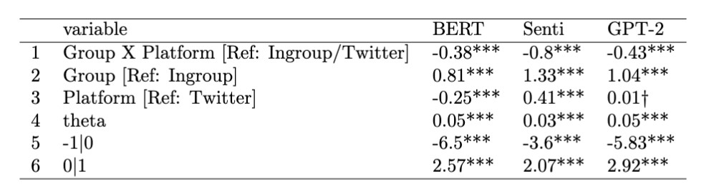
Table S26. Right-leaning, exclude extreme subreddits

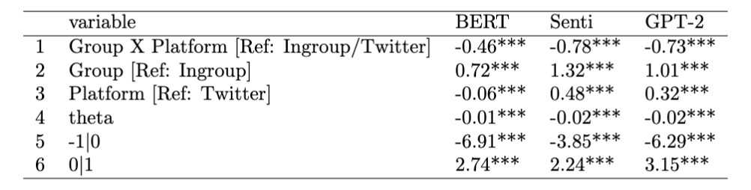
Table S27. Left-leaning, exclude extreme subreddits
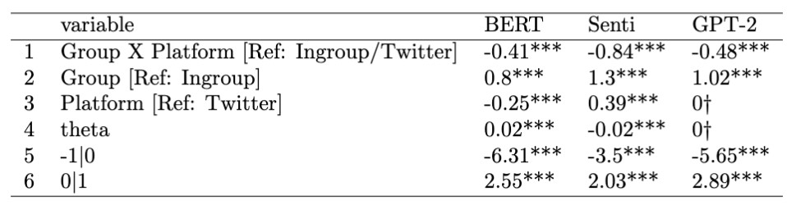
Table S28. Right-leaning, include extreme subreddits
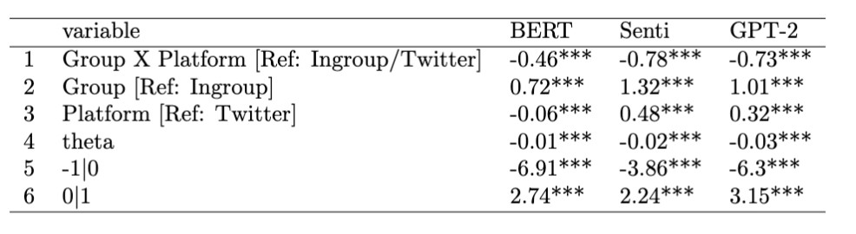
Table S29. Left-leaning, include extreme subreddits

We also find that varying the cutoff for theta does not materially change this relationship.
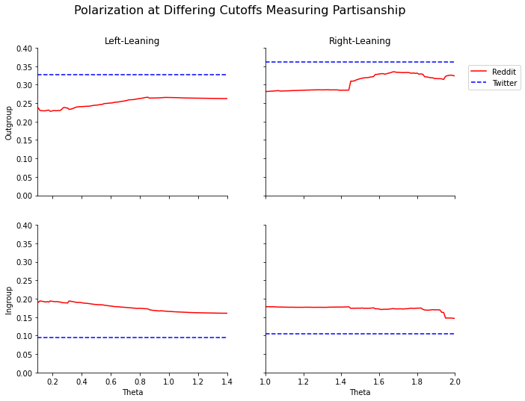

Figure S10: Varying the cutoff for inferring political orientation does not meaningfully change the aggregate polarization level.

S5 Audience Size and Influence

S5.1 Audience Size

We run an ordinal logistic regression, regressing the polarity of each comment on the follow count of the user that tweeted it as well as their political orientation, and an interaction of the two (and controlling for time). The relationship between the (log) number of followers and the polarization is negative, but for right-leaning users this is weaker indicated by the positive coefficient on the interaction term. We use User Timeline data in this analysis to maximize sample size and include a control variable for temporal trends.
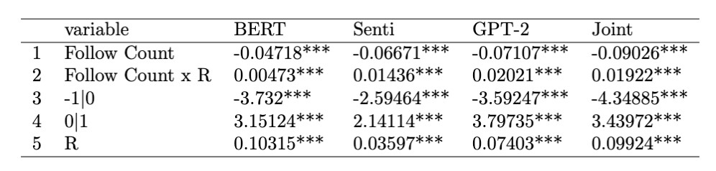
Table S30. Followers vs. polarization (outgroup)
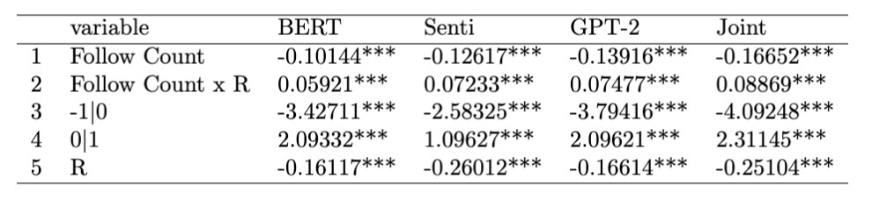
Table S31. Followers vs. polarization (ingroup)

S5.2 Mega-influencer Accounts

Screen Name | Followers
dbongino | 3,845,701
w_terrence | 1,412,740
IngrahamAngle | 4,530,529
DonaldJTrumpJr | 9,585,414
TomiLahren | 2,296,126
RudyGiuliani | 1,545,532
KellyannePolls | 3,520,211
DLoesch | 1,276,655
ksorbs | 1,529,775
JackPosobiec | 1,904,913
kayleighmcenany | 3,198,451
EricTrump | 4,064,036
AnnCoulter | 2,109,240
ericbolling | 1,130,224
DanScavino | 1,657,560
RubinReport | 1,311,015
MattWalshBlog | 1,243,029
realDailyWire | 1,429,077
JustinColeMoore | 1,189,858
Cernovich | 1,102,161
brandi_love | 1,050,979
Table S32. Mega-influencer accounts on the right. We find that on the right, there are a handful of journalists but also accounts that fall outside mainstream politics.

Screen Name | Followers
thelittleidiot | 1,127,089.00
chelseahandler | 7,719,580.00
BernieSanders | 15,552,053.00
ewarren | 5,894,853.00
SenSanders | 12,502,471.00
RepSwalwell | 1,429,334.00
TheLastWord | 1,081,113.00
JoeNBC | 2,765,504.00
billyeichner | 2,318,140.00
YahooNews | 1,092,113.00
funder | 1,100,941.00
MarkRuffalo | 8,364,416.00
BillKristol | 1,020,371.00
davidhogg111 | 1,213,372.00
ananavarro | 1,993,938.00
SophiaBush | 1,235,356.00
mmpadellan | 1,153,899.00
tribelaw | 1,365,362.00
mitchellreports | 1,928,460.00
VICENews | 1,018,161.00
Table S33. Mega-influencer accounts on the left. The left has more of a balanced mix of mega-influencers, with some mainstream media accounts and politicians. However, there are still influencers outside of these traditional categories such as musicians and comedians.

S5.3 Distribution of Polarization across Users

In addition to aggregate measures of polarization, we investigate how users contribute differently to negatively polarized and neutral political speech. As documented in other research, users contribute to content on Reddit and Twitter in accordance with a power law; generally, a small group of users contributes to a large share of comments/tweets (12). However, these distributions are different between negative and neutral content. In Figure S8, we plot the Lorenz curve, where the x-axis represents the decile of users according to the percent of comments/tweets they post, and the y-axis represents the total percent of all comments posted by users in the specified decile or higher. For example, we find that on Twitter, the top decile of users by posting activity of neutral comments post 39/35% of all neutral comments for left/right-leaning users, respectively. However, the top 10% of users by posting activity of negative comments post 46/40% of all negative comments. We broke ties randomly such that each decile contains the same number of observations.

To confirm that the distributions are indeed statistically significantly different, we discretize the contributions into percentiles and run the one-sided Kolmogorov–Smirnov test that determines whether the CDF of negative comments is higher than that of neutral comments. For all users except left-leaning politicians and media on Twitter, we find that the distribution of negative comments is indeed more skewed than neutral comments (p < .05). We note that “Voter” refers to “Twitter” in the chart below.

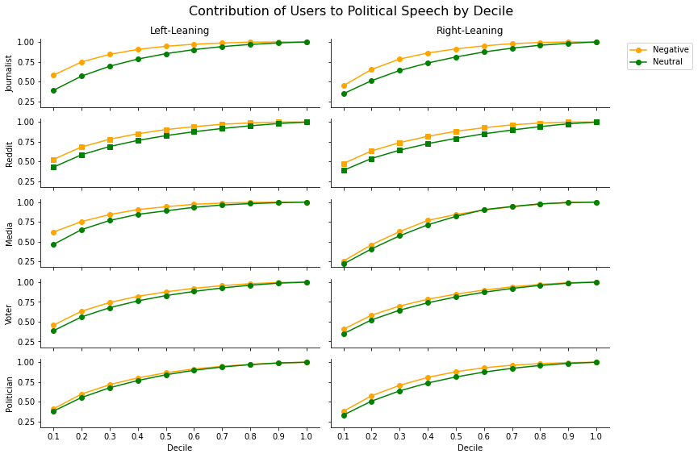

Figure S11

Type | Pol Orient | K-S Statistic | p-value
Journalist | L | 0.31 | 0
Reddit | L | 0.29 | 0
Reddit | R | 0.29 | 0
Journalist | R | 0.24 | 0.003
Politician | R | 0.19 | 0.027
Twitter | L | 0.17 | 0.056
Twitter | R | 0.17 | 0.056
Media | L | 0.09 | 0.446
Politician | L | 0.08 | 0.529
Media | R | 0.04 | 0.853

Table S34. We report the K-S statistic and corresponding p-value for each group and political orientation. We discretized the distribution into percentiles to compare CDFs.

We also plot the same Lorenz curves as above but now compare the two platforms. On the top chart we examine the distribution of neutral content across users on the two platforms, while on the bottom we examine the distribution of negative content. The red curve (Reddit) above the blue curve (Twitter) indicates that the distribution is more skewed on Reddit than on Twitter.

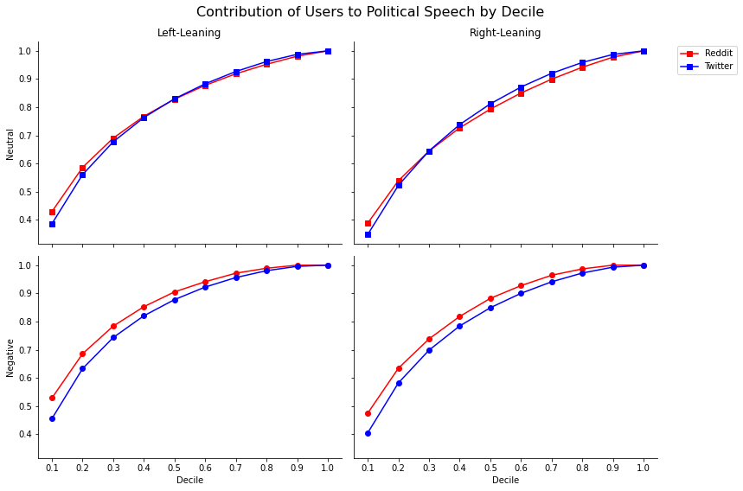
Figure S12

S6 Additional Charts

S6.1 Historical Powertrack Groups/Platforms
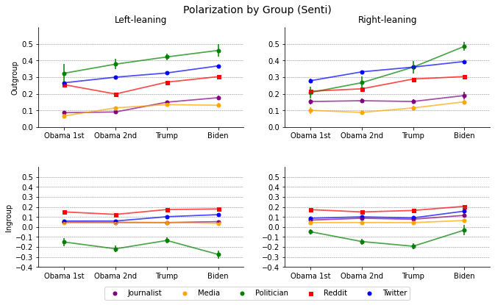

Figure S13. Using only our sample of Historical Powertrack data, we plot changes in polarization over time across groups and find that the relative patterns are fairly consistent, with high polarization amongst politicians, recent acceleration amongst right-leaning politicians, and higher outgroup polarization on Twitter relative to Reddit.

S6.2 User Timeline Groups/Platforms

We re-create all our main charts using multiple different models. We see that the high-level results stay consistent; polarization is rising for all groups, Twitter users are more polarized than Reddit users, and right leaning politicians have accelerated the most since 2016. We see that polarization of left-leaning politicians peaks in 2019 and then declines, although our most accurate model (the fine-tuned sentiment model) shows less of a decline than fine-tuned base BERT and GPT models. When investigating this difference, we find that the higher recall of the fine-tuned sentiment model makes it more likely to find speech that is polarized by does not include explicit personal attacks. Thus, the greater decline we see for the fine-tuned BERT/GPT models could be due to the shifting nature of the types of polarized speech that left-leaning politicians are using, although in all cases we find that while polarized speech by right-leaning politicians has been increasing since around 2016 and is at its peak today, the peak for left-leaning politicians occurred in 2019.

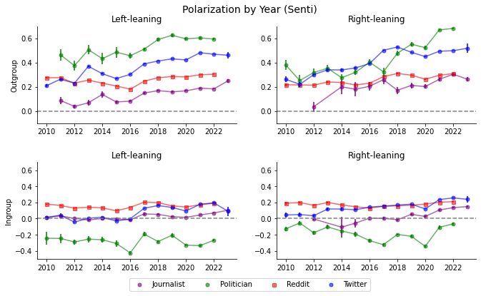

Figure S14

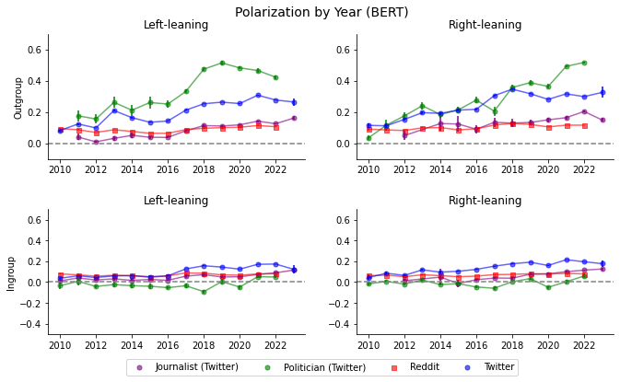

Figure S15
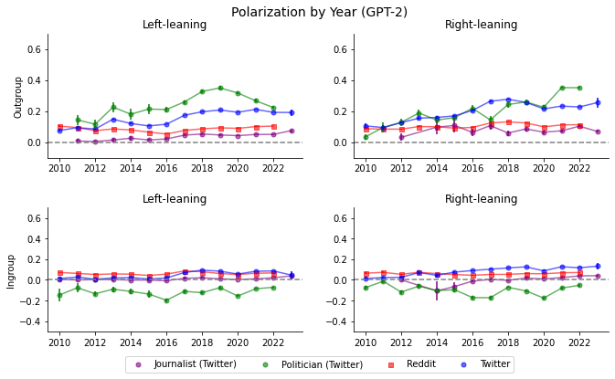

Figure S16

S6.3 Cohorts (Raw)
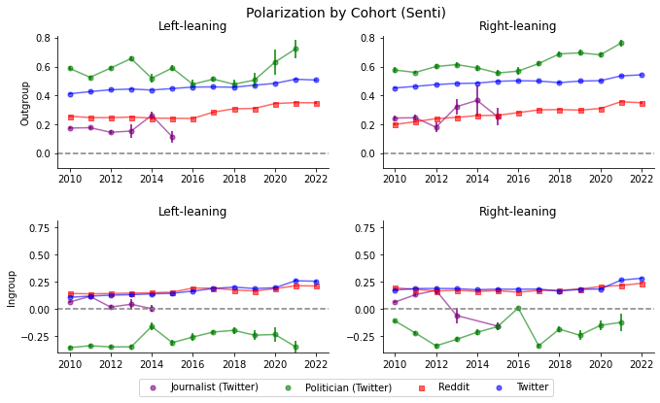 Figure S17

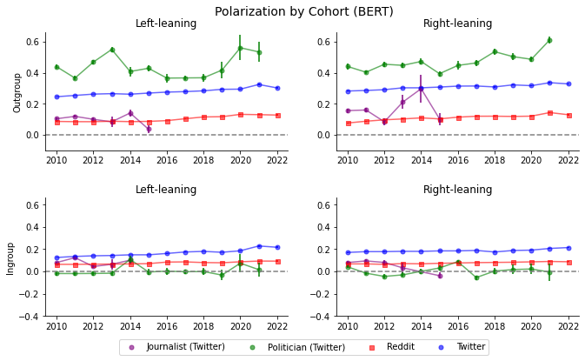

Figure S18

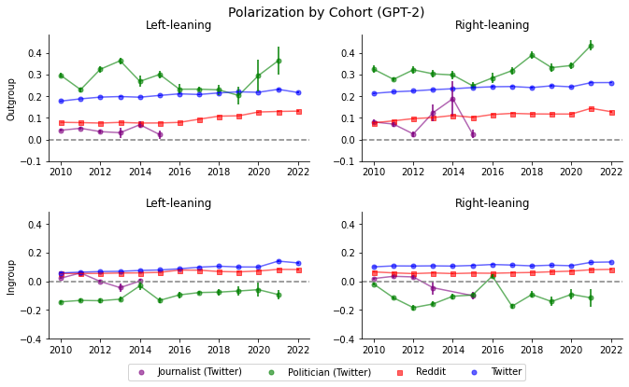

Figure S19

S6.4 Subreddit and Cohort Contributions
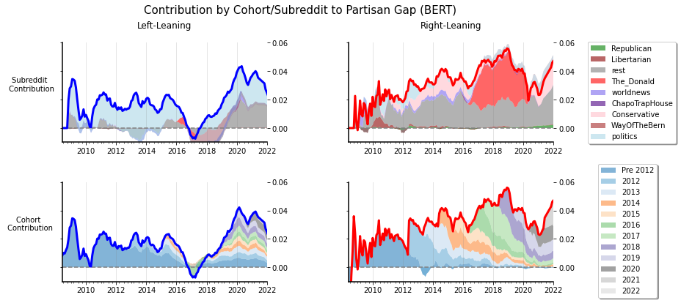

Figure S20
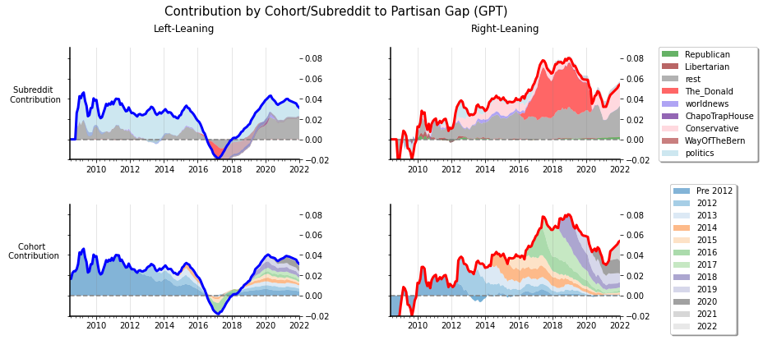

Figure S21

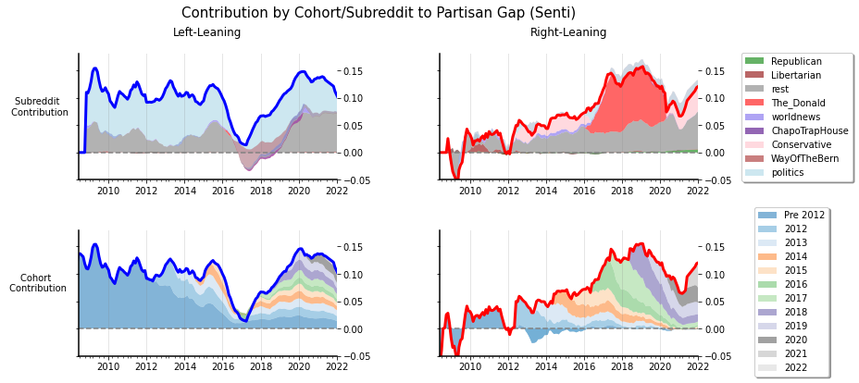

Figure S22
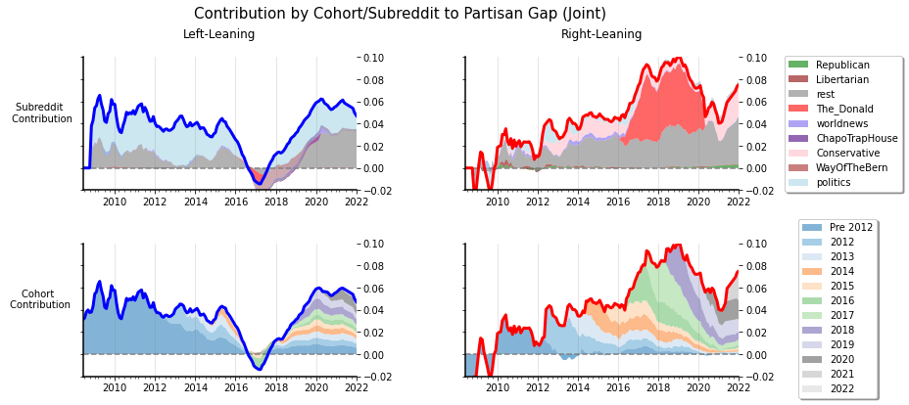

Figure S23

S6.5 Followers vs. Polarization
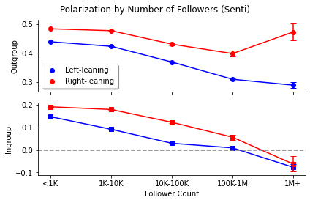

Figure S24

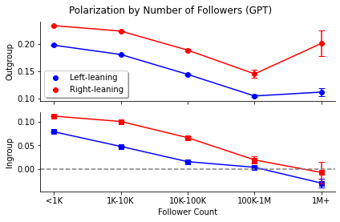

Figure S25

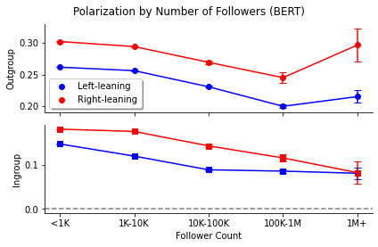

Figure S26

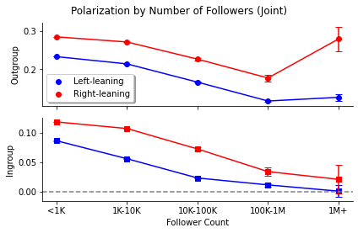
Figure 27

S6.6 Topics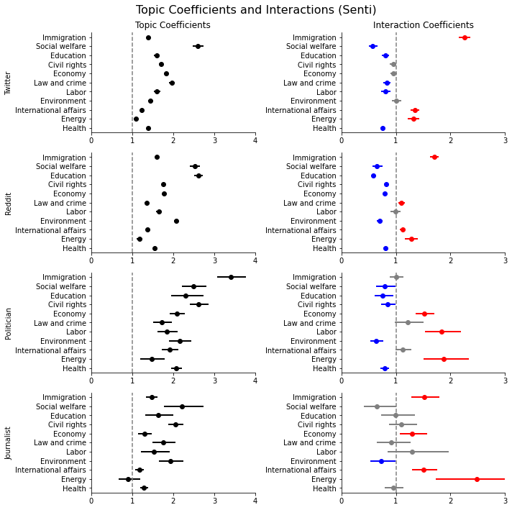

Figure S28
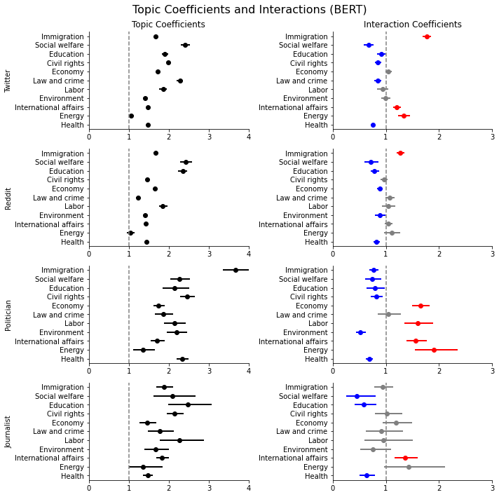
Figure S29
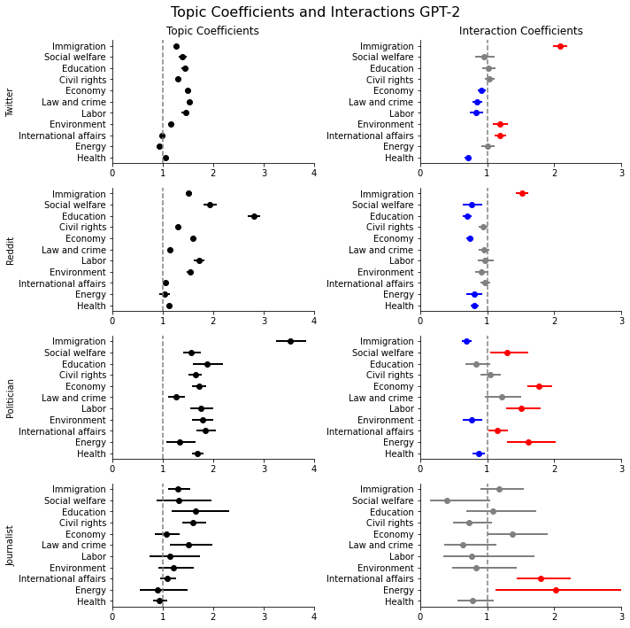

Figure S30

