Extended Data Figure Legends

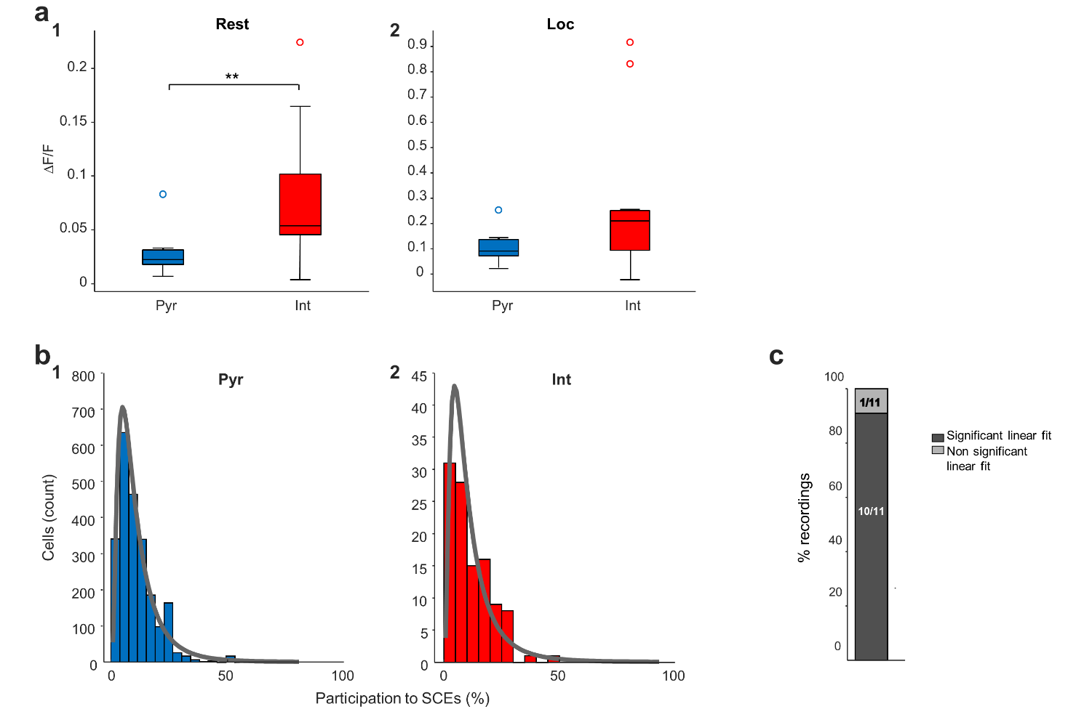

Fig. 1 - Activity of pyramidal cells and interneurons in relation to locomotion and SCEs.
a. Same as Fig. 1c, but restricted to rest or locomotion periods. Interneurons show higher activity than pyramidal cells during rest periods (p = 0.009), but not locomotion periods (p = 0.115, both Wilcoxon signed rank tests, n=11 FOVs from 6 mice). b. Distribution of the proportion of SCEs to which each cell participates. Both pyramidal cell and interneuron distribution show lognormal shapes. Lognormal fits are depicted in grey. c. Linear model fitted for individual recordings: proportion of recordings displaying significant fit (p<0.05).

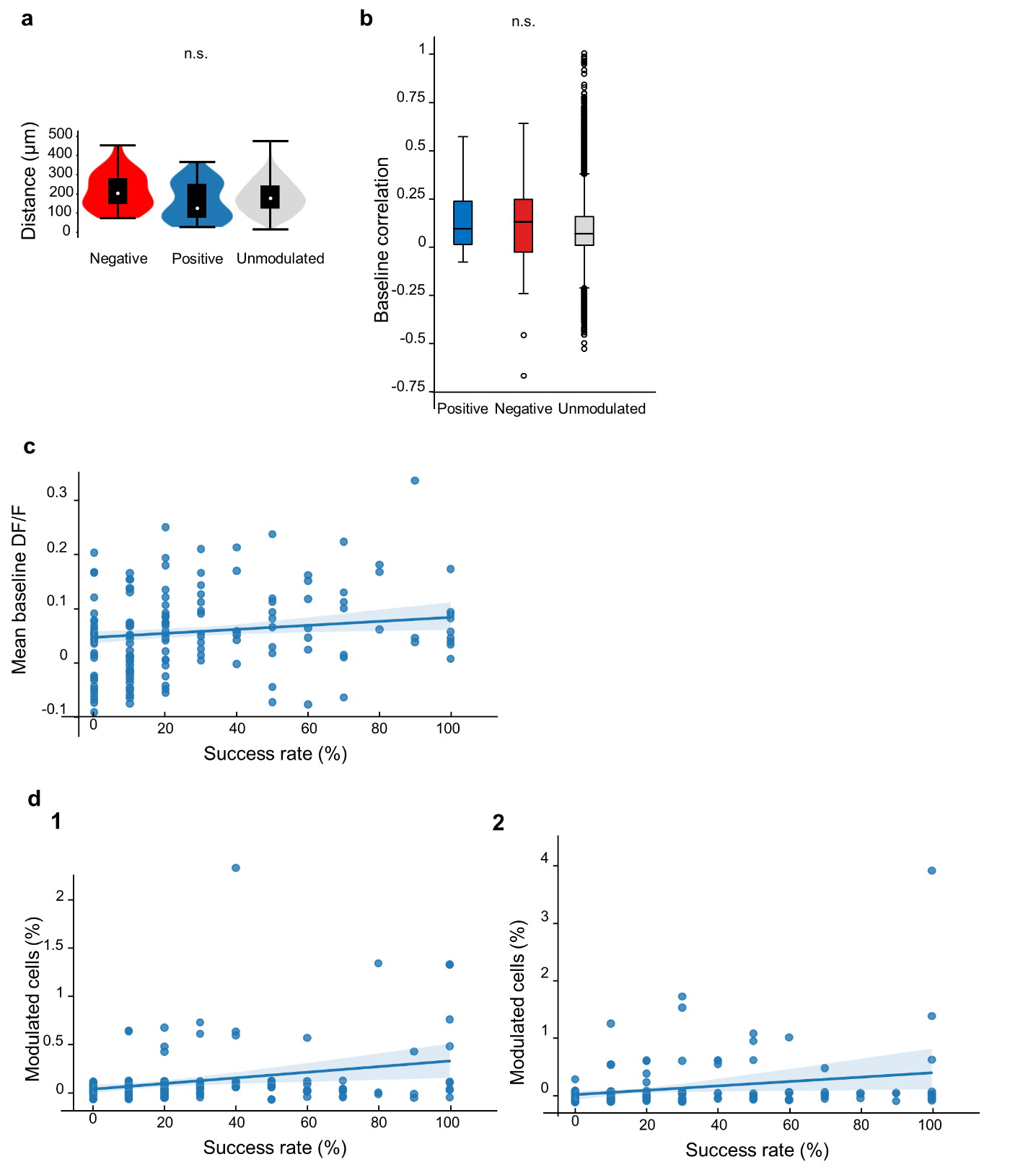
Fig. 2 - Indirectly modulated cells: spatial distribution, correlation and link to success rate of the stimulated neuron
a. Distribution of the distance between the stimulated interneuron and negatively (red), positively (blue) or unmodulated (gray) cells (Kruskal–Wallis H-test, three groups, p=0.08). b. Box plot indicates the correlation between the fluorescence calcium traces of positively (blue), negatively (red), and unmodulated (gray) neurons (Kruskal–Wallis H-test, three groups, p=0.17). c. Scatter plot with linear regression best-fit line indicating a significant correlation between the stimulation success rate and the mean baseline dF/F signal of the stimulated neuron (Pearson r=0.206, p=0.012) d. Scatter plot with linear regression best-fit line indicating a correlation between the fraction of positively (d1) or negatively (d2) modulated neurons and the success rate of the target cell (Pearson's r=0.251, p=0.002; Pearson's r=0.295, p=0.0003, respectively).

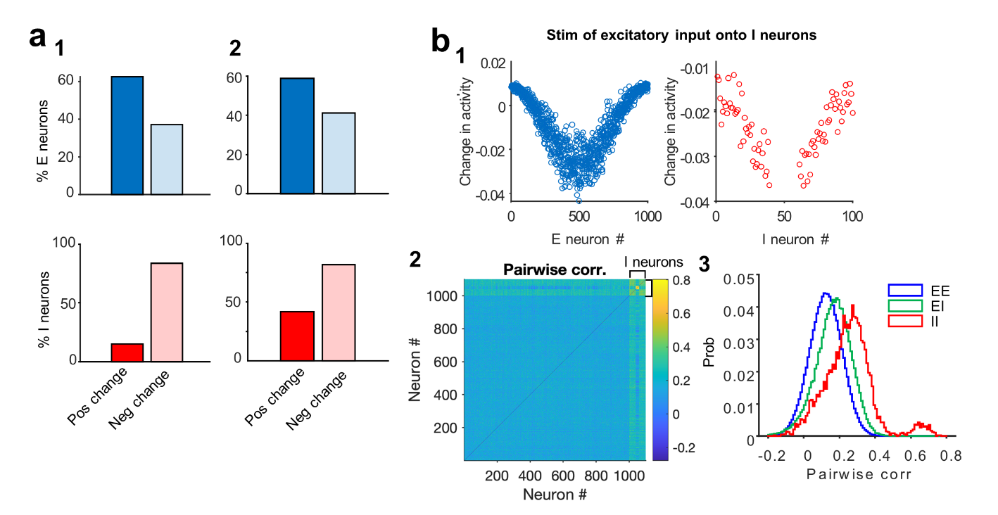
Fig. 3 - Additional results on the network model
a1. Same as Fig. 3a, but when the effect of single I neuron perturbations is assessed from a linear analysis of the network dynamics and its weight matrix (W). a2. Same as Fig.3a, but with I-I connections displaying the same specificity as E-I connections (m_II = 1). b. Same as Fig. 3d, but with external stimulation of inhibitory neurons (20 I neurons in the middle; the changes in the activity of stimulated I neurons are not shown).

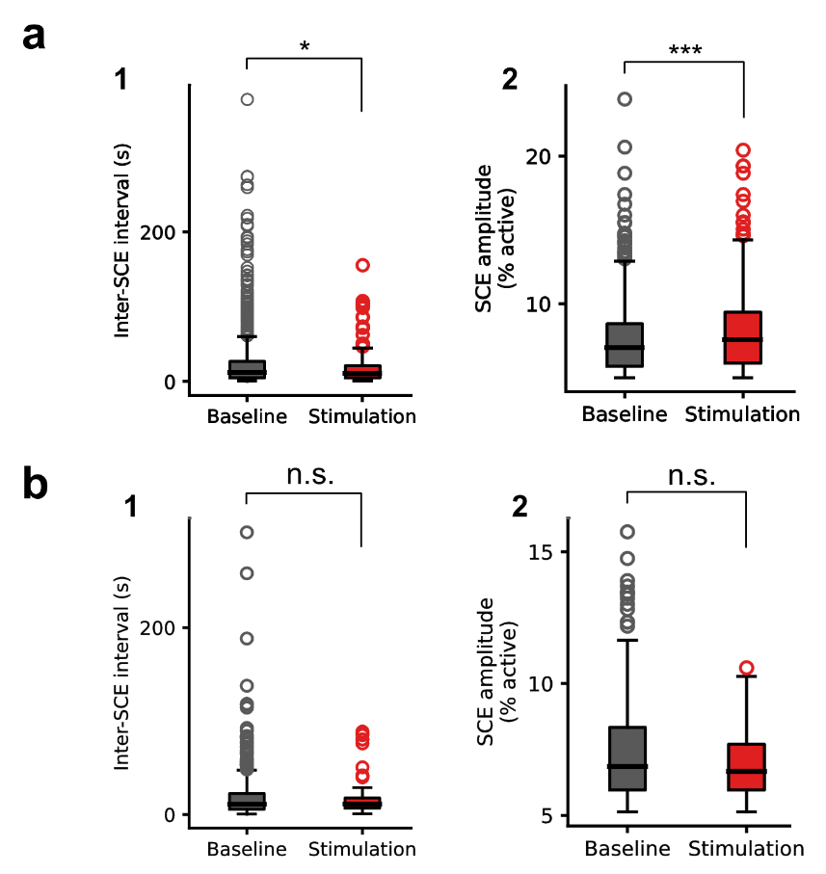
Fig. 4 - Additional results related to the impact of single interneuron photostimulation on SCEs
a1. Same as Fig. 4 b3, but for all the experiments, excluding the experiments with unresponsive cells, p=0.035. a2. Same as Fig. 4 b4, but for all the experiments, excluding the experiments with unresponsive cells, p=0.0007. b1. Same as Fig. 4 b3, but for the experiments with unresponsive cells only, p=0.45. b2. Same as Fig. 4 b4, but for the experiments with unresponsive cells only, p=0.13 (Mann Whitney U test in all cases)

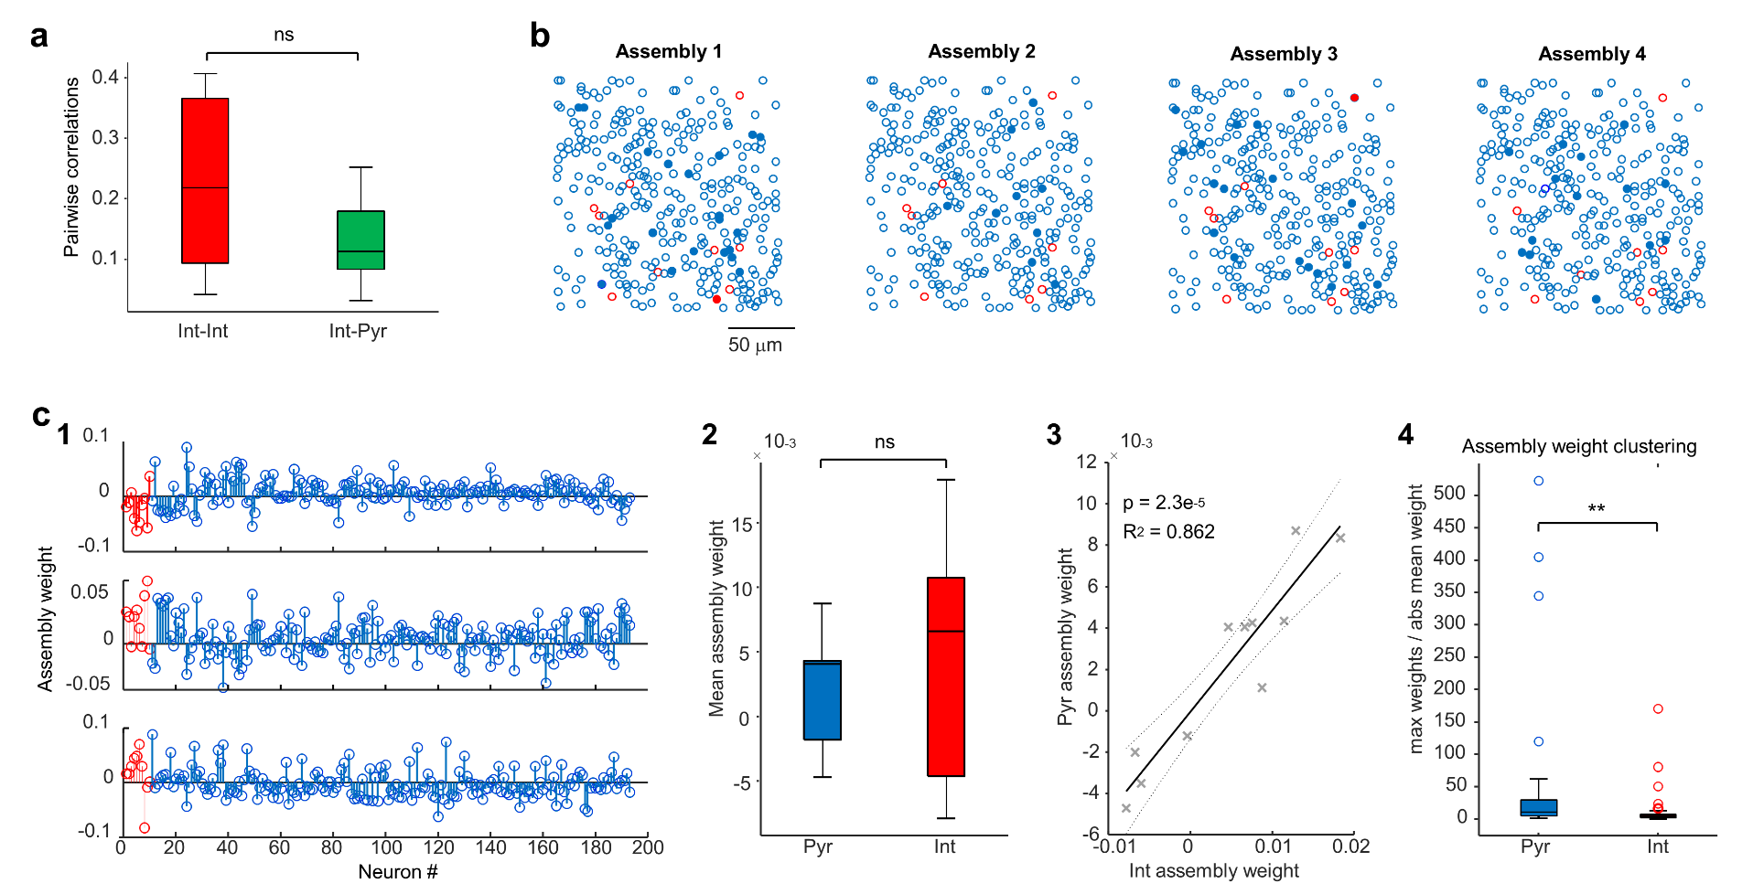
Fig. 5 - Relationship between interneuron activity and cell assemblies
a. Interneurons are not clustered into single assemblies, as evidenced by the fact that pairwise correlations between interneurons are not higher than correlations between interneurons and pyramidal cells (p = 0.16791, Wilcoxon signed rank tests, n=11 FOVs from 6 mice). b. Contour maps indicating the centroids of all active neurons in a representative imaging session with four cell assemblies (SCE-based method). Pyramidal cells are depicted in blue, interneurons in red. Filled contours belong to an individual assembly, whereas empty contours do not. Note the lack of spatial clustering: pyramidal cells and interneurons, as well as cells forming and not forming assemblies, are intermingled. c1. Assembly patterns (from 3 significant cell assemblies) obtained from a representative recording (same imaging session as c1) using the PCA/ICA assembly detection method (see Methods for details). Each plot represents a significant principal component (assembly), with a given weight for each neuron. Interneurons’ weights are depicted in red, pyramidal cells’ weights in blue. c2. Pyramidal cells and interneurons display similar assembly weights (p=0.4, Wilcoxon signed rank test, n = 31 assemblies from 11 recordings from 6 mice). c3. Fit of linear model between pyramidal cell assembly weight and interneuron assembly weight for each recording (averaged across 31 assemblies, n = 11 recordings, 6 mice). c4. Pyramidal cell assembly weights are more clustered in a single assembly compared to interneurons (maximum assembly weight across assemblies divided by the absolute average of assembly weights; p = 0.0025, Mann Whitney U test, n = 31 assemblies, from 11 FOVs from 6 mice).

Supplementary movie. Effect of single interneuron photoactivation on SCEs.
Representative movie of a stimulation experiment corresponding to Fig. 4b. Synchronous calcium events (SCEs) were recorded in the CA1 region of a GAD67-Cre adult mouse, injected with AAV1.Syn-GCaMP6m and AAV9.CAG.DIO.ChroME-ST.mRuby3 at birth. Movie (top) was recorded at 8.4 Hz in a field of view of 280x280μm². The baseline period was followed by a stimulation period and a post stimulation period. Stimulated cell corresponds to the cell illustrated in Fig. 2c. At the frame corresponding to stimulation, the cell is highlighted with a white rectangle. Presented alongside the movie above is a raster plot that displays the average calcium fluorescence signal from all imaged neurons over time. This rasterplot shows vertical white stripes that identify SCEs. They occur at a higher rate during the stimulation period.

