Supplementary material file 1

FIGURE S1 | Rarefaction curves of OTUs for the 28 samples. FW: forest musk deer during the winter; FS: forest musk deer during the summer; SS: Siberian musk deer during the summer; SW: forest musk deer during the summer.

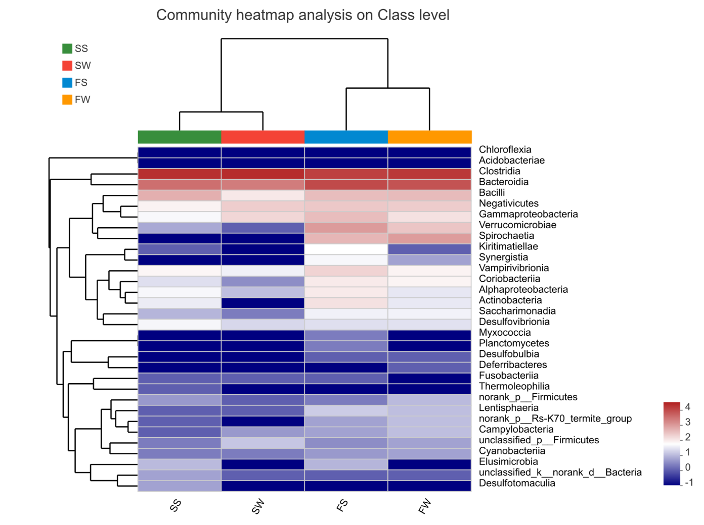
FIGURE S2 | Heatmap showing bacterial distributions at the class level.

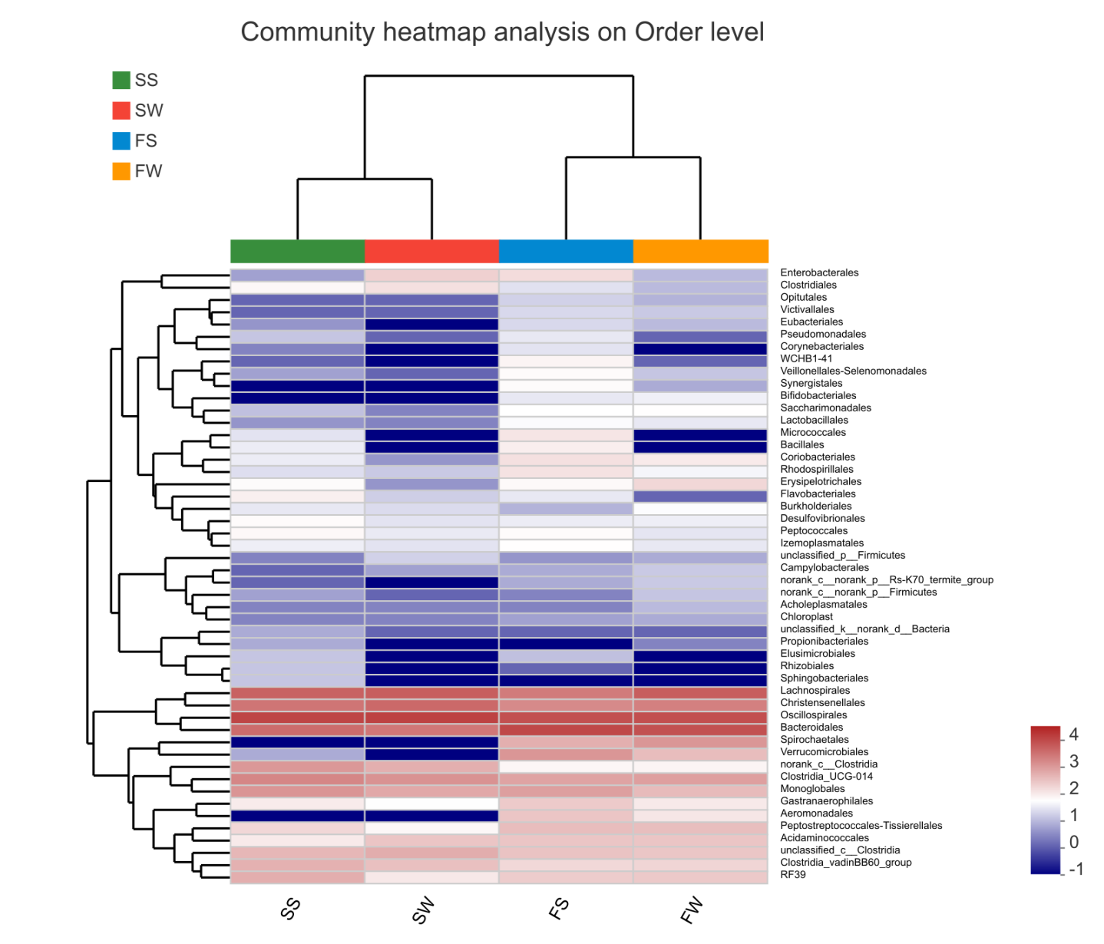
FIGURE S3 | Heatmap showing bacterial distributions at the order level.

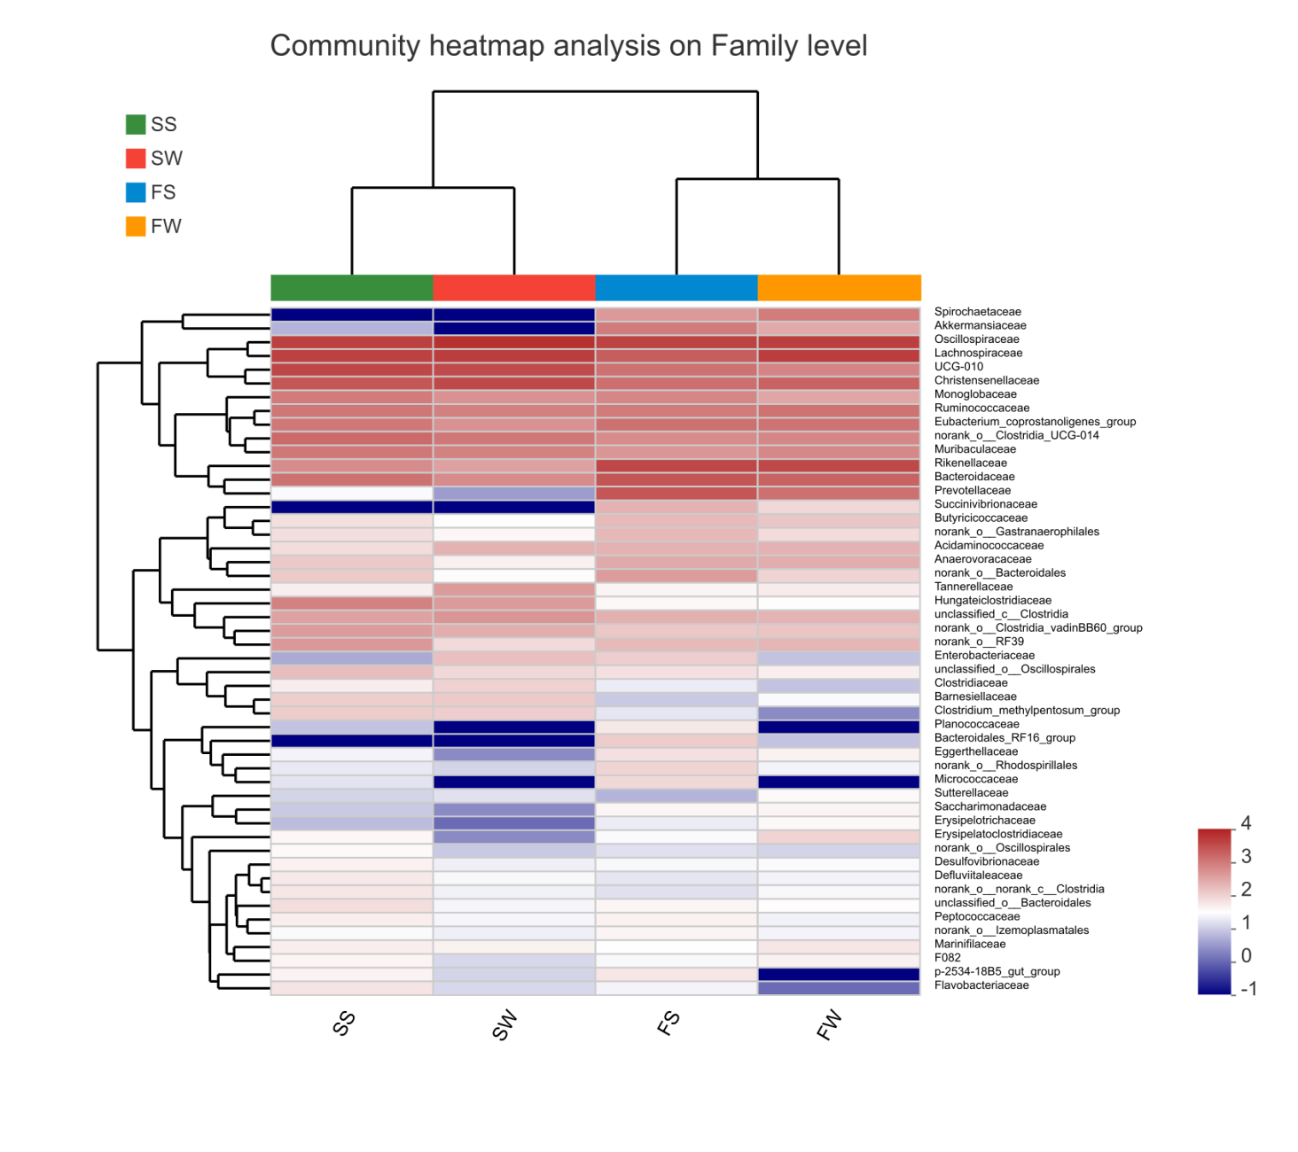

FIGURE S4 | Heatmap showing bacterial distributions at the family level.

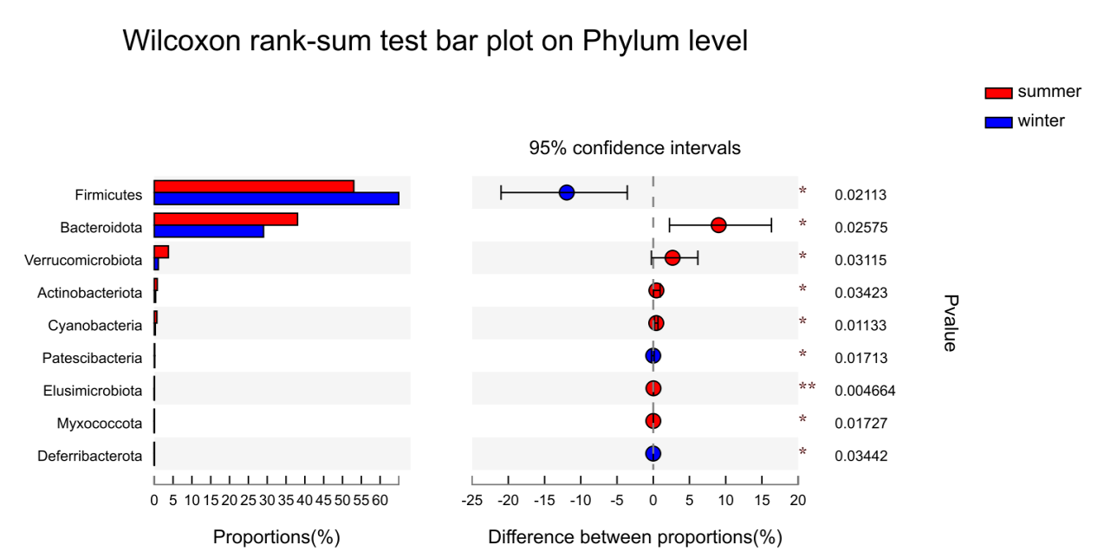
FIGURE S5 | Seasonal variations in bacterial composition in FMD. Histogram showing differentially abundant taxa at the phylum level. Significance was determined using Wilcoxon Rank-sum tests. (0.01 < p ≤0.05 marked as *, 0.001 < p ≤ 0.01 marked as **, p ≤ 0.001 marked as***).

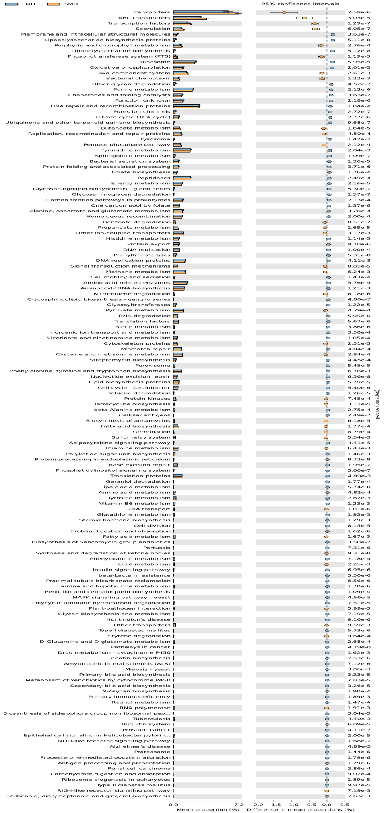
FIGURE S6 | Predication of microbial function. Histogram comparing functional pathways in the SMD and FMD groups (Level 3).143 functional differences (p<0.001) were selected for differential analysis.

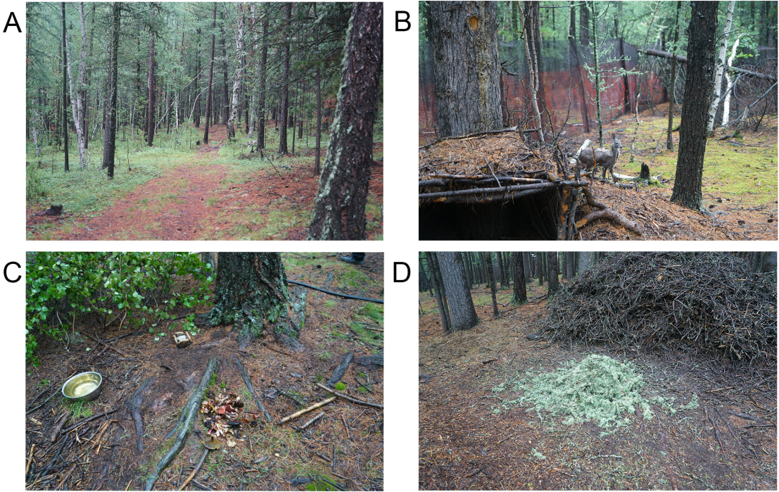
FIGURE S7 | Habitat of the Siberian musk deer. (A) and (B) showing that the Siberian musk deer breed environment in the virgin forest, fenced with black mesh. (C) and (D) figures show the fresh Cetrarian lichens and mushrooms provided by the keeper.

Table S1 | List of the effective sequence number, base number, and mean length for each sample. FW: forest musk deer during the winter; FS: forest musk deer during the summer; SS: Siberian musk deer during the summer; SW: forest musk deer during the summer.

Samples | Sequence number | Base number | Sequence mean length
FS12 | 61510 | 26628803 | 432.9182735
FS13 | 52886 | 22859258 | 432.2364709
FS18 | 54921 | 23886515 | 434.9249832
FS19 | 53279 | 23137597 | 434.2723587
FS20 | 45762 | 19976458 | 436.5293912
FS21 | 45229 | 19537142 | 431.9605121
FS24 | 53158 | 23074557 | 434.0749652
FS26 | 50698 | 21973891 | 433.4271766
FS27 | 59351 | 25760863 | 434.0426109
FS9 | 59218 | 25778775 | 435.3199196
FW10 | 46641 | 20122151 | 431.4262344
FW12 | 45593 | 19917741 | 436.8596276
FW13 | 48843 | 21142792 | 432.8725099
FW14 | 51177 | 22227945 | 434.3346621
FW15 | 53017 | 22781306 | 429.6981346
FW16 | 49631 | 21546848 | 434.14092
FW17 | 45106 | 19515387 | 432.6561211
FW6 | 47468 | 20378536 | 429.3110306
FW7 | 55637 | 24022912 | 431.7794274
FW9 | 52704 | 22797701 | 432.5611149
SS1 | 41638 | 18291586 | 439.3003026
SS10 | 67899 | 27632706 | 406.9677904
SS6 | 37789 | 15440335 | 408.5933737
SS8 | 74759 | 30488992 | 407.8303883
SS9 | 71760 | 29392548 | 409.5951505
SW1 | 45340 | 19408907 | 428.0747023
SW2 | 58215 | 24913320 | 427.9536202
SW3 | 53073 | 22811487 | 429.8134079

Table S2 | Number of OTUs, estimated OTU richness (ACE and Chao1), diversity indices (Shannon and Simpson), and estimated sample coverage for the samples. FW: forest musk deer during the winter; FS: forest musk deer during the summer; SS: Siberian musk deer during the summer; SW: forest musk deer during the summer.
Sample ID | OTUs | ACE | Chao | Shannon | Simpson | Coverage
FS12 | 805 | 4.963597 | 0.022285 | 950.809318 | 960.164948 | 0.993194
FS13 | 817 | 5.305454 | 0.010985 | 944.718792 | 957.225806 | 0.993663
FS18 | 784 | 4.812615 | 0.031832 | 924.056664 | 959.011236 | 0.993076
FS19 | 805 | 5.220382 | 0.013307 | 922.187673 | 927.085106 | 0.994054
FS20 | 713 | 4.446286 | 0.039378 | 877.14947 | 888.223404 | 0.992881
FS21 | 657 | 4.750644 | 0.022519 | 766.33437 | 784.743243 | 0.994602
FS24 | 823 | 4.921749 | 0.027172 | 953.678632 | 984.604396 | 0.993272
FS26 | 759 | 5.004004 | 0.020744 | 865.261172 | 887.888889 | 0.994328
FS27 | 756 | 4.983801 | 0.021319 | 878.745545 | 881.329787 | 0.993976
FS9 | 728 | 4.7191 | 0.03367 | 849.46174 | 858.172414 | 0.994093
FW10 | 763 | 4.820776 | 0.022331 | 871.088001 | 860.554545 | 0.99425
FW12 | 515 | 3.830628 | 0.075997 | 601.412389 | 603.333333 | 0.995854
FW13 | 773 | 5.144585 | 0.016813 | 885.013459 | 909.280488 | 0.994132
FW14 | 437 | 3.997938 | 0.057708 | 520.825898 | 518.9 | 0.99644
FW15 | 578 | 4.234618 | 0.049729 | 693.916717 | 668.725275 | 0.994954
FW16 | 654 | 4.792515 | 0.022008 | 796.232127 | 782.448276 | 0.994132
FW17 | 652 | 4.037083 | 0.104953 | 783.062943 | 809.08 | 0.993976
FW6 | 522 | 4.133853 | 0.068737 | 622.136009 | 614.776119 | 0.995619
FW7 | 657 | 4.65108 | 0.025613 | 774.232461 | 763.566667 | 0.994563
FW9 | 755 | 4.868695 | 0.019997 | 877.243702 | 910.121951 | 0.993741
SS10 | 700 | 4.38521 | 0.041137 | 835.391237 | 863.070588 | 0.993467
SS6 | 608 | 4.497884 | 0.027015 | 748.018874 | 765.652174 | 0.994211
SS8 | 865 | 5.499972 | 0.010065 | 956.760836 | 964.69697 | 0.994484
SS9 | 801 | 5.045609 | 0.015281 | 927.047633 | 912.889831 | 0.993624
SW1 | 599 | 4.464945 | 0.031482 | 688.505766 | 692.642857 | 0.995501
SW2 | 538 | 4.211789 | 0.03807 | 654.426346 | 657.230769 | 0.99511
SW3 | 396 | 3.60383 | 0.059232 | 520.480767 | 524.82 | 0.995541
SW4 | 616 | 4.607166 | 0.023907 | 739.558381 | 732.45 | 0.994641

Table S3 | The differences in microbial diversity (Shannon, Simpson, Ace, and Chao) between the four groups. Significance was determined using Wilcoxon Rank-sum tests. FW: forest musk deer during the winter; FS: forest musk deer during the summer; SS: Siberian musk deer during the summer; SW: forest musk deer during the summer.

Sample group | Shannon | simpson | ace | chao
FS-Mean | 4.9128 | 0.024321 | 893.24 | 908.84
FS-Sd | 0.24862 | 0.0088633 | 58.384 | 60.694
SS-Mean | 4.8572 | 0.023374 | 866.8 | 876.58
SS-Sd | 0.51657 | 0.013801 | 94.548 | 84.795
SW-Mean | 4.2219 | 0.038173 | 650.74 | 651.79
SW-Sd | 0.44333 | 0.015185 | 93.623 | 90.048
FW-Mean | 4.4512 | 0.046389 | 742.52 | 744.08
FW-Sd | 0.45434 | 0.030039 | 127.56 | 136.39
Pvalue(FS-SS) | 0.9436 | 0.832 | 0.832 | 0.6206
Qvalue(FS-SS) | 0.9436 | 0.9436 | 0.9436 | 0.9436
Pvalue(SS-SW) | 0.1939 | 0.3123 | 0.03038 | 0.03038
Qvalue(SS-SW) | 0.2327 | 0.3123 | 0.06077 | 0.06077
Pvalue(FS-FW) | 0.02575 | 0.162 | 0.009108 | 0.005795
Qvalue(FS-FW) | 0.0309 | 0.162 | 0.01822 | 0.01822
Pvalue(FW-SW) | 0.4367 | 0.9436 | 0.1791 | 0.2888
Qvalue(FW-SW) | 0.524 | 0.9436 | 0.524 | 0.524
FMD-Mean | 4.682 | 0.035355 | 817.88 | 826.46
FMD-Sd | 0.42793 | 0.024347 | 123.69 | 133.04
SMD-Mean | 4.5396 | 0.030774 | 758.77 | 764.18
SMD-Sd | 0.56026 | 0.015589 | 144.66 | 144.89
Pvalue | 0.4306 | 0.9797 | 0.2972 | 0.3468
Qvalue | 0.5167 | 0.9797 | 0.5167 | 0.5167

Table S4 | List of the Siberian Musk deer’s diet. ++++: very good; +++: good; ++: average; +: eat less.

№ | Names of Plants | snowy-period | no snowy-period
№ | Names of Plants | Winter |  | Spring | Summer | Autumn
1. | Salix caesia Vill. | + |  | ++++ | ++++ | ++++
2. | Salix rosmarinifolia L. | + |  | ++++ | ++++ | ++++
3. | Betula fruticosia Pall. | + |  | ++++ | ++++ | ++++
4. | Belula patyphylla Sukacz | + |  | ++++ | ++++ | ++++
5. | Betula rotundifolia Spach. | + |  | ++++ | ++++ | ++++
6. | Dasiphora fruticosa L. |  |  | + | + | ++
7. | Spiraea alpina Pall. |  |  | ++ | ++ | +
8. | Spiraea salicifolia L. |  |  | ++ | + | +
9. | Spiraea pubescens Turct. |  |  | ++ | + | +
10. | Rhododendron dahuricum  L. |  |  | +++ | +++ | ++++
11. | R. parvifolium Adams |  |  | ++ | +++ | ++
12. | Ribes rubrum L. | + |  | ++ | +++ | ++
13. | Ribes nigrum L. | + |  | ++ | +++ | ++
14. | Ribes altissimum Turct. | + |  | ++ | ++ | ++
15. | Rubus arcticus L. | + |  | ++ | ++ | ++
16. | Rubus saxatilis L. | + |  | ++ | ++ | ++
17. | Rosa acicularis Lindt. |  |  |  | ++ | +
18. | Vaccimum myrtillus L. | + |  | ++ | ++ | ++
19. | V. uliqinosum L. | + |  | ++ | ++ | ++
20. | V. vitis idaea L. | + |  | ++ | ++ | +++
21. | Pinus sibirica (Rupr.)  Mayr. | + |  | ++ | + | +
22. | Larix sibirica Ldb |  |  |  | + | +
23. | Pulsatilla flavescens Juz. |  |  | ++++ | ++++ | +++
24. | P. ambigua Juz. |  |  | ++++ | ++++ | +++
25. | P. campanula Fisch. |  |  | ++++ | +++ | +++
26. | P. Bungeana C.A.M. |  |  |  | +++ | +++
27. | P. Turczaninovii Kry.et  Serg. |  |  | ++++ | +++ | +++
28. | Trollius asiaticus L. |  |  | ++ | ++ | +
29. | Eguisetum palustre L. |  |  |  | ++ | +
30. | E sylvaticum L. |  |  |  | ++ | ++
31. | Geranium pratense |  |  | ++++ | ++++ | ++++
32. | G. pseudosibiricum  J.Meyer. |  |  | ++++ | ++++ | ++++
33. | Vicia craeca L |  |  | + | ++ | +
34. | Kladonia stellaris | +++ |  | ++++ | ++ | +++
35. | Usnea hirta (L) H.Wigy | +++ |  | ++++ | ++ | +++
36. | U. subfloridona Stirt. | +++ |  | ++++ | ++ | +++
37. | Evenia mesomorpha Nyl. | +++ |  | ++++ | ++ | +++
38. | Cetraria nivalis L. Ach. | ++++ |  | ++++ | ++ | +++
39. | C. islandica L. Ach. | ++++ |  | ++++ | ++ | +++
40. | C. cuccullata Bell.  Ach. | ++++ |  | ++++ | ++ | +++
41. | Cladonia  amouraeraea | ++++ |  | ++++ | ++ | +++
42. | Phloydicarpus sibiricus |  |  | ++ | ++ | ++
43. | Arenaria capillaris |  |  | ++ | ++ | ++
44. | Sanguisorba officinalis L |  |  | ++++ | ++++ | ++++
45. | S.alpina Bqe. |  |  | +++ | ++++ | ++++
46. | Polygonum viviparum |  |  |  | +++ | +++

