Supplementary material file 1

FIGURE S1 | Rarefaction curves of OTUs for the 28 samples. FW: forest musk deer during the winter; FS: forest musk deer during the summer; SS: Siberian musk deer during the summer; SW: forest musk deer during the summer.

FIGURE S2 | Heatmap showing bacterial distributions at the class level.

FIGURE S3 | Heatmap showing bacterial distributions at the order level.

FIGURE S4 | Heatmap showing bacterial distributions at the family level.

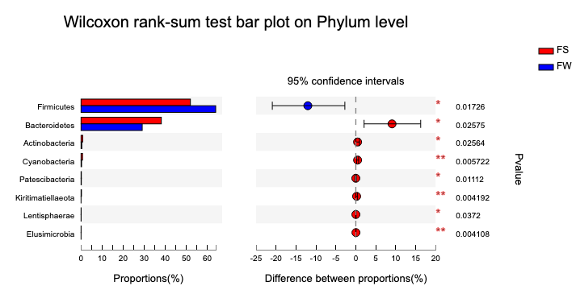
FIGURE S5 | Seasonal variations in bacterial composition in FMD. Histogram showing differentially abundant taxa at the phylum level. Significance was determined using Wilcoxon Rank-sum tests. (0.01 < p ≤0.05 marked as *, 0.001 < p ≤ 0.01 marked as **, p ≤ 0.001 marked as***).

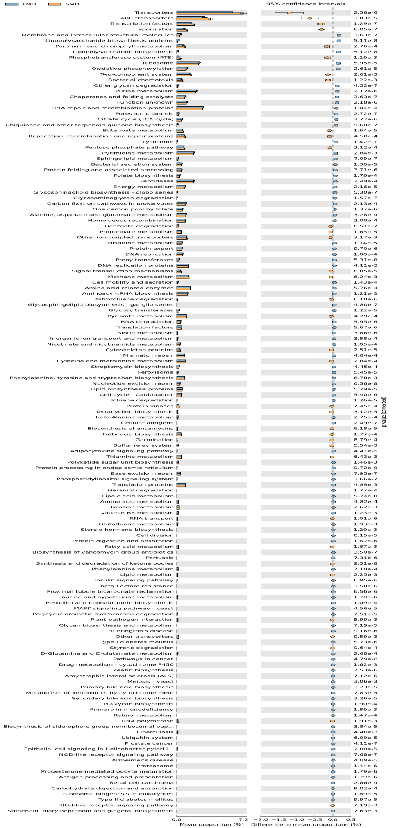
FIGURE S6 | Predication of microbial function. Histogram comparing functional pathways in the SMD and FMD groups (Level 3).143 functional differences (p<0.001) were selected for differential analysis.

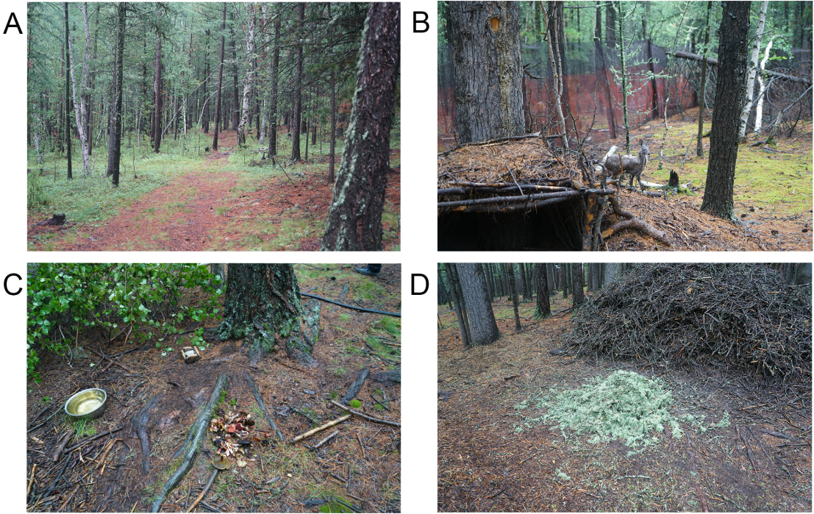
FIGURE S7 | Habitat of the Siberian musk deer. (A) and (B) showing that the Siberian musk deer breed environment in the virgin forest, fenced with black mesh. (C) and (D) figures show the fresh Cetrarian lichens and mushrooms provided by the keeper.

Table S1 | List of the effective sequence number, base number, and mean length for each sample. FW: forest musk deer during the winter; FS: forest musk deer during the summer; SS: Siberian musk deer during the summer; SW: forest musk deer during the summer.

Samples | Base number | Sequence number | Sequence mean length
SW4 | 20981827 | 48982 | 428.357907
SW3 | 22811487 | 53073 | 429.8134079
SW2 | 24913320 | 58215 | 427.9536202
SW1 | 19408907 | 45340 | 428.0747023
SS9 | 29392548 | 71760 | 409.5951505
SS8 | 30488992 | 74759 | 407.8303883
SS6 | 15440335 | 37789 | 408.5933737
SS10 | 27632706 | 67899 | 406.9677904
FW9 | 22797701 | 52704 | 432.5611149
FW7 | 24022912 | 55637 | 431.7794274
FW6 | 20378536 | 47468 | 429.3110306
FW17 | 19515387 | 45106 | 432.6561211
FW16 | 21546848 | 49631 | 434.14092
FW15 | 22781306 | 53017 | 429.6981346
FW14 | 22227945 | 51177 | 434.3346621
FW13 | 21142792 | 48843 | 432.8725099
FW12 | 19917741 | 45593 | 436.8596276
FW10 | 20122151 | 46641 | 431.4262344
FS9 | 25778775 | 59218 | 435.3199196
FS27 | 25760863 | 59351 | 434.0426109
FS26 | 21973891 | 50698 | 433.4271766
FS24 | 23074557 | 53158 | 434.0749652
FS21 | 19537142 | 45229 | 431.9605121
FS20 | 19976458 | 45762 | 436.5293912
FS19 | 23137597 | 53279 | 434.2723587
FS18 | 23886515 | 54921 | 434.9249832
FS13 | 22859258 | 52886 | 432.2364709
FS12 | 26628803 | 61510 | 432.9182735

Table S2 | Number of OTUs, estimated OTU richness (ACE and Chao1), diversity indices (Shannon and Simpson), and estimated sample coverage for the samples. FW: forest musk deer during the winter; FS: forest musk deer during the summer; SS: Siberian musk deer during the summer; SW: forest musk deer during the summer.

Sample ID | OTUs | ACE | Chao | Shannon | Simpson | Coverage
SW4 | 602 | 707.775172 | 696.879518 | 4.567832 | 0.02482 | 0.995071
SW3 | 410 | 567.670092 | 549.75 | 3.6008 | 0.059625 | 0.994914
SW2 | 536 | 657.644419 | 667.047619 | 4.195494 | 0.03891 | 0.994953
SW1 | 599 | 701.25329 | 730.355932 | 4.466282 | 0.031401 | 0.99511
SS9 | 783 | 924.84471 | 946.597826 | 5.016013 | 0.015746 | 0.993193
SS8 | 846 | 936.607717 | 949.511111 | 5.46711 | 0.010458 | 0.99464
SS6 | 597 | 726.026016 | 734.28 | 4.487332 | 0.027181 | 0.994367
SS10 | 686 | 820.573856 | 817.134021 | 4.365025 | 0.040932 | 0.993741
FW9 | 750 | 878.211473 | 915.0375 | 4.837072 | 0.02124 | 0.993623
FW7 | 644 | 737.44584 | 733.62963 | 4.639748 | 0.025616 | 0.995266
FW6 | 514 | 603.044416 | 600.953125 | 4.11756 | 0.069813 | 0.995853
FW17 | 641 | 753.48619 | 780.014085 | 4.033337 | 0.103621 | 0.994484
FW16 | 638 | 743.701436 | 715.970297 | 4.77031 | 0.022428 | 0.995071
FW15 | 577 | 702.84359 | 684.361446 | 4.233828 | 0.04789 | 0.994758
FW14 | 433 | 517.995099 | 536.636364 | 3.993982 | 0.057082 | 0.996244
FW13 | 760 | 867.48054 | 877 | 5.116807 | 0.017107 | 0.994367
FW12 | 504 | 573.199826 | 573.090909 | 3.803655 | 0.076057 | 0.996244
FW10 | 754 | 845.478259 | 834.279279 | 4.793034 | 0.022742 | 0.994758
FS9 | 732 | 874.414109 | 905.2625 | 4.688119 | 0.034586 | 0.993467
FS27 | 732 | 845.047118 | 865.846154 | 4.945846 | 0.022254 | 0.994328
FS26 | 759 | 864.527086 | 881.571429 | 4.97529 | 0.021893 | 0.994367
FS24 | 818 | 960.95712 | 993.011236 | 4.885601 | 0.0285 | 0.993076
FS21 | 652 | 757.554692 | 781.295775 | 4.743835 | 0.02254 | 0.99468
FS20 | 710 | 871.06154 | 899.321839 | 4.410512 | 0.040672 | 0.99288
FS19 | 798 | 916.057275 | 941.795181 | 5.211027 | 0.013365 | 0.993936
FS18 | 781 | 906.058545 | 938.413793 | 4.812216 | 0.031953 | 0.993506
FS13 | 821 | 957.598708 | 982.404494 | 5.277152 | 0.011381 | 0.99335
FS12 | 796 | 921.200598 | 945.896552 | 4.951284 | 0.022508 | 0.993662

Table S3 | The differences in microbial diversity (Shannon, Simpson, Ace, and Chao) between the four groups. Significance was determined using Wilcoxon Rank-sum tests. FW: forest musk deer during the winter; FS: forest musk deer during the summer; SS: Siberian musk deer during the summer; SW: forest musk deer during the summer.

Sample group | Shannon | simpson | ace | chao
FS-Mean | 4.8901 | 0.024965 | 887.45 | 913.48
FS-Sd | 0.2506 | 0.0091189 | 59.873 | 61.984
SS-Mean | 4.8339 | 0.023579 | 852.01 | 861.88
SS-Sd | 0.50796 | 0.013511 | 98.863 | 105.1
SW-Mean | 4.2076 | 0.038689 | 658.59 | 661.01
SW-Sd | 0.43399 | 0.015098 | 64.567 | 78.551
FW-Mean | 4.4339 | 0.04636 | 722.29 | 725.1
FW-Sd | 0.4478 | 0.029582 | 125.07 | 129.07
Pvalue(FS-SS) | 0.9436 | 0.832 | 0.7237 | 0.7237
Qvalue(FS-SS) | 0.9436 | 0.9436 | 0.9436 | 0.9436
Pvalue(SS-SW) | 0.1939 | 0.3123 | 0.03038 | 0.03038
Qvalue(SS-SW) | 0.2327 | 0.3123 | 0.06077 | 0.06077
Pvalue(FS-FW) | 0.02113 | 0.1405 | 0.002827 | 0.001706
Qvalue(FS-FW) | 0.02536 | 0.1405 | 0.005655 | 0.005119
Pvalue(FW-SW) | 0.4367 | 0.9436 | 0.2293 | 0.358
Qvalue(FW-SW) | 0.655 | 0.9436 | 0.655 | 0.655
FMD-Mean | 4.662 | 0.035662 | 804.87 | 819.29
FMD-Sd | 0.42366 | 0.023966 | 127.62 | 138.02
SMD-Mean | 4.5207 | 0.031134 | 755.3 | 761.44
SMD-Sd | 0.55078 | 0.015529 | 129.09 | 137.5
Pvalue | 0.4306 | 0.9797 | 0.2972 | 0.4014
Qvalue | 0.6458 | 0.9797 | 0.6458 | 0.6458

Table S4 | List of the Siberian Musk deer’s diet

Plant | Parts being used | winter | summer
Usnea | Fully | Vastly | Vastly
Bryophyta | Fully | Rare, few | Rare, few
Abietoideae /Pinaceae/ | Coniferous | Medium, often | -
Phododendron dauricum | Leaf, bud | - | -
Larix decidua | Coniferous | Less, rare
Salix pentandra | Leaf | Very few | Few
Acer ginnala | Leaf, bud | Very few | Vastly
Padus asiatica | - | - | -
Pinus sibirica | Coniferous | - | -
Vaccinium vitis | Leaf, bud | Less, rare | Less, rare
Tricholoma mongolicum | Body | - | Medium, often
Aralia mandshurica | Fully | - | -
Elymus repens L. | Leaf | - | Less, rare
Equisetophyta | Fully | Very few | Very few

