ELECTRONIC SUPPLEMENT

Global Longitudinal Strain by Speckle Tracking Echocardiography and Mortality in Septic Patients: an updated systematic review and meta-analysis with trial sequential analysis.
Critical Care

Pruszczyk Andrzej, Zawadka Mateusz, Andruszkiewicz Pawel, La Via Luigi, Herpain Antoine, Sato Ryota, Dugar Siddharth, Chew Michelle S., Sanfilippo Filippo

Corresponding Authors:
Mateusz Zawadka, m.t.zawadka@gmail.com

2nd Department of Anesthesiology and Intensive Care, Medical University of Warsaw, Poland
Filippo Sanfilippo, 00393289178766; filipposanfi@yahoo.it

Department of General Surgery and Medico-Surgical Specialties, School of Anaesthesia and Intensive Care, University of Catania, Catania, Italy.

e-Table 1. PICOS criteria
PICOS | Characteristics of clinical studies included for the qualitative synthesis and meta-analysis
- Participants | Adult patients with sepsis
- Intervention | Strain echocardiographic assessment with TTE, conducted within the first 48 h from diagnosis
- Comparison | Primary: comparison of strain values between survivors and non-survivors  Secondary: comparison of LVEF between survivors and non-survivors (only studies providing Strain)  Sensitivity: excluding studies with high risk of bias, leave-one-out, including studies performing TTE beyond 48h after the diagnosis of sepsis; including retrospective and case-control studies, based on software used for Strain assessment
- Outcomes | Mortality (at longest follow-up)
- Study design | Prospective clinical studies

e-Table 2. Details on the software version used for GLS and on the approach for LVEF quantification. ASE: American Society of Echocardiography; EACVI: European Association of Cardiovascular Imaging

Author, year | Strain software | Method for LVEF quantification
Bazalgette, 2021 | EchoPAC (GE®) | -
Bendary, 2022 | Image Arena (TomTec) | As recommended by ASE
Boissier, 2017 | Philips’ Qlab 8.1 (Philips®) | Simpson’s method
Chang, 2015 | EchoPAC v. BT09 (GE®) | As recommended by ASE
de Braga L. C. Canesso, 2019 | EchoPAC (GE®) | As recommended by ASE/EACVI
De Geer, 2014 | EchoPac v. 112 (GE®) | Modified Simpson’s method
Ehrman 2022 | EchoPAC (GE®) | LVEF assessed by visual estimation in increments of 5%
Hai, 2020 | EchoPac v. 112 | Modified Simpson’s method
Innocenti, 2021 | Philips’ Qlab 8.1 (Philips®) | Simpson’s method
Landesberg, 2014 | Philips’ Qlab 8.1 (Philips®) | Modified Simpson’s method
Lanspa, 2021 | TomTec | As recommended by ASE
Orde, 2014 | Syngo Velocity Vector Imaging (Siemens®) | As recommended by ASE
Ricarte-Bratti, 2017 | Echo Pac v. 113 (GE®) | As recommended by ASE
Shahul, 2015 | Cardiac perf. Analysis v1.1 (TomTec®) | Simpson’s method

e-Figure 1. Forest plot comparing left ventricular global longitudinal strain (GLS) values between survivors and non-survivors among septic patients, with subgroup analysis according to the number of views used to calculate GLS values. CI: Confidence Interval; IV: inverse variance; SD: standard deviation.
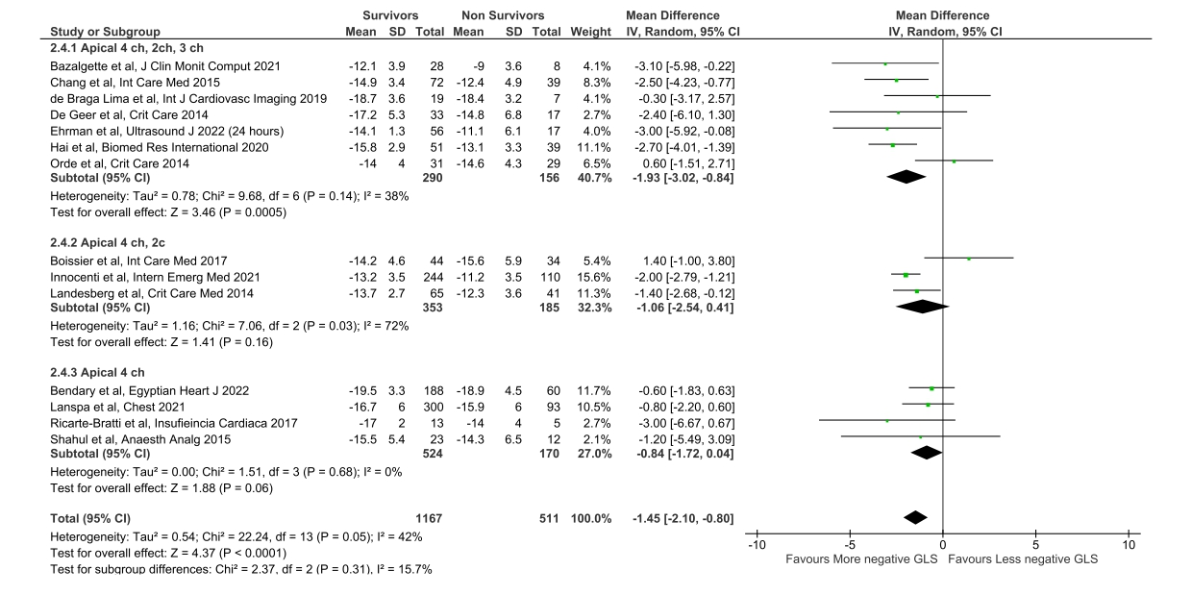

e-Figure 2. Forest plot comparing left ventricular global longitudinal strain (GLS) values between survivors and non-survivors among septic patients, with subgroup analysis according to the criteria used to diagnose septic patients. CI: Confidence Interval; IV: inverse variance; SD: standard deviation.

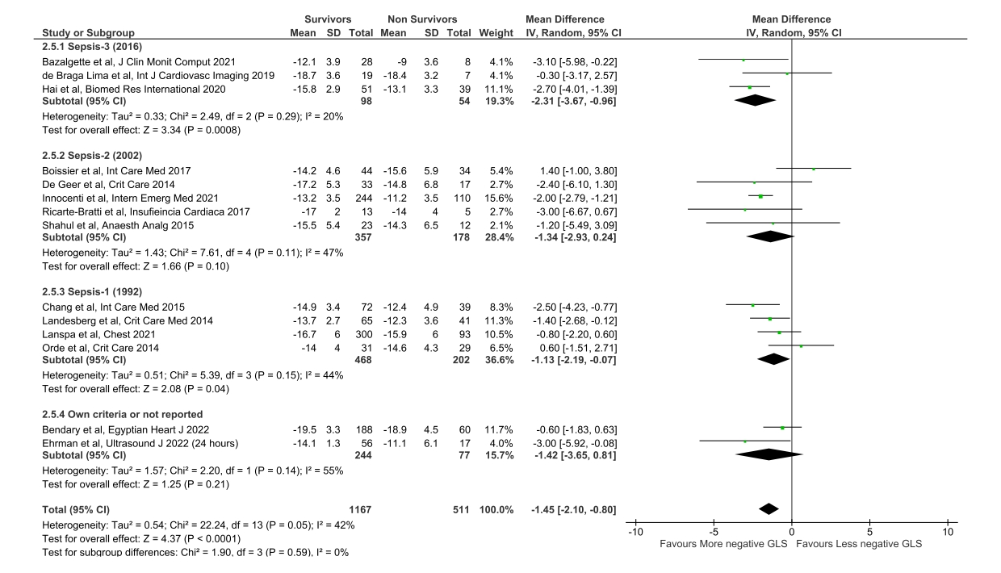

e-Figure 3. Forest plot comparing left ventricular global longitudinal strain (GLS) values between survivors and non-survivors among septic patients, with subgroup analysis separating studies according to the presence of septic shock only or of all stages of septic disease. CI: Confidence Interval; IV: inverse variance; SD: standard deviation.

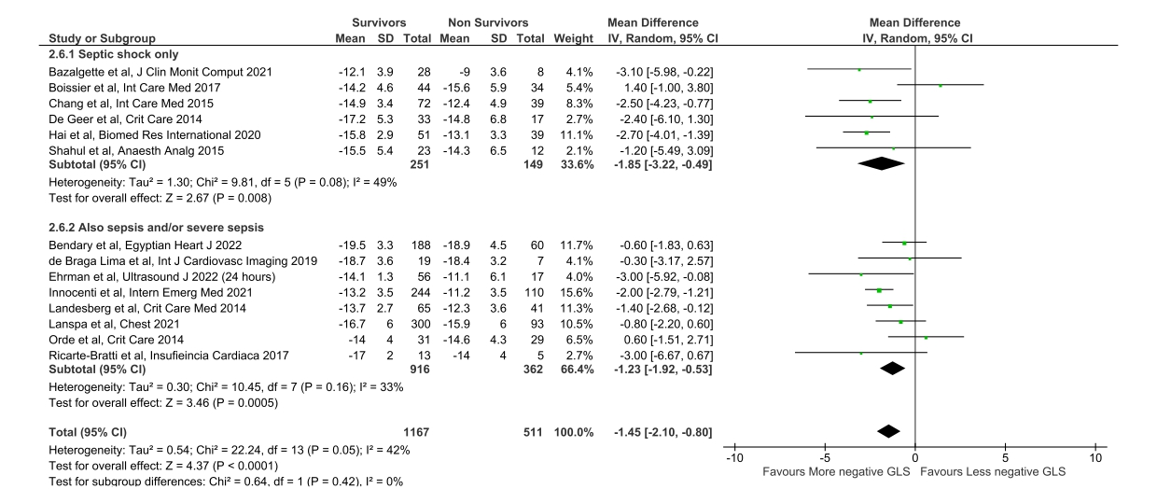

e-Figure 4. Funnel plot inspection for the primary analysis of the GLS
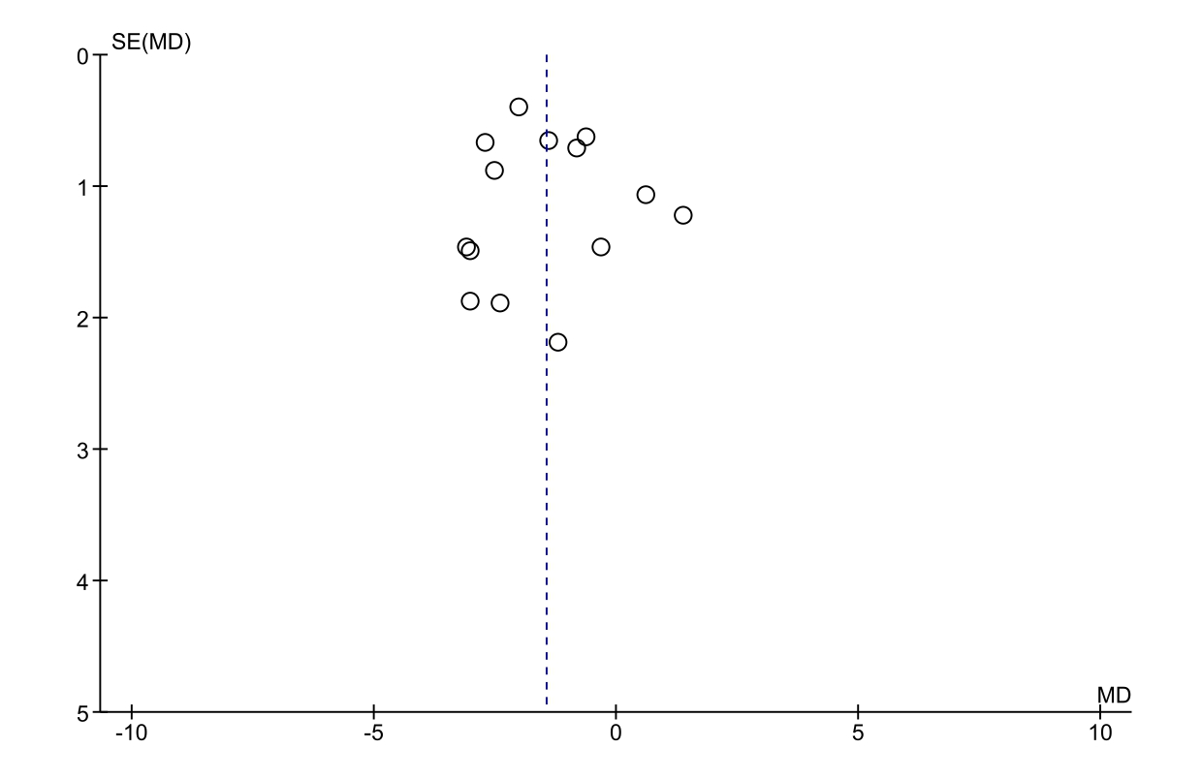
e-Table 3. Newcastle-Ottawa Scale assessment of quality of included cohort studies. Each asterisk represents fulfillment of the acceptable criteria within each subsection
Study | Selection |  |  |  | Comparability | Outcomes |  |  | Total
Study | Representativeness of exposed cohort | Selection of nonexposed cohort | Ascertainment of exposure | Outcome not present at the start of the study |  | Assessment of outcomes | Length of follow-up | Adequacy of follow-up
Acceptable Criteria | Sepsis with criteria well-defined and following established guidelines.  Consecutive patients enrolled. | Same with exposed cohort. | Blinded assessment and reporting interobserver repeatability | Echocardiography was performed after the diagnosis of sepsis. | *: Adjusting for age or sex.  *: additional factors including severity score, past medical conditions, fluid status, or vasopressor dose. | Secured records / Electronic medical records | At least 28 days or in-hospital mortality. | Reporting whether there was a loss of follow-up. If any, it was below 10% of the cohort?
Bendary 2022 | - | * | - | * | - | * | * | * | 5
Ehrman 2022 | - | - | - | * | - | * | * | * | 4
Bazalgette 2021 | * | * | - | * | - | * | * | * | 6
Innocenti 2021 | * | * | - | * | - | * | * | * | 6
Lanspa 2021 | - | * | - | * | - | * | * | * | 5
Hai 2020 | * | * | - | * | - | * | * | * | 6
De Braga Lima 2019 | - | * | - | * | - | * | * | * | 3
Boissier 2017 | * | * | - | * | - | * | * | * | 6
Ricarte-Bratti 2017 | - | * | - | * | - | * | * | * | 5
Chang 2015 | - | * | * | * | - | * | * | * | 6
De Geer 2015 | - | * | - | * | - | * | * | * | 5
Shahul 2015 | * | * | - | * | - | - | * | * | 6
Landesberg 2014 | * | * | - | * | - | * | * | * | 6
Orde 2014 | - | * | - | * | - | * | * | * | 5

