Supplementary
Supplementary 1. STROBE Checklist

Supplementary 2. The original survey (in Norwegian)

Supplementary 3. Which electronic health record (EHR) system do you have in your main workplace in specialist health services
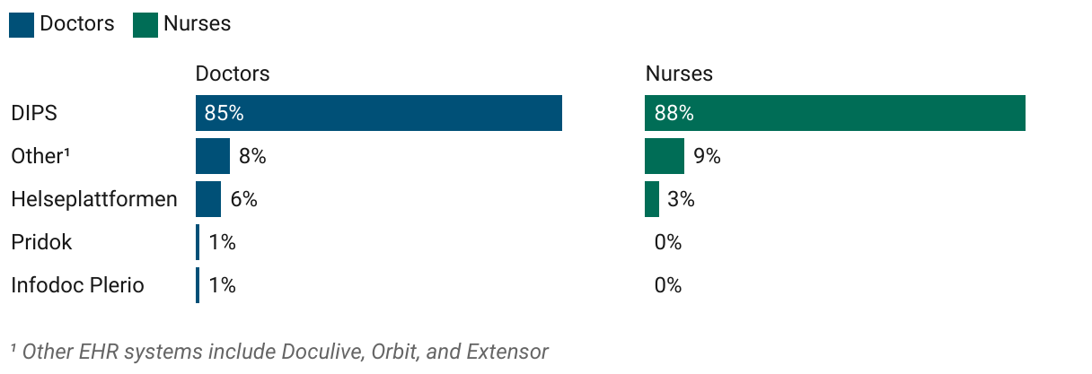

Supplementary 4. Which electronic health record (EHR) system do you have in your main workplace in municipal health services
